Description:
WVDEP Lidar data was collected by the Natural Resource Analysis Center at WVU under contract with the West Virginia Department of Environmental Protection, Division of Mining and Reclamation.
The data was collected between 04/09/2010 and 12/13/2011 during leaf-off, snow and flood free conditions in the spring and fall.
The data format is 1.5x1.5 km LAS v1.2 files in UTM 17 NAD83 (CORS96), NAVD88 (GEOID09). Contractor software initially classified ground returns for comprehensive and bare earth tiles, but did not perform other classifications.
The Technical Applications and GIS (TAGIS) unit at the WVDEP performed Quality control checking and error correction on a tile-by-tile basis before creating derived products and edited LAS files.
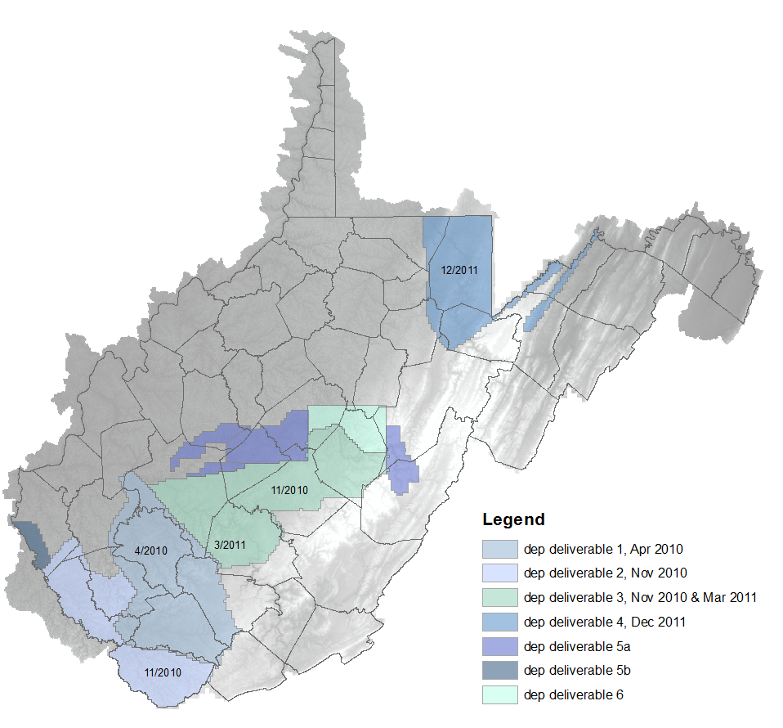
Hardware and flight parameters:
Scanner: | Optech ALTM-3100
Post Spacing (Average): | 3.3 ft / 1.0 meter
Flying Height (Above Ground Level): | 5,000-ft / 1,524 meters
Average Ground Speed: | 135 knots (155 MPH)
Scanner Pulse Rate Frequency: | 70,000 Hz
Scanner Frequency / Field of View: | 35 Hz / 36 degrees (18 half angle)
Overlap (Average): | 30%

Independent elevation accuracy analysis, open terrain:
Product | Number of points | RMSE | RMSE * 1.96
Deliverable 1 | 23 | 0.107 | 0.210
Deliverable 2 | 11 | 0.223 | 0.436
Deliverable 3 | 18 | 0.14 | 0.28

