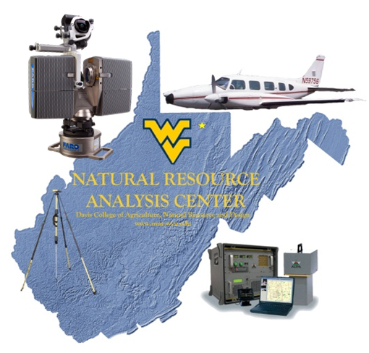
AERIAL LIDAR ACQUISITION REPORT
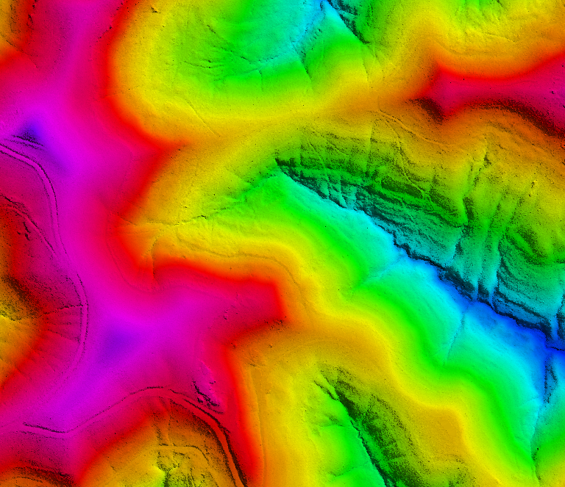
__________________
TUG NOTCH
LIDAR *.LAS1.2 DATA
COMPREHENSIVE AND BARE EARTH

WEST VIRGINIA
DEPARTMENT OF ENVIRONMENTAL PROTECTION
JUNE 2013
PREPARED BY:
WVU NATURAL RESOURCE ANALYSIS CENTER
2014 AGRICULTURAL SCIENCES
PO BOX 6108
MORGANTOWN, WV 26506-6108

TABLE OF CONTENTS
Section 1:………………………………………………………………………….Overview
Section 2:…………………………………………………..GPS Base Station Data
Section 3:………………………………….…….LiDAR Systems Specifications

SECTION 1: OVERVIEW
Project Name: Tug Notch Airborne LiDAR

NRAC was contracted to perform an aerial acquisition survey of the pertinent mine areas in and around Tug Watershed pertaining to Wayne County, WV for the purpose of high-resolution (1-meter) airborne LiDAR to ultimately produce products (digital elevation models, contours, flood and surface modeling, change detection, permit boundaries, etc) for the public. The Tug Notch project was collected 19 Dec 2011 and is composed of 125 working segments, covering 63,846.64 acres.
LiDAR data was collected by the Optech ALTM-3100 100k Hz Multi-pulse LiDAR system mounted in a Piper Navajo PA-31. The ALTM-3100 collects up to four returns per pulse, as well as backscatter reflectance (intensity) data. The aerial LiDAR was collected at the following sensor specifications:
Post Spacing (Average): | 3.3 ft / 1.0 meter
Flying Height (Above Ground Level): | 5,000-ft / 1,524 meters
Flying Height (Mean Sea Level): | Varies with terrain
Average Ground Speed: | 135 knots (155 MPG)
Scanner Pulse Rate Frequency: | 70,000 Hz
Scanner Frequency / Field of View: | 35 Hz / 36 degrees (18 half angle)
Overlap (Average): | 30%

Flight line acquisition was performed around weather, winds, GPS PDOP, vegetation emergence conditions, and fuel, collecting data in as few missions as possible, as close together as possible, to ensure consistency across the project area.
The data collected was flown back to the WVU NRAC office in Morgantown, WV, extracted, viewed, and quality controlled such that immediate re-flights could be performed if necessary.
NRAC’s aerial acquisition team coordinated with the necessary Air Traffic Control and Restricted Airspace personnel prior to flying to ensure permissions.

Flight Summary Log

Date of Flight | Lines/Trajectories | Start week/time  (GPS, UTC) | Stop week/time  (GPS, UTC)
19 Dec 2011 | 29 | 643/ 133151.8106 | 643/ 151988.0027
19 Dec 2011 | 5 | 643/ 161858.2068 | 643/ 164497.3279

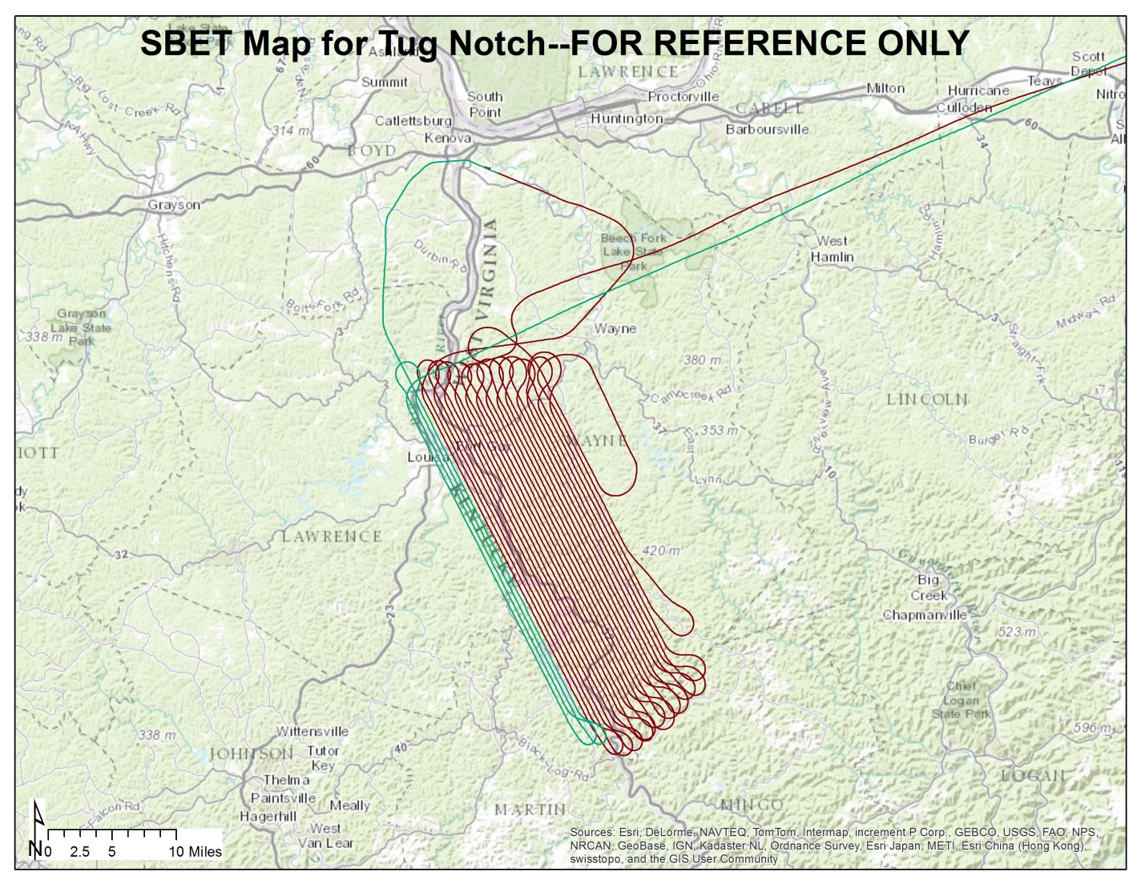

SECTION 2: GPS BASE STATION DATA
Ground GPS data is collected via two TOPCON HiPER GD dual-frequency, 12-channel geodetic quality receivers. Locations occupied for collection are either registered National Geodetic Survey (NGS) control monuments, or created Online Positioning User’s Service (NGS OPUS) control points.
NRAC determines appropriate locations for GPS base station collections and only operates equipment/occupies site with appropriate permissions. Locations are determined based off baseline length from rover (aircraft) to base stations, site assessments (view of sky, obstructions [masks], and multipath sources), along with permissions/access.
Base stations locations for the Tug Notch project area are detailed with the following NGS OPUS Datasheets (dates are referenced in file name):
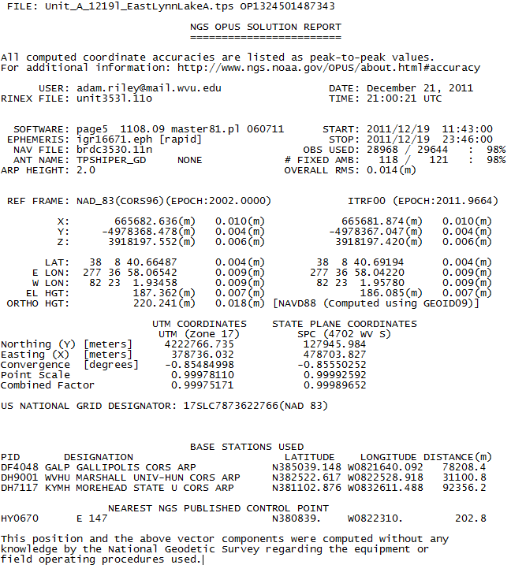
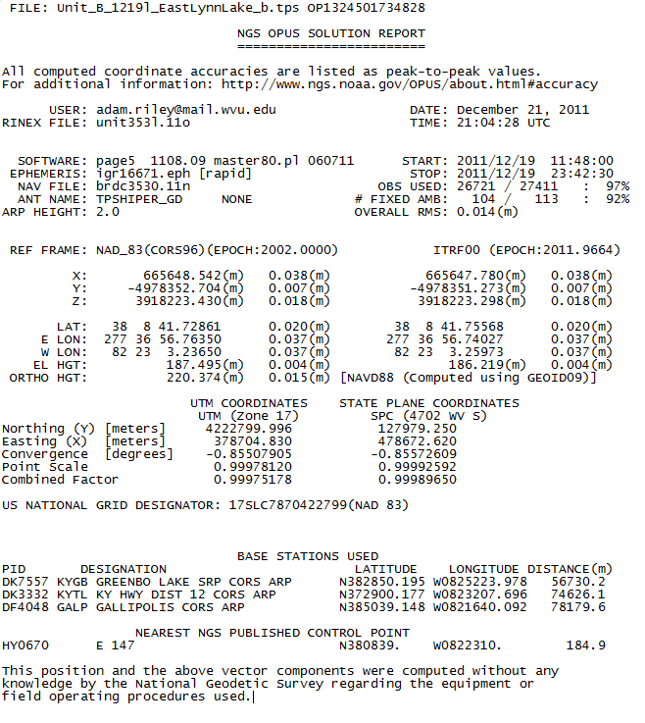

SECTION 4: LIDAR SYSTEMS SPECIFICATIONS
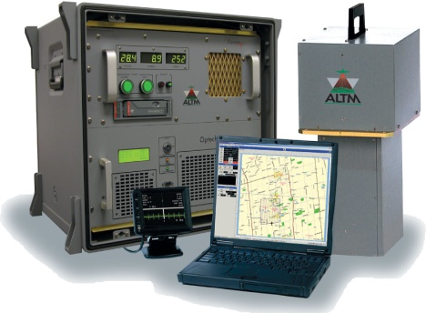
- NRAC operates an OPTECH ALTM-3100C airborne laser mapping system. The system integrates a laser Altimeter, a high-end Applanix POS/AV Inertial Measurement Unit (IMU), also called an Inertial Navigation System (INS), and a dual frequency Trimble GPS receiver. The system offers several user-configurable parameters that allow the data capture campaign to be tailored to each specific project. This integrated system is capable of 100kHz operation at an operating height of 1,100 meters (3,609 feet). LiDAR technology offers fast, real-time collection of three-dimensional points that are employed in the creation of Digital Elevation Models (DEMs) and other desired deliverables.
- In-flight data are logged to hard drives, which provides for immediate extraction and viewing of post-mission data. Data quality, coverage, and other mission critical information are reviewed immediately to determine if re-flights are necessary. Basic parameters of NRAC’s LiDAR system include:
The OPTECH ALTM-3100

