TABLE OF CONTENTS

PAGE
1.0 INTRODUCTION 3
2.0 PURPOSE 3
3.0 STANDARDS & SPECIFICATIONS 5
3.1 Overview 5
3.2 Horizontal Accuracy 5
3.3 Vertical Accuracy 6
4.0 QUALITY REVIEW DOCUMENTATION 6
5.0 SUMMARY 10

TABLE OF CONTENTS (cont)
PAGE

LIST OF TABLES

Table of Contents i
Table 2.1 Studied Stream Reaches 3
Table 2.2 Aerial Surveys 5
Table 4.1 Vertical Accuracy Statistic Worksheet 8

LIST OF FIGURES

Figure 4.1 Error Frequency Distribution 9
Figure 4.2 Error Frequency Distribution - Pavement 9
Figure 4.3 Error Frequency Distribution - Grass 10
Figure 4.4 Error Frequency Distribution - Woods 10

LIST OF APPENDICES

Appendix A: CD1 with LIDAR Raw Data
Appendix B: CD2 with LIDAR Grid Data; Breakline Data; Mass Point Data
Appendix C: CD3 with LIDAR Mass Point Data
Appendix D: CD4 with LIDAR; Non-studied stream TINs, shapefiles; Studied stream shapefiles
Appendix E: CD5 with Studied stream TINs
Appendix F: EnerQuest Systems LLC Quality Control Report

INTRODUCTION

Jackson County is located on the western border of West Virginia approximately 35 miles north of Charleston. The Mill Creek Watershed is located in the center of the county and includes the City of Ripley. The Sandy Creek Watershed is located in the northern portion of the county; while Grasslick Creek and Pocatalico Creek Watersheds are located in the southern portions of the county. Little Mill Creek, Elk Fork, and Tug Fork are all in the upper reaches of Mill Creek.

PURPOSE

FEMA tasked AMEC Earth & Environmental, Inc. (AMEC) to update the Flood Insurance Study (FIS) and Flood Insurance Rate Maps (FIRM) for Jackson County, West Virginia in accordance with FEMA’s Guidelines and Specifications for Study Contractors (FEMA-37). For the FIS restudy AMEC has developed topographic mapping using the services of EnerQuest Systems, LLC, and DTMs to produce 1”=500’, 4 foot contour interval topographic maps per the Guidelines and Specifications for Flood Hazard Mapping Partners. The mapping contractor, EnerQuest Systems LLC, utilized Global Positioning System (GPS) surveys to establish horizontal and vertical control for the mapping effort. The streams studied by AMEC are identified below in Table 2.1.
Table 2.1 Studied Stream Reaches

Stream | Study Area Description | Study Type | Study Length (miles) | Number Of Stream Crossings
Mill Creek | Outlet to Ohio River U/S to D/S limit of detailed study at State Highway 87. | Detailed | 12.1 | 6
Mill Creek | Through the City of Ripley (effective detailed study reach). | Update existing study to HEC-RAS | 8.1 | 6
Mill Creek | From U/S limit of detailed study approximately 4000’ U/S of School Street crossing to 1000’ U/S of County Road 34-1 crossing. | Detailed | 3.7 | 2
Grasslick Creek | From first State Route 34 crossing D/S of Town of Kenna to 500’ D/S of Interstate 77 crossing. | Limited Detail (100-year only) | 5.3 | 7
Sandy Creek | From outlet to Ohio River U/S to confluence of Right and Left Forks of Sandy Creek. | Limited Detail | 6.1 | 8
Right Fork Sandy Creek | From confluence with Left Fork to U/S side of County Highway 13-1 crossing. | No study
Left Fork Sandy Creek | From confluence with Right Fork to U/S side of County Highway 13 crossing. | Limited Detail | 1.3 | 2
Left Fork Pocatalico Creek | From 500’ D/S of State Route 21 at Interstate 77 to 2000’ U/S of County Highway 21-33 crossing. | Limited Detail | 4.5 | 7

FEMA tasked AMEC to collect topographic data for the above listed streams and several others. Table 2.2 Aerial Surveys lists the flooding sources for which topographic data was collected. EnerQuest Systems, LLC used an airborne Light Detection and Ranging (LIDAR) survey system to collect the topographic data.

TABLE 2.2 Aerial Surveys

 |  |  |  | Aerial (Photogrammetric) Survey
Watershed | Stream | Study Area Description | Approximate Mapping Corridor Length (miles) | Ground Control | Aerial Data Collection | Map Production
Mill Creek | Mill Creek | Outlet to Ohio River U/S to D/S limit of detailed study at State Highway 87 | 12.1 | Yes | Yes | Yes
Mill Creek | Mill Creek | Through the City of Ripley | 8.1 | Yes | Yes | Yes
Mill Creek | Mill Creek | From U/S limit of detailed study approximately 4000’ U/S of School Street crossing to 1000’ U/S of County Road 34-1 crossing. | 3.7 | Yes | Yes | Yes
Mill Creek | Mill Creek | From 1000’ U/S of County Road 34-1 crossing to confluence with Tug Fork. | 1.1 | No | Yes | No
Mill Creek | Little Mill Creek | From confluence with Elk Fork to confluence of Frozencamp Creek. | 5.3 | No | Yes | No
Mill Creek | Elk Fork | From confluence with Little Mill Creek to confluence of Billy Run. | 8.0 | No | Yes | No
Mill Creek | Tug Fork | From confluence of Mill Creek to confluence of Grasslick Creek | 5.7 | No | Yes | No
Mill Creek | Grasslick Creek | From first State Route 34 crossing D/S of Town of Kenna to 500’ D/S of Interstate 77 crossing | 5.3 | Yes | Yes | Yes
Mill Creek | Grasslick Creek | From first State Route 34 crossing D/S of the Town of Kenna to U/S of the Town of Kenna | 0.5 | No | Yes | No
Sandy Creek | Sandy Creek | From outlet to Ohio River U/S to confluence of Right and Left Forks of Sandy Creek | 6.1 | Yes | Yes | Yes
Sandy Creek | Right Fork Sandy Creek | From confluence with Left Fork to U/S side of County Highway 13-1 crossing | 1.3 | No | Yes | No
Sandy Creek | Left Fork Sandy Creek | From confluence with Right Fork to U/S side of County Highway 13 crossing. | 1.3 | Yes | Yes | Yes
Left Fork Pocatalico Creek | Left Fork Pocatalico Creek | From 500’ D/S of State Route 21 at Interstate 77 to 2000’ U/S of County Highway 21-33 crossing | 4.5 | Yes | Yes | Yes

STANDARDS & SPECIFICATIONS

Overview

To produce the high-accuracy elevation data required for hydraulic analyses (both detailed and limited detailed flood hazard analyses) on the studied streams, ground surveys and LIDAR-generated mapping is used. The LIDAR-derived data met the National Standard for Spatial Data Accuracy (NSSDA) that is required to produce topographic maps and products as outlined in the Guidelines and Specifications for Flood Hazard Mapping Partners (G&S), dated February 2002. The guidelines state that the Root Mean Square Error (RMSE) cannot exceed 1.2 for 4-foot contour interval mapping and the NSSDA cannot exceed 2.4.

AMEC has used a statistical testing methodology, consistent with aforementioned G&S, for estimating the positional accuracy of points in digital geospatial data, with respect to georeferenced ground positions that provide higher accuracy. Checkpoint surveys were performed to establish independent Quality Assurance/Quality Control (QA/QC) checks for more accurate ground points. They were mostly used to check the vertical accuracy of LIDAR datasets.

Triangulated Irregular Networks (TINs) were developed from the LIDAR and used for QA/QC reviews. The survey checkpoints were compared to the interpolated TIN values as part of the accuracy checks.

Keeping the mapping contractor unaware of the ground-surveyed checkpoints facilitated an independent third party review. In addition, the land surveyors had no knowledge of the LIDAR datasets rendering the ground survey points completely impartial. This process led to a completely independent third party review or double blind assessment of the LIDAR data.

As per the February 2002 G&S, TIN accuracy is evaluated for the main categories of ground cover in the study area. These typical ground cover categories are surveyed for a minimum of 20 test points. Increasing the number of test points increases the confidence level in the calculated root mean square error (RMSE) values and improves performance standards.

Horizontal Accuracy

Please refer to the attached report Appendix F for the Quality Control report submitted by EnerQuest Systems LLC for checking horizontal accuracy.

Vertical Accuracy

In accordance with the NSSDA recommendations the RMSE was computed for vertical accuracy. The squared difference between the independent (ground-surveyed) elevations and test (LIDAR) elevations was averaged and the square root of that yielded the RMSE. As per FEMA guidelines, vertical accuracy of the LIDAR dataset is 1.96 times the computed RMSE value.

QUALITY REVIEW DOCUMENTATION

The LIDAR survey system, developed by EnerQuest Systems, LLC, gathered data necessary to create the digital elevation information. The raw LIDAR data consisted of 81 tile polygons with respective grid, breakline, and mass point datasets. For each tile, the mass point and breakline data were converted to respective shape files using ArcView extensions and Avenue scripts. The mass point datasets were examined for any errors in reporting mass point elevations. Clipping boundaries were established at tile edges to only include the outermost edges of mass points. The mass points were visually inspected within the clipped boundary to spot irregularities at overlaps or flight seams. After these preliminary checks were complete, TINs were created for each stream corridor. The TINs were visually inspected for any artifacts within the datasets. No artifacts were found within the floodplain corridors.

A checkpoint survey was performed for independent QA/QC checks to determine vertical accuracy of LIDAR datasets. Three major ground cover categories were identified and a minimum of 20 test points were surveyed/selected for each category. Thus a minimum of 60 test points were selected for three major land cover types– pavement, woods, and grass. In accordance with FEMAs Guidelines and Specifications for Flood Hazard Mapping Partners, the survey checkpoints were compared to the interpolated TIN elevations. The square root of the mean of the squared errors was computed as the vertical RMSE. The computed RMSE for the entire dataset was computed to be 0.93 feet, within the NFIP standard of 1.2 feet. Table 4.1 on the next page reflects the results of the accuracy analysis.

For more details on LIDAR data collection please refer to Appendix F for the Quality Control report submitted by EnerQuest Systems LLC.

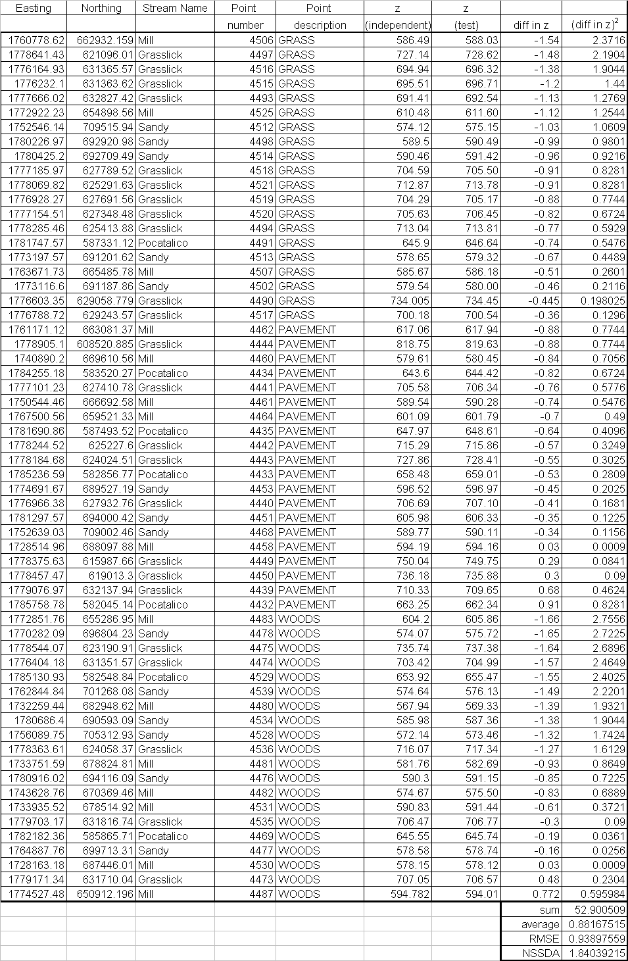
Table 4.1 Vertical Accuracy Statistic Worksheet
Also an analysis of the error frequency distribution for all the checkpoints is shown in the following histogram plots. Histograms were also used to analyze error frequency distributions in each ground cover categories.
Figure 4.1 Error Frequency Distribution

Figure 4.2 Error Frequency Distribution – Pavement
Figure 4.3 Error Frequency Distribution – Woods

Figure 4.4 Error Frequency Distribution – Grass

SUMMARY

Aerial photogrammetric LIDAR data was collected for all the reaches as per Task Order (001). The LIDAR data was checked for errors on all streams as per the Guidelines and Specifications for Flood Hazard Mapping Partners, dated February 2002 and was found to be within acceptable limits. This data was used to create TINs for lower Mill Creek, Sandy Creek & Left Fork Sandy Creek, Pocatalico Creek, Grasslick Creek, Little Mill Creek, Elk Fork, and Tug Fork. The elevations derived from the TINs were checked against ground-surveyed points and found to be within acceptable ranges in accordance with the Guidelines and Specifications for Flood Hazard Mapping Partners, dated February 2002. The TINs will be used to perform hydraulic analysis for Mill Creek, Sandy Creek & Left Fork Sandy Creek, Pocatalico Creek, and Grasslick Creek.

Appendix A: LIDAR Backup Data

Description: | Contains LIDAR Raw Data for Tiles 1 through 81 (*raw.dat)
Comments:

Appendix B: LIDAR Backup Data

Description: | Contains LIDAR Grid Data for Tiles 1 through 81 (*gr.dat); LIDAR Mass Point Data for Tiles 61 through 81 (*.dat); and Breakline Data for Tiles 1 through 81 (*.dgn)
Comments:

Appendix C: LIDAR Backup Data

Description: | Contains LIDAR Mass Point Data for Tiles 1 through 60 (*.dat)
Comments:

Appendix D: LIDAR Backup Data

Description: | Triangulated Irregular Networks (TIN) for non-studied streams - Little Mill Creek, Elk Fork and Tug Fork with their respective shape files and clip boundaries; Shape files and clip boundaries for the studied streams - Mill Creek, Sandy Creek, Pocatalico Creek, and Grasslick Creek; and, shape file for LIDAR Tiling scheme
Comments: | TIN for the studied streams are on CD-E

Appendix E: LIDAR Backup Data

Description: | Triangulated Irregular Networks (TIN) for Mill Creek, Sandy Fork, Pocatalico Creek, and Grasslick Creek. Also contains electronic copy of the LIDAR report.
Comments:

Appendix F: EnerQuest Systems LLC Quality Control Report

