Landsat Linear Features of West Virginia
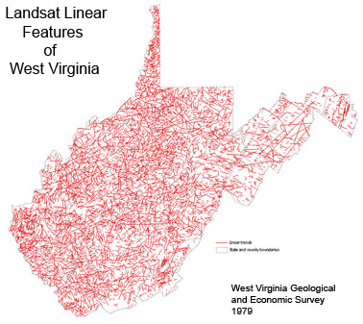
Summary Metadata
DESCRIPTION A reference map of linear and curvilinear features observable on Landsat images published by the WV Geologic and Economic Survey in 1979.
SCALE 1:150,000
LOCATION Statewide
ATTRIBUTE INFORMATION None
DATA SOURCE LINEAGE Two hardcopy map sheets of the 1979 Landsat Linear Features of West Virginia map were scanned at 300 dpi 8-bit color by the WV GIS Technical Center. The scanned TIFs were converted to index color mode, and resampled to 150 dpi. The map sections were then mosaicked together and georeferenced to a 15-minute Longitude/Latitude grid.
COORDINATE SYSTEM UTM Zone 17 (NAD 83) with map units in meters.
FILE FORMAT Index Color compressed TIF (32 MB)
SUPPLEMENTAL INFORMATION

