Mitigated Buyout Property Update Procedures
12/10/2024
Mitigated buyout properties may originate from various sources, including counties, WV Emergency Management Division, or federal agencies such as the Natural Resources Conservation Service. West Virginia buyout properties from new sources are integrated into a master geodatabase and published to the WV Flood Tool (www.mapwv.gov/flood).
The updated procedures for integrating new properties into the standardized geodatabase are described as follows (summarized in Figure 1). First, the source agency file is standardized on the full parcel identifier. The unique property identifier is the full GIS Parcel Identifier (e.g., 0108-0011-0069-0000). The source file is then checked against the Master Buyout Property file for duplicate records. Next, the source agency file is converted from an Excel file to a geodatabase format and updated with the parcel geometry from the seamless Statewide Master GIS Surface Parcel file. New records are joined with FEMA’s Community Boundary File to add the Community Identifier (CID) and Community Name data fields. The CID may also be added manually using the query results panel of the Flood Tool. Quality checks are performed for mismatches of the parcel geometry, assessment records, acreage mismatches between the IAS deed book and GIS calculated acreages, OSP overlap, and structures present on aerial imagery. The final step merges the Source Data File with the Master Buyout Property GIS File, standardized on key attributes (Table 1).

Buyout Property Processing Steps:
- Receive Source Agency Data file. Full parcel identifier required to process buyout properties.
- Standardize Parcel ID to GIS Parcel Identifier Format (e.g., 01-08-0011-0069-0000)

01 | - | 08 | - | 0011 | - | 0069 | - | 0000
County |  | District |  | Map |  | Parcel |  | Suffix

- Check Source Data File for duplicate records with Master Buyout Properties Table. If duplicate master record is an “unverified” parcel, then update verified status information from Source Agency Data File.
- Reconcile and update Source Agency Data parcel geometry with Master Surface parcel geometry. Perform parcel geometry QC. Update Source File.
- Join Source Agency Data to Community Boundary File. Update Source File
- Join Source Agency Data to IAS Assessment Records. Update Source File
- Perform final QC checks of duplicate records, parcel geometry, assessment attributes, acreage mismatches, OSP overlap, and aerial imagery with Master Buyout Property GIS File. Record data issues. Update Source File.
- Merge validated Source File with Master Buyout Property GIS File. Update Master Buyout GIS File with source, community, assessment, and geo-processing data fields. See Data Schema for which data fields are retained for Source and Master Buyout Property Files.

Table 1. Data Schema for Source and Master Buyout Property Files
# | Fields | Data Field Category | Join or Calc. | Description
1 | Root_PID / CleanParcelID | Identifier | Source | Full GIS Parcel Identifier
2 | Parcel_ID | Identifier | Join Tax | GIS Parcel ID Identifier
3 | CountyCode | Identifier | Join Tax | Parcel ID: County Code
4 | DISTRICT | Identifier | Join Tax | Parcel ID: Tax District Number
5 | MAP | Identifier | Join Tax | Parcel ID: Map Number
6 | PARCEL | Identifier | Join Tax | Parcel ID: Parcel Number
7 | SUFFIX | Identifier | Join Tax | Parcel ID: Parcel Suffix
8 | Source_Agency | Source | Source | Source Agency Information for buyout properties (WVEMD, county, NRCS, etc.). "WV Property Viewer" records are parcels owned by the county or municipality with low or zero building value; deed restriction needs to be verified by source agency
9 | Source_Project_ID | Source | Source | Source Agency Project Identifier
10 | S_Address | Source | Source | Source Address of Property*
11 | S_PrevOwner | Source | Source | Source Previous Owner*
12 | S_Date_Executed | Source | Source | Source Date Sell Executed
13 | S_Hazard_Type | Source | Source | Source Hazard Type: Flood or Landslide
14 | S_Program |  | Source | FEMA, NRCE, USACE, HUD, etc. If buyout program unknown, listed as "WV Property Viewer", "FEMA?", "Unknown", or left intentionally blank
15 | Source Comments | Source | Source | Source Comments on the data
JOINED TO COMMUNITY DATA
16 | CID | Community | Join Comm. | FEMA Community ID
17 | CID_Name | Community | Join Comm. | FEMA Community Name
18 | Community_Name | Community | Join Comm. | Incorporated or Unincorporated* Community Name
19 | County_Name | Community | Join Comm. | County name
20 | Incorp_Unincorp | Community | Join Comm. | Incorporated or Unincorporated
21 | Region | Community | Join Comm. | Regional Planning & Development Council Region
JOINED TO ASSESSMENT DATA
22a | IAS_Owner1 (Parcel Owner) | Tax Assessment | Join Tax | Current Owner 1
22b | IAS_Owner2 (Parcel Owner) | Tax Assessment | Join Tax | Current Owner 2
23a | IAS_Legal_Description1 | Tax Assessment | Join Tax | Legal description of the structure and/or property
23b | IAS_Legal_Description2 | Tax Assessment | Join Tax | Legal description of the structure and/or property
23c | IAS_Legal_Description3 | Tax Assessment | Join Tax | Legal description of the structure and/or property
24 | IAS_DeedBook | Tax Assessment | Join Tax | The number of the deed book containing the tax information
25 | IAS_DeedPage | Tax Assessment | Join Tax | The page number within the deed book
26 | IAS_DeedAcres | Tax Assessment | Join Tax | Total acres as indicated in the deed book.
27 | IAS_PropertyClass | Tax Assessment | Join Tax | Current classification of the property.
28 | IAS_LandUseCode | Tax Assessment | Join Tax | Current land usage of the parcel (code)
29 | IAS_LandUseDesc | Tax Assessment |  | Current land usage of the parcel (description)
30 | IAS_BuildingAppraisal | Tax Assessment | Join Tax | Total value of the primary structure(s)
31 | IAS_Parcel_Address | Tax Assessment | Join Tax | Address of the parcel.
32 | IAS_Sale_Date | Tax Assessment | Join Tax | Last Sale Date of Property
33 | IAS_TaxYear | Tax Assessment | Join Tax | The current tax year of the parcel.
PROCESSING/CALCULATED FIELDS
34 | OSP_Land_Use | Processing | Calc. | OSP Land Use Designation (Park, Residential, Commercial, Non-Profit, etc.)
35 | OSP_Class | Processing | Calc. | Open Space Preservation Type  DR = OSP parcel deed-restricted  OSP = Community-owned OSP parcel not deed restricted or deed restriction unverified;  UKNOWN = major flag errors from tax assessment data (owner name, building value)
36 | QC_Acres_C | Processing | Calc. | Calculated Acreage from GIS Shape
37 | QC_Acres_Flag | Processing QC | Calc. | Major difference between IAS Deed and GIS calculated acreage ( >1 acre difference) (Y if applicable)
38 | QC_Geometry_Flag | Processing QC | Calc. | Source geometry does not match statewide parcel geometry (Y if applicable)
39 | QC_Assmt_Flag | Processing QC | Calc. | Assessment mismatches (Y if applicable). Non-public owner and/or non-zero building value. Building value relating to open structures may be valid
40 | QC_Imagery_Flag | Processing QC | Calc. | Building Present on Imagery (Y if applicable). An open pavilion or similar structures may be valid.
41 | QC_Overlap_Flag | Processing QC | Calc. | Overlap with other open space preservation lands (Y if applicable)
42 | QC_Unverified_Flag | Processing QC | Calc. | Parcel has not been verified as a deed-restricted buyout parcel. Source information likely the WV Property Viewer
43 | QC_Comments | Processing QC | Calc. | QC Comments
44 | LAT_83 | Processing Identifier | Calc. | GIS calculated latitude
45 | LONG_83 | Processing Identifier | Calc. | GIS calculated longitude
46 | WV_FloodTool_Link | Processing Web Link | Calc. | Link to WV Flood Tool (Risk Map View)
47 | WV_PropertyViewer_Link | Processing Web Link | Calc. | Link to WV Property Viewer
48 | IAS_Link | Processing Web Link | Calc. | Link to detailed web assessment report

Source Information |  | Input Data Fields from Client
Tax Assessment Information
Community Boundary Layer Information
WVGISTC Processing

APPENDIX
Figure 1. Processing Steps
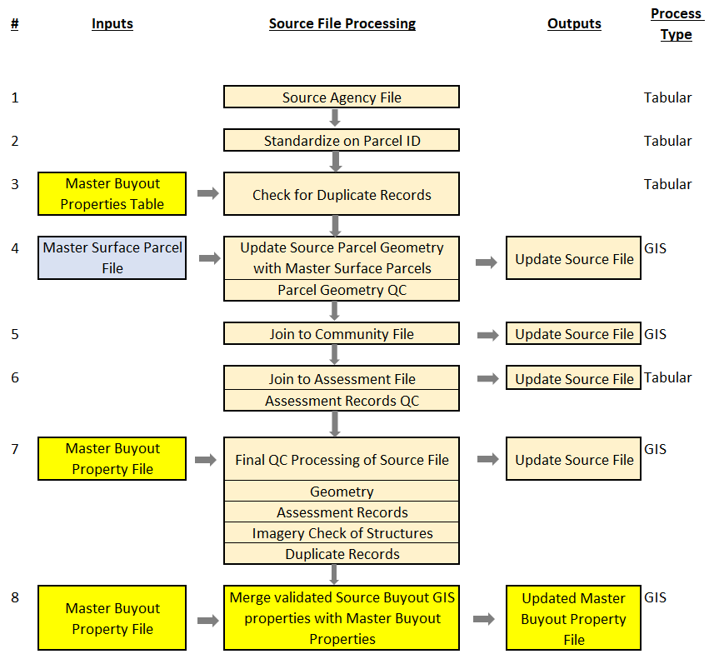
Updated 2023 Buyout Property Processing Steps:
- Fill out access table with required column information
- Export the table to excel (may need to clean up formatting)
- Add Standalone table to ArcPro (Excel to table)
- Add XY Point data
- Select all buyout property parcel (Shift key to select more than one; Ctrl Command to unselect, make sure to unselect the last XY point)
- Spatial Join selection with Master Surface Parcels dataset
- Create a copy of the latest buyout property layer and name it with today’s date. Drag newly copied layer to ArcPro map
- Append new polygon layer to copy of master buyout property layer (join based on parcel ID)
- Review attribute table after appending and calculate fields as necessary

Alternative Method for Importing Existing Table with Parcel ID Values
If new buyout properties are organized in a table that includes their Parcel ID values, then it may be practical to import in the following manner:
- Clean up new table (e.g. Excel spreadsheet): Copy data rows to a separate sheet / tab then delete all cells outside data rows and field headers
- Delete redundant fields and / or those with values in formats that will conflict with the current buyout property feature class; this may avoid errors when joining, appending or copy / pasting features into the final schema
- Add the clean sheet of new buyout records to a session of ArcGIS Pro
- Load the most recent countywide Master Surface feature class and Parcel Summary table in the ArcGIS Pro session and Join the Parcel Summary table to the Master Surface features using the “CleanParcelID” field (or another common field)
- In ArcGIS Pro, Join the new buyout records to the countywide parcel feature class; uncheck the option to retain all features so that only the matching features are displayed
- Export the matched parcel polygon features to a new buyouts geodatabase feature class; include the community name in the feature class name to distinguish it from the statewide buyouts feature class
- Populate all fields in the new buyouts feature class for which you have information; Join the buyouts sheet used to select the parcel polygons from the Master Surface in step 5 if necessary to facilitate the Calculate Field function
- Make a copy of the current statewide buyouts feature class and select and delete all features leaving only the field structure (Hint: In the attribute table, select the first row, switch the selection (selects all other rows), CTRL-click select the first row to have all records selected; delete all records using the Delete function in the table header
- Append the new buyout features to the new copy of the current statewide buyouts feature class using the Field Mapping option, or copy / paste the new features from the new feature class into the new copy of the current feature class (Note: working with disparate schemas can be a fraught exercise.)

