If you’d like to bring the terrain into the model, please follow the steps below. For a complete guide on RAS Mapper, please follow the official guide which can be accessed via the “Help” manual of the HEC-RAS program:
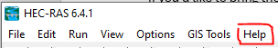
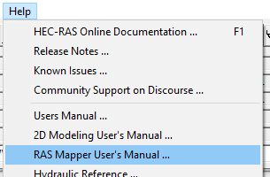
1. Download the RAS Mapper terrain for X County from this URL and unzip it (be advised, the size of the terrain file is large, e.g., several GBs):
Insert WV Flood Tool link ….
2. Open the HEC-RAS model.
3. On the HEC-RAS program interface, click on the Open RAS Mapper button:
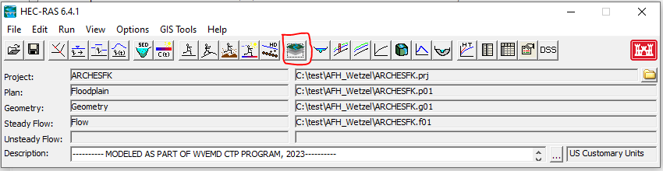
4. On the RAS Mapper interface, click on the “Project” menu then “Set Projection”:
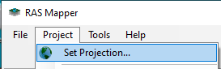

5. Use the browse button on the RAS Mapper Options interface to browse to and select the projection file, and then click “Open” (The projection file is provided as part of the RAS Mapper Terrain zip file you downloaded earlier, e.g., “NAD 1983 StatePlane West Virginia S FIPS 4702 (US Feet).prj”):
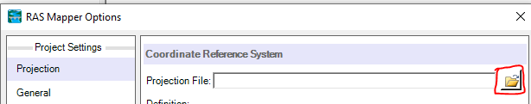
Once you are back on the RAS Mapper Options interface, the “Definition” area should have been populated with information, e.g.:
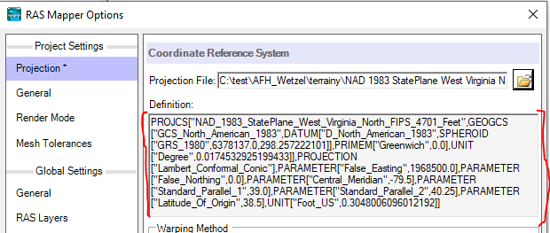
Click the “Ok”.
6. Back on the main RAS Mapper interface, right click on the “Terrain” layer, and select “Add Existing Terrain”:
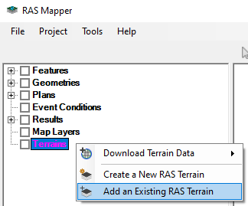
Browse to and select the “.hdf” file that came with the Terrain, then click the “Open” button:
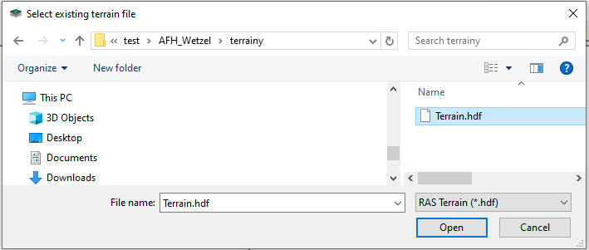
7. The terrain now should appear in the main window of RAS Mapper:
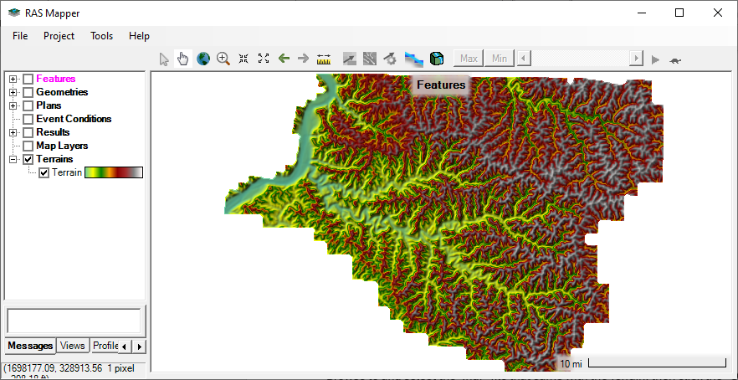
8. Confirm Terrain Association
Right click on the “Terrain” layer and select “Manage Terrain Associations”. On the “Manage Layer Associations” window, if the “Terrain” column is not populated for any layer, use the dropdown to select the Terrain just added:
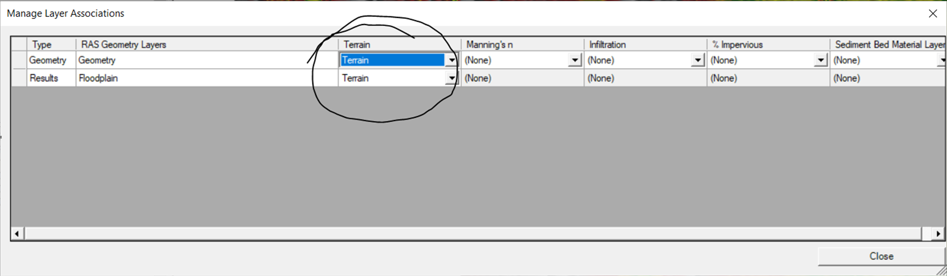
Close the “Manage Layer Associations” window.
9. Follow the official RAS Mapper Guide to perform any desired operations.

