**Distribution Management**

|  |  |
| --- | --- |
| **Lead Agency**  West Virginia Emergency Management Division  (WVEMD) | West Virginia Department of Transportation/ Division  of Highways (WVDOT)  West Virginia National Guard (WVNG) West Virginia State Police (WVSP) National Veterinary Stockpile (NVS)  Volunteer WV  West Virginia Volunteer Organizations Active in  Disasters (WV VOAD) American Red Cross |
| **Supporting Agencies and Organization**  Federal Emergency Management Agency (FEMA) Public Service Commission (PSC)  West Virginia Department of Agriculture (WVDA) West Virginia Department of Education (WVDE)  West Virginia Department of Health and Human  Resources (WVDHHR) |

Record of Concurrence

When assistance is requested by West Virginia Emergency Management Division, the following agencies have concurred to provide the role of supporting the response to the State of West Virginia during an emergency where the Specific Annex #6 Drought Incident is activated.

|  |  |  |
| --- | --- | --- |
| **Support Agency** | **Authorized Representative** | **Date of Concurrence** |
|  |  |  |
|  |  |  |
|  |  |  |
|  |  |  |
|  |  |  |
|  |  |  |
|  |  |  |
|  |  |  |
|  |  |  |
|  |  |  |
|  |  |  |
|  |  |  |
|  |  |  |
|  |  |  |

Authorization & Concurrence

This Plan is considered operational and serves as the logistics guide for responding to Drought Emergencies in West Virginia. It supersedes all previous editions.

Approved: ____________________________________________________       Date: ___________

Director of West Virginia Emergency Management Division

# Purpose

* 1. The Distribution Management Support Annex to the West Virginia Emergency Operations Plan (WV EOP) provides guidance to assist in the distribution of commodities to support emergency management activities.
  2. This annex describes the process for the direction and control of personnel and commodities during an incident. The Distribution Management Plan (DMP) outlines the procedures used by the West Virginia State Emergency Operations Center (SEOC) staff to manage commodities across the life cycle of emergency response.
  3. Distribution management means effective and efficient distribution of critical resources to disaster survivors in the community. Distribution management involves managing a comprehensive supply chain. This includes end-to-end commodity and resource management; warehouse and transportation operations to distribute supplies to distribution points and staging areas; provision of equipment and services to support incident requirements; and a mechanism for supplies and commodities to be provided to survivors.

# Planning Assumptions

* 1. An incident has occurred requiring the activation of the SEOC and the Distribution Management Program (DMP).
  2. The ability of local agencies such as Volunteer Organizations, American Red Cross, or other supporting state agencies to provide basic commodities from their own inventories or local sources has been exceeded.
  3. Local agencies have developed their own plans for the activation of community points of distribution (CPODs). This includes necessary equipment and trained personnel. WV State Code 15-5-8” Each political subdivision of this state is hereby authorized and directed to establish a local organization for emergency services in accordance with the state plan and program for the provision of emergency services.” The state EOP is the referenced plan in WV State Code 15- 5-8.
  4. All agencies assigned roles and responsibilities in this annex have developed necessary supporting plans and procedures. The WVEMD has developed a CPOD guide that provides a checklist-based approach to standardize jurisdiction CPOD plans throughout the state. The developed and locally approved plans should be updated and made immediately available to the WVEMD Preparedness section any time a change in management occurs, any major revision to the plan is made, or at a minimum of annually to ensure accuracy and efficacy. Plans can be sent to [wvemd@wv.gov](mailto:wvemd@wv.gov) ATTN: Planning section
  5. All commodities requested by impacted communities will be coordinated through the SEOC via WebEOC primarily to avoid duplication.
  6. WVEMD will use existing Memorandums of Understanding (MOUs), rental agreements, and Emergency Management Assistance Compact (EMAC) requests to obtain necessary equipment to support operations.
  7. WVEMD will use existing inventories, state contracts, or requests to the Federal Emergency Management Agency (FEMA) to obtain necessary commodities.
  8. State agency assets will be returned to normal operations as soon as possible.
  9. This plan will be used for state managed response and for federally declared emergencies. Implementation of this plan will occur when an incident or event that occurs within a county exceeds the ability of the county to respond. Requests for large and continuous amounts of commodities will be the first indicator for implementing the DMP. Authority to implement this plan rests with the WVEMD Director or their appointed designee.

# Scope

* 1. This annex describes the management and distribution of commodities acquired for the response to, and recovery from disaster situations.
  2. This annex does not alter the need for private-sector businesses to return to normal operations as soon as possible following a disaster situation.
  3. This annex does not dictate the distribution process from counties to impacted communities. The variables present in an event are too numerous to attempt to pre plan for every scenario; instead, the WVEMD Distribution Management Plan will provide a general strategic planning framework for counties to operate within without detriment to scenario driven tactical plans.
  4. This annex will describe the distribution process between major distribution hubs controlled by WVEMD and CPODS (Community Points of Distribution) at the county or municipality level.

# Policies

* 1. This plan is intended to be consistent with the West Virginia Emergency Operations Plan, the National Response Framework (NRF), the National Disaster Recovery Framework (NDRF), and the National Incident Management System (NIMS).
  2. All departments and agencies assigned responsibility within the Distribution Management Plan will develop and maintain the necessary plans, standard operating procedures, and mutual aid agreements necessary to accomplish assigned tasks.
  3. WVEMD is responsible for planning, coordinating, and managing the resources needed to support the Distribution Management Plan.
  4. All records are preserved and kept in accordance with local, state, and federal records retention schedules.
  5. WVEMD will coordinate with private sector entities to establish a primary and alternate temporary distribution hub within each of the 6 WV Homeland Security Regions. Coordination will be accomplished using a memorandum of understanding and a graphical depiction of inflow, outflow, and security for the sites. The establishment of regional hubs will innovate the current distribution methods employed by WVEMD and harden WVEMD’s logistic capabilities during large scale or multijurisdictional incidents.
  6. Local jurisdictions are ultimately responsible for the identification and operations of community points of distribution. Once local CPODs are operational, the West Virginia Emergency Management Division through the WV State Emergency Operations Center will provide logistical support to move commodities from WVEMD distribution hubs to CPODs if the counties are unable to do so

themselves. Local jurisdictions are responsible for generating the CPOD security plan prior to commodities being delivered. The plan must specifically address how continuous physical security of commodities will be implemented to ensure equitable distribution to survivors.

* 1. WVEMD will integrate to the maximum extent possible the private sector into the DMP. Inclusion of private sector especially at the local level enhances WVEMD’s response regarding time and asset flexibility with the added advantage of strengthening local economies during events.
  2. WVEMD will provision all approved resource requests from current stock, existing state contracts, private sector, or federal sources.
  3. WVEMD will terminate Distribution Management support at the earliest appropriate time, generally when community lifelines have stabilized to the point that local jurisdictions are no longer seeking external assistance. Prior to termination WVEMD will notify local jurisdictions of their intent to terminate all or portions of the DMP prior to termination.

# Situation

* 1. An incident or disaster (natural, technological, or intentional) has occurred which limits, denies, degrades, or destroys one or more of the Community Lifelines. The Community Lifeline construct consists of the following eight areas:
     1. Safety and Security
     2. Food, Hydration, Sheltering
     3. Health and Medical
     4. Energy Power/Fuel
     5. Communications
     6. Transportation
     7. Hazardous Materials
     8. Water Systems
  2. Disasters have an immediate impact on local and State resources resulting in shortages that may require the unplanned expenditure of funds by State and local governments.
  3. The incident exceeds the capacity of local response and recovery agencies to fill resource requests.
  4. The needed commodities are essential to recovery efforts and survival.
  5. The distribution of commodities to impacted populations is best accomplished in

a systematic, organized manner.

5.6. Suitable facilities, equipment, personnel, and physical security of commodities are needed for the management of commodities.

# Organizational Structure

## Local Government

* + 1. A designated person or organization is identified to serve as liaison between the local jurisdiction and the state.
    2. Local agencies are responsible for the distribution of commodities to impacted communities.
    3. Local agencies will submit resource requests to the SEOC using the official state emergency management information system.
    4. Local agencies will maintain a list of potential locations to serve as CPODs. Local agencies are responsible for leases or rental agreements, or MOUs necessary for acquiring space for CPOD operations.
    5. Local agencies will maintain necessary equipment and personnel to operate the CPODs. Local agencies will be responsible for the acquisition, lease, rent, or MOUs to obtain necessary equipment to operate the CPODs.
    6. Local agencies will be responsible for staffing the CPODs. Local agencies will be responsible for ensuring that all CPOD personnel are properly trained.
    7. Local agencies will notify the SEOC of the location and hours of operation for all CPODs. This information should be updated at least daily or as information changes.

## State Government

* + 1. WVEMD is the coordinating agency for the State of West Virginia in times of emergencies. In the event an emergency may require the activation of the WV EOP and the SEOC, WVEMD will verify the emergency, and notify and coordinate with all State agencies and other stakeholders.
    2. State resources will be utilized in accordance with the WV EOP, unless otherwise directed by the Governor or the WVEMD Director.
    3. The State organization for response to activation of the Distribution Management Support Plan is determined by the SEOC.
    4. WVEMD should consolidate local CPOD information into a single press release and maintain information in the SEOC.
    5. WVEMD will provide technical support to local jurisdictions in the

development of CPODs and the training of staff.

6.3. **Federal Government**

* + 1. Provides support for distribution management activities as requested by WVEMD only in the event of a federal declaration.
    2. Provides necessary training and technical support related to Distribution Management planning, exercising, training, and operations.

## Private Sector

* + 1. Activities should be performed to encourage the private sector to return to normal operations as soon as possible or incorporate the private sector as much as possible into response and recovery efforts.
    2. WVEMD has generated a blanket MOU for each county to distribute to private sector entities in their jurisdictions. The purpose is to generate a comprehensive list of private sector assets that are available to assist during events. Each county EM will be responsible for maintaining these MOUs for their jurisdiction.
    3. WVEMD will generate a private sector asset layer in the Geographic Information System (GIS) platform to graphically depict resource types and locations throughout the state. This layer will reference by form number and file location the MOU that corresponds to the icon depicted so that the user can quickly pull up the MOU for detailed information or any caveats for the private sector asset being sourced. The addition of this layer will greatly expedite the preparedness and response phases of management by increasing the SEOC’s visibility of assets.
    4. The Private Sector will be utilized to the maximum extent possible during response and recovery phases not only for the procurement of commodities but also to assist in transportation operations. Utilization of local private sector helps to stabilize community lifelines, stimulate affected economies, decreases response times, and fosters trust with communities as the private sector asset is usually familiar to them.

# Concept of Operations

* 1. WVEMD is responsible for the coordination of all aspects of Distribution Management, including administrative, management, planning, preparedness, response, and recovery activities.
  2. WVEMD is responsible for developing, coordinating, and maintaining the overall Distribution Management Plan (DMP) and the designation of a Distribution Management Team.
  3. The Distribution Management Team composition will be mainly volunteers provided through Volunteer Organizations with supervision provided mainly by local jurisdiction Emergency Managers (EMs) or

personnel from WVEMD if needed. Distribution Management Teams will comply with the state developed NQS training standards.

* 1. All personnel designated to support distribution management activities are to be trained in the principles of NIMS and the Incident Command System (ICS). These principles are integrated into Distribution Management planning and response activities via the Integrated Preparedness Plan (IPP). The IPP is derived from multiple Integrated Preparedness Plan Workshops (IPPW) that will take place annually within each of the WVDHS security regions. Input from each of the regions will facilitate a comprehensive statewide preparedness plan.

# Training (NIMS/NQS BASED)

* 1. Volunteer Organizations and other NGOs will assist in sourcing the volunteers necessary to establish a distribution management team and conduct semi-annual reviews of that list to ensure that there are individuals who are always available to fill this critical role. Volunteers that comprise the management structure will be vetted to determine their suitability and that they understand their role and duties before training commences. Volunteer management will fall directly under the supervision and direction of WVEMD. WVEMD will be responsible for training volunteers using the following guidelines. The WVEMD has created a Community Points of Distribution (CPOD) Guide designed to address planning, training, management, and operation of CPODs within a jurisdiction to standardize CPOD operations throughout the state.
  2. The following is a breakdown of a distribution management team. This is the minimum required personnel by position for an effective team. Training required for each position will be in accordance with the state approved NQS standards.

## Mobile Distribution Team (Single Type) + Support

* + - 1. NIMS Type 3 Planning Section Chief
      2. NIMS Type 3 Resources Unit Leader
      3. NIMS Type 3 Supply Unit Leader

## Distribution of Emergency Supplies Task Force

* + - 1. NIMS Type 3 DES Task Force Leader
      2. NIMS Type 3 Mass Care Specialist
      3. NIMS Type 3 Logistics Section Chief (NQS)

## Distribution Support Team

* + - 1. NIMS Type 3 Planning Section Chief
      2. NIMS Type 3 Resources Unit Leader
      3. NIMS Type 3 Situation Unit Leader
      4. NIMS Type 3 Supply Unit Leader

## Mobile Distribution Team (Single Type) + Support

* + - 1. NIMS Type 3 Planning Section Chief
      2. NIMS Type 3 Resources Unit Leader
      3. NIMS Type 3 Supply Unit Leader
  1. The following guidelines represent the minimum required training based on location or transportation mode.

## Airfield operations <https://www.emsics.com/training>

Designated personnel participating in Airfield operations will be required to meet following:

* + - 1. [E/L 987: Introduction to Air Operations](https://training.fema.gov/emicourses/crsdetail.aspx?cid=E987&ctype=R).
      2. TSA - Security compliance training (as required)
      3. FAA - Controlled movement area training and airfield procedures
      4. Fire Prevention and extinguisher training

## Railyard Operations

Designated personnel participating in rail yard operations will be required to meet following:

* + - 1. Federal Railroad Administration (FRA) Basic safety training and awareness program
      2. Fire Prevention and extinguisher training

## Maritime Port Operations

* + - 1. US Coast Guard Basic Water Safety Instruction

## Warehouse Operations

Designated personnel participating in warehouse operations will be required to meet following:

* + - 1. Forklift operator, Pallet Jack operation
      2. Fire Prevention and extinguisher training

# Direction and Control

* 1. Local and State authorities should utilize NIMS and the ICS structure through all phases of emergency operations.
  2. It is imperative that Local EMs, CPOD Managers, and Distribution Team Managers notify WVEMD via the SEOC of the quantity and movement of all commodities and assets. The continuous communication between WVEMD and EMs, CPOD Managers, and Distribution Team Managers is critical for effective distribution management.
  3. Community Points of Distribution are the primary distribution centers for impacted communities. These CPODs will be operated under the direction and control of local jurisdictions. The WVEMD CPOD Guide specifically addresses the type and frequency of communications between the CPOD and the SEOC.
  4. Transportation assets will be utilized in accordance with ESF-1: Transportation.

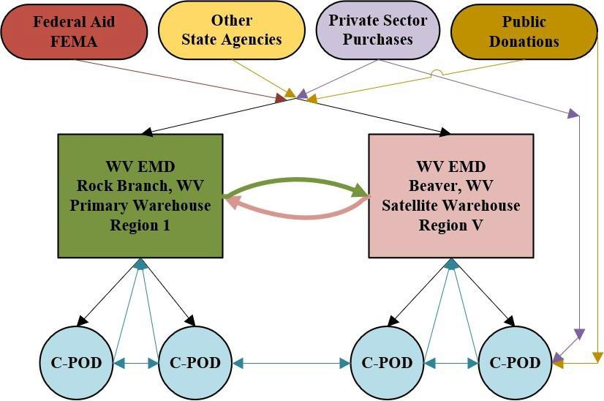

*Figure 1-1*

## Logistics Relationship Graphic

* 1. Commodities and equipment will flow from Federal Aid, Other State Agencies, Private Sector, and Public Donations into WVEMD permanent warehouses which serve as the primary distribution hubs. WVEMD and partners will receive, sort, inventory, and coordinate transportation of commodities and assets to individual CPODS. WVEMD will coordinate and track all cross leveling of commodities from CPOD to CPOD to decrease time and transportation costs. CPOD managers will coordinate with WVEMD to return unused commodities for redistribution or storage. Utilization of WVEMD Form# DMP-208 “Demobilization Checklist” can assist CPOD managers in the return or redistribution of commodities by detailing the coordination required. CPOD managers must coordinate all return or redistribution activities with the WV SEOC prior to starting activities.
  2. The WV National Guard maintains several Supply Support Activities (SSAs) throughout the state that serve as additional supply hubs during incident response.
  3. There are times when commodities and assets will bypass WVEMD or partner warehouses and enter the CPOD logistic chain directly to decrease time and transportation costs. WVEMD will still track and maintain inventory of goods that enter the CPOD chain directly to ensure equity and track consumption for resource ordering.
  4. County EMs and CPOD Managers will immediately notify the SEOC of any commodities or assets that enter the CPOD chain directly without WVEMD knowledge.

# Phases of Management

## Mitigation

* + 1. Ensure that stored commodities are properly inventoried.
    2. Ensure that commodities are properly stored from any potential damage.
    3. Ensure that commodities are secured from theft and misappropriation.

## Preparedness

* + 1. Establish a Distribution Management Team. The Distribution Management Team is responsible for activation and operation of distribution management programs. While WVEMD is the coordinating agency, representatives of support agencies such as Non-Governmental Organizations (NGO) and other volunteers will make up the Distribution Management Team.
    2. Ensure that all Distribution Management Team members are fully trained in distribution management activities, NIMS, and other required training. This training is based upon standards set forth in the NQS standards. All personnel will be trained to the most current NQS standards except for “*in*

*extremis*” cases such as a lack of personnel. WVEMD will make every attempt to cross-level trained individuals so that every critical area has an adequate amount of trained personnel with emphasis on critical functions. Develop a standardized checklist to evaluate potential distribution management staging areas.

* + 1. Identify potential sites to collect, stage, sort, and distribute commodities. Secure memorandums of understanding (MOUs), mutual aid agreements (MAA), or other agreements necessary to use these locations.
    2. Develop appropriate Distribution Management SOGs that make full use of all available resources, including those from government, non-profit organizations, and the private sector.
    3. Identify and acquire equipment and supplies necessary for distribution management activation. This would include computers, printers, and material handling equipment. (Reference section 22.8 for comprehensive list of required materials)
    4. Establish mutual aid agreements and/or contingency contracts in accordance with WV Code 15-5-28 that allow for the prompt delivery of resources.
    5. Establish a computerized database inventory system to track all commodities. This system should be capable of reporting current inventories, goods delivered, and commodities in transit. In addition, this system should be able to provide all necessary reports.
    6. Maintain accurate inventory lists of state agency supplies, equipment, vehicles, and trained personnel.
    7. Train personnel who will be managing resources in NIMS compliance and the NIMS resource typing and management system.
    8. Test plans through exercises (table-top, functional, and full-scale exercises developed consistent with the Homeland Security Exercise and Evaluation Program (HSEEP) to assure that all personnel know how to request, transfer, track, utilize, demobilize, return, and account for resources.
    9. WVEMD Finance/Administration Section will maintain ability to acquire commodities utilizing existing state contract and emergency purchase authorities.

## Response

* + 1. Alert Distribution Management Team following an incident regarding potential activation.
    2. Determining what commodities are needed:
       - 1. When available, use similar historical information to determine commodities to request.
         2. Incident specific considerations include, but are not limited to, the following: type of incident, time of year, population affected, expected duration of incident, expected recovery time, power outages, location, and terrain.
         3. The SEOC Director and key stakeholders will evaluate the current situational reports to determine which commodities are needed.
         4. Solicit information from impacted communities through the WVEMD Area Liaisons.
         5. Conduct generic modeling to predict potential resource requests.
    3. Commodity burn rates are a necessary tool for ensuring the proper amount of commodities reach an impacted area’s survivors. Burn rate is the title given to the formula used to calculate anticipated consumption of commodities such as water, food, fuel, etc., in an impacted area. Burn rates are not rigid, as variables change in the impact area and survivor needs change through the evolution of an event or disaster so must the burn rate.
    4. Local EMs with assistance of CPOD managers will determine the initial burn rate per capita based on the number of survivors and report it to the SEOC when known. Local EMs and/or CPOD managers will notify the SEOC any time the rate changes. The following will help distribution hub managers and CPOD managers with determining an initial burn rate.
    5. Water (Used for consumption and hygiene)
       1. Bulk Water 3.7 Liters per person per day
       2. Individual bottled water (using standard 16.9-ounce bottle) 8 bottles per person per day
    6. Food should be part of the food pattern of the population.
       1. The quantity of food in a ration should depend on the stage of the crisis and on available resources.
       2. For a period of weeks or even months, and while the victims depend exclusively or almost exclusively on food aid, rations

should aim to provide 1700 to 2000 Kcal per person/day (Caloric calculation based on Pan American Health Organization “PAHO” Food and Nutrition in disasters guidelines)

* + - 1. Local EMs and CPOD managers must determine how many specialties dietary needs are in the survivor population such as infants who may require formula or baby food and individuals with food allergies that have specific diets.
      2. Pet food does not exist in Federal or State inventories but is usually resourced via donations primarily and in certain cases through private sector purchases. SEOC will attempt to source pet food requests, however survivor needs will always be prioritized first.
    1. Fuel consumption is often difficult to calculate so the following considerations will assist in determining need.
       1. Fuel type is critical e.g., Ordering bulk gasoline for a diesel generator will cause a lack of generator power at your site since you don’t have the right fuel type and can create a situation at a similar site that’s using gasoline generators but now their requested fuel is at your site. Local EMs and CPOD Managers must correctly determine and identify fuel types in resource requests.
       2. Most equipment, especially generators have fuel burn rates based on hours of operation and under what load they’re operated. Check equipment manuals to determine type and assist in making your burn rate projections for fuel consumption.
    2. Other Commodity types: There are many types of commodities that will be required based on the type of event or disaster, the impacted community lifelines, and the needs of the individual survivors. It is imperative that those needs are communicated to the SEOC in an accurate and timely manner to ensure that what you need is when and where you need it.
    3. Based upon recommendations, the Distribution Management Team and SEOC Procurement Unit will work to determine availability of commodities. The following sources will be used (in order of preference):
       1. Existing agency inventories
       2. Other State Agency Warehouses
       3. Private sector contracts
       4. FEMA
       5. Donated goods from public
    4. Local agencies activate CPODs. County representatives provide SEOC with the location, hours of operations, special directions, and the point of contact for each CPOD.
    5. The Distribution Management Team will prepare for receiving commodities. This will include sorting and organizing staging areas to ensure efficient operations.
    6. WVEMD provides notification when commodities are available. This should include information related to ordering quantities and special instructions.
    7. WVEMD will ensure that all commodities will be tracked in the inventory tracking system.
    8. WVEMD, through the SEOC, will review all requests for support. These requests will be verified using a variety of real-time data collections methods.
    9. Approved resource requests will be forward to the Distribution Management Team for processing.
    10. If the Distribution Management Team can fill the resource request, the Distribution Management Team will update the request in the emergency management information system.
    11. The Distribution Management Team will provide a detailed mission report to each transportation asset prior to dispatching. This will include a mission tasking order with the following information:
        1. Delivery location
        2. Point of contact
        3. Resources delivered (items and quantities)
        4. Including any other pertinent information
    12. When placing orders, it is imperative that the quantity is accurately conveyed. Water as an example can be ordered by the liter, gallon, case of individual bottles, pallet of individual cases, etc. Since there are so many metrics for quantity WVEMD will utilize the following:

Liter will be used when ordering bulk water (FEMA Standard)

* + - 1. When ordering items by the pallet; pallet will mean a standard

warehouse pallet

* + - 1. When requesting a truck load of a commodity specify whether it is a standard tractor trailer, box moving truck, dump truck, etc.
      2. When ordering meals specify the total number of individual meals requested i.e., 3 meals for 1 person for 1 day. Example: you’re ordering enough meals for 100 people to have 3 meals a day for a 5-day period. You will multiply the number of people by the number of meals per day by the numbers of days required (100x3x5=1500 meals total) The individual responsible for sourcing or purchasing those meals will find the best quantity type to meet the request without generating excess, whether that's a pallet of MREs or individual cases.
    1. The Distribution Management Team should update the emergency management information system with information related to mission status as benchmarks are met.
    2. Local agencies will prepare for the arrival of requested commodities. The local jurisdiction coordinates the response and recovery actions of local volunteer organizations involved in the operation of CPODs.
    3. State Distribution Management Staging Area(s) should be established to operate 24/7. Normal distribution will occur between 0800 and 1700. Receiving commodities should take place between 0600 and 1800. Orders will be processed 24/7. Limited emergency distribution capability should be available 24/7.
    4. County EMs will work with CPOD managers to determine hours of operation. If the CPOD will be open for greater than an 8-hour period, CPOD managers should consider how best to divide volunteers amongst shifts to avoid fatigue and to ensure the effectiveness of the CPOD. CPOD security will be maintained 24/7 regardless of hours of operation until CPOD is demobilized. County EMs will inform the SEOC of the hours of each CPOD in their jurisdictions and the best time for each CPOD to receive commodities to prevent bottlenecking during transportation.

## Recovery

* + 1. Distribution Management activities should be demobilized as soon as supply chains return to normal operations.
    2. The SEOC should monitor conditions and the status of normal supply chains and make recommendations for ending distribution management

activities.

* + 1. CPOD Managers should be given the order to demobilize via thejurisdiction EM after the appropriate EM has coordinated the intent to demobilize with the SEOC. Once an order to demobilize has been received CPOD managers will complete the WVEMD Form# DMP-208 Demobilization Checklist which should be available as printed forms contained within the CPOD kit and is also available within the WVEMD CPOD Guide given to each CPOD manager. Immediately upon completion the DMP-208 will be forwarded to the SEOC for review and acceptance.

## Resource Ordering

* + 1. WVEMD will maintain an electronic inventory of existing inventories. WVEMD currently uses “Inventory Cloud” from the Wasp company to achieve inventory control. Inventory reports should be maintained and verified monthly to ensure efficient control of equipment and commodities.
    2. When possible, resources should be pulled from existing inventories.
    3. Commodities remaining after an incident should be maintained in the inventory for future incidents. These commodities should be stored in a safe and secure location. CPOD managers should make every attempt to redistribute excess commodities by communicating the excess in advance to the SEOC to prevent waste and fiscal burden to the state.
    4. Commodities with limited shelf-life should be rotated to ensure use before expiration date. Commodities near the end of their shelf-life should be used for training, exercises, or donated to other agencies prior to expiration to reduce waste.\
    5. Where possible the WVEMD should utilize Vendor Managed Inventory (VMI) to reduce the storage space required to store commodities and to ensure the highest quality control standards for shelf-life items. Using VMI also reduces the burden of commodity rotation by reducing the staffing and man-hour requirements for those activities. The single greatest benefit to VMI is that a prescribed quantity of a commodity is always available and any commodities that are near end-of-life can be given to other customers for immediate use in an incident and the used quantity replaced at no cost to the WVEMD with fresh shelf-life dates.
    6. Equipment inventories should be maintained using the NIMS Tier and Typing system.

## Inventory Management

* + 1. Inventory Management should be accomplished using software or technologies that afford remote operability and multi-location flexibility. Any software utilized for inventory management should be capable of the following:
       - 1. Reorder point. Should inventory reach a specific threshold, a company's inventory management system can be programmed to tell managers to reorder that product
         2. Asset tracking
         3. Service management
         4. Product identification
         5. Inventory optimization and visibility
         6. Product shelf-life tracking 10.6.1.1.7. Increased efficiency
         7. Warehouse organization
         8. Remote operations
         9. Multi-Site operations 10.6.1.1.11. User role-based permissions

# State Contracts and Purchasing

* 1. WVEMD Finance/Administration should maintain multiple methods for acquiring commodities.
  2. WVEMD Finance/Administration should maintain the ability to make emergency purchases using state contracts and other purchasing procedures.
  3. WVEMD Finance/Administration should maintain the ability to purchase commodities using state purchasing credit cards (i.e., P-cards).
  4. WVEMD Finance/Administration should track all relevant purchases associated with an incident for potential reimbursement.

## Thresholds

* + 1. **Non-Emergency Spending**
       1. Purchases of $2,500 or less: competitive bids are not required.
       2. Purchases of $2,500.01 to $5,000 require a minimum of three (3)

verbal bids and the lowest bid meeting specifications must be awarded the purchase order/contract.

* + - 1. Purchases of $5,000.01 to $25,000 require a minimum of three (3) written bids and the lowest bid meeting specifications must be awarded the purchase order/contract.

## Purchasing Process and Authorities

* + - 1. Once resource requests are received the following steps are taken:
* A purchase request is completed
* The following signatures are required on all purchase requests
  + - 1. Requestor:

11.5.2.3. Authorized Signer – The Director has assigned signature authority to 10 personnel by Memo dated August 2, 2021. When the SEOC is in a non-active state (blue sky) the WVEMD Director, Deputy Director, Section Chiefs, and Assistant Section Chiefs are authorized signatories for purchase requests. When the SEOC is in a fully activated status (gray sky) the WVEMD Director may designate additional signatories such as the WVEMD SEOC Director to authorize purchase requests.

* + - * 1. For purchases up to $25,000.00 one signature is required from this list
        2. Purchases $25,000.00 and over require two of these signatures.

## Asset Manager:

Must sign for all purchases over $500.00 – The only exceptions to this rule are for IT Purchases including computers and computer accessories/equipment, vehicle items and weapons.

IT Director will approve all computers, computer equipment and accessories and software.

* + - 1. When all signatures are obtained, the purchase request is forwarded to the Procurement Specialist who then follows the WV Purchasing Division’s Procedures Handbook guidelines and takes the following steps:
         1. Verifies Purchasing Division Registration
         2. Confirms good standing with Secretary of State’s office 11.5.2.6.3. Verifies Federal and State Debarment
         3. Completes procurement document in WV Oasis – Agency Purchase Order (APO) for non-contract purchases or Agency Deliver Order (ADO) for Contract Purchases.
         4. Sends APO or ADO to Purchase card holders to process.

## Emergency Spending

* + - 1. Compliance with state purchasing requirements is suspended during declared states of emergency. In the event of a declared emergency W.Va. Code § 5A-3-15 grants the Purchasing Director authority to make emergency procurements without completing the more formal bidding process for purchases of $25,000 or less.
      2. Emergency Purchase-card spending authority of $1,000,000.
      3. Expenditures must be directly tied to supporting response/recovery efforts of the declared emergency.

11.5.3.4. The file should contain all documentation necessary to substantiate the declared emergency.

* + - 1. For emergency purchases needed after hours and over weekends and holidays, all documentation and signatures are still required to be completed as soon as possible once back in normal operating hours and steps 1 through 5 above are followed at this point.
      2. Keep in mind that emergency purchases are not used for hardship resulting from neglect, poor planning, or lack of organization by the Agency.

Reference: <https://www.state.wv.us/admin/purchase/Handbook/default.html>

# Donations and Faith-Based Organizations

* 1. WVEMD will encourage use of private donations and donations provided by faith-based organizations as primary sources for commodities. When practical, these requests should be carried out by the partner organizations.
  2. WVEMD will coordinate with faith-based organizations to determine available local resources.
  3. WVEMD will maintain ability to receive local donations in conjunction with WV EOP Support Annex #7 (Volunteer and Donations Management).
  4. Organizations such as Volunteer Organizations and Non-governmental Organizations as well as other partners maintain their own donations plans and the WVEMD may utilize these plans or portions of these plans as determined by the WVEMD Director when dealing with donations management so that all donation activities are synchronous throughout an incident area.

# Federal Resource Requests

* 1. Designated WVEMD personnel will coordinate with the FEMA Federal

Coordinating Officer or designee to process resource requests.

* 1. WVEMD should coordinate closely with FEMA Logistics personnel to process shipment of commodities to the State Distribution Management Staging Area(s).

# Delivery Locations

14.1. All commodities ordered for distribution should be delivered directly to the appropriate State Distribution Management Stage Area(s). This location must be conveyed by the Distribution Management Team to the SEOC and the WVEMD Finance/Administration Section.

14.2. WVEMD Finance/Administration Section and the SEOC should notify the Distribution Management Team when commodities have been ordered and anticipate arrival time.

# Re-ordering of Commodities

* 1. The Distribution Management Team will provide anticipated burn rate and inventory reports to the SEOC and the WVEMD Finance/Administration Section to calculate re-ordering of commodities.
  2. Re-ordering needs to anticipate time for orders to be approved, processed, and delivered.
  3. Prior to re-ordering, the SEOC Director and the WVEMD Director should determine if commodities should be re-ordered or if the Distribution Management program should begin demobilization.

# Distribution Methods

* 1. Local jurisdictions will be responsible for the direct distribution of the commodities to the public. This will be conducted at local CPODs that have been identified by the County EMs or designated representative. County EMs are best suited for selecting CPODs due to their familiarity with their areas and the fact that they are already integrated into WVEMD networks and processes.
  2. Local jurisdictions will need to provide the SEOC with distribution methods and preference for receiving commodities. State Staging Area Operations will be designed to support a variety of CPOD operational methods as selected by the location jurisdictions. This could include any of the following:
     1. Quantities received at any specific time
     2. Delivery vehicle (i.e., vehicle size);
     3. Shipping considerations (i.e., palletized or not); and
     4. Shipping hours or days of operation.

# State Distribution Management Staging Area Operations

* 1. The SEOC will determine which distribution staging area(s) will be used to facilitate distribution of commodities based on the following criteria. Scalability follows the NIMS framework.

## Geographic area of impact

* + - 1. Statewide
      2. Regional
      3. County or Municipality

## Severity of incident

* + - 1. Extensive
      2. Moderate
      3. Minor

## Operational status

* + - 1. Does the site have Power and Water?
      2. Is the site accessible?
      3. Do we have manning to support the site?
      4. Do we have equipment to support the site?
      5. How long will it take to make the site partially or fully operational?
  1. To ensure the safety of all assigned personnel, managers will ensure that personnel have been trained on the use of equipment prior to utilization. Failure to adequately train personnel on equipment can result in injury, death, and/or failure of mission.
  2. Managers will establish a rest/break area away from storage, packing, and transport areas to safeguard personnel from potential accidents associated with machinery, vehicles, and exposure to chemicals while consuming food or drink. Break areas designed for the consumption of meals also prevent attracting unwanted insects and pests that can damage commodities and possibly harm survivors receiving commodities. Managers will also designate and brief personnel on approved smoking areas that are outside and greater than 100’ from a flammable or combustible material.
  3. Staging Area operations will be conducted in accordance with this plan, Federal, state, and Local regulations.
  4. WVEMD will coordinate all activities within the State Distribution Management Staging Area.
  5. At least one State Staging Area will be activated for all Distribution Management activations.
  6. The primary state staging area for Distribution Management is the WVEMD Rock Branch Warehouse located in Poca, WV.

17.8 Staging area sites should be predetermined and assessed for equipment, staff, contracts, and other support needs. Preselected sites, when determined, will be included into this plan as figures contained at the end of this section. The figures will provide detailed overviews of footprint, inflow processes, outflow processes, and site security plans. Staging area assessments should include the identification of the following workflow components:

* 1. Command and control – computer workspace, printing, and network.
  2. Commodity storage – both within trailers and unloaded.
  3. Vehicle routing – ingress and egress of trucks/trailers.
  4. Empty trailer storage area – location where empty trailers are parked.
  5. Security checkpoints – access control considerations.
  6. Breakroom/feeding area – feeding area for personnel.
  7. Climate control capabilities – ability to keep commodities in appropriate storage.
  8. Ease and efficiency for the Inflow/Outflow of equipment, vehicles, personnel
  9. Establish a State Distribution Management Staging Area, if needed. Determine resources required to support the staging area operations. Minimum operational equipment will include the following:

## Minimum Required Items:

* + - 1. Forklifts (with fuel) – (already on Rock Branch site)
      2. Pallet jacks
      3. Hand Trucks
      4. Supplies – boxes, pallets, wrap
      5. Technology – Computers, printers, and networking equipment
      6. Spare batteries, cables, surge protectors, office supplies
      7. First Aid Kit
      8. Way Radios with spare batteries and charger (1 radio for each

manager, supervisor, and individual group manager)

* + - 1. PPE for all assigned personnel (Hard hats if indoors with multi- tier shelving, reflective vests, safety shoes, ANSI Z87.1 eye- pro, hearing protection, flashlight or headlamp, work gloves)
      2. Emergency Spill Kit
      3. Emergency Eye Wash Station

## Additional Items if required (site specific) or available:

* + - 1. Service Carts
      2. Cranes / Hoists
      3. Dollies and Castors
      4. Bins and Totes
      5. Shelves
      6. Racks
      7. Industrial Scales
      8. Strapping and Banding Equipment
      9. Stretch Wrap Machines
      10. Packing Tables
      11. Dock Boards and Plates
      12. Edge of Dock Levelers
      13. Truck Restraints
      14. Dock Seals and Shelters
      15. Dock Bumpers
      16. Yard Ramps
      17. Wheel Chocks
      18. Dock levelers & Dock Lifts
  1. Staging area operations should remain flexible and scalable. Considerations for size and operations include:
     1. Anticipated duration of event.
     2. Severity of incident.
     3. Expected quantity of commodities to be distributed; and
     4. Scale of incident (geographic area).
  2. The state staging area is the focal point in the supply chain for resources to be delivered to survivors in a community.
  3. The State Distribution Management Staging Area(s) will use a hub-and-spoke model. This approach will support all types of local distribution plans. The State Distribution Management Staging Area will distribute to CPODs.

17.21 Staging Area operations will be conducted in the most efficient means necessary related to off-loading of materials.

* 1. Cross-docking will be conducted when mixed commodity loads are necessary.
  2. Large quantity, single-commodity loads will be utilized if necessary.
  3. WVEMD will coordinate the identification and training of personnel to work in the State Distribution Management Staging Area. The following positions will be filled, as necessary, at the State Distribution Management Staging Area(s):
     1. Staging Area Manager.
     2. Security (logs truckers/trailers in and out of site).
     3. Yard master (responsible for direction of vehicles on site).
     4. Transportation coordinator.
     5. Loading/unloading crew (forklift operators); and
     6. Documentation Unit (responsible for processing orders, generating mission orders).
  4. State Distribution Management Staging Area(s) will not ordinarily be used for direct distribution to the public.
  5. Staging area planning will include an area for empty trailers. Upon return to the staging area, empty trailers will be placed in a pre-designated area.
  6. Additional staging areas will be selected using the Staging Area selection criteria outlined in (22.5) of this section.
  7. See (*Figure AA-1 through AA-5)* for an aerial photo of the State Distribution Management Staging Area and alternate staging areas.

# Transportation

* 1. Transportation activities will be conducted in accordance with ESF-1: Transportation.
  2. Upon identification of distribution staging areas (hubs) and CPODs the SEOC must make every attempt to identify the routes that will be used to get commodities to hubs and from hubs to CPODs. The SEOC will notify WVDOH, Law Enforcement, Local EMs, Staging Area Managers, CPOD managers, and driver/operators of the intended routes for hazard

abatement and route deconfliction. Some of the followings are considerations for determining routes, hazards, and challenges:

* + 1. Major Roadway or transportation artery closure
    2. Minor roadway or artery closure
    3. Distance to be traveled (greater distance means less turns per day)
    4. Driver/Operator Lodging and Rest Area
    5. Fuel Availability and Ease of Procurement
    6. High Traffic Areas / Metro Areas
    7. Current and predicted weather effects on roads
    8. Mountainous Terrain
    9. Unimproved surfaces such as gravel or dirt
    10. Narrow roadways such as single lane roads
    11. Unmarked roads
    12. Areas of low illumination
    13. Low water crossings
    14. Bridge weight limits
    15. Parking and Turn-Around Spots
    16. Overpass/bridge height clearances

## Modes of Transportation:

* + 1. There are several intermodal transportation hubs located within the state that can efficiently support hub and spoke logistics. The capability to facilitate ground, rail, and air transportation of resources exist, however consideration as to the mode of movement must be factored into the planning of any resource movement. Consider the following when selecting a mode.
    2. Ground transportation: Is the most prevalent, supported by several major road corridors, and requires very little coordination outside of selecting the roadways that will be used especially if the transportation asset is organic to the state. For transportation assets that are not organic such as private sector assets, more coordination and time are required. The cost of ground transportation is also significantly lower than any other mode due to the availability of assets and supporting infrastructure. Ground affords the most reliable movement of

commodities at a moderate speed and moderate volume.

* + 1. Rail transportation: Is prevalent in the southern portions of the state and more sporadic in the northern half which means that it may only be beneficial to certain areas of the state. To be effective rail must be used in combination with other transportation modes such as ground and this will require a greater amount of coordination and/or planning. Rail affords the reliable movement of commodities at a slow speed and high volume.
    2. Air transportation: Is available throughout the state but is limited due to the size of most of the airfields. There are only a few airports within the state that can receive large transport aircraft whether military or private sector. To be effective air must be used in combination with other transportation modes such as ground and this

will require a greater amount of coordination and/or planning. Air affords the movement of commodities at a high speed and low volume.

* 1. There are many pros and cons to choosing a mode of transportation and the urgency and size of resource requests will ultimately drive the decision on how to move resources. Weather, speed, reliability, accessibility, and cost will all play an important role in determining the best way to transport resources to an incident area.

## Transportation Arteries:

Multiple transportation arteries exist within the state to facilitate the rapid movement of resources within the state and from areas outside the state. The most important of these arteries are Interstate 64, Interstate 77, and Interstate 79 which all allow rapid access to a large portion of the state and all of these interstate roadways intersect in Charleston which is centrally located in the state. Interstate 70 allows access to the northern panhandle and Interstate 81 allows limited access to the eastern panhandle. These interstates link all but 3 of the WVNG SSAs are strategically placed near major interstates within the state as depicted in (*Fig 23-1*) smaller Troop Support SSAs are in more remote regions in the state and do not have the benefit of being in proximity to a major roadway.

## Logistics Hubs:

* + 1. WVEMD along with partnered organizations maintain several permanent logistics hubs throughout the state as depicted in *(Fig. 23-1*). These hubs are generally the first stop in the logistics chain as these are the permanent locations where large quantities are broken down, sorted, stored, or repackaged for distribution to staging areas or CPODs. Hubs exist primarily to allow the rapid buildup of resources to feed a continuous, reliable, and unbroken stream of resources or commodities to incident areas. The

capability of a hub largely depends on the size of the area or facility, the

amount of staff that can support it, and the type of specialized logistics handling equipment at the site.

* + 1. The most capable hubs within the state are maintained by the WVNG which has 5 primary SSAs and 3 smaller Troop Support SSAs. The WVDA also maintains its own warehouse and staff in Fairplain, WV adjacent to Interstate 77 which is comparable to the capabilities of the WVEMD warehouse located in Rock Branch, WV. Together these hubs have the capability to receive, store, and redistribute large quantities of resources and should be utilized when planning a distribution chain to support incident areas.
    2. In addition to hubs there are several staging area locations throughout the state. Staging areas serve as a bridge between hubs and CPODs and are typically temporary in nature. Staging areas are designed to temporarily

store large amounts of resources or commodities closer to a CPOD so that the limited space at the CPOD is not overwhelmed. WVEMD along with partnered organizations continuously search for suitable areas that can be utilized as staging areas for future distribution management needs. Currently the WVEMD has identified the former USDA Complex in Beaver, WV and the Tri-State Airport in Huntington, WV as staging areas for distribution management.

(PENDING)

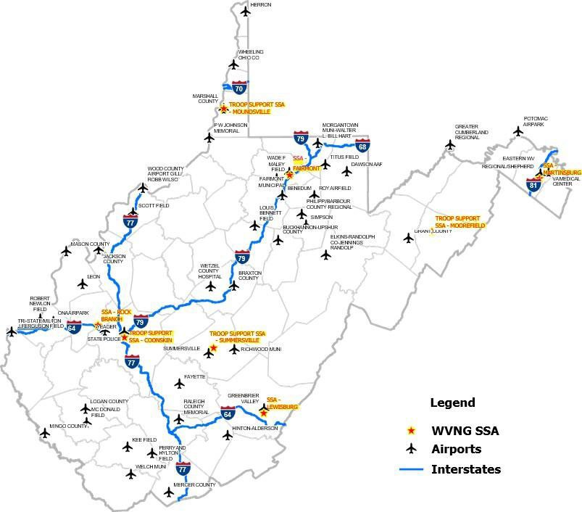

*Fig 1-2 WVNG SSA Interstate/Airport Ops*

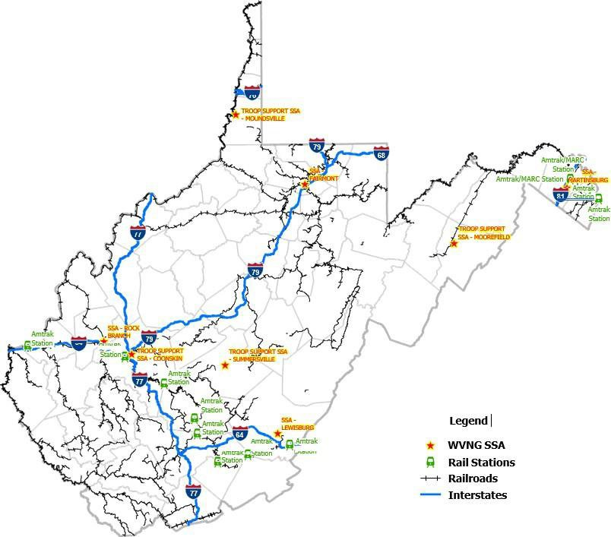

*Figure 1-3 WVNG SSA Rail Ops*

* 1. Transportation assets will be provided from a variety of sources such as:
     1. WV Division of Highways
     2. WV National Guard
     3. Various state agencies
     4. Private sector agencies
     5. FEMA Loan/Lease Program (equipment only), reference FEMA Directive 075-2 Rev 1
  2. Transportation of commodities from hubs or staging areas will only occur if approved by the SEOC through official channels utilizing the emergency management information system (EMIS). This process will entail the following steps:
     1. Resource request submitted (typically by local jurisdiction).
     2. Resource review and approval (WVEMD via SEOC).
     3. Approved request forwarded to State Distribution Management Staging Area (via EMIS).
     4. Distribution Management Team (documentation unit) reviews and confirms order can be processed (updates EMIS).
     5. Distribution Management Team arranges transportation and loads vehicle(s) for shipment (updates EMIS upon departure).
     6. The Distribution Management Team provides mission order sheets for each load.
     7. Outbound loads will be tracked by security at the facility.
     8. Local jurisdiction updates EMIS upon arrival of commodities to CPOD.
     9. Truck/trailer checks back in upon return to State Distribution Management Staging Area; and
     10. The Distribution Management Team will update the inventory system and generate necessary reports.
  3. Each transportation mission will be provided a detailed mission request log. This mission log will include routing information, points of contact, and other related information.
  4. Transportation routing will utilize the most efficient means possible. Maps and detailed directions to CPODs will be generated and provided for each mission. This should include a review of WV511 to check on road conditions.
  5. A list of drivers, agency, and contact information will be maintained by the Distribution Management Team(s) at the State Distribution Management Staging

Area. This should include cell phone numbers, emergency contacts, and any other source of information necessary. Availability of mobile radio communications capability should also be noted.

* 1. Relevant tracking information will be recorded for each transportation mission. This should include truck and trailer numbers.
  2. Trucks and trailers will be tracked both upon departure and return.
  3. Coordinate with WV Public Service Commission (PSC) if waivers are needed for transportation of commodities.

# Inventory Management

* + 1. WVEMD and the Distribution Management Team(s) will utilize a computerized commodity inventory system. This system should be capable of identifying commodities on hand, commodities delivered, and commodities in transit. The inventory management system should include, at a minimum, the following information:
    2. Acquisition – source of commodity.
    3. Use – what is the purpose of the commodity.
    4. Distribution – how was commodity distributed to a CPOD.
    5. Storage – if still in inventory, what is its location and status.
    6. Disposal – final disposition of commodities (CPOD, warehouse, returned).
  1. All commodities received will be entered into the inventory system. End of mission report must document disposition of all commodities received.
  2. Commodities near the end of shelf-life will be disposed of properly.
  3. Expired commodities will not be distributed to the public.
  4. Distribution Management Team(s) will update the computerized commodity inventory system as orders are processed.
  5. Distribution Management Team(s) will run reports required by the SEOC using the computerized commodity inventory system.
  6. During demobilization, the Distribution Management Team will ensure that final inventory reports reflect disposition of all commodities.
  7. The location, condition, and expiration date (if any) for all commodities will be maintained.

# Demobilization

* 1. The SEOC will determine when Distribution Management activities are no longer

needed to support operations. The decision to deactivate the Distribution Management function should include the following considerations:

* + 1. Status of normal supply chains.
    2. Life safety concerns in local communities; and
    3. Inventory of commodities on hand.
  1. Release transportation assets as soon as possible. The Distribution Management Team will notify the SEOC as assets are released. Required logs and paperwork should be completed before assets are released.
  2. Conduct a briefing with all Distribution Management Team members and other volunteers as they are being released.
  3. Finalize inventory of remaining commodities once operations have ceased. Members of the Distribution Management Team will count remaining commodities to verify inventory numbers.
  4. Complete required end of mission paperwork and provide to the SEOC.
  5. Replenish used materials and replace damaged equipment.
  6. All unused commodities at CPODs will be inventoried and the SEOC will determine whether commodities will remain in jurisdiction control or return to WVEMD control.
  7. Return all borrowed, leased, or rented equipment to the originating source.
  8. Ensure all transactional data/receipts are organized and available for post incident reimbursements.
  9. The Distribution Management Team develops an after-action report (AAR) and an Improvement Plan (IP) for the Distribution Management mission.
  10. Demobilization of each site or activity will be documented on a WVEMD Form DMP-208 Demobilization Checklist and submitted to the SEOC for review prior to the release of site or activity managers. A detailed inventory of all remaining commodities will be provided to the SEOC.

1. **Agency Responsibilities Matrix**

|  |  |  |
| --- | --- | --- |
| **Agency** | **Acronym** | **Responsibilities** |
| West Virginia Emergency Management Division | WVEMD | * Responsible for overall coordination of distribution management activities. * Responsible for maintaining the Distribution Management Plan. * Receive, validate, and approve local requests for assistance. * Responsible for developing and maintaining State Distribution Management Staging Area Standard Operating Guide. |

|  |  |  |
| --- | --- | --- |
| Public Service Commission | PSC | * Responsible for coordinating waiving of transportation related restrictions during declared emergencies. |
| West Virginia Department of  Administration | WV Dept of Admin | * Provide support to acquisition of commodities as requested. * Coordinate use of state-owned transportation assets. |
| West Virginia Department of Agriculture | WVDA | * Provides guidance via IS 9 with incidents requiring access to veterinary supplies, equipment, animal vaccines, and human antiviral medications from the National Veterinary Stockpile (NVS) when requested. * Provide transportation support to Distribution Management activities as requested and if available for non-agriculture incidents. * Provide warehouse storage and support as requested. * Provide support in acquisition of bulk commodity food items |
| West Virginia Department of Education | WVDE | * Provide support in acquisition of bulk commodity food items |
| West Virginia Department of Health | WVDH | * Provide technical support in the development of distribution procedures. * Provide technical support in the distribution of medical supplies and related commodities. * Coordinate supply chain activities during declared emergencies. |
| West Virginia Department of Transportation/ Division of  Highways | DOH | * Responsible for providing transportation assets as directed under ESF-1. * Provide specialized equipment to support distribution management activities as requested. * Provide support in vehicle routing and road closure information. |
| West Virginia National Guard | WVNG | * Provide transportation support as requested. * Provide personnel to support distribution management activities as requested. * Provide materials handling equipment and support as requested. |
| West Virginia State Police | WVSP | * Provide security at state staging areas as requested. * Provide convoy security/escorts as requested. |
| Voluntary Organizations and Non-Governmental Organizations | NGO | * Provide assistance in warehouse management. * Provide donations management needs/ standards for wider public dissemination. |
| Volunteer WV |  | * Serve as the state governmental focal point for volunteer preparedness and response coordination. * Provide training programs focused on selected volunteer preparedness topics. * Manage the Ready WV Program of outreach. * Provide management capabilities for unaffiliated volunteers before and during disaster operations. |

**RECORD OF CHANGES**

|  |  |  |  |
| --- | --- | --- | --- |
| **Change Number** | **Date of Change** | **Page/Change** | **Change made by (SIGNATURE)** |
| 1 | 22SEP2021 | Major revision of entire document | X  WVEMD Emergency Management Specialist |
| 2 | 13SEP2022 | Major revision of section 23 Transportation and addition of CPOD Guide and Demob  Checklist |  |
|  |  |  |  |
|  |  |  |  |
|  |  |  |  |
|  |  |  |  |
|  |  |  |  |
|  |  |  |  |
|  |  |  |  |
|  |  |  |  |
|  |  |  |  |
|  |  |  |  |
|  |  |  |  |
|  |  |  |  |

1. **Authorities & References**

*Authorities*

West Virginia Code §15-5-6 West Virginia Code §15-5-8 West Virginia Code §15-5-16 West Virginia Code §15-5-28

*References*

WVEMD Community Points of Distribution Guide 24 AUG 22 WV Department of Agriculture Incident Support Annex 9 West Virginia Emergency Operations Plan, Basic Plan

WV State Purchasing Handbook

National Response Framework, as amended National Incident Management System

The Disaster Relief Act of 1974 (Public Law 93-288)

Act of Congress (Act of January 5, 1905, 33 Stat. 599) as amended (36 U.S. Code, Section 1); Disaster Relief Act of 1974, (Public Law 92-288; Executive Order 11795)

Pan American Health Organization, Food and Nutrition in Disasters Guidelines FEMA Policy Directive 075-2 Rev 1 Loan/Lease Program

# Appendix A: Staging Area – Rock Branch Warehouse

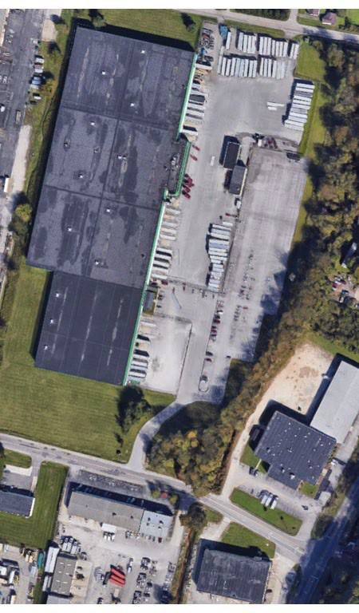

*Figure AA-1*

## WVEMD Rock Branch Warehouse, Poca W.V.

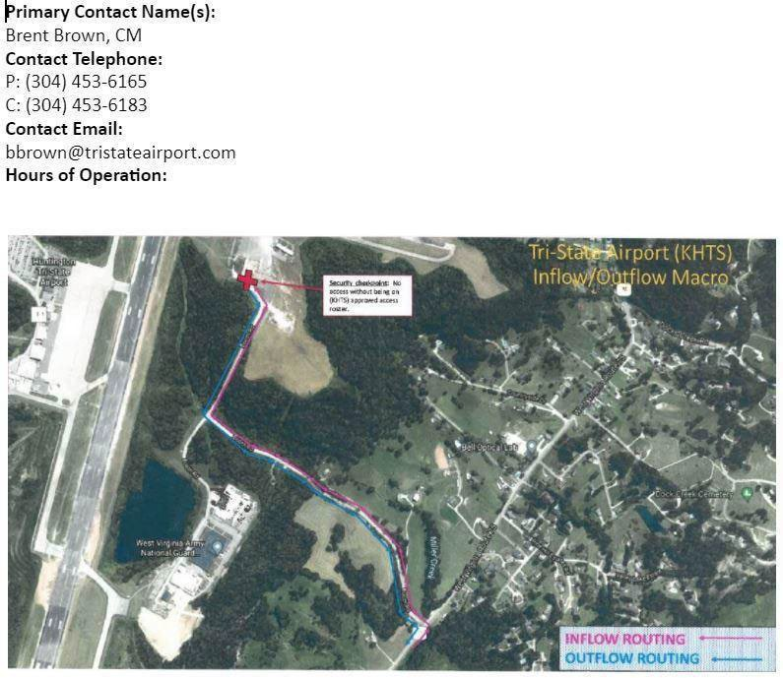

*Figure AA-2*

## Tri-State Airport (KHTS macro) Region VI

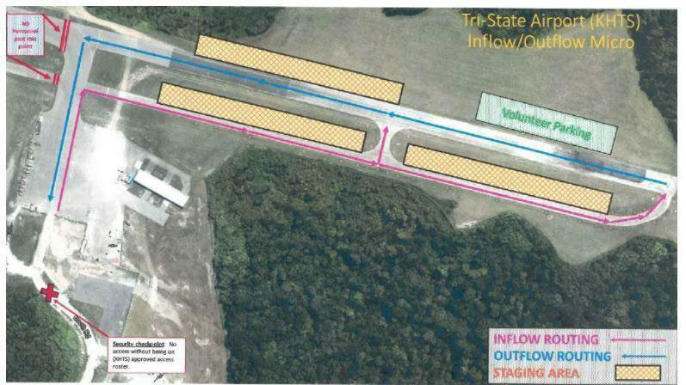

*Figure AA-3*

## Tri-State Airport (KHTS micro) Region VI

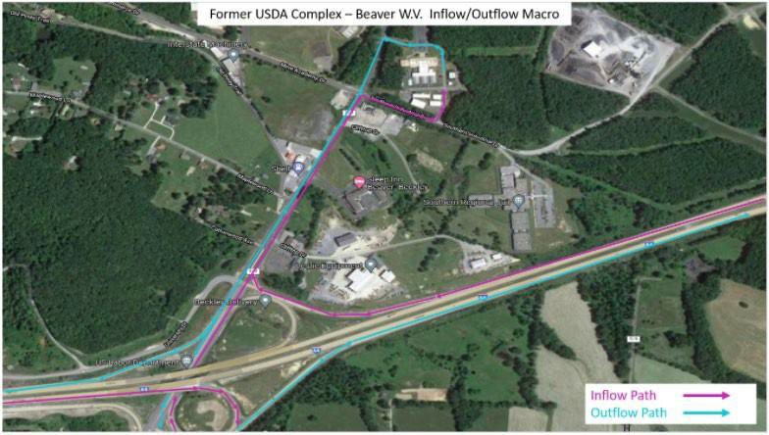

*Figure AA-4*

# USDA Complex, Beaver WV (macro) Region V (Pending Approval)

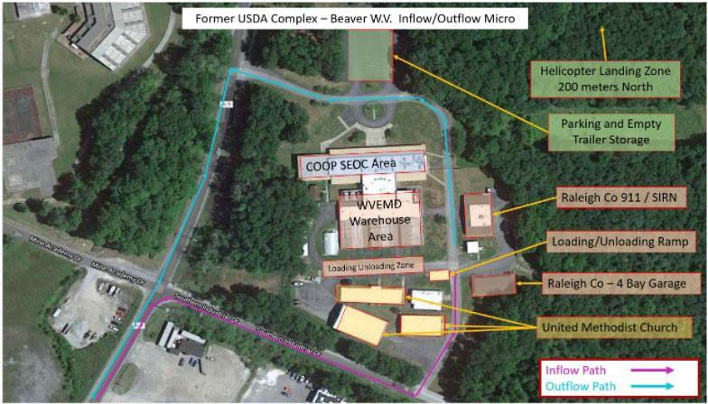

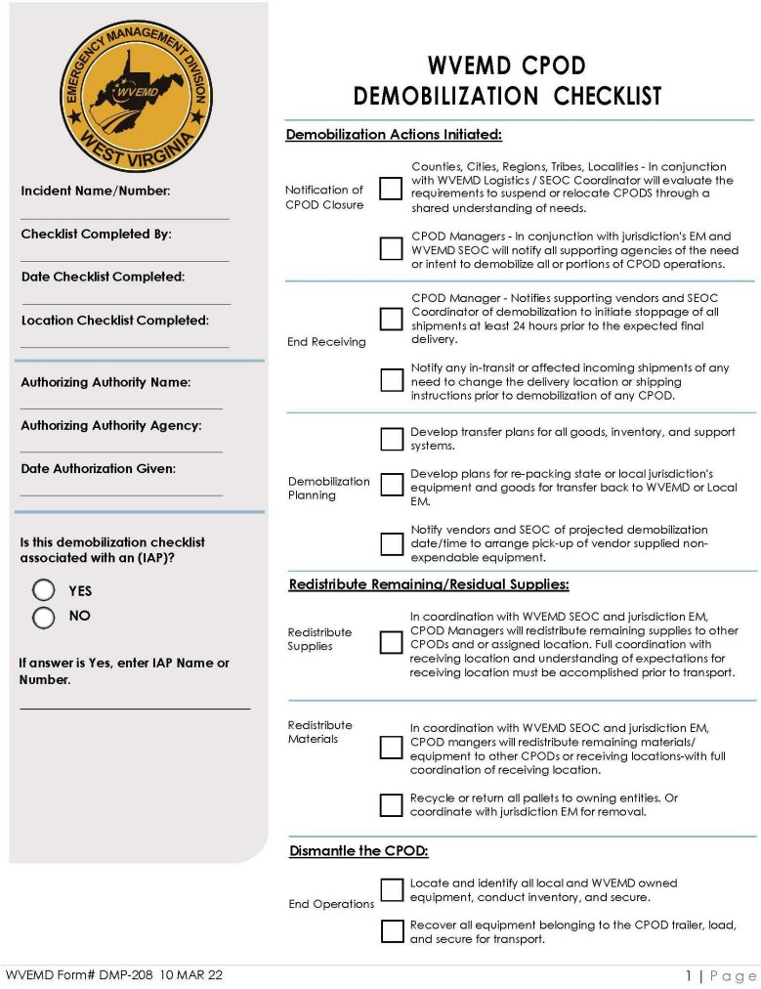

*Figure AA-6*

# Appendix B: Acronyms

|  |  |
| --- | --- |
| AAR | After Action Report |
| CPODs | Community Points of Distribution |
| DMP | Distribution Management Plan |
| EMAC | Emergency Management Assistance Compact |
| EMIS | Emergency Management Information System |
| EOP | Emergency Operations Plan |
| ESF | Emergency Support Function |
| FEMA | Federal Emergency Management Agency |
| HSEEP | Homeland Security Exercise and Evaluation Program |
| ICS | Incident Command System |
| IP | Improvement Plan |
| IPP | Integrated Preparedness Plan |
| IPPW | Integrated Preparedness Plan Workshop |
| IS | Incident Support |
| NVS | National Veterinary Stockpile |
| NRF | National Response Framework |
| PSC | Public Service Commission |
| SEOC | State Emergency Operations Center |
| SOG | Standard Operating Guide |
| SOP | Standard Operating Procedures |
| SSA | Supply Support Activity |
| WVEMD | WV Emergency Management Division |
| WV SEOC | WV State Emergency Operations Center |

**Appendix C: 2023 Action Plan**

January to March 2023

* Distribute Inventory Management Licenses to partners
* Conduct Inventory Management Training and inventory builds for each partner
* Development of State Distribution Management Staging Area SOG
* Procure kit items for use in CPOD training at the conclusion of county CPOD plans
* Develop and implement MOU for use of Beaver WV complex as staging area and COOP site

April to June 2023

* Conduct CPOD planning workshops with county EMs using the new WV CPOD Planning guide
* Conduct tabletop inventory management exercise with partners pending completion of training
* Review and revise Distribution Management Plan
* Review and revise WV EOP (Base plan and related ESFs)

July to September 2023

* Functional Exercise on State Distribution Management Staging Areas
* Final review of Distribution Management Plan
* Submission of Distribution Management Plan

October to December 2023

* Functional exercise of selected CPOD plans with partial SEOC activation using partnered organizations that are using the WVEMD inventory management system
* Seek approval on all revisions to all of WV EOP
* Identification of new training requirements
* Stakeholder outreach
* Development of a training plan for 2024 Future Needs
* L660 course – Federal Staging Operations