Incident Specific Annex 9 - Agriculture Incidents Appendix 2 - Highly Pathogenic Avian Influenza



Plan(HPAI)



Foo·r-.AND-MOUT R'ESPON.SEPLA *THE RED BOOK*

 \

DISEASE

FADPReP

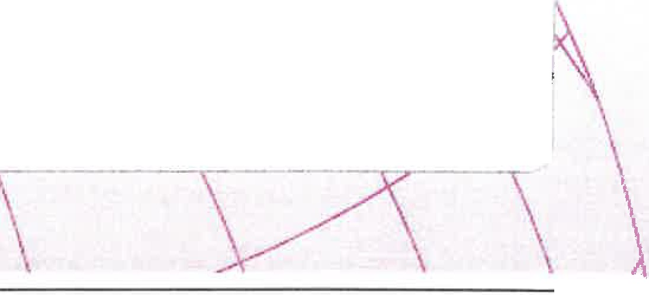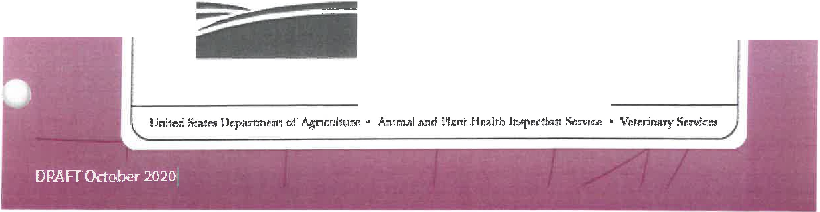

Foreign .Animal D1isease

Preparedne.ss & Response Plan

**USDA** United States

Department O·f

Agriculture

**USDA**

-

**United States Department of Agriculture**

**FADPReP**

**Foreign Animal Disease**

**Preparedness** & **Response Plan**

October 2020

USDA APHIS, Veterinary Services

National Preparedness and Incident Coordination Center

By the end 2015, the United States experienced its largest Foreign Animal Disease (FAD) outbreak-highly pathogenic avian influenza (HPAl)-in history. Subsequent to the 2015 HPAI outbreak, APHIS has tested its response capabilities with FAD outbreaks in 2016, 2017, 2018 and 2019, as well as the planning and execution of the 2018 ARMAR (Agriculture Response Management and Resources foot-and-mouth disease (FMD) functional exercise. This version of the *USDA APHIS FMD Response Plan: The Red Book (Updated October 2020)* reflects knowledge and lessons learned during these activities. Additionally, this version incorporates changes made in related Foreign Animal Disease Preparedness and Response Plan (FAD PReP) materials.

The following list highlights important revisions that were made to this version *of* the FMD Response Plan.

* Reflects policy that explicitly recognizes vaccine as a likely response tool in an FMD outbreak.
* Reflects the new National Response Framework, released June 2019.
* References and includes the latest text of the World Organization for Animal Health (OIE)

*Terrestrial Animal Health Code.*

* Includes new surveillance sections, revised by the Center for Epidemiology and Animal Health.
* Provides revised templates for epidemiology questionnaires and State FMD vaccine planning.
* Streamlines content into four chapters specific to FMD: 1) general information; 2) national roles, responsibilities, and authorities; 3) response goals and strategy; and 4) critical response activities.
* Includes critical activity "Essentials" sidebars, highlighting available training resources and often overlooked planning considerations.
* Incorporates policy guidance prepared for ARMAR on managing a National movement standstill.
* Corrects comments made on, and any errors identified in, the prior version.

This version *of* the FMD Red Book is being distributed as an early draft to assist in the preparation for the next cycle of FMD response planning and exercises. Links to appendices in the body of the document are internal and do not require an internet connection; however, connectivity is needed to access other links in the body and in the Essentials sidebars. It is our hope that those involved in preparing for the Southern Animal Health Association FMD functional exercise (scheduled in November 2021) will find the updated material and format useful. Future updates of this plan will incorporate new National policy guidance and/or lessons learned from FAD response experiences and exercises.

We invite comments on the FMD Response Plan for incorporation into the next version. Please email all comments to [FAD.PReP.Comments@usda.gov](mailto:FAD.PReP.Comments@usda.gov) with the subject line of "Comments to Updated FMD Response Plan."

Additional policy guidance documents for FMD, as well as general response topics, are available at [www.aphis.usda.gov/fadprep.](http://www.aphis.usda.gov/fadprep) These documents, alongside the FMD Response Plan: The Red Book, should be consulted in an FMD outbreak.

The Foreign Animal Disease Preparedness and Response Plan (FAD PReP) mission is to raise awareness, define expectations, and improve capabilities for FAD preparedness and response.

For more information, please go to: <http://www.aphis.usda.gov/fadprep>

or e-mail [FAD.PReP.Comments@usda.gov](mailto:FAD.PReP.Comments@usda.gov)

ii

*Contents*

**Contents**



Preface x

Chapter 1 Introduction and FM□Information 1-1

* 1. INTRODUCTION TO RESPONSE PLAN..................................: 1-1
  2. AUDIENCE AND.PURPOSE OF DOCUMENT **1-2**
  3. FMD INFORMATION ......................................................······························· 1-2
     1. Etiology 1-3
     2. History and Global Distribution 1-3
     3. International Trade 1-5
     4. Impact of an FMD Outbreak 1-5
     5. Ecology 1-6
     6. Diagnosis 1-9
     7. Immunity 1-11

Chapter 2 National Coordination for FM□Preparedness and Response. 2-1

* 1. FOUNDATIONS OF PREPAREDNESS AND RESPONSE 2-1
     1. National Response Framework 2-1
     2. National Incident Management System 2-1
     3. USDA Roles and Responsibilities Overview 2-2
  2. USDAAUTHORITIESANDACTIVITIES **2-3**
     1. Authorities 2-4
     2. Foreign Animal Disease Preparedness and Response Plan 2-5
     3. Exercises 2-6
     4. Domestic Activities 2-6
     5. International Activities 2-8
     6. International Trade 2-8
  3. **USDA** ORGANIZATIONAL STRATEGY 2-9
  4. **APHIS** INCIDENT MANAGEMENT STRUCTURE. **2-9**
     1. Multi-Program Committee 2-9
     2. APHIS Incident Coordination Group 2-11
     3. Organization at the Field Level 2-12

Updated October 2020-DRAFT iii

* 1. DIAGNOSTIC RESOURCES AND LABORATORY SUPPORT **2-13**
     1. National Veterinary Services Laboratories 2-13
     2. National Animal Health Laboratory Network 2-13
     3. Center for Veterinary Biologics 2-14

Chapter 3 FMD Outbreak Response Goals and Strategy 3-1

* 1. RESPONSE GOALS 3-1
  2. PRINCIPLES AND CRITICAL ACTIVITIES OF AN FMD RESPONSE 3-2
     1. Critical Activities 3-2
     2. Epidemiological Principles 3-2
     3. Coordinated Public Awareness Campaign 3-3
     4. FMD Vaccination Strategy 3-4
     5. Incident Management 3-4
     6. Authorization for Initial Response Activities 3-4
     7. Timeline in any FMD Response for the First 72 Hours 3-5
  3. RESPONSE STRATEGIES FOR CONTROL AND ERADICATION OF FMD IN

DOMESTIC LIVESTOCK **3-6**

* + 1. Stamping-Out as a Response Strategy 3-8
    2. Stamping-Out Modified with Emergency Vaccination to-Kill or to-

Slaughter 3-9

* + 1. Stamping-Out Modified with Emergency Vaccination to-Live 3-11
    2. Emergency Vaccination to-Live without Stamping-Out 3-12
  1. FACTORS INFLUENCING THE SELECTION OF RESPONSE STRATEGY OR

STRATEGIES 3-13

* + 1. General Factors that Influence a Response Strategy 3-14
    2. Emergency Vaccination Sourcing and Availability 3-14
    3. Determining an Appropriate FMD Response Strategy 3-16
    4. Phases and Types of FMD Outbreaks 3-18
  1. RECOVERY AFTER **AN FMD** OUTBREAK **3-19**
     1. FMD-Free Designations 3-20
     2. OIE Minimum Time to FMD-Free Designations 3-20
     3. Surveillance for Recognition of Disease-Freedom 3-22
     4. Release of Control Area Restrictions 3-22

) 3.5.5 Disposition of Vaccinates 3-22

lV

*Contents*

3.5.6 Country Freedom Declaration 3-22

Chapter 4 Specific FMD Response Critical Activities and Tools 4-1

* 1. ETIOLOGY AND ECOLOGY 4-1
  2. LABORATORY DEFINITIONS AND CASE DEFINITIONS **4-1**
     1. Laboratory Criteria 4-1
     2. Case Definitions ..................................................................................: 4-3
  3. SURVEILLANCE **4-4**
     1. Surveillance Planning for FMD Outbreak 4-4
     2. Surveillance Sampling 4-9

**4.4** DIAGNOSTICS **4-15**

* + 1. Sample Collection and Diagnostic Testing 4-15
    2. Surge Capacity 4-20
    3. Reporting 4-20
  1. EPIDEMIOLOGICAL INVESTIGATION AND TRACING **4-21**
     1. Summary of Zones, Areas, and Premises Designations 4-21
     2. Epidemiological Investigation 4-23
     3. Tracing 4-24
     4. Considerations for Size of Control Area and Minimum Sizes of Other Zones 4-25
  2. INFORMATION MANAGEMENT **4-28**
     1. EMRS2 4-28
  3. COMMUNICATION **4-29**
     1. Objectives 4-30
     2. Key Messages 4-30
     3. Social Media 4-31
  4. HEALTH AND SAFETY AND PERSONAL PROTECTIVE EQUIPMENT **4-32**
     1. Personal Protective Equipment. 4-33
     2. Mental Health Concerns 4-33
  5. BIOSECURITY **4-34**
     1. Biosecurity Hazards and Mitigating Measures 4-34
     2. Closed Herds 4-35
     3. Waiting Period 4-35

Updated October 2020-DRAFT V

* 1. QUARANTINE AND MOVEMENT CONTROL **4-36**
     1. Movement Standstill 4-37
     2. Moving Commodities, Animals, and Conveyances in FMD Outbreak 4-38
     3. Repopulation 4-47
  2. CONTINUITY OF BUSINESS **{COB) 4-48**
  3. REGIONALIZATION FOR INTERNATIONAL TRADE (FOR A U.S. FMD RESPONSE) 4-49
     1. Compartmentalization 4-49
     2. Further Guidance 4-50
  4. MASS DEPOPULATION AND EUTHANASIA 4-50
  5. DISPOSAL **4-51**
  6. CLEANING AND DISINFECTION **4-53**
  7. VACCINATION **4-54**
     1. Vaccination Plan 4-54
     2. Zone, Area, and Premises Designations 4-55
     3. Movement Restrictions for Vaccinates 4-58
     4. Cessation of Vaccination 4-58
  8. LOGISTICS **4-59**
  9. WILDLIFE MANAGEMENT AND VECTOR CONTROL. **4-59**
     1. Wildlife Management 4-60
     2. Vector Control 4-60
  10. ANIMAL WELFARE 4-60
  11. MODELING AND ASSESSMENT TOOLS **4-61**
  12. APPRAISAL AND COMPENSATION 4-61
  13. FINANCE 4-62
      1. Federal Funding Sources 4-62
      2. Supplemental Cooperative Agreements 4-63
  14. INCIDENT MANAGEMENT **4-64**

Appendix A FAD PReP Materials to Support FMD Response A

Appendix BOIE Terrestrial Animal Health Code for FMD (2019) B

Appendix C Laboratory Network List for FMD C

Appendix D Procedures for FMD Investigation and Specimen

Submission D

vi

*Contents*

Appendix E Emergency Vaccine Plan and Vaccination Priorities E

Appendix F FMD Outbreak Surveillance Guidance and Rationale F

Appendix G Epidemiological questionnaires G

Appendix H Movement Control Notice Examples H

Appendix I FMD Vaccines and Vaccination I

Appendix J Selected References J

Appendix K FMD Acronyms K

Figures

Figure 1-1. Worldwide FMD Events in 2018 1-4

Figure 2-1. APHIS Multiagency Coordination Structures and APHIS Emergency Operations: Relationship to Incident Management Team 2-11

Figure 2-2. Details of USDA APHIS Multiagency Coordination, Incident

Coordination Group, and a Unified Incident Management Team 2-12

Figure 3-1. Critical Activities in the First 72 Hours of a U.S. FMD Outbreak 3-5

Figure 3-2. Example of Zones and Areas in Relation to Stamping-Out (Infected Premises Would be Depopulated) 3-9

Figure 3-3. Examples of Zones and Areas Utilizing Stamping-Out: Modified with Emergency Vaccination to Kill or Slaughter (Infected Premises Would be Depopulated in Either Case) 3-10

Figure 3-4. Example of Zones and Areas for Stamping-Out Modified with

Emergency Vaccination to Live (Infected Premises would be Depopulated) 3-12

Figure 3-5. Example of Zones and Areas for Emergency Vaccination to Live

without Stamping-Out 3-13

Figure 3-6. Phases of FMD Response 3-19

Figure 3-7. Minimum OIE waiting periods and pathways for recovery of FMD

free status after an outbreak where vaccination is not practiced 3-21

Figure 4-1. Diagnostic Flowchart for Initial Investigation of FMD 4-17

Updated October 2020-DRAFT vii

Figure 4-2. Outbreak Diagnostics after Positive Confirmation of FMD in United States 4-19

Figure 4-3. Example of Zones, Areas, and Premises in FMD Outbreak

Response 4-23

Figure 4-4. Premises Designations in Relation to Permitting and Movement

Control 4-46

Figure 4-5. Examples of Containment Vaccination Zones (Figures are not to

scale.) 4-56

Figure 4-6. Examples of Protection Vaccination Zones (Figures are not to scale.)4-57 Figure 4-7. Vaccinated Premises (Figures are not to scale.) 4-58

Tables

Table 3-1. Overview of Traditional FMD Response Strategies 3-7

Table 3-2. Factors Influencing a Response Strategy or Strategies for U.S. FMD Outbreak 3-17

Table 4-1. Descriptive statistics of serotype O FMDV infection periods by

species ...; 4-5

Table 4-2. Examples of animals with a Higher Probability of Disease (HPD)

during an FMD outbreak 4-6

Table 4-3. Sampling Frequency Guidelines by Premises Designations 4-13

Table 4-4. Summary of Premises 4-21

Table 4-5. Summary of Zones and Areas 4-22

Table 4-6. Minimum Sizes of Areas and Zones 4-25

Table 4-7. Factors to Consider in Determining Control Area Size for FMD 4-26

Table 4-8. Movement into Control Area from Outside Control Area to Specific Premisesa 4-40

Table 4-9. Movement within a Control Area8 •••••••••••.•••••..••••••.•.••••••••••.••••••.••••••••••• 4-42 Table 4-10. Movement from Inside a Control Area to Outside a Control Area

from Specific Premises8 ••••••••••••.•...••••••••••••••••••••••••••••••••••••••••••.••••••••••••••••••••.•• 4-44

viii

*Contents*

Table 4-11. Projected Vaccine Dose Need 4-55

Updated October 2020-DRAFT lX