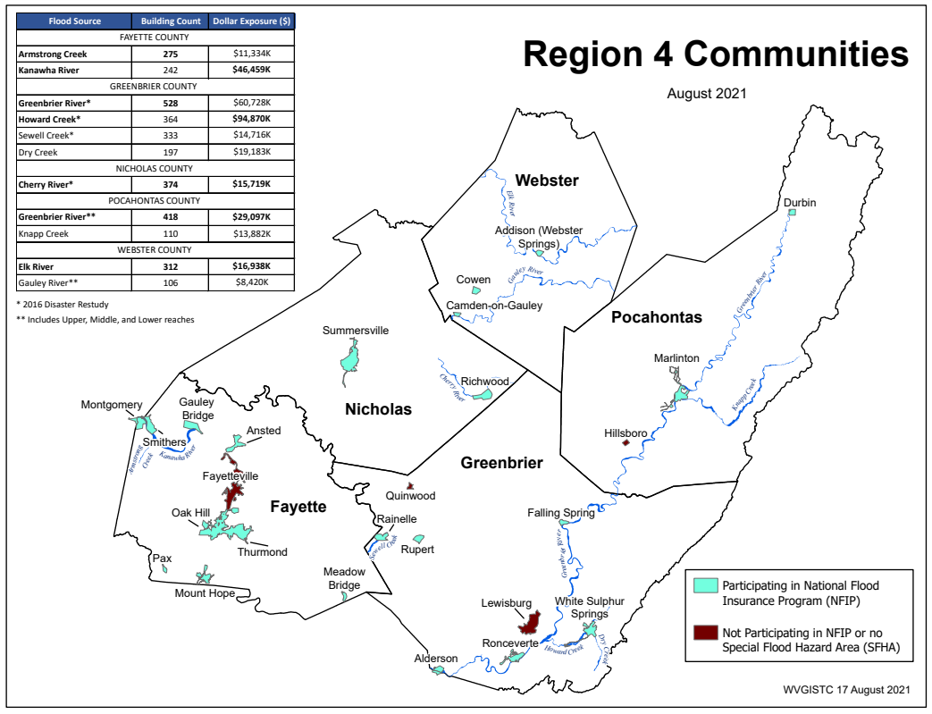

Region 4 Risk Assessment Report

d-r-a-f-t

2/9/2022

West Virginia University  
WV GIS Technical Center

Contents

OVERVIEW 1

FLOOD ZONE MAP INFORMATION 2

Historical Flood Information 2

Active Flood Studies and Mapping 2

Flood Zone Measurements 2

Special Flood Hazard Area (in acres): 3

High-Risk Effective and Advisory Flood Zone Length (in miles): 3

FLOODPLAIN BUILDING INVENTORY AND FUTURE MAP CONDITIONS 3

Building Risk by Flood Source 3

Building Risk by Flood Zone 3

Summary Building Risk by Community Type 5

Future Map Conditions – Structures Mapped into SFHA 6

Building Exposure and Type 6

Primary Structures Vulnerable to Riverine Flooding Floodplain 6

Building Dollar Exposure 6

Residential/Non-Residential Occupancy Type 6

Median Building Replacement Value 7

Owner Occupied 7

The Manufactured Homes 7

Historical Structures (Building Year) 7

New Development (Building Year and FIRM Status) 7

SIGNIFCANT STRUCTURES OF IMPORTANCE 8

Essential Facilities 8

Essential Facilities Vulnerable to Riverine Flooding 8

Essential Facilities by Type 8

Essential Facilities by Flood Depth 8

Community Assets 8

Community Assets Vulnerable to Riverine Flooding 8

Historical Community Assets 9

FLOOD DAMAGE LOSS ESIMATES (1% FLOOD EVENT) 10

Building Damage Dollar and Percent Estimates 10

TEIF Building Dollar Loss Estimates 10

TEIF Building Percent Loss Estimates 11

Substantial Damage Estimates 11

Building Debris Removal Estimates 12

Population Displacement and Short-Term Shelter Estimates 12

Population Residing in High-Risk Flood Zones 13

Displaced Population for Flood Depth >= 1 Foot 13

Estimated Population in Need of Short-Term Shelter 14

Transportation Inundation Models 14

Road Miles Inundated 14

Railroad Miles Inundated 14

Minus-Rated Structures of Post-FIRM Construction 14

Flood Loss Model Limitations 15

MITIGATION 16

Mitigated Structures 16

Buyout Properties 17

Repetitive Loss Structures 17

Open Space Preservation 18

Areas of Mitigation Interest (AoMI) 18

OTHER HAZARDS 19

Dams 19

Landslides 19

Landslide Risk Information 20

COMMUNITY ENGAGEMENT AND DATA VERIFICATION 21

Building-Level Risk Flood Risk Assessment Data Verification 21

Flood Risk Factor Matrices 21

Flood Risk Community Risk Dashboards 21

Top 20 Community Risk Rankings 21

# OVERVIEW

The Regional and Planning Development Councils should use the riverine flood and landslide risk assessment products to support their local hazard mitigation plans and flood reduction efforts. The comprehensive risk assessment data supports detailed, site-specific analysis at the building or feature level (stream, buyout parcel, roads/railroads, National Register Areas, etc.). It also allows analysis at the community level (county, unincorporated/incorporated areas) to identify which jurisdictions are at more risk than others. All the building, feature, and community level risk assessment data in this report should assist stakeholders in evaluating specific risk factors and correlating these risks to potential mitigation measures.

An [Index Guide](https://data.wvgis.wvu.edu/pub/RA/_engage/_IndexDocs/) provides *access* to the various risk assessment products that include GIS files, risk assessment tables at the building and community level scales, static and online maps, subject reports, and 3D flood visualizations. Most of the risk assessment data can be viewed on the interactive WV Flood Tool (<https://www.mapwv.gov/flood>).

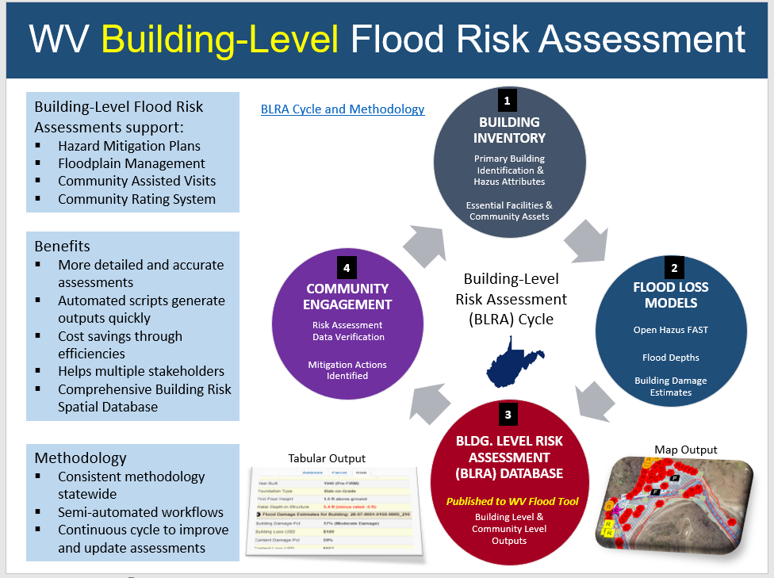 The [WV Building-Level Risk Assessment (BLRA) Cycle and Methodology](https://data.wvgis.wvu.edu/pub/RA/_engage/_IndexDocs/BLRA_cycle/) provides procedural information about how the flood risk assessment data and flood models are generated and validated through engagement with the communities. The statewide building risk assessment database is updated annually with new building characteristics from the statewide tax assessment database. It can be updated with user-defined values, corrections, or updates from stakeholders, especially in validating properties that have been mitigated.

# FLOOD ZONE MAP INFORMATION

*What flood zone map information is available now or in the future?*

FEMA’s effective and advisory flood zone maps for riverine flooding are utilized for the inventory of all primary structures in the high-risk 1%-annual-chance floodplain. Certain regions of the State have advisory floodplains which in the future most likely will become effective upon the completion of restudies. The flood zone maps are continuously being restudied and changing based on historical flood and updated stream flow information.

## Historical Flood Information

USGS high-water marks (n=421) collected from the June 2016 flood event and other historical flood information should be evaluated as a risk factor. [West Virginia High-Water Marks](https://data.wvgis.wvu.edu/pub/RA/State/BL/Graphic/HWM_20201221.pdf) are viewable on the WV Flood Tool. *For new development, the design flood elevation should be above the recorded high-water marks.*

An excellent resource for risk assessment and planning is the FEMA Region III published report named the “[Understanding Flood Dangers in Central West Virginia: Lessons Learned from the June 2016 Flood](https://www.fema.gov/sites/default/files/documents/Region_III_WV_FloodReport.pdf).” Story Maps created as supplemental to this report about the devastating June 2017 flood:

* [Flood Risk in West Virginia: What We Learned from the June 2016 Flood](https://wvu.maps.arcgis.com/apps/Cascade/index.html?appid=32292859b21b44e99c0be706f6da8aa3)
* [WV Flooded Towns, June 2016. The Historic Flooding of Southern West Virginia on June 23, 2016](https://wvu.maps.arcgis.com/apps/Cascade/index.html?appid=7b98379452094cd6827dc8f09c8293bd)

## Active Flood Studies and Mapping

FEMA is creating new flood maps for part of entire in **Region 4** which will alter the floodplain boundaries and base flood elevations. The [active flood studies](https://data.wvgis.wvu.edu/pub/RA/_resources/status/WV_FloodStudies.pdf) will significantly affect the floodplain boundary and base flood elevations of certain communities, which in turn will affect the building-level inventory and risk assessments as well. For example, the base flood elevation is increasing six feet along the *Gauley River* for the community of **Camden-on-Gauley** in Webster County. The restudies also show where the base flood elevation is decreasing by 3 feet for the **Ronceverte Wastewater Treatment Plant** in Greenbrier County. During the restudies new high-water marks, stream flow data, and topography are incorporated into the new flood map studies to determine the base flood elevations.

## Flood Zone Measurements

Measurements of the flood zones allow for the calculations of the acreage and miles of flood zones which can be compared with other jurisdictions. The first calculation is the acreage of the Special Flood Hazard Area (SFHA), the effective 1%-annual-chance flood zone. A second calculation estimates the mileage of both the high-risk effective and advisory 1%-annual chance floodplains.

### Special Flood Hazard Area (in acres):

* **Greenbrier County** (4th largest in the State) and **Greenbrier Unincorporated** (ranked 4th) have the largest acreage in the Special Flood Hazard Area (SFHA), the effective 1%-annual-chance floodplain.
* The SFHA (red floodplains on WV Flood Tool) will increase for several communities in **Greenbrier County** when the Preliminary flood zones (orange) become effective. The town of **Rainelle** will have the largest SFHA increase. See [Rainelle map link](https://www.mapwv.gov/flood/map/?wkid=102100&x=-8990998&y=4575054&l=8&v=0).
* About 20% of the total incorporated land of **Rupert**, **Marlinton**, **Alderson**, and **Meadow Bridge** are in the Special Flood Hazard Area (SFHA) and thus these jurisdictions have a higher 1%-annual-chance (100-yr) floodplain exposure than other communities.
* The acreage of the SFHA (aSFHA) is a programming variable required for those communities (**Fayette Unincorporated** and **Greenbrier Unincorporated**) participating in FEMA Community Rating System (CRS) program.

### High-Risk Effective and Advisory Flood Zone Length (in miles):

* **Greenbrier County** is ranked 2nd in the State in flood zone stream miles.
* New flood studies by FEMA will likely double the flood zone miles for Fayette County. If the Advisory Floodplains (orange color) for Fayette County become effective (red color) upon completion of new flood studies, then most likely the flood zone miles will more than double (55%) with an increase of 187 miles of effective A Zones. Refer to [High-Risk Advisory Floodplains](https://data.wvgis.wvu.edu/pub/RA/_resources/FloodTool/WV_Flood_Tool_High-Risk_Advisory_Zones.pdf) for more information.

# FLOODPLAIN BUILDING INVENTORY AND FUTURE MAP CONDITIONS

*What buildings are at risk?*

## Building Risk by Flood Source

The riverine flood sources are often the focus of enhanced mapping and mitigation priorities. High building counts and high flood depths along river/stream reaches are potential focus areas. A density of structures in the Approximate A Zone with high flood depths may qualify for a detailed study, for example.

* **Greenbrier River** in Region 4 has the most structures in the 1%-annual-chance floodplain. Estimated *Greenbrier River* totals for Greenbrier and Pocahontas counties: 946 buildings in 1% floodplain, $90M dollar exposure
* **Howard Creek** in Greenbrier County has the highest building dollar exposure of all Region 4 communities.

## Building Risk by Flood Zone

Buildings are inventoried for high-risk effective and advisory 1%-annual chance floodplains. Counties with the highest building counts in the Special Flood Hazard Area (SFHA) are Greenbrier (1,481) and Fayette (1,219) counties. Buildings in the Approximate A Zone (2,598) studies and Detailed AE Zone studies (2,888) comprise 47% and 53%, respectively, of all buildings mapped in the SFHA. Greenbrier (165) and Nicholas (150) counties have the most buildings in the regulatory floodway, the main channel of the river or stream where floodwaters are likely the deepest and with highest velocities.

Counties with the highest number of structures in both the effective and advisory floodplains are Greenbrier (2,225) and Fayette (1,819) counties. **Webster Unincorporated** (119) and **Richwood Incorporated** (109) have the most structures in the floodway. *Buildings in the main floodway channel of the river or stream, or close to the flood source, will be subject to the greatest flood depths, highest velocities, and greatest debris potential.*

**Table 1.** Building Count Breakdown by Special Flood Hazard Area (SFHA).

|  |  |  |  |  |  |  |  |
| --- | --- | --- | --- | --- | --- | --- | --- |
| **SFHA BREAKDOWN (Effective Only)** | | | | | | | |
| County | Approx. A | AE | Floodway | AO | AH | Detailed Sum | Sum Effective |
| FAYETTE | 752 | 410 | 57 | 0 | 0 | 467 | 1219 |
| GREENBRIER | 679 | 637 | 165 | 0 | 0 | 802 | 1481 |
| NICHOLAS | 591 | 260 | 150 | 0 | 0 | 410 | 1001 |
| POCAHONTAS | 299 | 413 | 69 | 0 | 0 | 482 | 781 |
| WEBSTER | 277 | 586 | 141 | 0 | 0 | 727 | 1004 |
|  | 2,598 | 2,306 | 582 | 0 | 0 | 2,888 | 5,486 |

**Table 2.** Building Counts for High-Risk Floodplains

|  |  |
| --- | --- |
| **High-Risk Effective Floodplains (Special Flood Hazard Areas)** | |
| SFHA (Effective only) | **5,486** |
| Approximate A | 2,598 |
| Detailed AE | 2,306 |
| Detailed AE Floodway | 582 |

|  |  |
| --- | --- |
| **High-Risk Effective and Advisory Floodplains** | |
| SFHA | **5,486** |
| Mapped in Advisory A / AE | 1,636 |
| **Total High-Risk (Effective & Advisory) 1% Floodplains** | **7,122** |

## Summary Building Risk by Community Type

* Incorporated Areas: **White Sulphur Springs** and **Marlinton** Incorporated Areas have the highest 1% flood zone building counts and dollar exposure.
* Unincorporated Areas: **Greenbrier** and **Fayette** Unincorporated Areashave the highest building counts and dollar exposure.
* 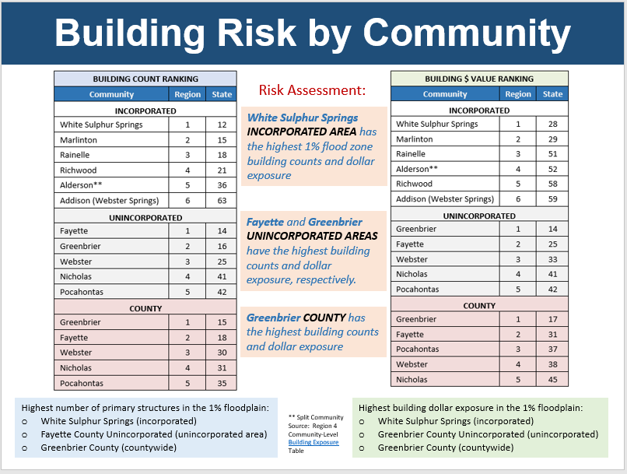Countywide: **Greenbrier County** has the highest building counts and dollar exposure.

## Future Map Conditions – Structures Mapped into SFHA

Where advisory floodplains exist, the "mapped-in" structures (orange color primary structures on WV Flood Tool) represent buildings that most likely will be included in the SFHA when future FEMA Restudies are done and new FIRMS become effective. Non-regulatory advisory floodplains are generated from Preliminary/Draft Risk MAP studies or Advisory Flood Height studies. *Communities should review all "mapped-in" structures. Homeowners are at higher risk to flooding and should be contacted about Flood Insurance Preferred Risk Policies and other potential mitigation measures.*

*A*ccording to future flood maps, **Greenbrier** (735), **Fayette** (590), and **Pocahontas** (167) counties have many structures being mapped in to future SFHA. The towns of **Rainelle** (331) and **White Sulphur Springs** (68) have many mapped in structures as well.

## Building Exposure and Type

This section identifies high-valued buildings and other building characteristics exposed in the 1%-annual-chance (100-year) floodplain. Building level risk assessments (BLRA) are developed by pinpointing all primary insurable structures in the high-risk effective and advisory floodplains. Building characteristics inventoried and verified are Occupancy Class, Foundation Type, First Floor Height, Number of Stories, Area, and Replacement Cost. Default values are populated from the WV Property Tax Assessment Database and if necessary modified with user-defined values. Building pictures can be linked to the structure-level risk assessment using the unique building identifier (Parcel ID + Address Number).

Primary Structures Vulnerable to Riverine Flooding Floodplain: **Region 4** has a total of 7,123 structures in the high-risk effective and advisory 1%-annual-chance (100 yr.) floodplains valued at $525,285 million.**Greenbrier County** (ranked 15th in the State) has the highest countywide building count in the region. **Fayette County Unincorporated** (ranked 14th for unincorporated areas) and the towns of **White Sulphur Springs** (ranked 12th for incorporated areas) and **Marlinton** (ranked 15th) also have high building counts.

Building Dollar Exposure: **Greenbrier County** (ranked 9th in the State) and the incorporated city of **White Sulphur Springs** (ranked 20th for incorporated areas) have the *highest building dollar values* exposed to a 1%-annual-chance flood. *Higher building values increase substantial damage thresholds and mitigation reconstruction costs.*

Residential/Non-Residential Occupancy Type: Most of the primary buildings in the floodplain are *residential*: **Webster County** (92%), **Fayette County** (91%), **Greenbrier County** (87%), **Nicholas County** (86%), and **Pocahontas County** (85%). Municipalities typically have a higher percentage of *non-residential* structures, such as the towns of **Gauley Bridge** (53%) and **Ronceverte** (49%) in which half the structures are non-residential. *The specified residential/non-residential occupancy class according to structure use or structure type is an important requirement for multiple flood reduction programs, activities, and products: FEMA's NFIP Specific Rating Guidelines, Substantial Damage Estimator (SDE) Tool, Community Rating System (CRS 214) Program Data Table, Hazus Flood Loss Estimation Models, Non-Residential Mitigation Measures; WV Flood Tool's Risk MAP View (****R****esidential,* ***C****ommercial, and* ***O****ther Non-Residential). Mitigation solutions are often defined by the occupancy type (residential/non-residential) and replacement cost.*

Residential Structure Type: The majority of the residential structures (<= 4 units) valued at more than $1 million dollars for both **Region 4** and the **State** are located along *Howard Creek* in **Greenbrier County**. In fact, 74% of million-dollar structures in State are located along Howard Creek. It is expected that some of these structures will be removed from the 1%-annual-chance floodplain when the preliminary study flood maps become effective.

Non-Residential Structure Type: The top non-residential structures in the 1%-annual-chance floodplain with the highest building value are the **Ronceverte Wastewater Treatment Plant** ($24M) and **White Sulphur Springs (Caldwell) Wastewater Treatment Plant** ($17M) in Greenbrier County, **Summersville Wastewater Treatment Plant** ($10M) in Nicholas County, **Hacker Valley School** ($9M) in Webster County, **White Sulphur Springs Elementary School** ($8.5M) in Greenbrier County, **Pocahontas Center (Marlinton) Nursing Home** ($5.3M) and **Marlinton Elementary School** ($5M) in Pocahontas County, **Cowen Public Service District Wastewater Treatment Plan**t ($7M) in Webster County, and **Anthony Correction Center** ($4M) in Greenbrier County, and **White Oak Public Service District Wastewater Treatment Plant** ($4M) in Fayette County. New flood studies and maps conducted by FEMA may remove some of these highly valued structures from the 1%-annual-chance (100-yr.) floodplain but not from the higher standard 0.2%-annual-chance (500 yr.) floodplain.

Median Building Replacement Value: **Greenbrie**r ($43K) and **Pocahontas** ($34K) counties rank 32nd and 43rd, respectively, in the State for countywide median single-family dwelling (RES 1 Occupancy Class) replacement value. The value for Greenbrier County is close to the statewide median single family dwelling value of $44,000.

Owner Occupied: Of the residential buildings, most of the building stock is *owner-occupied*: **Nicholas** (82%), **Fayette** (79%), **Pocahontas** (72%), **Webster** (70%), and **Greenbrier** (66%). *Renters may not have flood insurance and be at higher risk.*

The Manufactured Homes: **Webster County Unincorporated** (ranked 28th in the State) has the highest percentage (28%) of *manufactured homes* for *single family dwelling* building stock. The town of **Cowen** (ranked 10th for incorporated areas) also has a high percentage (54%). *Lighter-weight manufactured homes are more vulnerable to flood damage.*

Historical Structures (Building Year): The cities of **Mount Hope** and **Ronceverte** are two of the oldest communities in the region with *building year median values* of 1920. *A designated historic structure can obtain the benefit of subsidized flood insurance through the NFIP even if it has been substantially improved or substantially damaged so long as the building maintains its historic designation.*

New Development (Building Year and FIRM Status): **Webster County** ranks 27th in the State for the highest percentage of *post-FIRM structures* or new development since the initial flood maps became effective and floodplain development standards adopted by communities. *Post-FIRM structures should be built according to the floodplain development standards set forth in the local floodplain management ordinance.*

# SIGNIFCANT STRUCTURES OF IMPORTANCE

*What critical facilities are at risk?*

## Essential Facilities

Essential facilities provide critical services to the community and include police and fire stations, E-911 emergency operations centers, schools (often used as shelters), hospitals, and nursing homes. FEMA identifies these critical facilities as *essential* in its Hazus-MH risk assessment tool.

Essential Facilities Vulnerable to Riverine Flooding: A total of 37 essential facilities are exposed to flood risk. There are 25 facilities in the high risk *effective* and *advisory* 1%-annual-chance (100-yr) flood level and 12 facilities in the moderate risk 0.2%-annual-chance (500-yr) flood level. No essential facilities exist in the Regulatory Floodway.

Essential Facilities by Type: Fifty-eight percent or 15 of the 26 flood-prone communities in **Region 4** have essential facilities vulnerable to flooding. The county with the most essential facilities (n=16) is **Fayette County** (ranked 8th for all counties), while the incorporated towns with the highest number of facilities (n=5) are **Marlinton** (Pocahontas County) and **Smithers** (Fayette County) which have a tied ranking of 7th for all municipalities in State. The highest number of essential facilities are fire stations (n=13), followed by police stations (n=10) and K-12 schools (n=10). *Hospitals and nursing homes with immobile patients or residents are particularly vulnerable to a flood disaster. Small towns situated mostly in the floodplain are more challenged than unincorporated areas or larger cities to identify suitable sites that provide a high level of protection from flooding. If a* [*critical facility*](https://www.fema.gov/glossary/critical-facility) *must be in a floodplain, then it should be provided a higher level of protection so that it can continue to function and provide services after the flood. Communities should develop emergency plans to continue to provide these services during the flood.*

Essential Facilities by Flood Depth: The top five essential facilities with the highest mapped base flood depths: **Alderson Elementary School** (3.5 ft.), **Marlinton Police Station** (2.2 ft.), **Marlinton Volunteer Fire Department** (2.2 ft.), Fayette County’s **Loup Creek Volunteer Fire Department** (1.5 ft.), and Webster County’s **Erbacon Volunteer Fire Department** (1.0 ft.). *Essential facilities mapped to higher flood depths will most likely be subject to greater flood damage. Communities should identify socio-economic effects if these facilities are not restored to original function within days after flood event.*

Community Assets  
Community assets are historical structures listed on the National Register of Historic Places, government facilities (federal, state, local), emergency medical services (EMS), religious organizations, utilities, postsecondary educational facilities, or other buildings of significance that contribute to the *built environment* of community.

Community Assets Vulnerable to Riverine Flooding: A total of 170 community assets (non-historical) and 102 historical buildings were inventoried in the 1%-annual-chance floodplain for the **Region 4** Planning and Development Council. **Fayette County** has the largest number of inventoried community resources (n=53) of which the majority are *religious* buildings. The town of **Marlinton** (ranked 3rd of all incorporated areas) has six *government* and two *utility* buildings (ranked 5th) located in the floodplain. *A hazard vulnerability analysis of community historic/cultural should be conducted by floodplain managers and risk planners to develop mitigation strategies for these assets.*

Ronceverte’s Wastewater Treatment Plan: In 2018, the new **Ronceverte's Wastewater Treatment Plant** was constructedat a cost of $24 million. All structures of the wastewater treatment plant are in the effective high-risk floodplain at a 1% (100-year) estimated flood inundation depth of 9.5 feet. At the treatment plant location, the 0.2% (500-year) estimated flood inundation depth is about two feet higher than that of the 1% floodplain. The USGS high water marks show the maximum inundation of 3.24 feet above the ground at the facility site for the 2016 flood event. The structures are also located in a preliminary floodplain at a 1% (100-year) estimated inundation depth of 6.5 feet. The preliminary floodplain delineated based on the new flood study is under review to become effective.  *Examples of mitigation measures for utilities are emergency response plans, barriers around key assets, elevated electrical equipment, emergency generators, and bolted down chemical tanks.*

**Community Assets by Flood Depth.** The top three community assets with the greatest flood depth are the **Ronceverte Wastewater Treatment Plant** (9.6 ft.) in Greenbrier County, and the **U.S. Postal Service Offices** in Fayette County (7.0 ft.) and Webster County (5.5 ft.).

**Religious Community Assets by Flood Depth:**  The top three churches with the greatest flood depth are the **Pocahontas Cooperative Parish** in Marlinton (17.4 ft.), Webster County’s **Bergoo Baptist Church** (12.6 ft.), and Fayette County’s **First Church of God Alta** (9.4 ft.). *First floors are completely inundated at nine feet.*

Historical Community Assets: A total of 102 *historical buildings* were inventoried in the 1%-annual-chance floodplain for **Region 4**. The data sources for the historical buildings are from the National Register *site* and *area* designations. Buildings identified within National Register Areas or registered historic districts are older than 1930. *Although the NFIP provides relief to historic structures from having to comply with NFIP floodplain management requirements for new construction, communities and owners of historic structures should consider mitigation measures that can reduce the impacts of flooding on historic structures located in Special Flood Hazard Areas (44 CFR §60.3).*

Community Ranking: **Greenbrier County** is ranked 7th in the State as having the most historical buildings (n=56) in the high-risk floodplain of which the majority are in the city of **Ronceverte** (ranked 14th of all incorporated areas). The split community of **Alderson** and the city of **Mount Hope** also have significant numbers of historical buildings in the high-risk floodplain (18 and 16 rank respectively). For communities with the most National Register Areas in the State that intersect the 1% floodplain, **Greenbrier County** (12 NR Areas) is ranked fourth and **Fayette County** (7 NR Areas) seventh. For more complete information about the historical designations, refer to the [National Register WV Listings.](http://www.wvculture.org/shpo/shpoindex.aspx)

Historic District Ranking: The National Register Areas with the estimated highest number of historic buildings are the **Alderson Historic District** and **Ronceverte Historic District**.

**Historical Community Assets by Flood Depth:**  The top three historical buildings with the greatest flood depth are in the **Mount Hope Historic District** (6.8 ft.) of Fayette County, **Bank of Glen Jean** (4.8 ft.) of Fayette County, and **Alderson Historic District** (4.8 ft.).

# FLOOD DAMAGE LOSS ESIMATES (1% FLOOD EVENT)

*What is the degree of flood risk?*

Hazus flood loss models and the best-available depth grids quantify the degree of flood risk of each structure or feature. FEMA’s open-source Hazus utility, Flood Assessment Structure Tool (FAST), provides a standardized methodology for estimating potential building losses for a 1%-annual-chance flood event. Debris removal and maximum restoration times are also determined. The FAST utility is supplemented with population and short-term sheltering models according to Hazus methodology. *Flood loss models quantify the degree of flood risk, including estimates of substantially damaged structures. Quantifying the degree of flood risk is important for risk communications and flood reduction efforts.*

## Building Damage Dollar and Percent Estimates

*Total Exposure in Floodplain (TEIF)* provides an approximate value of potential economic losses in the high-risk flood hazard areas and a relative comparison of potential flood loss. FEMA’s Flood Assessment Structure Tool is used to assess potential flood risk. FEMA uses TEIF to:

* Inform community engagement priorities. Prioritize hazard mitigation projects and inform resource allocation for pre-disaster planning.
* Identify highest risk communities. Identify areas and populations of highest risk.
* Illustrate the value of developing enhanced Hazus risk assessments through Risk MAP
* Used to prioritize Community Assistance Visits meeting schedule.

TEIF Building Dollar Loss Estimates: The Hazus flood loss model for a 1%-annual-chance flood event for Region 4 reveals the Total Exposure in Floodplain (TEIF) dollar losses *exceed $3 million* for the following communities: **Greenbrier County** (1081 damaged buildings at $15.9M), **Greenbrier Unincorporated** (546 bldgs. at $7.1M), **Pocahontas County** (520 bldgs. at $5.7M), **Ronceverte** (50 bldgs. at $5.4 Million), **Fayette County** ($5.1M), **Fayette Unincorporated** ($4.4M), and **Marlinton** ($3.4M).

Communities at or above the statewide *median damage value of $6,000* are **Summersville** ($30K), **Montgomery – Fayette** ($12K), **Alderson – Greenbrier** ($7K), **Greenbrier Unincorporated** ($6K), **Nicholas Unincorporated** ($6K), and **Pocahontas Unincorporated** ($6K). All these communities are greater than the statewide *mean dollar damage value of $17,000*.

TEIF Building Dollar Loss Ratio: The Total Building Dollar Value Exposure in the floodplain is divided by the Flood Loss Damage Dollar Estimates for a 1%-annual-chance flood to determine the ratio between building dollar exposure and flood loss damage estimates. Communities with the largest loss ratios between the floodplain building dollar damage and building dollar exposure are **Camden-on-Gauley** (17%), **Pax** (10%), **Alderson** (10%), and **Marlinton** (10%).

TEIF Building Percent Loss Estimates: The community with the largest loss ratio between the floodplain building dollar damage and building dollar exposure is the town of Camden-on-Gauley in Webster County. Communities at or above the statewide percent median damage of 17% are **Camden-on-Gauley** (32%), **Summersville** (28%), **Greenbrier Unincorporated** (24%), **Montgomery – Fayette** (18%), and **Pocahontas Unincorporated** (17%).

Potential high damage loss of $5 million to utility located in Ronceverte, WV (Greenbrier County).

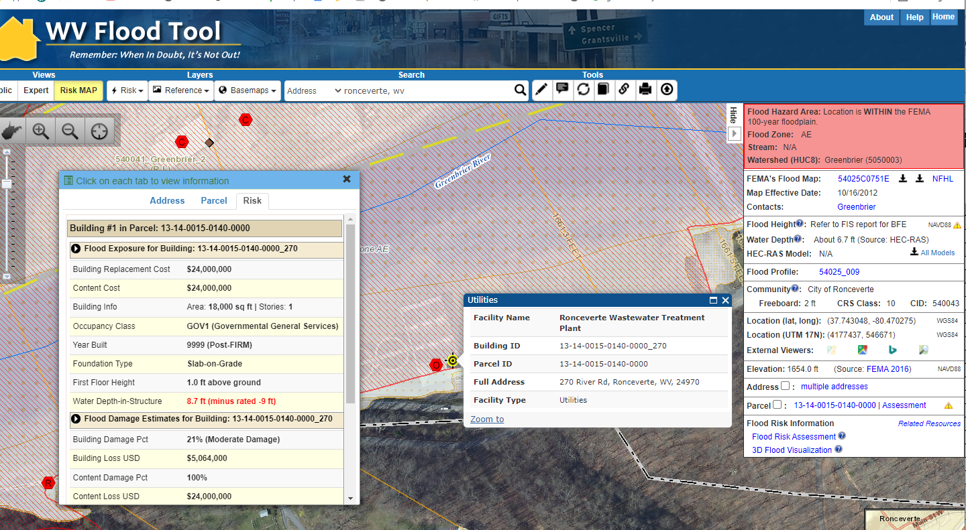

WV Flood Tool link: <http://mapwv.gov/flood/map/?wkid=102100&x=-8957910&y=4543190&l=11&v=2>

## Substantial Damage Estimates

Damage of any origin sustained by a structure whereby the cost of restoring the structure to its before damaged condition would *equal or exceed 50 percent* of the market value of the structure before the damage occurred.   
  
Substantial Damage Estimates: Unincorporated communities estimated to have more than 75 building substantially damaged from a 1%-annual-chance flood are Fayette and Greenbrier counties. The incorporated town of Marlinton is estimated to have the 18 substantially damaged buildings, the highest number for a municipality in Region 4. The communities with the highest percentage of substantially damaged buildings are Camden-On-Gauley (19%), Greenbrier Unincorporated (9%), Fayette County (5%), and Marlinton (5%). The top two counties with buildings where the building damage is >= 50% and damage loss estimates > $10,000 are Greenbrier County (1,152 buildings) and Fayette County (718) buildings.

## Building Debris Removal Estimates

Building debris removal estimates are computed at the building level for a 1%-annual-chance flood event using FEMA’s Hazus flood model methodology. The model calculate only debris from the structure and not other types of debris (e.g., woody debris, sediment, content of buildings, etc.).

The community-level report shows total tonnage of building debris that will be generated from a riverine 1%-annual-chance flood event for **Region 4** is 19,746 tons. Debris tonnage can be converted to estimate truckloads by dividing the total debris by 25 tons/truck, or 790 truckloads. Building debris estimates are dependent on flood-depth damage estimates and building area. Structures with higher substantially damage estimates will correlate to higher debris. Total county debris removal estimates are as follows: **Greenbrier County** (5,921 tons), **Pocahontas County** (5,068 tons), **Fayette County** (4,540 tons), **Nicholas County** (2,556 tons), and **Webster County** (1,661 tons). The Building Level Risk Assessment (BLRA) geodatabase contains all debris categories (finished, structural, foundation) and total debris. The debris models only estimate building debris and do not estimate woody (logs or trees) materials, sediment deposits, or damaged building contents.

*Debris disposal can be a significant issue following floods. The Hazus Flood Model estimates debris from building damage during floods, including building finishes, and structural components. The physical damage estimates are not made for building contents, or for bridges or other lifelines. Debris removal estimates should be incorporated into debris removal plans.*

Debris Removal Methodology. FEMA’s Hazus Flood Model debris estimation methodology determines the expected amounts of debris generated at various depths of water and reported at the building level. Output from this module is the debris weight (in tons). The classes of debris are defined as follows: (1) building finishes (carpeting, dry wall, insulation, etc.), (2) structural components (wood, brick, etc.) and (3) foundation materials (concrete slab, concrete block, rebar, etc.). This distinction is made because of the different types of material handling equipment required to handle the debris. For more information about the Hazus Flood Model debris estimation methodology, refer to the Hazus-MH Technical Manual.

## Population Displacement and Short-Term Shelter Estimates

Population displacement at the building level and short-term shelter requirements at the community level are computed for a 1%-annual-chance flood event using FEMA’s Hazus flood model methodology.

A Short-Term Shelter is in an existing facility (or facilities), such as a school, community center, convention center, or church temporarily converted to provide safe, accessible, and secure short-term housing for disaster survivors. It provides safe and accessible locations with a wide range of services for the survivors for up to two weeks. Most American Red Cross shelters cannot accept pets because of health and safety concerns and other considerations, so displaced people may need to find alternative sheltering arrangements.

Shelter Model Methodology. The number of displaced people in the 1%-annual-chance (100-year) floodplain was calculated for all residential occupancy units for a flood inundation depth equal or greater than one foot depth. Population displacement per structure is calculated from multiplying residential units by the average household size determined from 2019 Census data. At the community level, short-term shelter needs are computed according to FEMA's Flood Model Hazus-MH Technical Manual that incorporates population displacement and weighted socio-economic categories of *income* (80% weight) and *age* (20% weight). The primary factor *income* consists of five income classes adjusted to inflation (< $20K, $20-$30K, $30-$50K, $50-$60K, > $60K) and secondary factor *age* of three age classes (< 15 years, 15-64 years, > 65 years). The shelter model equation determines the number of displaced people requiring established shelters. Although only family income and age were factors for the population displacement/shelter need model, other factors such as ethnicity, housing ownership, and geography should be considered.

* Family Income: (HH Income < $20K; $20K-$30K; $30K-$50K; $50K-$60K; HH Income > $60K)
* Age: (Age < 15, 15 < Age < 65, Age > 65)
* *Ethnicity*: (White, African American, Hispanic, Asian/Other)
* *Housing Ownership*: Owned-occupied homes are inclined to be more flood-proofed or resilient to flooding.
* *Urban versus Rural Geography*: Homeowners in rural areas are more inclined to be more self-reliant, or have nearby relatives to temporarily reside, and thus less dependent on shelters.

Shelter Model Estimate Compared to June 2016 Flood Sheltering Data. For **Greenbrier County**, Red Cross sheltering data from the 2016 flood was compared to the shelter model estimates. According to the Red Cross shelter data, a total of 114 people stayed at six designated Red Cross shelters during the flood event. However, many displaced residents also stayed at unregistered shelters, including the 300 people at the Greenbrier Resort and 129 people at the Baptist Church gymnasium in Rainelle. If the registered persons of the Red Cross Shelters requiring shelter are summed together at 543 people, then this estimate is close to the shelter need model estimate of 603 people for Greenbrier County.

Companion Pets. Companion Dogs Shelter Need is calculated from 38.4% of households displaced, and Companion Cats Shelter Need from 25.4% of households displaced. Pet displacement percentages are from the 2017-2018 U.S. Pet Ownership & Demographics Sourcebook.

Regional Summaries: For **Region 4**, total population estimate is 115,679 people, estimated population in 1%-annual-chance floodplain is 15,147 people, total population displacement from a 1%-annual-chance flood event is 5,655 people, and 1,234 of the displaced persons requiring short-term shelter. Companion dog and cat shelter requirements are 213 and 145, respectively. Community breakdowns are below.

Population Residing in High-Risk Flood Zones: A high percentage of the population reside in the 1%-annual-chance floodplain for **Marlinton** (65%), **Rainelle** (43%), Pax (42%), **White Sulphur Springs** (39%), **Alderson** (31%), **Richwood** (29%), and **Webster County Unincorporated** (28%). The counties of **Webster** (26%) and **Pocahontas** (23%) have the highest percentages of population residing in the flood zone. Population estimates are calculated at the building level by multiplying the Hazus defined residential occupancy class units (source tax assessment database) by average household size (source Census).

Displaced Population for Flood Depth >= 1 Foot: Counties with the largest amount of people displaced are **Greenbrier County** (n=2870) and **Pocahontas County** (n-1200). Significant communities with the highest displacement from a flood inundation of more than 1 foot are **Marlinton** (85%), **Rainelle** (85%), **Alderson** (76%), **Camden-on-Gauley** (69%), **Pocahontas County** (62%), **Greenbrier County** (61%), **Greenbrier Unincorporated** (60%), **Richwood** (60%), **Ronceverte** (59%), **Rupert** (58%), **Montgomery** (50%), **Pocahontas Unincorporated** (48%), **White Sulphur Springs** (47%), and **Webster Unincorporated** (37%).

Estimated Population in Need of Short-Term Shelter: Counties requiring the largest amount of short-term shelter for a 1%-annual-chance flood event are **Greenbrier County** (n=630) and **Pocahontas County** (n-273). Significant communities with the highest need for short term shelters are **Marlinton** (21%), **Rainelle** (21%), **Camden-on-Gauley** (18%), **Richwood** (14%), **Pocahontas County** (14%), **Montgomery** (14%), **Greenbrier County** (13%), **Greenbrier Unincorporated** (12%), **Alderson** (11%).

*Communities should incorporate estimated population displacements and sheltering needs into local hazard mitigation plans*.

## Transportation Inundation Models

Transportation inundation models for roads, railroads, and bridges are computed for a 1%-annual-chance flood event. Road and railroad inundation models exists for **Greenbrier** and **Fayette counties** where countywide model-backed flood depth information exists. Bridge inundations can be determined where the bridge deck elevation is known and compared to the base flood depth.

Road Miles Inundated: Communities with high percentages of roads inundated at 1 foot or greater flood depth are **Alderson** (42% inundated), **Rainelle** (36%), **Camden-On-Gauley** (35%), **White Sulphur Springs** (23%), **Richwood** (22%), **Pax** (21%), **Marlinton** (16%), **Meadow Bridge** (12%), **Rupert** (11%), and **Montgomery** (10%). Most of the inundated roads are above 3-foot flood depth for the towns of **Montgomery**, **Alderson**, **Camden-On-Gauley**, and **Ronceverte**. *A foot of water will float many vehicles and make roads impassable. About three feet is near the limit to use high profile vehicles to perform high water rescues and instead boats and helicopters are required to perform rescues.*

Railroad Miles Inundated: Railroad miles inundated at 1 foot or greater flood depth are 19.2 inundated miles for **Fayette County** and 18.3 miles for **Greenbrier County**. In **Fayette** and **Greenbrier counties**, 66% and 46%, respectively, of the inundated railroad miles are above 3-foot flood depth.

*Use the Risk MAP View of the WV Flood Tool to view roads and railroads inundated by a 1%-annual-chance flood event. Communities should compare historical flooding events to the flood estimation models for active railroads and major highways (interstates, federal, state). To determine if bridges will be inundated by a 1%-annual-chance flood, the bridge deck elevation should be higher than the base flood depth.*

## Minus-Rated Structures of Post-FIRM Construction

For insurance rating purposes, a post-FIRM building is one that was constructed or substantially improved after December 31, 1974, or after the effective date of the initial Flood Insurance Rate Map (FIRM) of a community, whichever is later. A post-FIRM building is required to meet the National Flood Insurance Program’s minimum Regular Program flood protection standards. For building level risk assessments, the Post-FIRM building is computed from the Building Year of the assessment records. If there is no Building Year listed in the property records, then the FIRM category status is unknown. The Pre-FIRM or Post-FIRM category is displayed in the Flood Risk Assessment Tab of the WV Flood Tool.

Minus-rated properties are those that have the lowest floor one foot or more below the base flood elevation. Some minus-rated policies may not be eligible for CRS premium discounts. Mitigation actions for minus rated structures include retrofitting with proper flood openings, eliminating below-grade crawl spaces, elevating HVAC systems, and other measures. Post-FIRM structures shouldn’t be minus rated if built to code at the time. The Water Depth-in-Structure estimates displayed on the Risk MAP View of the WV Flood Tool are calculated from the best available elevations for the base flood and lowest floor. An Elevation Certificate provides a way for a community to document compliance with the community's floodplain management ordinance by determining if the lowest floor of a structure is above the base flood elevation.

In **Region 4**, 142 building are Minus -3 or greater rating (2% of the buildings inventoried in the 1%-annual-chance floodplain). Determine if Post-FIRM minus-rated structures are mitigated. Focus initially on structures with the highest minus ratings (or highest water-in-depth values) and high dollar loss estimates.

The communities with the largest number of buildings that exceed Minus 10 ratings or in which the lowest floor is 10 feet or more below the BFE are Fayette Unincorporated (19 buildings) and Marlinton (10 buildings). The building level risk assessment for these specific structures should be checked to ensure there are no mapping irregularities with the flood depth and that the first-floor height is correctly computed for the estimated flood inundation depth in the structure (Depth-in-Structure). *First floors are completely inundated at nine feet.*

The communities with the highest number of Post-FIRM structures that exceed a Minus 2 rating (lowest floor is 2 feet or more below the BFE) are Greenbrier Unincorporated (111 buildings), Pocahontas Unincorporated (52 buildings), Fayette Unincorporated (22), and Marlinton (20). First-floor height audits of these structures should be performed to determine if the lowest floor living space is above the base flood elevation.

Flood Loss Model Limitations

Undervalued Building Values. The building damage loss estimates will be lower if the market value of the building stock is undervalued. The tax assessment database is the replacement value for most of the building level risk assessments. Other building value sources are used for tax exempt structures or mobile homes assessed as personal property.

Flood Damage Overestimates: To avoid flood damage overestimates, communities should verify that the designated Foundation and First Floor Heights of highly damaged building estimates are correct. The basement information from the tax assessment database does not distinguish between a subgrade basement or a walkout basement enclosure, for example. Elevation certificates and buildings pictures are useful in determine the correct [foundation type](https://data.wvgis.wvu.edu/pub/RA/_resources/FRA/Basement-Foundation_Types-FFH_Reference.xlsx) and first-floor height for structures, resulting in more accurate depth-damage building loss estimates.

Flood Damage Outside SFHA: The flood loss models also do not calculate damage estimates for buildings outside the effective or advisory 1%-annual-chance floodplains. FEMA’s publication “Understanding Flood Dangers in Central West Virginia: Lessons Learned from the June 2016 Flood” reported that extensive property damage occurred outside the Special Flood Hazard Areas. Besides overbank flooding on major rivers and streams, flash flooding on small streams, runoff rushing down mountainsides, and urban stormwater flooding can all contribute to significant damage outside designated Special Flood Hazard Areas. The report concluded of the nearly 1,000 flood insurance claims in the declared counties, 77% were in the 1% annual-chance floodplain and approximately 23% of the insurance claims were outside. On average, in floods across the country, about 25% of claims are outside the Special Flood Hazard Area, so this is consistent with the national trend.

Model-Backed Flood Depths: The best-available HEC-RAS model-backed depth grids at a preferred grid resolution of 1-meter cell are employed for the building-level risk assessments. Unfortunately, model-backed depth grids do not exist for Approximate A Zones for 18 counties in West Virginia and are missing for smaller tributary streams in other counties. Where no model backed depth grids exist, a Hazus depth grid is substituted if depth values are available for that stream location.

* No Model-Backed Base Flood *Depth Grids* or [Advisory Flood Heights](http://www.mapwv.gov/flood/content/documents/AFHhandout.pdf)exist for Approximate A Zones for Nicholas, Pocahontas, and Webster counties. See [status graphic](https://data.wvgis.wvu.edu/pub/RA/_resources/status/Advisoy_A_and_AFH_Status.pdf).
* A less accurate *Hazus*depth grid is utilized for Building Damage Loss Estimates until model-backed depth grids for Approximate A Zones become available.

# MITIGATION

*What has been mitigated?*

Mitigated Structures

A comprehensive inventory of mitigated structures results in more accurate building level risk assessments and shows how communities have applied flood adaptive measures in response to major flood events. Sources for verifying first floor heights of elevated structures are elevation certificates, building pictures (step 7” rise, cinder block 8”), and major post-disaster mitigation reconstruction projects (1977 and 2016 floods) described below.

June 2016 Flood of Central West Virginia: The devastating floods from the June 2016 flood have resulted in the largest regional mitigation project since the historic April 1977 flood in the Tug Fork River Basin. From the June 2016 flood thousands of buildings were destroyed or damaged, at least 23 people were killed, and communities throughout West Virginia were inundated with floodwaters. A State of

Emergency was declared in 44 of West Virginia’s 55 counties, and 12 of these counties received a Presidential Disaster Declaration. The National Oceanic and Atmospheric Administration (NOAA) estimated that overall damages from the storm system amounted to over $1 billion ([FEMA 2016 Flood Report](https://www.fema.gov/sites/default/files/documents/Region_III_WV_FloodReport.pdf)). A [news article](https://www.theintelligencer.net/news/top-headlines/2021/12/rise-wv-program-is-investigated/) dated December 7, 2021, in *The Intelligencer / Wheeling News-Register* newspaper, reported that as of November 2021, the WV RISE program had completed 350 housing projects and 42 bridges. According to RISE, 90% of its housing projects were complete, with 78% of bridge projects completed. Combined with the 47 demolition projects, $82.4 million has been spent for mitigation measure associated with the June 2016 flood.

April 1977 Flood of Tug Fork Basin: The Tug Fork Basin was devastated in April 1977 by the flood record of the basin, causing an estimated $698.7 million (October 1996 Price Level) in damages. Comparing the WV RISE mitigation program to the 1977 flood reconstruction program, the USACE Section 202 Non-Structural Project resulted in an estimated 397 housing projects 257 buyout property acquisitions completed for Mingo and Wayne counties. A significant number of property acquisitions occurred in McDowell County as well. The mitigation projects including the close-out reports and operation manuals were and were completed by 2008.

Buyout Properties

Buyout land parcels located within floodplains that experience frequent flooding and damage due to flood events, may be altered, purchased, or have deed restrictions placed upon them by FEMA or other agencies to prevent loss of life and property damage. Property owners/communities with public lands in floodplains are compensated for their land, and the land usually becomes public green space or restored to its natural floodplain function. Mitigated buyout properties are displayed in the EXPERT and RISK MAP Views of the WV Flood Tool.

**Fayette County** has the most verified buyout properties in **Region 4** at 184 (ranked 3rd in the State) and 54 non-verified properties. **Greenbrier County** has 85 (ranked 5th the State) verified properties and 10 non-verified properties. **Mount Hope** in Fayette County has the most buyout properties (75 verified and 23 non-verified) of any incorporated municipality in the State.

*Confirm buyout properties are allowable for open space purposes only. Every three years communities are required to inspect and certify that buyout properties are uses only for allowable open space purposes. Source: https://www.fema.gov/sites/default/files/2020-07/fy15_hma_addendum.pdf*

*Verify all deed-restricted buyout properties are shown on the WV Flood Tool. Unverified properties (possible buyout properties) are compiled from the statewide property tax database where the parcel intersects the high-risk 1% floodplain, maximum building value is $1000, and part of the owner name contains “commission” or “council” or “city” or “town.”*

Repetitive Loss Structures

Repetitive Loss (RL) properties are a mitigation priority for West Virginia and FEMA. The primary objective of the RL properties strategy is to eliminate or reduce the damage to property and the disruption to life caused by repeated flooding of the same properties. Repetitive loss data is important for NFIP Coordination, Building-Level Loss Estimate Model Verification, Hazard Mitigation Planning / Implementation, and Community Rating System (CRS). Repetitive loss data of private structures at the site-address level are subject to the Privacy Act of 1974.

Address Matching (Geocodlng) of RL Structures: Of the 3,132 RL structures in the State, after clean-up and editing, only 73% have addresses that can be geocoded (address matched to x,y coordinates) by a house number or street. 54% (1,679) of the total RL structures were site address matched and 20% (613) were street matched. Although the statewide address match is only 54% for site addresses, RL information combined with other risk data layers (Substantial Damage Model Estimates, Mitigated Properties, Flood Depths, High-Water Marks) are beneficial in identifying Areas of Mitigation Interest (AoMI).

## Open Space Preservation

Natural floodplains provide flood risk reduction benefits by slowing runoff and storing flood water. They also provide other benefits of considerable economic, social, and environmental value that are often overlooked when local land-use decisions are made. Open Space Preservation restores the floodplain to its natural function and provides opportunities for credits from FEMA’s Community Rating System (CRS). Open Space Preservation mapping layers include Deed Restricted Buyout Properties, Private Lands (Nature Preserves, Land Trust) and Public Lands (state and local lands). These layers are viewable on the RiskMAP View of the WV Flood Tool.

The National Flood Insurance Program's (NFIP) Community Rating System (CRS) is a voluntary incentive program that recognizes and encourages community floodplain management activities that exceed the minimum NFIP requirements. The community’s CRS class is displayed in the Flood Query Results Panel of the WV Flood Tool. State-based CRS credits are provided by the WV Flood Tool to support CRS activities for its communities.

It is estimated that more than 100 CRS open space credits can be earned for each of the categories Open Space Preservation (CRS 420 activity) and Acquisition and Relocation of Buildings (CRS 520 Activity). Refer to the [Mount Hope Case Study](https://data.wvgis.wvu.edu/pub/RA/State/CL/Mitigation/OSP/Reports/Fayette%20County%20(Mount%20Hope)/) on how CRS credits can be calculated for these activities. All CRS credits must be verified by a CRS/ISO Specialist.

CRS Class 9 communities **Fayette Unincorporated** and **Greenbrier Unincorporated** are eligible for these credits. The towns of **Mount Hope**, **Rupert**, **Marlinton**, **Ronceverte**, and **Webster Springs** would also be eligible if these communities were to participate in the CRS program.

Resources: CL Table | FL Table | Graphic | CRS Calculations

## Areas of Mitigation Interest (AoMI)

Areas of Mitigation (AoMI) are identified by Repetitive Loss structures, Substantial Damage Model Estimates, Mitigated Properties, Flood Depths, High-Water Marks, and Similar Topography. Graphics of reference data for AoMI determinations:

* [Areas of Mitigation Interest (AoMI)](https://data.wvgis.wvu.edu/pub/RA/State/CL/Graphic/AoMI.pdf)
* [Repetitive Loss Structures](https://data.wvgis.wvu.edu/pub/RA/State/BL/Graphic/RL_structures.pdf)
* [Buyout Properties](https://data.wvgis.wvu.edu/pub/RA/State/CL/Graphic/Buyouts.pdf)
* [High Flood Depths or Water Depths-in-Structure](https://data.wvgis.wvu.edu/pub/RA/State/BL/Graphic/REG4_post-FIRM_water_depth_20211014.pdf)
* [High-Water Marks](https://data.wvgis.wvu.edu/pub/RA/State/BL/Graphic/HWM_20201221.pdf)
* [Building Damage $ Non-Residential](https://data.wvgis.wvu.edu/pub/RA/State/BL/Graphic/BL_Top_Damage_Loss_Estimate.pdf) |[Building Damage $ Residential](https://data.wvgis.wvu.edu/pub/RA/State/BL/Graphic/BL_Top_RES1_Damage_Loss_Estimate.pdf)
* [Substantial Damage Estimates](https://data.wvgis.wvu.edu/pub/RA/State/BL/Graphic/BL_Damage_estimate_greater_50percent.pdf)

Areas of Mitigation Interest (AoMI) identified with the criteria above are displayed on the WV Flood Tool’s RiskMAP View. Reports can also be generated with the building within the AoMIs. *For local hazard mitigation plan updates, communities should review and prioritize AoMIs for potential mitigation actions.*

# OTHER HAZARDS

Dams  
**Description:** **Dams** play a vital role in the nation’s overall infrastructure and contribute to the economic development and to the social welfare of the public. Dam infrastructure can be affected by natural hazards, man-made threats, as well as an imbalance between resources invested and a dam’s age. The **National Inventory of Dams** (NID) includes dams more than 25 feet in height or storing more than 50 acre-feet or classified as High Hazard or Significant Hazard potential. About 60% of the [632 dams](https://data.wvgis.wvu.edu/pub/RA/_resources/Dam/WV_Dams_20191205.pdf) listed in the National Inventory of Dams 2020 database for West Virginia are regulated by the State.

**High Hazard Potential:** Dams are assigned the **high hazard potential classification** if failure or mis-operation will probably cause loss of human life. Of the 295 high hazard dams (47%) in West Virginia, 11 dams are maintained by the USACE and 153 dams are supported by the NRCS.

**Region 4 Dams:** Region 4 has 36 dams of which 17 are classified as high hazard potential. **Fayette County** has the highest number of high hazard dams at 6. Constructed in 1965, the **Summersville Dam** is located on the Gauley River in Nicholas County near the town of Summersville. The height of the dam is 390 feet tall and the maximum storage 413,400 acre-feet.

*Review the* ***Emergency Action Plans (EAP)*** *and* ***dam failure inundation maps*** *of all* ***high hazard dams*** *and identify the farthest downstream community impacted. Coordinate with the dam owner and dam safety regulators about dam maintenance, mitigation strategies, flood warning and response, and potential downstream effects of overtopping or failure. Review Community Rating System (CRS) credits for activities Flood Warning and Response (CRS 600) and Dams (CRS 630).*

*Verify* [*inundation zones*](https://data.wvgis.wvu.edu/pub/RA/_resources/Dam/Dam_Inundation_Zones.pdf) *with the built environment using the dam inundation viewer. Not all inundation zones are accessible.*

Landslides  
The West Virginia Emergency Management Division (WVEMD), Department of Homeland Security (DHS), and Federal Emergency Management Agency (FEMA) have facilitated landslide susceptibility studies and community-based risk assessments in support of local and state hazard mitigation plans. Landslide susceptibility was modeled using a random forest machine learning method. The model used LiDAR identified landslide locations, topography, soil type, and proximity to roads and streams among many input variables to produce landslide susceptibility grids. Overall, **9,180 landslide points** were identified using LiDAR in **Region 4**. Risk assessment was performed at the sub-county scale and includes results on roads and structures/parcels. This report summarizes risk assessment results by West Virginia planning and development council regions. Results for Region 4 can be integrated into hazard mitigation plans to enhance resilience and protect communities from landslide hazards. This landslide risk report provides non-regulatory landslide risk information to help local officials, planners, emergency managers, and others better understand their landslide risk, take steps to mitigate those risks, and communicate those risks to citizens and local businesses.

The [Region 4 Landslide Risk Report](https://data.wvgis.wvu.edu/pub/RA/State/CL/Landslide/Reports/Landslide_Risk_Assessment_Report_Region_4.pdf) provides non-regulatory landslide risk information to help local officials, planners, emergency managers, and others better understand their landslide risk, take steps to mitigate those risks, and communicate those risks to citizens and local businesses.

**Road risk analysis:** In Region 4, **Fayette County** has approximately 96 miles of road that is susceptible to high/medium probability of landslides. **Greenbrier County** has almost 110 miles, **Nicholas County** has 46 miles, **Pocahontas County** has about 119 miles, and **Webster County** has nearly 105 miles of road prone to high/medium risk for slope failure. Several Region 4 counties rank in the Top 20 for highest number of road miles at risk from landslides in the state. Of all 55 counties, **Fayette County** ranks 19th, **Greenbrier** 12th, **Nicholas** 39th, *Pocahontas* 11th, and **Webster** 15th.

**Structure/Parcel analysis**: **Fayette County** has a total of 305 primary structures with a total appraisal value of $17,653,817 that are in high/medium susceptibility areas. **Greenbrier County** has 281 primary structures with a total appraisal value of $61,943,791 in high/medium susceptibility areas. **Nicholas County** has 282 primary structures with a total appraisal value of $5,033,059 in high/medium susceptibility areas. **Pocahontas County** has 219 primary structures with a total appraisal value of $18,129,847 in high/medium susceptibility areas. Webster County has 214 primary structures with a total appraisal value of $1,795,466 in high/medium susceptibility areas. **Fayette County** ranks 32nd, **Greenbrier** 35th, **Nicholas** 34th, **Pocahontas** 42nd, and **Webster** 43rd for total number of at-risk structures in WV counties. For the value of total assets at high or medium risk of landslides, **Fayette County** ranks 23rd, **Greenbrier** 6th, **Nicholas** 46th, **Pocahontas** 21st, and **Webster** 51st. **Fayette**, **Greenbrier**, and **Pocahontas** counties have higher rankings for total asset value at risk than for the total number of structures at risk. This may be due to higher property values in these counties.

Landslide Risk Information:

*Community Engagement and Verification: Review Landslide points identified using LiDAR data in the WV Landslide Tool. Add any missing major landslide points in the web application. A photo of the landslide incident can also be uploaded to the Landslide Tool. Review the susceptibility grid in WV Landslide or WV Flood Tool. Report any major discrepancies in high/medium landslide susceptible zones.*

# COMMUNITY ENGAGEMENT AND DATA VERIFICATION

*Verify risk assessment information and determine what mitigated actions can be identified*

## **Building-Level Risk Flood Risk Assessment Data Verification**

Use Building-Level (BL) Tables to identify Most Vulnerable Structures:

* [Statewide BLRA](https://data.wvgis.wvu.edu/pub/RA/State/BL/BLRA/WV/) (GIS)
* [BLRA County](https://data.wvgis.wvu.edu/pub/RA/State/BL/BLRA/) Tables organized by region
* [BLRA Data Extract Tables](https://data.wvgis.wvu.edu/pub/RA/State/BL/Extract/):  High Building Value, High Damage Loss, High Minus Ratings
* [BLRA Statewide Top Lists](https://data.wvgis.wvu.edu/pub/RA/State/BL/Top-List/Top100/):  Building Value, Flood Depth, Damage Loss $, Damage Loss %, Minus Rated, Mitigated Structures

## **Flood Risk Factor Matrices**

Refer to the State [Flood Risk Factor Matrices](https://data.wvgis.wvu.edu/pub/RA/State/CL/Risk_Matrices/) EXPSOSURE and DAMAGE LOSS to develop community risk profiles in the county, region, and state. Risk matrix data from FEMA’s Community Engagement Prioritization Tool [(CEP-T)](https://data.wvgis.wvu.edu/pub/RA/State/CL/FEMA-R3/CEP-T_Flood/) is also included. Measurements of central tendency (e.g., median, mean) and higher risk thresholds are computed for select risk factors.

## Flood Risk Community Risk Dashboards

Refer to the community risk dashboards developed by [FEMA](https://data.wvgis.wvu.edu/pub/RA/_resources/Dashboard/) and the [State Risk Assessment Project](https://data.wvgis.wvu.edu/pub/RA/State/CL/Risk_Dashboards/) for flood risk planning and reduction. Use the [Community-Level (CL) risk assessment tables](https://data.wvgis.wvu.edu/pub/RA/State/CL/Risk_Dashboards/) and resources to supplement Flood Risk Dashboards of jurisdictions.

Top 20 Community Risk Rankings  
[Community risk rankings](https://data.wvgis.wvu.edu/pub/RA/State/CL/Risk_Rankings/) were computed for key flood risk factors. Flood vulnerability rankings are by **communities**, **unincorporated areas**, and **incorporated places**.

