WEst Virginia Flood REsiliency Framework Survey Methods and Results | Olson Harris Ltd.
Availability of Survey Data - All de-identified data from the WFRF Statewide Survey is available by request for community stakeholders to use to support community-based projects.
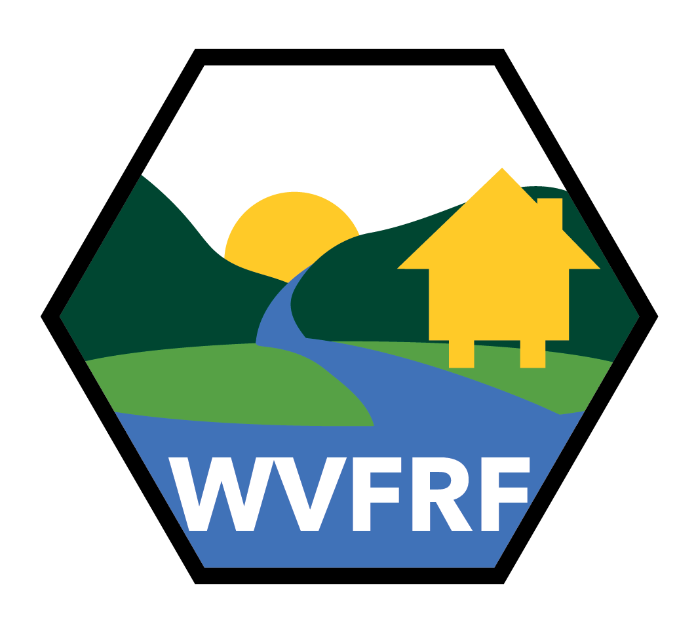

October 2024
Created as part of the West Virginia Flood Resiliency Framework

TABLE OF

CONTENTS
Table of Contents
INTRODUCTION & BACKGROUND 3
OBJECTIVES & RESEARCH QUESTIONS 4
METHODS 4
KEY FINDINGS 6
REFERENCES……………………………………………………………………………………………………22

1. Introduction & background
West Virginia has one of the highest flood risks in the nation due to the state’s mountainous topography, frequent heavy rainfall, and extensive network of rivers and streams (NOAA, 2016). Every county in the state has been declared a federal flood disaster area at least once since 1967, with some counties having had more than 10 such declarations. The state has experienced many severe flooding events, including a 2016 storm disaster that dropped up to 10 inches of rain within a few hours (NOAA, 2016); flash flooding ensued, and a state of emergency was declared in 44 of the state’s 55 counties.
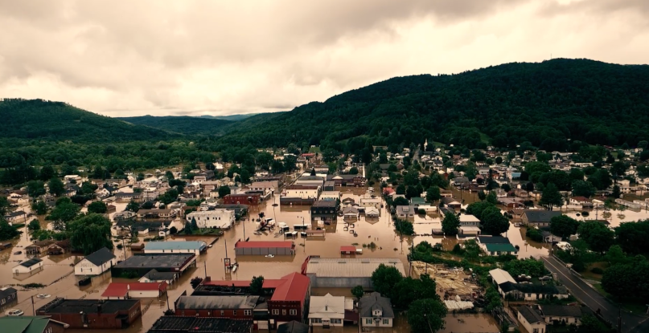
Rainelle, WV in Greenbrier County during the 2016 floods

The 2016 flood is considered one of the worst natural disasters in the state's history, causing 23 deaths, around $1.3 Billion in damages including more than 1500 destroyed homes, 4000 damaged homes, and extensive damage to roads, bridges, and public infrastructure (NCEI, 2024; NOAA, 2016).This statewide survey was conducted by a multidisciplinary team as part of National Science Foundation Award Number 2321985: CIVIC-FA Track B: Creating the West Virginia Flood Resilience Framework (WVFRF) for comprehensive disaster response and long-term community recovery. The goal of the survey was to assess how WV residents have recovered from past floods, how prepared they are for future floods, and to develop a comprehensive understanding of West Virginia residents’ experiences with floods and flood risk, an internet survey was conducted by the WVFRF team.

  - 2. Objectives & Research questions
The aim of the WVFRF survey: To assess West Virginians' recovery from floods, preparedness for future floods, and identify gaps in resiliency and risk awareness.
Research Questions:
- RQ1: How fully have West Virginians recovered from past floods, and how resilient are they against future flooding?
- RQ2: What flood risk knowledge is needed to promote comprehensive pre-disaster resilience in WV?
- RQ3: What are the best practices to build cross-organizational coordination and community resilience, from local to national levels, to promote comprehensive pre-disaster resilience in WV?
- RQ4: Can previously identified gaps in community-level capacity be improved through the creation and delivery of accessible training to build resilience?

3.methods
Key Highlights
Survey Methodology: A 71-question online survey was developed by the WVFRF team targeting current and former WV residents over 18 years old.
Distribution & Participation: The survey was distributed through emergency response and preparedness networks, email, Facebook, and Instagram. 1,228 valid responses were collected, with many responses from flood-prone counties

Surveys, or questionnaires, are used to capture a breadth of individual perspectives, understandings, and experiences of a particular, context-specific phenomenon. As a cost-effective method, online surveys are capable of reaching more individuals than paper mechanisms and are able to maintain respondents’ anonymity (McGuirk & O'Neill, 2021; Kaplowitz et al., 2012).
To understand the experiences of West Virginia residents around flooding, this study used purposive (Patton, 2014) and snowball sampling (Adler & Clark, 2011) to establish descriptive themes, patterns, trends, and understandings of flood experiences in West Virginia (McGuirk & O'Neill, 2021). Out of the 71 questions, types of questions included attribute (demographic), multiple choice, Likert scale, open response, closed response, dropdown, checkbox, matrix, and hypothetical. In addition, the survey adapted questions from similar flood related studies in the United States to measure social capital (Bukvic & Barnett, 2023). WVFRF team members from state agencies, non-governmental organizations, residents, disaster case managers, researchers, and other major stakeholders generated survey questions through an iterative process. The 15–30-minute survey–disseminated through Qualtrics–assessed experiences with floods, damages incurred, assistance received, satisfaction with response and recovery, ongoing needs, awareness of flood risk, and preparations for future floods. Before distribution, the survey was pre-tested by multiple individuals outside of the project team to assess readability, appropriateness, clarity, and whether the survey met research goals.
From February 2024 to May 2024, the state-wide survey was distributed via emergency management and flooding-related listservs, WVFRF team networks, newspaper, Facebook, and Instagram advertisements, in-person flyers, and through word-of-mouth. The survey received 1,228 valid responses across the state after the identification and removal of responses submitted by automated bots (for which the research team established parameters to characterize suspected automated bot submissions and removed them prior to analysis). Valid respondents were 18 years of age or older and current or former residents of West Virginia. There was a concentration of responses in Greenbrier County, Kanawha County, and Ohio County, all of which experience higher flood risk than national averages.
To incentivize participation, respondents had the opportunity to enter a raffle for one of eight $250 gift cards. Research approval was granted from participating institutions and informed consent was obtained from each participant before the start of the survey, and respondents were made aware of how their information would be securely stored, confidentiality, and the potential for the survey to cause emotional discomfort. All questions were optional, and respondents could stop at any time.
Survey results were analyzed using MaxQDA, R, a large language model, and Microsoft Excel software.

4. key findings
Key Highlights

Demographics: The average respondent age was 59; 64% were full-time employed; 44% held a bachelor’s degree or higher.
- Flood Impacts: 82% of respondents experienced community flooding; the most frequent years were 2016, 2022, and 2024.
- Preparedness & Perceptions:
  - 59% have experienced a flood at their primary residence.
  - Before the flood that impacted their residence, 32% knew their residence was in a floodplain, while 25% knew their residence was not in a floodplain (with 42% unsure).
  - The main barriers to flood preparation include financial and health issues.
- Resiliency & Relocation:
  - 47% report a willingness to relocate if flood risk increases; financial help being a major factor.
  - Strong emotional and community ties preclude relocation for some.
Open-Ended Responses: Open-ended questions inquired about what factors would improve household and community flood preparation, barriers to household flood preparation, factors around relocation due to flooding, and what could be included in a handbook or website to support community flood resiliency. Response themes include financial constraints, the need for better flood warnings, and overall community resiliency.

Demographics
The average birth year of respondents was 1965, indicating an average age of 59. Out of all respondents, 59.14% identified as female, 39.05% identified as male, 0.84% checked other, not listed here, and 0.98% preferred not to say. The number of adults in the household (i.e. household size, including the respondent) was 1 (14.73%), 2 (45.16%), 3 (22.30%), 4 (15.85%), 5 (1.54%), and more than 5 (0.42%) and the number of children was 0 (57.10%) 1 (25.39%), 2 (11.76%), 3 (4.59%), 4 (0.86%), and more than 5 (0.29%). The respondents’ highest level of education were: middle school (0.28%), some high school (1.81%), high school (14.62%), associates degree (12.40%), bachelor's degree (31.48%), master’s degree (20.47%), PhD/MD/DO/JD or higher (9.47%), trade school/technical/vocational training (5.71%), other (3.06%), and preferred not to say (0.70%).

When asked about employment, 64.02% were employed full time, 10.18% were employed part time, 16.46% were retired, 5.30% were not currently employed, 3.21% received disability, and 0.84% preferred not to say. The annual household income of respondents was less than $19,999 (8.07%), $20,000 to $29,999 (7.79%), $30,000 to $49,000 (12.89%), $50,000 to $59,000 (8.50%), $60,000 to $69,000 (9.63%), $70,000 to $79,000 (13.31%), $80,000 to $89,000 (11.19%), $90,000 to $99,999 (11.19%), and $100,000 or more (17.42%). In respondents’ households, 25.10% experienced a disability, 71.69% did not, and 3.21% were unsure. Most respondents worked in Education/Higher Education (10.44%), Government (8.46%), and Healthcare/Public Health (7.48%) industries.

Community Flood Impacts
The next set of questions asked respondents about flooding impacts in their communities. The survey defined “community” to mean the place where they live. When asked if their community had been impacted by flooding in their lifetime, 82.41% reported yes, 12.06% reported no, and 5.53% were unsure. If respondents selected yes, the survey asked them to select all the years between 1950 and 2024 in which their community was impacted by a flood. The most commonly selected years were 2016, 2022, and 2024.

Respondents then were asked to rate their community’s level of recovery (fully recovered, partially recovered, or not recovered). Respondents rated their community as fully recovered (53.78%), partially recovered (39.33%), or not recovered (6.89%). When asked if any structures had ever been damaged by a flood, respondents selected public school (40%), private school (10%), fire department (20%), police department (13%), hospital (11%), medical clinic (14%), nursing home (14%), college/university (8%), business (56%), community center (27%), government building (16%), and place of worship (39%). Other structures that were mentioned specifically are land/properties, homes, roads/bridges, libraries, and parks.

Of public infrastructure that had been damaged by previous floods and not yet repaired, respondents selected bridges (31%), culverts (38%), roads (46%), water systems (24%), sewer systems (25%), and stormwater drainage systems (37%). When asked about private infrastructure that had been damaged by previous floods and not yet repaired, 37% of respondents selected bridges, culverts (39%), roads (41%), water systems (21%), and sewer systems (20%).

To gauge how respondents solved problems such as flooding in their community, most selected I am self-sufficient and take care of problems on my own (28%), followed by I engage with local government to solve problems in my community (27%), I rely on my neighbors and friends to help me solve problems in my community (28%), I rely on the internet and media to help me solve problems in my community (12%), and I do not try to solve the problems in my community (4%).

Individual/Household Impacts
The following questions asked respondents about their individual and household experiences with flooding. When asked if they personally experienced a flood while in WV, 66.61% reported yes and 33.39% reported no. If respondents selected yes, the survey asked them to select all the years between 1950 and 2024 in which they personally experienced a flood in WV. The most commonly selected years were 2016, 2022, 2023, and 2024.

When asked whether their primary residence had been impacted by flooding, 28% responded yes, their current primary residence, 31% noted yes, their previous primary residence, and 42% noted no, their primary residence had never been impacted by flooding. Of those that selected yes, 27% of respondents’ current primary residences were damaged and 7% were destroyed, 26% of respondents’ previous primary residences were damaged and 13% were destroyed. Also, 19% of respondents’ driveways were damaged or destroyed and 8% of private bridges were damaged or destroyed.

To evaluate risk perception, the survey asked respondents to rate their knowledge of their own flood risk prior to the flood that impacted their current and/or previous residence. In other words, how did respondents view their flood risk before they experienced a flood? 9.8% of respondents reported believing they were very at-risk of flooding, 53.27% somewhat at-risk of flooding, 30.39% not at-risk of flooding , and 6.54% did not know their risk.

Prior to the flooding event that impacted their residence, 32.25% knew that their residence was in a floodplain, 25.41% knew that their residence was not in a floodplain, and 42.35% did not know whether or not their residence was or was not in a floodplain.

Of those impacted by a flood, 43.48% received assistance for recovery and 56.52% did not. The most common types of assistance received included emergency shelter (provided by friends or family, water and/or food, and cleaning and/or other household supplies. To evaluate satisfaction with organizations involved with the disaster cycle, the survey asked respondents to rank their level of satisfaction on a scale of extremely dissatisfied to extremely satisfied

For current and/or previous residences that were flooded, 53.93% of respondents stayed in their home, 30% left temporarily for an average of 118 days, and 12.14% left permanently. For those that left, most went to stay with friends or family (62.28%), followed by to another home that they rented (16.67%), to another home that they bought (7.02%), hotel/motel (7.89%), shelter (2.63%), and other (5.51%). Income or potential income because of flooding while 62.62% reported they did not and 20.74% were unsure. While 44% selected they had no emotional/mental health impacts (either diagnosed by a medical professional or not) as a result of flooding, 19% had new or worsened anxiety, 11% had new or worsened depression, and 24% had new or worsened fear of large storms causing another flood, and 2% selected other. For those that have/had emotional or mental health impacts from flooding, some received support while others wanted support as seen in the following graph.

Flood Preparation
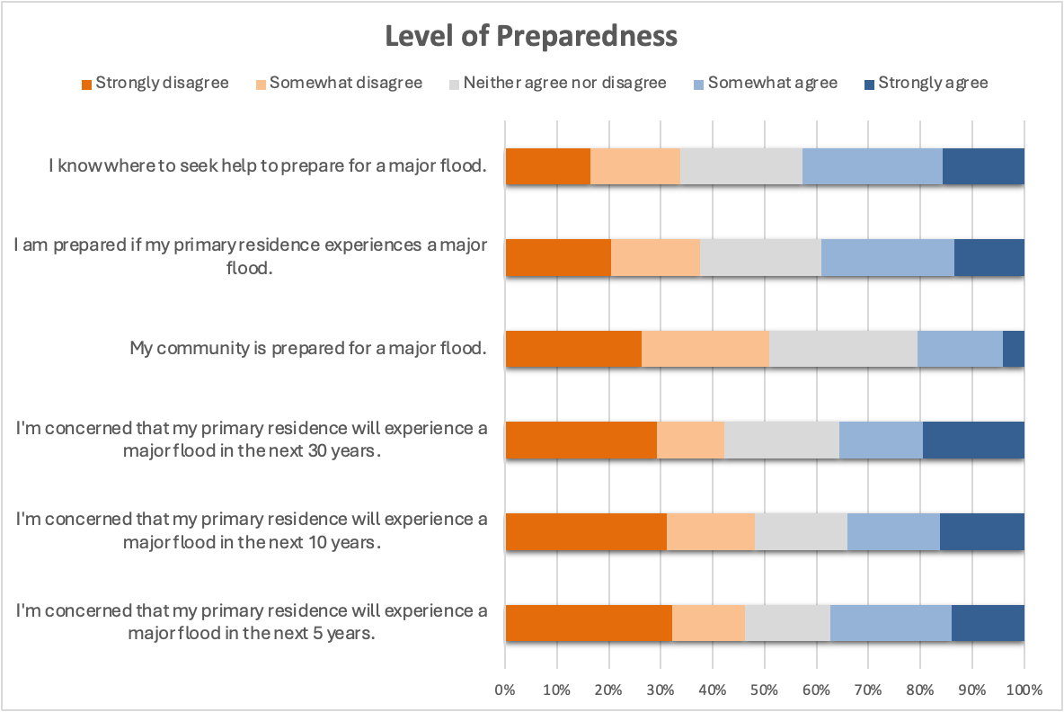
The next set of questions asked about information and activities related to preparing for future floods. When asked if their current primary residence was in a floodplain (floodplain defined as any land area which is at risk of experiencing flooding), 28.60% stated yes, 55.58% stated no, and 15.82% were unsure. The survey prompted respondents to rate their level of agreement (strongly disagree to strongly agree) related to their level of preparedness for various flooding scenarios.

For the place where respondents slept most nights, 43.20% owned (outright), 30.83% owned (with a mortgage), 14% rented, 0.20% couchsurfed, 7.10% stayed with family, 2.03% stayed with friends, 1.01% stayed in transitional housing, 1.22% stayed in a residential facility, and 0.41% stayed in other places. The survey asked respondents to rate their level of agreement (strongly disagree to strongly agree) with awareness of flood risk and insurance.

Flood insurance was required for 22.73% of respondents as part of their mortgage, 19.01% voluntarily purchased flood insurance even though it was not required, and 8.26% were unsure if their residence had flood insurance.
For those who did not have flood insurance at their primary residence (50%), reasons included not being able to afford (too expensive), living in an area that’s not at risk of being flooded (not in a floodplain), and people not believing they needed it.
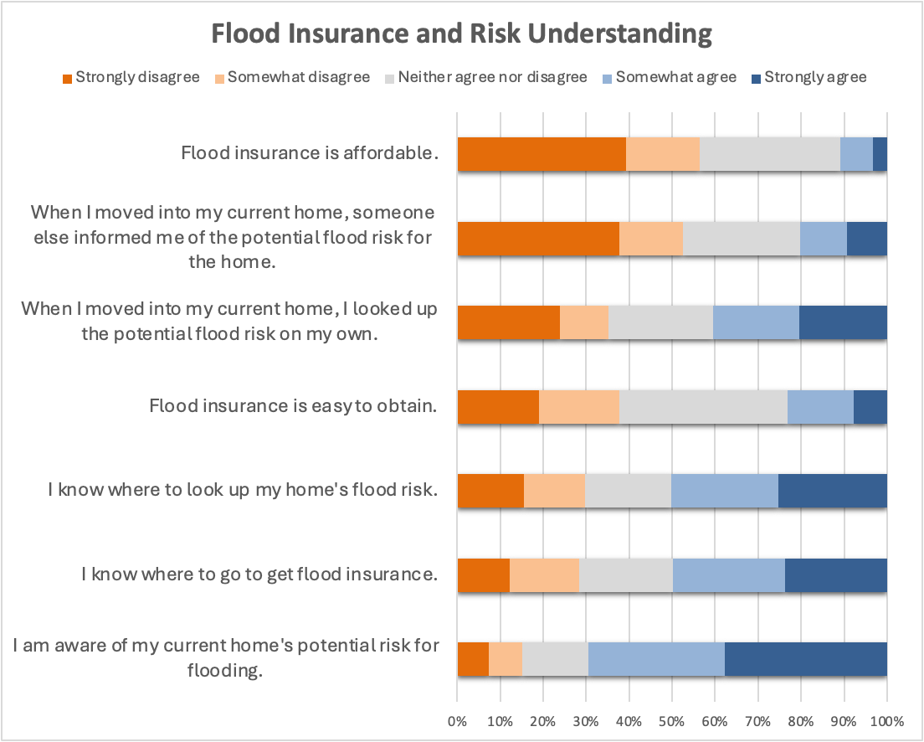
On a scale of extremely easy to extremely difficult, most respondents (43.08%) found it neither easy nor difficult to get flood insurance. Some households have taken precautions to prepare for future floods. The most common precautions taken were purchased flood insurance, cleared gutters, monitored water level changes to streams or rivers, purchased a generator, and created an emergency kit (flashlight, food, water, etc). However, 7.54% had not taken any precautions.

Pets and livestock are often a common worry during flooding events. Out of the respondents, 63.74% had pets, 11.64% had livestock, and 24.62% had neither. For those with pets in the event of a flood, respondents reported that ensuring the safety of their pets would be their highest priority (38.14%), a high priority (52.85%), a low priority (8.41%), and not a priority (0.60%). For those with livestock, respondents reported that ensuring the safety of their livestock would be their highest priority (24.59%), a high priority (70.49%), a low priority (4.92%), and not a priority (0%). If there was a severe flood, 13.47% of respondents would go to a shelter if pets were not allowed at that shelter, 67.37% would not go, and 19.16% were unsure.

Resiliency
The next set of questions asked respondents about resiliency, defined as the ability to withstand the stress of a disaster. Respondents ranked their level of agreement (strongly disagree to strongly agree) with resiliency statements at different scales. The results can be seen in the following graph. Using the same scale, respondents ranked their level of agreement as applied to their local community and government.

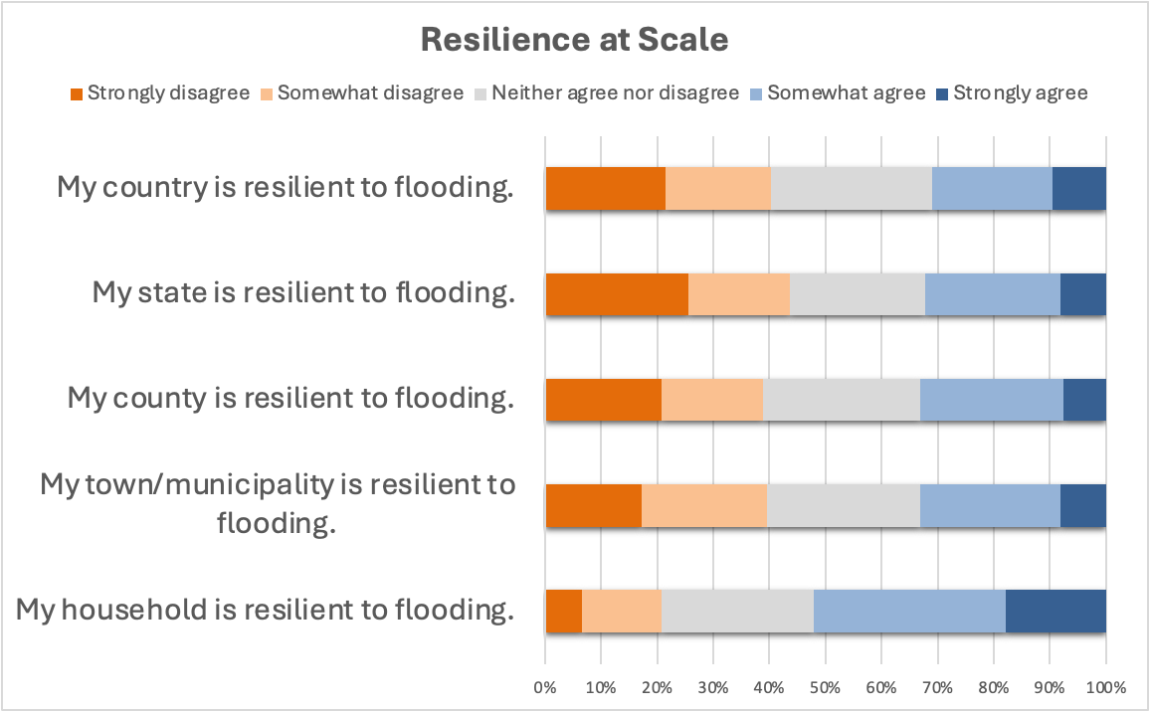

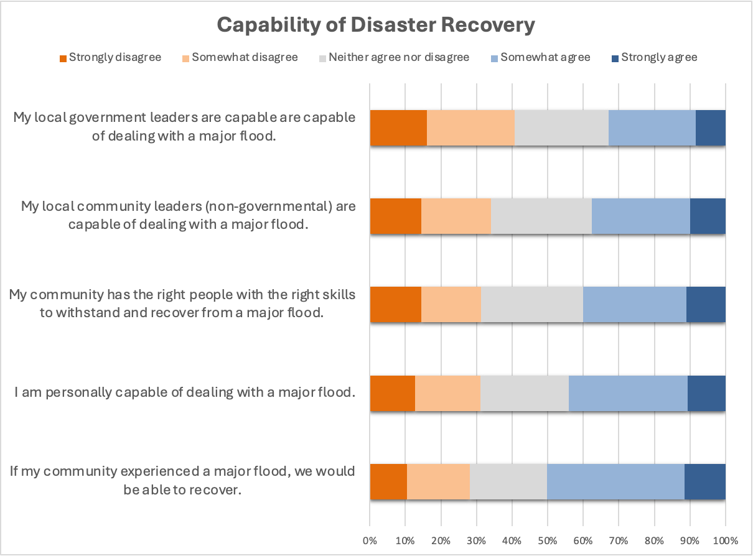
Relocation
The subsequent questions asked respondents’ opinions about moving or relocation due to flooding. When asked if they would consider permanently moving/relocating if flooding in their community becomes more frequent and
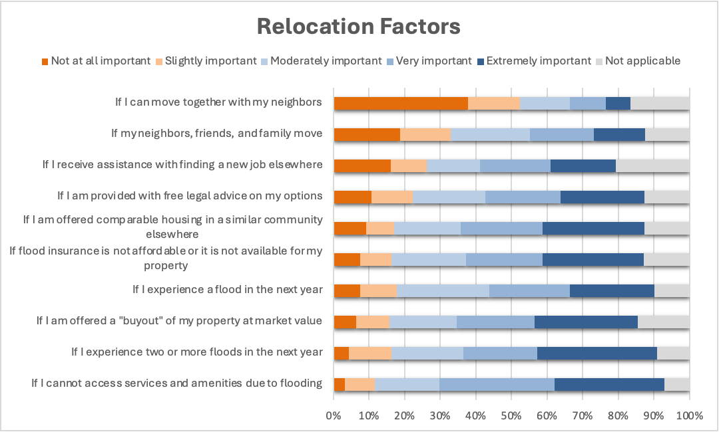
severe than it is now, most reported yes (47.30%), followed by maybe in the future (31.98%), and no (20.72%). Respondents were then asked to rank different considerations (relocation factors) about moving to a new place to avoid possible flooding (Figure X).

Problem Solving in Community
The next set of questions asked how respondents handle problems in their community. In the last 12 months, 45.23% had joined together with other community members to address a problem or common issue and 45.91% had talked with a local authority or governmental organization about problems in their community.

Open-Ended Responses on Community Needs and Resilience
Key Highlights

Needs for Flood Preparedness: Key suggestions from respondents included improved community-level flood planning, better warning systems, and government support for mitigation efforts.
Emotional and Psychological Challenges: Open-ended feedback highlighted emotional challenges, such as uncertainty, the need for trauma counseling, and the emotional impact of flooding.
Willingness to Relocate: While many respondents expressed a willingness to relocate if flooding became more severe, strong emotional ties and serious financial concerns influenced decisions to stay in high-risk areas​.

The final questions were open responses to allow respondents to provide more detail and share their perspectives on flooding.

Question: “Would you be willing and able to move/relocate if you found out that your home was in a high flood risk area?”

There were 299 responses to the open-ended question (Q51) “Would you be willing and able to move/relocate if you found out that your home was in a high flood risk area?” After thematic analysis, common themes emerged:
- Willingness to Move: Many respondents express a straightforward readiness to relocate if their home was identified as being in a high flood risk area.
- Reluctance to Move: A contrasting theme is found in responses with a flat "No."
Of the 299 responses in Q51, they can be classified in three buckets:
- Yes: 132 responses
- No: 82 responses
- Other: 84 responses
The "Other" responses to Q51 include a mix of conditional or uncertain answers, such as:
- "be willing"
- "Maybe"
- "Maybe if there was financial help."
- "Maybe if flood was a possibility. Don't think it is though."
- "I am in a high flood area. I like my neighborhood."
Common Themes in the "Other" Responses included:
- Uncertainty/Conditional Responses: Many responses reflect indecision using terms like "Maybe" or expressing willingness under certain conditions (e.g., financial help, confirmation of their flood risk).
- Emotional or Community Ties: Some responses suggest that even if they recognize a flood risk, respondents have strong ties to their home or community, making relocation a difficult factor to consider.
- Financial Considerations: A few responses mention that moving would depend on financial aid or other forms of support.

Representative Quotes from Q51
“I love living here and would prefer not to leave, but I would be willing to move if it was dangerous to stay. I would not, however, be financially able to move.”

“Easy access to information on flood risks and probability of flooding in this location. We are new to the area so know very little.”

“No, I want to stay where I am. This has been my family property for years. Flood waters have gotten around, but never inside even during the bigger floods of 1967 and 1997. My house is at a higher level than the house I grew up in.”
Question: "Is there anything else you'd like us to know about your experience recovering from a flood?”

There were 138 responses to Q82,"Is there anything else you'd like us to know about your experience recovering from a flood?” Identified themes from this question fall into multiple categories:
- No Additional Information:
  - Responses like "No" and "none.”
- Emotional and Psychological Challenges:
  - Responses such as "Struggles with uncertainty" and "Need for trauma counseling services" highlighting the emotional toll of flood recovery.
- Planning and Recovery Support:
  - Multiple responses, such as "Need for disaster recovery planning" and "Importance of economic recovery programs," reflecting the importance of preparedness and support systems in the recovery process.
- Community and Volunteerism:
  - Responses like "Importance of volunteer efforts" emphasize the value of community solidarity during flood recovery.
- Economic and Environmental Effects:
  - Responses such as "Impact on tourism industry" and "The scale was not very large" point to the broader economic impacts of floods, as well as how the severity of the event influences recovery efforts.
- Personal and Community Vulnerability:
  - Responses like "The river does not reach our house, but a creek floods" reflect the variability in personal vulnerability to flooding.

Representative Quotes from Q82
Any time that heavy rain is forecasted, you worry about flooding."
"No help from city or state officials."
"Importance of faith-based organizations."
“Challenges in rebuilding infrastructure.”
“The emotional/spiritual damage is rarely acknowledged”
“Lost all pictures of my children”
“I lost my home to the late September 2023 flood and was not approved for fema help”

Question: "What, if anything, would help your household be more prepared for a flood?”

There were 273 responses to Q48, "What, if anything, would help your household be more prepared for a flood?” Identified themes from this question fall into multiple categories:
- Preparedness and Planning:
  - Responses like "Keeping emergency contact information handy" point to the respondent’s focus on the importance of personal preparedness during floods.
- Warning Systems:
  - The call for "a better warning system" points to a recurring theme in the survey–and in earlier community work by the WVFRF team–the need for effective early warning systems.
- Emergency Preparation:
  - The response mentioning "Stocking up on necessities, preparing to be self-sufficient"" reflects a theme of gathering materials and preparing with practical steps to mitigate flood damage. plies.

Representative Quotes from Q48
"Having my home more organized so I could quickly gather essentials."
"Just keeping emergency supplies on hand along with food and water."
"Stocking up on necessities, preparing to be self-sufficient."
"Elevating my home would be an option but my wife won't allow it."
"Information on how to protect my house from damage during floods."
"We need to find out if our place of residence is vulnerable to flood risk and stock up."
“I feel that I am prepared for flooding. I have lived by the river my whole life and have learned to read the river. I have a plan that I follow like moving vehicles, making sure I have food/water/important papers, etc. If it would get close, I would put furniture, etc. up high.”
Information to the flood area on a yearly [basis]. People buy and sell homes all the time flood information would be helpful.”
“Alarm from weather service”
“Easy access to a comprehensive guide to flood preparation and risk level.”

Question: “What, if anything, are the barriers that are preventing your household from preparing for a future flood?”

There were 265 responses to the question “What, if anything, are the barriers that are preventing your household from preparing for a future flood?” Identified themes that emerged include:
- Access to Emergency Services:
  - Responses like "Emergency services not connected" highlight the theme of lack of access to emergency support.
- Financial Constraints:
  - Responses such as "Finances and health" and "The cost of flood insurance" reflect a major theme around financial barriers. The cost of flood insurance and general financial limitations are key factors that prevent households from fully preparing for future flood risks. Many respondents face challenges in affording necessary protections like insurance, supplies, or structural upgrades.
- Health and Physical Limitations:
  - The mention of "health" as a barrier point to personal or physical limitations. Some households are unable to prepare adequately due to health-related constraints, making it harder for them to take preventive actions or respond in an emergency.
These themes show that both systemic (e.g., lack of services, high costs) and personal (e.g., health) factors are major barriers to flood preparedness.

Representative Quotes from Q49
Limited resources to invest in flood preparedness measures.
Cost of flood insurance
I live on Elk River on property owned by my family for over 150 yrs. Basement’s flooded many times in the 60 yrs I’ve been here, so we have a system. If it another major flood like 2016 no barriers would have helped.
Cost of living / economy
Lack of awareness: Lack of awareness of the potential threat of flooding
Finance
Lack of any efforts on part of local govt. to make applications with state or federal govt. when assistance is available. No return call, no nothing. No follow up, just a way of ignoring me.
the cost
Lack of awareness about the flood risk in my area.

Question: "What, if anything, would help your community be more prepared for a flood?”

There were 267 responses to the question (Q50) "What, if anything, would help your community be more prepared for a flood?” Identified themes that emerged include:
- Community Preparedness and Education:
  - Responses such as "Encourage residents to make flood-resistant modifications" reflect goals of both increased community awareness and action in improving flood resilience.
- Environmental Management and Mitigation:
  - The response "Clearing debris and downed trees from streams" highlights a theme of infrastructure and environmental measures to mitigate flood risks.
- Government Involvement and Support:
  - "More government involvement" highlights a common theme of an identified need for governmental and institutional support and intervention. These responses suggest that respondents believe that local and state government action is critical to support communities to be more prepared for flooding.
These themes showcase a combination of community action, environmental maintenance and mitigation, and governmental support as key factors to enhance flood preparedness.

Representative Quotes from Q50
-A community flooding plan to mobilize volunteers for preparing for homes along the river to flood. Many volunteers do great work, but it would be nice if the entire community knew to go to the city building and you will be dispatched to places where help is needed. Rather than just wandering aimlessly asking people if they want help.
-A community meeting between citizens and leaders of churches and emergency services to prepare AHEAD of a flooding emergency. Perhaps talking beforehand to churches or other locations for possible shelter or collection of donations. Consistently keeping ditches cleaned out is needed as well.
-A dam on South Fork.
-A good weather forecast and drainage system
-A program to clean creeks such as was conducted in the 70's. Establishing a dedicated disaster response team that has access to addresses of physically and medically impaired individuals that require well-checks, assistance or evacuation. This team would need to practice effective intervention strategies and have access to communications, transportation and emergency medical/rescue equipment and supplies. Consultation with the US Army Corps of Engineers or (possibly) FEMA. USCOE consulted with this community prior to [COVID] but that initiative seems to have been abandoned. We need people with practical knowledge of flood mitigation, not titled bureaucrats. Our community sorely needs an assessment of how land management impacts flood risk. More specifically WESTVACO strips the land and doesn't replant. I fear this elevates flood risk such as happened to Ellicott City, MD. We may need legislation to control misuse.
-affordable flood insurance for all,
-Audits from state or federal officials to see what is not happening and why not. No accountability. I call all the time and get promises but never no call back. Then I call again. Been going on since 2004 and no feedback on my concerns. No one cares or qualified to help. This is so frustrating and depressing. A yes, a no, or denied application is better than no follow up at all. JUST SILENCE!
-Better planning by community and government leaders, but the Federal Government would have to force them to. Right now, we have a very reactionary group of community and government leaders. Their emergency plans are boiler plate with few specifics. Like instead of listing emergency routes for traffic it simply states, "Law enforcement will handle traffic." That is NOT a plan.

Question: "If you were creating a website or handbook to give to West Virginia residents to help them prepare for and deal with floods, what would you include?”
There were 271 responses to the question (Q52) "If you were creating a website or handbook to give to West Virginia residents to help them prepare for and deal with floods, what would you include?” Identified themes that emerged include:
- Resources around Emergency Contact and Support Information to use during a Flood Response:
  - Responses like "A phone number and people on call 24/7" highlight the need for clear, accessible emergency contact details and support systems for residents to get critical information before, during, and after a flood event.
- Resources to Encourage Active Preparedness and Practical Advice for Residents during Mitigation and Preparedness:
  - The response "Have an evacuation plan, water and heating source " reflects a theme of active preparedness and practical advice.
- Resources to promote Awareness of Flood Risks:
  - The response "Location, history of flooding, basic percentage of risk for locations" indicates a theme of resources for continual awareness and education on flood risk.
These themes suggest that respondents feel that important components of a handbook for residents to prepare and deal with floods would include practical support and knowledge around how to prepare for all phases of the disaster life cycle including knowledge of emergency contacts and support, actionable guidance for flood mitigation and preparation, and increasing knowledge around risk to enhance community readiness for floods.

Representative Quotes from Q52
-Emergency Contacts at the Community level within each county should be included in the handbook. In severe flood scenarios, sometimes entire communities are cut off from the world due to high water and mudslides. Then you have no electricity, no water/sewer, nowhere to go (if dwelling was destroyed/damaged) and no way for the flood victims to leave. Worst of all, no one can get to the community to assist the flood victims.
-Pictures of 2016 flood (100-year flood)
-The risks of different areas.
-A map of all the flood zones.
-Information about finding floodplain location, flood insurance, help in case of flood. Also place to go in case of flood and information about pets in case of flood. Everything you could possibly include about floods.
-Contact information for assistance
-Names and phone numbers of those who can assist in disasters.
-What to include in a "go bag". A checklist of items to make sure you have with you should you need to evacuate for any reason (even as simple as chargers for phones).
-guide on start to finish of things needed and what to do if you waited [too] late to evacuate
-Phone numbers of places with information, and locations
-A list of emergency supplies and resource centers

Question: “Is there anything else you would like us to know about the topics covered in this survey?”

There were 177 responses to the question (Q61) “Is there anything else you would like us to know about the topics covered in this survey?” The responses to this question were varied and did not lend to clear delineation of themes, but representative responses are included below.

Representative Quotes from Q61
-Thank you for doing this very thorough survey. Since flooding is WV's major natural disaster, hopefully this will help fund state government resources to help communities prepare, respond and recover.
-This has and is hard on many people and some have nobody to guide them for assistance
-I have lost complete faith in the government of this country to react and support all people that are impacted.
-Funding is always needed for private road, stream and bridge restoration after a flood.
-This is big problem, because the floods are worsening. Post traumatic stress is a real result of any flood
-affordable flood insurance is a MUST for communities
-Very few of the local or county or state agencies take the training for or follow the National Incident Management System. They all take a "we'll deal with it when it comes" attitude. Been that way for decades and I've seen it first hand. A website is a nice idea, but forced training and drills of the emergency providers and the local and state government would make more a of a difference. But that's not what this survey is for.
-This state has one of the most expensive utilities in all the states I’ve lived in yet we are one of the poorest. How the heck are West Virginians supposed to recover from flood when most can’t even afford to pay their power bill?
-The city needs to properly dredge every major creek and river, that would help the people of WV
-Very well done.
-I hope there will never be another flood.
-West Virginia is poorly prepared for the next flood.

References

Adler, E. S., & Clark, R. (2011). An invitation to social research: How it’s done. Wadsworth, Cengage Learning.

Bukvic, A., & Barnett, S. (2023). Drivers of flood-induced relocation among coastal urban residents: Insight from the US east coast. Journal of Environmental Management, 325, 116429.

Kaplowitz, M. D., Lupi, F., Couper, M. P., & Thorp, L. (2012). The effect of invitation design on web survey response rates. Social Science Computer Review, 30(3), 339-349.

McGuirk, P. M., & O'Neill, P. (2021). Using questionnaires in qualitative human geography. In Hay, I. & Cope, M. (Eds.), Qualitative research methods in human geography (5th ed.), (pp. 244-270). Oxford University Press.

National Centers for Environmental Information. (2024). West Virginia: Billion-dollar weather and climate disasters. NOAA. https://www.ncei.noaa.gov/access/billions/state-summary/WV

NOAA. (2016, July 5). A thousand-year downpour led to deadly West Virginia floods. Climate.gov. https://www.climate.gov/news-features/event-tracker/thousand-year-downpour-led-deadly-west-virginia-floods

Patton, M. Q. (2014). Qualitative research & evaluation methods: Integrating theory and practice. Sage publications.

U.S. Geological Survey. (1999). The 100-year flood (Fact Sheet 050-99). https://pubs.usgs.gov/fs/fs-050-99/pdf/fs05099.pdf

