**Creating the West Virginia Flood Resilience Framework for comprehensive disaster response and long-term community recovery**

**Appendix to Report of Research**

**Survey Appendix**

A survey of Greenbrier County residents on flood impacts and preparation was conducted in December 2022 - January 2023, with a total of 1,168 responses. The age range of participants was 18-82, with an average age of 27.5. Annual household income ranged from less than $20,000 (5%) to over $100,000 (16%). A total of 56% identified as female and 43% as male, with 80% identifying as white, 11% as Black or African American, and 6% as Asian. The average number of adults in households was 2.73, with .84 children. Approximately 75% of respondents were employed full time and 15% were employed part time. Nearly 70% had some form of education beyond high school, ranging from trade school to advanced degrees. Answers to all non-demographic questions are provided in full below.

**Q1. Was your community impacted by the 2016 flood?**

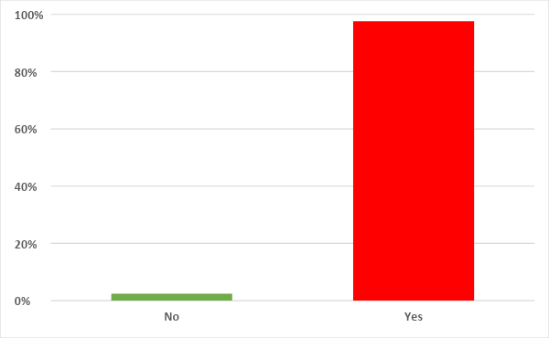

**Q2. If your community was impacted, how would you describe the level of recovery at this moment?**

**Q3. Did the 2016 flood impact your primary residence?**

**Q4. How did the flood impact your primary residence?**

**Q5. Did you stay or go elsewhere if your home was damaged or destroyed?**

**Q6. If you left your home due to damage from the flood, where did you go?**

| **Place of Staying in time of Damage** | **Count** |
| --- | --- |
| Stay with friends or family | 268 |
| Hotel/motel | 238 |
| Shelter | 235 |
| Other not listed | 17 |

**Q7. Prior to the 2016 flood, how vulnerable did you think your residence was to flooding?**

**Q8. Prior to the 2016 flood, did you know if your primary residence was in a floodplain (defined as any land area which is at risk of experiencing flooding)?**

**Q9. Did you receive assistance for household recovery after the 2016 floods?**

**Q10. Please check all types of assistance received:**

**Q11. Please select groups from which you received assistance and your level of satisfaction with each.**

**Q12. How satisfied were you with each stage of flood recovery?**

**Q13. What is your level of recovery at this moment?**

**Q14. Was your job impacted by the 2016 flood?**

**Q15. Was your place of work impacted by the 2016 Flood? If so, to what degree?**

**Q16. Was your income impacted as a result of the 2016 flood? If so, to what degree?**

**Q17.** **Did your experiences during the 2016 flood cause any emotional/mental health impacts?**

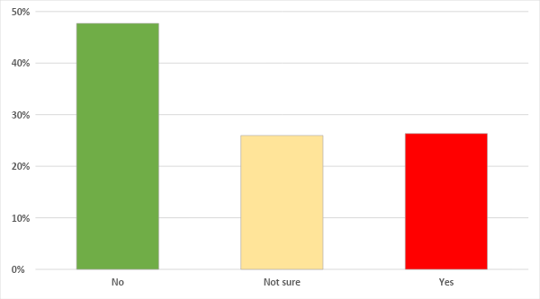

**Q18. If you have/had emotional/mental health impacts from the 2016 flood, did you get support?**

**Q19. Is your current primary residence in a floodplain?**

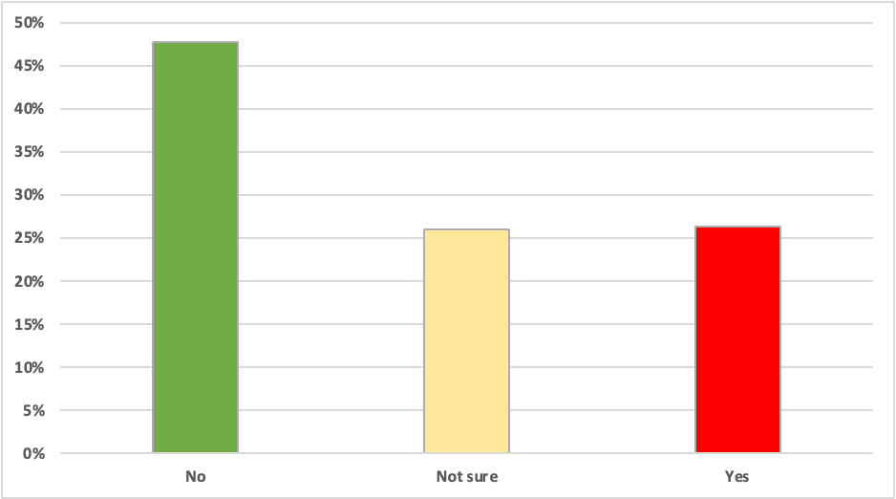

**Q20. How concerned are you that your primary residence or community will experience a major flood in the next 10 years?**

**Q21. How concerned are you that your primary residence or community will experience a major flood in the next 30 years?**

**Q22. How prepared are you if your primary residence experiences a major flood?**

**Q23. How prepared is your community if they experience a major flood?**

**Q24. Do you have flood insurance for your primary residence and if so, was it legally required for you to obtain this insurance?**

**Q25. Has your household taken any precautions to prepare for a future flood (check all that apply):**

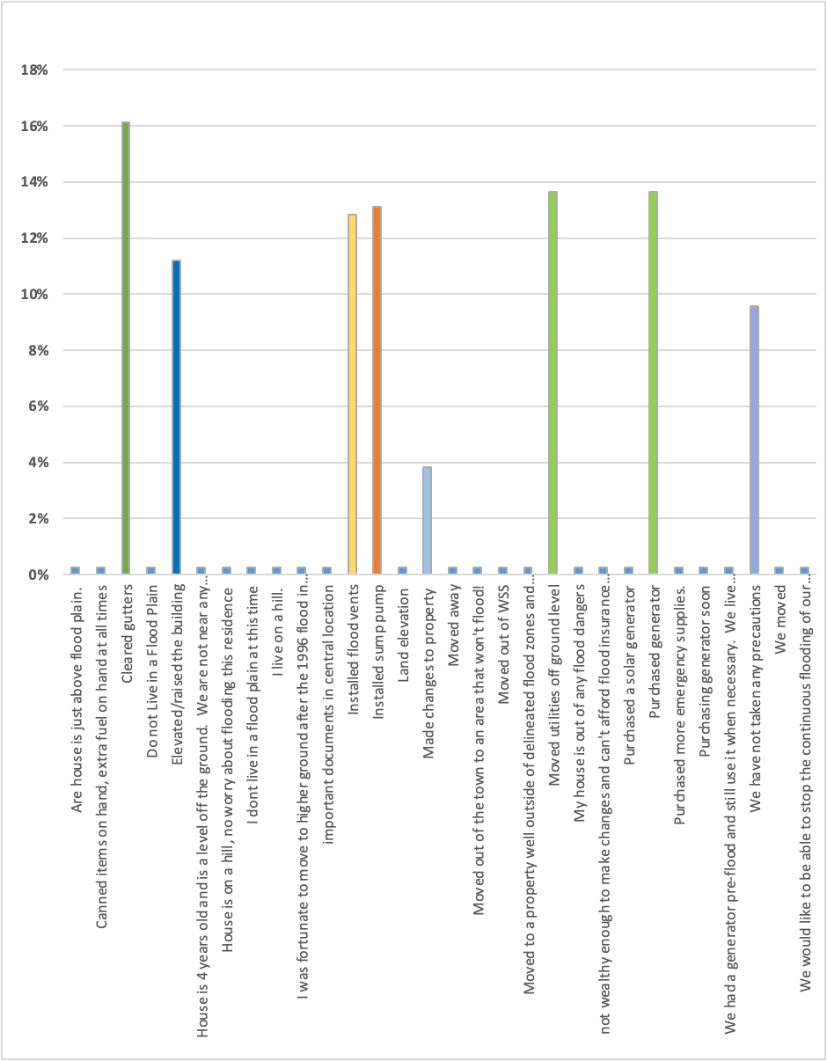

Questions 26, 27, and 28 of the survey were open-ended and asked respondents to think through what would help their household better prepare for a future flood, what the barriers are to prepare for future floods, and what would help their community be more prepared for future flooding. Around 200 people submitted responses to these questions which were then coded into categories. All categories and the number of responses are below, and are summarized in the Research Report.

**Q26. Briefly describe anything that you think would help your household be more prepared for a future flood?**

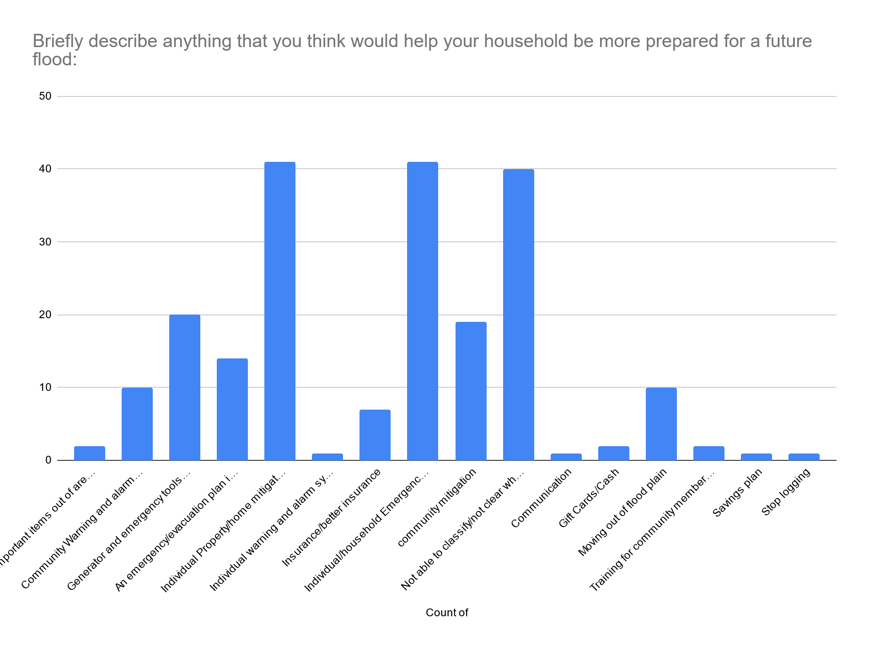

**Q26 Coded responses**

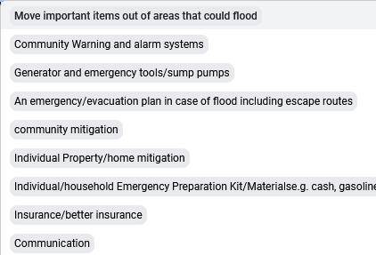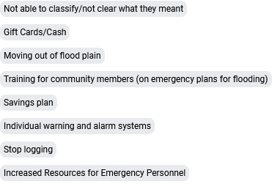

**Q27. Briefly describe any barriers to implementing additional preparations for a future flood:**

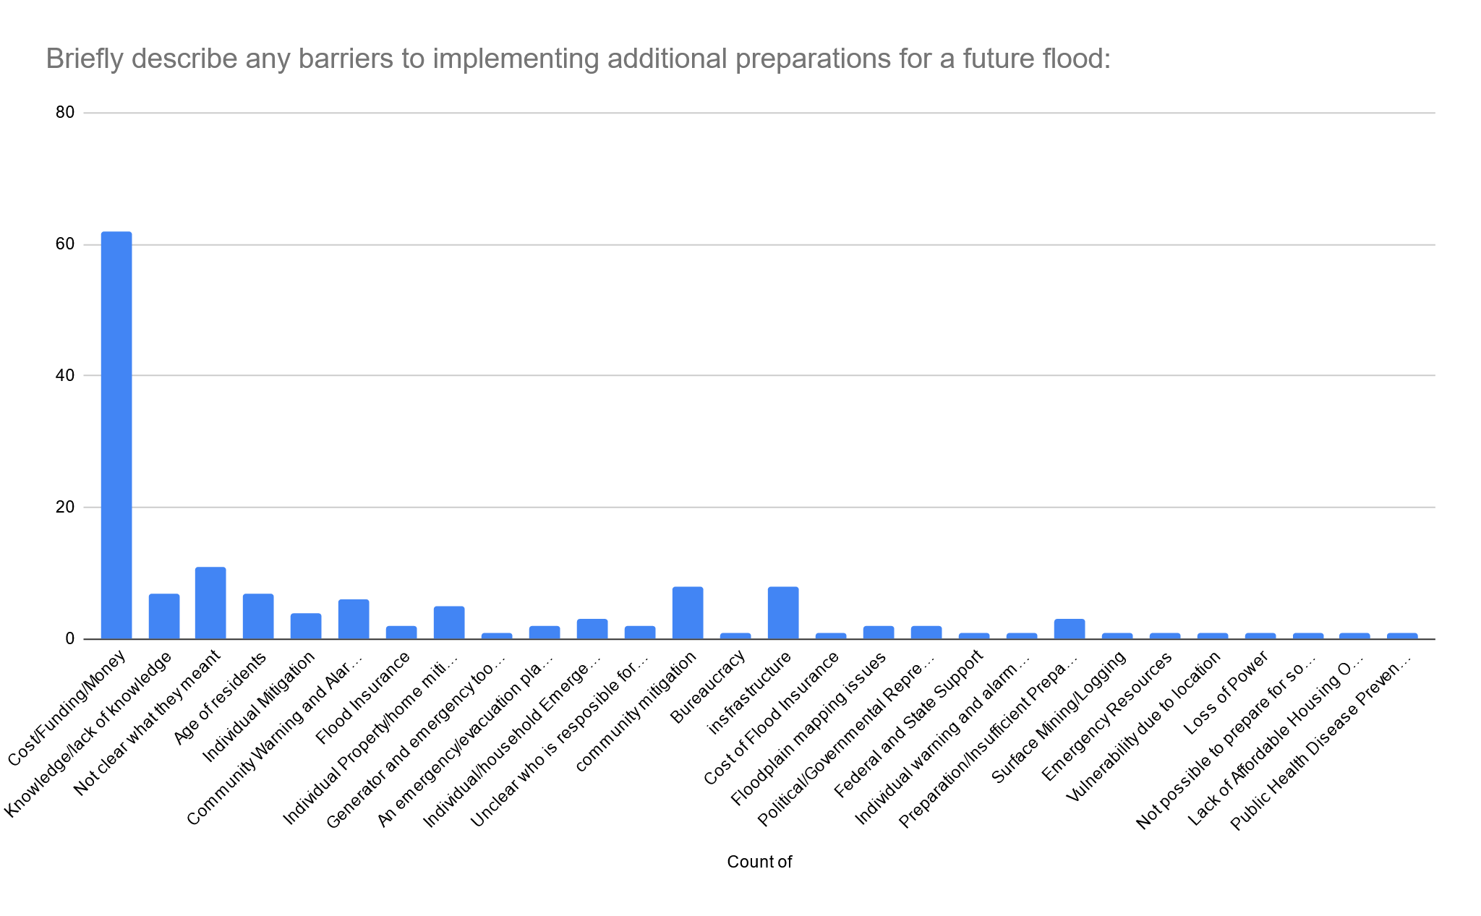

**Q27 Coded responses**

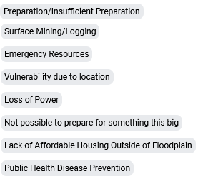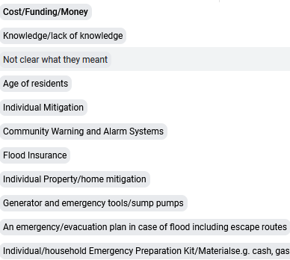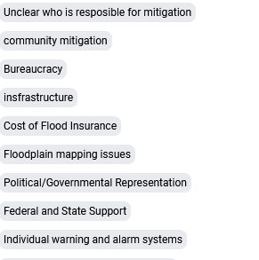

**Q28. Briefly describe anything that you think would help your community be more prepared for a future flood:**

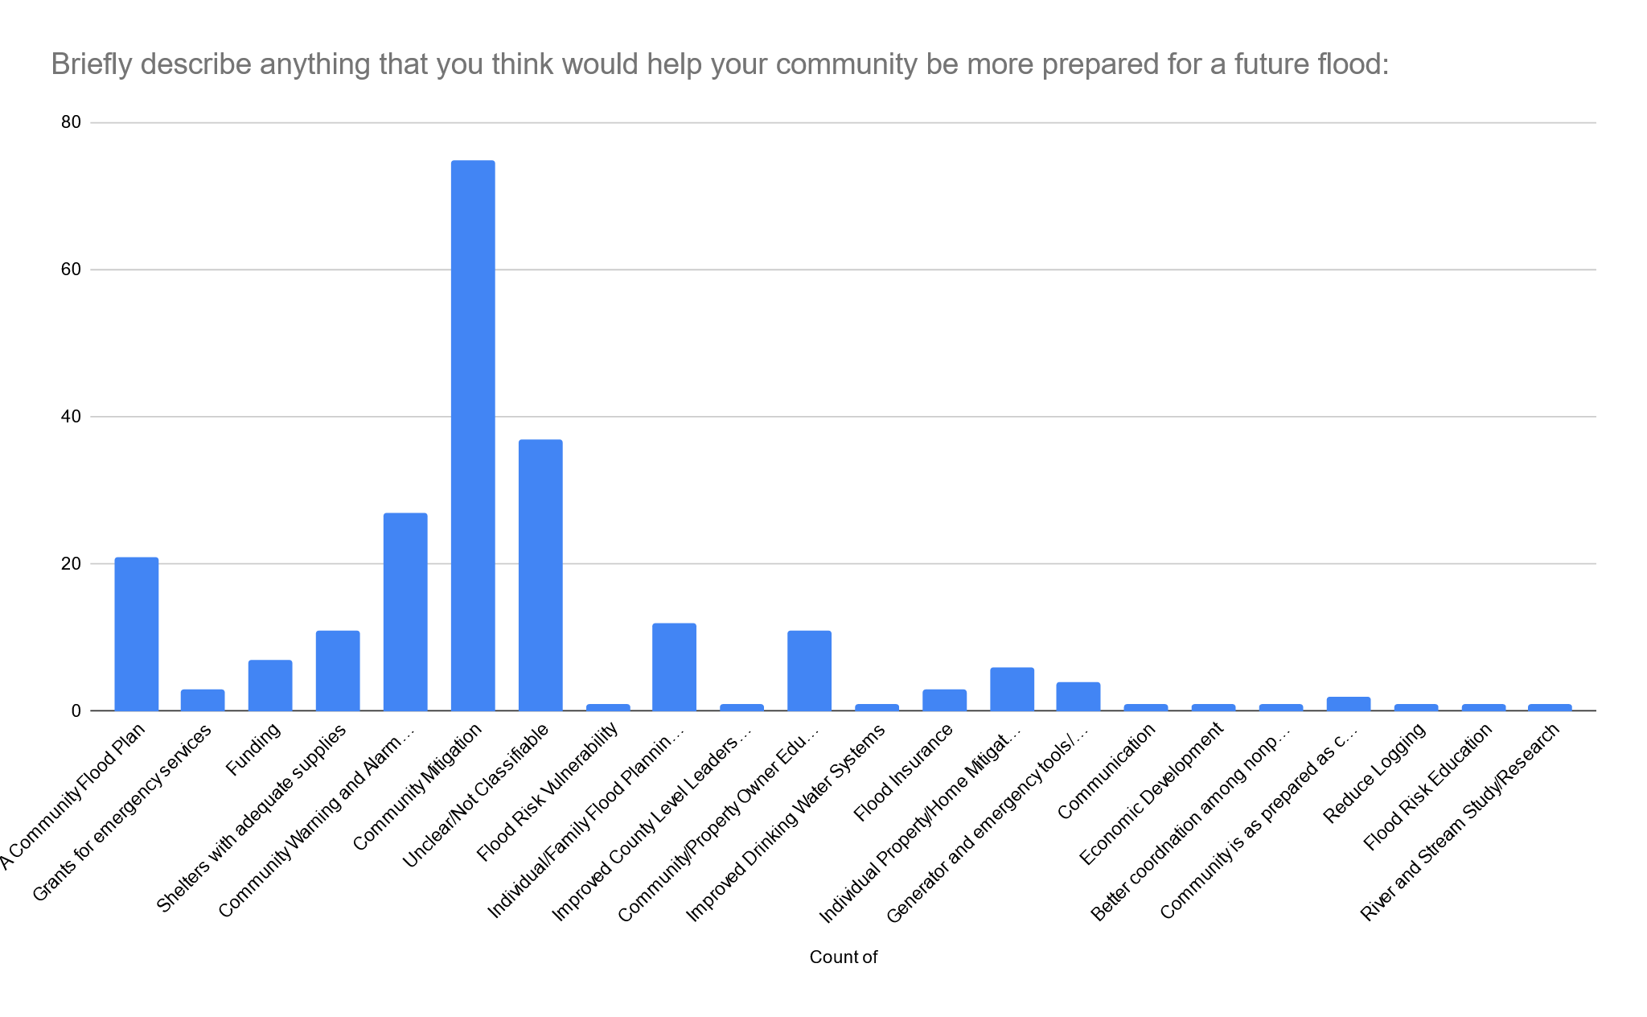

**Q28 Coded responses**

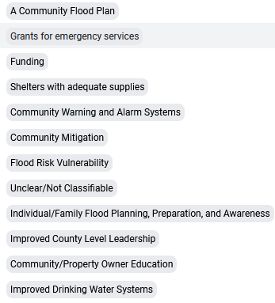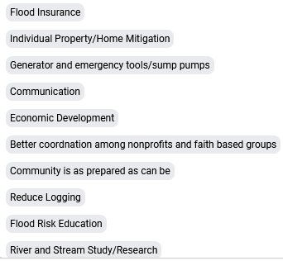

**GIS Appendix**

The pilot study on the city of White Sulphur Springs and the town of Rainelle is summarized below in three categories: Flood risk, loss, and mitigation. The significant findings for each category are discussed.

**Flood Risk**

According to academic literature, flood risk is determined by three factors: 1) Flood hazard, which includes frequency, depth, duration, velocity, and rise/fall characteristics; 2) Exposure of people and assets, such as buildings and infrastructure, to the hazard; and 3) Vulnerability of the exposed elements and the population. We used this definition to conduct this study and report the following findings.

**Flood Hazard**

## Flood Zone Measurements

FEMA’s effective and preliminary flood zone maps for riverine flooding were utilized for the inventory of all primary structures in the high-risk 1%-annual-chance (100-year) floodplain. Measurements of the flood zones allow for the calculations of the acreage and miles of flood zones which can be compared with other jurisdictions. The first calculation is the acreage of the Special Flood Hazard Area (SFHA), the effective 1%-annual-chance flood zone. In White Sulphur Springs, the effective 1%-annual-chance flood zone area also known as Special Flood Hazard Area (SFHA) is 266 acres which is 21.9% of the community area while in Rainelle, it is 223 acres which represents 31.1% of the community area. These percentages are higher than the median ratio for all incorporated areas in the state (10.2%).

## Active Flood Studies and Mapping

FEMA is creating new flood maps for Greenbrier County which will alter the floodplain boundaries and base flood elevations. During the restudies new high-water marks, stream flow data, and topography are incorporated into the new flood map studies to determine the base flood elevations.

The flood zone maps are continuously being restudied and changing based on historical flood and updated stream flow information. The SFHA (red floodplains on WV Flood Tool) will increase for several communities in Greenbrier County when the Preliminary flood zones (orange) become effective. The town of Rainelle will have a significant SFHA increase (Figure 1). This is mainly due to the inaccurate effective floodplain maps currently in use, which date back to 2012.

**Historical Flood Information**

In June 2016, Central West Virginia including Rainelle and White Sulphur Springs experienced a catastrophic flood that led to the initiation of the most extensive regional mitigation project since the historic April 1977 flood in the Tug Fork River Basin. The impact of the 2016 flood was severe resulting in the destruction or damage of numerous buildings, the loss of at least 23 lives, and widespread flooding across various communities in West Virginia. The 2016 Flood Elevation high-water marks in Rainelle show an elevation of 2,396 feet while the 2022 base flood elevation (BFE) for a 100-year event is 2,393 feet in a large part of the town and the 500-year Flood elevation is 2,399 feet.

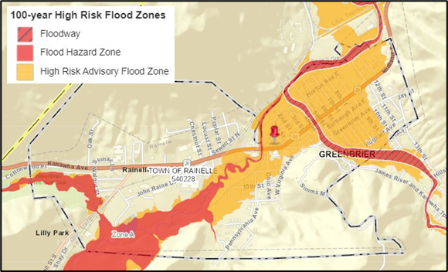

Figure 1: Mapped SFHA area increase in Rainelle

**Exposure**

**Physical Exposure**

***Building Counts in SFHA:*** The number of structures located in floodplain indicates the level of physical and human exposure, as elements of flood risk, in a community. We used the latest Building Level Risk Assessment (BLRA) developed by the WV GIS Tech Center to estimate building exposure. The BLRA is developed by pinpointing all primary insurable structures in the 1%-annual-chance or high-risk effective and advisory floodplains. Based on the results, 425 primary buildings are located in the high-risk floodplain of White Sulphur Springs (ranked 12th in the state) that is 26% of all structures in the community. In Rainelle, 338 primary structures are exposed to a 1%-annual-chance flood (ranked 18th in the state) that can be translated to 34% of the buildings community wide. These ratios are much higher than the statewide ratio of 9% for all incorporated areas, indicating that both communities have a high number of at-risk buildings.

***Buildings in Floodway:*** Buildings in the main floodway channel of the river or stream, or close to the flood source, will be subject to the greatest flood depths, highest velocities, and greatest debris potential. White Sulphur Springs is ranked 6th in the state with 105 primary structures (25% of the building count in the SFHA) located in the mapped floodways, which is much higher than the statewide ratio of 8% for all incorporated communities. In Rainelle, 47 buildings (14% of the at-risk structures) are situated in the floodway.

***Building Dollar Exposure:*** Higher building values increase substantial damage thresholds and mitigation reconstruction costs. Based on the 2022 tax assessment, the BLRA estimates the total value of primary buildings in the high-risk floodplain of White Sulphur Springs (ranked 16th in the state) to be $41,.015MK, with a median building replacement cost of $49K. In Rainelle, the total estimated value of at-risk structures is $16,.889MK, with a median value of $38K. The median replacement cost in White Sulphur Springs is higher than the statewide value of $42K, while in Rainelle, it is lower. Based on the flood zone maps currently in effect, the White Sulphur Elementary School has the highest appraised value ($8.54M) among the structures susceptible to flooding in White Sulphur Springs. In Rainelle, the Kroger store located on John Raine Drive has the highest value ($1.44M) in the floodplain. 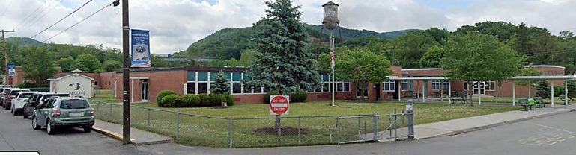

Figure 2: White Sulphur Elementary School, the highest value in White Sulphur Springs’ floodplain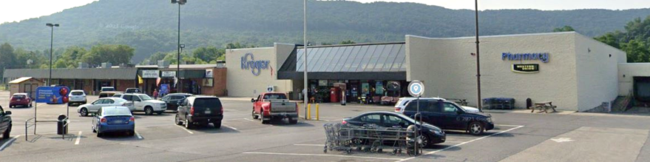

Figure 3: Kroger store on John Raine Dr., the highest value in Rainelle’s floodplain

***Residential/Non-Residential Occupancy Type:*** The specified residential/non-residential occupancy class according to structure use or structure type is an important requirement for multiple flood reduction programs, activities, and products. Therefore, mitigation solutions are often defined by the occupancy type (residential/non-residential) and replacement cost. Residential buildings located in flood-prone areas can result in significant human losses and economic risks for households, while damages to non-residential structures can disrupt businesses in affected communities. Non-residential buildings are often expensive to replace, and it is more challenging to mitigate flood risk for these structures, such as by elevating them.

*Residential Structure Type:* The majority of primary buildings susceptible to flooding in the communities under study are residential. White Sulphur Springs is ranked 12th in the state in terms of the number of residential buildings in the floodplain with 372 of these structures constituting 88% of all flood-prone buildings in the community. This ratio is higher than the percentage for all incorporated areas statewide (81%) increasing the risk of human loss in the city. In Rainelle, there are 250 residential buildings in the 1%-annual-chance floodplain making up 74% of the total at-risk primary structures. The estimated total building value in the floodplain of White Sulphur Springs (ranked 16th in the state) is 50% residential ($20,454KM) while it is 55% in Rainelle ($9,294KM).

*Non-Residential Structure Type:* Rainelle is ranked 11th in the state for the number of non-residential primary structures in the high-risk floodplain with 88 buildings (26% of all exposed structures) indicating the total at-risk value of $7,595KM. The percentage mentioned above is higher than the statewide ratio of all incorporated areas indicating higher risk of business interruption by flooding in this town. There are 53 non-residential buildings located in the 1%-annual-chance floodplain of White Sulphur Springs with the total value of $20,561KM.

***Building Year and FIRM Status:*** The construction year can show the structure age as an indicator of quality of the foundation and other elements. It can also show if the building was constructed prior to or after the Flood Insurance Rate Map (FIRM) date when the initial flood maps became effective and floodplain development standards were adopted by the community. Post-FIRM structures should be built according to the floodplain development standards set forth in the local floodplain management ordinance. In White Sulphur Springs, a significant proportion of flood-prone structures (88%) were constructed before the FIRM date of 8/1/1978 and are classified as Pre-FIRM structures. This percentage is higher than the corresponding ratio for all incorporated areas of West Virginia (77%). In Rainelle, 77% of at-risk buildings were built before 11/19/1987 and are labeled as Pre-FIRM structures. In addition, the median construction year for primary structures located within the floodplain is 1940 in White Sulphur Springs while it is 1950 in Rainelle.

***Future Map Conditions:*** Where advisory floodplains exist, the "mapped-in" structures represent buildings that most likely will be included in the SFHA when future FEMA restudies are done and new FIRMS become effective. Non-regulatory advisory floodplains are generated from Preliminary/Draft Risk MAP studies or Advisory Flood Height studies. Communities should review all "mapped-in" structures. Homeowners are at higher risk to flooding and should be contacted about Flood Insurance Preferred Risk Policies and other potential mitigation measures. “Mapped-out” structures are primary buildings no longer located within the high-risk advisory flood zones. Although the purchase of flood insurance is not required for such structures it is recommended that the owners maintain flood insurance coverage, since the risk of flooding has not been removed. Based on the future flood maps, Rainelle (ranked 3rd in the state) is expected to have 325 structures mapped in to the new high-risk floodplains. The significant number of those structures is largely due to the incorrect flood maps that have been in effect since 2012 which depict a much narrower floodplain, as mentioned previously. White Sulphur Springs has 75 structures mapped in to the new high-risk floodplains, ranking it 11th among incorporated areas in the state. Furthermore, there are 117 mapped-out structures in White Sulphur Springs (ranked 8th in the state) whereas there is only one in Rainelle. Moreover, 38 of the above structures in Rainelle will be mapped in the floodways. The number of buildings to be mapped in floodways of White Sulphur Springs is 14. In White Sulphur Springs, there are 40 buildings that are currently in the effective floodplain and will be mapped in floodways.

***Significant Structures***

## *Essential Facilities:* Essential facilities provide critical services to the community and include police and fire stations, E-911 emergency operations centers, schools (often used as shelters), hospitals, and nursing homes. FEMA identifies these critical facilities as essential in its *Hazus-MH* risk assessment tool. If a critical facility must be in a floodplain, then it should be provided with a higher level of protection so that it can continue to function and provide services after the flood. Communities should develop emergency plans to continue to provide these services during the flood. In addition, hospitals and nursing homes with immobile patients or residents are particularly vulnerable to a flood disaster, and schools, on the other hand, are usually used as shelters in the aftermath of floods. Under federal Executive Order 11988, Floodplain Management, federal agencies funding and/or permitting critical facilities are required to avoid the 0.2 percent (500-year) floodplain or protect the facilities to the 0.2%-annual-chance flood level. Two essential facilities were identified in the high-risk (100-year) floodplain of White Sulphur Springs that are the White Sulphur Elementary School and the White Sulphur Springs Police Department. However, the school will no longer be within the floodplain when the new Flood Insurance Rate Map (FIRM) becomes effective, and it will be mapped out accordingly. In Rainelle, there are two essential facilities located in the high- and moderate- risk flood zones. These structures are Rainelle Volunteer Fire Department in the 100-year floodplain and the Rainelle Police Department in the 500-year zone. The location of these structures within the floodplains can lead to significant operational challenges during flooding events increasing the risk for the town of Rainelle.

## *Community Assets:* Community assets include government facilities (federal, state, or local), facilities providing emergency medical response (EMS), structures of religious organizations, utilities (water, sewage, gas, electric, or phone), postsecondary educational facilities, historical structures listed on the National Register of Historic Places, or other buildings of significance that contribute to the built environment of community. Many of these buildings such as churches are usually used as emergency shelters during flooding events. The malfunction of utilities caused by floods can damage critical community lifeline systems, including those related to safety and security, water, shelter, health and medical services, and energy. A hazard vulnerability analysis of community assets should be conducted by floodplain managers and risk planners to develop mitigation strategies for these assets. This study solely focused on non-historical community assets located within the high-risk (100-year) floodplains. In White Sulphur Springs, eight non-historical community assets were identified within this area, including four churches, the city hall, the municipal court, a United States Postal Service (USPS) office, and the White Sulphur Springs National Fish Hatchery which was appraised at the highest dollar value of $425K. In Rainelle, there are seven community assets in the high-risk flood zone including four churches, Rainelle Public Library, the Municipal Water Department, and a USPS office. Among these, the Church of God has the highest dollar value of $435K.

Figure 4: White Sulphur Springs National Fish Hatchery in the high-risk floodplain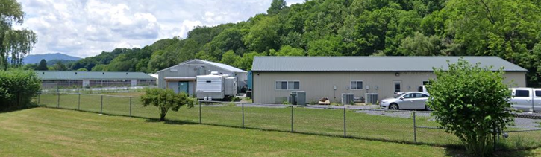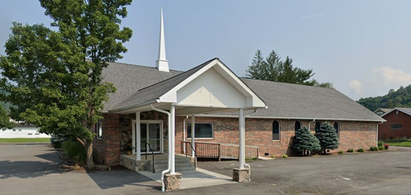

Figure 5: Church of God in Rainelle’s high-risk floodplain

***Transportation Inundation***

A foot of water will float many vehicles and make roads impassable. About three feet is near the limit to use high profile vehicles to perform high water rescues and instead boats and helicopters are required to perform rescues. Communities should compare historical flooding events to the flood estimation models for active railroads and major highways (interstates, federal, state). To determine if bridges will be inundated by a 1%-annual-chance flood, the bridge deck elevation should be higher than the base flood depth. Transportation inundation models for roads, railroads, and bridges are computed by the WV GIS Tech Center for a 1%-annual-chance flood event. Road inundation models exist for Greenbrier County where countywide model-backed flood depth information exists. The findings reveal that a considerable portion of the road network including U.S. 60 in White Sulphur Springs is at risk of flooding, with 23% of the total mileage estimated to be susceptible to inundation at a flood depth of 1 foot or higher. Three bridges within the city limits are also vulnerable to flooding. In Rainelle, the percentage of road mileage at risk is even higher, at 36%, which is a cause for concern. Additionally, two bridges in the town are identified as being subject to inundation by flooding events.

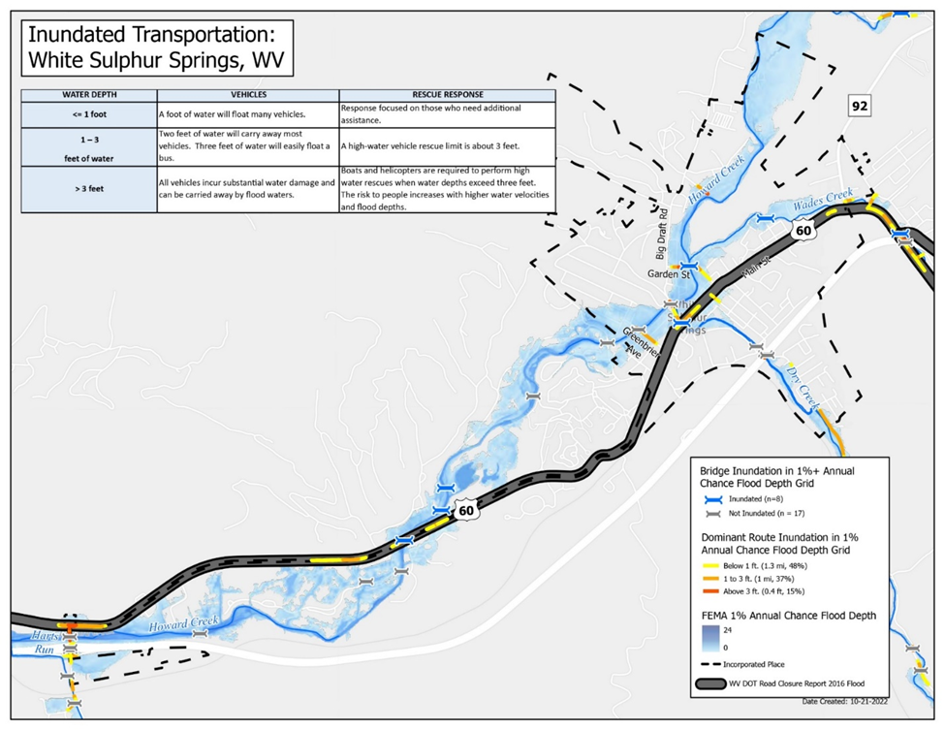

Figure 6: Roads at risk of being inundated in White Sulphur Springs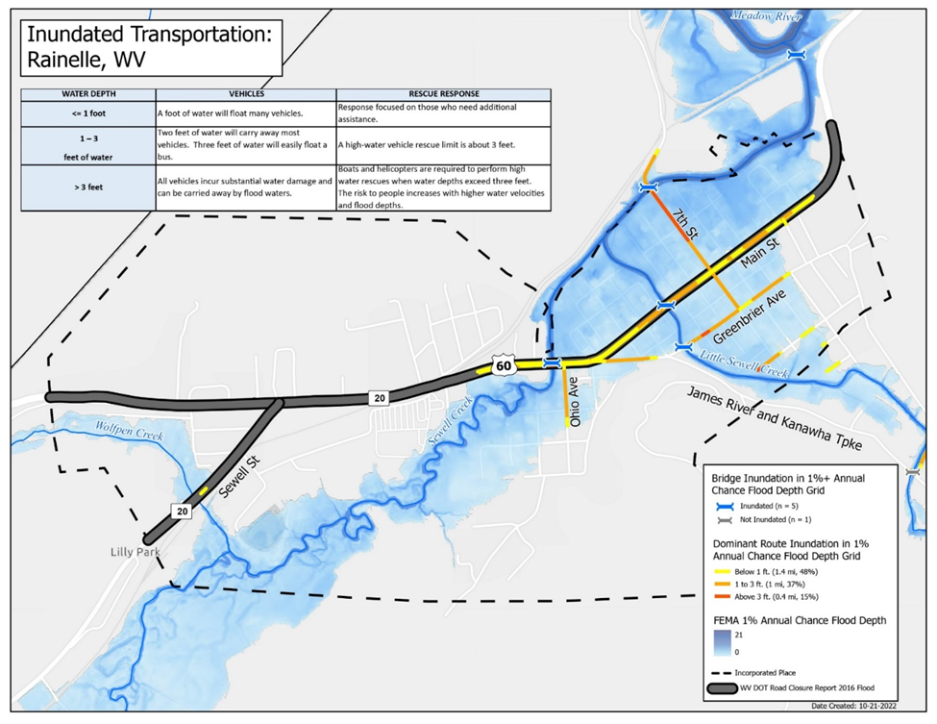

Figure 7: Roads at risk of being inundated in Rainelle

**Human Exposure**

Flooding poses a significant threat to human life and health. People are the most important and valuable exposed elements that should be protected when a flood occurs. They may suffer directly from the impacts such as drowning, physical trauma, heart attack, and electrocution or be affected by the future indirect consequences of flooding like mental trauma and economic problems. The number of people residing in floodplains can serve as an indicator of human exposure to floods, potentially leading to higher human losses. For this study, population estimates were calculated at the building level by multiplying the *Hazus* defined residential occupancy class units (obtained from the tax assessment database) by average household size (obtained from the Census). A significant portion of the population resides in the floodplains with a 1%-annual-chance of flooding in both study areas. In White Sulphur Springs, 1026 individuals are estimated to live in the high-risk area representing 39% of the city's total population. In Rainelle, the estimated population residing in the floodplain is 582 accounting for 43% of the total population. This percentage is significantly higher than the statewide percentage of 10% for all incorporated areas, indicating a high level of human exposure to flood hazards in both cities.

**Vulnerability**

**Institutional Vulnerability**

Institutional vulnerability refers to the characteristics related to the ability of institutions and organizations to cope with natural hazards, including their level of preparedness and experience of previous disasters. This type of vulnerability is closely related to human activities and decisions, as it depends on the effectiveness of policies, regulations, and emergency management plans implemented by institutions and organizations. The level of institutional vulnerability can affect the ability of a community to respond and recover from natural disasters.

***Current CRS Class:*** The Community Rating System (CRS) demonstrates the willingness of a community to adopt high standards, which is crucial as this program motivates communities to exceed the minimum requirements of the National Flood Insurance Program (NFIP). Communities with a higher CRS class or a current CRS application are ranked higher than those without a CRS class, emphasizing the importance of this program in determining a community's preparedness for flooding. Unfortunately, Since Rainelle and White Sulphur Springs are not part of the Community Rating System yet, they may face higher institutional vulnerability compared to communities that participate in this program.

***Previous Disaster Experience:***Assessing a community's vulnerability to floods based on the number of disasters that occurred in the last years can provide valuable insights. FEMA considers the number of federally declared disasters with flooding since 1989 as a measure to assess the level of flood risk faced by the community. Greenbrier County experienced nine such declared disasters during this period. This indicates that the communities in the county including White Sulphur Springs and Rainelle are prone to the hazard and require effective flood risk management strategies to mitigate the impact of future floods. Otherwise, these communities may become even more vulnerable to such events.

***Community-Based, Faith-Based, and Non-Governmental Organizations:*** Local community-based organizations can play a crucial role in disaster response and recovery efforts. These organizations often have deep roots in the community and are well-positioned to mobilize quickly and efficiently to provide aid to disaster victims. They may also have existing networks and resources that can be leveraged during a disaster, such as volunteers, supplies, and transportation. The presence of a large number of active community-based organizations can assist in reducing a community's vulnerability to natural hazards by providing additional support and resources during a disaster. This can help ameliorate the impacts of the disaster on the community and facilitate a more rapid recovery. According to a survey conducted in 2022 for this study in Rainelle and White Sulphur Springs, over 60% of respondents were highly satisfied with the role of assistance groups such as faith-based, voluntary, and non-governmental organizations, in aiding the communities after the 2016 flood.

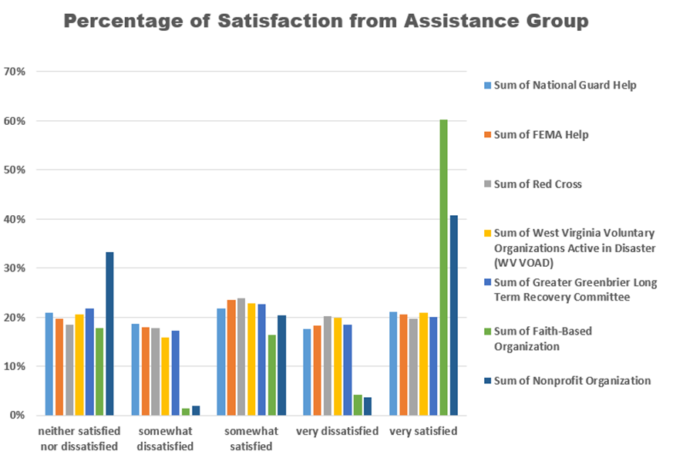

Figure 8: Satisfaction level from assistance groups by the survey respondents

***Social Media/Local Mass Media:*** Insufficient communication regarding the potential flood risk can increase the vulnerability of communities. Additionally, the absence of access to accurate and up-to-date information during a flood event can further exacerbate the community's susceptibility to the resulting consequences. Creating a webpage or social media platform for a community is an effective way to share flood news with the public. In addition, social media platforms can also be used to share safety tips, emergency contact information, and evacuation procedures during a flooding event. It is crucial to ensure that the information shared on the platform is accurate, up-to-date, and relevant to the specific flood event. Social media can also be used to engage the community in flood preparedness activities, such as conducting flood drills and sharing information on flood insurance and mitigation measures. It will facilitate communication and coordination among community members, emergency responders, and local authorities which can ultimately lead to a more efficient and effective response to natural disasters. Therefore, the availability of a digital public platform for a community can be identified as a significant factor that can reduce its vulnerability to natural hazards. According to the 2020 survey conducted among the residents of five cities highly impacted by the 2016 flood in West Virginia, including White Sulphur Springs and Rainelle, 57% of the respondents reported using social media while 15% reported using local radio stations as the reliable sources for updated information during the disaster.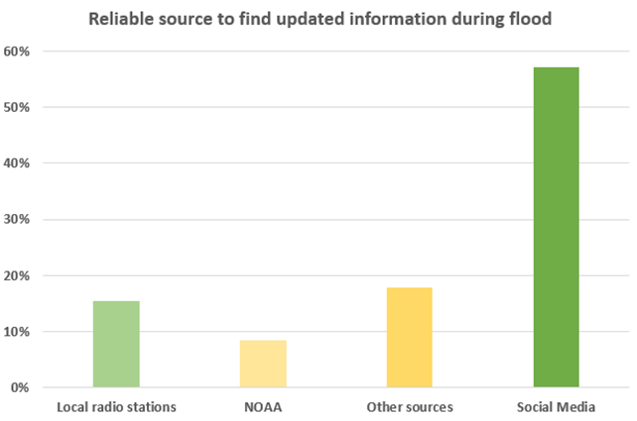

Figure 9: Reliable sources of information by the survey respondents

**Social Vulnerability**

Natural hazards, such as floods, can impact individuals and communities differently depending on their social and demographic characteristics. The social context of a community can function as a filter, moderating or exacerbating the consequences of a hazard. Social vulnerability is a situation where certain demographic and socioeconomic characteristics make some groups of people more susceptible to hazards, affecting their ability to anticipate, respond to, and recover from them. Based on a local approach, we considered the vulnerability factors that were more applicable to the social context in the state of West Virginia. Therefore, we selected seven factors of poverty, unemployment, age, disability, population growth, renter-occupied residential units, and housing value to develop the social vulnerability indicators for the pilot study communities of White Sulphur Springs and Rainelle. We used data from the 2019 American Community Survey (ACS) 5-year Estimates published by the Census Bureau for most factors, except for population growth which was based on the Decennial Census (DEC) data from 2010 and 2020. To provide a broader context for the indicator values, we also computed the values at the state and national levels. The comparison can help in better understanding the magnitude of vulnerability in the study areas.

***Poverty Rate:*** The economic status including income and personal wealth is among the most agreed-upon social vulnerability factors. Households with lower incomes and fewer assets are generally considered to be more socially vulnerable to natural hazards like floods. The poor often lack the financial means to prepare for potential disasters and may be less able to recover from their effects. The poverty rate was calculated as the percentage of households with incomes below the poverty level according to the Census data. According to the results of this study, the percentage of households living below the poverty level in White Sulphur Springs is 14.4%, while in Rainelle, this ratio is much higher with 37% of households falling below the poverty line. Rainelle’s poverty rate is considerably higher than both the state and national ratios which are 17.3% and 12.9%, respectively.

***Unemployment Rate:*** Unemployment can exacerbate vulnerability to natural hazards, as those who are unemployed may face financial difficulties and may lack access to health benefits to cover the costs of injuries or deaths caused by disasters. In this study, the unemployment rate was calculated as the percentage of families (composed of two or more people living together and related by birth, marriage, or adoption) with no workers in the past 12 months (as of 2019). Based on the results, it is evident that the unemployment rate in Rainelle is considerably higher than that of White Sulphur Springs, the state, and the nation. White Sulphur Springs has an unemployment rate of 21.4% which is lower than the state ratio of 23.8% but still higher than the national rate of 14.7%. Rainelle has an unemployment rate of 33.6%, which is significantly higher than both the state and national ratios.

***Vulnerable Ages Ratio:*** Age can be a significant factor that influences people's vulnerability to natural disasters, including floods. Children and the elderly are generally more susceptible to disasters such as flooding due to the lack of experience or physical and cognitive limitations that hinder their ability to protect themselves. For this study, we defined the vulnerable age ratio as the proportion of the population who are either under 15 or over 65 years of age. In White Sulphur Springs, the above ratio is 41.7% while it is 39.8% in Rainelle. Both incorporated areas have higher percentages of the vulnerable age groups compared to the state (30.8%) and national (28.3%) ratios.

***Disability Ratio:*** Individuals with physical or mental disabilities, regardless of their age, are more vulnerable to natural hazards. To measure this vulnerability, we calculated the disability ratio by using census data to determine the percentage of the civilian noninstitutionalized population with disabilities related to independent living, self-care, ambulatory, cognitive, vision, or hearing difficulties. In White Sulphur Springs, the ratio is 17.8%, which is slightly lower than the state ratio of 18.7% but higher than the national ratio of 13.0%. However, in Rainelle, the disability ratio is much higher at 26.9%, compared to the rates in the state and the country.

***Population Growth Ratio:*** While rapid population growth in densely populated urban areas can increase the risk of natural hazards, we believe that population decrease can contribute to social vulnerability in West Virginia by weakening the social and economic structures and making the communities less viable. In this study, we calculated the population growth ratio as the percentage of population change from 2010 to 2020. Based on our findings, the population in Rainelle is experiencing a significant decline at a growth rate of -20.9%. Meanwhile, the population in White Sulphur Springs is decreasing at a rate of -9.1%, which is still a considerable reduction when compared to the state and national ratios of -3.2% and 7.4%, respectively.

***Renter-Occupied Ratio:*** Housing characteristics can affect the degree of vulnerability to natural hazards. Low ratios of home ownership can indicate a community with a faltering economy and a population with a less long-term commitment to the community. Renters generally have less ability or motivation to make their homes resistant structurally or buy flood insurance. The ratio of renter-occupied units refers to the proportion of residential units that are occupied by renters out of the total number of occupied housing units. Both study areas have a high percentage of renter-occupied units, which may increase their susceptibility to flooding. White Sulphur Springs has a ratio of 42.8%, and Rainelle has a ratio of 43.0%. These ratios are higher than the state ratio of 26.8% and the national ratio of 36.0%.

***Housing Value:*** The value of housing can serve as an indicator of building quality which is an important factor in determining the vulnerability to natural hazards. Low-quality buildings are more susceptible to damage during flooding, which can exacerbate vulnerabilities of residents. Housing value can also be related to personal wealth. Therefore, the physical and social vulnerabilities to floods are generally tied at this point. For the housing value, we used the census data to calculate the percentage of the owner-occupied residential units with values less than $50K. We also took into account the median housing value in each community. Based on the data, we can observe that the two study areas have different patterns in terms of housing value. In White Sulphur Springs, a small percentage of housing units (3.9%) have a value of less than $50K, while the median housing value is $125,700. However, in Rainelle, a significantly higher proportion (37.5%) of owner-occupied residential units have a value below $50K, and the median housing value in this community is $59,400. The state-wide ratio of housing units with values less than $50K is 16.9%, with a median value of $119,600. At the national level, the ratio is 6.6%, and the median value is $229,800.

**Physical Vulnerability**

Physical vulnerability refers to the characteristics of physical assets, such as buildings and infrastructure, that makes them more susceptible to significant damage during flooding. These characteristics are crucial factors in determining the degree of damage to the physical assets caused by floods. Based on the available data, physical vulnerability may be determined by several factors including floor elevation, building type, number of stories, age, quality, and construction materials. In this study, the following indicators were investigated for physical vulnerability, based on the available data.

***Manufactured Homes:*** Lighter-weight manufactured homes are particularly more susceptible to flooding compared to conventional dwellings. These structures are not designed to withstand extreme weather conditions or flooding. Mobile homes are commonly located in rural areas or less desirable urban districts and are more affordable for low-income families. As a result, the concentration of such housing units can exacerbate both physical and social vulnerabilities. In some communities, manufactured homes are clustered together in separate parcels or mobile home parks which can increase the susceptibility. Based on the data, it can be concluded that the number of mobile homes in the high-risk floodplains is relatively low in both White Sulphur Springs and Rainelle. In White Sulphur Springs, only 1% of the total building exposure consists of mobile homes (n=4), while in Rainelle, it is 4% (n=14). These percentages are significantly lower than the statewide ratio of 11% for all incorporated areas, indicating that both communities are less vulnerable to flooding in this regard.

***Buildings with Basements:*** Floor elevation is one of the most important factors that determines the extent of flood damage to structures. Buildings with the lowest floor situated below the base flood elevation (BFE) or the level of a 1%-annual-chance flood are at greater risk of physical damage. Any area of a building having its floor below ground level (subgrade) can cause higher susceptibility to floods. Thus, primary structures located in flood zones that have basements are more vulnerable to flooding. The BLRA used in this study relies on the tax assessment database which does not differentiate between subgrade basements and walkout basement enclosures. Therefore, elevation certificates and building pictures should be used to confirm the accurate foundation type to prevent overestimating flood vulnerability and damage. In total, 93 at-risk primary buildings in White Sulphur Springs have basements accounting for 22% of the exposed structures while Rainelle has 27 such buildings (8%). In comparison to the statewide ratio of 37% for all incorporated areas, both communities have a low percentage of these structures.

***One-Story Buildings:*** One-story buildings are more vulnerable to flooding compared to multi-story structures. During a flood event, residents in single-story buildings have limited options for seeking higher elevations within their places. Additionally, because the entirety of a one-story building is typically exposed to floodwaters, the ratio of flood damage to replacement cost is often higher for such structures. In this study, we considered all residential buildings, including mobile homes, in one story for analysis of this type of vulnerability. The findings show that 336 one-story residential buildings exist in the high-risk floodplain of White Sulphur Springs which accounts for 79% of the total community-wide building exposure. In Rainelle, there are 292 single-story residential structures in the floodplain representing 86% of the total flood exposure in the town. The percentages are higher than the statewide ratio of 69% indicating higher vulnerability in this regard.

***Building Age and FIRM Status:*** Building age is an important factor to consider when assessing vulnerability to floods. Older buildings may have deteriorated foundations or other internal or external elements that are not visible leading to increased vulnerability during flooding events. The age of a building can be an indicator of its overall quality and its ability to withstand flood damage. The construction year of a building can also reveal whether it was built before or after the FIRM date of the community, with Post-FIRM buildings expected to be more flood-resistant due to adherence to the National Flood Insurance Program’s flood protection standards. However, this is not a guarantee for all Post-FIRM structures as some of them may still be minus-rated structures that means they have the lowest floor one foot or more below the base flood elevation. The median construction year for buildings located in the 1%-annual-chance flood zone in White Sulphur Springs is 1940 which is earlier than the statewide median of 1947. Therefore, the buildings in White Sulphur Springs may be more vulnerable to flooding due to their older construction. On the other hand, in Rainelle, the median building year in the floodplain is 1950 which is slightly higher than the statewide median. According to the study results, a large proportion of the at-risk structures in both communities were built before the FIRM dates, with Pre-FIRM percentages of 88% and 77% for White Sulphur Springs and Rainelle, respectively. This suggests that the flood-prone buildings in these communities may be more susceptible to damage as they were not constructed to meet the established standards.

***Low Valued (Red Tag) Structures:*** The quality of a building which is determined by its construction conditions and maintenance state is a crucial factor in flood vulnerability. Buildings of low quality and unmaintained vacant structures are unable to withstand flooding making them more vulnerable to its effects. In this study, the dilapidated or vacant residential and commercial Buildings with low values were extracted and marked as red tag in the communities. Based on the study, it was found that 14 buildings in White Sulphur Springs and 49 buildings in Rainelle were identified as having red tags, indicating a low percentage of 3% for White Sulphur Springs and a higher ratio of 14% for Rainelle. Therefore, Rainelle may be more vulnerable in terms of building quality.

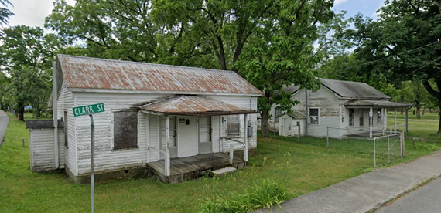

Figure 10: Examples of low valued (Red Tag) structures in Floodplain of White Sulphur Springs

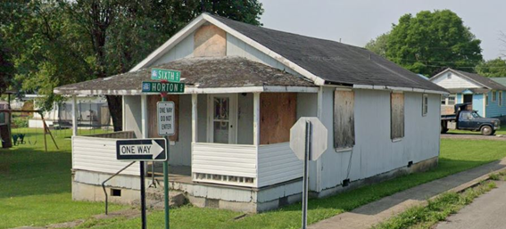

Figure 11: Example of low valued (Red Tag) structures in Floodplain of Rainelle

**Flood Loss Estimates**

Quantifying the degree of flood risk is important for risk communications and flood reduction efforts. Flood loss models quantify the degree of flood risk, including estimates of substantially damaged structures. *Hazus* flood loss models and the best-available depth grids quantify the degree of flood risk of each structure or feature. FEMA’s open-source *Hazus* utility, Flood Assessment Structure Tool (FAST), provides a standardized methodology for estimating potential building losses for a 1%-annual-chance flood event. Debris removal and maximum restoration times are also determined. The FAST utility is supplemented with population and short-term sheltering models according to *Hazus* methodology.

**Physical Loss**

In this study, the results from FAST calculated for a 1%-annual-chance flood event were summarized to investigate the following physical loss indicators for the study areas.

**Building Damage Dollar and Ratio Estimates**

Total Exposure in Floodplain (TEIF) provides an approximate value of potential economic losses in the high-risk flood hazard areas and a relative comparison of potential flood loss. The Hazus flood loss model for a 1%-annual-chance flood event for White Sulphur Springs reveals the Total Exposure in Floodplain (TEIF) dollar losses of $1.2M while the estimated dollar loss is $994K for Rainelle. The Total Building Dollar Value Exposure in the floodplain is divided by the Flood Loss Damage Dollar Estimates for a 1%-annual-chance flood to determine the ratio between the flood loss damage estimates and building dollar exposure. The percentage of building loss is 3% for White Sulphur Springs whereas it is 6% for Rainelle. It is noteworthy that both communities have lower percentages than the statewide ratio of 10% for all incorporated areas. In White Sulphur Springs, the median damage for individual buildings is $3,000 while it is $2,000 in Rainelle. These values are both lower than the statewide median dollar damage value of $7,000.

## Substantial and Moderate Damage Estimates

Damage of any origin sustained by a structure whereby the cost of restoring the structure to its before damaged condition would equal or exceed 50 percent of the market value of the structure before the damage occurred is known as substantial damage. According to the FAST, Rainelle has only one structure identified as substantially damaged by a 1%-annual-chance flood while no such damage is mapped in White Sulphur Springs. However, the data collection after the 2016 flood (between August 1st and August 9th) showed that 87 primary structures in White Sulphur Springs were substantially damaged, meaning the cost of restoring was equal to or greater than 50% of the replacement cost.

Damages of greater than 10% and less than 50% of the building replacement cost are referred to as moderate damages. The FAST model shows 78 primary structures at risk of moderate damages by a 1%-annual-chance flood in White Sulphur Springs which means 18% of the buildings located in the community’s floodplain are subject to such a damage. The collected data of the 2016 flood indicates that 98 structures were damaged to that level. In Rainelle, 106 buildings are marked for being at risk of moderate damage by a 100-year flood which represents 31% of the total exposed structures.

## Building Debris Removal Estimates

## Debris disposal can be a significant issue following floods. The Hazus Flood Model estimates debris from building damage during floods, including building finishes, and structural components. The physical damage estimates are not made for building contents, or for bridges or other lifelines. Debris removal estimates should be incorporated into debris removal plans. Building debris removal estimates are computed using Hazus flood model methodology as the total tonnage of debris that will be generated from a structure by a riverine 1%-annual-chance flood event. The model calculates only debris from the structure, not other types of debris (e.g., woody debris, sediment, content of buildings, etc.). The model estimates a total of 450 tons of debris for White Sulphur Springs and 809 tons for Rainelle. It appears that both communities have higher estimated amounts of debris compared to the statewide median of 165 tons for all incorporated areas.

**Previous Paid Losses**

A high number of flood insurance claims in a community indicates that flooding is occurring, and community members are making claims against their policies. Based on the data from the FEMA Community Engagement Prioritization (CEP), it can be observed that the number of flood insurance claims paid until 2019 is higher in Rainelle compared to White Sulphur Springs. Specifically, 152 flood losses were paid in Rainelle, while 89 claims were paid in White Sulphur Springs. Rainelle's high number of paid losses ranked the community 20th in the state for this parameter. In terms of the dollar amount of previous claims, about $3M was paid in White Sulphur Springs (ranked 15th in the state) until 2019. For Rainelle (ranked 10th in the state), the total amount of paid claims to that year is $3.7M.

**Repetitive Loss Structures**

Repetitive loss structures are defined by the National Flood Insurance Program (NFIP) as buildings that have had two or more losses of at least $1,000 in a ten-year period. If a community has a high number of repetitive loss structures, it may indicate that the area is more susceptible to flood damage and therefore at higher risk for future losses. The NFIP offers resources to help communities reduce the number of repetitive loss structures, such as floodplain management strategies and elevation requirements for structures in flood-prone areas. According to FEMA's CEP of 2019, Rainelle has a higher number of repetitive loss structures, with 23 such buildings identified. In contrast, White Sulphur Springs has only two repetitive loss structures, indicating a lower risk of future losses due to flooding in that community.

**Human Loss**

This study utilized the population displacement and shelter need models developed at the building level by the WVGISTC which were modified versions of FEMA's Hazus, to estimate human loss. The estimates are based on the Census Bureau’s American Community Survey (ACS) 5-year estimates of 2017.

**Displaced Population Estimates**

Exposure to floods can lead to population displacement or relocation which can be either temporary (short-term) or permanent (long-term). In cases where residential buildings are substantially damaged and uninhabitable or the location is at high risk of repeated floods, permanent relocation may occur. Short-term displacement can occur due to damage to residential units or inundation that blocks access to them. In such cases, evacuees plan to return to their communities once the inundation ends and the damaged residential units are restored. Until then, they may stay with relatives or friends, go to hotels, or use short-term shelters in safer areas. The physical access and property damages, which are functions of flood depth, are usually the factors that determine this type of evacuation. Typically, the flood depth for evacuation ranges from six inches, which is the typical height of a street curb, to one foot, which is the inundation depth at which vehicles start to float.

This study focused on the number of individuals who were displaced on a short-term basis due to flood inundation of one foot or higher caused by a 1%-annual-chance (100-year) flood event. The findings indicate that Rainelle is ranked 16th in the state with 487 displaced individuals which accounts for 36% of the total community population. In White Sulphur Springs (ranked 17th in the state), the estimated number of people displaced by a 1%-annual-chance flood is 462 which represents 17% of the city’s population.

**Short-Term Shelter Estimates**

A Short-Term Shelter is in an existing facility (or facilities), such as a school, community center, convention center, or church temporarily converted to provide safe, accessible, and secure short-term housing for disaster survivors. It provides safe and accessible locations with a wide range of services for the survivors for up to two weeks. Most American Red Cross shelters cannot accept pets because of health and safety concerns and other considerations, so displaced people may need to find alternative sheltering arrangements.

In order to further examine the impact of floods on human loss, we looked into the number of people who would require short-term shelters in the study areas. To estimate this, we used FEMA's Flood Model Hazus-MH Technical Manual, with some adjustments and updates, which takes into account population displacement as well as income (80% weight) and age (20% weight) in its calculation of short-term shelter needs at the community level. Based on the study, Rainelle would require short-term shelters for 123 individuals in case of a 1%-annual-chance flood, ranking it 14th in the state. In White Sulphur Springs (ranked 18th in the state), 104 people would need short-term shelters in such a scenario.

**Flood Mitigation**

**Mitigated Structures**

West Virginia has experienced a significant history of extreme rainfall and flooding. According to a 1998 analysis conducted by the U.S. Geological Survey, each county in the state has been designated as a federal flood disaster area at least once since 1967.

In recent decades, there has been a national increase in heavy downpours, and this trend is anticipated to persist due to the effects of climate change. For regions with mountainous terrains, such as West Virginia, extreme precipitation poses a heightened risk of flooding, particularly in valleys where water accumulates. The recent instances of flooding have vividly demonstrated the formidable force of water, capable of devastating lives and livelihoods, despite the availability of advanced warning systems.

In June 2016, Central West Virginia experienced a catastrophic flood that led to the initiation of the most extensive regional mitigation project since the historic April 1977 flood in the Tug Fork River Basin. The impact of the June 2016 flood was severe, resulting in the destruction or damage of numerous buildings, the loss of at least 23 lives, and widespread 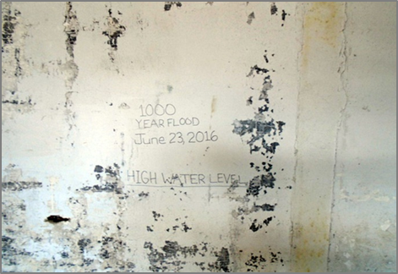flooding across various communities in West Virginia. Thus, flood mitigation strategies should be adopted since the number of severe flooding will increase in the future. Identifying mitigated structures will provide accurate information about building-level risk assessments. It will also highlight the implementation of flood adaptive measures in response to significant flood events in the communities.

Figure 12: High Water Mark in Rainelle, 2021. Image Courtesy: [**WVU Today**](https://wvutoday.wvu.edu/media-center-blog/2021/06/23/expert-pitch-a-double-whammy-of-tragedy-rainelle-residents-document-ongoing-2016-flood-recovery-work-in-the-time-of-covid-19-as-part-of-wvu-project). Retrieved on May 4, 2023

*Mitigation indicators* include Mitigation Reconstruction or Elevated Structures, Rehabilitated or Repaired Structures, Unmitigated Low-value Structures, and Removing Structures (vacant parcels).

Table 1: Number of properties for each of the mentioned indicators in both communities of Rainelle and White Sulphur Springs

| **MITIGATED STRUCTURES** | | |
| --- | --- | --- |
| **Mitigation Indicators** | **White Sulphur Springs** | **Rainelle** |
| Elevated Structures to Design Flood Elevation (DFE) | **217** | **87** |
| Percent of Residential Structures in 100-year floodplain elevated to Design Flood Elevation (DFE) | **59%** | **35%** |
| Rehabilitated or repaired structures | **394** | **278** |
| Unmitigated low-value structures | **14** | **47** |
| Removal of structures (vacant parcels) | **49** | **41** |

Figure 13: Mitigated Structures in Rainelle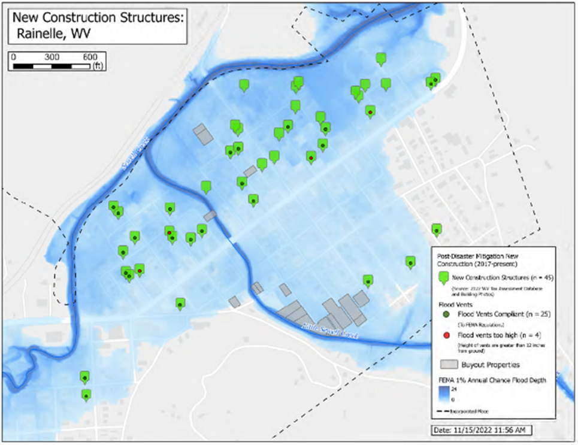

|  | Figure 14: Mitigated Structures in White Sulphur Springs |
| --- | --- |

**Open Space Preservation**

Natural floodplains reduce flood risk by effectively slowing down runoff and storing floodwater. However, their significant economic, social, and environmental benefits are mostly unnoticed during local land use decision-making processes. Open Space Preservation's primary rule is to restore floodplains to their natural function while providing credits through FEMA's Community Rating System (CRS). A parcel must meet specific criteria to be classified as an open space parcel under the Community Rating System (CRS) program. According to the CRS program, open space must be free from any buildings, filling, paving, or other encroachments that may impede flood flows. As defined by the CRS program, preservation refers to a piece of land that is protected by a valid statement from a public (or credible private) owner or by regulations that explicitly prohibit any construction, filling, or other encroachments that obstruct flood flows. It should be considered that communities are not required to pass specific ordinances or maintain the land completely undeveloped in order to be eligible for credit under the Community Rating System (CRS) program.

The mitigation indicators for Open Space Preservation are listed as Buyout Parcels (Deed Restricted), Community-owned vacant parcels, Area of Open Space Preservation (OSP), and Ratio of Open Space Preservation (OSP to SFHA).

Buyout Properties are defined as parcels of land located within floodplains prone to frequent flooding and damage. They may undergo alterations, purchase, or have deed restrictions imposed by FEMA or other relevant agencies. These parcels are implemented to mitigate the risk of loss of life and property damage. Property owners or communities that possess public lands within floodplains are typically provided compensation for their properties, with the land often being transformed into public green spaces or restored to its original floodplain function.

Table 2: Number of each indicator in both communities of Rainelle and White Sulphur Springs.

| **Open Space Preservation** | | |
| --- | --- | --- |
| **Mitigation Indicators** | **White Sulphur Springs** | **Rainelle** |
| Buyout Parcels (Deed Restricted) | **16** | **18** |
| Community-owned vacant parcel | **66** | **88** |
| Area of Open Space Preservation (OSP) | **5 Acres** | **3 Acres** |
| Ratio of Open Space Preservation (OSP to SFHA) | **2.6%** | **4.5%** |

**Building Value Recovery**

Based on tax assessment data from 2016 to 2022, due to the 2016 flood, the building values experienced a sharp decline in 2017, and in subsequent years, the building values started to recover gradually. This suggests that the communities impacted by the flood have been able to implement mitigation measures and rebuild damaged properties, leading to a slow but steady recovery of property values. However, tax assessment data may not provide a complete picture of a property's actual value since it may not consider market demand, property condition, or other local economic factors that can impact property values. Additionally, the recovery of building values may vary depending on the specific location and level of flood mitigation efforts implemented in the area.

It is important to note that the recovery process may vary across different communities and individual properties, and some properties may still struggle to recover from the flood damage fully. Thus, the pace of recovery would be different in the two communities. For instance, building costs have increased steadily in Rainelle, while White Sulphur Springs' have risen since 2020. The number of buildings in a flood zone in White Sulphur Springs is higher than in Rainelle, so the cumulative building values in this town would be higher. However, the graph indicates that the building recovery after the 2016 flood has been significant. In 2020, the cumulative building value exceeded the total value of buildings in 2015 (before the flood). On the other hand, in Rainelle, the graph shows that the cumulative building value is still less than it was in 2015.

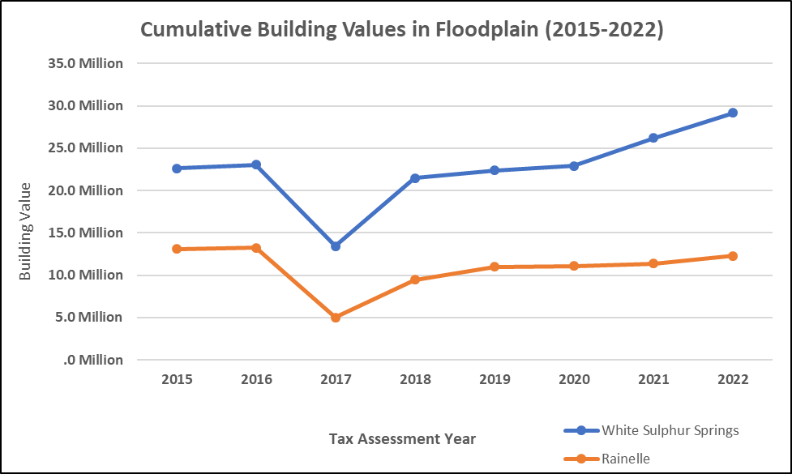

Figure 15: Cumulative Building Values between 2015-2022 in Rainelle & White Sulphur Springs

Table 3: Building value Recovery among the years 2015-2022

| **COMMUNITY** | **VALUES ON MILLION DOLLAR BASED ON 2022 TAX ASSESSMENT** | | | | | | | |
| --- | --- | --- | --- | --- | --- | --- | --- | --- |
| **2015** | **2016** | **2017** | **2018** | **2019** | **2020** | **2021** | **2022** |
| **Rainelle (n=326)** | **13.1** | **13.3** | **5.0** | **9.4** | **11.0** | **11.1** | **11.3** | **12.3** |
| **White Sulphur Springs (n=409)** | **22.6** | **23.0** | **13.4** | **21.5** | **22.4** | **22.9** | **26.2** | **29.2** |

**Source: Tax assessment database. May not include values for tax exempt properties.**

**Loss Avoidance 100-year Flood**

Flood loss avoidance refers to the measures taken to minimize or prevent flood damage to buildings and personal property before a flood event, as defined by FEMA(2018). It is a proactive approach to protecting the buildings and personal belongings. Taking proactive measures to protect buildings and personal belongings can help minimize flood damage and losses. These measures can be implemented both in and around the property. They may include various flood mitigation strategies such as elevating the structure, installing flood-resistant materials, sealing walls and foundations, and relocating valuables to higher ground. For example, the communities of White Sulphur Springs and Rainelle spent an orderly 2.6 and 2.3 million dollars for their flood loss avoidance in a 100-year flood.

**Higher Standards**

To participate in the National Flood Insurance Program, a community must follow the minimum floodplain management regulations requirements. These regulations are designed to prevent loss of life, property damage, and social and economic hardships caused by flooding. Therefore, the community must adopt and enforce these regulations, ensuring they meet or exceed the standards set by the NFIP. These higher standards include freeboard (constructing two feet above Base flood elevation) and implementing flood mitigation strategies, which is higher than a Community Rating System above the minimum requirement. Unfortunately, neither White Sulphur Springs nor Rainelle is not in the CRS credit system.

**Flood Insurance**

Based on FEMA's calculations, the presence of as little as 3 inches of floodwater in a home is typically sufficient to require replacement of several key components, including drywall, baseboards, carpets, and furniture. The cost of repairs is likely to increase with the depth of the floodwater, as water levels reaching 18 inches or more may necessitate work on the electrical system and heating/cooling systems, as well as replacement of doors, appliances, and cabinetry. In the absence of flood insurance coverage, the projected out-of-pocket expense for a 1,000 square foot, single-story home experiencing 3 inches of floodwater is roughly $12,000. For 6 inches of water, the estimated cost of losses increases to around $21,000 (FEMA, 2021).

The National Flood Insurance Program's (NFIP) Community Rating System (CRS) is a voluntary incentive program that recognizes and encourages community floodplain management activities that exceed the minimum NFIP requirements. Although flood zones are designated as specific geographic areas where the likelihood of flooding is statistically higher, it's important to note that floods can still happen outside of these zones. According to FEMA (2021), it's a smart decision to think about purchasing flood insurance for a property, even if it is situated outside of a high-risk flood zone (known as a Special Flood Hazard Area). This is because statistics indicate that over 25% of flood claims filed across the nation come from individuals who reside outside of these high-risk areas.

According to the FEMA Community Engagement Prioritization (CEP), in 2019, 133 policies in White Sulphur Springs and 44 in Rainelle were issued. The FEMA’s Flood Insurance Data and Analytics* of 2023 shows 67 policies in force in White Sulphur Springs which represents about 16% of the primary structures in the high-risk floodplain. For Rainelle, the data indicate 36 policies in force which is about 11% of the at-risk primary buildings.

* Link to download: <https://nfipservices.floodsmart.gov/reports-flood-insurance-data>

Nobody is exempt from flood risk, where it can rain it can flood. While the purchase of flood insurance is not required for structures outside of the Special Flood Hazard Area (SFHA), buying flood insurance is strongly recommended. According to the FEMA’s report of the 2016 flood in West Virginia**, approximately 23% of the insurance claims related to that event in the affected counties were outside the SFHA. In such cases, the owners have to apply for FEMA’s Individual Assistance (IA) program which provides a small amount of grant funding to disaster survivors who do not have flood insurance.

** Link to download: <https://www.fema.gov/sites/default/files/documents/Region_III_WV_FloodReport.pdf>