APPENDIX A: Building Counts Risk Indicator
Detailed Analyses of Building Counts at 8 aggregate scales along with findings, description, rationale, recommendations, and data sources. The Building Counts indicator is one of 29 risk factors.

BUILDING COUNT Fast Facts and Graphics

Statewide
- Building Risk Percentage by FEMA Mapped Flood Zones. Of the estimated 1.1 million primary structures in West Virginia, 13% of the buildings (138,623) in the state are subject to riverine and flash flooding, according to FEMA’s mapped flood zones of reduced/moderate risk (Shaded X Zones) and high risk (A and AE Zones).
  - Building Count by Special Flood Hazard Area (SFHA). In West Virginia, 84,490 primary structure or 8% of all structures in the state are in the high-risk Special Flood Hazard Area or 1%-annual chance (100-YR) floodplain.
  - Building Count by Floodway. 10% of all structures (8,572) in the state are in the Regulatory Floodway, the main channel of the river or stream that is subject to the greatest flood depths, highest velocities, and greatest debris potential.
  - Building Count by Flood Study Type. A breakdown of buildings within the high-risk flood areas reveals that 65% of the buildings (55,112) are in Detailed “Zone AE” studies and 35% (29,378) in “Approximate Zone A” studies.
  - Building County by High-Risk Advisory Zones / Future Map Conditions. Currently 54 of 55 counties in the state have advisory floodplains, increasing the high-risk effective and advisory floodplain building count of 97,936 structures. If the future flood studies were to become effective, then an additional 14% structures will be mapped into the SFHA, 16% structures mapped out, resulting in a decrease of 2% structures stateside, and the remaining 70% no change.
  - Flood Zone Study Types. Of the 14,255 miles of Special Flood Hazard Areas in the state, the flood studies comprised 70% Approximate A Zones and 30% Detailed AE Zones.
Static Map Links: SFHA Building Density Graphic | SFHA Zone A/AE Study Types

Regions
- 3 Regional Councils in the southern and southwestern parts of the state have the highest building floodplain counts greater than 11,000 structures, representing 58% of all high-risk floodplain structures in the state: Region 3 (19,221 buildings), Region 2 (17,016), and Region 1 (11,158).
Static Map Links: Natural Break Graphic | Percent Rank Graphic

Counties
- The top 10% counties with the highest building counties are Kanawha (13,452), Logan (4,498), McDowell (3,479), Mingo (3,229), Boone (3,094), and Ohio (2,992) counties.
- In the high-risk Special Flood Hazard Area, Kanawha County has the most primary structures of 13,452, three times the second ranked Logan County of 4,498 structures.

Static Map Links: Natural Break Graphic | Percent Rank Graphic

Communities
- The unincorporated areas of Kanawha, Logan, and Mingo counties, followed by the city of Wheeling, are the top four ranked communities with the highest building counts in the Special Flood Hazard Area.
- Of the 28 unincorporated and incorporated communities which comprise the top 10% of all 266 floodprone communities, four are municipalities are located on the Ohio and Kanawha Rivers: Wheeling (Ranked 4th), Charleston (12th), Huntington (18th), St. Albans (19th), and Dunbar (23rd).
Static Map Links: Natural Break Graphic | Percent Rank Graphic

Unincorporated Areas
- The top 10% ranked unincorporated areas (1-Kanawha, 2-Logan, 3-Mingo, 4-Boone, 5-Lincoln, 6-McDowell) are the same as the top 10% counties (1-Kanawha, 2-Logan, 3-McDowell, 4-Mingo, 5-Boone, 6-Ohio) except that Ohio County is ranked 5th and Lincoln County ranked 9th for the countywide floodplain totals.
- Static Map Links: Natural Break Graphic | Percent Rank Graphic

Incorporated Places
- The top 8 ranked municipalities and nearly half of the top 10% places are located along the Ohio or Kanawha Rivers: Wheeling (2,685 structures), Charleston (1,512), Huntington (1,099), St. Albans (1,043), Dunbar (903), New Martinsville (756), Wellsburg (716), and Nitro (659).
- The city of Wheeling has the highest number of structures at 2,685 followed by the cities Charleston and Huntington with more than a thousand structures in the Special Flood Hazard Area. Additionally, the cities of Charleston and Huntington intersect three different HUC-8 subbasin watersheds, which are analogous to medium sized river basins.
- All the top 10% or top-ranked 23 places have multiple flood sources, or at least a single confluence where a tributary joins a larger river, which during major storms can lead to backwater flooding and much higher flood depths.
- A new floodwall planned for the incorporated place of Milton, Cabell County, currently ranked tenth in state with 407 structures in the Special Flood Hazard Area, will significantly reduce the town’s flood risk.
Static Map Links: Natural Break Graphic | Percent Rank Graphic

Watersheds
- The top 10% ranked, or top 4 subbasins of 33 HUC-8 watersheds in the state, according to the most buildings in the high-risk Special Flood Hazard Area, are the Lower Kanawha (7,989 buildings), Coal (6,240), Upper Guyandotte (6,211), and Upper Ohio-Wheeling (5,845) watersheds.
Static Map Links: Natural Break Graphic | Percent Rank Graphic

Streams
- The top 5% ranked streams with more than a thousand floodplain structures are the Ohio River (7,237 buildings), Kanawha River (7,116), Elk river (2,253), Greenbrier River (1,821), Guyandotte River (1.494), Tug Fork (1,410), Little Kanawha River (1,205), Mud River (1,133), and Island Creek (1,110).
- Only 2% of all the named streams or rivers (n=6,748 streams) in the State have more than 100 buildings, while 46% of all names streams have a minimum of 1 building.
Static Map Links: Natural Break Graphic | Percent Rank Graphic

BUILDING COUNT Detailed Findings

STATEWIDE
SPECIAL FLOOD HAZARD AREA. In West Virginia, 84,490 primary structure or 8% of all structures in the state are in the high-risk Special Flood Hazard Area or 1%-annual chance (100-YR) floodplain. In the Special Flood Hazard Area, flood insurance is mandatory for structures with federally-back mortgages. A breakdown of buildings within the high-risk flood areas reveals that 65% of the buildings (55,112) are in Detailed “Zone AE” studies and 35% (29,378) in “Approximate Zone A” studies. Zone AE studies are studied in more detail to include floodways and field surveys. Ten percent of all structures (8,572) in the state are in the Regulatory Floodway, the main channel of the river or stream that is subject to the greatest flood depths, highest velocities, and greatest debris potential. Development is not allowed in the floodway unless “no rise” in flood levels is certified.
HIGH-RISK ADVISORY FLOOD ZONES. Advisory flood studies represent future map conditions for floodplain boundaries and base flood elevations. Type of advisory floodplains are (1) Advisory Flood Heights (Approximate A Zones), (2) Redelineated Updated AE Zones, (3) and Draft/Preliminary National Flood Hazard Layers generated during ongoing restudies. For floodplain determinations, the best-available flood information should always be considered.
The state has published non-regulatory flood studies for 54 counties in which it is estimated 30% of all the SHFA structures will either be mapped in or out of the SFHA. Although more detailed mapping of smaller watersheds is resulting in additional structures being mapped into the Special Flood Hazard Area, more structures are being mapped out of the SFHA because of better-quality LiDAR-derived topography and flood models. Currently there are 97,936 structures in the high-risk, effective and advisory flood areas, of which it is estimated that as future flood studies become effective, 16% of the statewide structures will be mapped out of the SFHA, while 14% of the structures mapped into the SFHA, resulting in a net statewide decrease of 2% structures mapped out of the SFHA.
OTHER FLOOD ZONES. If buildings are counted in other flood zones, such as the moderate risk 0.2% annual chance (500-YR) and reduced risk levee protected zones, then 138,623 structures or13% of all structures in the state are at flood risk. Besides riverine flooding, many homes outside the Special Flood Hazard Area may be vulnerable to other types of flooding, particularly flash flooding on small streams, runoff rushing down mountainsides, and urban stormwater flooding. In fact, FEMA makes a regular point of noting that 25 percent of flood claims come from areas outside the Special Flood Hazard Area with low-to-moderate risk. For example, during the major June 2016 flood, multiple houses were swept away and a person died in an unmapped FEMA flood zone during the flash flooding of a small stream named Jordan Creek, a tributary of the Elk River near Clendenin, WV. Historical research of flood fatalities in the state reveals that extreme rainfall events and flash flooding in the headwaters of watersheds can turn small streams like Jordan Creek into raging rivers, resulting in loss of life and property.
In summary, of the estimated 1.1 million primary structures in West Virginia, 13% of the structures (138,623) are subject to riverine and flash flooding. In the Special Flood Hazard Area, it is estimated that 8% of all primary structure (84,490) in the state are subject to the highest risk of flooding, of which 1% of these structures are mapped in the floodway where the highest flood depths and velocities can occur.
FLOOD ZONE STUDY TYPES. Of the 14,255 miles of Special Flood Hazard Areas in the state, the flood studies comprised 70% Approximate A Zones and 30% Detailed AE Zones. For many rural counties with few metropolitan centers, most of the flood zones mapped in the county are Approximate A Zones.
During FEMA’s Discovery Phase of Risk MAP studies, the state should identify Approximate A Zone stream reaches with a high density of structures and loss potential for upgrading to detailed studies. Typically, detailed studies use more refined hydrologic modeling instead of just using regression equations. In addition, detailed studies include the floodway and hydraulic models with structure and bathymetric surveys. Extra FEMA products such as the “floodway data table” and “flood profiles” are only included in detailed studies. Per federal regulations, FEMA cannot publish base flood elevations for Approximate A Zones like is done on the WV Flood Tool.
Fewer miles of floodplain in West Virginia are detailed studies because of the higher costs. Prices differ by mapping contractor, but the costs are approximately $350 per Zone A mile and $2,500 per Zone AE mile.

REGIONS (11)
Three Regional Councils in the southern and southwestern parts of the state have the highest building floodplain counts greater than 11,000 structures: Region 3 (19,221 buildings), Region 2 (17,016), and Region 1 (11,158). Although Region 1 (6 counties), Region 2 (6 counties), and Region 3 (4 counties) represent 29% of all 55 counties, this contiguous southwest portion of the state has 58% of all high-risk floodplain structures in the state. These three regions also contain the top 5 ranked countywide building count totals: Region 3 – Kanawha and Boone counties; Region 2 – Logan and Mingo counties; and Region 1 – McDowell County.
Region 11 (2 counties) in the Northern Panhandle and Region 9 (3 counties) in the Eastern Panhandle have the least number of structures of 1,372 and 1,436, respectively. The median and mean statistics of 11 Regional Planning and Development Councils in the state are 6,204 and 7,492 structures, respectively. The eight split communities across regional and county borders are summarized accordingly to the corresponding Regional Council or county.

COUNTIES (55)
The top 10% counties with the highest building counties are Kanawha (13,452), Logan (4,498), McDowell (3,479), Mingo (3,229), Boone (3,094), and Ohio (2,992) counties. In the high-risk Special Flood Hazard Area, Kanawha County has the most primary structures of 13,452, three times the second ranked Logan County of 4,498 structures. While Kanawha County, the fourth largest county in the state by land area, has the most buildings in the Special Flood Hazard Area, Grant County, ranked 19th in land size, has the least number of structures for a county with 300 buildings. Regionally, except for Ohio County in the Northern Panhandle with the large urban center of Wheeling, the counties with the most structures in the Special Flood Hazard Area are in the southwestern part of West Virginia. The median and mean statistics of 55 counties in the state are 939 and 1,498 structures, respectively. Additionally, Mason County has the highest percentage of detailed Zone AE flood zones at 71%, while Ritchie County has the lowest percentage of detailed flood zones at 0.4%.

COMMUNITIES (284)
There are 284 communities in the state comprised of 55 unincorporated areas and 229 incorporated places. The incorporated places are further subdivided into 211 floodprone communities and 18 communities with no Special Flood Hazard Areas. Additionally, there are 8 incorporated places that are split across the county boundary (Wheeling, Huntington, Nitro, Alderson, etc.). At the community level, floodplain managers enforce the floodplain management ordinance as participants of FEMA’s National Flood Insurance Program.
The unincorporated areas of Kanawha, Logan, and Mingo counties, followed by the city of Wheeling, are the top four ranked communities with the highest building counts in the Special Flood Hazard Area. Of the 28 unincorporated and incorporated communities which comprise the top 10% of all 266 floodprone communities, four are municipalities are located on the Ohio and Kanawha Rivers: Wheeling (Ranked 4th), Charleston (12th), Huntington (18th), St. Albans (19th), and Dunbar (23rd). The median and mean statistics of 266 floodprone communities in the state are 77 and 310 structures, respectively. It should also be noted that typically both the unincorporated area and countywide rankings are similar.

UNINCORPORATED AREAS (55)
The top 10% ranked unincorporated areas (1-Kanawha, 2-Logan, 3-Mingo, 4-Boone, 5-Lincoln, 6-McDowell) are the same as the top 10% counties (1-Kanawha, 2-Logan, 3-McDowell, 4-Mingo, 5-Boone, 6-Ohio) except that Ohio County is ranked 5th and Lincoln County ranked 9th for the countywide floodplain totals. Kanawha County Unincorporated has the highest floodplain building count of 7,950 structures, which is greater than all the countywide totals of all the other counties in the state. Brooke County has the smallest count of floodplain structures of 94 in the high-risk Special Flood Hazard Area. The median and mean statistics of the 55 unincorporated areas in the state are 595 and 1,028 structures, respectively.

INCORPORATED PLACES (229)
Twenty-three municipalities comprise the top 10% of all the 211 floodprone municipalities. The top 8 ranked municipalities and nearly half of the top 10% places are located along the Ohio or Kanawha Rivers: Wheeling (2,685 structures), Charleston (1,512), Huntington (1,099), St. Albans (1,043), Dunbar (903), New Martinsville (756), Wellsburg (716), and Nitro (659). The city of Wheeling has the highest number of structures at 2,685 followed by the cities Charleston and Huntington with more than a thousand structures in the Special Flood Hazard Area. The median and mean statistics of 211 floodprone incorporated places in the state are 50 and 123 structures, respectively.
All the top 10% or top-ranked 23 places have multiple flood sources, or at least a single confluence where a tributary joins a larger river, which during major storms can lead to backwater flooding and much higher flood depths. Five of the top ranked communities are in the Lower Kanawha Watershed and four communities in the Upper-Ohio Wheeling Watershed. The cities of Charleston and Huntington intersect three different HUC-8 subbasin watersheds, which are analogous to medium sized river basins.
A new floodwall planned for the incorporated place of Milton, Cabell County, currently ranked tenth in state with 407 structures in the Special Flood Hazard Area, will significantly reduce the town’s flood risk. The proposed new flood mitigation project for Milton will protect over 600 homes and businesses in the town after constructing a 1.5-mile-long earthen levee estimated at a cost of 190.7 million. Like other floodwalls (e.g., Matewan, Williamson, Huntington), the Milton floodwall project along the Lower Mud River will substantially reduce the flood risk behind the levee. It is estimated the new floodwall will lower the annual chance of exceedance to 0.4% (250-YR flood), thereby removing a significant number of structures from the high-risk Special Flood Hazard Area or 1% annual chance floodplain.

STREAMS/RIVERS (6,748)
There are 6,748 named streams in the state, of which 3,115 streams or 46% of the total named streams have a minimum of one building in the Special Flood Hazard Area, and 115 or 2% of all the named streams have more than 100 buildings.
The Ohio and Kanawha Rivers have more than 7,000 buildings in the high-risk floodplains at 7,237 and 7,116 structures, respectively. The top 5% ranked streams with more than a thousand floodplain structures are the Ohio River (7,237 buildings), Kanawha River (7,116), Elk River (2,253), Greenbrier River (1,821), Guyandotte River (1.494), Tug Fork (1,410), Little Kanawha River (1,205), Mud River (1,133), and Island Creek (1,110).

WATERSHEDS (33)
The top 10% ranked, or top 4 subbasins of 33 HUC-8 watersheds in the state, according to the most buildings in the high-risk Special Flood Hazard Area, are the Lower Kanawha (7,989 buildings), Coal (6,240), Upper Guyandotte (6,211), and Upper Ohio-Wheeling (5,845) watersheds.
Of the 33 watersheds, the geographic extents of only 13 of these watersheds are totally within West Virginia. In terms of watershed size, the largest four watersheds in square miles are the Little Kanawha, Greenbrier, Elk, and Gauley watersheds.

BUILDING COUNT Top Rankings and Maps

DESCRIPTION. A count of all primary insurable structures in the high-risk, 1%-annual-chance (100-yr) floodplain, or Special Flood Hazard Area (SFHA) on FEMA’s Flood Insurance Rate Maps (FIRMs).
RATIONALE.
- The higher number of buildings in the floodplain indicates higher physical and human exposure to riverine flooding. If a building owner has a mortgage from a federally regulated lender and the property is in the Special Flood Hazard Area, then the building owner is required by Federal law to carry flood insurance.
- The building count in the SFHA is a programming variable required for those communities participating in FEMA’s Community Rating System (CRS) program.
RECOMMENDATIONS.
- Communities with a high floodplain building count should actively engage property owners about flood insurance and minimizing flood losses of property owners. See Floodsmart.gov for more information.
- Communities can become more resilient to flooding by exceeding the minimum NFIP requirements. Higher building standards adopted by local communities may include increasing the freeboard of the base flood elevation; or encourage property owners to build to the higher 500-year flood elevation or historical high-water mark.
- Floodplain managers and emergency planners should pre-load at-risk structures into substantial damage estimator software. Local officials should review early warning systems as well as short-term shelters located outside the floodplain and away from inundated roads.
- State and county leaders should prioritize pre-disaster planning for communities with many flood-prone buildings.

METHODOLOGY. A statewide, detailed inventory of all primary structures in the Special Flood Hazard Area was validated using the best available data, including leaf-off aerial imagery, tax parcels, E-911 addresses, and other reference layers. The following key attributes were inventoried and checked individually for each building: building value, occupancy class, foundation type, number of stories, and building area. A unique identifier was assigned to each building by combining the Parcel ID and Address Number. The statewide building inventory is updated when new flood studies become available and periodically from new tax assessment data. For structures located in the reduced and moderate risk flood zones, structures were only inventoried using building footprints in which full building characteristics were not individually collected or verified.

8 GEOGRAPHIC SCALES ANALYSES

- Statewide
- 11 Regional Councils
- 55 Counties
- 284 Communities
  - 55 Unincorporated Areas
  - 229 incorporated Places
(8 split municipalities across county border)

- 33 Watersheds
- 6,748 Named Streams

Figure BC-1. Building Count in Special Flood Hazard Area (Statewide Scale)
BUILDING COUNT (STATEWIDE SCALE)
DESCRIPTION: A count of all primary insurable structures in the high-risk, 1%-annual-chance (100-yr) floodplain, or Special Flood Hazard Area (SFHA) on FEMA’s Flood Insurance Rate Maps (FIRMs).
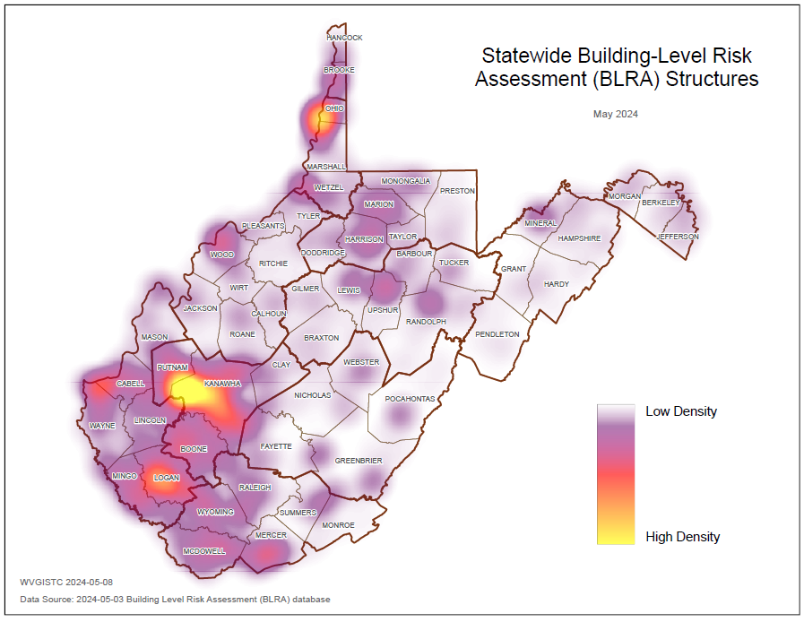 |  |  |  | HIGH-RISK REGULATORY ZONES
Buildings in Special Flood Hazard Area
1% Annual Chance (100-YR) Flood Zone
 |  |  |  | Special Flood Hazard Area |  |  | 84,490
 |  |  |  | - Detailed Zone AE |  | 65% | 55,112
 |  |  |  | - Approximate Zone A |  | 35% | 29,378
 |  |  |  | - Zone AE Floodway |  | 10% | 8,572
 |  |  |  | HIGH-RISK ADVISORY FLOOD ZONES
Includes Buildings in Non-Regulatory Zones
Future Map 1% AEP (100-YR) Flood Zones
 |  |  |  | High-Risk Flood Zones |  |  | 97,936
 |  |  |  | - Mapped No Change |  | 70% | 69,093
 |  |  |  | - Mapped out SFHA |  | 16% | -15,528
 |  |  |  | - Mapped in SFHA (non-regulatory) * |  | 14% | 13,315
 |  |  |  | - SFHA net change |  | -2% | -2,213
 |  |  |  | Structures est. in SFHA |  |  | 82,408
 |  |  |  | * 54 counties have Advisory A / AE Flood Zones
 |  |  |  | OTHER FLOOD ZONES
Buildings in Shaded X Zones
Moderate or Reduced Flood Risk Areas
 |  |  |  | High and Moderate Risk Zones |  |  | 138,623
 |  |  |  | - 0.2% annual chance (500-YR) flood (moderate risk) |  |  | 44,415
 |  |  |  | - Levee Protected Zones (reduced risk) |  |  | 9,718
SFHA ZONE A STUDY TYPES
- 70% Approximate A Zones
- 30% Detailed AE Zones
WEB LINKS: | SFHA Building Density Graphic | SFHA Zone A/AE Study Types | Web Map |  | Web Report
Sources: WV BLRA (Building-Level-Risk Assessment) for High-Risk Effective/Advisory Zones; FEMA Flood Insurance Rate Maps (FIRMs) for SFHA. Report Date 20240429.
Figure BC-2. Building Count in Special Flood Hazard Area (County Scale)
BUILDING COUNT (REGIONAL COUNCIL SCALE)
DESCRIPTION: A count of all primary insurable structures in the high-risk, 1%-annual-chance (100-yr) floodplain, or Special Flood Hazard Area (SFHA) on FEMA’s Flood Insurance Rate Maps (FIRMs).

 |  |  |  | Rank | Region (11) |  | Count | % Rank
 |  |  |  | 1 | Region 3 |  | 19,221 | 92%
 |  |  |  | 2 | Region 2 |  | 17,016 | 83%
 |  |  |  | 3 | Region 1 |  | 11,158 | 75%
 |  |  |  | 4 | Region 6 |  | 6,049 | 67%
 |  |  |  | 5 | Region 4 |  | 6,044 | 58%
 |  |  |  | 6 | Region 10 |  | 6,024 | 50%
 |  |  |  | 7 | Region 5 |  | 5,752 | 42%
 |  |  |  | 8 | Region 7 |  | 5,418 | 33%
 |  |  |  | 9 | Region 8 |  | 2,918 | 25%
 |  |  |  | 10 | Region 9 |  | 1,436 | 17%
 |  |  |  | 11 | Region 11 |  | 1,372 | 8%
 |  |  |  | REGIONAL SCALE STATISTICS
 |  |  |  | Minimum (REGION 11) |  |  |  | 1,372
 |  |  |  | Maximum (REGION 1) |  |  |  | 19,221
 |  |  |  | Median |  |  |  | 6,204
 |  |  |  | Mean |  |  |  | 7,492
 |  |  |  | Statewide Total |  |  |  | 82,408
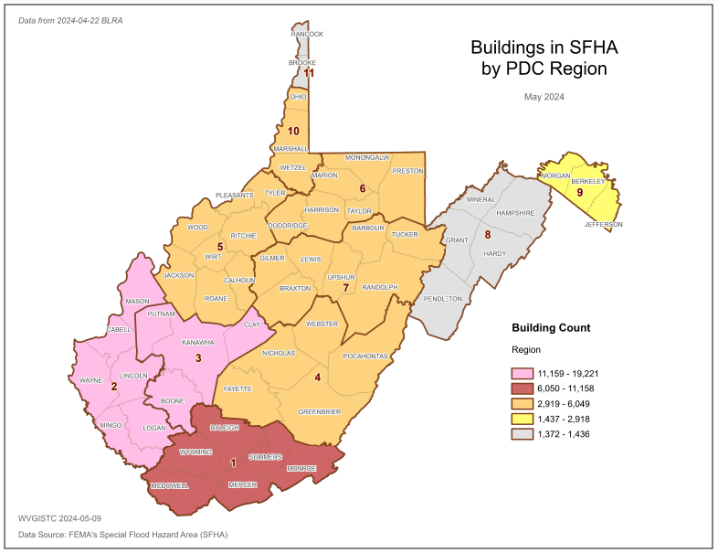
WEB LINKS: | Natural Break Graphic | Percent Rank Graphic | Web Map |  |  | Web Report
Sources: WV BLRA (Building-Level-Risk Assessment) for High-Risk Effective/Advisory Zones; FEMA Flood Insurance Rate Maps (FIRMs) for SFHA. Report Date 20240429.

Figure BC-3. Building Count in Special Flood Hazard Area (County Scale)
BUILDING COUNT (COUNTY SCALE)
DESCRIPTION: A count of all primary insurable structures in the high-risk, 1%-annual-chance (100-yr) floodplain, or Special Flood Hazard Area (SFHA) on FEMA’s Flood Insurance Rate Maps (FIRMs).
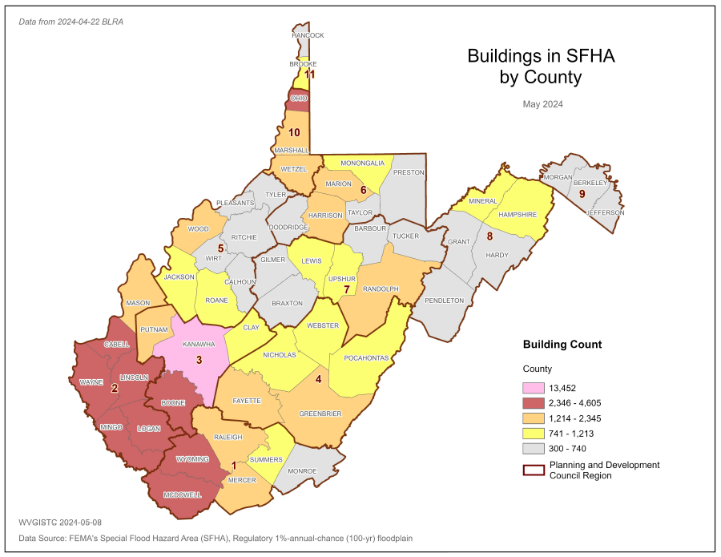 |  |  |  | Rank | County (55) |  | Count | % Rank
 |  |  |  | 1 | KANAWHA |  | 13,452 | 100%
 |  |  |  | 2 | LOGAN |  | 4,498 | 98%
 |  |  |  | 3 | MCDOWELL |  | 3,479 | 96%
 |  |  |  | 4 | MINGO |  | 3,229 | 94%
 |  |  |  | 5 | BOONE |  | 3,094 | 93%
 |  |  |  | 6 | OHIO |  | 2,992 | 91%
 |  |  |  | 7 | CABELL |  | 2,808 | 89%
 |  |  |  | 8 | WYOMING |  | 2,592 | 87%
 |  |  |  | 9 | LINCOLN |  | 2,556 | 85%
 |  |  |  | 10 | WAYNE |  | 2,485 | 83%
 |  |  |  | 11 | MERCER |  | 2,019 | 81%
 |  |  |  | 12 | RALEIGH |  | 1,945 | 80%
 |  |  |  | 13 | PUTNAM |  | 1,932 | 78%
 |  |  |  | 14 | GREENBRIER |  | 1,879 | 76%
 |  |  |  | 15 | HARRISON |  | 1,872 | 74%
 |  |  |  | 16 | WOOD |  | 1,663 | 72%
 |  |  |  | 17 | MARION |  | 1,641 | 70%
 |  |  |  | 18 | WETZEL |  | 1,571 | 69%
 |  |  |  | 19 | MARSHALL |  | 1,463 | 67%
 |  |  |  | 20 | MASON |  | 1,440 | 65%
 |  |  |  | COUNTY SCALE STATISTICS
 |  |  |  | Minimum (GRANT) |  |  |  | 300
 |  |  |  | Maximum (KANAWHA) |  |  |  | 13,452
 |  |  |  | Median |  |  |  | 939
 |  |  |  | Mean |  |  |  | 1,498
 |  |  |  | Statewide Total |  |  |  | 82,408
WEB LINKS: | Natural Break Graphic | Percent Rank Graphic | Web Map |  |  | Web Report
Sources: WV BLRA (Building-Level-Risk Assessment) for High-Risk Effective/Advisory Zones; FEMA Flood Insurance Rate Maps (FIRMs) for SFHA. Report Date 20240429.
Figure BC-4. Building Count in Special Flood Hazard Area (Community Scale)
BUILDING COUNT (COMMUNITY SCALE)
DESCRIPTION: A count of all primary insurable structures in the high-risk, 1%-annual-chance (100-yr) floodplain, or Special Flood Hazard Area (SFHA) on FEMA’s Flood Insurance Rate Maps (FIRMs).

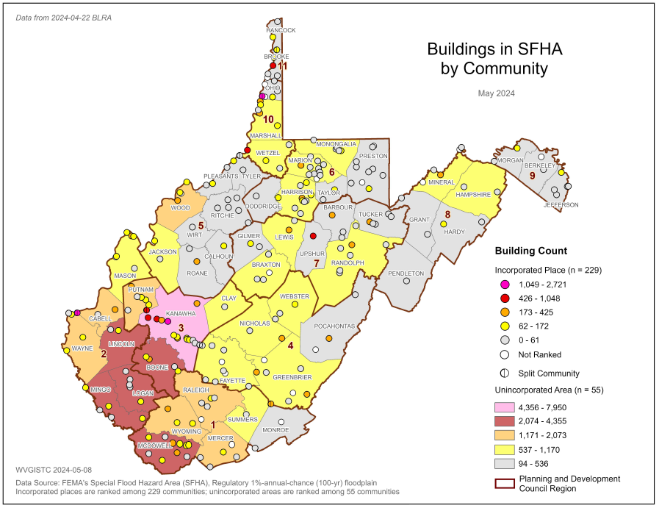 |  |  |  | Rank | Community (284) |  | Count | % Rank
 |  |  |  | 1 | Kanawha County* |  | 7950 | 100%
 |  |  |  | 2 | Logan County* |  | 4279 | 100%
 |  |  |  | 3 | Mingo County* |  | 2899 | 99%
 |  |  |  | 4 | Wheeling** |  | 2685 | 99%
 |  |  |  | 5 | Boone County* |  | 2572 | 98%
 |  |  |  | 6 | Lincoln County* |  | 2407 | 98%
 |  |  |  | 7 | McDowell County* |  | 2223 | 98%
 |  |  |  | 8 | Wyoming County* |  | 2059 | 97%
 |  |  |  | 9 | Wayne County* |  | 1944 | 97%
 |  |  |  | 10 | Raleigh County* |  | 1818 | 97%
 |  |  |  | 11 | Mercer County* |  | 1792 | 96%
 |  |  |  | 12 | Charleston |  | 1512 | 96%
 |  |  |  | 13 | Cabell County* |  | 1489 | 95%
 |  |  |  | 14 | Wood County* |  | 1316 | 95%
 |  |  |  | 15 | Putnam County* |  | 1297 | 95%
 |  |  |  | 16 | Fayette County* |  | 1157 | 94%
 |  |  |  | 17 | Marion County* |  | 1112 | 94%
 |  |  |  | 18 | Huntington** |  | 1099 | 94%
 |  |  |  | 19 | St. Albans |  | 1043 | 93%
 |  |  |  | 20 | Greenbrier County* |  | 997 | 93%
 |  |  |  | * Unincorporated Area ** Split Community
 |  |  |  | COMMUNITY AREA STATISTICS
 |  |  |  | Minimum |  |  |  | 0
 |  |  |  | Maximum (Kanawha*) |  |  |  | 7,950
 |  |  |  | Median |  |  |  | 77
 |  |  |  | Mean |  |  |  | 310
 |  |  |  | Communitywide Total |  |  |  | 82,408
 |  |  |  | Statewide Total |  |  |  | 82,408
WEB LINKS: | Natural Break Graphic | Percent Rank Graphic | Web Map |  |  | Web Report
Sources: WV BLRA (Building-Level-Risk Assessment) for High-Risk Effective/Advisory Zones; FEMA Flood Insurance Rate Maps (FIRMs) for SFHA. Report Date 20240429.
Figure BC-5. Building Count in Special Flood Hazard Area (Unincorporated Area Scale)
BUILDING COUNT (UNINCORPORATED AREA SCALE)
DESCRIPTION: A count of all primary insurable structures in the high-risk, 1%-annual-chance (100-yr) floodplain, or Special Flood Hazard Area (SFHA) on FEMA’s Flood Insurance Rate Maps (FIRMs).

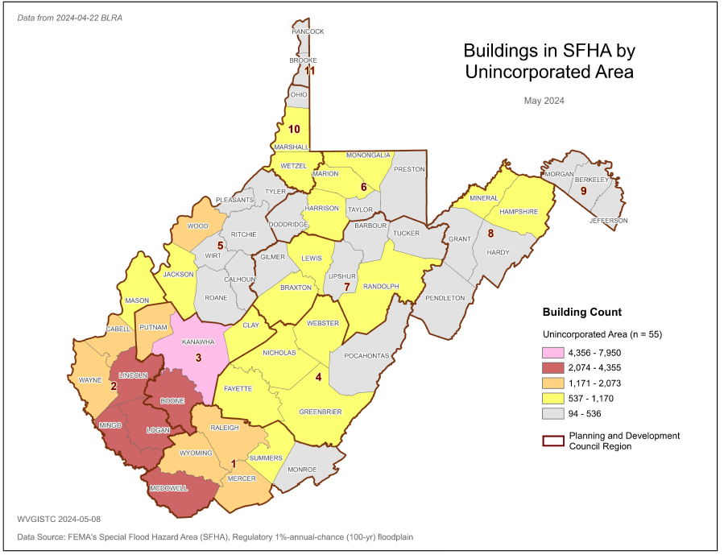 |  |  |  | Rank | Unincorporated (55) |  | Count | % Rank
 |  |  |  | 1 | Kanawha County* |  | 7,950 | 100%
 |  |  |  | 2 | Logan County* |  | 4,279 | 98%
 |  |  |  | 3 | Mingo County* |  | 2,899 | 96%
 |  |  |  | 4 | Boone County* |  | 2,572 | 94%
 |  |  |  | 5 | Lincoln County* |  | 2,407 | 93%
 |  |  |  | 6 | McDowell County* |  | 2,223 | 91%
 |  |  |  | 7 | Wyoming County* |  | 2,059 | 89%
 |  |  |  | 8 | Wayne County* |  | 1,944 | 87%
 |  |  |  | 9 | Raleigh County* |  | 1,818 | 85%
 |  |  |  | 10 | Mercer County* |  | 1,792 | 83%
 |  |  |  | 11 | Cabell County* |  | 1,489 | 81%
 |  |  |  | 12 | Wood County* |  | 1,316 | 80%
 |  |  |  | 13 | Putnam County* |  | 1,297 | 78%
 |  |  |  | 14 | Fayette County* |  | 1,157 | 76%
 |  |  |  | 15 | Marion County* |  | 1,112 | 74%
 |  |  |  | 16 | Greenbrier County* |  | 997 | 72%
 |  |  |  | 17 | Mason County* |  | 951 | 70%
 |  |  |  | 18 | Harrison County* |  | 943 | 69%
 |  |  |  | 19 | Randolph County* |  | 903 | 67%
 |  |  |  | 20 | Jackson County* |  | 822 | 65%
 |  |  |  | * Unincorporated Area
 |  |  |  | UNINCORPORATED AREA STATISTICS
 |  |  |  | Minimum (Brooke*) |  |  |  | 94
 |  |  |  | Maximum (Kanawha*) |  |  |  | 7,950
 |  |  |  | Median |  |  |  | 595
 |  |  |  | Mean |  |  |  | 1,028
 |  |  |  | Unincorporated Area Total |  |  |  | 56,529
 |  |  |  | Statewide Total |  |  |  | 82,408
WEB LINKS: | Natural Break Graphic | Percent Rank Graphic | Web Report |  |  | WEB LINKS:
Sources: WV BLRA (Building-Level-Risk Assessment) for High-Risk Effective/Advisory Zones; FEMA Flood Insurance Rate Maps (FIRMs) for SFHA. Report Date 20240429.
Figure BC-6. Building Count in Special Flood Hazard Area (Incorporated Place Scale)
BUILDING COUNT (INCORPORATED PLACE SCALE)
DESCRIPTION: A count of all primary insurable structures in the high-risk, 1%-annual-chance (100-yr) floodplain, or Special Flood Hazard Area (SFHA) on FEMA’s Flood Insurance Rate Maps (FIRMs).
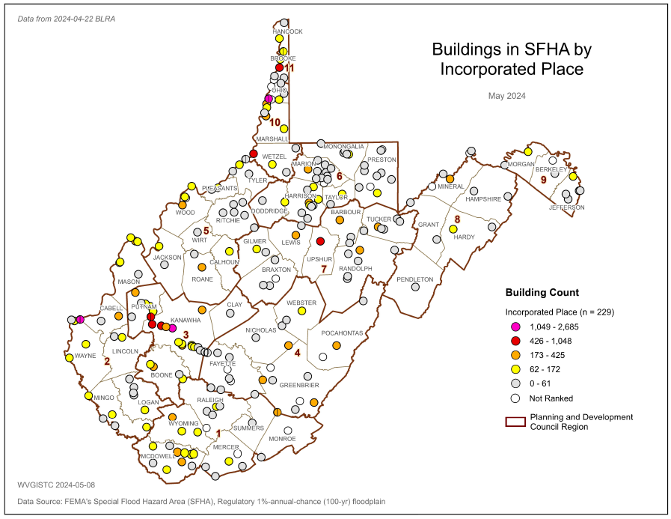 |  |  |  | Rank | Incorporated (229) |  | Count | % Rank
 |  |  |  | 1 | Wheeling** |  | 2,685 | 100%
 |  |  |  | 2 | Charleston |  | 1,512 | 100%
 |  |  |  | 3 | Huntington** |  | 1,099 | 99%
 |  |  |  | 4 | St. Albans |  | 1,043 | 99%
 |  |  |  | 5 | Dunbar |  | 903 | 98%
 |  |  |  | 6 | New Martinsville |  | 756 | 98%
 |  |  |  | 7 | Wellsburg |  | 716 | 97%
 |  |  |  | 8 | Nitro** |  | 659 | 97%
 |  |  |  | 9 | Buckhannon |  | 568 | 96%
 |  |  |  | 10 | Milton |  | 407 | 96%
 |  |  |  | 11 | Clarksburg |  | 394 | 95%
 |  |  |  | 12 | Marlinton |  | 371 | 95%
 |  |  |  | 13 | Keyser |  | 354 | 94%
 |  |  |  | 14 | Rainelle |  | 336 | 94%
 |  |  |  | 15 | Moundsville |  | 321 | 93%
 |  |  |  | 16 | South Charleston |  | 319 | 93%
 |  |  |  | 17 | Welch |  | 318 | 92%
 |  |  |  | 18 | Benwood |  | 317 | 92%
 |  |  |  | 19 | Oceana |  | 303 | 91%
 |  |  |  | 20 | White Sulphur Spr. |  | 302 | 90%
 |  |  |  | 21 | Clendenin |  | 302 | 90%
 |  |  |  | 22 | Richwood |  | 286 | 90%
 |  |  |  | 23 | Gary |  | 267 | 90%
 |  |  |  | ** Split Community Italicized = Focus Studies
 |  |  |  | INCORPORATED PLACE STATISTICS
 |  |  |  | Minimum |  |  |  | 0
 |  |  |  | Maximum (Wheeling) |  |  |  | 2,685
 |  |  |  | Median |  |  |  | 50
 |  |  |  | Mean |  |  |  | 123
 |  |  |  | Incorporated Place Total |  |  |  | 25,879
 |  |  |  | Statewide Total |  |  |  | 82,408
WEB LINKS: | Natural Break Graphic | Percent Rank Graphic | Web Map |  |  | Web Report
Sources: WV BLRA (Building-Level-Risk Assessment) for High-Risk Effective/Advisory Zones; FEMA Flood Insurance Rate Maps (FIRMs) for SFHA. Report Date 20240429.
Figure BC-7. Building Count in Special Flood Hazard Area (Watershed Scale)
BUILDING COUNT (WATERSHED SCALE)
DESCRIPTION: A count of all primary insurable structures in the high-risk, 1%-annual-chance (100-yr) floodplain, or Special Flood Hazard Area (SFHA) on FEMA’s Flood Insurance Rate Maps (FIRMs).

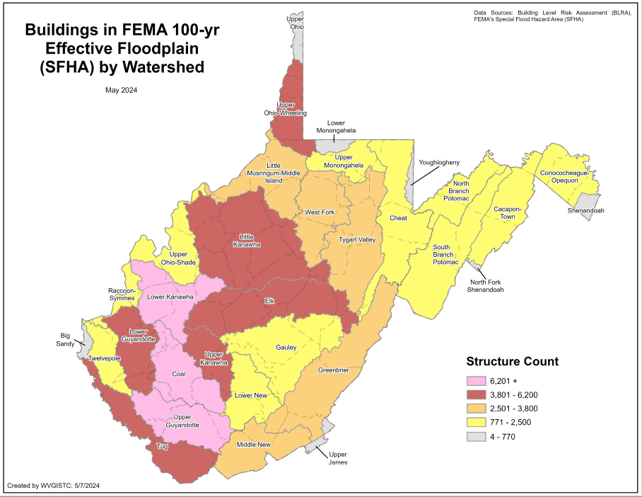  Update Graphic |  |  |  | Rank | Watershed (33) |  | Count | % Rank
 |  |  |  | 1 | Lower Kanawha |  | 7,989 | 100%
 |  |  |  | 2 | Coal |  | 6,240 | 97%
 |  |  |  | 3 | Upper Guyandotte |  | 6,211 | 94%
 |  |  |  | 4 | Upper Ohio-Wheeling |  | 5,845 | 91%
 |  |  |  | 5 | Tug |  | 5,527 | 88%
 |  |  |  | 6 | Elk |  | 4,909 | 84%
 |  |  |  | 7 | Upper Kanawha |  | 4,692 | 81%
 |  |  |  | 8 | Little Kanawha |  | 4,502 | 78%
 |  |  |  | 9 | Lower Guyandotte |  | 4,487 | 75%
 |  |  |  | 10 | Little Musringum-Middle Island |  | 3,518 | 72%
 |  |  |  | 11 | Tygart Valley |  | 3,194 | 69%
 |  |  |  | 12 | West Fork |  | 2,902 | 66%
 |  |  |  | 13 | Greenbrier |  | 2,835 | 63%
 |  |  |  | 14 | Middle New |  | 2,602 | 59%
 |  |  |  | 15 | Upper Ohio-Shade |  | 2,390 | 56%
 |  |  |  | WATERSHED SCALE STATISTICS
 |  |  |  | Minimum (North Fork Shenandoah) |  |  |  | 4
 |  |  |  | Maximum (Lower Kanawha) |  |  |  | 7,503
 |  |  |  | Median |  |  |  | 2,042
 |  |  |  | Mean |  |  |  | 2,631
 |  |  |  | Statewide Total |  |  |  | 84,490
WEB LINKS: | Natural Break Graphic | Percent Rank Graphic | Web Map |  |  | Web Report
Sources: WV BLRA (Building-Level-Risk Assessment) for High-Risk Effective/Advisory Zones; FEMA Flood Insurance Rate Maps (FIRMs) for SFHA. Report Date 20240429.
Figure BC-8. Building Count in Special Flood Hazard Area (Stream Scale)
BUILDING COUNT (STREAM SCALE)
DESCRIPTION: A count of all primary insurable structures in the high-risk, 1%-annual-chance (100-yr) floodplain, or Special Flood Hazard Area (SFHA) on FEMA’s Flood Insurance Rate Maps (FIRMs).
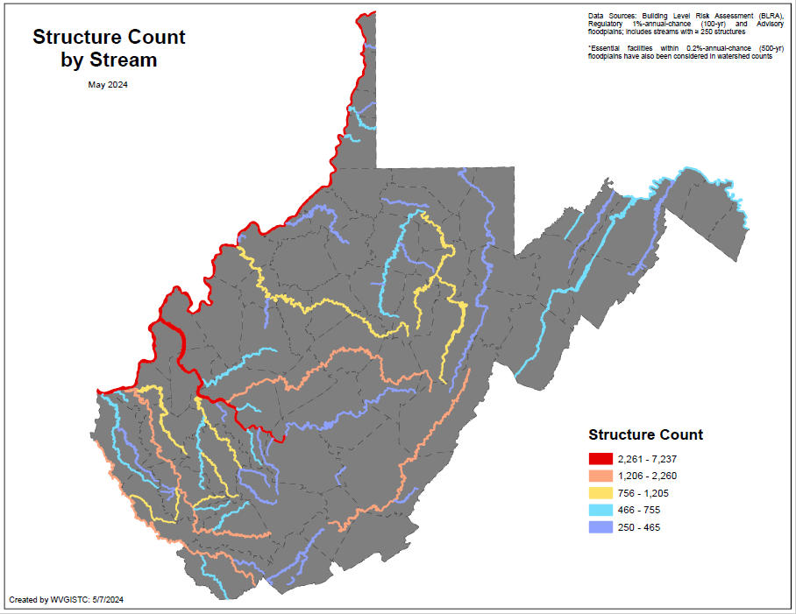  Update Graphic |  |  |  | Rank | Streams* (6,761) |  | Count |  | % Rank
 |  |  |  | 1 | Ohio River |  | 7,237 |  | 100%
 |  |  |  | 2 | Kanawha River |  | 7,116 |  | 99%
 |  |  |  | 3 | Elk River |  | 2,253 |  | 99%
 |  |  |  | 4 | Greenbrier River |  | 1,821 |  | 98%
 |  |  |  | 5 | Guyandotte River |  | 1,494 |  | 97%
 |  |  |  | 6 | Tug Fork |  | 1,410 |  | 97%
 |  |  |  | 7 | Little Kanawha R. |  | 1,205 |  | 96%
 |  |  |  | 8 | Mud River |  | 1,133 |  | 95%
 |  |  |  | 9 | Island Creek |  | 1,110 |  | 95%
 |  |  |  | 10 | Buckhannon River |  | 951 |  | 94%
 |  |  |  | 11 | Pond Fork |  | 948 |  | 94%
 |  |  |  | 12 | Coal River |  | 933 |  | 93%
 |  |  |  | 13 | Buffalo Creek |  | 932 |  | 92%
 |  |  |  | 14 | Big Coal River |  | 904 |  | 92%
 |  |  |  | 15 | Tygart Valley River |  | 891 |  | 91%
 |  |  |  | 16 | Pigeon Creek |  | 855 |  | 90%
 |  |  |  | 17 | Wheeling Creek |  | 755 |  | 90%
 |  |  |  | * Streams with buildings > 100
 |  |  |  | STREAM SCALE STATISTICS
 |  |  |  | Total Named Streams |  |  |  |  | 6,748
 |  |  |  | - Streams >= 1 Building |  |  |  | 46% | 3,115
 |  |  |  | - Streams > 100 Bldgs. |  |  |  | 2% | 155
 |  |  |  | Stream and River Statistics
WEB LINKS: | Natural Break Graphic | Percent Rank Graphic | Web Map |  |  | Web Report
Sources: WV BLRA (Building-Level-Risk Assessment) for High-Risk Effective/Advisory Zones; FEMA Flood Insurance Rate Maps (FIRMs) for SFHA. Report Date 20240429.

BUILDING COUNT Description, Rationale, and Recommendations

Table BC-9. BUILDING COUNTS RISK INDICATOR: Description, rationale, recommendations, and data sources of risk indicator.
Category | Indicator | Short Description | Unit | Rationale | Recommendations | Data Sources | State | Region | County | Community | Unincorporated | Community | Stream | Watershed
Physical Exposure | Building Counts in SFHA | All primary insurable structures in the effective 100-year Floodplain or Special Flood Hazard Area (SFHA). | # | The higher number of buildings in the floodplain indicates higher physical and human exposure to riverine flooding.  If a building owner has a mortgage from a federally regulated lender and the property is in the Special Flood Hazard Area, then the building owner is required by Federal law to carry flood insurance.  The building count in the SFHA is a programming variable required for those communities participating in FEMA’s Community Rating System (CRS) program. | Communities with a high floodplain building count should actively engage property owners about flood insurance and minimizing flood losses of property owners. See Floodsmart.gov for more information.  Communities can become more resilient to flooding by exceeding the minimum NFIP requirements. Higher building standards adopted by local communities may include increasing the freeboard of the base flood elevation; or encourage property owners to build to the higher 500-year flood elevation or historical high-water mark.  Floodplain managers and emergency planners should pre-load at-risk structures into substantial damage estimator software. Local officials should review early warning systems as well as short-term shelters located outside the floodplain and away from inundated roads.  State and county leaders should prioritize pre-disaster planning for communities with many flood-prone buildings. | All political scales: FEMA Special Flood Hazard Area (SFHA) for effective 1%-Annual-Chance Floodplains; Watershed and Stream scales: Effective and Advisory Floodplains for 1% Annual-Chance event; BLRA | Y | Y | Y | Y | Y | Y | Y | Y

