

**ESSENTIAL FACILITIES (Region 8)**

**Description:** **Essential facilities** provide critical services to the community and include police and fire stations, E-911 emergency operations centers, schools (often used as shelters), hospitals, and nursing homes. FEMA identifies these critical facilities as *essential* in its Hazus-MH risk assessment tool. If a [critical facility](https://www.fema.gov/glossary/critical-facility) must be in a floodplain then it should be provided a higher level of protection so that it can continue to function and provide services after the flood. Communities should develop emergency plans to continue to provide these services during the flood.

Under Executive Order 11988, Floodplain Management, Federal agencies funding and/or permitting critical facilities are required to avoid the 0.2 percent (500-year) floodplain or protect the facilities to the 0.2 percent chance flood level.

**Community Engagement and Verification:**Review the accuracy and completeness of all *active* **essential facilities**. Report any facilities that are missing. Verify the facilities and location using the [Table](https://data.wvgis.wvu.edu/pub/RA/State/CL/Essential_Facility/) and RiskMAP View of the [WV Flood Tool](https://www.mapwv.gov/flood/map/?wkid=102100&x=-8767062&y=4764425&l=3&v=2).

**Table EF-1.** Essential Facility Types and Qualification Criteria for Statewide Risk Assessment

|  |  |  |  |  |  |  |
| --- | --- | --- | --- | --- | --- | --- |
| **Essential Facility** | **Police Station** | **Fire Station** | **Emergency Operations Center** | **K-12 School** | **Hospital** | **Nursing Home** |
| **Qualification** | Police Cars | Fire Trucks | E-911 Dispatch Office | Classrooms of students | Inpatients | Staffed continuously for 24-hour medical supervision |
| **FEMA Lifeline Component** | Law Enforcement and Security | Fire Service | 911 and Dispatch | Government Service, Shelter | Medical Care (Public Health) | Medical Care  (Long-Term Facilities) |

**Community Lifelines:** FEMA recently developed the [community lifelines](https://www.fema.gov/emergency-managers/practitioners/lifelines) construct to increase effectiveness in disaster operations and better position the Agency to respond to catastrophic incidents. Community lifelines cover seven sectors: Safety and Security; Food, Water, Shelter; Health and Medical; Energy; Communications; Transportation; and Hazardous Material. Essential facilities are identified by six of the FEMA Lifeline Components (Table EF-1). Refer to other state risk assessment reports for additional information on housing, shelters, flood control (dams, levees), highways, railways, bridges, and other hazards (landslides).

**Other Related Risk Layers:** Primary Structures, Community Assets, Transportation, Dams, Levees

**Bringing Lifelines into Hazard Mitigation Planning:** [Slides](https://data.wvgis.wvu.edu/pub/RA/_resources/CF/Bringing_Lifelines_into_Hazard_Mitigation_Planning_Presentation.pdf) | [Audio](https://data.wvgis.wvu.edu/pub/RA/_resources/CF/Bringing_Lifelines_into_Hazard_Mitigation_Planning_Webinar.mp4) | [Fact Sheet](https://data.wvgis.wvu.edu/pub/RA/_resources/CF/LifelinesFactSheetandPosterv2_201911.pdf) | [BRIC](https://data.wvgis.wvu.edu/pub/RA/_resources/CF/FEMA_BRIC_Session-4_Community-Lifelines_20200722.pdf) | [FEMA Website](https://www.fema.gov/emergency-managers/practitioners/lifelines)

**Critical Facilities:** [Definition](https://www.fema.gov/glossary/critical-facility) | [Critical Facilities and Higher Standards](https://data.wvgis.wvu.edu/pub/RA/_resources/CF/FPM_1_Page_CriticalFacilities_and_Higher_Standards.pdf)

**Essential Facilities by Type:**  Sixty percent or 9 of the 15 flood-prone communities in **Region 8** have essential facilities vulnerable to flooding. The county with the most essential facilities is **Mineral County** (ranked 16th for all counties), while the incorporated town with the highest number of facilities is **Keyser** (ranked 7th for all municipalities in State) in Mineral County. Hospitals and nursing homes with immobile patients or residents are particularly vulnerable to a flood disaster. Small towns situated mostly in the floodplain are more challenged than unincorporated areas or larger cities to identify suitable sites that provide a high level of protection from flooding.

**Table EF-2.** Essential Facilities by Type. What is at risk?

|  |  |  |  |  |  |  |  |  |  |
| --- | --- | --- | --- | --- | --- | --- | --- | --- | --- |
| COMMUNITY IDENTIFICATION | | | ESSENTIAL FACILITIES | | | | | | |
|
| **CID** | **Community Name** | **County** | **Police Station** | **Fire Station** | **911 Center** | **School** | **Hospital** | **Nursing Home** | **CID** |
| 540240 | Bayard | GRANT | 0 | 0 | 0 | 0 | 0 | 0 | 0 |
| 540038 | Grant County* | GRANT | 0 | 0 | 0 | 1 | 0 | 0 | 1 |
| 540039 | Petersburg | GRANT | 0 | 1 | 0 | 2 | 0 | 0 | 3 |
| *SUM* |  | **GRANT** | **0** | **1** | **0** | **3** | **0** | **0** | **4** |
| 540046 | Capon Bridge | HAMPSHIRE | 0 | 1 | 0 | 0 | 0 | 0 | 1 |
| 540226 | Hampshire County* | HAMPSHIRE | 0 | 2 | 0 | 0 | 0 | 0 | 2 |
| 540276 | Romney | HAMPSHIRE | 0 | 0 | 0 | 0 | 0 | 0 | 0 |
| *SUM* |  | **HAMPSHIRE** | **0** | **3** | **0** | **0** | **0** | **0** | **3** |
| 540051 | Hardy County* | HARDY | 0 | 0 | 0 | 0 | 0 | 0 | 0 |
| 540052 | Moorefield | HARDY | 0 | 1 | 0 | 2 | 0 | 0 | 3 |
| 540245 | Wardensville | HARDY | 0 | 0 | 0 | 0 | 0 | 0 | 0 |
| *SUM* |  | **HARDY** | **0** | **1** | **0** | **2** | **0** | **0** | **3** |
| 545555 | Carpendale | MINERAL | 0 | 0 | 0 | 0 | 0 | 0 | 0 |
| 540091 | Elk Garden | MINERAL | 0 | 0 | 0 | 0 | 0 | 0 | 0 |
| 540130 | Keyser  (ranked 7th for all municipalities in State) | MINERAL | 2 | 0 | 0 | 3 | 0 | 0 | 5 |
| 540129 | Mineral County* | MINERAL | 0 | 4 | 0 | 0 | 1 | 0 | 5 |
| 540131 | Piedmont | MINERAL | 0 | 0 | 0 | 0 | 0 | 0 | 0 |
| 540155 | Ridgeley | MINERAL | 0 | 0 | 0 | 0 | 0 | 0 | 0 |
| *SUM* | **Ranked 16th in State** | **MINERAL** | **2** | **4** | **0** | **3** | **1** | **0** | **10** |
| 540154 | Franklin | PENDLETON | 0 | 1 | 0 | 0 | 0 | 0 | 1 |
| 540153 | Pendleton County* | PENDLETON | 0 | 1 | 0 | 1 | 0 | 0 | 2 |
| *SUM* |  | **PENDLETON** | **0** | **2** | **0** | **1** | **0** | **0** | **3** |
| **TOTAL** |  |  | **2** | **11** | **0** | **9** | **1** | **0** | **23** |

* Unincorporated Community

**Essential Facilities by Flood Zone:**  Two essential facilities are in the Regulatory Floodway, or the main channel of the river or stream where floodwaters are likely the deepest and with the highest velocities. There are 16 facilities in the high risk *effective* and *advisory* 1%-annual-chance (100-yr) flood level and five facilities in the moderate risk 0.2%-annual-chance (500-yr) flood level.

**Table EF-3.** Essential Facilities by Flood Zone.

|  |  |  |  |  |  |  |  |
| --- | --- | --- | --- | --- | --- | --- | --- |
| COMMUNITY IDENTIFICATION | | | FLOOD ZONE BREAKDOWN | | | | |
| 1%-Annual-Chance (100-yr) Floodplain | | | 0.2% (500-yr) Floodplain | High & Moderate Risk |
| **CID** | **Community Name** | **County** | **Floodway** | **Effective** | Advisory | Effective | **TOTAL** |
| 540240 | Bayard | GRANT | 0 | 0 | 0 | 0 | 0 |
| 540038 | Grant County* | GRANT | 0 | 1 | 0 | 0 | 1 |
| 540039 | Petersburg | GRANT | 0 | 1 | 0 | 2 | 3 |
| *SUM* |  | **GRANT** | **0** | **2** | **0** | **2** | **4** |
| 540046 | Capon Bridge | HAMPSHIRE | 0 | 0 | 0 | 1 | 1 |
| 540226 | Hampshire County* | HAMPSHIRE | 0 | 2 | 0 | 0 | 2 |
| 540276 | Romney | HAMPSHIRE | 0 | 0 | 0 | 0 | 0 |
| *SUM* |  | **HAMPSHIRE** | **0** | **2** | **0** | **1** | **3** |
| 540051 | Hardy County* | HARDY | 0 | 0 | 0 | 0 | 0 |
| 540052 | Moorefield | HARDY | 0 | 1 | 0 | 2 | 3 |
| 540245 | Wardensville | HARDY | 0 | 0 | 0 | 0 | 0 |
| *SUM* |  | **HARDY** | **0** | **1** | **0** | **2** | **3** |
| 545555 | Carpendale | MINERAL | 0 | 0 | 0 | 0 | 0 |
| 540091 | Elk Garden | MINERAL | 0 | 0 | 0 | 0 | 0 |
| 540130 | Keyser | MINERAL | 2 | 2 | 1 | 0 | 5 |
| 540129 | Mineral County* | MINERAL | 0 | 4 | 1 | 0 | 5 |
| 540131 | Piedmont | MINERAL | 0 | 0 | 0 | 0 | 0 |
| 540155 | Ridgeley | MINERAL | 0 | 0 | 0 | 0 | 0 |
| *SUM* |  | **MINERAL** | **2** | **6** | **2** | **0** | **10** |
| 540154 | Franklin | PENDLETON | 0 | 1 | 0 | 0 | 1 |
| 540153 | Pendleton County* | PENDLETON | 0 | 0 | 2 | 0 | 2 |
| *SUM* |  | **PENDLETON** | **0** | **1** | **2** | **0** | **3** |
| **TOTAL** |  |  | **2** | **12** | **4** | **5** | **23** |

* Unincorporated Community

**Essential Facilities by Flood Depth:**  Facilities most vulnerable to a high-risk 1%-annual-chance (100-yr) flood event are displayed below. The flood depth grid and building damage estimates identify which facilities may be subject to the greatest flood damage. Refer to the building-level [Table](https://data.wvgis.wvu.edu/pub/RA/State/BL/EssentialFacility/) and RiskMAP View of the [WV Flood Tool](https://www.mapwv.gov/flood/map/?wkid=102100&x=-8767062&y=4764425&l=3&v=2) to review base flood depths and damage estimates of facilities.

**Table EF-4.** Essential Facilities by 1% Flood Depth. What is the degree of risk?

|  |  |  |  |  |  |  |
| --- | --- | --- | --- | --- | --- | --- |
| Community Name | County | Facility Name | **Facility Type** | Flood Tool Link | **Depth Grid** | Building Damage Percent |
| Mineral County* | MINERAL | Burlington Volunteer Fire Department Incorporated Company 44 | **Fire Station** | [FT](https://mapwv.gov/flood/map/?wkid=102100&x=-8783675.296734858&y=4769938.251583621&l=13&v=2) | 6.3 | 15.7 |
| Pendleton County* | PENDLETON | South Fork Volunteer Fire Department | **Fire Station** | [FT](https://mapwv.gov/flood/map/?wkid=102100&x=-8821570.388026072&y=4667424.864956323&l=13&v=2) | 4.0 | 11.0 |
| Grant County* | GRANT | BMF Christian School | **School** | [FT](https://mapwv.gov/flood/map/?wkid=102100&x=-8813352.466177799&y=4720881.48341885&l=13&v=2) | 3.7 | 8.5 |
| Petersburg | GRANT | Petersburg High School | **School** | [FT](https://mapwv.gov/flood/map/?wkid=102100&x=-8807910.64815865&y=4721727.086947034&l=13&v=2) | 2.0 | 0.0 |
| Petersburg | GRANT | Petersburg Elementary School | **School** | [FT](https://mapwv.gov/flood/map/?wkid=102100&x=-8807231.254285706&y=4721915.5709460955&l=13&v=2) | 1.8 | 5.7 |
| Petersburg | GRANT | Petersburg Volunteer Fire Department | **Fire Station** | [FT](https://mapwv.gov/flood/map/?wkid=102100&x=-8808146.216453815&y=4720344.87831405&l=13&v=2) | 1.8 | 4.0 |
| Hampshire County* | HAMPSHIRE | Springfield Valley Fire Co | **Fire Station** | [FT](https://mapwv.gov/flood/map/?wkid=102100&x=-8759773.085028592&y=4786195.944927521&l=13&v=2) | 1.7 | 5.0 |
| Hampshire County* | HAMPSHIRE | North River Valley Volunteer Fire Company | **Fire Station** | [FT](https://mapwv.gov/flood/map/?wkid=102100&x=-8757537.60842533&y=4741649.366647288&l=13&v=2) | 1.1 | 0.4 |
| Capon Bridge | HAMPSHIRE | Capon Bridge Volunteer Fire Department | **Fire Station** | [FT](https://mapwv.gov/flood/map/?wkid=102100&x=-8730692.237956505&y=4764262.304076236&l=13&v=2) | 0.6 | 0.0 |
| Moorefield | HARDY | Moorefield Elementary School | **School** | [FT](https://mapwv.gov/flood/map/?wkid=102100&x=-8790851.172748495&y=4731493.467269757&l=13&v=2) | 0.3 | 0.0 |

* Unincorporated Community

**WV Flood Tool Risk MAP:** The **WV Flood Tool Risk Map View** should be used to view and verify mapped essential facilities and other risk layers. For example, the essential facilities of Keyser are vulnerable to both riverine and dam failure flood hazards. New Creek No.1 Dam is designated a High Hazard Potential dam, a classification standard for any dam whose failure or mis-operation will cause loss of human life and significant property destruction.

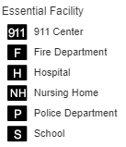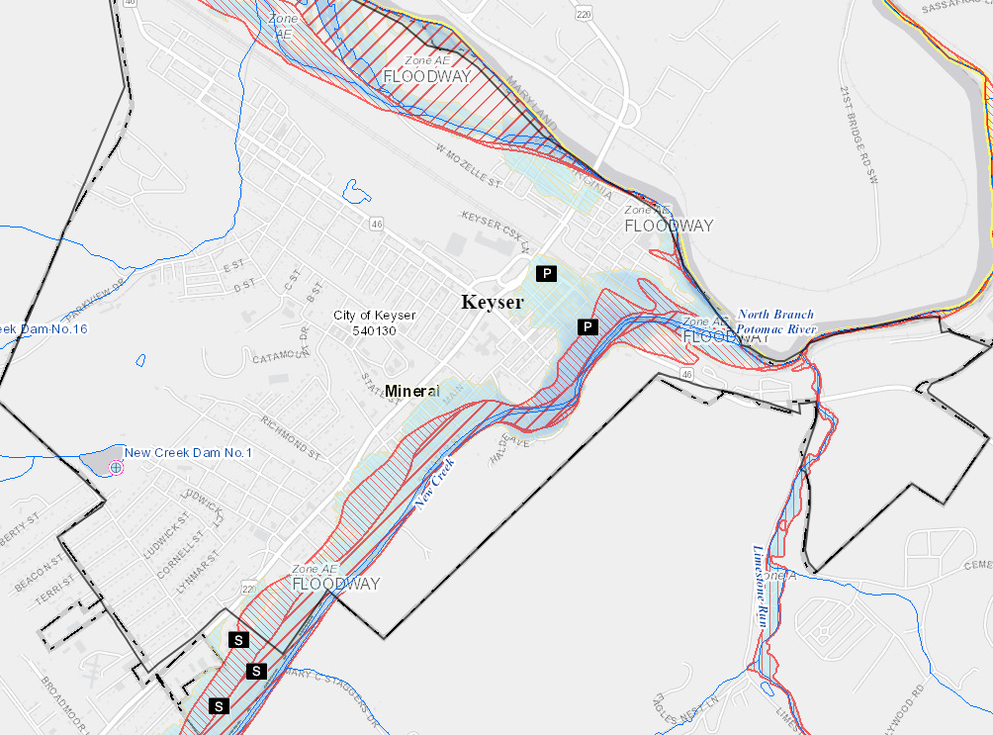**Figure EF-5.** Essential Facilities for city of Keyser displayed on [Risk MAP View](https://www.mapwv.gov/flood/map/?wkid=102100&x=-8792118&y=4785065&l=8&v=2) of the WV Flood Tool.

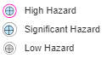

Dam Hazard

WV Flood Tool Map Link: <https://www.mapwv.gov/flood/map/?wkid=102100&x=-8792118&y=4785065&l=8&v=2>

**Verification with Building-Level Tabular Report:** Essential facilities can also be viewed and verified for each community by linking to the risk assessment **tabular report** (Excel spreadsheet). To verify the geographic location of each facility, the Excel table provides map view links. Essential facility data fields include Community Identifiers, Building ID, Address, Facility Type, Occupancy Code, Building Value, Building Value Source, Floodplain, Floodway, and Flood Tool Link.

**Table EF-6.** Essential Facilities for city of Keyser displayed in [Tabular Report](https://data.wvgis.wvu.edu/pub/RA/State/BL/EssentialFacility/) with map links.

|  |  |  |  |
| --- | --- | --- | --- |
| Facility Name | Full Address | **Facility Type** | Flood Tool Link |
| Mineral County Sheriff's Department | 100 East St, Keyser, Mineral, WV, 26726 | **Police Station** | [FT](https://mapwv.gov/flood/map/?wkid=102100&x=-8791234.01327908&y=4784828.12824197&l=13&v=2) |
| Keyser Middle School | 879 Harley O Staggers Dr, Keyser, Mineral, WV, 26726 | **School** | [FT](https://mapwv.gov/flood/map/?wkid=102100&x=-8793027.639001006&y=4782930.004748998&l=13&v=2) |
| Keyser Primary School | 1123 Harley O Staggers Dr, Keyser, Mineral, WV, 26726 | **School** | [FT](https://mapwv.gov/flood/map/?wkid=102100&x=-8792928.548846833&y=4783343.419342185&l=13&v=2) |
| Mineral County Vocational Technical Center | 981 Harley O Staggers Dr, Keyser, Mineral, WV, 26726 | **School** | [FT](https://mapwv.gov/flood/map/?wkid=102100&x=-8792871.058452416&y=4783116.222295489&l=13&v=2) |
| Keyser Police Department | 107 N Davis St, Keyser, Mineral, WV, 26726 | **Police Station** | [FT](https://mapwv.gov/flood/map/?wkid=102100&x=-8791459.951659055&y=4785065.89204619&l=13&v=2) |

Region 8 Tabular Report Link: [data.wvgis.wvu.edu - /pub/RA/State/BL/EssentialFacility/](https://data.wvgis.wvu.edu/pub/RA/State/BL/EssentialFacility/)

**Verification with Community-Level Report:** A summary report for all communities and regions can be accessed at [data.wvgis.wvu.edu - /pub/RA/State/CL/Essential_Facility/](https://data.wvgis.wvu.edu/pub/RA/State/CL/Essential_Facility/). See Tables EF-2 and EF-3 for sample outputs.

* * *

**Statewide Risk Assessment Contacts:**

Statewide Risk Assessment Technical Support, WVU GIS Technical Center  
 - Kurt Donaldson ([kurt.donaldson@mail.wvu.edu](mailto:kurt.donaldson@mail.wvu.edu))  
 - Maneesh Sharma ([maneesh.sharma@mail.wvu.edu](mailto:maneesh.sharma@mail.wvu.edu))  
 - Eric Hopkins ([Eric.Hopkins@mail.wvu.edu](mailto:Eric.Hopkins@mail.wvu.edu))  
   
State NFIP Coordinator, WV Office of the Insurance Commissioner  
 - Chuck Grishaber ([Charles.C.Grishaber@wv.gov](mailto:Charles.C.Grishaber@wv.gov))  
  
WV Emergency Management Division

- Brian Penix, State Hazard Mitigation Project Officer ([Brian.M.Penix@wv.gov](mailto:Brian.M.Penix@wv.gov))

- Tim Keaton, State Hazard Mitigation Planner ([Tim.W.Keaton@wv.gov](mailto:Tim.W.Keaton@wv.gov))  
 - Kevin Sneed, CTP Coordinator ([Kevin.L.Sneed@wv.gov](mailto:Kevin.L.Sneed@wv.gov))  
 - Nuvia E. Villamizar, GIS Manager ([nuvia.e.villamizar@wv.gov](mailto:nuvia.e.villamizar@wv.gov))