*Study Area*

As a prototype, Jefferson County in West Virginia was selected for the analyses of the demographic inventory. Jefferson County founded in 1801 is the easternmost [county](https://en.wikipedia.org/wiki/County_(United_States)) of the state located in the Shenandoah Valley. The area of the county equals to 212 square miles and its total population is 55,673 according to 2017 American Community Survey (ACS)(United States Census Bureau, 2019).

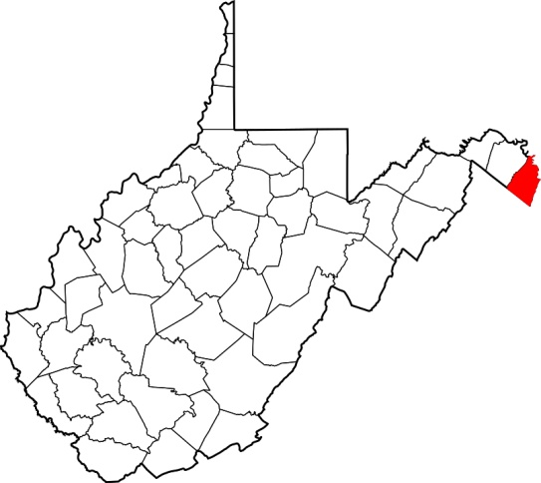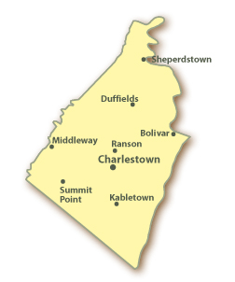

Jefferson County in West Virginia

As the programs of floodplain management in West Virginia are defined at the scale of communities, that level was selected for data collection and analysis of the project in Jefferson County. There are six communities in the county including Charles Town, Ranson, Shepherdstown, Bolivar, and Harpers Ferry in addition to the unincorporated area of Jefferson.

*Data Collection*

The study required data of the residential buildings located in the flood zones of Jefferson County including their location, occupancy type, land use description, and flood depth value. WV GIS Tech. Center had produced those data in form of an excel sheet as the result of the building inventory of the county. That dataset was used in developing the demographic inventory.

The 2013-2017 American Community Survey 5-Year Estimates of the United States Census Bureau were used to gather the needed demographic data. The data including population, household size, household income, and age were downloaded from the Bureau’s website called *American Fact Finder*. In order to collect the above data at the scale of the communities, we used the advanced search on the website setting the geography type to “*places”.* The data of the towns could be downloaded directly but they were not available for the unincorporated area of Jefferson. In each category, we deducted the values of the towns from the total value of the county to obtain the required data for the unincorporated area.

*Estimation of Displaced Population*

This part of the study estimated the number of displaced individuals due to the inundation of 100-year flooding events. Those are relatively large events occurring with the recurrence interval of 100 years or, in other words, with one percent probability of flooding in a year. The methodology of estimation was derived from FEMA’s Hazus-MH Technical Manual. The difference made in the method was the scale of the estimations changed from census blocks, in the manual, to the buildings located in the flood zones of the communities, in our study. We believed that estimations starting at the scale of buildings would produce results that were more accurate.

The estimation is based on the area and depth of inundation. If the depth exceeds a certain value people will be displaced from their homes because of the limitations of access to the properties or damages to the buildings. According to FEMA, the inundation depth of displacement may vary from six to 12 inches. The latter is the depth in which roads cannot be used and cars begin to float. For this study, the inundation depth of 12 inches (one foot) was selected as the threshold of displacement.

In the study, the number of displaced individuals was calculated as a proportion of the number of the people residing in the 100-year flood zones who would experience an inundation equal or more than one foot deep. For that purpose, the residential buildings located in the 100-year flood zones of the communities in Jefferson County with depth values of one foot or more were extracted from the table of building inventory. Then, for each building, the number of the residential units was multiplied by the average household size of the community to estimate the residing population in the building. The total number of displaced individuals of each community was calculated by adding the populations of the above buildings.

Equation 1 summarizes the carried out calculation. The formula is different from the one explained by the FEMA’s manual because we redefined the process based on the buildings instead of the census blocks.

$${\#DI}_{IN}=\sum_{j=1}^{n}{{(ResUNIT}_{IN}×{AveHHSize}_{COMM})}$$

Equation 1. Displaced population

Where:

#DIIN = the number of displaced individuals as a result of inundation with equal or more than 1 foot depth

ResUNITIN= the number of residential units in each building located within the area of inundation with equal or more than 1 foot depth

AveHHSizeCOMM= the average household size of the community where the building is located

j= the number of residential buildings within the flooded area with equal or more than 1 foot depth

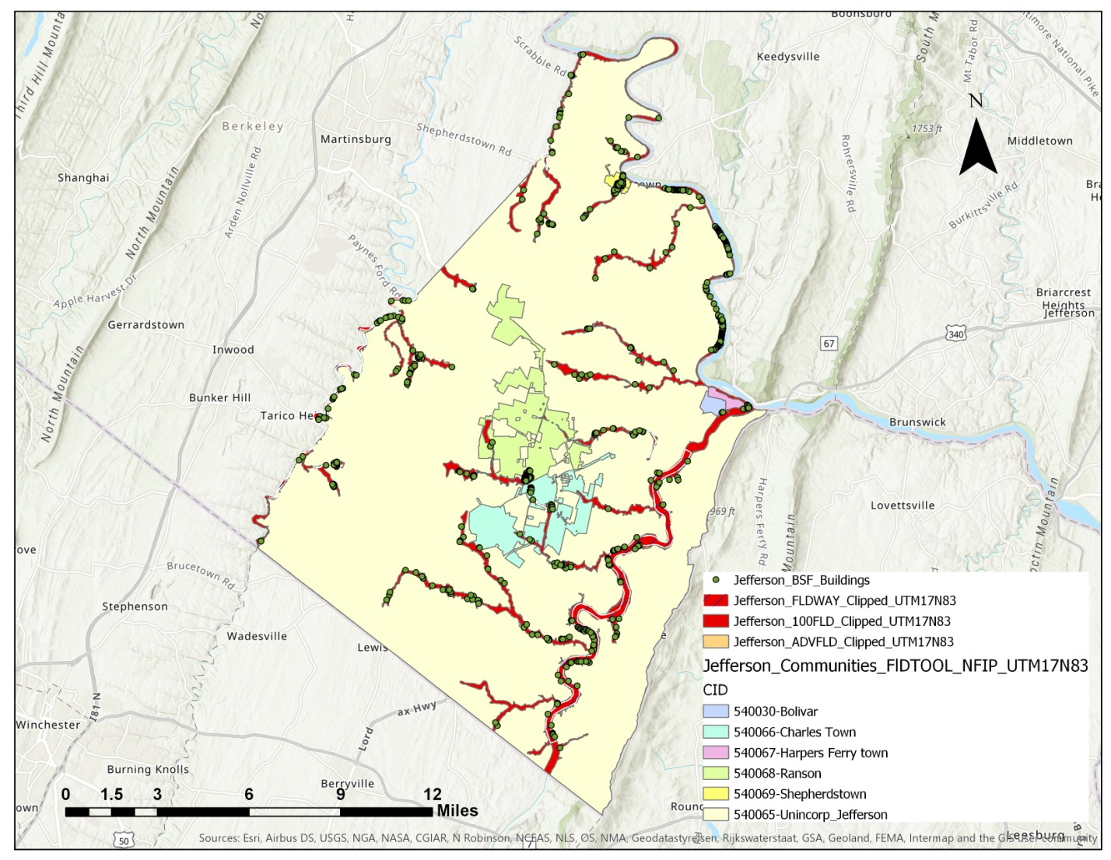

The buildings in flood zones and the communities in Jefferson County

*Estimation of Shelter Needs*

During a severe flood event, a percentage of the displaced population will require government-provided short-term shelters. Estimation of the number of individuals in need of the shelters is a significant part of flood risk management and response planning. The methodology of this part of the project was based on the same manual of FEMA mentioned earlier.

The estimation of shelter needs is related to the probability of using the shelters by displaced population. For that purpose, two factors of income and age should be taken into account. Income is a much more effective factor in the process as it determines the economic status of the displaced population. Households with lower incomes are more likely to use the shelters because they would not afford accommodation in hotels or finding shelters on their own during floods. On the other hand, it is likely that their family and friends live in the similar economic condition. Therefore, there is a lower probability for people in poverty to go to the places of their friends or family in such cases. Age is the secondary factor in estimation of shelter population. There is a higher probability that elderly families (65 years or older) in addition to younger less established families use shelters.

In this project, income data of the households in addition to age data of the individuals of the communities in Jefferson County were downloaded. Then, the data were processed in the categories described by the FEMA’s manual and the percentages of population in each income and age class were calculated for all of the communities. Assuming that the income intervals of the manual dated back to 1990, we updated the income classes based on the inflation rate, and the available census data, to these categories. Additionally, for calculations of the modification factors, percentage of more than $35,000 in the manual was changed to percentage more than $60,000.

The income classes

Income classes:

* Household income up to $20,000 per year;
* Household income greater than $20,000 but less than $30,000 per year;
* Household income from $30,000 to less than $50,000 per year;
* Household income from $50,000 to less than $60,000 per year; and
* Household income of $60,000 or greater per year.

Age categories:

* Individuals less than 16 years of age;
* Individuals from 16 to 65 years of age; and
* Individuals greater than 65 years of age.

Furthermore, we used the equation represented in the manual to calculate the number of individuals in need of shelters:

$$\#STP=\sum_{k=1}^{5}{\sum_{m=1}^{3}{[α_{km}×DP×{HI}_{k}×{HA}_{m}]}}$$

Equation 2. Shelter population

Where:

#STP = Number of people using established shelters

km = a constant

DP = Displaced population by inundation with equal or more than 1 foot depth

HIk = Percentage of population in the kth income class

HAm = Percentage of population in mth age class

Equation 3 was used to calculate the constant needed above (km).

Equation 3. Calculation of the constant

IW = Shelter category weight for income

AW = Shelter category weight for age

IMk = Relative modification factor for income

AMm = Relative modification factor for age

As the income factor is more effective in shelter needs compared to age, the manual recommends the income weight (IW) of 0.8 and the age weight (AW) of 0.2. We used the same values in our model. The relative modification factors for each income and age class (IMk and AMk) were extracted from the relevant table in the manual.

**References**

United States Census Bureau. (2019). *American Fact Finder*. Retrieved from https://factfinder.census.gov/faces/nav/jsf/pages/community_facts.xhtml

Department of Homeland Security and Federal Emergency Management Agency (FEMA). (n.d.). *Hazus®-MH technical manual: Multi-hazard loss estimation methodology, flood model*. Washington, D.C.: FEMA. Retrieved from https://www.fema.gov/media-library/assets/documents/24609