**Data Collection.** The study required data of the residential buildings located in the flood zones of Greenbrier County, including their location, occupancy type, land use description, and flood depth value. WV GIS Tech. The Center had produced those data in the form of an excel sheet as the result of the building inventory of the county.

**DISPLACEMENT & SHELTER NEEDS (Greenbrier County)**

The 2013-2017 American Community Survey 5-Year Estimates of the United States Census Bureau were used to gather the needed demographic data. The data, including population, household size, household income, and age, were downloaded from the Bureau’s website. In order to collect the above data at the scale of the communities, we used the advanced search on the website setting the geography type to “*places”.*

**Estimation of Displaced Population.** This part of the study estimated the number of displaced individuals due to the inundation of 100-year flooding events. Those are relatively large events occurring with the recurrence interval of 100 years or, in other words, with a one percent probability of flooding in a year. The methodology of estimation was derived from FEMA’s Hazus-MH Technical Manual. The difference made in the method was the scale of the assessments changed from census blocks, in the manual, to the buildings located in the flood zones of the communities in our study. We believed that estimations starting at the scale of buildings would produce more accurate results.

The estimation is based on the area and depth of inundation. If the depth exceeds a certain value, people will be displaced from their homes because of the limitations of access to the properties or damages to the buildings. According to FEMA, the inundation depth of displacement may vary from six to 12 inches. The latter is the depth in which roads cannot be used, and cars begin to float. Therefore, for this study, the inundation depth of 12 inches (one foot) was selected as the displacement threshold.

In the study, the number of displaced individuals was calculated as a proportion of the number of the people residing in the 100-year flood zones who would experience an inundation equal to or more than one foot deep. For that purpose, the residential buildings located in the 100-year flood zones of the communities in Greenbrier County with depth values of one foot or more were extracted from the table of building inventory. Then, for each building, the number of the residential units was multiplied by the average household size of the community to estimate the residing population in the building. Finally, the total number of displaced individuals of each community was calculated by adding the populations of the above buildings.

Equation 1 summarizes the carried-out calculation. The formula is different from the one explained by FEMA’s manual because we redefined the process based on the buildings instead of the census blocks.

$${\#DI}_{IN}=\sum_{j=1}^{n}{{(ResUNIT}_{IN}×{AveHHSize}_{COMM})}$$

Equation 1. Displaced population

Where:

#DIIN = the number of displaced individuals as a result of inundation with equal or more than 1 foot depth

ResUNITIN= the number of residential units in each building located within the area of inundation with equal or more than 1 foot depth

AveHHSizeCOMM= the average household size of the community where the building is located

j= the number of residential buildings within the flooded area with equal or more than 1 foot depth

**Estimation of Shelter Needs:** In this study, shelter needs were estimated based on the probability of using shelters by the displaced population. For that purpose, two factors of income and age should be taken into account. Income is a more effective factor in the process as it determines the economic status of the displaced population. Age, on the other hand, is the secondary factor in the estimation of the shelter population. Therefore, it is more likely that elderly families (65 years or older), and younger less established families use shelters. However, this assumption may be changed due to the high population in another specific age group. Since our model of shelter-needs estimation is based on an equation in which the factors of age and income are very effective. Thus, if in a county (for instance, Greenbrier), the number of people ages 18-65 years is sharply more than the other groups, it is more expected that the displaced people would be in this age group (Piechart1). Additional data regarding the distribution of people in three age groups are found in Table 2.

**Table1.** Estimation of Shelter needs in Greenbrier County

|  |  |  |  |  |  |  |
| --- | --- | --- | --- | --- | --- | --- |
| **Demographic Data** | | **Displacement Data** | | | **Shelter Data** | |
| **Community Name** | **Population Residing in High-Risk Flood Zone** | **Displaced Population** | **Percentage of Population in Flood Zones Displaced** | **Number of Households with inundation water depth >= 1 foot** | **Estimated Population in Need of Short Term Shelter** | **Percentage of Population in Flood Zones in Need of Shelter** |
| Alderson | 271 | 198 | 73% | 94 | 32 | 12% |
| Falling Springs | 7 | 8 | 100% | 3 | 2 | 27% |
| Greenbrier County** | 2592 | 1546 | 60% | 644 | 310 | 12% |
| Rainelle | 582 | 492 | 85% | 234 | 123 | 21% |
| Ronceverte | 99 | 58 | 59% | 25 | 12 | 12% |
| Rupert | 151 | 87 | 58% | 36 | 20 | 13% |
| White Sulphur Springs | 1026 | 481 | 47% | 209 | 104 | 10% |
| ***SUM*** | **4728** | **2870** | **61%** | **1245** | **603** | **13%** |

\*\**Unincorporated Area*

**PieChart1.** Estimation of Shelter needs Per Age Group in Greenbrier Communities

**Table2.** Estimation of shelter needs per age group in Greenbrier communities

|  |  |  |  |  |
| --- | --- | --- | --- | --- |
| **Community’s Name** | **Shelter Needs per age group** | | | |
| **less than 16** | **16 to 65** | **Older than 65** | **Total** |
| Alderson | *6* | *17* | *9* | *32* |
| Falling Spring | *0* | *1* | *0* | *1* |
| Greenbrier County ** | *40* | *184* | *85* | *305* |
| Rainelle | *15* | *71* | *38* | *124* |
| Ronceverte | *2* | *6* | *4* | *12* |
| Rupert | *3* | *11* | *5* | *19* |
| White Sulphur Springs | *15* | *60* | *28* | *103* |
| ***SUM*** | **8** | **350** | **169** | **606** |
|  |  |  |  | |

**Analyzing Shelter Needs in the 2016 Flood:** According to the Red Cross data, during the 2016 flood, six public buildings were designated as emergency shelters in Greenbrier County (**Map.1)**. These shelters were in the cities of Charmco, Lewisburg, Ronceverte, and Rupert and settled 114 people for 20 days. In addition, Greenbrier resort in White Sulphur Springs and Amsted Baptist Church gymnasium in Rainelle hosted 300 and 129 displaced residents. From the 114 people who used Red Cross shelters, the demographic data of 94 residents were available.

**Map.1:** Location of Red Cross Shelters in 2016 flood

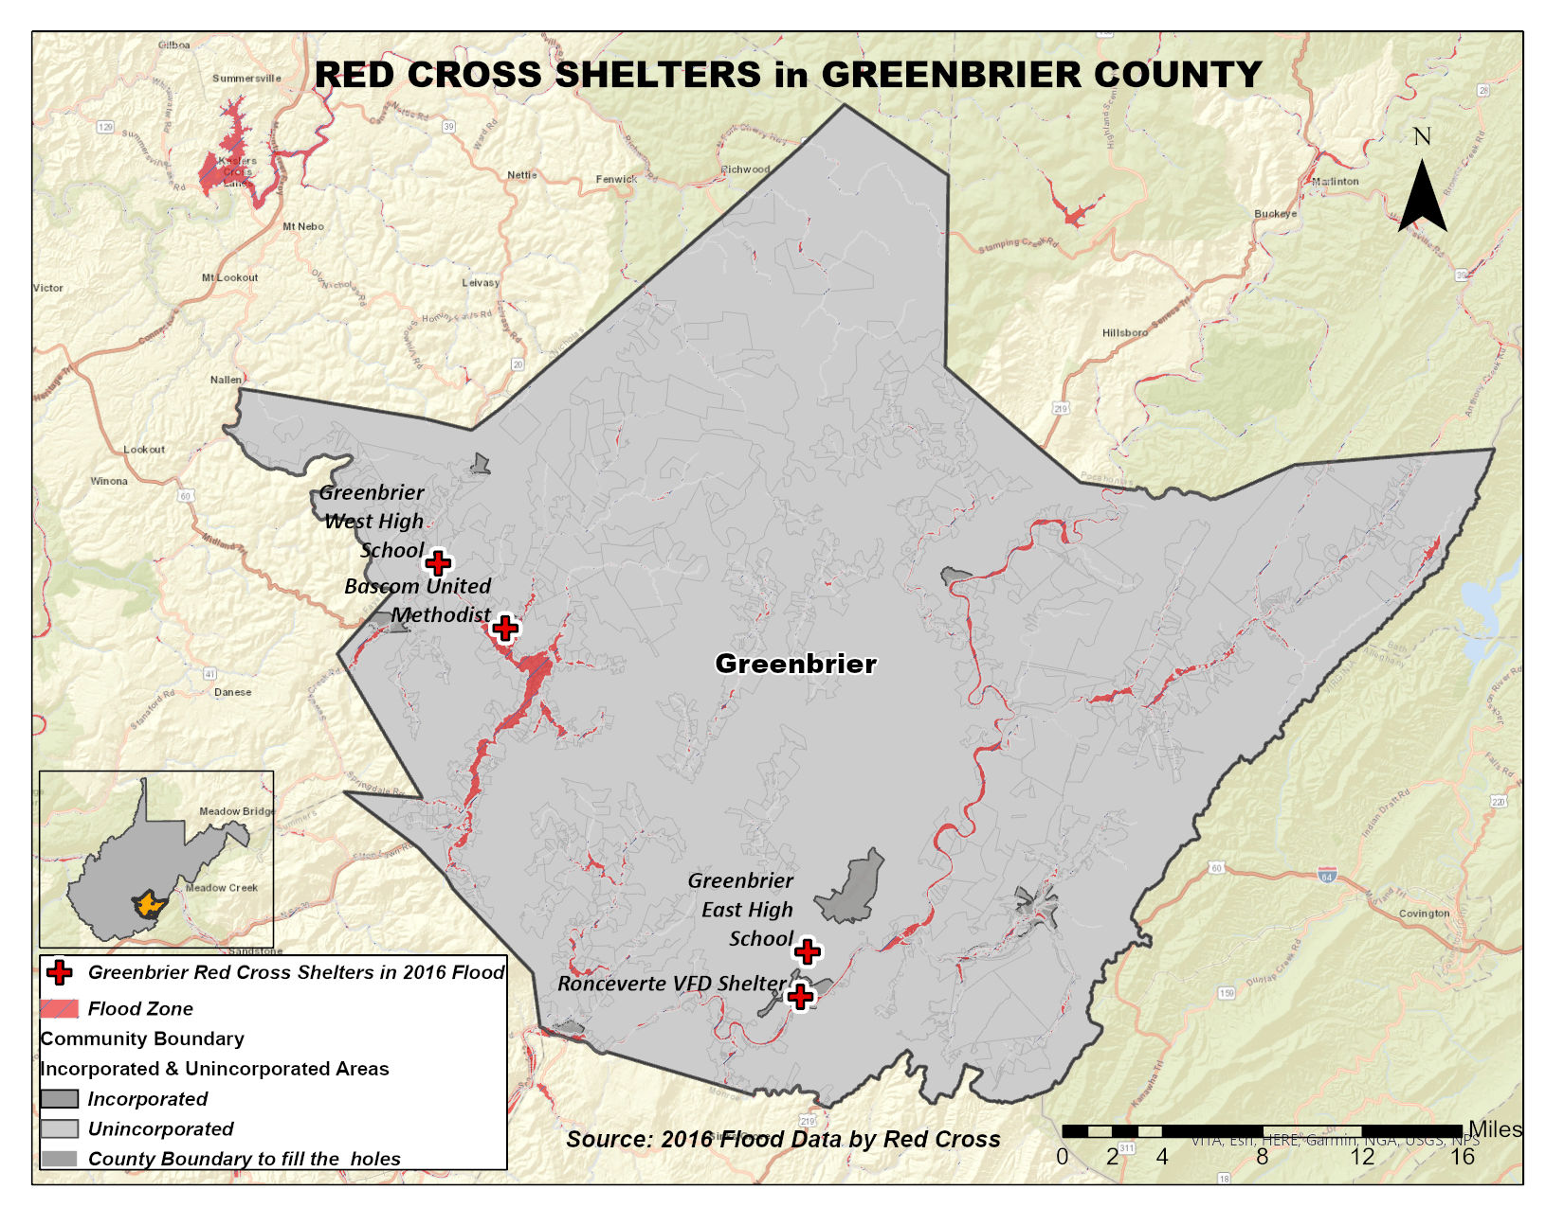

Chart 1 indicates the distribution of shelters residents in three age groups. As the chart shows, the highest number of shelter users had 18 years or less (43%), while the third age group, including people over 65 years old, had the lowest number of users (20%). Table 2 indicates the distribution of people in need of shelter for three age groups.

Although the shelter needs estimation states that the older adults would contain the highest number of shelter users, the Red Cross analysis does not entirely confirm that. The reasons can be described as follow:

* Based on 2017 census data, the group containing people aged 65 and above included 21.9 % of the whole population in Greenbrier County and ranked as the lowest populated group. On the other hand, the most populated group was between 15 and 64 (62.2% of the entire population). Therefore, the shelter data might follow the age composition in the county.
* The data received from Red Cross was restricted to only four shelters and didn’t cover all the emergency shelters used in the 2016 flood event. For instance, it didn’t cover the demographic information of 300 people settled in Greenbrier resort or 129 residents sheltered in Baptist Church gymnasium in Rainelle. In addition, it also didn’t specify the demographic data of 20 people in Charmco town.

Thus, we can say that the chart of the age group in this study might have been affected by the limitation of data. However, it provides general knowledge regarding the age of users and duration of stay. Besides, it shows that in which city people were more tended to use emergency shelters.

**Chart.1:** The Age Group of Red Cross Shelter Users

***Source: West Virginia 2016 Flood, Red Cross Data***

**Limitation:** There are always some limitations to access the accurate data regarding the number of open and used shelters during a flood and the number of people who stayed there. Some of these limitations are as follows:

* In addition to Red Cross shelters, there might be some other unregistered shelters, such as churches or fire departments or any other public places in the neighborhoods, that the residents know and use it.
* Some older adults have medical or physical issues or are not interested in staying in crowded places. Therefore, they may prefer to remain in quiet and small safe places, with a limited number of people in the neighborhood. Thus, finding information about these places and the users will not be easily possible.**
* The people who settle in a shelter may come from different communities. People select the shelter based on the distance, access, and type of facilities in that shelter. In addition, people displaced from their homes by the emergency teams will be placed based on the capacities of a shelter; thus, they may be settled in some safe places far from residing communities.
* Due to respect to the privacy of the shelter users, Red Cross will not provide data regarding the location and origin community of users. Therefore, it would not be easy to compare the estimated number for each community with the absolute number of users.
* Red Cross shelters are not pet-friendly; therefore, they will not be the first option for pet owners.**

*\*\* Some of these data were acquired from a survey, prepared to assess the demand and use of flood shelter by 2016 flooded communities*

**Conclusion:** The average number of people who need shelters in Greenbrier County, including the split community of Alderson (split between Greenbrier and Monroe Counties), is 80, and the median number is 36. Comparing the average and median of the whole state, 99 and 20, by order, we can see that Greenbrier’s average and mean of shelter requirements are lower than the state.

In addition, to find the accuracy of our model, we compared the result with the actual data. Data of people who used shelters during the 2016 flood was acquired from the Red Cross data and some online sources (references are available at the end of the report). Therefore, we can see that the total number, estimated by the model, and the number of people who used shelter in the 2016 flood are pretty close.

**Table3.** Comparing shelter needs estimation with the actual data

|  |  |  |  |
| --- | --- | --- | --- |
| **Estimation of Shelter Needs** | **Source of Data** | | **Total Number of People in Greenbrier County** |
| **Red Cross Data** | **Other Sources** |
| **2016 Flood** | **114** | **429** | **543** |
| **Tech Center Model** | **Acquired from the Equation** | | **603** |

**Reference:**

Department of Homeland Security and Federal Emergency Management Agency (FEMA). (n.d.). *Hazus®-MH technical manual: Multi-hazard loss estimation methodology, flood model*. Washington, D.C.: FEMA. Retrieved from https://www.fema.gov/sites/default/files/2020-09/fema_hazus_flood-model_technical-manual_2.1.pdf

United States Census Bureau. (2019). *American Fact Finder*. Retrieved from https://factfinder.census.gov/faces/nav/jsf/pages/community_facts.xhtml

West Virginia Development Office. (2020). *The State of West Virginia Community Development Block Grant – Mitigation Action Plan*. Retrieved from: <https://wvcad.org/assets/files/resources/cdbg/MIT/WV_CDBGMIT_Action_Plan_Final_Approved_22Dec2020.pdf>

**Appendix.1**