Joy Wu

**Transportation Infrastructure Impacted by a 1% Annual Chance Flood**

**Key History of Flooding:**

* January 19-21, 1996: 3-day period of flooding after blizzard of 1996; flooding resulted in $593,000 in damages to public and private facilities
* Sept 6, 1996: heavy rain resulting from Hurricane Fran caused $2.8 million dollars of damage to Harpers Ferry—some roads washed out and railroads damaged
* May 26, 2002: heavy downpours with hail on WV 480 near Shepherdstown
* May 16, 2003: lots of rain; WV 230 closed and US 340 flooding near Harpers Ferry
* Sept 18-20, 2003: moderate flooding as result of Hurricane Isabel; reached moderate flooding stage of 17.31 ft over 13.5 ft flood stage; total property and crop damage for Eastern Panhandle was $1,070,000
* Sept 28, 2004: Hurricane Jeanne caused widespread flooding
* June 26, 2006: flooding in Bolivar, caused accident on WV 230
* March 13, 2010: John Rissler Road, Bloomery Road, and River Road closed due to flooding
* April 16, 2011: mudslide and flooded basements; Chestnut Hill Road closed due to water going down to US 340

**Water Depth Categories:**

The following water depth categories were created around emergency vehicle response ability.

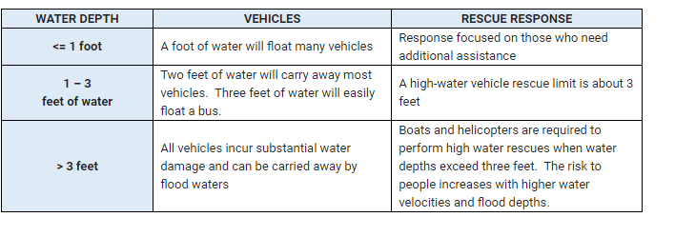

Table : Water Depth and Emergency Response

With water levels below one foot, rescue response is focused on those who need additional assistance, such as the elderly or disabled. However, a foot of water can float many vehicles, so driving may be very risky.

When water levels are between one foot and three feet, high profile vehicles can be used to rescue individuals. However, three feet is reaching the upper limit for using these vehicles. Two feet of water will carry away most vehicles, and three feet can easily float a bus. Driving in these conditions can be **EXTREMELY** dangerous.

When water levels are above three feet, boats and helicopters are required to perform high-water rescues. Risks people may incur will increase with higher water velocities and flood depths. All vehicles will sustain substantial water damage and can be carried away by flood waters.

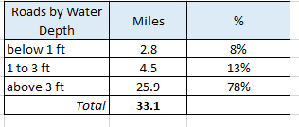

Table : Road Mileage and Water Depth

**Routes Affected:**

The following major routes will be affected by the 1% annual chance flood: WV Routes 9, 45, 51, 115, 230, and 480. The only US Route that runs through Jefferson County is US 340, but it most likely will not be inundated by water due to its higher deck elevation.

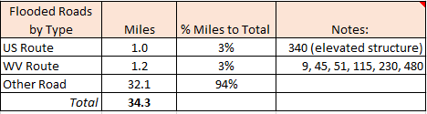

Table : Road Classification and Flooded Mileage

County and local routes along the Shenandoah and Potomac Rivers will likely be flooded. Data shows the majority of routes flooded will be these routes.

No roads within Bolivar will be flooded, but sections of the Baltimore and Ohio Railroad along the outskirts of the town following the Potomac and Shenandoah Rivers will be flooded.

In Shepherdstown, a section of WV Route 230 will be flooded near the middle of the town. A small section of WV Route 480 leading into Maryland will also be flooded. Very small sections of a railroad may be flooded leading out of Shepherdstown towards the southern portion of the county. All three of these flooding events follow Town Run.

In Harpers Ferry, a section of alternate US Route 340 leading into Maryland may be flooded near the Potomac River. The Baltimore and Ohio Railroad comes to a junction point where the Potomac and Shenandoah rivers meet and is likely to be flooded there.

No roads within Charles Town city borders will be flooded, but three WV Routes leading into and out of Charles Town will be flooded. This includes WV 9 and 115 where they cross the Shenandoah and WV 51 where it crosses Evitts Run in the northern part of the city. No railroads are flooded within or near Charles Town.

No roads within Ranson will be flooded, but a significant portion of the Baltimore and Ohio Railroad will be flooded near Evitts Run and Flowing Springs Run. A small section of the Norfolk and Western Railroad will also be flooded as it crosses the B&O Railroad near Evitts Run.

**Mileage Affected:**

Approximately 75 miles of roads and railroads are within the flood plain formed from the 1% annual chance flood data. Of those 75 miles, about 43 miles will be inundated by flood waters, which will present some obstacles to smooth traveling across the county. The vast majority of roads and railroads will be covered with flood waters above three feet, so these will need to be closed.

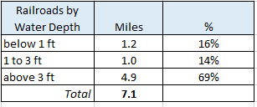

Table 4: Railroad Mileage and Water Depth

However, only 8.2% of the total county road and railroad mileage will be flooded, so the majority of roads will be fine. But nevertheless, a 1% annual chance flood can still cause transportation problems.

**Bridges Affected:**

Eleven bridges will be inundated with water—Avon Bend Bridge, Bakerton Road Bridge, Dailey Bridge, Kabletown Bridge, King Lear Bridge, Knott Island Bridge, Moler Crossroads Bridge, Scrabble Bridge, Shannondale Bridge, Sulphur Springs Bridge, and Wheatland Road Bridge.

The majority of these bridges fall along Opequon Creek near the western border of the county, the Shenandoah River, and the Potomac River along the northern border of the county. Other affected bridges are concentrated around smaller streams and rivers.

Three major bridges on WV 115 will be closed where the route crosses the Shenandoah. This may present some trouble for those wanting to drive out to Maryland or drive in to Charles Town or Ranson.

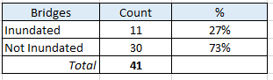

Table : Inundated Bridges

**Most-at-risk Areas by Community:**

The areas most at risk for flooding include Lower Town in Harpers Ferry, areas in Bolivar along the Shenandoah River, the middle of Shepherdstown surrounding Town Run, and areas of Ranson and Charles Town bordering Evitts Run.

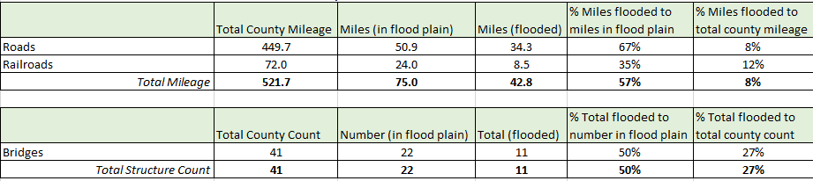

Table : Transportation Infrastructure in a Special Flood Hazard Area (SFHA)

**References:**

<http://www.jeffersoncountywv.org/home/showdocument?id=11359>