**Mitigated Buyout Property Update Procedures**Drafted by Kurt Donaldson 9/20/2021

Mitigated buyout properties may originate from various sources, including counties, WV Division of Homeland Security and Emergency Management, or federal agencies such as the Natural Resources Conservation Service. West Virginia buyout properties from new source are integrated into a master geodatabase and published to the WV Flood Tool (www.mapwv.gov/flood).

The updated procedures for integrating new properties into the standardized geodatabase are described as follows (Figure 1). First, the source agency file is standardized on the full parcel identifier. The unique property identifier is the full GIS Parcel Identifier (e.g., 01-08-0011-0069-0000). The source file is then checked against the Master Buyout Property file for duplicate records. Next, the source agency file is converted to a geodatabase format and updated with the parcel geometry from the seamless Statewide Master GIS Surface Parcel file. New records are joined with FEMA’s Community Boundary File to add the Community Identifier (ID) and Community Name data fields. The original source records are also joined with the State’s Master Assessment Database for quality data checks and adding additional fields (e.g., current property owner, land use code). Quality checks are performed for mismatches of the parcel geometry, assessment records, and structures present on aerial imagery. The final step merges the Source Data File with the Master Buyout Property GIS File and standardized on key attributes (Table 1).

**Buyout Property Processing Steps:**

1. Receive Source Agency Data file. Full parcel identifier required to process buyout properties.
2. Standardize Parcel ID to GIS Parcel Identifier Format (e.g., 01-08-0011-0069-0000)

|  |  |  |  |  |  |  |  |  |
| --- | --- | --- | --- | --- | --- | --- | --- | --- |
| 01 | - | 08 | - | 0011 | - | 0069 | - | 0000 |
| County |  | District |  | Map |  | Parcel |  | Suffix |

1. Check Source Data File for duplicate records with Master Buyout Properties Table. If duplicate master record is an “unverified” parcel, then update verified status information from Source Agency Data File.
2. Reconcile and update Source Agency Data parcel geometry with Master Surface parcel geometry. Perform parcel geometry QC. Update Source File.
3. Join Source Agency Data to Community Boundary File. Update Source File
4. Join Source Agency Data to IAS Assessment Records. Update Source File
5. Perform final QC checks of duplicate records, parcel geometry, assessment attributes, and aerial imagery with Master Buyout Property GIS File. Record data issues. Update Source File.
6. Merge validated Source File with Master Buyout Property GIS File. Update Master Buyout GIS File with source, community, assessment, and geo-processing data fields. See Data Schema for which data fields are retained for Source and Master Buyout Property Files.

Figure 1. Processing Steps

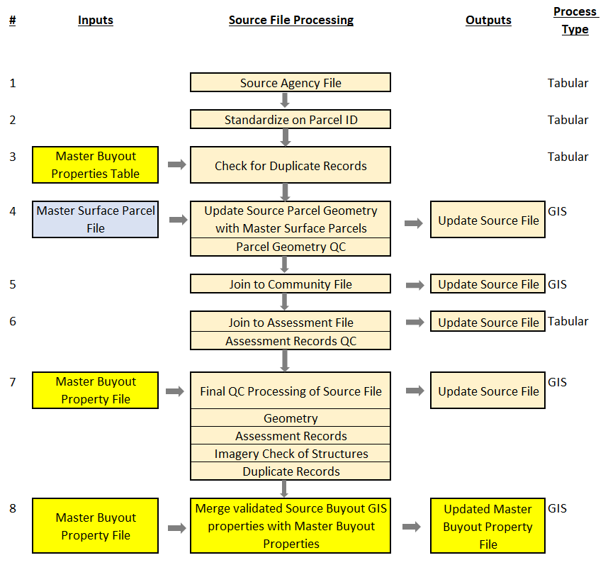

Table 1. Data Schema for Source and Master Buyout Property Files

|  |  |  |  |
| --- | --- | --- | --- |
| **#** | **Fields** | **Data Field Category** | **Description** |
| 1 | **PID** | Identifier | Full GIS Parcel Identifier (unique JOIN record) |
| 2 | **CountyCode** | Identifier | Parcel ID: County Code |
| 3 | **DISTRICT** | Identifier | Parcel ID: Tax District Number |
| 4 | **MAP** | Identifier | Parcel ID: Map Number |
| 5 | **PARCEL** | Identifier | Parcel ID: Parcel Number |
| 6 | **SUFFIX** | Identifier | Parcel ID: Parcel Suffix |
| 7 | **Source_Agency** | Source | Source Agency for buyout properties. (WVEMD, Kanawha, NRCS, etc.). “Unverified” records are parcels owned by the county or municipality with zero building value and need to be verified by source agency if property deed restricted. |
| 8 | **Source_Project_ID** | Source | Source Agency Identifier |
|  | S_Address | Source | Source Address of Property* |
|  | S_PrevOwner | Source | Source Previous Owner* |
|  | S_DeedBook | Source | Source Deed Book |
|  | S_DeedPage | Source | Source Deed Page Number |
| 9 | **S_Date_Executed** | Source | Source Date Sell Executed |
|  | S_Legal_Description | Source | Source Legal description of the structure and/or property |
| 10 | **S_Hazard_Type** | Source | Source Hazard Type: Flood or Landslide |
|  | **S_Program_FEMA_NRCS_USACE** |  | If not known then list “Unknown” |
|  | S_Lat | Source | Source Latitude Coordinate |
|  | S_Long | Source | Source Longitude Coordinate |
|  | S_Comments | Source | Source Comments on the data (copy relevant comments to master) |
|  |  |  |  |
|  |  |  |  |
|  | JOINED TO COMMUNITY DATA | | |
| 11 | **CID** | Community | Community ID |
| 12 | **CID_Name** | Community | Community Name |
| 13 | **Incorp_Unincorp** | Community | Incorporated or Unincorporated |
|  |  |  |  |
|  | JOINED TO ASSESSMENT DATA | | |
| 14 | **IAS_Owner1** | Assessment QC | Current Owner 1 |
| 15 | **IAS_Owner2** | Assessment QC | Current Owner 2 |
| 16 | **IAS_Legal_Desc1** | Assessment QC | Legal description of the structure and/or property |
| 17 | **IAS_Legal_Desc2** | Assessment QC | Legal description of the structure and/or property |
| 18 | **IAS_Legal_Desc3** | Assessment QC | Legal description of the structure and/or property |
| 19 | **IAS_DeedBook** | Assessment QC | The number of the deed book containing the tax information |
| 20 | **IAS_DeedPage** | Assessment QC | The page number within the deed book |
| 21 | **IAS_DeedAcres** | Assessment QC | Total acres as indicated in the deed book. |
|  | IAS_TaxClass | Assessment QC | Tax Class |
|  | IAS_PropertyClass | Assessment QC | Current classification of the property. |
|  | IAS_LandUse | Assessment QC | Current land usage of the parcel |
|  | IAS_DwellingValue | Assessment QC | Used for the value of a home. |
|  | IAS_CommercialValue | Assessment QC | Used for the value of a commercial structure. |
|  | IAS_OBY_Value | Assessment QC | The value of Other Building and Yard Improvements. |
|  | IAS_LandAppraisal | Assessment QC | Total value of the land. |
|  | IAS_BuildingAppraisal | Assessment QC | Total value of the primary structure(s) |
|  | IAS_TotalAppraisal | Assessment QC | Sum value of the land and building appraisals |
|  | IAS_Parcel_Address | Assessment QC | Address of the parcel. |
|  | IAS_Sale_Date | Assessment QC | Last Sale Date of Property |
|  | IAS_TaxYear | Assessment QC | The current tax year of the parcel. |
|  |  |  |  |
|  |  |  |  |
|  | PROCESSING | | |
| 22 | **QC_Acres_C** | Processing GIS Acreage | Calculated Acreage from GIS Shape |
| 23 | **QC_Geometry_Flag** | Processing QC | Source geometry does not match statewide parcel geometry (Y if applicable) |
| 24 | **QC_Assmt_Flag** | Processing QC | Assessment Mismatches (Y if applicable) including Deed/Calculated Acreage |
| 24 | **QC_Imagery_Flag** | Processing QC | Building Present on Imagery (Y if applicable) |
| 26 | **QC_Coments** | Processing QC | QC Comments |
| 27 | **LAT_83** | Processing Identifier | GIS Calculated |
| 28 | **LONG_83** | Processing Identifier | GIS Calculated |
| 29 | **Parcel_Link** | Processing Web Link | **Link to parcel in WV Flood Tool (Expert View)** |
| 30 | **IAS_Link** | Processing Web Link | Link to detailed web assessment report |

|  |  |
| --- | --- |
| **Yellow Boldfaced** | Master Buyout Property Field |
| **Highlighted Green** | Input Data Fields from Client |

Web Service Fields

<https://services.wvgis.wvu.edu/arcgis/rest/services/Hazards/floodTool_preservedOpenSpaces/MapServer/1>

Logical Groups: Community Identification, Property Identification, Source Data Fields, IAS Data Fields, QC Notes

* OBJECTID*( type: esriFieldTypeOID, alias: OBJECTID )*
* Shape*( type: esriFieldTypeGeometry, alias: Shape )*
* CleanPID*( type: esriFieldTypeString, alias: CleanPID, length: 100 )*
* PID*( type: esriFieldTypeString, alias: PID, length: 100 )*
* CountyCode*( type: esriFieldTypeString, alias: CountyCode, length: 10 )*
* DISTRICT*( type: esriFieldTypeString, alias: DISTRICT, length: 10 )*
* MAP*( type: esriFieldTypeString, alias: MAP, length: 10 )*
* PARCEL*( type: esriFieldTypeString, alias: PARCEL, length: 10 )*
* SUFFIX*( type: esriFieldTypeString, alias: SUFFIX, length: 10 )*
* Source_Agency*( type: esriFieldTypeString, alias: Source_Agency, length: 100 )*
* Source_Project_ID*( type: esriFieldTypeString, alias: Source_Project_ID, length: 50 )*
* S_Hazard*( type: esriFieldTypeString, alias: S_Hazard, length: 50 )*
* CID*( type: esriFieldTypeString, alias: CID, length: 6 )*
* CID_Name*( type: esriFieldTypeString, alias: CID_Name, length: 100 )*
* Incorp_Unincorp*( type: esriFieldTypeString, alias: Incorp_Unincorp, length: 50 )*
* IAS_Owner1*( type: esriFieldTypeString, alias: IAS_Owner1, length: 100 )*
* IAS_Owner2*( type: esriFieldTypeString, alias: IAS_Owner2, length: 100 )*
* IAS_Legal_Desc1*( type: esriFieldTypeString, alias: IAS_Legal_Desc1, length: 100 )*
* IAS_Legal_Desc2*( type: esriFieldTypeString, alias: IAS_Legal_Desc2, length: 100 )*
* IAS_Legal_Desc3*( type: esriFieldTypeString, alias: IAS_Legal_Desc3, length: 100 )*
* IAS_DeedBook*( type: esriFieldTypeString, alias: IAS_DeedBook, length: 10 )*
* IAS_DeedPage*( type: esriFieldTypeString, alias: IAS_DeedPage, length: 10 )*
* IAS_DeedAcres*( type: esriFieldTypeDouble, alias: IAS_DeedAcres )*
* QC_Acres_C*( type: esriFieldTypeDouble, alias: QC_Acres_C )*
* QC_Geometry_Flag*( type: esriFieldTypeString, alias: QC_Geometry_Flag, length: 1 )*
* QC_Assmt_Flag*( type: esriFieldTypeString, alias: QC_Assmt_Flag, length: 1 )*
* QC_Imagery_Flag*( type: esriFieldTypeString, alias: QC_Imagery_Flag, length: 1 )*
* QC_Comments*( type: esriFieldTypeString, alias: QC_Comments, length: 100 )*
* LAT_83*( type: esriFieldTypeDouble, alias: LAT_83 )*
* LONG_83*( type: esriFieldTypeDouble, alias: LONG_83 )*
* Parcel_Link*( type: esriFieldTypeString, alias: Parcel_Link, length: 255 )*
* IAS_Link*( type: esriFieldTypeString, alias: IAS_Link, length: 255 )*
* FloodTool_Link*( type: esriFieldTypeString, alias: FloodTool_Link, length: 255 )*
* Date_Executed*( type: esriFieldTypeString, alias: Date_Executed, length: 255 )*
* ORIG_FID*( type: esriFieldTypeInteger, alias: ORIG_FID )*