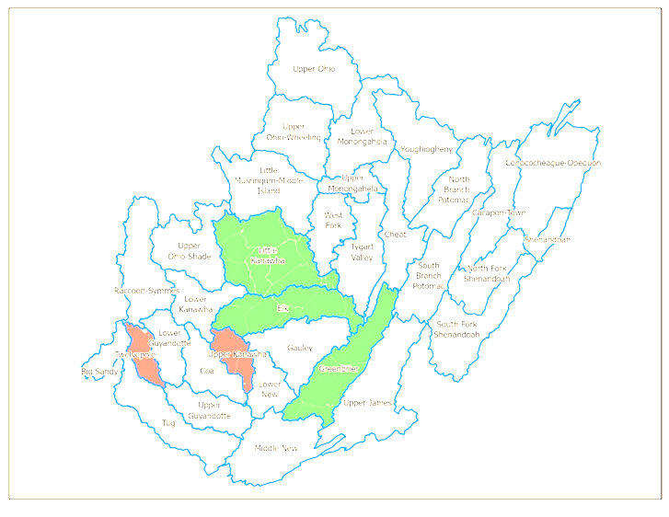

WV GIS Tech. Center

September 2023

September 2023

Watershed-level Flood Risk

Summary Report

**Table of Content**

Flood Hazard 1

Natural Characteristics 1

*Flood Zone Area in the Watersheds* 2

*Top Streams in the Watersheds* 2

Building Exposure 3

Watershed Level 3

Stream Level 9

Community Level 12

UnIncorporated Area  12

*Incorporated Area* 17

Especial Buildings 22

Flood Loss 24

Building Damage Estimates 24

Building Debris Removal Estimates 24

**List of Figures**

**Figure 1.** Location of the Largest and Smallest Watersheds in West Virginia 1

**Figure 2.**Total number of Buildings in each watershed 5

**Figure 3.** Residential, Non-Residential and mobile homes in each watershed 6

**Figure 4.** The sum of Pre-firm and post-firm Structures in Unincorporated areas 15

**Figure 5.** Total mapped-in, mapped-out, and floodway structures in the unincorporated areas 16

**Figure 6.** The sum of Pre-firm and post-firm Structures in Incorporated areas 19

**Figure 7.** Total mapped-in, mapped-out, and floodway structures in the Incorporated areas 21

**Figure 8.** Highest Value Structures in Upper Monongahela watershed 23

**List of Tables**

**Table 1.** Percentage of the 100-year flood zone in WV watersheds 2

**Table 2.** Watersheds with the highest Stream Length 3

**Table 3.** Watersheds with the highest number of Buildings and Residential Buildings 3

**Table 4.** Name of the Streams and Watersheds 9

**Table 5.** Unincorporated areas with the highest building number 12

**Table 6**.Five highest total building cost (USD) in Unincorporated Areas 14

**Table 7.** Sum of Pre-firm and Post-firm structures in Unincorporated areas 15

**Table 8.** Five highest total building cost (USD) in Incorporated Areas 17

**Table 9.** Five highest total Building costs (USD) in incorporated areas 18

**Table 10.** Number of Pre-firm and Post-firm structures in Incorporated areas 20

**Table 11.** Highest value Buildings 22

# Flood Hazard

## Natural Characteristics

***Watersheds Boundaries***

A total of 33 watersheds intersect with West Virginia. Among these watersheds, 13 are entirely within West Virginia's borders, containing approximately 60 percent of the state's area. The largest watershed entirely situated in West Virginia is the Little Kanawha watershed, spanning an area of 2,303 square miles, followed by the Greenbrier and Elk watersheds, with areas of 1,649 and 1,531 square miles, respectively. Twelvepole, with a 442 square mile area, is the smallest watershed in the state, while Upper Kanawha and Lowe New are the second and third smallest, respectively. Figure 1 indicates the geographical location of these watersheds in the state.

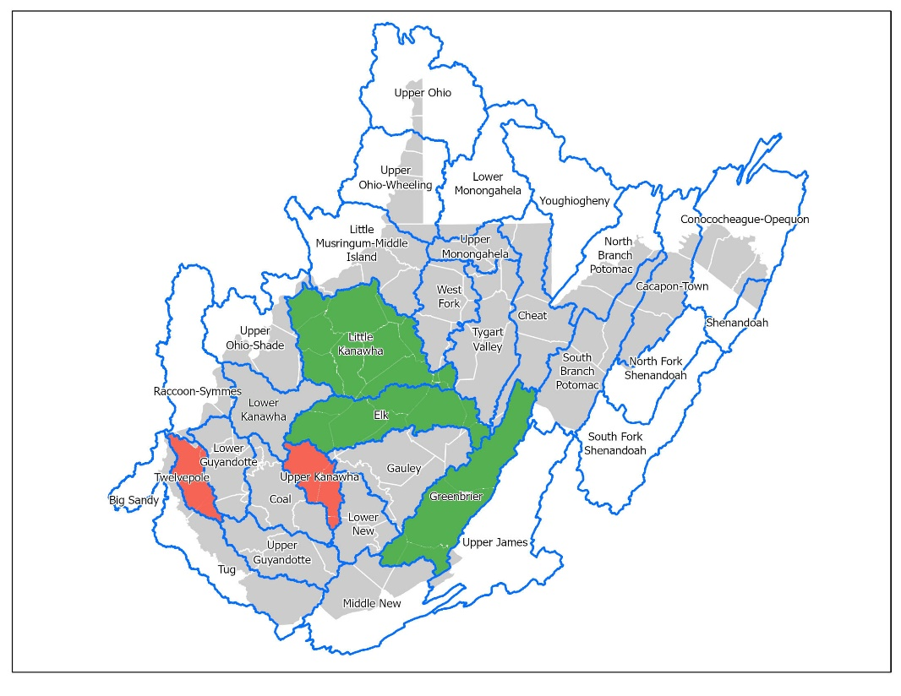

**Figure 1.** Location of the Largest and Smallest Watersheds in West Virginia

## *Flood Zone Area in the Watersheds*

This study mainly focuses on estimating 100-year flood zones containing A, AE, AH, and AO, while this study has not considered 500-year flood Zones (X).

The flood zone ratio, obtained by dividing the floodplain area by the watershed area in West Virginia, indicates that Racoon-Symmes, Upper Ohio-shade, and Shenandoah have the highest percentage of floodplain coverage among the thirty-three watersheds. Table 1 shows that after these top threes, the largest flood zones are respectively observed in the Upper Ohio, Big Sandy, and Lower Kanawha watersheds.

|  |  |
| --- | --- |
| Watershed | Percentage of 100-year FloodPlain in the Clipped Watershed |
| Raccoon-Symmes | 21% |
| Upper Ohio-Shade | 15% |
| Shenandoah | 14% |
| Upper Ohio | 13% |
| Big Sandy | 11% |
| Lower Kanawha | 10% |

**Table 1.** Percentage of the 100-year flood zone in WV watersheds

Although Lower Kanawha ranks sixth in terms of the percentage of floodplain area according to Table 1, the application of spatial data in this study reveals that this watershed has the most extensive flood zone area, covering 139 square miles, with 111 miles of it falling within flood zone A. Following closely is South Branch Potomac, with 113 square miles of floodplain area and 83 miles within flood zone A. In addition, flood zone AE is broadly extended in Raccoon-Symmes, Upper Ohio, and Upper Ohio-Shade watersheds. The percentage of Flood zone AE in these watersheds are 19%, 13%, and 10%, respectively.

## *Top Streams in the Watersheds*

Analyzing these watersheds regarding stream lengths clarifies that the Little Kanawha watershed boasts the highest total length of streams, amounting to 2017 miles. In contrast, Elk and Gauley watersheds rank second and third, with stream lengths of 1,298 and 1,176 miles, respectively. The Youghiogheny Watershed has the shortest stream length, measuring only 49.9 miles. The total stream length for each of these five highest has been described in Table 2.

|  |  |
| --- | --- |
| Stream Name | Total Stream Length |
| Little Kanawha | 2,017 |
| Elk | 1,298 |
| Gauley | 1,176 |
| Greenbrier | 1,173 |
| Tygart Valley | 982 |

The most significant streams in Gauley and Lower New Watersheds are Sewell Creek, Cherry River, and Gauley River (including Gauley River and Gauley River (Upper)).

**Table 2.** Watersheds with the highest Stream Length

# Building Exposure

## Watershed Level

The Lower Kanawha Watershed has the highest number of buildings, with a total count of 9130, of which 8311 (91%) are classified as residential (Figure 2). As a result, this watershed boasts the highest building value in Residential and non-residential buildings, amounting to $588,381,996 and $742,070,411, respectively. Table 3 shows that the Upper Guyandotte and Coal watersheds are ranked second and third in the total number of buildings. However, when considering the percentage of residential buildings to the total number of buildings, the Raccoon-Symmes and Upper Kanawha watersheds take the lead, with 93% of their buildings being residential, placing them in the first and second positions, respectively.

|  |  |  |  |  |
| --- | --- | --- | --- | --- |
| Watershed | Building Count | Density (bldgs/acre) | Residential | Percentage of Residential to the Total Building |
| Lower Kanawha | 9,130 | 9.9 | 8,311 | 91% |
| Upper Guyandotte | 7,745 | 8.2 | 6,915 | 89% |
| Coal | 7,280 | 8.2 | 6,731 | 92% |
| Tug | 7,204 | 7.7 | 6,513 | 90% |
| Upper Ohio-Wheeling | 6,248 | 11.1 | 5,234 | 84% |
| Upper Kanawha | 5,650 | 10.8 | 5,262 | 93% |
| Elk | 5,372 | 3.5 | 4,869 | 91% |

**Table 3.** Watersheds with the highest number of Buildings and Residential Buildings

On the other hand, the building density, calculated by dividing the number of buildings by the area of the WV watersheds, is highest in the Upper Ohio-Wheeling watershed, followed by the Upper Kanawha and Lower Kanawha. These results were somewhat predictable, considering that the densely populated city of Charleston is located in these areas. Upon a closer examination of the building analysis in WV watersheds, the following points are noticeable:

* **Lower Kanawha**: It has the highest number of buildings (9,130 structures), the highest number of Residential Buildings (8,311), and the third number of Non-residential Buildings (819). Meanwhile, this watershed also has the highest number of Pre-firm structures (6,316) and Post-firm structures (2,043). (Figure 3)
* **Upper Ohio-Wheeling:** This watershed hasthe highest building density (11.1), the highest Non-residential buildings (1,014 structures), and the lowest percentage of owner-occupied buildings (53%). The buildings in this watershed also exhibit the least median year built (1932), which is understandable. Since there are many historical buildings in this area, dating back to the 18th and 19th centuries, this observation aligns with historical trends. Thus, it has the highest percentage of Pre-firm structures (86%).
* **Coal Watershed:** Third watershed in terms of building numbers (7,280 structures), Third in the number of Residential buildings (6,731 buildings), and Third place in the number of mobile homes (2,205 mobile homes).
* **Upper Kanawha:** It is the Second high-density buildings watershed (10.8), the first[1] in the percentage of residential (93%), and the fifth watershed in the number of owner-occupied buildings (3,792).
* **Coal:** The Coal watershed has third place inthe number of buildings (7,280), third in the number of residential buildings (6,731), second in the percentage of residential (92%), and third in the number of mobile homes (2,205).
* **Elk:** Third top in the percentage of residential buildings (91%) with three other watersheds: *Lower Guyandotte*, *Cacapon-Town*, and *Lower Kanawha*.
* **Upper Guyandotte:** It is Second in the number of buildings (7,745 structures), Second in the number of residential buildings (6,915), Third in the number of Non-residential buildings (830 structures), and Second in the number of mobile homes (2,445 mobile homes). Also, this watershed has the maximum number of post-firm Structures (2,190).

**Figure 2.**Total number of Buildings in each watershed

**Figure 3.** Residential, Non-Residential and mobile homes in each watershed

**Mobile Homes**

Tug watershed has the highest number of mobile homes (2,536), while in the case of percentage, the highest rate of mobile homes is found in Middle New watershed. On the other hand, the lowest number of mobile homes is in the North Fork Shenandoah watershed, with only one mobile home, and the lowest percentage belongs to the Shenandoah watershed, with 8% of mobile homes.

**Buildings in Floodways**

Buildings in the main floodway channel of the river or stream or close to the flood source will be subject to the greatest flood depths, highest velocities, and greatest debris potential. In the floodways statewide, there are a total of 8,272 primary buildings located. The Upper Guyandotte Watershed has the highest number, with 1,263 structures in these areas. The Tug and Upper Kanawha watersheds rank second and third, with 992 and 785 buildings located in floodways, respectively.

**Total and mean building cost/exposure (USD)**

The Lower Kanawha watershed records the highest total residential building cost/exposure, amounting to $581,381,996, while the Upper Monongahela watershed reports the highest cost/exposure in non-residential buildings, totaling $1,078,982,877

However, regarding the mean residential building cost/exposure, the Shenandoah watershed has the highest amount, with $105,981, and the highest non-residential mean is found in the Upper Monongahela watershed ($2,932,019).

**FIRM status**

The highest percentage of Post-Firm buildings is 38% in the Big Sandy Watershed. Also, the lowest percentage of Post-Firm buildings is in the Upper Ohio-Wheeling watershed (11%).

On the other hand, the highest percentage of Pre-Firm buildings is in the Upper Ohio-Wheeling watershed (86%), and the lowest percentage is in the Upper Ohio Shade, followed by the Twelvepole watershed.

**Critical Structures**

* **Essential Facilities**

Essential facilities provide critical services to the community, including police and fire stations, E-911 emergency operations centers, schools (often used as shelters), hospitals, and nursing homes.

A total of 493 essential facilities are exposed to flood risk within all watersheds statewide. Among them, the Upper Kanawha and Tug watersheds have the highest number, with 53 essential facilities exposed to 100- or 500-year floods. Following closely behind is the Lower Kanawha Watershed, which has 43 at-risk structures facing the same flood risks.

* **Non-historical Community Assets**

Non-historical community assets are government facilities (federal, state, local), emergency medical services (EMS), religious organizations, utilities, postsecondary educational facilities, or other buildings of significance that contribute to the community's built environment.

In all watersheds across the state, a total of 2,139 community assets (excluding historical ones) were identified within the 1%-annual-chance floodplain. The Upper Guyandotte Watershed has the highest number of at-risk community assets, with 196 structures in the floodplain. The Tug and Coal watersheds rank second and third, with 191 and 176 at-risk community assets.

**Future Map Conditions**

According to the future flood maps, 13,668 buildings will be mapped in high-risk floodplains statewide when they become effective. Among all watersheds, the Tug Watershed will have the highest number of mapped-in structures, with 1,649 buildings. The Lower Kanawha Watershed closely follows it with 1,587 structures, and the Upper Guyandotte Watershed with 1,513 buildings.

On the other hand, when the advisory floodplains become effective, a total of 14,985 structures will be mapped out statewide. The Lower Kanawha watershed will have the highest number of mapped-out buildings, with 1,383 structures. The Coal and Elk watersheds rank second and third, with 1,365 and 1,042 mapped-out buildings, respectively.

## Stream Level

**Total Building Count**

There are ten main streams in these watersheds. Elk watershed, with 1531 square miles, is the most extensive watershed in this study area, which encompasses Elk River. However, clipping the stream in the watershed and assessing the building density indicates that the area that contains the Kanawha River, with 6490 buildings, has the highest number of buildings. Elk River and Coal River areas are in second and third place in terms of number of buildings. Piney Creek, flowing in the Lower New watershed, has the smallest watershed (691 square miles) and the lowest number of buildings (181 structures). In the Kanawha River area, 90% of buildings (5813 total)are residential, while this amount is 88% (2157) in the Elk River area. Also, the lowest number of residential and non-residential buildings belong to the Piney Creek area in the Lowe New watershed, with 169 residential structures and 12 non-residentials.

|  |  |  |  |
| --- | --- | --- | --- |
| Stream Name | Watershed | Watershed Area (sq. mi) | Building Count |
| Kanawha River | Lower Kanawha, Upper Kanawha | 1445.3 | 6,490 |
| Elk River | Elk | 1530.8 | 2,441 |
| Coal River | Coal | 890.8 | 2,335 |
| Pond Fork | Coal | 890.8 | 956 |
| Pocatalico River | Lower Kanawha | 923.7 | 676 |
| Sewell Creek | Gauley | 1417.2 | 352 |
| Cherry River | Gauley | 1417.2 | 345 |
| Gauley River | Gauley | 1417.2 | 256 |
| Meadow River | Gauley | 1417.2 | 187 |
| Piney Creek | Lower New | 691.3 | 181 |

**Table 4.** Name of the Streams and Watersheds

**Mobile Homes**

In the context of the ten stream areas studied, the Pocatalico River area within the Lower Kanawha watershed has the highest proportion of mobile homes, constituting 33% of the overall building inventory. A close contender is Pond Creek, situated within the Coal watershed, where mobile homes comprise 30% (total count: 288) of the structures.

Interestingly, despite the Kanawha River area spanning both the Lower Kanawha and Upper Kanawha watersheds housing the largest count of mobile homes, totaling 633 structures, it holds the second lowest percentage of mobile homes within its composition, accounting for only 10%. In contrast, the Sewell Creek area in the Gauley Watershed boasts the lowest proportion of mobile homes, comprising a mere 9% of its building distribution.

**Buildings in Floodways**

Within the Coal Watershed, the Coal River area stands out with the greatest number of buildings within the floodway. Subsequently, the Elk River area claims second place, with 231 structures falling within this flood-prone zone. Close behind is the Pond Fork region, also within the Coal watershed, housing 148 buildings within its floodway. Conversely, in stark contrast, none of the 181 structures present in the Piney Creek area, encompassed by the Lower New watershed, are located within the floodway, showcasing a notable absence of buildings within this vulnerable area.

**Total and mean building cost/exposure (USD)**

Remarkably, the Kanawha River area situated within the Lower and Upper Kanawha watersheds emerges as the holder of the highest cumulative value of buildings, reaching an impressive sum of $1,425,632,865. This notable correlation finds its basis in the watershed's vast building presence. Moreover, this watershed also claims the highest count of residential buildings, commanding a value of $431,888,953. In stark contrast, the Meadow River area within the Gauley Watershed showcases the lowest total building value at $7,212,774. It's noteworthy that while this watershed doesn't possess the lowest residential building value, the Piney Creek area in the Lower New watershed has the lowest residential building value at $14,494. However, Piney Creek rises to prominence by securing the highest total value of non-residential buildings among these top ten streams.

On the other hand, the Piney Creek area in the Lower New watershed boasts the highest overall mean value, amounting to $1,609,201. This is closely trailed by the Kanawha River area within the Upper and Lower Kanawha watersheds, exhibiting a combined total mean value of $1,542,161. Remarkably, these two watersheds also lead in terms of the mean value for non-residential buildings, with values of $1,594,706 and $1,467,864 respectively. Moreover, the Upper and Lower Kanawha Watershed stands out with the highest mean value in residential buildings, averaging $74,297.

**FIRM status**

The Kanawha River area spanning the Upper and Lower Kanawha watersheds is home to the largest Pre-Firm and Post-Firm structures, totaling 5,021 (77%) and 980 (15%), respectively. Conversely, the Cherry River area within the Gauley watershed exhibits the lowest count of Post-Firm buildings, with a striking 85% of its 345 Pre-Firm structures totaling 293 buildings.

**Critical structures**

The Kanawha River area, encompassing the Upper and Lower Kanawha watersheds, further stands out with the highest count of Essential Facilities and Community Assets, boasting 82 and 379 buildings, respectively. In stark contrast, the Meadow River and Piney Creek areas within the Gauley and Lower New watersheds do not feature any essential facilities. However, they each have six community assets.

**Future map conditions**

The Kanawha River area, spanning both the Upper and Lower Kanawha watersheds, boasts the highest count of mapped-out buildings, totaling 1616, and mapped-in buildings, totaling 983, among all the streams. Notably, 75 buildings remain situated within the same floodway. In the Elk Watershed, the Elk River area anticipates 141 structures to be placed in the new Special Flood Hazard Area (SFHA), bringing the total number of buildings in the floodway, in addition to the previous ones, to 231 buildings. This positions the Elk Watershed as the second highest in terms of buildings within the floodway, following the Coal River in the Coal watershed, which has 375 buildings.

Ten buildings are expected to be mapped out within the Piney Creek area, situated in the Lower New watershed, and no structures will be mapped in. Conversely, in the Gauley watershed, specifically the Meadow River area, 85 buildings are designated to be mapped in, while only two buildings are anticipated to be mapped out.

## Community Level

## *Unincorporated Areas*

**Total Building Count**

The table includes information regarding the total building numbers of the five highest building counts in Unincorporated areas.

|  |  |  |  |  |  |
| --- | --- | --- | --- | --- | --- |
| Unincorporated Area | Communities | Watershed | Building Count | Residential | Non-residential |
| **Kanawha** | Coal, Elk, Lower Kanawha, Upper Kanawha | 8,777 | 8,192 | 585 |
| **Boone** | Coal | 3,278 | 3,084 | 194 |
| **Putnam** | Coal, Lower Kanawha | 1,750 | 1,614 | 136 |
| **Raleigh** | Coal, Upper Kanawha | 1,331 | 1,228 | 103 |
| **Clay** | Elk | 931 | 892 | 39 |

**Table 5.** Unincorporated areas with the highest building number

* The unincorporated region of Kanawha County, situated across the Coal, Elk, Lower Kanawha, and Upper Kanawha watersheds, boasts the highest count of structures, with a total of 8,777 buildings. Remarkably, 93% of these buildings are designated as residential.
* In the unincorporated areas, Pocahontas County within the Elk watershed registers the lowest building count at 23. This is closely pursued by the unincorporated Kanawha region in the Gauley Watershed, comprising 29 buildings, and another unincorporated area in Pocahontas County, again within the Gauley Watershed, with 29 buildings.

**Mobile Homes**

* In the *unincorporated areas* of Kanawha County, spanning the Coal, Elk, Lower Kanawha, and Upper Kanawha watersheds, the largest concentration of mobile homes, totaling 2556, is observed. However, these mobile homes represent only 29% of the total structures in this area. Regarding the highest percentage of mobile homes relative to all buildings, Mason in the Lower Kanawha watershed stands out with 49%. In contrast, the lowest count of mobile homes, only 3 in total, is found in the unincorporated area of Pocahontas County, constituting 13% of all structures in this region.

**Buildings in Floodways**

* In Greenbrier, within the Gauley Watershed, seven buildings have been newly mapped within the floodway area.
* The watershed with the highest number of buildings in the floodway is Kanawha, spanning the Coal, Elk, Lower Kanawha, and Upper Kanawha watersheds, totaling 1384 structures. Following closely is Boone, located in the Coal watershed, with 402 buildings within the floodway.
* Conversely, the lowest count of buildings in the floodway is found in Raleigh, which extends across the Coal and Upper Kanawha watersheds, with only two structures. Fayette, in the Upper Kanawha Watershed, is next, with just three buildings in the floodway.
* In the Gauley Watershed, Clay, Kanawha, and Pocahontas have no structures within the floodway.
* Specifically, within Greenbrier, in the Gauley Watershed, 17 buildings remain within the same floodway, while the total number of structures within the floodway stands at 42. This suggests that 25 buildings have been newly added to a different floodway.
* Additionally, in Webster, another part of the Gauley Watershed, the total count of buildings within the floodway indicates that five structures have been incorporated into a new floodway.
* Considering all this, it's apparent that the Gauley Watershed has undergone the most significant changes in adding buildings to different floodway areas.

**Total and mean building cost/exposure (USD)**

* Among the 25 unincorporated areas analyzed in this study, Kanawha County, spanning the Coal, Elk, Lower Kanawha, and Upper Kanawha watersheds, claims the highest total building cost at $697,598,195, as outlined in Table 6. This is followed by Putnam, Boone, and Raleigh. Conversely, the lowest total building cost is attributed to Pocahontas, with Kanawha and Clay nestled within the Gauley watershed, following closely behind in terms of low total building cost.
* It's worth noting that Randolph in the Elk watershed and Jackson in the Lower Kanawha watershed exhibit the lowest total building cost. This phenomenon may be attributed to the absence of non-residential buildings in both unincorporated areas, resulting in the total cost being reflective of residential structures exclusively. Additionally, it's interesting to observe variations within Kanawha County itself. As previously mentioned, the portion of Kanawha County extending into the Coal, Elk, and Lower Kanawha watersheds records the highest total building value. However, the segment of Kanawha County situated in the Gauley watershed registers the lowest total value, along with the second-lowest residential and non-residential building values.

|  |  |  |  |  |  |
| --- | --- | --- | --- | --- | --- |
| Unincorporated Area | Communities | Watershed | Residential | Non-residential | Total |
| **Kanawha** | Coal, Elk, Lower Kanawha, Upper Kanawha | $469,988,604 | $27,609,591 | $697,598,195 |
| **Putnam** | Coal, Lower Kanawha | $130,802,790 | $41,899,000 | $172,701,790 |
| **Boone** | Coal | $122,484,314 | $48,765,009 | $171,249,323 |
| **Raleigh** | Coal, Upper Kanawha | $42,572,331 | $20,426,586 | $62,998,917 |
| **Raleigh** | Lower New | $ 18,360,905 | $32,290,778 | $ 50,651,683 |

**Table 6**.Five highest total building cost (USD) in Unincorporated Areas

* Webster in the Gauley watershed boasts the highest total mean, closely followed by Roane and Raleigh, located in the Elk, Lower Kanawha, and Lower New watersheds, respectively. Raleigh also ranks fifth in terms of the highest total building cost.
* On the other hand, Pocahontas' unincorporated area within the Elk watershed holds the highest mean for residential buildings. However, it ranks among the five areas with the lowest total residential building costs.

**FIRM status**

Kanawha, situated in the Coal, Elk, Lower Kanawha, and Upper Kanawha watersheds, boasts the highest number of Pre-firm and Post-firm structures. Following Kanawha, the second-highest number of Pre-firm and Post-firm structures is found in Boone, located within the Elk watershed. In addition, Table 7 indicates the number of Prefirm-and Post-firm structures in each unincorporated community.

**Figure 4.** The sum of Pre-firm and post-firm Structures in Unincorporated areas

|  |  |  |  |  |
| --- | --- | --- | --- | --- |
| Unincorporated Area | Communities | Sum of Pre-FIRM | Sum of  Pre-FIRM | Watershed |
| **Boone** | 2188 | 603 | **Coal** |
| **Braxton** | 287 | 25 | **Elk** |
| **Clay** | 529 | 290 | **Elk & Gauley** |
| **Fayette** | 1109 | 191 | **Upper & Gauley** |
| **Greenbrier** | 229 | 61 | **Gauley** |
| **Jackson** | 56 | 23 | **Lower Kanawha** |
| **Kanawha** | 5815 | 2342 | **Coal, Elk, Lower Kanawha, Upper Kanawha** |
| **Lincoln** | 337 | 218 | **Coal** |
| **Logan** | 95 | 111 | **Coal** |
| **Mason** | 88 | 118 | **Lower Kanawha** |
| **Nicholas** | 476 | 148 | **Elk** |
| **Pocahontas** | 26 | 20 | **Elk & Gauley** |
| **Putnam** | 740 | 712 | **Coal & Lower Kanawha** |
| **Raleigh** | 1229 | 436 | **Lower New** |
| **Randolph** | 34 | 12 | **Elk** |
| **Roane** | 246 | 131 | **Elk & Lower Kanawha** |
| **Summers** | 69 | 13 | **Lower New & Gauley** |
| **Webster** | 625 | 197 | **Gauley** |

**Table 7.** Sum of Pre-firm and Post-firm structures in Unincorporated areas

**Critical structures**

Kanawha (within the Coal, Elk, Lower Kanawha, and Upper Kanawha watersheds) has the highest number of community assets (152), followed by Boone (in the Coal watershed), with 78 and Raleigh (within Coal and Upper Kanawha watersheds), with 37 community assets. In addition, these three unincorporated communities also have the highest number of essential facilities.

Pocahontas (in the Gauley watershed) and Randolph (in the Elk watershed) are two communities with the least facilities and community assets.

**Future map conditions**

Kanawha leads with the most mapped-in and mapped-out structures, followed by Boone and Putnam (Figure 4). Interestingly, certain parts of Kanawha's unincorporated areas, situated in the Elk watershed, and Clay, located in the Gauley watershed, have no structures mapped in or out.

**Figure 5.** Total mapped-in, mapped-out, and floodway structures in the unincorporated areas

## *Incorporated Areas*

**Total Building Count**

The table includes information regarding the total building numbers of the five highest building counts in Unincorporated areas.

|  |  |  |  |  |  |
| --- | --- | --- | --- | --- | --- |
| Unincorporated Area | Communities | Watershed | Building Count | Residential | Non-residential |
| **Charleston** | Upper Kanawha, Lower Kanawha, Elk | 1842 | 1574 | 268 |
| **Dunbar** | Lower Kanawha | 1069 | 996 | 73 |
| **St. Albans** | Coal, Lower Kanawha | 1062 | 1012 | 50 |
| **South Charleston** | Coal, Lower Kanawha | 357 | 314 | 43 |
| **Rainelle** | Gauley | 338 | 250 | 88 |

**Table 8.** Five highest total building cost (USD) in Incorporated Areas

* In the incorporated areas, Charleston emerges as the leader in building numbers, with a predominant 85% being residential structures.
* Rainelle, located in the Gauley watershed, secures the fifth position in the ranking of building count. However, it stands out by possessing the second-highest number of non-residential buildings, totaling 88 structures, following closely behind Charleston with 268 non-residential buildings.
* Based on the data presented in the table, it becomes evident that the Upper Kanawha, Lower Kanawha, Coal, and Elk watersheds exhibit higher building densities than the remaining ones.
* Among the 52 incorporated areas, Ansted, situated in the Lower New watershed, claims to have the smallest number of buildings, with just one structure. It is followed by Elenor, located in the Lower Kanawha Watershed, with a count of 7 buildings, and Sophia, once again in the Lower New watershed, housing 13 buildings.

**Mobile Homes**

Within the *incorporated areas*, Madison in the Coal Watershed, Buffalo in the Lower Kanawha Watershed, and Chesapeake in the Upper Kanawha Watershed host the most significant numbers of mobile homes, with 90, 85, and 55 mobile homes, respectively. Surprisingly, South Charleston, Winfield, and Poca have zero mobile homes, marking the lowest count in incorporated areas.

**Buildings in Floodways**

* Richwood, located within the Gauley watershed, boasts the highest number of buildings within the floodway, totaling 137 structures.
* Following Richwood, Clendenin in the Elk watershed, Danville in the Coal watershed, and Rainelle in the Gauley watershed have 119, 60, and 47 buildings within the floodway, respectively.
* Rainelle, a part of the Gauley watershed, is particularly noteworthy, as it has 38 structures newly mapped within the floodway.
* In Dunbar, situated within the Lower Kanawha watershed, there are 1069 buildings. However, only one building is positioned within the floodway.
* St. Albans, spanning the Coal and Lower Kanawha watersheds, hosts 1062 buildings. Among these, 856 structures have been mapped, yet none fall within the floodway zone.

**Total and mean building cost/exposure (USD)**

* Charleston, situated in the Upper Kanawha, Lower Kanawha, and Elk watersheds, boasts the highest total building cost at $638,307,038. This is primarily attributed to its substantial residential and non-residential building costs, making it the top-ranking city in terms of total cost.

|  |  |  |  |  |  |
| --- | --- | --- | --- | --- | --- |
| Incorporated Area | Community | Watershed | Residential | Non-Residential | Total |
| **Charleston** | Upper Kanawha, Lower Kanawha, Elk | $136,442,376 | $ 501,864,662 | $ 638,307,038 |
| **South Charleston** | Coal, Lower Kanawha | $23,831,538 | $134,024,233 | $ 157,855,771 |
| **St. Albans** | Coal, Lower Kanawha | $78,583,481 | $ 50,993,946 | $ 129,577,427 |
| **Dunbar** | Lower Kanawha | $58,815,832 | $63,379,556 | $ 122,195,388 |
| **Winfield** | Lower Kanawha | $ 33,134,100 | $ 25,037,787 | $ 58,171,887 |

* South Charleston, located within the Coal and Lower Kanawha watersheds, ranks second in total building cost. Interestingly, its total residential cost is lower than all the cities listed in Table 9. The notable factor contributing to its second-highest total cost is the significantly higher non-residential building cost, nearly twice as high as that of the following non-residential buildings in the table.

**Table 9.** Five highest total Building costs (USD) in incorporated areas

**FIRM status**

* Charleston boasts the highest number of Pre-FIRM and Post-FIRM structures, with 174 Pre-FIRM structures and a substantial 1,601 Post-FIRM structures. Figure 5 visually illustrates that, in all the incorporated areas, the number of Pre-FIRM structures exceeds that of Post-FIRM structures. This difference is particularly pronounced in Charleston.
* Following Charleston, Buffalo in the Lower Kanawha watershed has the second-highest post-FIRM structures.
* Table 8 provides an overview of communities with more than 100 Pre-FIRM structures, showcasing areas with notably high facilities.

**Figure 6.** The sum of Pre-firm and post-firm Structures in Incorporated areas

|  |  |  |  |  |
| --- | --- | --- | --- | --- |
| Incorporated Area | Community | Pre-FIRM | Post-FIRM | Watershed |
| **Charleston** | 1601 | 174 | Upper Kanawha, Lower Kanawha, Elk |
| **Dunbar** | 1020 | 46 | Lower Kanawha |
| **St. Albans** | 986 | 21 | Coal, Lower Kanawha |
| **South Charleston** | 306 | 45 | Coal, Lower Kanawha |
| **Richwood** | 272 | 19 | Gauley |
| **Rainelle** | 258 | 4 | Gauley |
| **Clendenin** | 257 | 42 | Elk |
| **Madison** | 223 | 41 | Coal |
| **Chesapeake** | 209 | 37 | Upper Kanawha |
| **Buffalo** | 163 | 107 | Lower Kanawha |
| **Belle** | 127 | 7 | Upper Kanawha |
| **Addison (Webster Springs)** | 121 | 8 | Elk |
| **Danville** | 105 | 23 | Coal |
| **Whitesville** | 103 | 17 | Coal |

**Table 10.** Number of Pre-firm and Post-firm structures in Incorporated areas

**Critical structures**

Charleston has the highest number of essential facilities (20) and community assets (309), indicating its importance as a hub for these critical resources. Clendenin follows closely in terms of community assets, with 137. However, it's noteworthy that St. Albans (located within Coal and Lower Kanawha watersheds), despite having a substantial number of buildings (1,062), has relatively fewer essential facilities (5) and community assets (7). It might indicate a potential disparity in the community's distribution of these critical resources.

**Future map conditions**

As depicted in Figure 6, the data reveals that Saint Albans, situated within the Coal and Lower Kanawha watersheds, commands the highest number of mapped-in structures, boasting a substantial count of 865 buildings. Notably, all these structures fall outside the floodway, underscoring the community's prudent land use and development practices. Rainelle, located in the Gauley watershed, closely follows with the second-highest number of mapped-in buildings, totaling 325, of which 47 are situated within the floodway. This data accentuates the community's vulnerability to flood hazards and suggests a need for heightened flood risk mitigation efforts. Additionally, Richwood, Clendenin, and Danville, found within the Gauley, Elk, and Coal watersheds, respectively, exhibit notable figures of mapped-in structures, amounting to 137, 119, and 60, further emphasizing their susceptibility to flooding. Conversely, Charleston, Dunbar, and Buffalo lead in mapped-out structures within the region, indicating a proactive approach to land development and flood risk reduction measures.

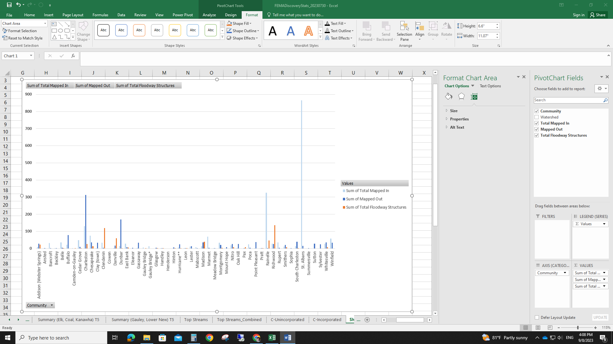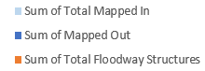

**Figure 7.** Total mapped-in, mapped-out, and floodway structures in the Incorporated areas

## Especial Buildings

The ten highest-value buildings have been indicated in Table 11. It shows that the Lower Kanawha watershed has the highest number of highest-value buildings. All these buildings have been located in the city of Charleston.

|  |  |  |  |  |  |  |
| --- | --- | --- | --- | --- | --- | --- |
| GIS Parcel ID | WV Flood Tool Link | Community | County | Critical Infrastructure | Building Appraisal (USD) | Watershed Name |
| 31-03-0006-0011-0000 | [FT](https://mapwv.gov/flood/map/?wkid=102100&x=-8897436.752769934&y=4823861.216481323&l=13&v=2) | Monongalia County | Monongalia County | Fort Martin Power Station | $800,000,000 | Upper Monongahela |
| 39-06-0028-0001-0000 | [FT](https://mapwv.gov/flood/map/?wkid=102100&x=-8868188.423965473&y=4786473.085904378&l=13&v=2) | Preston County | Preston County | Government | $276,000,000 | Cheat |
| 31-17-0004-0003-0000 | [FT](https://mapwv.gov/flood/map/?wkid=102100&x=-8904684.18951636&y=4816022.451864885&l=13&v=2) | Town of Star City | Monongalia County | Star City Wastewater Treatment Plan | $102,000,000 | Upper Monongahela |
| 20-18-0012-0047-0000 | [FT](https://mapwv.gov/flood/map/?wkid=102100&x=-9097743.598351846&y=4629629.349586339&l=13&v=2) | City of South Charleston | Kanawha County | Thomas Memorial Hospital | $96,224,000 | Lower Kanawha |
| 54-05-0053-00N1-0000 | [FT](https://mapwv.gov/flood/map/?wkid=102100&x=-9078594.814507142&y=4762043.232901076&l=13&v=2) | City of Parkersburg | Wood County | Parkersburg Utility Board Wastewater Treatment Plant | $69,000,000 | Upper Ohio-Shade |
| 31-09-0049-0016-0000 | [FT](https://mapwv.gov/flood/map/?wkid=102100&x=-8902352.475209555&y=4809338.300427538&l=13&v=2) | City of Morgantown | Monongalia County | Morgantown Utility Board, the Robert B. Creel Water Treatment Facility | $64,000,000 | Upper Monongahela |
| 06-03-0018-0061-0001 | [FT](https://mapwv.gov/flood/map/?wkid=102100&x=-9151277.775995426&y=4640175.848220188&l=13&v=2) | Cabell County | Cabell County | Cabell Midland High School | $60,947,644 | Lower Guyandotte |
| 20-11-0003-0012-0000 | [FT](https://mapwv.gov/flood/map/?wkid=102100&x=-9088003.267028665&y=4629359.273577992&l=13&v=2) | City of Charleston | Kanawha County | Government | $57,739,800 | Lower Kanawha |
| 02-06-0019-0170-0000 | [FT](https://mapwv.gov/flood/map/?wkid=102100&x=-8677726.850590711&y=4786530.347563355&l=13&v=2) | City of Martinsburg | Berkeley County | City of Martinsburg Wastewater Treatment Plant | $51,776,300 | Conococheague-Opequon |
| 20-11-0004-0004-0005 | [FT](https://mapwv.gov/flood/map/?wkid=102100&x=-9087871.740267307&y=4629521.558432323&l=13&v=2) | City of Charleston | Kanawha County | Utility | $44,331,800 | Lower Kanawha |

**Table 11.** Highest value Buildings

**Figure 8.** Highest Value Structures in Upper Monongahela watershed

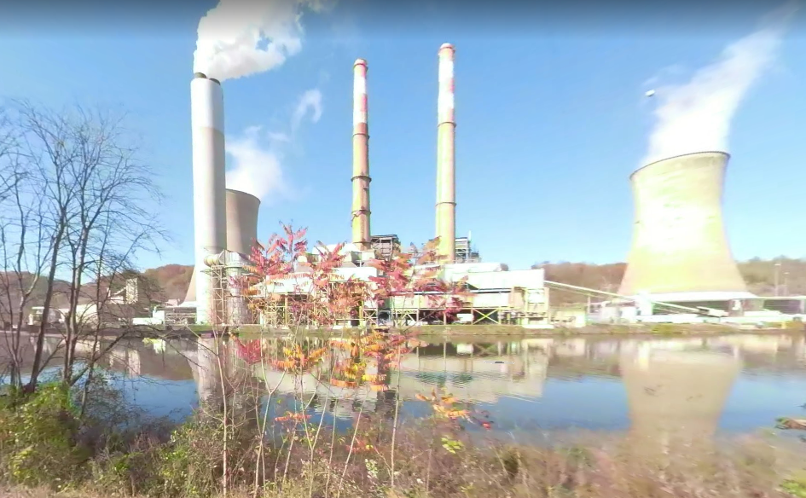

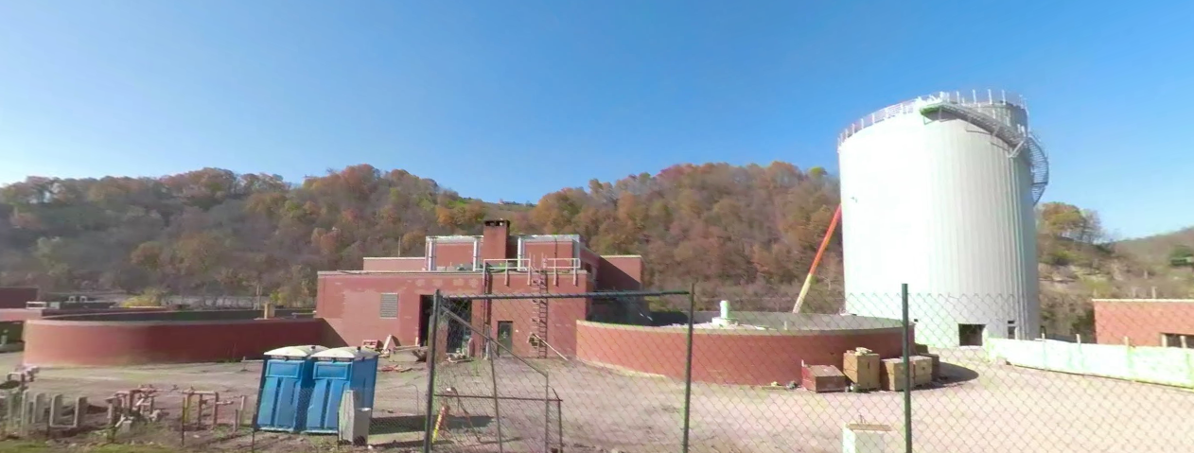**Fort Martin Power Station**

[**31-03-0006-0011-0000**](https://mapwv.gov/flood/map/?wkid=102100&x=-8897436.752769934&y=4823861.216481323&l=13&v=2)

[**31-17-0004-0003-0000**](https://mapwv.gov/flood/map/?wkid=102100&x=-8904684.18951636&y=4816022.451864885&l=13&v=2)

**Star City Wastewater Treatment Plan**

## Flood Loss

# Building Damage Estimates

The Hazus flood loss model for a 1%-annual-chance flood event for the state reveals the total estimated building loss as $853.8 million. The Upper Monongahela Watershed has a considerably higher building loss amounting to $229.8 million. The Upper Ohio-Wheeling and Lower Kanawha watersheds rank second and third, with building losses of $63.4 million and $54.0 million, respectively.

The higher mean building loss value of $109K was observed in the Upper Monongahela Watershed. Following this, in the Shenandoah and Cheat watersheds, the mean loss is $22K and $21K, respectively.

Damage of any origin sustained by a structure whereby the cost of restoring the structure to its before-damaged condition would equal or exceed 50 percent of the structure's market value before the damage occurred is known as substantial damage. In total, 6,644 structures are estimated to experience substantial damage by a 1% annual chance of flood event in the state. The highest number of the estimated substantially damaged structures can be observed in the Coal Watershed (n=746) followed by the Tug (n=460) and Lower Kanawha (n=456) watersheds.

# Building Debris Removal Estimates

Building debris removal estimates are computed at the building level for a 1%-annual-chance flood event using FEMA's Hazus flood model methodology. The model calculates only debris from the structure and not other types of debris (e.g., woody debris, sediment, content of buildings, etc.).

The watershed-level report shows the total tonnage of building debris that will be generated from a riverine 1%-annual-chance flood event for the state is 513,284 tons. The estimated debris tonnage is significantly higher in the Upper Ohio-Wheeling Watershed with 93,105 tons. The Lower Kanawha and Coal watersheds rank second and third with 38,901 and 36,539 tons, respectively. The top ten watersheds based on the mean tonnage of debris are the Shenandoah, Upper Ohio-Wheeling, and Upper Ohio-Shade watersheds, with 74.1, 33.7, and 28.6 tons, respectively.

1. Excluding Youghiogheny, Upper James, and Big Sandy in analysis, since the number of buildings in these three watersheds are very low (6, 54, and 154); thus the high percentage of residential concentration becomes more apparent.