**Watershed-level Flood Risk Summary Report**



**WV GIS Tech. Center**

**July 2023**

* **Flood Hazard**

**Natural Characteristics**

***Watersheds Boundaries***

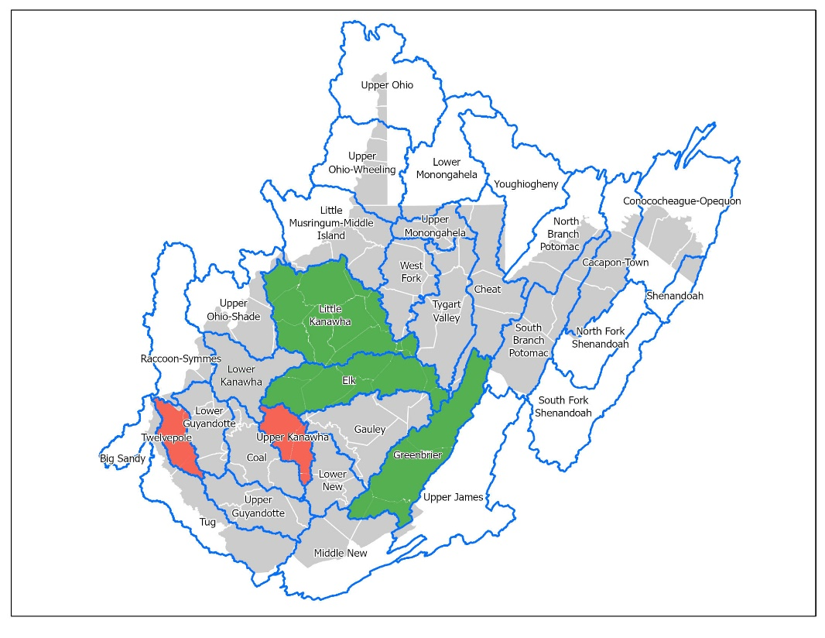A total of 33 watersheds intersect with West Virginia. Among these watersheds, 13 are entirely within West Virginia's borders, containing approximately 60 percent of the state's area. The largest watershed entirely situated in West Virginia is the Little Kanawha watershed, spanning an area of 2,303 square miles, followed by the Greenbrier and Elk watersheds, with areas of 1,649 and 1,531 square miles, respectively. Twelvepole, with a 442 square mile area, is the smallest watershed in the state, while Upper Kanawha and Lowe New are the second and third smallest, respectively. Figure 1 indicates the geographical location of these watersheds in the state.

**Figure 1.** Location of the Largest and Smallest Watersheds in West Virginia

***Flood Zone Area in the Watersheds***

This study mainly focuses on estimating 100-year flood zones containing A, AE, AH, and AO, while this study has not considered 500-year flood zone Zone (X).

The flood zone ratio, obtained by dividing the area of floodplain by the watershed area in West Virginia, indicates that Racoon-Symmes, Upper Ohio-shade, and Shenandoah have the highest percentage of floodplain coverage among the thirty-three watersheds. Table 1 shows that after these top threes, the largest flood zones are respectively observed in Upper Ohio, Big Sandy, and Lower Kanawha watersheds.

|  |  |
| --- | --- |
| Watershed | Percentage of 100-year FloodPlain in the Clipped Watershed |
| Raccoon-Symmes | 21% |
| Upper Ohio-Shade | 15% |
| Shenandoah | 14% |
| Upper Ohio | 13% |
| Big Sandy | 11% |
| Lower Kanawha | 10% |

Although Lower Kanawha ranks sixth in terms of the percentage of floodplain area according to Table 1, the application of spatial data in this study reveals that this watershed has the most extensive flood zone area, covering 139 square miles, with 111 miles of it falling within flood zone A. Following closely is South Branch Potomac, with 113 square miles of floodplain area and 83 miles within flood zone A. In addition, flood zone AE is broadly extended in Raccoon-Symmes, Upper Ohio, and Upper Ohio-Shade watersheds. The percentage of Flood zone AE in these watersheds are 19%, 13%, and 10%, respectively.

**Table 1** Percentage of the 100-year flood zone in WV watersheds

***Top Streams in the Watersheds***

Analyzing these watersheds regarding stream lengths clarifies that the Little Kanawha watershed boasts the highest total length of streams, amounting to 2017 miles. In contrast, Elk and Gauley watersheds rank second and third, with stream lengths of 1,298 and 1,176 miles, respectively. The Youghiogheny Watershed has the shortest stream length, measuring only 49.9 miles. The total stream length for each of these five highest has been described in Table 2.

|  |  |
| --- | --- |
| Stream Name | Total Stream Length |
| Little Kanawha | 2,017 |
| Elk | 1,298 |
| Gauley | 1,176 |
| Greenbrier | 1,173 |
| Tygart Valley | 982 |

**Table 2.** Watersheds with the highest Stream Length

The most significant streams in Gauley and Lower New Watersheds are Sewell Creek, Cherry River, and Gauley River (including Gauley River and Gauley River (Upper)).

* **Building Exposure**

The Lower Kanawha Watershed has the highest number of buildings, with a total count of 9130, of which 8311 (91%) are classified as residential (Figure 2). As a result, this watershed boasts the highest building value in Residential and non-Residential buildings, amounting to $588,381,996 and $742,070,411, respectively. Table 3 shows that the Upper Guyandotte and Coal watersheds are ranked second and third in the total number of buildings. However, when considering the percentage of residential buildings to the total number of buildings, the Raccoon-Symmes and Upper Kanawha watersheds take the lead, with 93% of their buildings being residential, placing them in the first and second positions, respectively.

|  |  |  |  |  |
| --- | --- | --- | --- | --- |
| Watershed | Building Count | Density (bldgs/acre) | Residential | Percentage of Residential to the Total Building |
| Lower Kanawha | 9,130 | 9.9 | 8,311 | 91% |
| Upper Guyandotte | 7,745 | 8.2 | 6,915 | 89% |
| Coal | 7,280 | 8.2 | 6,731 | 92% |
| Tug | 7,204 | 7.7 | 6,513 | 90% |
| Upper Ohio-Wheeling | 6,248 | 11.1 | 5,234 | 84% |
| Upper Kanawha | 5,650 | 10.8 | 5,262 | 93% |
| Elk | 5,372 | 3.5 | 4,869 | 91% |

**Table 3.** Watersheds with the highest number of Buildings and Residential Buildings

On the other hand, the building density, calculated by dividing the number of buildings by the area of the WV watersheds, is highest in the Upper Ohio-Wheeling Watershed, followed by the Upper Kanawha and Lower Kanawha. These results were somewhat predictable, considering that the densely populated city of Charleston is located in these areas. Upon a closer examination of the building analysis in WV watersheds, the following points are noticeable:

* **Lower Kanawha**: Highest number of buildings (9,130 structures), Highest number of Residential Buildings (8,311), and the third number of Non-Residential Buildings (819). Meanwhile, this watershed also has the highest number of Pre-firm structures (6,316) and Post-firm structures (2,043).
* **Upper Ohio-Wheeling:** Highest building density (11.1), Highest Non-Residential buildings (1,014 structures), and the least percentage of owner-occupied buildings (53%). The buildings in this watershed also exhibit the least median year built (1932), which is understandable. Since there are many historical buildings in this area, dating back to the 18th and 19th centuries, this observation aligns with historical trends. Thus, it has the highest percentage of Pre-firm structures (86%).
* **Coal Watershed:** Third watershed in terms of building numbers (7,280 structures), Third in the number of Residential buildings (6,731 buildings), and Third place in the number of mobile homes (2,205 mobile homes).
* **Upper Kanawha:** Second high-density buildings watershed (10.8), First[1] in the percentage of residential (93%), and Fifth watershed in the number of owner-occupied buildings (3,792).
* **Coal:** Third place inthe number of buildings (7,280), Third in the number of residential buildings (6,731), Second in the percentage of residential (92%), and Third in the number of mobile homes (2,205).
* **Elk:** Third top in the percentage of residential buildings (91%) with three other watersheds: *Lower Guyandotte*, *Cacapon-Town*, and *Lower Kanawha*.
* 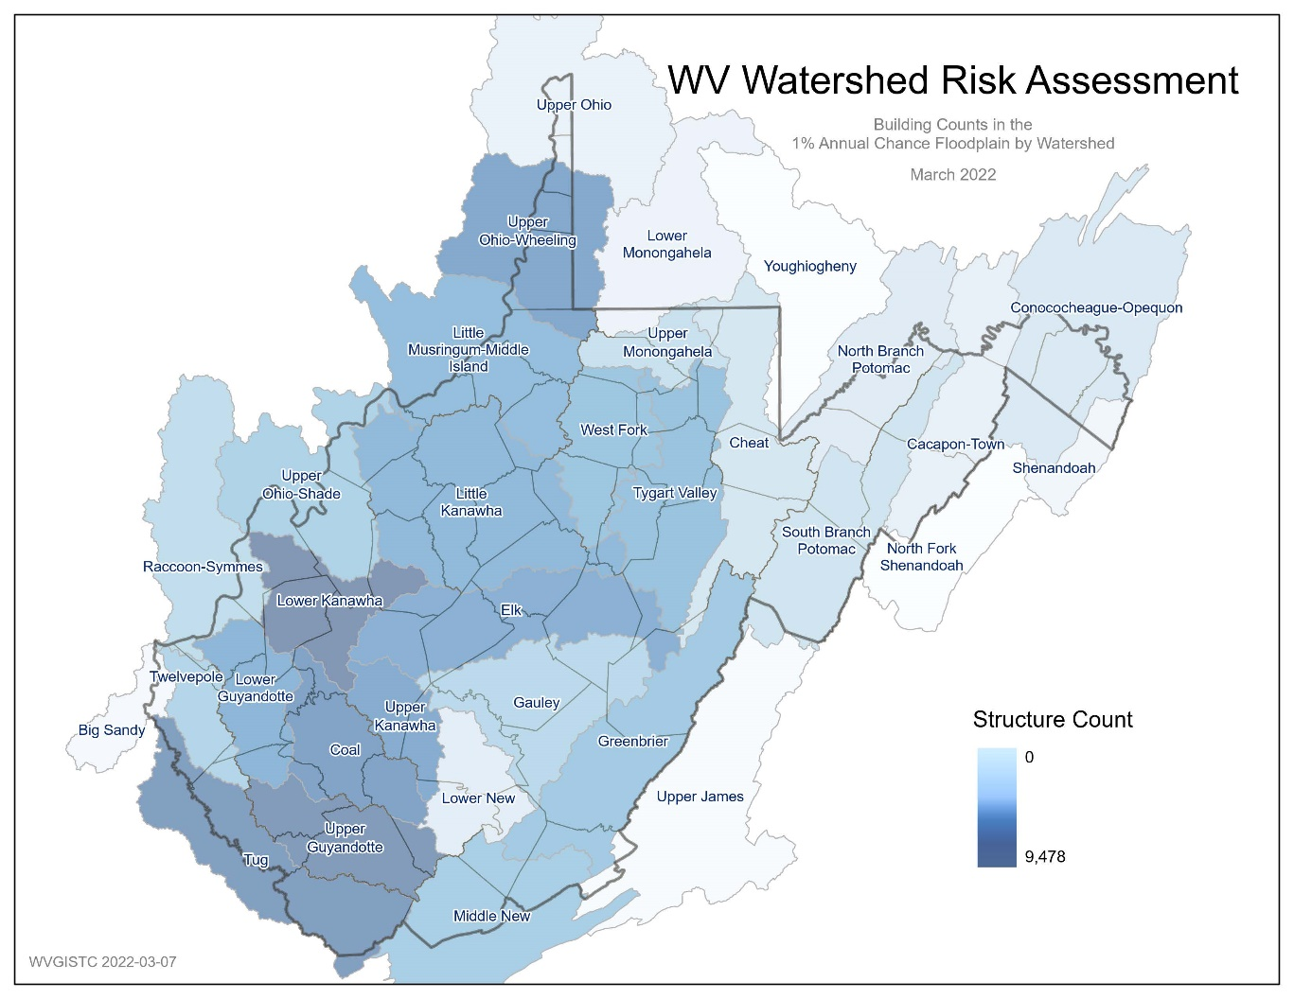**Upper Guyandotte:** Second in the number of buildings (7,745 structures), Second in the number of residential buildings (6,915), Third in the number of Non-Residential buildings (830 structures), and Second in the number of mobile homes (2,445 mobile homes). Also, this watershed has the maximum number of post-Firm Structures (2,190).

**Figure 2.** Number of Structures in WV Watersheds

***Buildings in Floodwayarc***

Buildings in the main floodway channel of the river or stream, or close to the flood source, will be subject to the greatest flood depths, highest velocities, and greatest debris potential. In the floodways statewide, there are a total of 8,272 primary buildings located. The Upper Guyandotte Watershed has the highest number, with 1,263 structures situated in these areas. The Tug and Upper Kanawha watersheds rank second and third, with 992 and 785 buildings located in floodways, respectively.

***Future Map Conditions***

According to the future flood maps, when they become effective, a total of 13,668 buildings will be mapped in high-risk floodplains statewide. Among all watersheds, the Tug Watershed will have the highest number of mapped-in structures, with 1,649 buildings. It is closely followed by the Lower Kanawha Watershed with 1,587 structures, and the Upper Guyandotte Watershed with 1,513 buildings.

On the other hand, when the advisory floodplains become effective, a total of 14,985 structures will be mapped out statewide. The Lower Kanawha watershed will have the highest number of mapped-out buildings, with 1,383 structures. The Coal and Elk watersheds rank second and third, with 1,365 and 1,042 mapped-out buildings, respectively.

***Critical Structures***

***Essential Facilities***

Essential facilities provide critical services to the community and include police and fire stations, E-911 emergency operations centers, schools (often used as shelters), hospitals, and nursing homes.

A total of 493 essential facilities are exposed to flood risk within all watersheds statewide. Among them, the Upper Kanawha and Tug watersheds have the highest number, with 53 essential facilities exposed to 100- or 500-year floods. Following closely behind is the Lower Kanawha Watershed, which has 43 at-risk structures facing the same flood risks.

***Non-historical Community Assets***

Non-historical community assets are government facilities (federal, state, local), emergency medical services (EMS), religious organizations, utilities, postsecondary educational facilities, or other buildings of significance that contribute to the built environment of community.

In all watersheds across the state, a total of 2,139 community assets (excluding historical ones) were identified within the 1%-annual-chance floodplain. The Upper Guyandotte Watershed has the highest number of at-risk community assets with 196 structures located in the floodplain. Following are the Tug and Coal watersheds ranking second and third with 191 and 176 at-risk community assets, respectively.

* **Flood Loss**

**Building Damage Estimates**

The Hazus flood loss model for a 1%-annual-chance flood event for the state reveals the total estimated building loss as $853.8 million. The Upper Monongahela Watershed has a considerably higher building loss amounting to $229.8 million. The Upper Ohio-Wheeling and Lower Kanawha watersheds rank second and third, with building losses of $63.4 million and $54.0 million, respectively.

The higher mean building loss value of $109K was observed in the Upper Monongahela Watershed. Following this, in the Shenandoah and Cheat watersheds the mean loss is $22K and $21K, respectively.

Damage of any origin sustained by a structure whereby the cost of restoring the structure to its before damaged condition would equal or exceed 50 percent of the market value of the structure before the damage occurred is known as substantial damage. In total, 6,644 structures are estimated to experience substantial damage by a 1%-annual-chance flood event in the state. The highest number of the estimated substantially damaged structures can be observed in the Coal Watershed (n=746) followed by the Tug (n=460) and Lower Kanawha (n=456) watersheds.

**Building Debris Removal Estimates**

Building debris removal estimates are computed at the building level for a 1%-annual-chance flood event using FEMA's Hazus flood model methodology. The model calculate only debris from the structure and not other types of debris (e.g., woody debris, sediment, content of buildings, etc.).

The watershed-level report shows total tonnage of building debris that will be generated from a riverine 1%-annual-chance flood event for the state is 513,284 tons. The estimated debris tonnage is significantly higher in the Upper Ohio-Wheeling Watershed with 93,105 tons. The Lower Kanawha and Coal watersheds rank second and third with 38,901 and 36,539 tons, respectively. Additionally, the top ten watersheds based on the mean tonnage of debris are the Shenandoah, Upper Ohio-Wheeling, and Upper Ohio-Shade watersheds with 74.1, 33.7, and 28.6 tons, respectively.

1. Excluding Youghiogheny, Upper James, and Big Sandy in analysis, since the number of buildings in these three watersheds are very low (6, 54, and 154); thus the high percentage of residential concentration becomes more apparent.