**Complied by Behrang on 9/7/2023**

* **Summary of SFHA change letters:**

|  |  |  |  |  |  |  |  |
| --- | --- | --- | --- | --- | --- | --- | --- |
| County | Community | Mapped Out | Mapped In | Mapped In Floodway | Total in Community | Total in County | Before/After Appeal |
| **Greenbrier** | Greenbrier Unincorporated | 173 | 268 | 70 | 511 | 1,105 | After |
| Rainelle | 1 | 284 | 38 | 323 |
| Rupert | 5 | 35 | 0 | 40 |
| White Sulphur Springs | 116 | 61 | 54 | 231 |
| **Hardy** | Hardy Unincorporated | 133 | 91 | N/A\* | 224 | 224 | Before |
| **Kanawha** | Kanawha Unincorporated | 220 | 132 | 3 | 355 | 388 | After |
| Clendenin | 5 | 26 | 2 | 33 |
|  |  |  |  |  | Sum in State: | 1,717 |  |

\* Hardy County not checked for mapped in floodway

* **Sample email text:**

Hello,

Enclosed are examples of outreach letters for your communities to notify owners of structures that are being “mapped in” the Special Flood Hazard Area (SFHA), "mapped in floodway" or “mapped out” of the SFHA for the new FEMA flood maps becoming effective July 5, 2023.  Both Word and PDF formats are provided.  Please use the links below to access the letters, map attachments, and address lists.  Please review and let us know if any changes have to be made before your mailing.

The text for these template letters was modified from [FEMA’s R3 Local Officials Toolkit](https://data.wvgis.wvu.edu/pub/RA/_engage/Local/SFHA_Change/Documentation/FEMA_R3_Local_Officials_Toolkit.pdf).  We also generated a map layout of each structure with a change in SFHA status; this printed map layout identified by a unique building identifier can be included with the 2-page information letter.

(1) **Merged Letters** (Word Doc and PDF).

* [Rainelle Mapped-In SFHA, Mapped-In Floodway, and Mapped-Out SFHA](https://data.wvgis.wvu.edu/pub/RA/_engage/Local/SFHA_Change/Greenbrier/Merged_Letters/Rainelle/" \t "_blank)
* [Rupert Mapped-In SFHA and Mapped-Out SFHA](https://data.wvgis.wvu.edu/pub/RA/_engage/Local/SFHA_Change/Greenbrier/Merged_Letters/Rupert/" \t "_blank)
* [White Sulphur Springs Mapped-In SFHA, Mapped-In Floodway, and Mapped-Out SFHA](https://data.wvgis.wvu.edu/pub/RA/_engage/Local/SFHA_Change/Greenbrier/Merged_Letters/White_Sulphur_Springs/" \o "https://data.wvgis.wvu.edu/pub/RA/_engage/Local/SFHA_Change/Greenbrier/Merged_Letters/White_Sulphur_Springs/" \t "_blank)
* [Greenbrier Unincorporated Mapped-In SFHA, Mapped-In Floodway, and Mapped-Out SFHA](https://data.wvgis.wvu.edu/pub/RA/_engage/Local/SFHA_Change/Greenbrier/Merged_Letters/Greenbrier_Unincorporated/" \t "_blank)

(2) **Map Attachments** for each property organized by “In”, “Floodway”, and “Out” folders (for inclusion with letters).  Properties are identified by a unique [building Identifier](https://data.wvgis.wvu.edu/pub/RA/_resources/FRA/FRA_Building_Identification.pdf) consisting of the Parcel Identifier and Address Number.     
[Rainelle](https://data.wvgis.wvu.edu/pub/RA/_engage/Local/SFHA_Change/Greenbrier/Maps/Rainelle_Maps/) | [Rupert](https://data.wvgis.wvu.edu/pub/RA/_engage/Local/SFHA_Change/Greenbrier/Maps/Rupert_Maps/)| [White Sulphur Springs](https://data.wvgis.wvu.edu/pub/RA/_engage/Local/SFHA_Change/Greenbrier/Maps/White_Sulphur_Springs_Maps/) | [Greenbrier Unincorporated](https://data.wvgis.wvu.edu/pub/RA/_engage/Local/SFHA_Change/Greenbrier/Maps/Greenbrier_Unincorporated_Maps/)

(3) **Address Lists** sorted by owner name (let us know if you want us to create mailing labels).  The address lists are combinations of tax assessment owner addresses and E-911 resident addresses.

<https://data.wvgis.wvu.edu/pub/RA/_engage/Local/SFHA_Change/Greenbrier/Address_Lists/>

(4)**Summary table** of letters:

|  |  |  |  |  |  |  |
| --- | --- | --- | --- | --- | --- | --- |
| Community Name | Letters & Attachments Status | Letter Date | Mapped-In Letters Count | Mapped-In Floodway\* Letters Count | Mapped-Out Letters Count | Total Letter Count |
| Greenbrier Unincorporated | Completed | 6/5/2023 | 268 | 70 | 173 | 511 |
| Rainelle | Completed | 5/30/2023 | 284 | 38 | 1 | 323 |
| Rupert | Completed | 6/6/2023 | 35 | 0 | 5 | 40 |
| White Sulphur Springs | Completed | 5/30/2023 | 61 | 54 | 116 | 231 |
| Letter Count Sum: | | | 648 | 162 | 295 | 1,105 |

\* Also including mapped from SFHA to new Floodway

(5) **The LOMAs** were revalidated with the issuance of new flood maps and may be superseded.  The final Summary of Map Actions (SOMA) for the county can be viewed here:  [Greenbrier County](https://data.wvgis.wvu.edu/pub/RA/_engage/Local/SFHA_Change/Greenbrier/SOMA/WV_SOMA_Greenbrier_LFDLetters_Return_Receipts.pdf)

Since the WV GIS Technical Center generated the mail merge letters for all mapped in/in floodway/out SFHA structures shown on the WV Flood Tool’s RiskMAP View ([www.mapwv.gov/Flood](http://www.mapwv.gov/Flood)), all the communities have to do is **download the files, then print, validate, and mail the letters**.

Please contact us if you have any questions or need assistance.

Sincerely,

* **Examples of the template letters:**

The mapped in, mapped in floodway, and mapped out templates for the Greenbrier Unincorporated Area are presented in the following pages, respectively. The templates are accompanied by sample map layouts to be attached.

April 19, 2023

Attention: Owner, «Owner\_Name\_Full»

«Mailing\_Address\_Line\_1»,

«Mailing\_Address\_Line\_2»

Subject: **NEW FEMA FLOOD MAPS SHOW YOUR PROPERTY IS IN HIGH-RISK FLOODPLAIN**,

Building ID: «Building\_ID»

Dear «Owner\_Name\_Full»,

Flooding can be the most frequent and costly disaster in a community, as it is in our state and nation. The likelihood of inland and riverine flooding changes over time due to erosion, changing land use, changing weather patterns, and other factors. The risk for flooding can vary within the same neighborhood and even between adjacent properties, but nobody is exempt from flood risk – where it can rain, it can flood. Knowing your flood risk is the first step to flood protection.

A multi-year project to re-examine «Community\_Name»’s flood zones and develop detailed digital flood hazard maps has been completed. The new maps, also known as Flood Insurance Rate Maps (FIRMs), were recently released for public view. The new maps reflect current flood risk based on the latest data and a more accurate understanding of our area’s topography. As a result, you and other property owners throughout «County\_Capitalized» will have up-to-date, Internet-accessible information about flood risk to your property.

**How will the flood map changes affect you?**

Based on the new maps, **your property is being mapped into a higher risk flood zone**, known as the Special Flood Hazard Area (SFHA). If you have a mortgage from a federally regulated lender and your property is in the SFHA, then you are **required** by Federal law to carry flood insurance when these flood maps are put into effect. We recommend that you use this time to contact your insurance agent to get the most favorable rate and learn about options offered by the National Flood Insurance Program (NFIP) for properties being mapped into higher risk areas for the first time.

If you do not have a mortgage, you are still **strongly recommended** to purchase flood insurance. Over the life of a 30-year loan, you are about three times more likely to have a flood in your home than a fire, and most homeowners’ insurance policies do not provide coverage for damage due to flooding.

If you do not currently carry flood insurance, your insurance company/agent should be able to provide you with a premium quote just by answering a few simple questions. To learn more about flood insurance rates and what options are available to you, please visit <http://www.floodsmart.gov> or call 1-877-336-2627 for more information.

**How do I view the flood maps?**

The maps that were recently released are still preliminary, which means they provide an early look at a property’s projected flood risk. You can determine where your property falls on the preliminary maps online by visiting the WV Flood Tool (<https://mapwv.gov/flood>) and entering your address in the search bar. Or you can use the direct link to your property provided below.

Whether or not your property falls within a flood zone, it is important to use this time to understand your flood risk and research your flood insurance options. Once FEMA considers the preliminary maps final, they will become effective, which means they will be used to determine your property’s flood risk as well as flood insurance requirements.

**Property Identification:**

Physical Address: «E911\_Address»

Parcel ID: «Parcel\_ID»

Building ID: «Building\_ID»

WV Flood Tool Link: «Flood\_Tool\_Parcel\_Link»

Flood Source: «Stream\_Name»

Flood Zone: «Flood Zone Designation» Floodway: «Floodway»

**What is the map update timeline?**

The preliminary maps, which show an early look at a property’s projected flood risk, were released to «County\_Capitalized» on 9/30/2021. Following the release, FEMA and its partners held a meeting with «County\_Capitalized» to discuss how the preliminary maps will affect property owners. After that meeting, a 90 day appeal period started on 5/13/2022 and ended on 8/11/2022. During this period, «County\_Capitalized» had the opportunity to submit appeals, supported by engineering data, related to discrepancies in the flood hazard data that they noticed in the preliminary flood maps. Now that the appeal period has passed, FEMA and its partners will finalize the maps. FEMA notified the community on 1/5/2023 that the maps shall be considered final through a Letter of Final Determination (LFD), and that the community has six (6) months from the LFD date or 7/5/2023 until the final flood maps are used to determine flood insurance requirements and building and development regulations.

**Why are these maps important to you?**

These flood hazard maps are important tools for protecting lives and property in «Community\_Name». The flood maps help business owners and residents make informed decisions about personal safety and financial protection. These maps also allow community planners, local officials, engineers, builders, and others to make determinations about where and how new structures and developments should be built.

**Whom to contact with questions?**

Please contact our office or coordinate directly with the «Community\_Name» Floodplain Manager by email at [kelly.banton@greenbriercounty.net](mailto:kelly.banton@greenbriercounty.net) or by telephone at (304) 647-6689 ext.0.

Sincerely,

Kelly Banton, CFM

County Commission Assistant

912 Court St N

Lewisburg, WV 24901

304-647-6689 ext.0

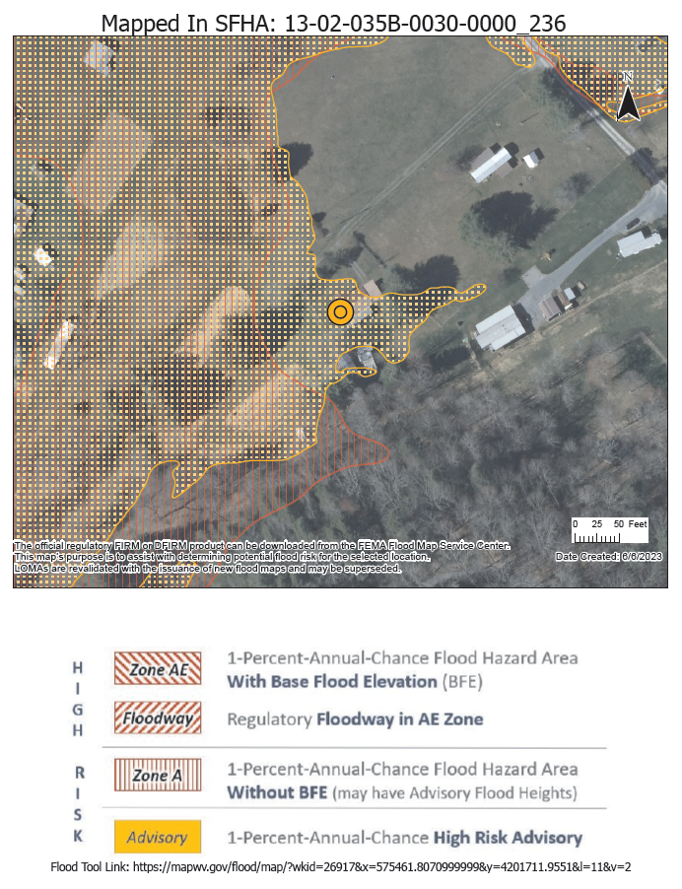

April 19, 2023

Attention: Owner, «Owner\_Name\_Full»

«Mailing\_Address\_Line\_1»,

«Mailing\_Address\_Line\_2»

Subject: **NEW FEMA FLOOD MAPS SHOW YOUR PROPERTY IS IN THE FLOODWAY OF A HIGH-RISK FLOODPLAIN,** Building ID: «Building\_ID»

Dear «Owner\_Name\_Full»,

Flooding can be the most frequent and costly disaster in a community, as it is in our state and nation. The likelihood of inland and riverine flooding changes over time due to erosion, changing land use, changing weather patterns, and other factors. The risk for flooding can vary within the same neighborhood and even between adjacent properties, but nobody is exempt from flood risk – where it can rain, it can flood. Knowing your flood risk is the first step to flood protection.

A multi-year project to re-examine «Community\_Name»’s flood zones and develop detailed digital flood hazard maps has been completed. The new maps, also known as Flood Insurance Rate Maps (FIRMs), were recently released for public view. The new maps reflect current flood risk based on the latest data and a more accurate understanding of our area’s topography. As a result, you and other property owners throughout «County\_Capitalized» will have up-to-date, Internet-accessible information about flood risk to your property.

**How will the flood map changes affect you?**

Based on the new maps, **your property is being mapped into a much higher risk flood zone** of the Special Flood Hazard Area (SFHA), known as the **Regulatory Floodway**, or the main channel of the river or stream where floodwaters are likely the deepest and with the highest velocities. Before a local permit can be issued for proposed development in the floodway, a “No-Rise/No Impact” certification must be submitted by a professional engineer licensed in West Virginia to ensure your proposed project won’t increase flood levels.

If you have a mortgage from a federally regulated lender and your property is in the SFHA, then you are **required** by Federal law to carry flood insurance when these flood maps are put into effect. We recommend that you use this time to contact your insurance agent to get the most favorable rate and learn about options offered by the National Flood Insurance Program (NFIP) for properties being mapped into higher risk areas for the first time.

If you do not have a mortgage, you are still **strongly recommended** to purchase flood insurance. Over the life of a 30-year loan, you are about three times more likely to have a flood in your home than a fire, and most homeowners’ insurance policies do not provide coverage for damage due to flooding.

If you do not currently carry flood insurance, your insurance company/agent should be able to provide you with a premium quote just by answering a few simple questions. To learn more about flood insurance rates and what options are available to you, please visit <http://www.floodsmart.gov> or call 1-877-336-2627 for more information.

**How do I view the flood maps?**

The maps that were recently released are still preliminary, which means they provide an early look at a property’s projected flood risk. You can determine where your property falls on the preliminary maps online by visiting the WV Flood Tool (<https://mapwv.gov/flood>) and entering your address in the search bar. Or you can use the direct link to your property provided below.

Whether or not your property falls within a flood zone, it is important to use this time to understand your flood risk and research your flood insurance options. Once FEMA considers the preliminary maps final, they will become effective, which means they will be used to determine your property’s flood risk as well as flood insurance requirements.

**Property Identification:**

Physical Address: «E911\_Address»

Parcel ID: «Parcel\_ID»

Building ID: «Building\_ID»

WV Flood Tool Link: «Flood\_Tool\_Parcel\_Link»

Flood Source: «Stream\_Name»

Flood Zone: «Flood Zone Designation» Floodway: **«Floodway»**

**What is the map update timeline?**

The preliminary maps, which show an early look at a property’s projected flood risk, were released to «County\_Capitalized» on 9/30/2021. Following the release, FEMA and its partners held a meeting with «County\_Capitalized» to discuss how the preliminary maps will affect property owners. After that meeting, a 90 day appeal period started on 5/13/2022 and ended on 8/11/2022. During this period, «County\_Capitalized» had the opportunity to submit appeals, supported by engineering data, related to discrepancies in the flood hazard data that they noticed in the preliminary flood maps. Now that the appeal period has passed, FEMA and its partners will finalize the maps. FEMA notified the community on 1/5/2023 that the maps shall be considered final through a Letter of Final Determination (LFD), and that the community has six (6) months from the LFD date or 7/5/2023 until the final flood maps are used to determine the flood insurance mandatory purchase requirement as well as “No Rise-No Impact” engineering studies for building and development regulations.

**Why are these maps important to you?**

These flood hazard maps are important tools for protecting lives and property in «Community\_Name». The flood maps help business owners and residents make informed decisions about personal safety and financial protection. These maps also allow community planners, local officials, engineers, builders, and others to make determinations about where and how new structures and developments should be built.

**Whom to contact with questions?**

Please contact our office or coordinate directly with the «Community\_Name» Floodplain Manager by email at [kelly.banton@greenbriercounty.net](mailto:kelly.banton@greenbriercounty.net) or by telephone at (304) 647-6689 ext.0.

Sincerely,

Kelly Banton, CFM

County Commission Assistant

912 Court St N

Lewisburg, WV 24901

304-647-6689 ext.0

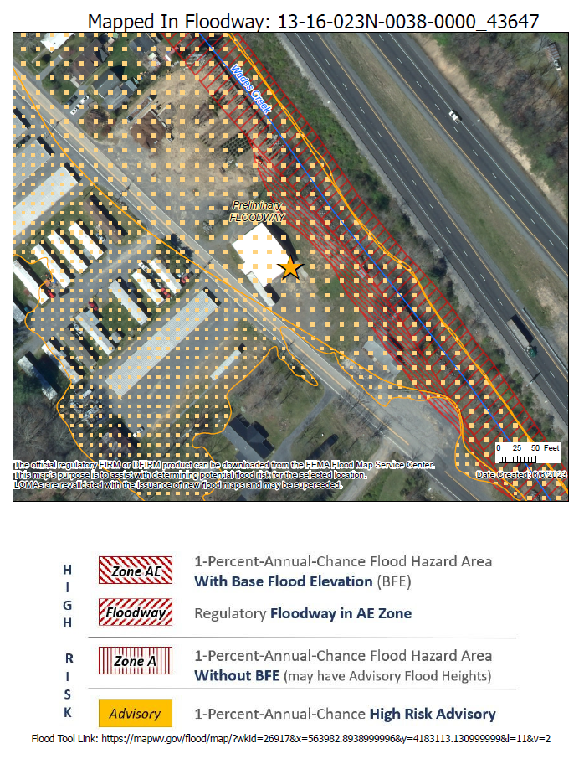

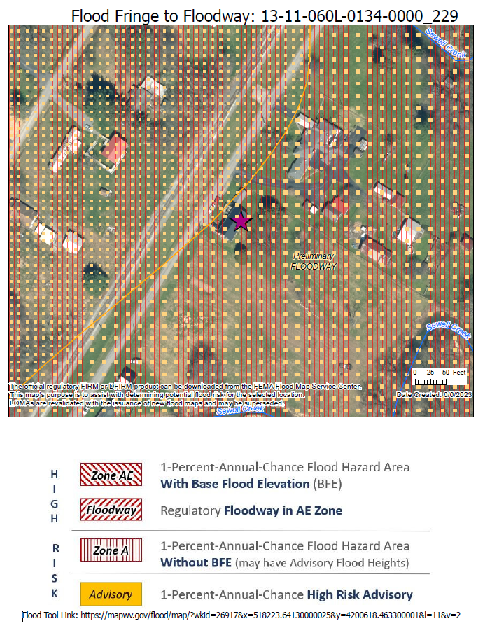

September 7, 2023

Attention: Owner, «Owner\_Name\_Full»

«Mailing\_Address\_Line\_1»,

«Mailing\_Address\_Line\_2»

Subject: NEW FEMA FLOOD MAPS SHOW YOUR PROPERTY IS NO LONGER IN HIGH-RISK FLOODPLAIN,

Building ID: «Building\_ID»

Dear «Owner\_Name\_Full»,

Flooding can be the most frequent and costly disaster in a community, as it is in our state and nation. The likelihood of inland and riverine flooding changes over time due to erosion, changing land use, changing weather patterns, and other factors. The risk for flooding can vary within the same neighborhood and even between adjacent properties, but nobody is exempt from flood risk – where it can rain, it can flood. Knowing your flood risk is the first step to flood protection.

A multi-year project to re-examine «Community\_Name»’s flood zones and develop detailed digital flood hazard maps has been completed. The new maps, also known as Flood Insurance Rate Maps (FIRMs), were recently released for public view. The new maps reflect current flood risk based on the latest data and a more accurate understanding of our area’s topography. As a result, you and other property owners throughout «County\_Capitalized» will have up-to-date, Internet-accessible information about flood risk to your property.

**How will the flood map changes affect you?**

Based on the new maps, your property is **no longer considered to be located within the high-risk flood zone**, also known as the Special Flood Hazard Area (SFHA), for purposes of determining the mandatory purchase of flood insurance. While the purchase of flood insurance is not required for structures outside of this area, we **strongly recommend** you maintain flood insurance coverage, since the risk of flooding has not been removed.

If you do not currently carry flood insurance, your insurance company/agent should be able to provide you with a premium quote just by answering a few simple questions. Please visit <http://www.floodsmart.gov> or call 1-877-336-2627 for more information.

If you do currently have flood insurance, you should not cancel your flood insurance before the new flood maps are officially adopted by the community. Moreover, if you have a federally-backed mortgage, NEVER cancel your flood insurance before consulting your mortgage lender!

**How do I view the flood maps?**

The maps that were recently released are still preliminary, which means they provide an early look at a property’s projected flood risk. You can determine where your property falls on the preliminary maps online by visiting the WV Flood Tool (<https://mapwv.gov/flood>) and entering your address in the search bar. Or you can use the direct link to your property provided below.

Whether or not your property falls within a flood zone, it is important to use this time to understand your flood risk and research your flood insurance options. Once FEMA considers the preliminary maps final, they will become effective, which means they will be used to determine your property’s flood risk as well as flood insurance requirements.

**Property Identification:**

Physical Address: «E911\_Address»

Parcel ID: «Parcel\_ID»

Building ID: «Building\_ID»

WV Flood Tool Link: «Flood\_Tool\_Parcel\_Link»

Flood Source: «Stream\_Name»

**What is the map update timeline?**

The preliminary maps, which show an early look at a property’s projected flood risk, were released to «County\_Capitalized» on 9/30/2021. Following the release, FEMA and its partners held a meeting with «County\_Capitalized» to discuss how the preliminary maps will affect property owners. After that meeting, a 90 day appeal period started on 5/13/2022 and ended on 8/11/2022. During this period, «County\_Capitalized» had the opportunity to submit appeals, supported by engineering data, related to discrepancies in the flood hazard data that they noticed in the preliminary flood maps. Now that the appeal period has passed, FEMA and its partners will finalize the maps. FEMA notified the community on 1/5/2023 that the maps shall be considered final through a Letter of Final Determination (LFD), and that the community has six (6) months from the LFD date or 7/5/2023 until the final flood maps are used to determine the flood insurance mandatory purchase requirement and for building and development regulations.

**Whom to contact with questions?**

Please contact our office or coordinate directly with the «Community\_Name» Floodplain Manager by email at [kelly.banton@greenbriercounty.net](mailto:kelly.banton@greenbriercounty.net) or by telephone at (304) 647-6689 ext.0.

Sincerely,

Kelly Banton, CFM

County Commission Assistant

912 Court St N

Lewisburg, WV 24901

304-647-6689 ext.0

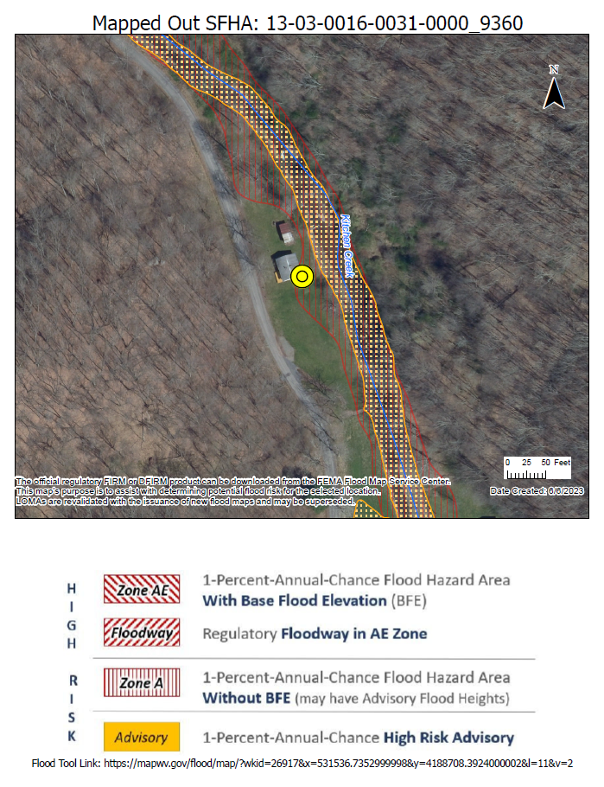

* **Examples of labels generated for the SFHA change letters:**

