**Mail merge setup for mapped-in/out letters.**

1. Open the **Mapped In** Word document, found in the **Templates** folder
2. **If the document opens without a popup, go to step 3**. If a popup appears after opening saying “Opening from this document will run the following SQL command:” select ‘No’ and continue to step 3.

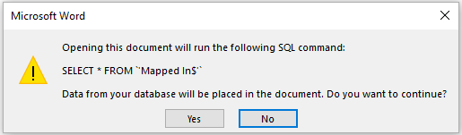

1. If the document opens with a “PROTECTED VIEW” banner, select ‘Enable Editing.’

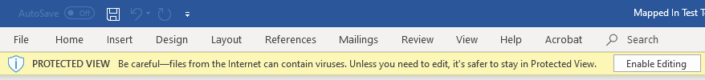

1. When the document is open, go to Mailings and choose ‘Select Recipients.’ In the dropdown, select ‘Use an existing list…’

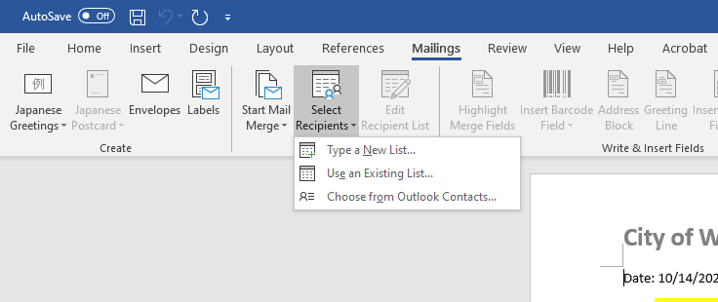

1. In file explorer, find your community by going to the Mail Merge Main Folder and opening the county your community is located in. There should be a spreadsheet named after your community. Select that one.
2. In the “Select Table” popup window, choose between ‘Mapped In$’ and ‘Mapped Out$’ depending on which letter you are working with (**if you have the Mapped In word document open, then choose ‘Mapped In$’. If you have the Mapped Out document open, choose ‘Mapped Out$’.**)

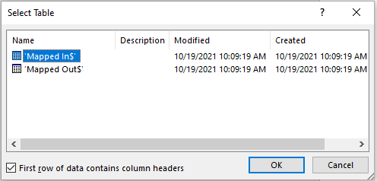

1. From there, you can go back to Mailings and choose ‘Preview Results’ to see what the document will look like with data in it. You can also cycle through each row of data using the blue arrows to the right of ‘Preview Results.’ When you do this, double check to ensure the proper community name (and other data) is being used. **Note: there may be no data to cycle through. This could mean that no buildings were mapped in (or mapped out) in your community. You can double check this by opening your corresponding spreadsheet. Check the proper sheet (Mapped In or Mapped Out) and if it only contains headers, then there is no problem with the data.**

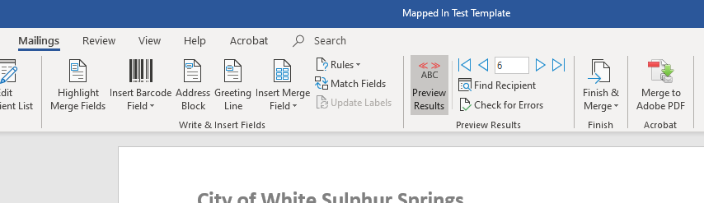

1. Repeat steps 1-6, except this time with the Mapped Out document. In step 5, be sure to select ‘Mapped Out$’, not ‘Mapped In$’

**After you’ve set up the documents for mail merge, follow these steps to create a PDF of the letters (this method does not use Adobe).**

1. Start by going to Mailings, then select ‘Finish & Merge.’ In the dropdown, choose ‘Print Documents…’

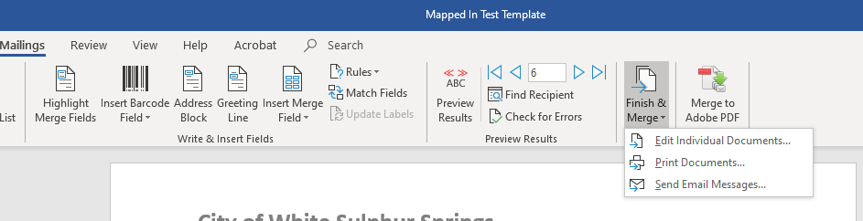

1. In the Merge to Printer popup window, you can choose whether you want to “print” (save to PDF) all records, only the current record, or a selection of records of your choosing. If you would like to save letters for all records, choose ‘All’ and click OK.

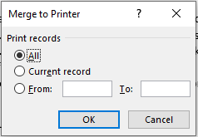

1. Under Printer Name, choose Microsoft Print to PDF, then click OK. From there, you can name your file and choose where to save it.

