**Working with the script**

1. The way I edit the script is by going to its location on my machine, right-clicking the script, then selecting “Edit with IDLE (ArcGIS Pro).”

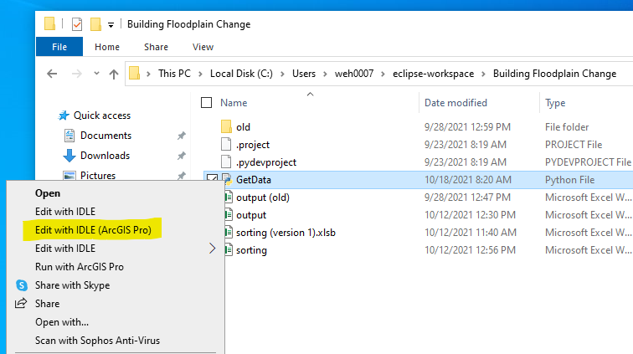

1. The entire script has comments explaining what each line or block of code does. From that, you can make any necessary changes.
2. A part of the script that may need to be changed in the future comes right after the import lines (within the first 10 lines of the script). Here, you will see “layer = r’path’” and “political = r’path’”. When the BLRA layer or flood tool political layer is updated, the corresponding file path should be changed to have the latest version.

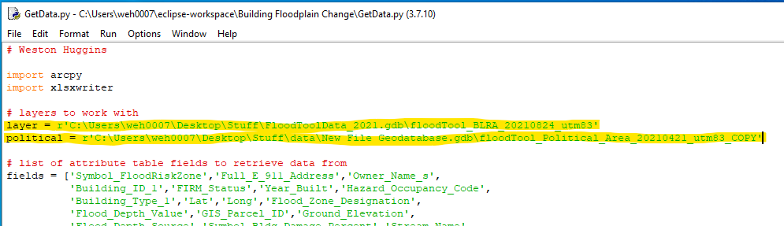

1. Other parts that may need to be changed involve the vertical datums and panel number. This would need changed if we add more regions/counties to this project. All communities (as found in the flood tool political layer) must be added as an “elif” statement to the end of this for loop, following the same pattern:

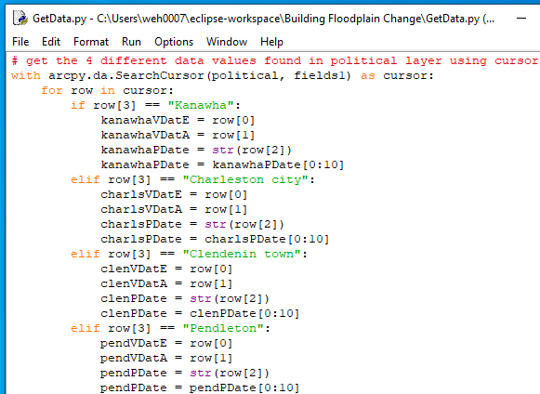

1. Then, an “elif” must be added to the end of this block of code as well, with the proper pattern:

