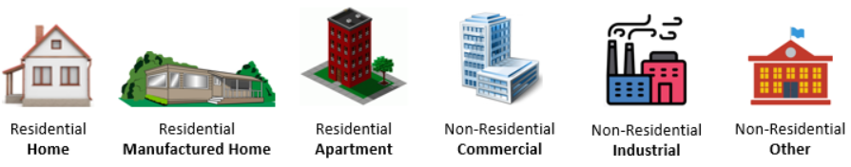

**BUILDING DOLLAR EXPOSURE & TYPE (Region 9)**

**Building Inventory of Flood-Risk Structures:** This report identifies high-valued buildings and other building characteristics exposed in the 1%-annual-chance (100-year) floodplain. Flood Risk Assessment datasets are developed by pinpointing all primary insurable structures in the high-risk effective and advisory floodplains. Essential facilities (schools, fire, police, E-911, nursing homes, hospitals, nursing homes) are inventoried to the 0.2-pecent (500-year) annual chance flood event. Community assets (government buildings, churches, historical structures, utilities, etc.) are also inventoried. Building characteristics inventoried and verified are **Occupancy Class**, Foundation Type, First Floor Height, Number of Stories, Area, and **Replacement Cost.** Default values are populated from the WV Property Tax Assessment Database and if necessary modified with user-defined values. Building pictures can be linked to the structure-level risk assessment using the unique building identifier (Parcel ID + Address Number).

**Building Replacement Value:** The repair costs to rebuild residential or non-residential structures from flood damage are significant insurance rating and mitigation construction factors. In addition, the structure’s replacement value and other building characteristics (occupancy class, foundation type, first floor height, number of stories, and structure area) are inputs to model flood damage estimates. Appraisal values from the West Virginia property tax assessment records are the primary data source for buildings exposed in the 1%-annual-chance (100-yr) floodplain. These building replacement values in the statewide tax assessment database are updated every year by the WV Property Tax Division. If necessary, modified or user-defined values are entered in the enhanced building inventory database to override default appraisal records values when no appraisal values exist or are identified in an adjacent parcel; or if multiple buildings on a single parcel must be apportioned. Other data sources for building dollar replacement costs include neighborhood appraisal values, BRIM Insurance, and RS Means.

**Occupancy Classes:** The building type categories for residential and non-residential structures follow FEMA's Hazus occupancy classification. The primary source for the occupancy type is the 186 land use categories from tax assessment data. These land use codes are converted to the 33 Hazus building specific occupancy classes, and further generalized to residential and non-residential building classes. On the Risk MAP View of the WV Flood Tool, the building occupancy types based on *structure use* are classified as **Residential** (R - single dwelling, farmhouse, mobile home, multi-family, apartments, nursing homes, group quarters); **Commercial** (C - businesses or industrial), and **Other** Non-Residential (schools, government buildings, churches, non-inhabitable agricultural structures, etc.).

Different residential/non-residential categories may apply to different FEMA programs. Typically, the main difference is that for **structure use** applications the **Other Residential (> 4 units)** occupancy class (e.g., apartments, group housing) is categorized as RESIDENTIAL but for **structure type** applications is classified as NON-RESIDENTIAL. The **structure use** occupancy classification is based on habitable on non-habitable occupancy whereas the **structure type** classification is based on design and materials. Refer to the [Occupancy Class Types](https://data.wvgis.wvu.edu/pub/RA/_resources/FRA/Occupancy_Class_Types_Reference.xlsx) table for a more detailed breakdown of the residential/non-residential categories by specific occupancy classes.

**FEMA Programs that utilize “Structure Use” Residential/Non-Residential Classification:** WV Flood Tool’s Risk MAP View (**R**esidential, **C**ommercial, and **O**ther Non-Residential), NFIP Specific Rating Guidelines; Open Hazus FAST Flood Assessment Structure Tool (Building Damage, Debris Total, and Restoration Time); Population Displacement Model. Note that Other Residential (> 4 units) is included in the RESIDENTIAL classification.

**FEMA Programs that utilize “Structure Type” Residential/Non-Residential Classification:** FEMA’s Community Rating System (CRS 214) Program Data Table; Substantial Damage Estimator (SDE) Tool; Nonstructural Mitigation Measures. Note that Other Residential (> 4 units) is included in the NON-RESIDENTIAL classification.

**Manufactured Homes:** Every manufactured mobile home in the floodplain is counted as a primary structure. If singlewide and doublewide mobile homes are assessed as personal property with no listed appraisal values, then replacement manufactured costs are derived from other sources. For example, manufactured replacement home costs may be compiled from the Other Building and Yard Improvements tax assessment table. However, if no tax appraisal values are present, then a countywide average value of singlewide or doublewide home values may be applied.

**Owner Occupancy:** Owner Occupancy is determined from the tax class data value records. Class II properties are owner-occupied residential property used exclusively for residential purposes and all farmland used for agricultural purposes by its owner or bona fide tenant.

**Building Year and FIRM Status:** Collected from the tax assessment records, the building year is compared to the effective date of the initial Flood Insurance Rate Map to determine the Pre-FIRM or Post-FIRM status of each inventoried building. If the site of a post-FIRM structure was not mapped as a Special Flood Hazard Area at the time of construction, then repairs or alterations are regulated as though it is a pre-FIRM structure.

**Community Engagement and Verification:**

Building-Level Verification: Verify the highly valued buildings using the [building-level table](https://data.wvgis.wvu.edu/pub/RA/Region9/BLRA/4_BldgDollarExposure) and [Risk MAP View](https://www.mapwv.gov/flood/map/?wkid=102100&x=-8682032&y=4782993&l=4&v=2) of the WV Flood Tool. For buildings inventoried in the 1% floodplains, review the most expensive residential and non-residential buildings located in the high-risk flood zones sorted on building appraisal value from largest to smallest value. Identify building-level mitigation and outreach strategies.

* Confirm highly valued residential and non-residential buildings for correctness. Confirm recently vacated or demolished structures for correctness. Use the Construction Grade with the building replacement value to identify superior quality structures versus dilapidated/vacated structures. Submit map links of missing noteworthy structures in the high-risk floodplains, especially those of significant importance to the community.
* Filter by Occupancy Class and Regulatory Floodway to refine analysis of building types exposed to higher flood velocities associated with the main channel of the river or stream.

Community-Level Verification: Review community-level flood risk assessment statistics of the building stock to identify mitigation and outreach strategies.

* Percentage of residential versus non-residential homes which impact flood disaster response and flood proofing mitigation efforts.
* Percentage of Post-FIRM buildings and compliance with floodplain development standards.
* Review the more vulnerable building stock such as lighter-weight manufactured homes and rental homes where renters may not carry rental insurance.

**Building Counts / Building Dollar ($) Exposure / Building Occupancy Type / Building Year.** Tables BE-1 through BE-5 present the building counts, building dollar exposure totals, median building values, residential/non-residential occupancy classes, owner-occupancy, building year, and Post-FIRM percentage. These building characteristics are for structures inventoried in the high-risk effective and advisory flood zones for a 1%-annual-chance (100-year) event.

Summary Community Building Counts

* **Jefferson**, **Berkeley**, and **Morgan** counties have similar countywide building counts and rank between 42 and 44 of the State’s 55 counties. **Berkeley Unincorporated** (ranked 36th in unincorporated areas) and the incorporated town of **Bath** (ranked 60th for incorporated areas) have the *most buildings* in the high-risk floodplain.

Summary Community Building Values

* **Berkeley**, **Morgan**, and **Jefferson** counties have similar countywide total building values and rank between 24 and 28 in the State. **Jefferson Unincorporated** (ranked 20th in unincorporated areas) and the incorporated town of **Martinsburg** (ranked 14th for incorporated areas) have the *highest building dollar values* vulnerable to a 1%-annual-chance flood event.

Median Building Replacement Value

* **Jefferson** ($96K), **Morgan** ($79K), and **Berkeley** ($62K) **counties** rank first, second, and fourth in the State for *countywide median building replacement value* and much higher than the statewide median building replacement value of $37,000.
* **Jefferson** ($101K), **Berkeley** ($96K), and **Morgan** ($80K) **counties** rank first, second, and fourth in the State for *countywide median single-family dwelling (RES 1 Occupancy Class) replacement value* and above the statewide median single family dwelling value of $44,000.

Building Occupancy Class Type

* Most of the primary buildings are *residential*: **Berkeley County** (94%), **Jefferson County** (89%), and **Morgan County** (81%). Of the residential buildings, most of the building stock is *owner-occupied*: Berkeley County (74%), Jefferson County (71%), and Morgan County (69%).
* The total building value for **Jefferson County** is 73% *residential* for the countywide building stock value exposed in the 1% floodplain, while for **Berkeley County** and **Morgan County** the *non-residential* properties are 51% and 59% respectively of the countywide building stock dollar value exposure.
* **Berkeley County Unincorporated** (ranked 12th in the State and 1st in Region 9) has the highest percentage (34%) of *manufactured homes* for *single family dwelling* building stock (Hazus specific occupancy categories: RES1-single family dwelling and RES2-mobile home).

Building Year and FIRM Status

* **Berkeley** and **Jefferson counties** rank 11th in the State for the highest percentage of *Post-FIRM structures* or new development.
* Historical **Harpers Ferry** and **Shepherdstown** are two of the oldest communities in the State with *building year median values* of 1830 and 1900, respectively.

**Table BE-1.** Community rankings of **Total Building Counts** and **Total Building Replacement Values**. Statewide there are [268 flood-prone communities](https://data.wvgis.wvu.edu/pub/RA/_Resources/Status/WV_Floodprone_Communities.pdf), consisting of 213 incorporated areas and 55 unincorporated areas/counties. For Region 9, eleven incorporated communities except for Hedgesville participate in the NFIP.

|  |  |  |  |  |  |  |
| --- | --- | --- | --- | --- | --- | --- |
| **BUILDING COUNT RANKING** | | |  | **BUILDING $ VALUE RANKING** | | |
| **Community** | **Region** | **State** |  | **Community** | **Region** | **State** |
| **INCORPORATED** | | |  | **INCORPORATED** | | |
| Bath | 1 | 60 |  | Martinsburg | 1 | 14 |
| Ranson | 2 | 86 |  | Bath | 2 | 27 |
| Martinsburg | 3 | 91 |  | Shepherdstown | 3 | 44 |
| Shepherdstown | 4 | 103 |  | Harpers Ferry | 4 | 89 |
| Harpers Ferry | 5 | 143 |  | Ranson | 5 | 102 |
| **UNINCORPORATED** | | |  | **UNINCORPORATED** | | |
| Berkeley | 1 | 36 |  | Jefferson | 1 | 20 |
| Jefferson | 2 | 40 |  | Morgan | 2 | 21 |
| Morgan | 3 | 41 |  | Berkeley | 3 | 31 |
| **COUNTY** | | |  | **COUNTY** | | |
| Jefferson | 1 | 42 |  | Berkeley | 1 | 24 |
| Berkeley | 2 | 43 |  | Morgan | 2 | 27 |
| Morgan | 3 | 44 |  | Jefferson | 3 | 28 |

Source: Region 9 Community-Level [Building Exposure](https://data.wvgis.wvu.edu/pub/RA/State/CL/)Table

* Highest number of primary structures in the 1% floodplain:
  + Bath (incorporated)
  + Berkley County Unincorporated (unincorporated area)
  + Jefferson County (countywide)
* Highest building dollar exposure in the 1% floodplain:
  + Martinsburg (incorporated)
  + Jefferson County Unincorporated (unincorporated)
  + Berkeley County (countywide)

**Table BE-2.** Building Dollar Exposure: Residential versus Non-Residential

|  |  |  |  |  |  |  |  |  |  |  |  |
| --- | --- | --- | --- | --- | --- | --- | --- | --- | --- | --- | --- |
| **Community** | **RESIDENTIAL** | | | | **COMMERCIAL  NON-RESIDENTIAL** | | **OTHER NON-RESIDENTIAL** | | **TOTAL BUILDING VALUE** | | |
| **Community Name** | # | **% Count** | Value ($) | **% Value** | # | Value ($) | # | Value ($) | # | Value ($) | Rank1 |
| Berkeley County* | 619 | 97% | $50,593K | 96% | 12 | $1,965K | 4 | $373K | 635 | $52,931K | 3 |
| Martinsburg | 51 | 68% | $6,124K | 10% | 21 | $55,166K | 3 | $1,035K | 75 | $62,324K | 1 |
| **BERKELEY** | **670** | **94%** | **$56,717K** | **49%** | **33** | **$57,131K** | **7** | **$1,408K** | **710** | **$115,255K** | **1** |
| Bolivar | 3 | 100% | $251K | 100% | 0 | $0K | 0 | $0K | 3 | $251K | 8 |
| Charles Town | 23 | 85% | $2,073K | 65% | 4 | $1,107K | 0 | $0K | 27 | $3,180K | 6 |
| Harpers Ferry | 6 | 19% | $722K | 10% | 25 | $6,243K | 0 | $0K | 31 | $6,965K | 4 |
| Jefferson County* | 505 | 96% | $60,022K | 85% | 14 | $4,889K | 7 | $5,349K | 526 | $70,260K | 1 |
| Ranson | 79 | 99% | $5,206K | 98% | 0 | $0K | 1 | $100K | 80 | $5,305K | 5 |
| Shepherdstown | 38 | 58% | $7,873K | 42% | 24 | $6,057K | 4 | $4,794K | 66 | $18,724K | 3 |
| **JEFFERSON** | **654** | **89%** | **$76,146K** | **73%** | **67** | **$18,295K** | **12** | **$10,243K** | **733** | **$104,685K** | **3** |
| Bath | 64 | 50% | $7,226K | 21% | 52 | $11,499K | 13 | $16,499K | 129 | $35,224K | 2 |
| Morgan County* | 439 | 91% | $35,347K | 51% | 38 | $11,135K | 7 | $23,386K | 484 | $69,867K | 2 |
| Paw Paw | 16 | 53% | $1,133K | 41% | 13 | $1,507K | 1 | $130K | 30 | $2,770K | 7 |
| **MORGAN** | **519** | **81%** | **$43,705K** | **41%** | **103** | **$24,141K** | **21** | **$40,015K** | **643** | **$107,862K** | **2** |
| **SUMMARY** | **1843** | **3** | **$176,569K** | **54%** | **203** | **$99,567K** | **40** | **$51,666K** | **2086** | **$327,802K** |  |

* Unincorporated  
** Split Community  
1 Group Rank on Community Type: County, Unincorporated, Incorporated  
Region 9 Tabular Community-Level Report: <https://data.wvgis.wvu.edu/pub/RA/State/CL/> (Building Exposure)

**Table BE-3.** Building Dollar Exposure Breakdown by Single Family

|  |  |  |  |  |  |  |  |  |  |
| --- | --- | --- | --- | --- | --- | --- | --- | --- | --- |
| **Community** | | **SINGLE FAMILY HOME** | | **MANUFACTURED  (MOBILE) HOME** | | | **SINGLE FAMILY TOTAL** | | |
| **Community Name** | **County** | **Count** | **Value ($)** | **Count** | **% Count** | **Value ($)** | **Count** | **Value ($)** | **Group Rank1** |
| Berkeley County* | BERKELEY | 404 | $45,448K | 206 | 34% | $3,947K | 610 | $49,396K | 2 |
| Martinsburg | BERKELEY | 41 | $4,507K | 0 | 0% | $0K | 41 | $4,507K | 4 |
|  | **BERKELEY** | **445** | **$49,956K** | **206** | **32%** | **$3,947K** | **651** | **$53,903K** | **2** |
| Bolivar | JEFFERSON | 3 | $251K | 0 | 0% | $0K | 3 | $251K | 8 |
| Charles Town | JEFFERSON | 21 | $1,991K | 0 | 0% | $0K | 21 | $1,991K | 5 |
| Harpers Ferry | JEFFERSON | 6 | $722K | 0 | 0% | $0K | 6 | $722K | 7 |
| Jefferson County* | JEFFERSON | 421 | $56,946K | 77 | 15% | $2,311K | 498 | $59,257K | 1 |
| Ranson | JEFFERSON | 65 | $4,494K | 10 | 13% | $351K | 75 | $4,845K | 3 |
| Shepherdstown | JEFFERSON | 35 | $7,191K | 0 | 0% | $0K | 35 | $7,191K | 1 |
|  | **JEFFERSON** | **551** | **$71,595K** | **87** | **14%** | **$2,663K** | **638** | **$74,257K** | **1** |
| Bath | MORGAN | 52 | $5,542K | 3 | 5% | $53K | 55 | $5,595K | 2 |
| Morgan County* | MORGAN | 367 | $33,782K | 66 | 15% | $1,211K | 433 | $34,993K | 3 |
| Paw Paw | MORGAN | 12 | $806K | 0 | 0% | $0K | 12 | $806K | 6 |
|  | **MORGAN** | **431** | **$40,130K** | **69** | **14%** | **$1,265K** | **500** | **$41,394K** | **3** |
| **SUMMARY** |  | **1,427** | **$161,680K** | **362** | **20%** | **$7,875K** | **1,789** | **$169,555K** |  |

* Unincorporated  
** Split Community  
1 Group Rank on Community Type: County, Unincorporated, Incorporated  
Region 9 Tabular Community-Level Report: <https://data.wvgis.wvu.edu/pub/RA/State/CL/> (Building Exposure)

**Table BE-4.** Building Year, Building Value, Building Value Single Family Dwelling (RES 1 occupancy class)

|  |  |  |  |  |  |  |  |
| --- | --- | --- | --- | --- | --- | --- | --- |
| **Community Name** | **County** | **Average Building Year** | **Median Building Year** | **Average Building Value** | **Median Building Value** | **Average Building Value RES 1** | **Median Building Value RES 1** |
| Berkeley County* | BERKELEY | 1969.6 | 1978 | $83K | $57K | $82K | $56K |
| Martinsburg | BERKELEY | 1961.9 | 1970 | $831K | $103K | $120K | $103K |
|  | **BERKELEY** | **1968.7** | **1977** | **$162K** | **$62K** | **$112K** | **$96K** |
| Jefferson County* | JEFFERSON | 1958.3 | 1973 | $134K | $93K | $119K | $94K |
| Bolivar | JEFFERSON | 1878 | 1870 | $84K | $86K | $84K | $86K |
| Charles Town | JEFFERSON | 1938.2 | 1920 | $118K | $60K | $90K | $55K |
| Harpers Ferry | JEFFERSON | 1848.5 | 1830 | $225K | $188K | $120K | $110K |
| Ranson | JEFFERSON | 1970.5 | 1977 | $66K | $63K | $66K | $63K |
| Shepherdstown | JEFFERSON | 1886.5 | 1900 | $284K | $207K | $207K | $173K |
|  | **JEFFERSON** | **1947.4** | **1969** | **$143K** | **$96K** | **$130K** | **$101K** |
| Morgan County* | MORGAN | 1971 | 1975 | $144K | $70K | $81K | $65K |
| Bath | MORGAN | 1941.1 | 1940 | $273K | $113K | $113K | $92K |
| Paw Paw | MORGAN | 1946.9 | 1941 | $92K | $66K | $71K | $66K |
|  | **MORGAN** | **1963.7** | **1968** | **$168K** | **$79K** | **$93K** | **$80K** |
| **State Statistics** |  | **1959.1** | **1960** | **$91K** | **$37K** | **$57K** | **$44K** |

* Unincorporated  
Region 9 Tabular Community-Level Report: <https://data.wvgis.wvu.edu/pub/RA/State/CL/> (FIRM)

**Table BE-5.** Initial FIRM Effective Date, Pre-FIRM/Post-FIRM percentages

|  |  |  |  |  |  |  |  |
| --- | --- | --- | --- | --- | --- | --- | --- |
| **CID** | **Community Name** | **County** | **Initial FIRM Effective Date** | **Total Building Count** | **% Pre-FIRM** | **% Post-FIRM** | **% Unknown** |
| 540282 | Berkeley County* | BERKELEY | 8/4/1988 | 635 | 58% | 32% | 10% |
| 540006 | Martinsburg | BERKELEY | 12/18/1979 | 75 | 79% | 21% | 0% |
|  |  | **BERKELEY** |  | **710** | **60%** | **31%** | **9%** |
| 540030 | Bolivar | JEFFERSON | 12/18/2009 | 3 | 100% | 0% | 0% |
| 540066 | Charles Town | JEFFERSON | 12/4/1979 | 27 | 74% | 22% | 4% |
| 540067 | Harpers Ferry | JEFFERSON | 8/24/1984 | 31 | 100% | 0% | 0% |
| 540065 | Jefferson County* | JEFFERSON | 10/15/1980 | 526 | 59% | 36% | 5% |
| 540068 | Ranson | JEFFERSON | 6/15/1979 | 80 | 66% | 33% | 1% |
| 540069 | Shepherdstown | JEFFERSON | 3/18/1980 | 66 | 85% | 8% | 8% |
|  |  | **JEFFERSON** |  | **733** | **64%** | **31%** | **5%** |
| 540005 | Bath | MORGAN | 1/2/1980 | 129 | 88% | 12% | 0% |
| 540144 | Morgan County* | MORGAN | 7/1/1987 | 484 | 65% | 33% | 2% |
| 540252 | Paw Paw | MORGAN | 11/2/1984 | 30 | 90% | 10% | 0% |
|  |  | **MORGAN** |  | **643** | **71%** | **28%** | **2%** |

* Unincorporated  
Region 9 Tabular Community-Level Report: <https://data.wvgis.wvu.edu/pub/RA/State/CL/> (FIRM)

**Verification - Tabular Report:** Building Dollar Exposure for structures located in the high-risk 1%-annual-chance (100-yr) floodplain can be viewed and verified for each community by linking to the risk assessment [tabular report](https://data.wvgis.wvu.edu/pub/RA/Region9/BLRA/4_BldgDollarExposure) (Excel spreadsheet). To verify the geographic location of each high-valued building, the Excel table provides map view links. Refine the search by filtering residential and non-residential records.

**Table BE-6A.** Highly valued buildings in 1% Floodplain for **Berkeley County**. Source of Building Replacement Values: Assessment Records, Neighborhood Values, BRIM Insurance, RS Means, or any other available sources. Which high-valued-structures are vulnerable to riverine flooding?

|  |  |  |  |  |  |
| --- | --- | --- | --- | --- | --- |
| Community Name | WV Flood Tool Link | Owner Name or Building ID | Hazard Occupancy Code | **General Occupancy** | **Building Appraisal** |
| Martinsburg | [FT](https://mapwv.gov/flood/map/?wkid=102100&x=-8677726.850590711&y=4786530.347563355&l=13&v=2) | [Martinsburg Treatment Plant](https://www.heraldmailmedia.com/story/news/local/2016/10/21/ew-wastewater-treatment-plant-dedicated-in-martinsburg/45639907/) | COM4 | Commercial | $ 51,776,300 |
| Martinsburg | [FT](https://mapwv.gov/flood/map/?wkid=102100&x=-8679491.518105585&y=4788778.686020645&l=13&v=2) | COUNTY COUNCIL OF BERKELEY COUNTY WEST VIRGINIA | COM2 | Commercial | $ 945,800 |
| Berkeley County* | [FT](https://mapwv.gov/flood/map/?wkid=102100&x=-8664667.768209074&y=4792889.82748498&l=13&v=2) | SHEPHERDS COVE LLC | RES1 | Residential | $ 851,200 |
| Martinsburg | [FT](https://mapwv.gov/flood/map/?wkid=102100&x=-8679288.941901864&y=4788661.4530149195&l=13&v=2) | CITY OF MARTINSBURG | GOV1 | Other | $ 785,600 |
| Berkeley County* | [FT](https://mapwv.gov/flood/map/?wkid=102100&x=-8677716.823264942&y=4808353.619984377&l=13&v=2) | 02-04-0003-0049-0000_1340 | RES1 | Residential | $ 714,000 |
| Berkeley County* | [FT](https://mapwv.gov/flood/map/?wkid=102100&x=-8672596.675938819&y=4795965.849580068&l=13&v=2) | 02-02-0017-0040-0000_1210 | RES1 | Residential | $ 638,100 |
| Martinsburg | [FT](https://mapwv.gov/flood/map/?wkid=102100&x=-8678642.751070805&y=4788698.176232166&l=13&v=2) | MAGYARI PROPERTIES LLC | IND2 | Commercial | $ 573,200 |
| Berkeley County* | [FT](https://mapwv.gov/flood/map/?wkid=102100&x=-8675754.070508564&y=4807053.1053084945&l=13&v=2) | 02-02-005A-0055-0000_315 | RES1 | Residential | $ 559,900 |
| Berkeley County* | [FT](https://mapwv.gov/flood/map/?wkid=102100&x=-8689232.506992998&y=4769631.554820956&l=13&v=2) | BUNKER HILL ANTIQUES ASSOCIATES LLC | COM1 | Commercial | $ 546,000 |
| Martinsburg | [FT](https://mapwv.gov/flood/map/?wkid=102100&x=-8678847.061632192&y=4788338.478919011&l=13&v=2) | CAPITAL MEATS INC | COM2 | Commercial | $ 498,000 |
| Berkeley County* | [FT](https://mapwv.gov/flood/map/?wkid=102100&x=-8665534.32053626&y=4793204.376278801&l=13&v=2) | 02-08-0009-0001-0004_555 | RES1 | Residential | $ 411,000 |
| Berkeley County* | [FT](https://mapwv.gov/flood/map/?wkid=102100&x=-8677708.510593284&y=4808964.494594573&l=13&v=2) | 02-04-0003-0002-0000_413 | RES1 | Residential | $ 399,500 |
| Berkeley County* | [FT](https://mapwv.gov/flood/map/?wkid=102100&x=-8668186.75943174&y=4809083.366232532&l=13&v=2) | 02-02-0003-0075-0000_955 | RES1 | Residential | $ 369,400 |
| Berkeley County* | [FT](https://mapwv.gov/flood/map/?wkid=102100&x=-8681975.473170634&y=4791248.831191589&l=13&v=2) | 02-04-037M-0013-0000_197 | RES1 | Residential | $ 346,300 |
| Berkeley County* | [FT](https://mapwv.gov/flood/map/?wkid=102100&x=-8669984.218885615&y=4803381.4080479955&l=13&v=2) | LEATHERMAN LYNN EUGENE | COM1 | Commercial | $ 338,500 |
| Berkeley County* | [FT](https://mapwv.gov/flood/map/?wkid=102100&x=-8667991.733472485&y=4809057.770669137&l=13&v=2) | 02-02-0003-0077-0000_1061 | RES1 | Residential | $ 338,400 |
| Berkeley County* | [FT](https://mapwv.gov/flood/map/?wkid=102100&x=-8683588.59600804&y=4788660.002257734&l=13&v=2) | 02-04-0040-0005-0003_8973 | RES1 | Residential | $ 329,800 |
| Berkeley County* | [FT](https://mapwv.gov/flood/map/?wkid=102100&x=-8669819.74778887&y=4803232.94193963&l=13&v=2) | 02-02-0010-0052-0001_21 | RES1 | Residential | $ 314,000 |
| Berkeley County* | [FT](https://mapwv.gov/flood/map/?wkid=102100&x=-8668319.566701202&y=4796133.944561733&l=13&v=2) | 02-02-0018-0003-0009_1147 | RES1 | Residential | $ 313,700 |
| Berkeley County* | [FT](https://mapwv.gov/flood/map/?wkid=102100&x=-8667649.49149415&y=4808765.297486805&l=13&v=2) | 02-02-0003-0119-0000_421 | RES1 | Residential | $ 313,300 |
| Berkeley County* | [FT](https://mapwv.gov/flood/map/?wkid=102100&x=-8669536.058638185&y=4802683.254155642&l=13&v=2) | 02-02-010M-0007-0000_18 | RES1 | Residential | $ 302,800 |
| Berkeley County* | [FT](https://mapwv.gov/flood/map/?wkid=102100&x=-8670206.417709934&y=4809825.464479762&l=13&v=2) | 02-02-0002-0058-0000_1433 | RES1 | Residential | $ 301,500 |
| Martinsburg | [FT](https://mapwv.gov/flood/map/?wkid=102100&x=-8679949.94178743&y=4789456.42264351&l=13&v=2) | 02-06-004D-0146-0000_331 | RES3B | Residential | $ 300,300 |

* Unincorporated  
Region 9 Tabular Building-Level Report Link: <https://data.wvgis.wvu.edu/pub/RA/Region9/BLRA/4_BldgDollarExposure>

**Figure BE-6B.** Martinsburg Wastewater Treatment Plant. [Map link](https://mapwv.gov/flood/map/?wkid=102100&x=-8677802&y=4786507&l=12&v=2).

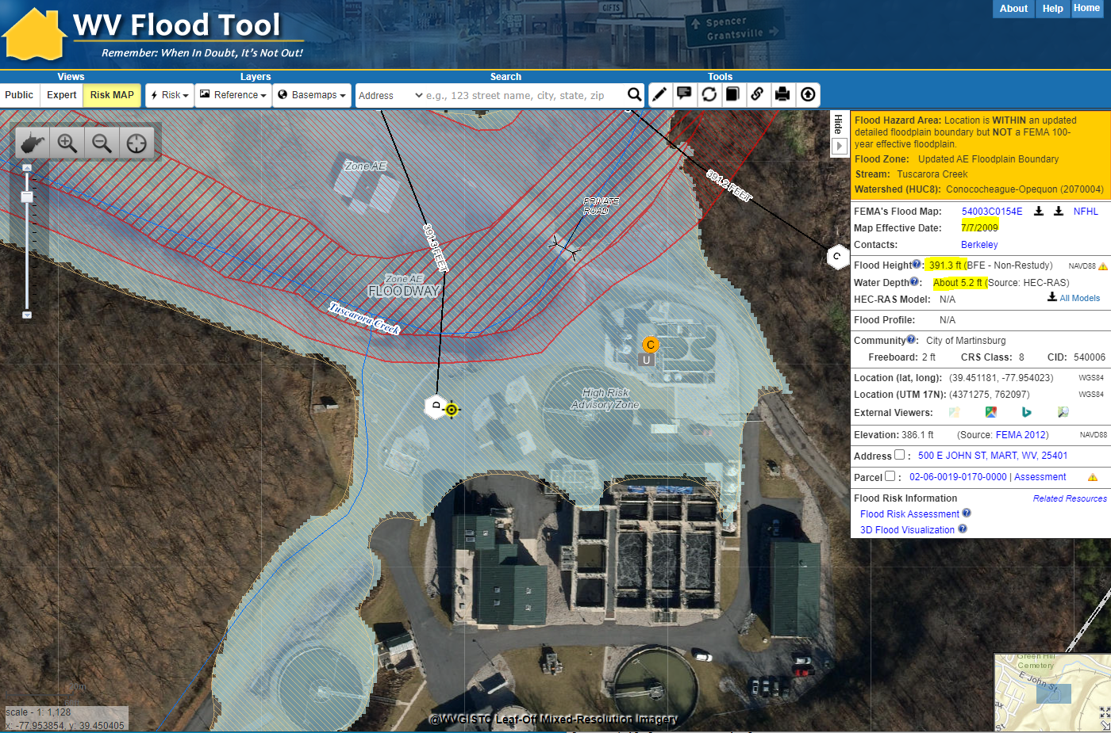

A high-risk advisory floodplain was redelineated using newer 2012 elevation LiDAR data. In 2016, **Martinsburg's wastewater treatment plant** was revamped at a cost of $53.5 million. Some structures of the wastewater treatment plant are in the high-risk advisory floodplain at a 1% (100-year) and 0.2% (500-year) estimated flood inundation depths of 5 feet and 10 feet, respectively.

New flood maps: An active flood study is being performed for this location which in the future will produce new effective flood maps and base flood elevations. If the natural grade changed when the new wastewater treatment plant was revamped, a newer topographic elevation source other than the 2012 LiDAR should be incorporated into the flood study update. In 2021 the USGS is setting up a task order for new LiDAR to be flown for the Eastern Panhandle which could be an updated topographic source.

Examples of mitigation measures for *utilities* include:

* Emergency response plan
* Barriers around key assets
* Elevated electrical equipment
* Emergency generators
* Bolted down chemical tanks

Online Resources:

* [EPA FLOOD RESILIENCE: A Basic Guide for Water and Wastewater Utilities](https://www.epa.gov/sites/default/files/2015-08/documents/flood_resilience_guide.pdf)
* [Tips for Flood-Proofing Wastewater Treatment Plants](https://atsinnovawatertreatment.com/blog/flood-proof-wastewater-treatment-plant/)
* [Flood-Resistant Wastewater Treatment Plant Upgrades](https://www.burnsmcd.com/projects/flood-resistant-wastewater-treatment-plant)

**Table BE-6C.** Highly valued buildings in 1% Floodplain for **Morgan County**. Which high-valued-structures are vulnerable to riverine flooding?

|  |  |  |  |  |  |
| --- | --- | --- | --- | --- | --- |
| Community Name | WV Flood Tool Link | Owner Name or Building ID | Hazard Occupancy Code | **General Occupancy** | **Building Appraisal** |
| Morgan County* | [FT](https://mapwv.gov/flood/map/?wkid=102100&x=-8708806.362532185&y=4810533.71985773&l=13&v=2) | BOARD OF EDUCATION | EDU1 | Other | $ 15,000,000 |
| Bath | [FT](https://mapwv.gov/flood/map/?wkid=102100&x=-8708221.565402174&y=4811906.557854602&l=13&v=2) | MORGAN CO BLDG COMM | GOV1 | Other | $ 10,591,500 |
| Morgan County* | [FT](https://mapwv.gov/flood/map/?wkid=102100&x=-8708805.5247417&y=4810461.206524533&l=13&v=2) | BOARD OF EDUCATION | EDU1 | Other | $ 6,210,000 |
| Morgan County* | [FT](https://mapwv.gov/flood/map/?wkid=102100&x=-8705753.328426586&y=4816654.765867322&l=13&v=2) | U S SILICA | IND4 | Commercial | $ 3,304,600 |
| Morgan County* | [FT](https://mapwv.gov/flood/map/?wkid=102100&x=-8708747.212586796&y=4810532.391654589&l=13&v=2) | BOARD OF EDUCATION | EDU1 | Other | $ 1,650,000 |
| Bath | [FT](https://mapwv.gov/flood/map/?wkid=102100&x=-8708269.684365261&y=4811750.148362044&l=13&v=2) | CATHOLIC CHURCH | REL1 | Other | $ 1,565,700 |
| Bath | [FT](https://mapwv.gov/flood/map/?wkid=102100&x=-8708077.328070035&y=4812027.985404303&l=13&v=2) | MORGAN ARTS COUNCIL INC | COM8 | Commercial | $ 1,482,300 |
| Bath | [FT](https://mapwv.gov/flood/map/?wkid=102100&x=-8708364.588349985&y=4811655.258386575&l=13&v=2) | CITIZENS NATIONAL BANK OF BERKELEY SPRINGS | COM5 | Commercial | $ 1,448,900 |
| Morgan County* | [FT](https://mapwv.gov/flood/map/?wkid=102100&x=-8709716.25276165&y=4808542.566524402&l=13&v=2) | RANKIN & ASSOCIATES LLC | COM8 | Commercial | $ 1,122,100 |
| Bath | [FT](https://mapwv.gov/flood/map/?wkid=102100&x=-8708449.881232511&y=4811772.163890018&l=13&v=2) | BERKELEY SPRINGS STATE PARK | COM8 | Commercial | $ 1,009,900 |
| Morgan County* | [FT](https://mapwv.gov/flood/map/?wkid=102100&x=-8709418.088069662&y=4809107.163674729&l=13&v=2) | DANIEL G KAMIN BERKELEY SPRINGS LLC | COM1 | Commercial | $ 934,900 |
| Bath | [FT](https://mapwv.gov/flood/map/?wkid=102100&x=-8708432.073898844&y=4811721.996057842&l=13&v=2) | THE COUNTRY INN OF BERKELEY SPRINGS LLC | RES4 | Residential | $ 931,600 |
| Bath | [FT](https://mapwv.gov/flood/map/?wkid=102100&x=-8708153.7239649&y=4811997.874770332&l=13&v=2) | MORGAN COUNTY COMMISSION (THE) | EDU1 | Other | $ 872,400 |
| Bath | [FT](https://mapwv.gov/flood/map/?wkid=102100&x=-8707661.326242382&y=4812488.861079519&l=13&v=2) | BOARD OF EDUCATION | EDU1 | Other | $ 702,900 |
| Morgan County* | [FT](https://mapwv.gov/flood/map/?wkid=102100&x=-8707580.91215918&y=4812712.174417414&l=13&v=2) | BERKELEY ON THE RUN LLC | COM2 | Commercial | $ 653,200 |
| Bath | [FT](https://mapwv.gov/flood/map/?wkid=102100&x=-8708309.640492734&y=4812002.534497429&l=13&v=2) | M E CHURCH TR | REL1 | Other | $ 615,900 |
| Morgan County* | [FT](https://mapwv.gov/flood/map/?wkid=102100&x=-8707083.862840425&y=4814119.479841215&l=13&v=2) | WARM SPRINGS PUBLIC SERVICE | COM4 | Commercial | $ 606,600 |
| Bath | [FT](https://mapwv.gov/flood/map/?wkid=102100&x=-8708422.053252244&y=4811223.830580444&l=13&v=2) | CHURCH OF CHRIST OF B S | REL1 | Other | $ 547,600 |
| Morgan County* | [FT](https://mapwv.gov/flood/map/?wkid=102100&x=-8714882.431031175&y=4793146.954759439&l=13&v=2) | 33-08-002A-0059-0000_167 | RES1 | Residential | $ 511,100 |
| Paw Paw | [FT](https://mapwv.gov/flood/map/?wkid=102100&x=-8733700.999632698&y=4798475.182618109&l=13&v=2) | ROGERS PROPERTIES LLC | COM1 | Commercial | $ 482,600 |
| Morgan County* | [FT](https://mapwv.gov/flood/map/?wkid=102100&x=-8703651.044480862&y=4805534.211630013&l=13&v=2) | 33-01-0019-0029-0000_4581 | RES1 | Residential | $ 448,900 |
| Morgan County* | [FT](https://mapwv.gov/flood/map/?wkid=102100&x=-8709507.82638473&y=4808780.884331904&l=13&v=2) | CITIZENS NATIONAL BANK OF BERKELEY SPRINGS | COM5 | Commercial | $ 439,100 |
| Morgan County* | [FT](https://mapwv.gov/flood/map/?wkid=102100&x=-8709466.111631949&y=4808919.035254914&l=13&v=2) | MCDONALDS CORP A DEL CORP | COM8 | Commercial | $ 409,800 |

* Unincorporated  
Region 9 Tabular Building-Level Report: <https://data.wvgis.wvu.edu/pub/RA/Region9/BLRA/4_BldgDollarExposure>

Two high-value structures greater than $10 million in or near Berkeley Springs (Bath) are the Berkeley Springs High School and Berkeley County Courthouse. The flood source is Warm Springs Run.

In the building-level dollar exposure report, data fields include Community Identifiers, Building Identifier, Address, Owner Name, Flood Zone designation, FIRM Status, Building Characteristics (year, occupancy, grade, foundation type, first floor height, area), Building Appraisal, Building Value Source, Depth Grid, Depth in Structure, Building Damage Percent, Building Loss Dollar Value, and Flood Tool Link.

**Verification - WV Flood Tool Risk MAP:** The **WV Flood Tool Risk Map View** should be used to view and verify inventories high-value buildings and other risk layers, such as the examples below of Martinsburg in Berkeley County and Berkeley Springs (Bath) in Morgan County. Figure BE-7A shows the primary structures default view for Residential, Commercial, and Non-Residential properties.

**Figure BE-7A.** Martinsburg’s *primary structures* viewable on the [Risk MAP View](https://mapwv.gov/flood/map/?wkid=102100&x=-8679568&y=4788783&l=7&v=2) of the WV Flood Tool. Symbol letters indicate general occupancy (**R**esidential, **C**ommercial, **O**ther Non-Residential).

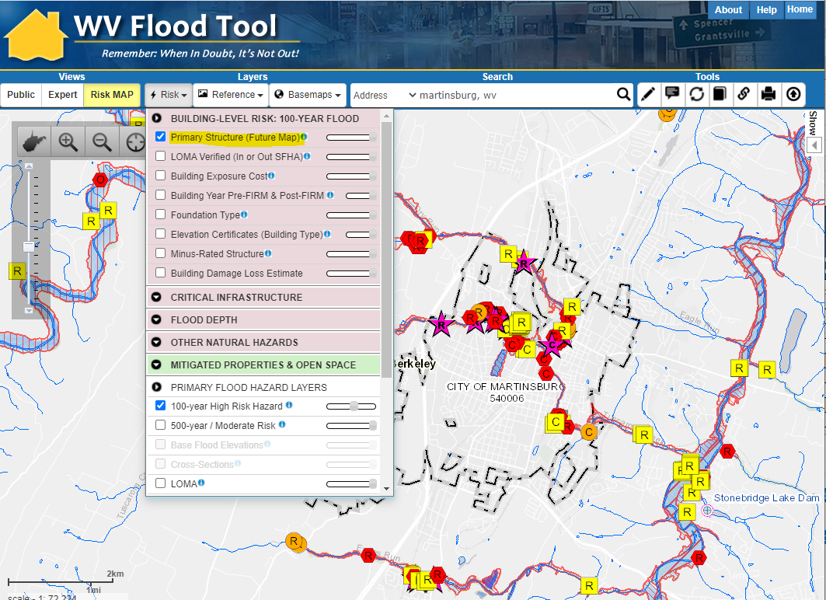

WV Flood Tool Map Link: <https://mapwv.gov/flood/map/?wkid=102100&x=-8679568&y=4788783&l=7&v=2>

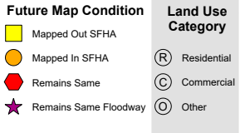

**Figure BE-7B.** Martinsburg’s *high-value building floodplain structures* viewable on the [Risk MAP View](https://mapwv.gov/flood/map/?wkid=102100&x=-8679568&y=4788783&l=7&v=2) of the WV Flood Tool. Symbol letters indicate building exposure cost.

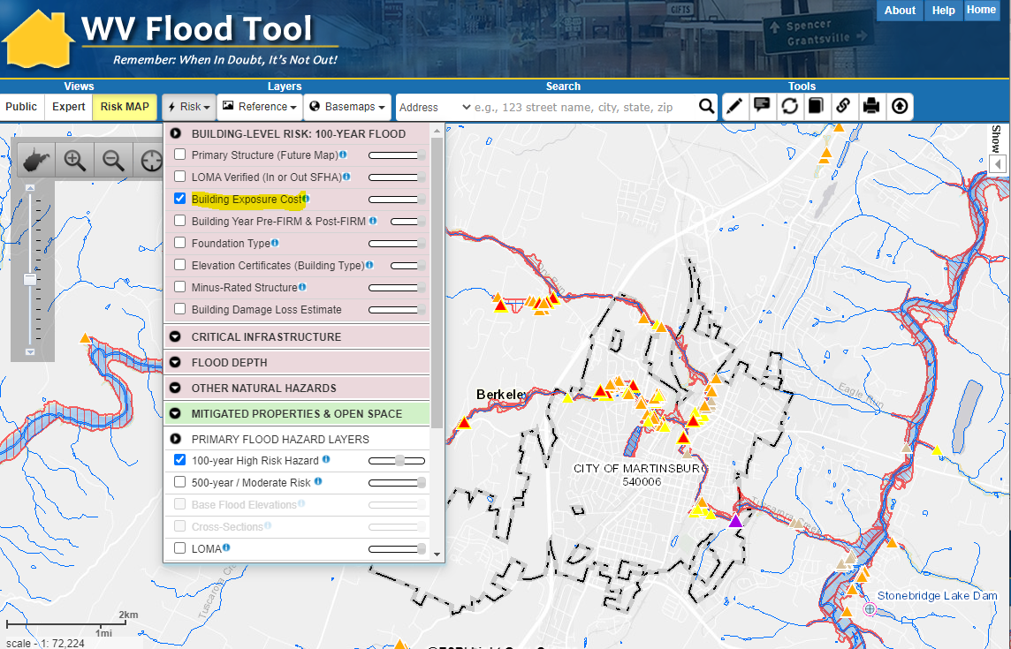

WV Flood Tool Map Link: <https://mapwv.gov/flood/map/?wkid=102100&x=-8679568&y=4788783&l=7&v=2>

Legend for General Occupancy Class

**R – Residential** (homes, apartments, group quarters)  
**C – Commercial** (industrial)  
**O – Other Non-Residential** (schools, churches, govt.)

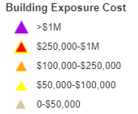Legend for Building Exposure Cost

**Figure BE-7C.** Bath’s *primary structures* viewable on the [Risk MAP View](https://mapwv.gov/flood/map/?wkid=102100&x=-8708553&y=4811397&l=9&v=2) of the WV Flood Tool. Symbol letters indicate general occupancy (**R**esidential, **C**ommercial, **O**ther Non-Residential).

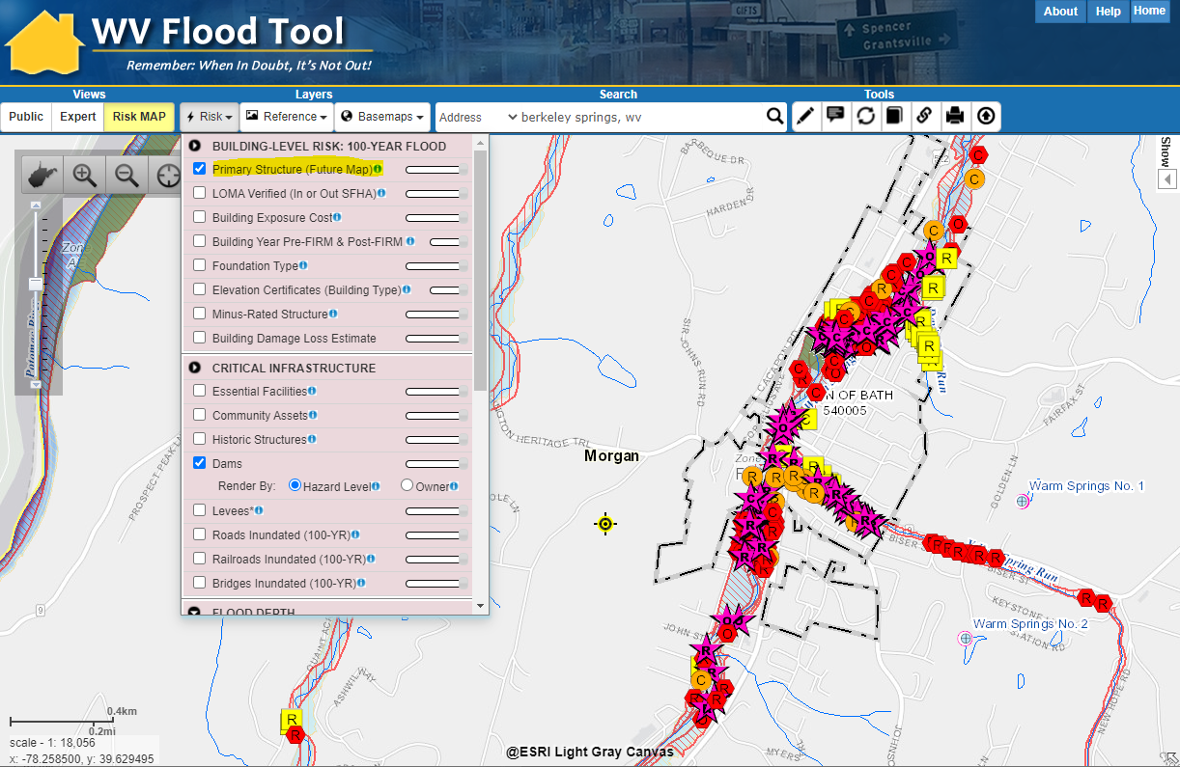

WV Flood Tool Map Link: <https://mapwv.gov/flood/map/?wkid=102100&x=-8708553&y=4811397&l=9&v=2>



**Figure BE-7D.** Bath’s *high-value building floodplain structures* viewable on the [Risk MAP View](https://mapwv.gov/flood/map/?wkid=102100&x=-8708553&y=4811397&l=9&v=2) of the WV Flood Tool. Symbol letters indicate building exposure cost.

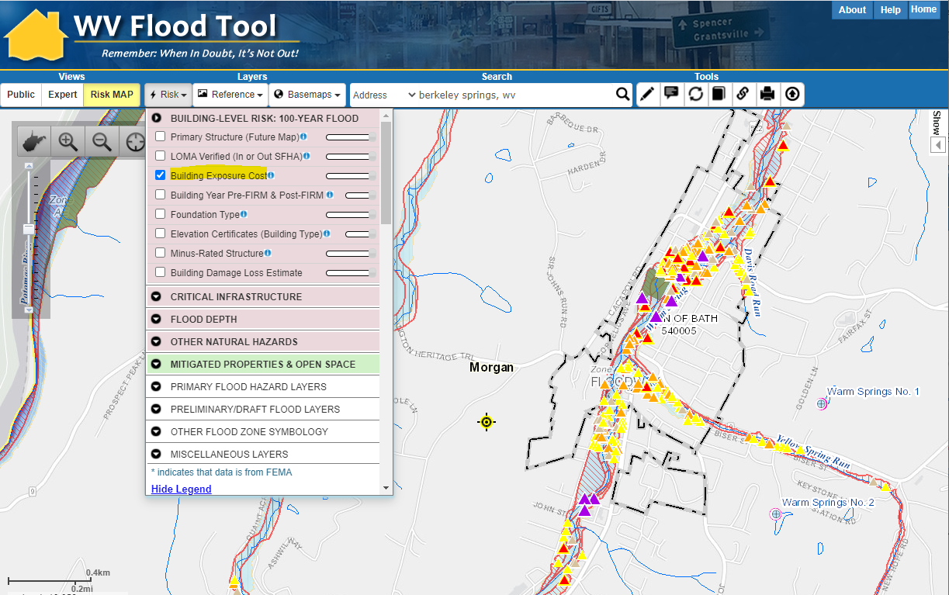

WV Flood Tool Map Link: <https://mapwv.gov/flood/map/?wkid=102100&x=-8708553&y=4811397&l=9&v=2>

Legend for General Occupancy Class

**R – Residential** (homes, apartments, group quarters)  
**C – Commercial** (industrial)  
**O – Other Non-Residential** (schools, churches, govt.)

Legend for Building Exposure Cost

**RESOURCES:**

**Reference Tables:** [Occupancy Classes](https://data.wvgis.wvu.edu/pub/RA/_resources/FRA/Occupancy_Class_Types_Reference.xlsx) | [Foundation Types](https://data.wvgis.wvu.edu/pub/RA/_resources/FRA/Basement-Foundation_Types-FFH_Reference.xlsx)

**Flood Risk Methodology:** [WV Flood Risk Assessment](https://data.wvgis.wvu.edu/pub/RA/_resources/Model/WV_FRA_Methodology.pdf)|[FEMA’s Hazus Loss Estimation](https://www.hsdl.org/?abstract&did=480580)

**WV Flood Tool:** [Resources Page](https://mapwv.gov/flood/resources.html) | [Glossary](https://data.wvgis.wvu.edu/pub/RA/_resources/FloodTool/WV-Flood-Tool_FRA_Glossary.pdf)

* * *

**Statewide Risk Assessment Contacts:**

Statewide Risk Assessment Technical Support, WVU GIS Technical Center  
 - Kurt Donaldson ([kurt.donaldson@mail.wvu.edu](mailto:kurt.donaldson@mail.wvu.edu))  
 - Maneesh Sharma ([maneesh.sharma@mail.wvu.edu](mailto:maneesh.sharma@mail.wvu.edu))

State NFIP Coordinator, WV Office of the Insurance Commissioner  
 - Chuck Grishaber ([Charles.C.Grishaber@wv.gov](mailto:Charles.C.Grishaber@wv.gov))  
  
WV Emergency Management Division  
 - Brian Penix, State Hazard Mitigation ([Brian.M.Penix@wv.gov](mailto:Brian.M.Penix@wv.gov))  
 - Kevin Sneed, CTP Coordinator ([Kevin.L.Sneed@wv.gov](mailto:Kevin.L.Sneed@wv.gov))  
 - Nuvia E. Villamizar, GIS Manager ([nuvia.e.villamizar@wv.gov](mailto:nuvia.e.villamizar@wv.gov))