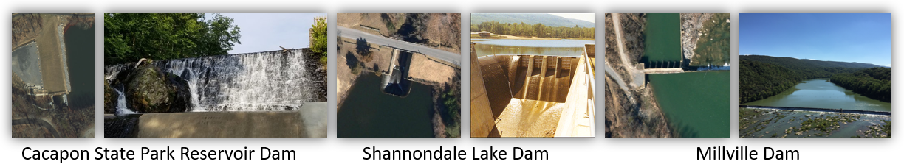

8/17/2021

**Dams (Region 9)**

**Description:** **Dams** play a vital role in the nation’s overall infrastructure and contribute to the economic development and to the social welfare of the public. Dam infrastructure can be affected by natural hazards, man-made threats, as well as an imbalance between resources invested and a dam’s age. The **National Inventory of Dams** (NID) includes dams more than 25 feet in height or storing more than 50 acre-feet or classified as High Hazard or Significant Hazard potential. About 60% of the [632 dams](https://data.wvgis.wvu.edu/pub/RA/_resources/Dam/WV_Dams_20191205.pdf) listed in the National Inventory of Dams 2020 database for West Virginia are regulated by the State.

**High Hazard Potential:** Dams are assigned the **high hazard potential classification** if failure or mis-operation will probably cause loss of human life. Of the 295 high hazard dams (47%) in West Virginia, 11 dams are maintained by the USACE and 153 dams are supported by the NRCS.

**Region 9 Dams:** Region 9 has 41 dams of which 15 are classified as high hazard potential. **Morgan County** has the highest number of high hazard dams at 12 of which a majority are eight flood-control dams for Warm Springs Run located upstream of Berkeley Springs. On March 11, 2020, it was reported in *The Morgan Messenger* that the town of Bath (Berkeley Springs) will help fund the maintenance of the eight “high hazard” flood control dams for another year. According to the executive director of the WV Conservation Agency, the eight dams are among the oldest in West Virginia. The dams were built in the 1950s and have been maintained through a cost-sharing agreement that has been in place. Besides supporting the funding request from the WV Conservation Agency, the town mayor also expressed concern about the adverse impact on the flood storage for Dams 3 and 4 by the construction of the proposed U.S. 522 Berkeley Springs bypass. News articles for Morgan County Dams: [January 9, 2019](https://www.morganmessenger.com/2019/01/09/flood-control-dams-need-maintenance-to-function/) | [July 31, 2019](https://www.morganmessenger.com/2019/07/31/officials-warn-of-impact-by-bypass-on-flood-control-dams/) | [March 11, 2020](https://www.morganmessenger.com/2020/03/11/town-will-support-maintenance-to-flood-control-dams/)

**Dams Outside Region 9:** Three “major” high-hazard dams located outside of Region 9 counties (Morgan, Berkeley, and Jefferson) have the potential to impact Region 9 communities.

**Jennings Randolph Dam** (Border of Mineral County, WV and Garett County, MD): The Jennings Randolph dam, located on the North Branch Potomac River in Garrett County, Maryland and Mineral County, West Virginia, is one of the largest dams in the region. Completed in 1981, the Jennings Randolph flood-control dam has a height of 296 feet and a maximum storage of 130,900 acre-feet. A dam failure of Jennings Randolph dam would affect downstream five counties (Mineral, Hampshire, Morgan, Berkeley, and Jefferson) and 12 jurisdictions, or from the unincorporated town of Barnum on the North Branch Potomac River downstream to Harpers Ferry at the confluence of the Potomac and Shenandoah Rivers. The U.S. Army Corps of Engineers, Baltimore District, has installed a [year-round early warning system](https://www.nab.usace.army.mil/Missions/Jennings-Randolph-Lake-Downstream-Early-Warning-System/) at Jennings Randolph Lake intended to notify downstream public users of impending rapid increases in water levels, and to evacuate the river immediately to higher ground for their safety.

**Savage River Dam** (Garrett County, MD): Completed by the U.S. Army Corps of Engineers (USACE) in 1952, the dam is 184 feet high with a maximum storage of 31,800 acre-feet of water. Five miles downstream of the dam, the Savage River flows into the Potomac River near the town of Piedmont, Mineral County, WV. The Savage River Dam, maintained by the U.S. Army Corps of Engineers, is classified as a “large”, “high” hazard structure.

**Lake Holiday Dam** (Frederick County, VA): The privately owned Lake Holiday Dam in Frederick County, Virginia, is located approximately 13 miles upstream from the Berkeley County border. In Virginia, the lake flows into Isaacs Creek, an east-flowing tributary of Back Creek, which flows north through Berkeley County to the Potomac River. This high hazard dam is 102 feet high and stores 10,166 acre-feet of water.

**Figure D-1.** Dams located in Eastern Panhandle

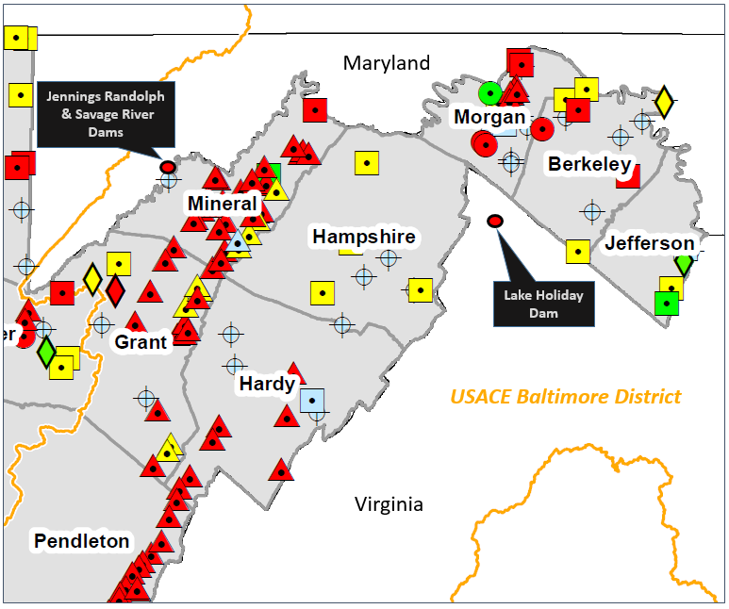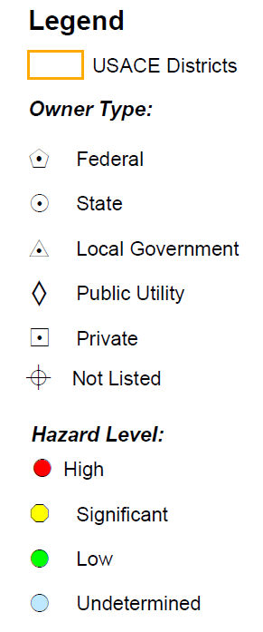

Source: National Inventory of Dams 2020 - [Statewide Dams Map](https://data.wvgis.wvu.edu/pub/RA/_resources/Dam/WV_Dams_20191205.pdf)

**Community Engagement and Verification:**Refer to the WV Flood Tool map and tables (Tables D-3 to D-7) to evaluate high-hazard potential dams in which failure is expected to result in loss of life and may also cause significant economic losses, including damages to downstream property or critical infrastructure, environmental damage, or disruption of lifeline facilities.

Review the **Emergency Action Plans (EAP)** and **dam failure inundation maps** of all **high hazard dams** and identify the farthest downstream community impacted. Coordinate with the dam owner and dam safety regulators about dam maintenance, mitigation strategies, flood warning and response, and potential downstream effects of overtopping or failure. Review Community Rating System (CRS) credits for activities Flood Warning and Response (CRS 600) and Dams (CRS 630).

**Figure D-2.** Eight high hazard flood-control dams upstream of Berkeley Springs

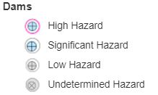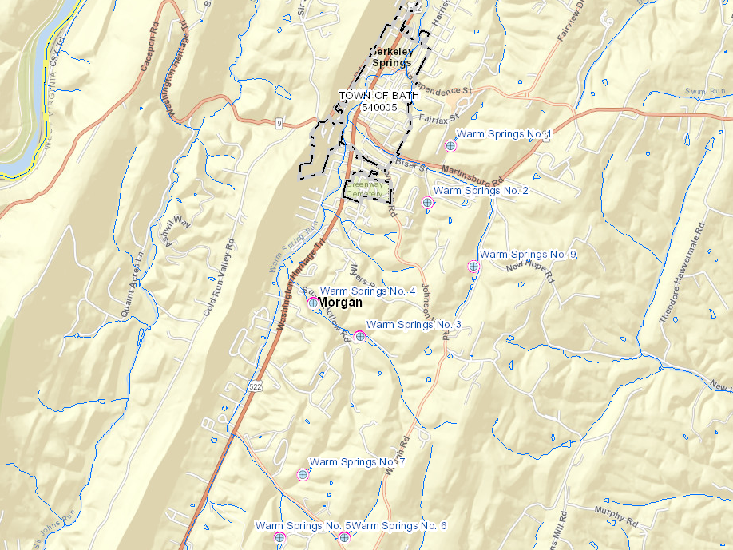

Map Link: <https://www.mapwv.gov/flood/map/?wkid=102100&x=-8708803&y=4809463&l=7&v=2>

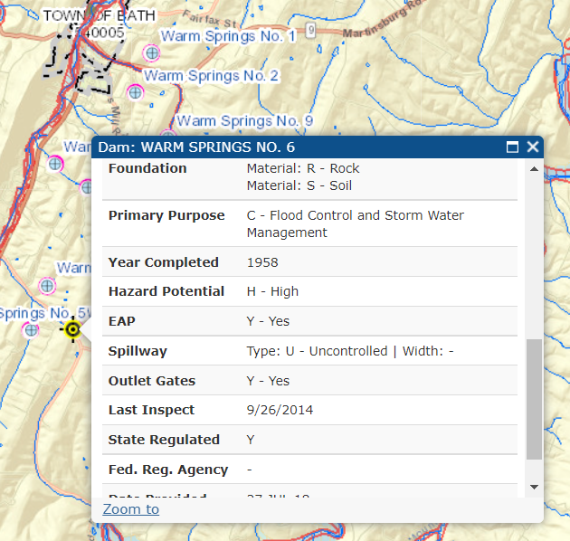

*Click on the Dam point on the WV Flood Tool to view attributes*

**Table D-3.** WV Dams by Owner Type

|  |  |  |  |  |  |  |  |
| --- | --- | --- | --- | --- | --- | --- | --- |
| **County** | **Total Count** | Federal Owned | State Owned | Local Govt. Owned | Public Utility Owned | Private Owned | Unknown Owned |
| BERKELEY COUNTY | 11 | 0 | 1 | 0 | 1 | 4 | 5 |
| JEFFERSON COUNTY | 6 | 0 | 0 | 0 | 1 | 3 | 2 |
| MORGAN COUNTY | 24 | 0 | 3 | 8 | 0 | 6 | 7 |

Source: National Inventory of Dams 2020 Database   
Community-Level Risk Assessment Tables: <https://data.wvgis.wvu.edu/pub/RA/State/CL/>

**Table D-4.** WV Dams by Hazard Classification

|  |  |  |  |  |  |
| --- | --- | --- | --- | --- | --- |
| **County** | **Total Count** | **High Hazard** | **Significant Hazard** | **Low Hazard** | **Undetermined Hazard** |
| BERKELEY COUNTY | 11 | 3 | 3 | 0 | 5 |
| JEFFERSON COUNTY | 6 | 0 | 1 | 2 | 3 |
| MORGAN COUNTY | 24 | 12 | 3 | 1 | 8 |

Source: National Inventory of Dams 2020 Database

Community-Level Risk Assessment Tables: <https://data.wvgis.wvu.edu/pub/RA/State/CL/>

**Table D-5.** High Hazard Dams impacting Region 9 – Owner Name, Owner Type, and Purposes

|  |  |  |  |  |  |  |  |
| --- | --- | --- | --- | --- | --- | --- | --- |
| **DAM NAME** | **NID ID** | **COUNTY** | **OWNER NAME(S)** | **OWNER TYPE** | **DAM**  **USES**1 | **YEAR BUILT** | **LINK** |
| SLEEPY CREEK DAM | WV00301 | Berkeley | WVDNR, WILDLIFE RESOURCES | State | R | 1962 | [FT](http://mapwv.gov/flood/map/?wkid=102100&x=-8699649.7248&y=4798079.1154&l=9&v=2) |
| STONEBRIDGE LAKE DAM | WV00310 | Berkeley | SEVEN KINGS HOLDINGS | Private |  |  | [FT](http://mapwv.gov/flood/map/?wkid=102100&x=-8674819.2767&y=4784617.2023&l=9&v=2) |
| TILHANCE FARMS | WV00307 | Berkeley | CARLTON A. THOMPSON | Private | P | 1989 | [FT](http://mapwv.gov/flood/map/?wkid=102100&x=-8689215.3712&y=4803826.3678&l=9&v=2) |
| LAKE HOLIDAY DAM | VA069014 | FREDERICK | LAKE HOLIDAY COUNTRY CLUB, INC. | Private | R | 1972 | [FT](https://mapwv.gov/flood/map/?wkid=102100&x=-8717111&y=4766155&l=7&v=2) |
| JENNINGS RANDOLPH DAM | MD00069 | GARRETT | CENAB | Federal | CSOR | 1981 | [FT](http://mapwv.gov/flood/map/?wkid=102100&x=-8807867&y=4783660&l=9&v=2) |
| SAVAGE RIVER DAM | MD00014 | GARRETT | UPPER POTOMAC RIVER COMMISSION, | State | CSR | 1952 (mod. 2010) | [FT](http://mapwv.gov/flood/map/?wkid=102100&x=-8809142&y=4794705&l=6&v=2) |
| CACAPON RESERVOIR DAM | WV06502 | Morgan | WVDNR, PARKS | State | S | 1974 | [FT](http://mapwv.gov/flood/map/?wkid=102100&x=-8716997.0223&y=4794591.7044&l=9&v=2) |
| CACAPON STATE PARK LAKE | WV06503 | Morgan | WVDNR, PARKS | State | R | 1937 | [FT](http://mapwv.gov/flood/map/?wkid=102100&x=-8716100.2818&y=4793549.7261&l=9&v=2) |
| DAM B |  | Morgan |  | Private |  |  | [FT](http://mapwv.gov/flood/map/?wkid=102100&x=-8705741.3801&y=4816900.0055&l=9&v=2) |
| GRASSHOPPER HOLLOW TAILINGS DAM | WV06523 | Morgan | U.S. SILICA COMPANY | Private | T | 1965 | [FT](http://mapwv.gov/flood/map/?wkid=102100&x=-8706514.4324&y=4818185.4518&l=9&v=2) |
| WARM SPRINGS NO. 1 | WV06506 | Morgan | EASTERN PANHANDLE SCD | Local | C | 1957 | [FT](http://mapwv.gov/flood/map/?wkid=102100&x=-8707349.3282&y=4811117.5425&l=9&v=2) |
| WARM SPRINGS NO. 2 | WV06507 | Morgan | EASTERN PANHANDLE SCD | Local | C | 1956 | [FT](http://mapwv.gov/flood/map/?wkid=102100&x=-8707627.6271&y=4810435.1101&l=9&v=2) |
| WARM SPRINGS NO. 3 | WV06508 | Morgan | EASTERN PANHANDLE SCD | Local | C | 1955 | [FT](http://mapwv.gov/flood/map/?wkid=102100&x=-8708431.6025&y=4808829.5732&l=9&v=2) |
| WARM SPRINGS NO. 4 | WV06509 | Morgan | EASTERN PANHANDLE SCD | Local | C | 1961 | [FT](http://mapwv.gov/flood/map/?wkid=102100&x=-8708988.2003&y=4809230.9336&l=9&v=2) |
| WARM SPRINGS NO. 5 | WV06510 | Morgan | EASTERN PANHANDLE SCD | Local | C | 1956 | [FT](http://mapwv.gov/flood/map/?wkid=102100&x=-8709390.1872&y=4806421.7517&l=9&v=2) |
| WARM SPRINGS NO. 6 | WV06511 | Morgan | EASTERN PANHANDLE SCD | Local | C | 1958 | [FT](http://mapwv.gov/flood/map/?wkid=102100&x=-8708617.1341&y=4806421.7518&l=9&v=2) |
| WARM SPRINGS NO. 7 | WV06512 | Morgan | EASTERN PANHANDLE SCD | Local | C | 1958 | [FT](http://mapwv.gov/flood/map/?wkid=102100&x=-8709111.8882&y=4807184.165&l=9&v=2) |
| WARM SPRINGS NO. 9 | WV06513 | Morgan | EASTERN PANHANDLE SCD | Local | C | 1956 | [FT](http://mapwv.gov/flood/map/?wkid=102100&x=-8707071.0292&y=4809672.449&l=9&v=2) |

1See Purpose Codes in NID Definitions: C = Flood Control, R = Recreation, S = Water Supply, T = Tailing, P = Fire Protection / Stock / Small Pond, O = Other

Source: National Inventory of Dams 2020 Database

**Table D-6.** High Hazard Dams – River or Stream on which the dam is built and name of the nearest downstream city or town.

|  |  |  |  |  |  |  |
| --- | --- | --- | --- | --- | --- | --- |
| **DAM NAME** | **COUNTY** | **RIVER or STREAM** | **NEAREST DOWNSTREAM CITY/TOWN** | **DISTANCE (mi) to NEAREST CITY/TOWN** | **MAP LINK** |  |
| SLEEPY CREEK DAM | Berkeley | MEADOW BRANCH | MICHAEL'S CHAPEL | 9 | [FT](http://mapwv.gov/flood/map/?wkid=102100&x=-8699649.7248&y=4798079.1154&l=9&v=2) |  |
| STONEBRIDGE LAKE DAM | Berkeley | UNNAMED OPEQUON CK | BLAIRTON | 0 | [FT](http://mapwv.gov/flood/map/?wkid=102100&x=-8674819.2767&y=4784617.2023&l=9&v=2) |  |
| TILHANCE FARMS | Berkeley |  | JOHNSONTOWN | 0 | [FT](http://mapwv.gov/flood/map/?wkid=102100&x=-8689215.3712&y=4803826.3678&l=9&v=2) |  |
| LAKE HOLIDAY DAM | FREDERICK | ISSACS CREEK | WV-VA State Line | 13 | [FT](https://mapwv.gov/flood/map/?wkid=102100&x=-8717111&y=4766155&l=7&v=2) |  |
| JENNINGS RANDOLPH DAM | GARRETT | NORTH BRANCH POTOMAC RIVER | BARNUM | 6 | [FT](http://mapwv.gov/flood/map/?wkid=102100&x=-8807867&y=4783660&l=9&v=2) |  |
| SAVAGE RIVER DAM | GARRETT | SAVAGE RIVER | LUKE | 5 | [FT](http://mapwv.gov/flood/map/?wkid=102100&x=-8809142&y=4794705&l=6&v=2) |  |
| CACAPON RESERVOIR DAM | Morgan | NORTH FORK | SLEEPY CREEK | 2 | [FT](http://mapwv.gov/flood/map/?wkid=102100&x=-8716997.0223&y=4794591.7044&l=9&v=2) |  |
| CACAPON STATE PARK LAKE | Morgan | NORTH, MIDDLE & SOUTH FK. | SLEEPY CREEK | 17 | [FT](http://mapwv.gov/flood/map/?wkid=102100&x=-8716100.2818&y=4793549.7261&l=9&v=2) |  |
| DAM B | Morgan |  |  |  | [FT](http://mapwv.gov/flood/map/?wkid=102100&x=-8705741.3801&y=4816900.0055&l=9&v=2) |  |
| GRASSHOPPER HOLLOW TAILINGS DAM | Morgan | POTOMAC RIVER | BERKELEY SPRINGS | 3 | [FT](http://mapwv.gov/flood/map/?wkid=102100&x=-8706514.4324&y=4818185.4518&l=9&v=2) |  |
| WARM SPRINGS NO. 1 | Morgan | WARM SPRING RUN | BERKELEY SPRINGS | 0 | [FT](http://mapwv.gov/flood/map/?wkid=102100&x=-8707349.3282&y=4811117.5425&l=9&v=2) |  |
| WARM SPRINGS NO. 2 | Morgan | WARM SPRING RUN | BERKELEY SPRINGS | 0 | [FT](http://mapwv.gov/flood/map/?wkid=102100&x=-8707627.6271&y=4810435.1101&l=9&v=2) |  |
| WARM SPRINGS NO. 3 | Morgan | WARM SPRING RUN | BERRYVILLE | 0 | [FT](http://mapwv.gov/flood/map/?wkid=102100&x=-8708431.6025&y=4808829.5732&l=9&v=2) |  |
| WARM SPRINGS NO. 4 | Morgan | WARM SPRING RUN | BERRYVILLE | 0 | [FT](http://mapwv.gov/flood/map/?wkid=102100&x=-8708988.2003&y=4809230.9336&l=9&v=2) |  |
| WARM SPRINGS NO. 5 | Morgan | WARM SPRING RUN | BERRYVILLE | 0 | [FT](http://mapwv.gov/flood/map/?wkid=102100&x=-8709390.1872&y=4806421.7517&l=9&v=2) |  |
| WARM SPRINGS NO. 6 | Morgan | WARM SPRING RUN | BERRYVILLE | 0 | [FT](http://mapwv.gov/flood/map/?wkid=102100&x=-8708617.1341&y=4806421.7518&l=9&v=2) |  |
| WARM SPRINGS NO. 7 | Morgan | WARM SPRING RUN | BERRYVILLE | 0 | [FT](http://mapwv.gov/flood/map/?wkid=102100&x=-8709111.8882&y=4807184.165&l=9&v=2) |  |
| WARM SPRINGS NO. 9 | Morgan | WARM SPRING RUN | BERKELEY SPRINGS | 0 | [FT](http://mapwv.gov/flood/map/?wkid=102100&x=-8707071.0292&y=4809672.449&l=9&v=2) |  |

Source: National Inventory of Dams 2020 Database

**Table D-7.** High Hazard Dams – Downstream communities affected by floods resulting from the failure of the dam. Sorted on Maximum Storage from highest to lowest.

|  |  |  |  |  |  |  |  |  |
| --- | --- | --- | --- | --- | --- | --- | --- | --- |
| **DAM NAME** | **DAM HEIGHT (Feet)** | **MAX. STORAGE (Acre-Feet)** | **HAZARD CLASS** | **EAP** | **LINK** | **DAM JURISDICTION** | **IN-BETWEEN JURISDICTIONS** | **FARTHEST**1 **IMPACTED JURISDICTION** |
| JENNINGS RANDOLPH DAM | 296 | 130,900 | High | Y | [FT](http://mapwv.gov/flood/map/?wkid=102100&x=-8807867&y=4783660&l=9&v=2) | **Mineral** | **Mineral,** Piedmont, Keyser, Carpendale, Ridgeley, **Hampshire**, **Morgan**, Paw Paw, **Berkley**, **Jefferson**, Shepherdstown | Harpers Ferry |
| SAVAGE RIVER DAM | 184 | 31,800 | High | Y | [FT](http://mapwv.gov/flood/map/?wkid=102100&x=-8809142&y=4794705&l=6&v=2) | **Garrett** | Mineral, Piedmont, Keyser, (?) | (?) |
| LAKE HOLIDAY DAM | 129 | 1,260 | High | Y | [FT](https://mapwv.gov/flood/map/?wkid=102100&x=-8717111&y=4766155&l=7&v=2) | **Frederick** | (?) | (?) |
| SLEEPY CREEK DAM | 38 | 4,890 | High | Y | [FT](http://mapwv.gov/flood/map/?wkid=102100&x=-8699649.7248&y=4798079.1154&l=9&v=2) | **Berkeley** | **Morgan** | (?) |
| GRASSHOPPER HOLLOW TAILINGS DAM | 129 | 1,260 | High | Y | [FT](http://mapwv.gov/flood/map/?wkid=102100&x=-8706514.4324&y=4818185.4518&l=9&v=2) | **Morgan** | Berkeley Springs | (?) |
| STONEBRIDGE LAKE DAM | 28 | 209 | High | Y | [FT](http://mapwv.gov/flood/map/?wkid=102100&x=-8674819.2767&y=4784617.2023&l=9&v=2) | **Berkeley** | Martinsburg | (?) |
| WARM SPRINGS NO. 3 | 48 | 110 | High | Y | [FT](http://mapwv.gov/flood/map/?wkid=102100&x=-8708431.6025&y=4808829.5732&l=9&v=2) | **Morgan** | Berkeley Springs | (?) |
| CACAPON RESERVOIR DAM | 36 | 102 | High | Y | [FT](http://mapwv.gov/flood/map/?wkid=102100&x=-8716997.0223&y=4794591.7044&l=9&v=2) | **Morgan** | (?) |  |
| WARM SPRINGS NO. 4 | 41 | 91 | High | Y | [FT](http://mapwv.gov/flood/map/?wkid=102100&x=-8708988.2003&y=4809230.9336&l=9&v=2) | **Morgan** | Berkeley Springs | (?) |
| WARM SPRINGS NO. 5 | 37 | 86 | High | Y | [FT](http://mapwv.gov/flood/map/?wkid=102100&x=-8709390.1872&y=4806421.7517&l=9&v=2) | **Morgan** | Berkeley Springs | (?) |
| CACAPON STATE PARK LAKE | 23 | 64 | High | Y | [FT](http://mapwv.gov/flood/map/?wkid=102100&x=-8716100.2818&y=4793549.7261&l=9&v=2) | **Morgan** | (?) | (?) |
| WARM SPRINGS NO. 9 | 32 | 53 | High | Y | [FT](http://mapwv.gov/flood/map/?wkid=102100&x=-8707071.0292&y=4809672.449&l=9&v=2) | **Morgan** | Berkeley Springs | (?) |
| WARM SPRINGS NO. 6 | 28 | 42 | High | Y | [FT](http://mapwv.gov/flood/map/?wkid=102100&x=-8708617.1341&y=4806421.7518&l=9&v=2) | **Morgan** | Berkeley Springs | (?) |
| WARM SPRINGS NO. 2 | 36 | 37 | High | Y | [FT](http://mapwv.gov/flood/map/?wkid=102100&x=-8707627.6271&y=4810435.1101&l=9&v=2) | **Morgan** | Berkeley Springs | (?) |
| WARM SPRINGS NO. 1 | 39 | 30 | High | Y | [FT](http://mapwv.gov/flood/map/?wkid=102100&x=-8707349.3282&y=4811117.5425&l=9&v=2) | **Morgan** | Berkeley Springs | (?) |
| WARM SPRINGS NO. 7 | 36 | 28 | High | Y | [FT](http://mapwv.gov/flood/map/?wkid=102100&x=-8709111.8882&y=4807184.165&l=9&v=2) | **Morgan** | Berkeley Springs | (?) |
| TILHANCE FARMS | 20 | 21 | High | Y | [FT](http://mapwv.gov/flood/map/?wkid=102100&x=-8689215.3712&y=4803826.3678&l=9&v=2) | **Berkeley** | (?) | (?) |
| DAM B |  |  | High |  | [FT](http://mapwv.gov/flood/map/?wkid=102100&x=-8705741.3801&y=4816900.0055&l=9&v=2) | **Morgan** | (?) | (?) |

1 Farthest downstream community impacted criteria: flood gate closure at floodwall or 1-foot water depth inundation. If the water depth is not accurate within 1 foot, then areas projected to be “wet” from inundation are identified.

Source: National Inventory of Dams 2020 Database

|  |
| --- |
| **RESOURCES:**  Dam Maps:   * [Interactive WV Flood Tool (Dams)](https://www.mapwv.gov/flood/map/?wkid=102100&x=-9004226&y=4528759&l=8&v=2) | [Statewide Dams Map - Ownership and Hazard Level](https://data.wvgis.wvu.edu/pub/RA/_resources/Dam/WV_Dams_20191205.pdf) * [USACE Dams with Corps District Divisions](https://data.wvgis.wvu.edu/pub/RA/_resources/Dam/USACE_District_Divisions_WV_Dams-Levees_20160817.pdf) * [WV Mining Dams](https://data.wvgis.wvu.edu/pub/RA/_resources/Dam/Dams_Mining_NonMining_20191106.pdf)   Dam Presentations / News Item   * FEMA Dam Presentation: [Addressing the Risks of High Hazard Potential Dams (HHPD)](https://data.wvgis.wvu.edu/pub/RA/_resources/Dam/Dams-AddressingRiskofHHPD_(FEMA_R3)_20200715.pdf) * [USACE Publishes Policy Update for Inundation Maps and the National Inventory of Dams](https://www.usace.army.mil/Media/News-Releases/News-Release-Article-View/Article/2483323/usace-publishes-policy-update-for-inundation-maps-and-the-national-inventory-of/)   Community Rating System (CRS) Resources:   * [Map of Dams in CRS Communities](https://data.wvgis.wvu.edu/pub/RA/_resources/Dam/WV_Dams_CRS_600_credit_High_Risk_Dams_20200129.pdf) * [CRS 600 Warning & Response](https://data.wvgis.wvu.edu/pub/RA/_resources/CRS/CRS_Activity_600_Warning_&_Response.pdf) * [Dams and Building Inventory (CRS 630)](https://data.wvgis.wvu.edu/pub/RA/_resources/Dam/Dams_and_BI_(CRS_630)_20201107.pdf) * WV CRS Community Map: [8.5 x 11](https://data.wvgis.wvu.edu/pub/RA/_resources/CRS/WV_CRS_8X11_20191210.pdf) | [11 x 17](https://data.wvgis.wvu.edu/pub/RA/_resources/CRS/WV_CRS_11x17_20200302.pdf)   Agencies:   * [USACE National Inventory of Dams (NID)](https://nid.sec.usace.army.mil/) | [Data Dictionary](https://www.mapwv.gov/flood/content/documents/NID_DataDictionary.pdf) * [FEMA Dam Safety](https://www.fema.gov/emergency-managers/risk-management/dam-safety) * [NRCS West Virginia](https://www.nrcs.usda.gov/wps/portal/nrcs/site/wv/home/) * [WV Dam Safety Office](https://damsafety.org/west-virginia) | [WV DEP (Division of Water and Waster Management) Dam Safety](https://dep.wv.gov/WWE/ee/ds/Pages/dsregs.aspx) * WV DEP (Division of [Mining](https://dep.wv.gov/dmr/Pages/default.aspx) and Reclamation) Mined Dams * [WV Conservation Agency](https://www.wvca.us/) |

**NID DEFINITIONS**

**National Inventory of Dams (NID):** The [National Inventory of Dams](https://nid.sec.usace.army.mil/) is a congressionally authorized database documenting dams in the United States and its territories. It is maintained and published by the US Army Corps of Engineers. It contains information about each dam's location, size, purpose, type, last inspection and regulatory facts. See more complete data field definitions.

The NID consists of dams meeting at least one of the following criteria:

* High hazard potential classification - loss of human life is likely if the dam fails,
* Significant hazard potential classification - no probable loss of human life but can cause economic loss, environmental damage, disruption of lifeline facilities, or impact other concerns,
* Equal or exceed 25 feet in height and exceed 15 acre-feet in storage,
* Equal or exceed 50 acre-feet storage and exceed 6 feet in height.

**Maximum Storage:** Maximum storage, in acre-feet, which is defined as the total storage space in a reservoir below the maximum attainable water surface elevation, including any surcharge storage. The acre-foot is a non-SI unit of volume commonly used in the United States about large-scale water resources, such as reservoirs, aqueducts, canals, sewer flow capacity, irrigation water, and river flows. An acre-foot equals approximately an eight-lane swimming pool, 82 ft (25 m) long, 52 ft (16 m) wide and 9.8 ft (3 m) deep.  One acre-foot equals about 326,000 gallons, or enough water to cover an acre of land, about the size of a football field, one foot deep.

**Dam Height:** Height of the dam, in feet to the nearest foot, which is defined as the vertical distance between the lowest point on the crest of the dam and the lowest point in the original streambed.

**Major Dams:** The National Inventory of Dams defines any "major dam" as being 50 feet (15 m) tall with a storage capacity of at least 5,000 acre-feet (6,200,000 m3), or of any height with a storage capacity of 25,000 acre-feet (31,000,000 m3).

**Dam Purposes:** NID Purpose Codes for which the reservoir is used. The order indicates the relative decreasing importance of the purpose. Codes are concatenated if the dam has multiple purposes. For example, SCR would indicate the primary purposes, Water Supply and Flood Control and Storm Water Management, followed by Recreation.

**I** for Irrigation  
**H** for Hydroelectric

**C** for Flood Control and Storm Water Management

**N** for Navigation

**S** for Water Supply

**R** for Recreation

**P** for Fire Protection, Stock, or Small Farm Pond

**F** for Fish and Wildlife Pond

**D** for Debris Control

**T** for Tailings

**O** for Other

**Emergency Action Plan:** An Emergency Action Plan (EAP), developed by the dam owner, is defined as a plan of action to be taken to reduce the potential for property damage and loss of life in an area affected by a dam failure or large flood.

**Downstream Hazard Potential:** Code indicating the potential hazard to the downstream area resulting from failure or mis-operation of the dam or facilities:

L for Low;  
S for Significant;  
H for High.

LOW HAZARD POTENTIAL: Dams assigned the low hazard potential classification are those where failure or mis-operation results in no probable loss of human life and low economic and/or environmental losses. Losses are principally limited to the owner’s property.

SIGNIFICANT HAZARD POTENTIAL: Dams assigned the significant hazard potential classification are those dams where failure or mis-operation results in no probable loss of human life but can cause economic loss, environment damage, disruption of lifeline facilities, or impact other concerns. Significant hazard potential classification dams are often located in predominantly rural or agricultural areas but could be located in areas with population and significant infrastructure.

HIGH HAZARD POTENTIAL DAMS: Dams assigned the high hazard potential classification are those where failure or mis-operation will probably cause loss of human life.

|  |  |  |
| --- | --- | --- |
| Hazard Potential Classification | Loss of Human Life | Economic, Environmental, Lifeline Losses |
| Low | None expected | Low and generally limited to owner |
| Significant | None expected | Yes |
| High | Probable. One or more expected | Yes (but not necessary for this classification) |

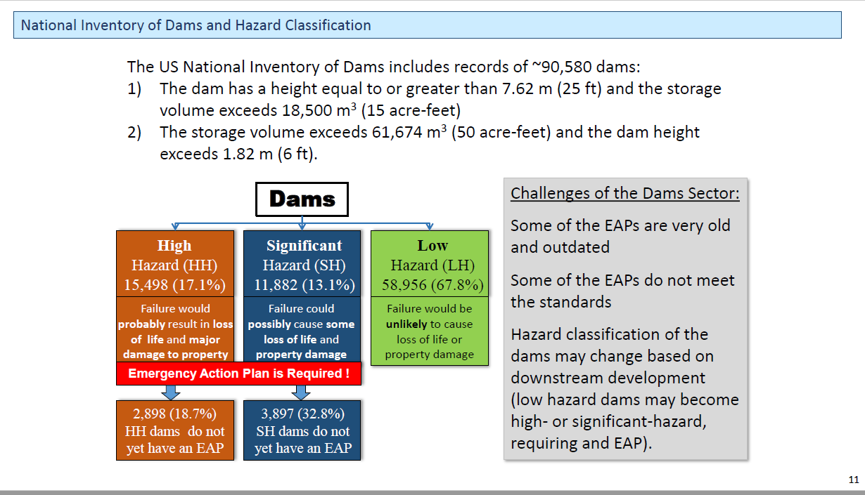

Source: National Inventory of Dams 2020

* * *

**Statewide Risk Assessment Contacts:**

Statewide Risk Assessment Technical Support, WVU GIS Technical Center  
 - Kurt Donaldson ([kurt.donaldson@mail.wvu.edu](mailto:kurt.donaldson@mail.wvu.edu))  
 - Maneesh Sharma ([maneesh.sharma@mail.wvu.edu](mailto:maneesh.sharma@mail.wvu.edu))  
 - Eric Hopkins ([Eric.Hopkins@mail.wvu.edu](mailto:Eric.Hopkins@mail.wvu.edu))  
   
State NFIP Coordinator, WV Office of the Insurance Commissioner  
 - Chuck Grishaber ([Charles.C.Grishaber@wv.gov](mailto:Charles.C.Grishaber@wv.gov))  
  
WV Emergency Management Division

- Brian Penix, State Hazard Mitigation Specialist ([Brian.M.Penix@wv.gov](mailto:Brian.M.Penix@wv.gov))

- Tim Keaton, State Hazard Mitigation Planner ([Tim.W.Keaton@wv.gov](mailto:Tim.W.Keaton@wv.gov))  
 - Kevin Sneed, CTP Coordinator ([Kevin.L.Sneed@wv.gov](mailto:Kevin.L.Sneed@wv.gov))  
 - Nuvia E. Villamizar, GIS Manager ([nuvia.e.villamizar@wv.gov](mailto:nuvia.e.villamizar@wv.gov))