September 19, 2022

Brian Penix
State Hazard Mitigation Specialist
WV Emergency Management Division
2403 Fairlawn Ave.
Dunbar, WV 25064
(304) 957-2572 Office Line
Re: Project Close-out for Statewide Multi-Hazard Risk Assessments for West Virginia. Also known as TEIF-TEAL Project

Dear Brian,

TEIF-TEAL Risk Assessment: Enclosed is the TEIF-TEAL project closeout report for site-specific risk assessments focused on flood and landslide hazards conducted for all 55 counties and 231 incorporated communities in West Virginia to supplement local and state hazard mitigation plans. The State Hazard Mitigation Office refers to these studies for assessing and mitigating risks to the 286 communities of West Virginia as the Total Exposure in Floodplain (TEIF) and Total Exposure Area Landslides (TEAL). The performance period for this hazard mitigation project (Project Number: FEMA-4273-DR-WV-0031) was from 6/20/2018 to 6/25/2022.

Statewide Assessment: This statewide approach and standardized methodology to multi-hazard risk assessments at the building level for every community in the State and for a geographic area over 24,000 square miles constitutes one of the largest risk assessment studies ever undertaken in the Nation. Importantly, the various risk assessment products generated from this grant will benefit future risk reduction plans and projects.

3 Major Work Tasks: Because this project was quite large in scope, it was subdivided into three major work tasks: flood risk assessments, landslide risk assessments, and data development activities focused on building inventories and reference layers that were necessary for achieving quality hazard risk assessments at the structure level. The risk assessment products and deliverables listed in this close-out report align with the work tasks and goals described in the Project Narrative. Refer to the Project Narrative of the proposal for a more detailed description of the goals and products of the project.

- Flood Risk Assessments: Created site-specific flood risk assessments for 268 flood-prone communities (231 municipalities and 55 unincorporated areas). Referred to as the Total Exposure in Floodplains (TEIF) project. Results are published on the WV Flood Tool’s RiskMAP View (www.mapwv.gov/flood) and accessed using the Risk Assessment Product Index.

- Landslide Risk Assessments: Generated landslide incident and susceptibility maps for 55 counties. Referred to as the Total Exposure in Areas of Landslides (TEAL) project. Results are published on both the WV Flood Tool (www.mapwv.gov/Flood) and the WV Landslide Tool (www.mapwv.gov/Landslide).

- GIS Data Development: Created a structure-level inventory of all buildings and facilities exposed to multi-hazards. A more detailed inventory was created of at-risk structures in the floodplain. The building inventories include building occupancy and replacement values of every structure in the State. In addition, key reference GIS data layers (community boundaries, leaf-off aerial imagery, parcels, and site addresses) necessary to fulfill the requirements of county and state hazard risk assessments were updated. For communities in West Virginia, a total of 45 distinctive data development projects were completed for improving leaf-off aerial imagery (30 unique counties; 41 total counties), parcels (7 counties), and E-911 addresses (8 communities). The total cost of the data development projects was $1,406,528, with the FEMA obligated dollars $542,541 and the remaining county cost share 61% or $863,987.

Please contact me if you have any questions.

Sincerely,



Manager
WV GIS Technical Center
West Virginia University
330 Brooks Hall, 98 Beechurst Avenue
PO Box 6300
Morgantown, WV 26506
(304) 293-9467
kdonalds@wvu.edu

Contents

FLOOD RISK ASSESSMENT DELIVERABLES 1
LANDSLIDE RISK ASSESSMENT DELIVERABLES 14
DATA DEVELOPMENT DELIVERABLES 18

FLOOD RISK ASSESSMENT DELIVERABLES

Table F-1. FLOOD RISK ASSESSMENT Products and Deliverables
Task | Task Description | Goal
Site-Specific Flood Risk Assessments | TASK 1: [Site-specific flood risk assessments] Complete Hazus Level 2 flood risk assessments for 55 counties and 213 incorporated communities to supplement Local and State Hazard Mitigation Plans]. The flood risk assessments for the 268 flood-prone areas are calculated for a riverine 1%-annual-chance flood event with Hazus flood loss models using as inputs the flood inundation area and composite of the best available depth grids.  STATWEWIDE FLOOD RISK ASSESSMENT. Referred to as the Total Exposure in Floodplains (TEIF) project. Created site-specific flood risk assessments for 286 communities (231 municipalities and 55 unincorporated areas) for the 1%-annual-chance (100-yr) flood event. Detailed risk profiles were generated at the building level and aggregated to the community, regional, and state levels. Risk profiles by stream name and watershed were produced as well.  FLOOD LOSS MODELS. The building-level flood risk assessments utilized FEMA’s Flood Assessment Structure Tool (FAST), a GIS-based, open-source utility designed by FEMA’s Hazus Program for estimating potential building losses for a 1%-annual-chance flood event.  FLOOD LOSS ESTIMATION METHODLOGY  - Standardized Flood Loss Methodology: FEMA’s open-source Hazus utility, Flood Assessment Structure Tool (FAST), provides a standardized methodology for estimating potential building losses for a 1%-annual-chance flood event. Debris removal and maximum restoration times are also determined.  - Population Displacement Models: Supplemented FEMA’s FAST utility with population and short-term sheltering models according to Hazus methodology.  - Automated Model Outputs: Automated python scripts generate the flood loss model outputs quickly.  - Quantifies Degree of Flood Risk: Flood loss models quantify the degree of flood risk, including estimates of substantially damaged structures. Quantifying the degree of flood risk is important for risk communications and flood reduction efforts.  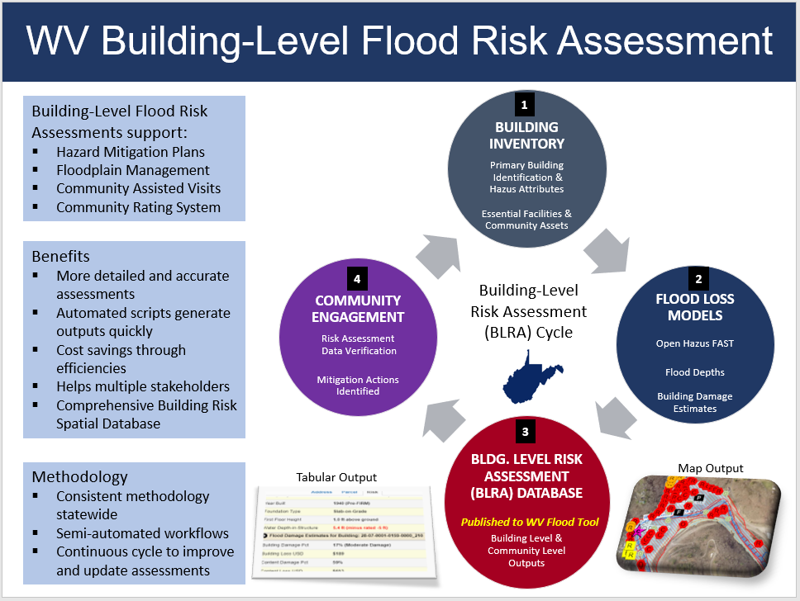  - BUILDING LEVEL RISK CYCLE. Refer to this directory for detailed documentation about how the building level risk assessment cycle (BLRA) creates the building-level risk assessments. See Task 1 of the Data Development tasks for community-wide building inventory which is required for the landslide hazard risk assessment. The building attributes can be updated annually when new statewide tax assessment database is published.  - PRESENTATION. Flood Risk Assessment Presentation (2022) PDF | PPTX  - SUPPPORT OF OTHER FEDERAL AGENCIES. The flood risk assessment data has successfully supported other risk reduction projects as well in West Virginia.  - “Voluntary Floodplain Buyout along Elkhorn Creek/Tug Fork River, McDowell County” report. Work for the Watershed Plan and Environmental Assessment performed by the West Virginia University Land Use and Sustainable Development Law Clinic and the Natural Resources Conservation Service.  - Provided USACE with project information to develop a collaborative Silver Jackets proposal in support of the statewide flood risk assessment. | Goal F1
Statewide Geodatabase of Site-Specific Flood Risk Structures | TASK 2: [Statewide Geodatabase of Site-Specific Flood Risk Structures] Create a statewide geodatabase of site-specific flood risk structures (called “User-Defined Facilities”, or UDFs, in Hazus) located in the Effective/Advisory Floodplains attributed with building exposure and flood loss values.  More than 98,000 structures in high-risk effective and advisory flood zones were inventoried and attributed with building exposure and flood loss values. Essential facilities, community assets, and other structures of significance are distinguished in the statewide building-level flood risk inventory.  The spatial location and building characteristic (building value, occupancy class, first-floor height, etc.) were compiled and verified by GIS Specialists using the best-available GIS and tax assessment reference data. Default building characteristics are updated annually from the WV Property Tax Database, while user-defined modified values may be supplied for missing or incorrect assessment attributes. A unique building identifier consisting of the parcel identifier and address number was assigned to every flood-risk structure for the management and reporting of building-level flood risk assessments. Customized online tax assessment reports allowed GIS Specialists to identify one-to-many relationships for single parcels with multiple buildings.  Enhanced Building Inventory and Accuracy Improvement Procedures: GIS Specialists used desktop GIS software to (1) pinpoint building locations to the most restrictive flood zone, (2) match building points to correct assessment records, (3) identify insurable primary structures, (4) classify significant structures as essential facilities and community assets, (5) complete missing building attributes, and (6) modify default assessment building values with user-supplied values (Cost, Area, Occupancy Class, etc.)  BUILDING-LEVEL RISK ASSESSMENT (BLRA) HIGHLIGHTS:  STATEWIDE FLOOD RISK ASSESSMENT BUILDING INVENTORY METHODLOGY  - Statewide Inventory: All primary structures in West Virginia flood-prone communities have been inventoried for both effective and advisory 1%-annual-chance floodplains.  - Detailed and Accurate: Detailed building inventory procedures using the best-available GIS and tax assessment reference layers result in an accurate and comprehensive building risk database.  - Primary Structures and Manufactured (Mobile) Homes: Primary insurable structures are verified by reference layers so as not to include car ports, outbuildings, and other ancillary structures in the building inventory. All manufactured homes are counted and special procedures have been established to populate building attributes for this occupancy class.  - Building Unique Identifier: A unique identifier consisting of the Parcel ID and Address Number allows flood risk structures to be linked to other building-level databases (e.g., building pictures, mitigated structures, elevation certificates, structures newly mapped into SFHA, etc.).  - Significant Structures: Essential facilities, community assets, and other structures of significance are distinguished in the building-level flood risk inventory.  - Maintenance Cycle: Building attributes are updated annually when the new statewide tax assessment database is published.  - Semi-Automated Procedures: Building inventory procedures are semi-automated to increase efficiencies and cost savings.  STATEWIDE FLOOD RISK BUILDING LEVEL RISK ASSESSMENT (BLRA) DATABASE  - Statewide Flood Risk Geodatabase: A comprehensive geodatabase of at-risk buildings in the 1%-annual-chance floodplain with over 80 risk assessment attributes. The database can be sorted and filtered on key variables (Building Dollar Exposure, Occupancy Class, Flood Depth, Depth-in-Structure, Building Dollar Damage, Building Damage Percent, etc.)  - Future Map Conditions: Where advisory floodplains exist, future building-level map conditions are generated to identify structures that most likely will be mapped in or out of the Special Flood Hazard Area upon the completion of flood restudies in which new flood maps become effective.  - Various Flood Risk Assessment Products: Various products are generated from the statewide building level risk assessment: online interactive maps, static graphics, tabular spreadsheet reports (building and community level), subject reports, community risk profiles and matrices, etc. The building inventory also allows flood risk structures to be preloaded into FEMA’s Substantial Damage Estimator Tool or for communicating future map conditions / SFHA changes to affected property owners.  - Most Vulnerable Building Lists: Top building exposure and building damage lists are generated at community, regional, or statewide scales. The data extracts are beneficial in identifying which high-value and high-damage potential structures have been mitigated.  - Community Flood Risk Profiles: Aggregate reports of the building level risk database can be used to generate flood risk profiles at the community and county levels. Program scripts generate the tabular reports quickly and efficiently.  - Consistent Methodology: A consistent and uniform risk assessment methodology allows for flood risk information to be evaluated at various geographic scales to determine which jurisdictions, regions, rivers/streams, or watersheds are at more risk than others.  - Publicly Accessible Risk MAP View: Building level risk assessment layers are published online to the RiskMAP view of the WV Flood Tool.  HIGH-RISK FLOOD ZONE BUILDING COUNTS  Special Flood Hazard Area  • 84,351 buildings  • 35% in Approximate Zone A  • 65% in Detailed Zone AE (9% in Regulatory Floodway)  Buildings in Non-Regulatory Zones  - 13,966 Structures (14%) mapped in High Risk Zone Advisory A / AE  - 98,347 Total High Risk Buildings  FUTURE PROJECTS USING BULDING-LEVEL RISK ASSESSMENT (BLRA) DATABASE  - Update the WV Building Level Risk Assessment (BLRA) from new data sources (e.g., flood studies, building characteristics from updated tax assessment database, community engagement/participation).  - Document the mitigation status of 98,467 flood-prone structures to include community check-ups, focusing on post-FIRM structures with a minus 3 or greater rating. To track building verifications, update the BLRA database schema with tracking variables, or link building confirmation data in a separate table by the building identifier.  - Enhance transportation flood inundation models for roads, railroads, and bridges to WV Flood Tool.  - Map riverine flood impacts of vulnerably disadvantaged communities with higher stream flow change forecast models.  - Model potential mitigation adaptive measures of buildings (e.g., foundations and flood depths suitable for flood vents) and communicate to communities.  - Engage communities to validate areas of mitigation (AoMI) on Flood Tool.  - For pre-disaster planning, substantial damage ICC and CRS credits, preload at-risk buildings from Statewide Flood Risk Assessment into FEMA’s Substantial Damage Estimator (SDE) Tool.  - Support community-engagement activities, specifically building-level local outreach communications (using FEMA's R3 Local Official Toolkit templates) for communities with new flood maps. Effectively communicate SFHA map changes to affected property owners. This activity requires community participation from the floodplain manager for successful execution.  - Develop and verify community flood risk profiles from TEIF/TEAL project.  - Explore integrating the WV Building Level Risk Assessment (BLRA) with FEMA’s national inventory (FEMA’s USA Structures Program) so standardized, consistent, and accessible building level information can be exchanged.  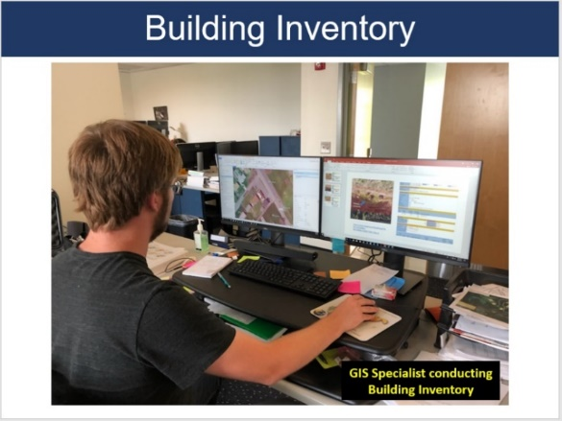  - Coordinate with the State and other partners in the development of key risk assessment data sets: mitigated structures from past flood events, state owned/leased buildings from WV Real Estate Division, water/sewer treatment plans from WVEMD or WVIJDC, WV Board of Risk and Insurance Management (BRIM) data, etc. | Goal F2
3D Flood Risk Visualizations | TASK 3: [3D flood risk visualizations] 3D visualizations for every individual flood-risk structure and neighborhood scale flood visualizations for select communities.  - SINGLE BUILDING 3D VIEW. 3D static visualizations were created of every flood-risk structure in the 100-year floodplain where a depth grid existed.  - COMMUNITY STRUCTURES 3D VIEW. 3D flood movies for visualizing damage loss estimates were created for five communities in Jefferson County.  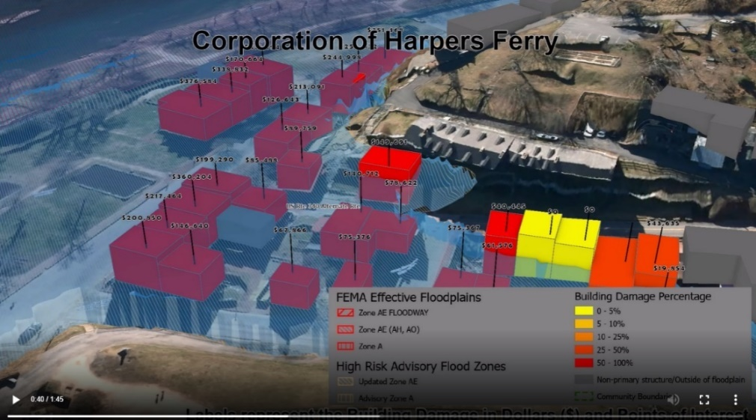  - Sample Harpers Ferry Flood Risk 3D Visualization Movie | Goal F3
Statewide Composite Flood Risk Products | TASK 4: [Assemble statewide composite flood risk products] Composite flood risk products include a statewide advisory floodplain from Advisory A and Advisory AE flood zones, statewide flood depth and water surface elevation grids.  Updated the statewide composite flood risk depth grids for flood loss estimate models.  Depth Grids: A more accurate statewide composite flood depth grid of 1-meter cell resolution was created from the best available sources for use in the Hazus flood loss damage and transportation inundation models. Performed a gap analysis of model-backed depth grids in Approximate A Zones of West Virginia and communicated results to State NFIP Office and FEMA Region III. The 2010 Hazus depth grid was used where model-backed depth grids did not exist.  Water Surface Elevation (WSEL) Grids: Water surface elevation grids were created from the FEMA CTP Projects and referenced for flood risk assessments.  Flood Depth/WSEL Sources:  - FEMA Studies  - Advisory A Flood Heights  - Updated AE Redelineation  FEMA QL2 LiDAR: The delivery of FEMA-purchased QL2 LiDAR improved the accuracy of the water depth grids. It also improved the accuracy of landslide mapping for predictive models and now allows for online LOMA submissions using LiDAR. See FEMA-purchased LiDAR projects graphic. | Goal F4
Update State Hazard Mitigation Plan | TASK 5: [Update State Hazard Mitigation Plan] Integrate county flood assessment data and reports into state hazard mitigation plan. A standardized data analysis process will ensure that future local and state plan updates are consistent and utilize comparable methodologies.  - Using a standardized methodology, created various flood risk assessment products in support of local and state hazard mitigation plans.  - Refer to the Index Guide spreadsheet named “RA_Info_Index.xlsx” to access the various risk assessment products (products, reports, tables, graphics) published in support of FEMA’s Hazard Mitigation Plans and NFIP/CRS activities. | Goal F5
Publish Flood Risk Data and Products | TASK 6: [Publish flood risk data and products] Publish flood risk data and products on state (www.MapWV.gov/flood) and FEMA’s federal geo-platforms according to required specifications. Flood risk deliverables for every county include Flood Risk Assessment reports, maps, and GIS data.  - Published data and products are accessed using the Risk Information Index.  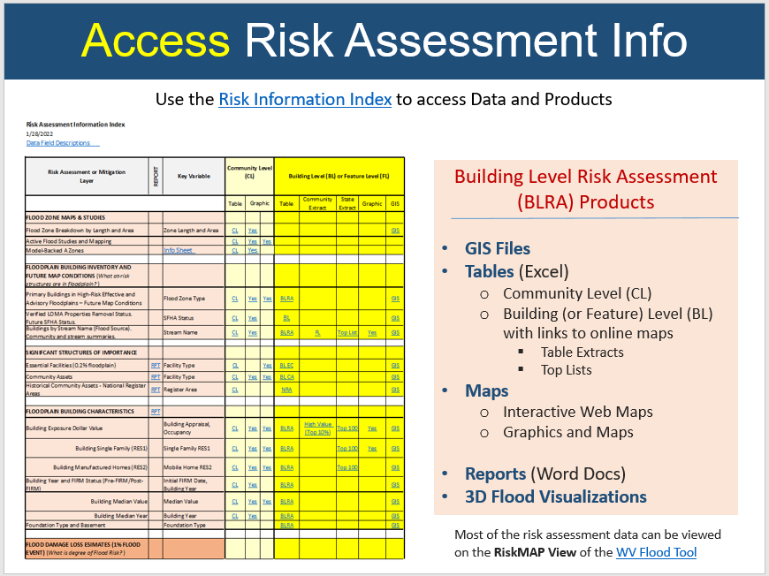  Interactive Map – RiskMAP View of the WV Flood Tool  - Primary Structures (Future Map Conditions)  - Building Exposure Cost  - Building Year Pre-FIRM & Post-FIRM  - Foundation Type  - Minus-Rated Structures  - Building Damage Loss Estimates  - Risk Assessment tab lists building and content damage estimates  Static Graphics  - FLOOD ZONE MAP INFORMATION  - High Water Marks  - Active Flood Studies and Mapping  - Flood Zone Types  - Model-Backed A Zones | A Zone Structure Clusters (5ft depth, 10ft. depth, 15 ft. depth; information forwarded to FEMA for consideration of mapping Approximate A Zones as detailed AE zones.  - Updated AE  - Model-Backed Depth Grid (1% Effective and Advisory)  - FLOODPLAIN BUILDING INVENTORY AND FUTURE MAP CONDITIONS (What at-risk structures are in the floodplain?)  - Primary Buildings in High-Risk Effective and Advisory Floodplains – Future Map Conditions. Community | County  - Verified LOMA Properties Removal Status. Future SFHA Status.  - Building Risk and Dollar Exposure by Stream Name (Flood Source) Regional Rivers/Stream Maps | Statewide Top Rivers/Streams  - Buildings by Watershed  - Buildings by PDC Region  - SIGNIFICANT STRUCTURES OF IMPORTANCE  - Essential Facilities (mapped to 0.2% floodplain)  - Community Assets Community | County  - FLOODPLAIN BUILDING CHARACTERISTICS  - Building Exposure Dollar Value Community | County  - WV BRIM data for identifying building replacement values of state owned buildings  - Building NON-RESIDENTIAL  - Percent Count: Community  - Percent Value: Community | County  - Top Non-Residential Structures >=$24M Top Non-Residential  - Top Utility Structures >= $15M Top Utility  - Building RESIDENTIAL Single Family (RES1)  - Percent Count: Community | County | Top Residential >= $300K  - Percent Value: Community| County  - Building Manufactured Homes (RES2)  - Count: Community | County  - Percent: Community | County  - Post-FIRM Buildings Percent (Post-FIRM structures 23%; n=22,812)  - Building Median Value All Occupancy Classes | Single Family (RES1)  - Building Median Year  - FLOOD DAMAGE LOSS ESIMATES (1% FLOOD EVENT) (What is the degree of Flood Risk?)  - Building Damage Loss  - Median Dollar Building Damage  - Median Percent Building Damage  - Top Building Damage Loss Structures  - Top Non-Residential Building Loss Estimates (Structure Loss >= $14M)  - Top Single-Family Residential Building Damage Loss Estimates (Structure Loss >= $205K)  - Substantial Damage Building Estimates  - 7% of total floodplain structures are estimated to be substantially damaged if a 1%-annual-chance (100-yr) flood event were to occur  - 6,751 (>= 50% damage) of 98,451 floodplain structures  - Debris Removal Community | County  - Minus Rated  - Minus Rated with FIRM Status (20% Post-FIRM, 71% Pre-FIRM, 9% Unknown)  - Top Minus-Rated Post-FIRM Structures. Structures >= 3 ft. Water Depth-in-Structure. Table on graphic lists top 20 Post-FIRM structures with water depth values >= 17 ft.  - Total Post-FIRM (n=4,223)  - 3-5 ft. (n=1,111)  - 10-15 ft. (n=187)  - >= 15 ft. (n=46)  - Estimated Population requiring Short-Term Shelter Needs Community | County  - Transportation Inundation  - Roads and Railroads  - Bridges  - MITIGATION (What structures have been mitigated?)  - Elevation Certificates (Mitigated structures - Building Diagrams 5-8)  - Mitigated Structures (Primarily mitigated structures >= 5 ft.)  - Building Pictures of Mitigated Structures (file directory)  - Repetitive Loss (RL) Properties. Data quality issues: Of 3,132 RL structures evaluated in 2019, only 73% could be geocoded)  - RL Community  - RL Structures  - Buyout Properties Community | County  - Areas of Mitigation Interest (AoMI) incomplete mapping statewide  - Identification Criteria: Identified by Repetitive Loss Structures, Substantial Damage Estimates, Mitigated Properties, High Flood Depths, High Water Marks, Similar Topography  - Example Region 4 AoMIs and Top Post-FIRM Minus Rated Structures  - Potential Buildings for Mitigation Adaptive Measures. (Residential & Non-Residential)  - OTHER Datasets that Support Risk Assessment. Includes COMMUNITYWIDE data.  - Floodplain Ratio to Community/County  - Ratio of Floodplain Building Count to Communitywide Count  - Ratio of Floodplain Building Count to Countywide Count  - Population Change between 2010 and 2020 Census  - Community Population Change  - County Population Change  - Declared Disasters / Claims / Insurance Policies / Repetitive Loss (Source: CEP 2019 data) Combined Graphics  - Declared Disasters with Flooding  - Dollar Amount of Previous Claims  - Number of Paid Losses  - Repetitive Loss Structures  - Flood Insurance Policies (NFIP national average is 30% according to Sep. 2022 report)  - Percent of SFHA Structures without Flood Insurance  - Social Vulnerability  - CDC Social Vulnerability Index (2018)  - ARC County Economic Levels (FY2022)  Spreadsheet Based – Risk assessment tabular reports generated and organized at the Community Level (CL), Building Level (BL), and Feature Level (FL)  - Floodplain Building Inventory and Future Map Conditions  - Significant Structures of Importance  - Floodplain Building Characteristics  - Flood Damage Loss Estimates  - Mitigation  - Other Risk Assessment Datasets  - Metadata Table Descriptions  - Refer to Risk Product Index and BLRA Report for access to risk assessment tables.  WV Building Level Risk Assessment (BLRA) Data and GIS Sources:  - Statewide BLRA Geodatabase (98,467 building points)  - BLRA Regional Files organized by WV Planning & Development Regions  - BLRA Data Extract Tables: High Building Value, High Damage Loss, High Minus Ratings  - BLRA Statewide Top Lists: Building Value, Flood Depth, Damage Loss $, Damage Loss %, Minus Rated, Mitigated Structures  Risk Assessment Subject Reports Regional or Statewide)  - Essential Facilities  - Community Assets  - Building Exposure and Type  - Open Space Preservation (Fayette County)  Community Risk Assessment Matrices, Dashboards, Rankings  - Flood Risk Factor Matrices  - Flood Risk Dashboards  - Community Risk Rankings  Other Flood Products  - 3D Flood Risk Visualizations (Jefferson County)  - Historical Flooding – Story Maps  - Flood Risk in West Virginia: What We Learned from the June 2016 Flood  - WV Flooded Towns, June 2016. The Historic Flooding of Southern West Virginia on June 23, 2016  - 1985 Flood: The Historic WV Flooding of November 4-5 1985  - Pre-Disaster Planning  - Preload Flood Risk Structures into FEMA’s Substantial Damage Estimator (SDE) Tool. The entire statewide flood risk inventory of 98,347 1% floodplain structures can be preloaded into FEMA’s SDE Tool. Refer to procedural guide on how to upload building inventory data into SDE.  - WV SDE Data Import and Instructions  - Target Audience: Emergency management officials and floodplain managers  - Communications for SFHA Changes from Flood Studies  - Provide risk assessment structures based on FEMA’s preliminary flood studies (mapped into SFHA, mapped out of SFHA, new BFE’s) for outreach communications to affected homeowners. In addition, restudied areas require updating floodplain management ordinance and an opportunity to review state model ordinance and incorporate higher standards. Refer to procedural instructions for more information.  - Mail Merge SFHA Change Template and Instructions  - Target Audience: Homeowners affected by new flood studies  Refer to the Index Guide spreadsheet named “RA_Info_Index.xlsx” to access the various risk assessment products (products, reports, tables, graphics, risk dashboards) published in support of FEMA’s Hazard Mitigation Plans and NFIP/CRS activities.  Future Directions: Continue refinement of risk assessment products, tables, reports, maps, metadata, presentation materials, supporting documents, etc. | Goal F6
Other Notes | - EXPANDED SCOPE OF WORK: For Flood Risk Assessments, the Scope of Work expanded to include mitigation data layers: Open Space Preservation CRS estimates, Repetitive Loss Structure verification lists, Buyout Properties, Mitigated Structures, etc.)  - ELEVATION CERTIFICATES. Expanded on initiative to collect Elevation Certificates and Building Pictures of select minus-rated structures to verify first-floor heights of elevated structures so flood loss damage estimates are not inflated.  - COMMUNITY RATING SYSTEM: Reviewed and focused on aligning project with FEMA’s Community Rating System (CRS) program activities.  - COMMUNITY ENGAGEMENT:  - Engaged in one-on-one data verification activities with floodplain managers for multiple flood-prone communities.  - Organized stakeholder meetings with regions and communities regarding risk assessments and vulnerability analysis.  - DAM/LEVEE FAILURE RESOURCES:  - Dam/Levee Resources: High Hazard Dam Risk Assessment Tables, Communities Downstream of High Hazard Dams  - Graphics  - Statewide Dams and Levees  - Dams with Inundation Zones  - Levees  - Dam Inundation Zones: The WV Flood Tool’s query result panel for the RiskMAP View could be updated to alert a location that falls within a failed dam inundation zone. New flood inundations zones have been made available by the WV Conservation Agency and USACE for select dams. In addition, risk assessments can be done by performing an intersection between the built-up environment and flood inundation zones.  - WV Dam Inundation Viewer of 168 High Risk Dams from the WV Conservation Agency  - USACE Dam Inundation Viewer: https://nid.usace.army.mil/viewer/index.html  - USACE Summersville Dam Example: https://nid.sec.usace.army.mil/viewer/index.html?dsLibrary=NID-MD00069,NID-WV06702&x=-80.901&y=38.223&z=15

LANDSLIDE RISK ASSESSMENT DELIVERABLES

Table L-1. LANDSLIDE RISK ASSESSMENT Products and Deliverables
Task | Task Description | Goal
Landslide  Inventory | TASK 1: [LANDSLIDE INVENTORY] – A statewide landslide incident inventory from various sources: WV GES, WV DOT, USGS, FEMA landslide buy-out properties, etc.  - Inventoried 159,247 landslide features from historical landslide data collections and LiDAR mapping.  - LiDAR Mapping  - 66,151 landslide initiation points mapped using high resolution (1- or 2-m) LiDAR.  - Other Sources  - 46,330 landslide polygons digitized based on WV Geological and Economic Survey 1976 study.  - 41,307 landslide polygons digitized based on a USGS 1975-1985 study.  - Other studies and 2016 WV DOT points (n=1,406)  - FEMA landslide buyout properties  - LiDAR Mapping: Most common landslides mapped were slides and slumps (97%). Landslide locations were mapped throughout West Virginia using LiDAR elevation data products, including hillshade and slopeshade grids. Mapped failure types included slide, debris flow, lateral spread, multiple failures (when several failures were present in a small area, but were too small or close together to map separately), rock falls, and undetermined failure type. The nature of the West Virginia landscape and the LiDAR imagery limited mapping to landslides at least 33 feet wide.  - FUTURE DIRECTIONS: Landslide mapping of areas where LiDAR coverage was incomplete; LiDAR for these areas was delivered by FEMA in fall 2021. | Goal L1
Landslide  Method  Development | TASK 2: [LANDSLIDE METHOD DEVELOPMENT] – Methodology and validation of landslide susceptibility models  - Created a statewide landslide susceptibility map  - Performed using machine learning of which the “Random Forest” method was determined to be the most efficient.  - Performed for various Major Land Resource Areas (MLRA) to minimize heterogeneity in physiographic conditions that may influence landslide susceptibility.  - Main Landslide contributing factors: Slope, soil type, and geology. Steeper slopes, unconsolidated soils, and less resistant rock units like shale and siltstone will increase landslide susceptibility.  - Anthropogenic disturbances contribute heavily to landslide risk  - FUTURE WORK: Rerun models after new LiDAR-based landslide mapping is complete.  Study Team. The West Virginia University Study Team included Dr. Steve Kite (Geomorphologist), Dr. James Thompson (Soil Scientist), Dr. Aaron Maxwell (Geologist/Modeler), and Dr. Maneesh Sharma (Geologist/GIS).  Methodology: Site characteristics and terrain variables, such as slope, lithology, soil type, and distance to roads and streams, were extracted from the mapped landslide locations. Using a random forest machine learning algorithm, these variables were used as inputs to calculate a probabilistic landslide susceptibility grid. A majority of the mapped landslide locations were used to train the model, and the remaining locations were used to validate the model’s accuracy. The resulting grid cells were classified into low, medium, and high susceptibility areas using professional judgement and model statistics. On average, over 95% of known failure locations were found to occur within the modeled high susceptibility areas (Maxwell et al., 2020).  Regional Models: Landslide susceptibility was modeled by Major Land Resource Area (MLRA). Models were generated for each MLRA in West Virginia to take advantage of similarities in physiographic conditions that may influence landslide susceptibility.  Landslide Predictors: The most important predictors of landside susceptibility include topographic variables such as slope angle, slope curvature, and topographic roughness.  Published Research Paper: “Assessing the Generalization of Machine Learning-Based Slope Failure Prediction to New Geographic Extents” | Goal L2
County level landslide map and report generation | TASK 3: [COUNTY LEVEL LANDSLIDE MAP AND REPORT GENERATION] – Generation of landslide County maps  - 55 County Landslide Susceptibility Maps. Created landslide susceptibility maps for all 55 counties. Susceptibility is classified according to low, medium, and high probability of slope failure.  - Low Risk: 0-30% probability of slope failure  - Medium: 30-70% probability of slope failure  - High: 70-100% probability of slope failure  - Map Limitations. The map is for informational purposes regarding landslide susceptibility at the county scale. It may not be used to identify susceptibility and site specific locations. To address susceptibility at a sub county scale, geotechnical evaluations should be performed by professional engineers or geologists. This map is not to be used for regulatory use.  - Reports. Created a statewide and 11 regional landslide reports in support of local and state hazard mitigation plans.  - Landslide Risk Assessment Results. (Refer to the landslide risk assessment reports and tables for more information).  - Risk assessment performed at sub-county scale  - 53% area in high/medium susceptibility. Note that areas of low susceptibility may be downslope of high/medium susceptibility areas and thus at risk.  - 11% roads in high/medium risk  - Structures- majority located in high/medium landslide susceptibility area are Residential buildings  - Kanawha and Monongalia counties rank 1st and 2nd  - Harrison and Ohio counties rank 1st and 2nd for Commercial asset values  - Essential Facilities – 14 located in high/medium susceptibility area  - Relative risk to humans and related infrastructure is highest in Region 6, which ranks either 1st or 2nd in all five road and structure risk analysis categories | Goal L3
Web Application | TASK 4: [WEB APPLICATION] – Interactive web application of landslide incidents and susceptibility zones  - Created interactive web applications for viewing known landslide incidence and susceptibility in West Virginia  - WV Landslide Tool  - WV Flood Tool (RiskMAP View) | Goal L4
Update State Hazard Mitigation Plan | TASK 5: [UPDATE STATE PLAN] – Update State Hazard mitigation plan  - Created various landslide risk assessment products in support of local and state hazard mitigation plans.  - Statewide landslide incident and susceptibility maps  - Risk assessments performed at the community-level scale for roads, structures/parcels (building dollar exposure), essential facilities, and total area. | Goal L5
Product Summary | SUMMARY OF KEY RISK LANDSLIDE ASSESSMENT PRODUCTS:  Reports and Maps:  - Regional and Statewide Landslide Risk Assessment Reports  - County Scale Landslide Susceptibility Maps for all 55 counties  - Landslide Characteristics by 5 MLRA Regions  Web Tools showing Landslide Incidents and Susceptibility:  - WV Landslide Tool  - WV Flood Tool (RiskMAP View)  Published Methodology Paper: Assessing the Generalization of Machine Learning-Based Slope Failure Prediction to New Geographic Extents  Landslide Risk Directory: Directory of reports, susceptibility maps, educational brochures, methodology papers, GIS data, community risk assessment tables, graphics, etc.  Outreach Materials:  - Brochures  - Community: Mitigating Landslide Risk through Planning  - Homeowner: Recognizing Landslide Risk on Your Property  - Story Maps  - Causes of Landslides in Mountain State  - WV Landslides and Slide-Prone Areas, WVGES 1976  Presentations:  - Landslide Risk Assessment (April 2022) PDF | PPTX  - GSA Poster Kite et al. (2021) PDF | PPTX

DATA DEVELOPMENT DELIVERABLES

Table D-1. DATA DEVELOPMENT Products and Deliverables
Task | Task Description | Goal
Create Statewide Building Inventory | TASK 1: [Statewide Building Inventory] – Create a structure-level inventory of all buildings and facilities exposed to multi-hazards. The inventory includes each building’s replacement or resell value and allows for site-specific risk analysis.  Created a structure-level inventory of all buildings and facilities exposed to multi-hazards. A more detailed inventory was created of at-risk structures in the floodplain. The building inventories include building occupancy and replacement values of every structure in the State.  COMMUNITY-WIDE BUILDING INVENTORY. For landslide hazards that affect the entire community area (unlike flood hazard which is limited to the floodplain area), total building counts and building replacement values were computed for the entire geographic area of the communities. When computing the number of structures and building exposure values susceptible to landslides, the Statewide Addressing and Mapping System (SAMS) Database and WV Property Tax Database were utilized. The addressing database provides the site point location while the tax assessment database provides the building value and occupancy class. The communitywide tables can be used for other hazards as well for risk assessments.  HIGH-RISK FLOODPLAIN BUILDING INVENTORY. A detailed building inventory of all primary buildings was inventoried for all high-risk effective and advisory 1%-annual-chance floodplains in the State. The spatial location and building characteristic (building value, occupancy class, first-floor height, etc.) were compiled and verified by GIS Specialists using the best-available GIS and tax assessment reference data. Default building characteristics were updated annually from the WV Property Tax Database, while user-defined modified values were supplied for missing or incorrect assessment attributes. A unique building identifier consisting of the parcel identifier and address number was assigned to every flood-risk structure for the management and reporting of building-level flood risk assessments. Customized online tax assessment reports allowed GIS Specialists to identify one-to-many relationships for single parcels with multiple buildings. Essential facilities, community assets, and other structures of significance were distinguished in the building-level flood risk inventory. The buildings inventoried in the 1%-annual-chance floodplain are published on the RiskMAP View of the WV Flood Tool as well as community- and building-level tabular reports.  - Developed a standardized, comprehensive building exposure inventory that includes critical facilities and community assets.  - Essential facilities provide critical services to the community and include police and fire stations, E-911 emergency operations centers, schools (often used as shelters), hospitals, and nursing homes.  - Community assets are historical structures listed on the National Register of Historic Places, government facilities (federal, state, local), emergency medical services (EMS), religious organizations, utilities, educational facilities (not K-12 schools), or other buildings of significance.  - Identified state-owned properties from tax assessment occupancy classes and business databases.  - Determined building replacement values from tax assessment, the WV Board of Risk and Insurance Management (BRIM) insurance database, and other available sources.  Refer to this directory for detailed documentation about the building inventory, which is part of building level risk assessment cycle (BLRA) for generating structure-level damage loss estimates. Also see Task 2 of the Flood Risk Assessment tasks. | Goal D1
Fill in Critical GIS Data Gaps for Quality Risk Assessments | TASK 2: [Fill in GIS Data Gaps] – Fill in the GIS data gaps that are preventing West Virginia from achieving detailed hazard identification and quality risk assessments: parcels, addresses, LiDAR, leaf-off imagery, and building specific datasets.  Completed all data development projects. Numerous counties are still taking advantage of the final year of the statewide aerial imagery contract with no cost share required from the State or FEMA.  STATEWIDE DATA CONTRACTS  - State GIS Contracts: Two state contracts through West Virginia University were established for aerial imagery, parcel, and addressing data development projects to fill GIS data gaps that were preventing West Virginia from achieving detailed hazard identification and quality risk assessments. Data development focused on setting up and executing statewide contracts for developing the following GIS reference layers: aerial imagery, parcels, and addresses. New QL2 LiDAR was purchased and provided by FEMA Region III.  - Total Projects: For West Virginia communities, a total of 45 distinctive data development projects were completed for improving leaf-off aerial imagery (30 unique counties; 41 total counties), parcels (7 counties), and E-911 addresses (8 communities). Multiple counties took advantage of the aerial imagery contract by paying for imagery for more than one year, and thus increasing the total data development projects to 56.  - Total Cost: The total cost of the data development projects was $1,406,528, with the FEMA obligated dollars $542,541 and the remaining county cost share 61% or $863,987.  - MOU Agreement: A Memorandum of Understanding (MOU) was prepared and signed by each community. A total of 56 MOU’s were created for all the projects that spanned the performance period of the grant. The MOU detailed the data deliverables, specifications, costs, cost-share, responsibilities, timeline, and signatures of all the partners (GIS Vendor, WV GIS Technical Center, and Community).  - Data Development Documentation:  - TEIF/TEAL Data Development Report PDF  - WV Flood Tool’s Reference Layers PDF | PPTX  AERIAL IMAGERY  - Business Case: Current and high-resolution aerial imagery is required for identifying at-risk structures and for developing foundation framework layers to include E-911 addressable structures and parcels. Aerial imagery is used throughout West Virginia to meet daily business needs. Imagery has many uses, including providing a common operating picture and accurately mapping the locations of natural and man-made features.  - Completed Projects: 30 unique counties tapped into the contract and multiple counties took advantage of the contract more than once for a total of 41 county aerial imagery contracts (18,987 square miles).  - Cost Share: The total cost share by counties was 85% ($713K) while the grant share was $124K. The entire aerial imagery cost with no county cost share contributions only had to be paid for two disadvantaged counties (Clay and Pendleton counties).  - Milestone Accomplished: Replaced the legacy WV Sheriffs Association (2010-12) as the best available leaf-off imagery  - Aerial Imagery Contract: In February 2019, a 4-year statewide contract (2019-22) through WVU Procurement was executed to provide bulk discounts for government agencies acquiring aerial imagery in West Virginia. Thrasher Group was awarded the contract.  - Flying Season: The spring flying season was from late February to mid-April during leaf-out and no snow conditions.  - Spatial Resolution: All counties were collected at 4-inch resolution except for Cabell (3”), Pendleton (6’”), and Randolph (6”) counties.  - Flyover Coverage: A total of 18,987 square miles were flown from this state contract.  - Unit Costs: Aerial imagery could be purchased at four different pixel resolutions and over multiple budget cycles. Counties with limited funding qualified for grant cost-share. A fixed unit price by resolution per square mile was negotiated with the vendor in which most counties chose 4-inch resolution at $45 per square mile, with some exceptions in which counties chose either 6-inch ($36 per square mile) or 3-inch ($62 per square mile).  - Non-Exclusive Contract: County offices still had the option to contract with other companies for the same services.  - Public Domain: All county imagery data sets acquired via the contract reside in the public domain.  - Resources:  - WV State Aerial Imagery Contract  - Aerial Imagery Program and Price Information  - MOU Template  - County Aerial Imagery Year Acquired  - County Aerial Imagery Resolution  - County Aerial Imagery Vendor  - Resolution Comparison – Baseball Fence  - Resolution Comparison – WVU Coliseum  - Statewide Leaf-Off imagery web map service  - Download County Aerial Imagery  DIGITAL PARCELS  - Business Case: Accurate, current property parcels and assessment attributes are essential to identifying structures in at-risk hazard zones.  - Completed Projects: Seven counties received grant funds of $321K with a 22% county cost share to convert paper to digital tax maps. A total of 136,364 parcels were mapped.  - Milestone Accomplished: In 2004, only five counties had GIS parcels. This grant provided funding to convert all remaining paper tax maps to digital so now all 55 counties maintain and publish tax maps in an electronic format.  - Parcel Contract: The GIS professional services company Atlas Geographic Data Inc. was awarded the parcel contract to convert all remainder paper tax maps to digital. For enhanced spatial accuracy, the parcel conversion projects involved imaging all existing tax maps and plats on file, and then using these legal sources combined with other source data (tax maps, assessment acreage, visible occupation lines, road widths, imagery, etc.) to construct the tax parcel geometry while linked to the correct assessment record.  - Parcel Error Tracking: Parcel errors tracked for the floodplain building inventory include errors in geometry (unmapped parcels, misaligned parcels) and tax assessment attribute issues (missing assessment records, assessment record not linked to parcel geometry where assessed structure is located on map).  ADDRESSES  - Business Case: Accurate, current E-911 addresses are essential to identifying structures in at-risk hazard zones. E-911 addresses are the authoritative address of structures and are an essential spatial identifier. Besides address required for E-911 emergency management purposes, complete and correct addresses are important for multiple state agencies involving a wide range of applications, to include COVID Tracking (DHHR), Voter Registration and Redistricting (County Clerks/Secretary of State Office), Statewide Building Level Risk Assessment (WV EMD), Transportation Road Network/Planning (WV DOT), etc.  - Completed Projects: Addresses for flood-prone communities such as Marlinton (Pocahontas County), Mullens (Wyoming County), and Rowlesburg (Preston County) were updated. In addition, the community of Rowlesburg was re-addressed. Addressing deficiencies for the counties of Clay, Fayette, Hardy, Morgan, and Pocahontas counties were updated as well.  - Milestones Accomplished: This project resulted in Morgan County, which had major gaps in its E-911 address mapping, to receive a complete GIS addressing and mapping database. It also provided funding to correct addressing deficiencies for communities devastated by floods in the past.  - Addressing Contract: The GIS professional services company Atlas Geographic Data Inc. was awarded the addressing contract to correct addressing deficiencies (missing/incorrect addresses, spatial location) of flood-prone communities in the State. The data was formatted according to NENA standards and submitted for inclusion in the Statewide Addressing and Mapping System (SAMS).  - Addressing Error Tracking. Addressing errors tracked for the building inventory included missing and incorrect addresses. | Goal D2
Report Data Gaps to Stakeholders | TASK 3: [Report Data Gaps] – Report data gaps at the county level for key geodatabase reference layers (parcels, addresses/geocoding, imagery, elevation, building footprints, critical infrastructure, etc.) that are hindering quality risk assessment studies. Provide recommendations to the appropriate organizations to improve data management and governance.  - Data Gaps for Parcels and Addresses: Data issues and gaps are listed at https://data.wvgis.wvu.edu/pub/RA/State/CL/Data_Issues/. Data gap information was used for this project to identify counties that needed improvement.  - Aerial Imagery: Replaced the legacy WV Sheriffs Association (2010-12) so all county leaf-off imagery was not older than 5 years.  - Elevation Data: All the newly purchased FEMA LiDAR was processed and published to the WV Elevation Download Tool. This includes the LiDAR derived elevation products to include DEMs and contours. All new elevation data has been published on the WV Flood Tool as part of the Cooperating Technical Partners (CTP) program.  - Metadata: https://www.mapwv.gov/lidar-metadata  - Elevation Download Site: https://data.wvgis.wvu.edu/elevation/  - FEMA-Purchased LiDAR Projects: Project coverage graphic  - Building footprints are being updated statewide from the statewide aerial imagery as part of another project. Building footprints are used for building counts and for 3D flood visualizations.  - Data development recommendations were provided to the counties and stakeholders of the project. | Goal D3
Exchange Risk Assessment Information | TASK 4: [Exchange Risk Assessment Information] – Exchange the best available risk assessment information among local, state, and federal geo-platforms.  - All risk assessment information is available to any stakeholders via the public access portal. An index file named “RA_Info_Index” catalogs all the various risk assessment products and data.  - WV Flood Tool. All the data development enhancements to the GIS reference layers for this project in support of HMGP have been published to the WV Flood Tool as part of the CTP program with the State. | Goal D4
ADDITIONAL TASKS COMPLETED OUTSIDE PROJECT SCOPE:
- The community boundaries layer from FEMA had to be updated to produce more accurate risk assessment products. A total of 268 flood-prone communities that include 8 split communities that span over two counties were verified and updated.
  - The updated community layer of all incorporated and unincorporated jurisdictions was created from U.S. Census incorporated boundaries, 1:24,000- scale USGS topo county boundaries, and local sources. Public land boundaries were extracted and not included in the Community Boundary Layer. The community boundary layer consists of 294 records: 55 counties, 231 municipalities (8 municipalities are geographically split over two counties). Data Link: http://www.wvgis.wvu.edu/data/dataset.php?ID=484

