|  |
| --- |
| West Virginia University |
| WV Building Level Risk Assessment (BLRA) |
|  |

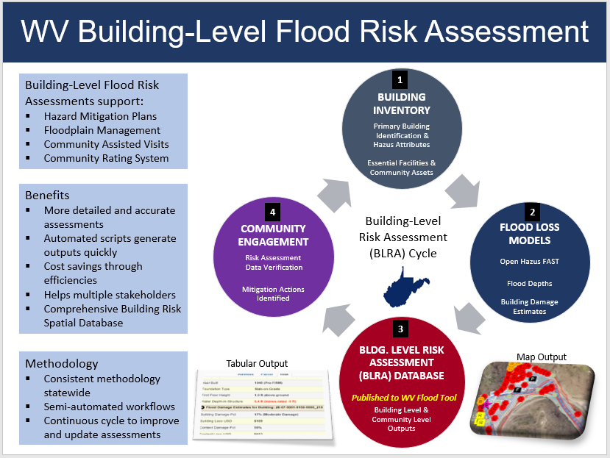

**WV Statewide Building-Level Risk Assessment (BLRA)**  
Compiled by Kurt Donaldson 9/15/2022

# BLRA FEATURES AND HIGHLIGHTS

Statewide Flood Risk Assessment **BUILDING INVENTORY METHODOLOGY**

* **Statewide Inventory**:  All primary structures in West Virginia flood-prone communities have been inventoried for both effective and advisory 1%-annual-chance floodplains.
* **Detailed and Accurate**:  Detailed building inventory procedures using the best-available GIS and tax assessment reference layers result in an accurate and comprehensive building risk database.
* **Primary Structures and Manufactured (Mobile) Homes**: Primary insurable structures are verified by reference layers so as not to include car ports, outbuildings, and other ancillary structures in the building inventory. All manufactured homes are counted and special procedures have been established to populate building attributes for this occupancy class.
* **Building Unique Identifier**:  A unique identifier consisting of the Parcel ID and Address Number allows flood risk structures to be linked to other building-level databases (e.g., building pictures, mitigated structures, elevation certificates, structures newly mapped into SFHA, etc.).
* **Significant Structures**:  Essential facilities, community assets, and other structures of significance are distinguished in the building-level flood risk inventory.
* **Maintenance Cycle**:  Building attributes are updated annually when the new statewide tax assessment database is published.
* **Semi-Automated Procedures**: Building inventory procedures are semi-automated to increase efficiencies and cost savings.

Statewide Flood Risk Assessment **FLOOD LOSS MODELS**

* **Standardized Flood Loss Methodology**: FEMA’s open-source Hazus utility, Flood Assessment Structure Tool (FAST), provides a standardized methodology for estimating potential building losses for a 1%-annual-chance flood event. Debris removal and maximum restoration times are also determined.
* **Population Displacement Models**: Supplemented FEMA’s FAST utility with population and short-term sheltering models according to Hazus methodology.
* **Automated Model Outputs**: Automated python scripts generate the flood loss model outputs quickly.
* **Quantifies Degree of Flood Risk**: Flood loss models quantify the degree of flood risk, including estimates of substantially damaged structures. Quantifying the degree of flood risk is important for risk communications and flood reduction efforts.

Statewide Flood Risk Assessment **BUILDING LEVEL RISK ASSESSMENT (BLRA) DATABASE**

* **Statewide Flood Risk Geodatabase**:  A comprehensive geodatabase of at-risk buildings in the 1%-annual-chance floodplain with over 80 risk assessment attributes. The database can be sorted and filtered on key variables (Building Dollar Exposure, Occupancy Class, Flood Depth, Depth-in-Structure, Building Dollar Damage, Building Damage Percent, etc.)
* **Future Map Conditions**: Where advisory floodplains exist, future building-level map conditions are generated to identify structures that most likely will be mapped in or out of the Special Flood Hazard Area upon the completion of flood restudies in which new flood maps become effective.
* **Various Flood Risk Assessment Products**: Various products are generated from the statewide building level risk assessment: online interactive maps, static graphics, tabular spreadsheet reports (building and community level), subject reports, etc. The building inventory also allows flood risk structures to be preloaded into FEMA’s Substantial Damage Estimator Tool or for communicating future map conditions / SFHA changes to affected property owners.
* **Most Vulnerable Building Lists**: Top building exposure and building damage lists are generated at community, regional, or statewide scales. The data extracts are beneficial in identifying which high-value and high-damage potential structures have been mitigated.
* **Community Flood Risk Profiles**: Aggregate reports of the building level risk database can be used to generate flood risk profiles at the community and county levels. Program scripts generate the tabular reports quickly and efficiently.
* **Consistent Methodology**: A consistent and uniform risk assessment methodology allows for flood risk information to be evaluated at various geographic scales to determine which jurisdictions, regions, rivers/streams, or watersheds are at more risk than others.
* **Publicly Accessible Risk MAP View**:  Building level risk assessment layers are published online to the RiskMAP view of the WV Flood Tool.

Statewide Flood Risk Assessment **COMMUNITY ENGAGEMENT**

* **Applicable FEMA Programs**: The risk assessment data provides information (e.g., post-FIRM minus-rated structures, mitigated structures) beneficial in engaging communities for NFIP/CRS management activities and support of local and state hazard mitigation plans. Building-Level Flood Risk Assessments support:
  + Hazard Mitigation Plans
  + Floodplain Management
  + Community Assisted Visits
  + Community Rating System
* **Risk Assessment Verification**. Communities validate flood risk assessments and provide feedback that make assessment more accurate. Post-FIRM minus-rated structures are verified if mitigated and compliant.
* **Identifiable Mitigation Actions**. Participating agencies identify potential mitigation actions from risk assessment data and analysis.
* **Targeted Audience and Stakeholders**: Community planners, floodplain managers, emergency management, local officials, etc.
* **Various Engagement Levels**: Community engagement of the risk assessment data includes participants from various levels including federal, state, regional, and local organizations.
* **Continuous Risk Assessment Cycle**: If new risk assessment data from community engagement activities occurs, then the risk assessment cycle is repeated starting with the building inventory step. Using semi-automated workflows, the continuous cycle follows a consistent methodology to improve and update risk assessments statewide.

**WV Statewide Building-Level Risk Assessment (BLRA)**

# BUILDING INVENTORY

1. **BUILDING INVENTORY.** A detailed building inventory of all primary buildings are inventoried for all high-risk effective and advisory 1%-annual-chance floodplains in the State. The spatial location and building characteristic (building value, occupancy class, first-floor height, etc.) are compiled and verified by GIS Specialists using the best-available GIS and tax assessment reference data. Default building characteristics are updated annually from the WV Property Tax Database, while user-defined modified values are supplied for missing or incorrect assessment attributes. A unique building identifier consisting of the parcel identifier and address number is assigned to every flood-risk structure for the management and reporting of building-level flood risk assessments. Customized online tax assessment reports allow GIS Specialists to identify one-to-many relationships for single parcels with multiple buildings. Essential facilities, community assets, and other structures of significance are distinguished in the building-level flood risk inventory. The buildings inventoried in the 1%-annual-chance floodplain are published on the RiskMAP View of the WV Flood Tool as well as community- and building-level tabular reports.
   1. Enhanced Building Inventory and Accuracy Improvement Procedures: GIS Specialists use desktop GIS software to (1) pinpoint building locations to the most restrictive flood zone, (2) match building points to correct assessment records, (3) identify insurable primary structures, (4) identify significant structures in essential facilities and community assets, (5) complete missing building attributes, and (6) modify default assessment building values with user-supplied values (Cost, Area, Occupancy Class, etc.)
   2. Building Identification
      1. Primary Structures. Primary insurable structures are identified and pinpointed within the structure footprint where the highest water depth and most restrictive flood zone (e.g., floodway) occur. Primary insurable structures are verified by reference layers so as not to include car ports, out buildings, and other ancillary structures in the building inventory.
      2. GIS Reference Layers.
         1. Building Identification. Leaf-Off Aerial Imagery, E-911 Site Addresses, and Parcels are key for identifying at-risk buildings. Other locational reference layers may include building footprints. Elevation certificates or assessment records may be sufficient when aerial imagery is not current. High-resolution elevation data is important for accurate base flood elevation determinations.
         2. Customized Tax Assessment Reports. Searchable [online tax assessment reports](https://mapwv.gov/assessment/assessment) have been customized to identify and record relevant building information for risk assessments. Assessment reports show one-to-many relationships for single parcels with multiple buildings. Consequently, Building Cost, Occupancy Class, Area, and Year can be determined for multiple specific buildings in a single parcel. In addition, building sketch diagrams from the tax assessment database are displayed for residential properties and useful for building identification purposes.
            1. [Multiple Buildings](https://mapwv.gov/assessment/Detail/?PID=31180021000100050000) in floodplain example
            2. [Residential Sketch Diagram](https://mapwv.gov/BuildingDrawings/Drawing.aspx?pid=3108011H000800000000) example
         3. Flood-Prone Community Layer. It is important the [community boundary layer](https://data.wvgis.wvu.edu/pub/RA/_resources/status/WV_Floodprone_Communities.pdf) is current and accurate for assigning and reporting risk assessment data to the correct community. For West Virginia there are 294 statistical geographies: 268 NFIP Communities (213 incorporated and 55 unincorporated areas, 18 no SFHA communities, and 8 split communities across county boundaries.
      3. Building Identifier: The unique building identifier consists of the GIS Parcel Identifier and Address Number. The building identifier allows linkage to other flood risk data sets (elevation certificates, mitigated structures, building pictures, etc.)
         1. GIS data development projects were executed to improve accuracy of building-level risk assessments. Refer to [GIS Data Development](https://data.wvgis.wvu.edu/pub/RA/_resources/status/GISDataDevelopment.pdf) graphic.
         2. Data Deficiency Procedures: Procedures are established for missing or incorrect address or parcel identifiers. A secondary parcel identifier tracks misaligned or shifted parcels.
   3. Building Characteristics. Building characteristics are captured as inputs for FEMA’s Hazus Flood Loss Models which identifies the degree of flood risk for each structure.
      1. Building Characteristics. A value (no blanks) is required for certain building data attributes to include Replacement Value, Occupancy Class, Number of Stories, Basement, First-Floor Height, and Area.
         1. Occupancy Class.
            1. Residential/Non-Residential Categories and Subcategories. The building type categories for residential and non-residential structures follow FEMA's Hazus occupancy classification. The primary source for the occupancy type is the 186 land use categories from tax assessment data. These land use codes are converted to the 33 Hazus building specific occupancy classes, and further generalized to residential and non-residential building classes. On the Risk MAP View of the WV Flood Tool, the building occupancy types based on structure use are classified as **Residential** (R - single dwelling, farmhouse, mobile home, multi-family, apartments, nursing homes, group quarters); **Commercial** (C - businesses or industrial), and **Other Non-Residential** (schools, government buildings, churches, non-inhabitable agricultural structures, etc.). Refer to [Occupancy Class categories](https://data.wvgis.wvu.edu/pub/RA/_resources/FRA/Occupancy_Class_Types_Reference.xlsx).
            2. Manufactured Homes. Every manufactured mobile home in the floodplain is counted as a primary structure. If singlewide and doublewide mobile homes are assessed as personal property with no listed appraisal values, then replacement manufactured costs are derived from other sources. For example, manufactured replacement home costs may be compiled from the Other Building and Yard Improvements tax assessment table. However, if no tax appraisal values are present, then a countywide average value of singlewide or doublewide home values may be applied. The manufactured homes occupancy class (RES2) has the greatest percentage of user-defined (or modified) building attributes due to missing tax assessment values.
         2. Number of Stories. Stories are determined from dwelling and commercial tax tables of the WV Property Tax Database.
         3. Basement, Foundation, First-Floor Height.
            1. Basement information is computed from residential and commercial tax assessment tables and then reclassified according to Hazus foundation types and first floor heights. Refer to [Basement-Foundation-First-Floor-Height](https://data.wvgis.wvu.edu/pub/RA/_resources/FRA/Basement-Foundation_Types-FFH_Reference.xlsx) documentation and lookup tables.
            2. Default first floor height information from tax assessment records may incorrect and should be validated by elevation certificates, building pictures, or field visit, especially for mitigated structures.
         4. Area (required for debris estimate models).
         5. Building Value.
            1. WV Property Tax Database. Appraisal values from the West Virginia property tax assessment records are the primary data source for buildings exposed in the 1%-annual-chance (100-yr) floodplain. These building replacement values in the statewide tax assessment database are updated every year by the WV Property Tax Division. If necessary, modified or user-defined values are entered in the enhanced building inventory database to override default appraisal records values when no appraisal values exist or are identified in an adjacent parcel; or if multiple buildings on a single parcel must be apportioned.
            2. Other Building Value Sources. Other data sources for building dollar replacement costs include neighborhood appraisal values, WV BRIM Insurance, WV IJDC utility project costs, WV DE school listings, RSMeans construction square footage estimates, Reference USA commercial database, etc.

WV BRIM: WV Board of Risk & Insurance Management (BRIM), a non-spatial database that provides insurance coverage for state agencies.

WV IJDC Utilities: Available utility building and infrastructure costs were compiled from the website of the WV West Virginia Infrastructure and Jobs Development Council.

WV DE Schools: School open/closure statuses and building square footage area are verified with databases from the WV Department of Education. For school building exposure values, BRIM values are typically used instead of the WV DE $300 square/foot RSMeans construction cost estimate.

Reference USA: An online subscription business database accessed to verify significant structures.

* + - 1. Building Year
         1. FIRM Status. The Pre-FIRM and Post-FIRM classification is determined by the building year and the initial FIRM effective date of the community. See [FIRM Status](https://data.wvgis.wvu.edu/pub/RA/_resources/FRA/CL-FRA_Bldg_FIRM-Status_Freeboard_FloodStudies.xlsx) resource document.
         2. Post-FIRM structures regulated to Pre-FIRM. If the site of a Post-FIRM structure was not mapped as a Special Flood Hazard Area at the time of construction, then repairs or alterations are regulated as though it is a Pre-FIRM structure. Mapped-in structures from preliminary studies are in the category.
    1. Data quality check are performed during the enhanced building inventory procedures to ensure all values are complete and as accurate as possible.
  1. Significant Structures.
     1. Essential Facilities. Essential facilities provide critical services to the community and include police and fire stations, E-911 emergency operations centers, schools (often used as shelters), hospitals, and nursing homes. FEMA identifies these critical facilities as essential in its Hazus-MH risk assessment tool. Essential facilities are inventoried to the higher standard 0.2%-annual-chance floodplain.
     2. Community Assets. Community assets are historical structures listed on the National Register of Historic Places, government facilities (federal, state, local), emergency medical services (EMS), religious organizations, utilities, educational facilities (not K-12 schools), or other buildings of significance to the community.
  2. Maintenance Cycle. Building attributes are updated annually when the new tax assessment database is published.
  3. Work Unit Scale: The unit of work is at the county level scale.
  4. Resource Documentation:
     1. [WV Flood Tool Resources](https://mapwv.gov/flood/resources.html)
     2. [WV Flood Tool and Flood Risk Assessment Glossary](https://data.wvgis.wvu.edu/pub/RA/_resources/FloodTool/WV-Flood-Tool_FRA_Glossary.pdf)
     3. [Building Identification](https://data.wvgis.wvu.edu/pub/RA/_resources/FRA/FRA_Building_Identification.pdf)
     4. [Reference Layers](https://data.wvgis.wvu.edu/pub/RA/_resources/FloodTool/WV_Flood_Tool_Reference_Layers.pdf)
     5. [High-Risk Advisory Flood Zones](https://data.wvgis.wvu.edu/pub/RA/_resources/FloodTool/WV_Flood_Tool_High-Risk_Advisory_Zones.pdf)

# FLOOD LOSS MODELS

* **FLOOD LOSS MODELS.**  The building-level flood risk assessments utilize FEMA’s Flood Assessment Structure Tool (FAST), a GIS-based, open-source utility designed by FEMA’s Hazus Program for estimating potential building losses for a 1%-annual-chance flood event. FAST was built from the ArcGIS Python script developed by Oregon’s Department of Geology and Mineral Industries (DOGAMI). Building and content damages are based on FEMA and U.S. Army Corps of Engineers Flood Depth-Damage Curves. A Hazus Level 2 advanced analysis increases the accuracy and precision of an analysis by incorporating user-supplied data relevant to the hazard. Flood loss models quantify the degree of flood risk, including estimates of substantially damaged structures.

1. The flood model results support local hazard mitigation plans and other flood reduction efforts.
   1. Hazus Standardized Methodology. The Hazus utility employs a standardize methodology in which structure and water depth inputs utilize Depth Damage Functions (DDFs) to calculate economic damage loss estimates. The proper Depth Damage Function (DDF) is assigned based on the Occupancy Type, Foundation Type, and Number of Stories of each structure. The First Flood Height for each structure point is subtracted from the Water Depth to calculate the Depth-in-Structure flood depth, in feet above ground level. Positive and negative water depth-in-structure values indicate flood levels above or below, respectively, the lowest finished floor. FEMA’s OpenHazus software program, Flood Structure Assessment Tool (FAST), estimates individual building damage loss for a base flood or 1%-annual-chance flood.
   2. Flood Model Estimates Quantify Degree of Flood Risk. The flood models estimate the building percent and dollar damage values for a 1-percent-annual-chance flood event (100-year flood or base flood). Flood loss models quantify the degree of flood risk, including estimates of substantially damaged structures. The physical building damage assessments communicate flood risk for individual property owners and communities in support of local hazard mitigation planning and actions. Property owners at flood risk are encouraged to obtain flood insurance through the National Flood Insurance Program (NFIP) to protect from financial loss. In addition, homeowners should adopt mitigation measures that can be used to protect properties from flooding, save money over time, and potentially reduce flood insurance premiums.
   3. Building Replacement Values: The depth-damage percent is applied to the building replacement to determine the building dollar loss per structure. Building values are primarily derived from building appraisal values of the State’s centralized WV Property Tax Assessment Database, an Oracle-based, centralized computer-assisted mass appraisal (CAMA) system known as the Integrated Assessment System (IAS), or WV Property Tax Database. Although the appraisal values may underestimate certain building values, it provides a consistent framework for determining building exposure and flood loss estimates. Default first floor heights are derived from basement assessment values recorded in residential and commercial tax assessment tables.
   4. Flood Depths: Ideal model-backed flood depths derived from high-resolution 1-meter elevation grids and for Approximate A Zones mapped at a 1-square-mile watershed threshold level. Less accurate Hazus-generated depth grid values are utilized for 18 counties were no model-backed depth grids exist for the Approximate A Zones.
   5. Model Limitations: Several factors may affect the building flood loss estimates, including inconclusive water depth models or elevated structures that have much higher first floor heights. Consequently, where necessary damage values should be based on historical flood data, construction standards, or other available information.
   6. Resource Documentation:
      1. [WV Flood Risk Assessment Methodology](https://data.wvgis.wvu.edu/pub/RA/_resources/model/WV_FRA_Methodology.pdf) (Procedural Guide)
      2. [Flood Loss Model Limitations](https://data.wvgis.wvu.edu/pub/RA/_resources/model/Flood-model-use_model-limits_mitigation-measures.pdf)

# BUILDING LEVEL RISK ASSESSMENT DATABASE

1. **BUILDING LEVEL RISK ASSESSMENT (BLRA) DATABASE**. The Building Level Risk Assessment (BLRA) is a statewide geodatabase of at-risk buildings in the 1%-annual-chance floodplain with over 80 risk assessment attributes. A variety of graphical and tabular products are generated from the BLRA for community engagement and flood reduction efforts. The BLRA is a culmination of the enhanced building inventory and flood loss model estimation procedural steps. During the BLRA creation, where advisory floodplains exist, future building-level map conditions are generated to identify structures that most likely will be mapped in or out of the Special Flood Hazard Area upon the completion of flood restudies in which new flood maps become effective. Various products are generated from the statewide building level risk assessment: online interactive maps, static graphics, tabular spreadsheet reports, subject reports, etc.
   1. Work Unit Scale. Counties are updated and then merged into the *statewide* Building Level Risk Assessment (BLRA) file available to stakeholders engaged in flood reduction planning and mitigation reduction activities.
   2. Future Map Conditions.
      1. Advisory Floodplains. Where advisory floodplains or LOMAs exist, structures are classified and symbolized as Mapped out of SFHA (yellow), Mapped in SFHA (orange), or No Change (red). Structures in the floodway are displayed as magenta stars. When advisory or preliminary floodplains become effective after new flood studies, then the advisory “mapped in” or “mapped out” statuses are set to “no change” (red color).
      2. Post-FIRM structures regulated to Pre-FIRM. Post-FIRM structures that were not mapped in the SFHA during time of construction are classified as Pre-FIRM Structures.
      3. [Metadata Documents and Guides](https://data.wvgis.wvu.edu/pub/RA/_engage/_IndexDocs/):
         1. Risk Assessment Information Index “RA_Info_Index” file
         2. Building Level (BL) Tables and Data Fields Metadata (Table Description Folder)
         3. Community Level (CL) Tables and Data Fields Metadata (Table Description Folder)
         4. WV Building-Level Risk Assessment (BLRA Cycle Folder)
   3. BLRA Data Sources and Index
      1. [Statewide BLRA Geodatabase](https://data.wvgis.wvu.edu/pub/RA/State/BL/BLRA/WV/GIS/)
      2. [BLRA County Files](https://data.wvgis.wvu.edu/pub/RA/State/BL/BLRA/) organized by region
      3. [BLRA Data Extracts Tables](https://data.wvgis.wvu.edu/pub/RA/State/BL/Extract/): High Building Value, High Damage Loss, High Minus Ratings
      4. [BLRA Statewide Top Lists](https://data.wvgis.wvu.edu/pub/RA/State/BL/Top-List/Top100/): Building Value, Flood Depth, Damage Loss $, Damage Loss %, Minus Rated, Mitigated Structures
   4. BLRA Data Fields (more than 80 fields).
      1. Location Identifiers (14 data fields)
         1. Building Identifiers
         2. Community (Incorporated or Unincorporated Places)
      2. Flood Zone (13)
         1. Floodplain Type (Floodway)
         2. Flood Source Name and Watershed
         3. Flood Depth and Source
         4. Ground Elevation and Source
      3. Building Characteristics (34)
         1. Occupancy Class (Residential versus Non-Residential)
         2. Grade (Quality of Construction)
         3. Building Value
         4. Basement, Foundation Type, First-Floor Height
         5. Area
      4. Flood Loss Models (23)
         1. Depth-in-Water
         2. Building Damage Loss and Percent
         3. Debris Estimate
         4. Population Displacement
   5. Flood Risk Assessment Products. Various products are generated from the statewide building level risk assessment: interactive maps, static graphics, tabular spreadsheet reports, subject reports, etc.
      1. **Interactive Map** – [RiskMAP View](https://www.mapwv.gov/flood/map/?wkid=102100&x=-8945497&y=4727849&l=3&v=2) of the WV Flood Tool
         1. Primary Structures (Future Map Conditions)
         2. Building Exposure Cost
         3. Building Year Pre-FIRM & Post-FIRM
         4. Foundation Type
         5. Minus-Rated Structures
         6. Building Damage Loss Estimates
         7. Risk Assessment tab lists building and content damage estimates
      2. **Static Graphics** 
         1. FLOOD ZONE MAP INFORMATION
            1. [High Water Marks](https://data.wvgis.wvu.edu/pub/RA/State/BL/Graphic/HWM_20201221.pdf)
            2. [Active Flood Studies and Mapping](https://data.wvgis.wvu.edu/pub/RA/_resources/status/WV_FloodStudies.pdf)
            3. [Flood Zones](https://data.wvgis.wvu.edu/pub/RA/_resources/status/WVFloodHazardZonesSummary.pdf)
            4. [Model-Backed A Zones](https://data.wvgis.wvu.edu/pub/RA/_resources/status/Advisoy_A_and_AFH_Status.pdf) | [A Zone Structure Clusters](https://data.wvgis.wvu.edu/pub/RA/State/CL/Stream_Name/Zone_A_Structure_Analysis/Zone_A_cluster_analysis_5-10-15ft_20220220.pdf) (5ft depth, 10ft. depth, 15 ft. depth; information used to propose new detailed study areas)
            5. [Updated AE](https://data.wvgis.wvu.edu/pub/RA/_resources/Status/Updated_Zone_AE_Status.pdf)
            6. [Model-Backed Depth Grid](https://data.wvgis.wvu.edu/pub/RA/_resources/Status/DepthWSEL.pdf) (1% Effective and Advisory)
         2. FLOODPLAIN BUILDING INVENTORY AND FUTURE MAP CONDITIONS (*What at-risk structures are in the floodplain?)*
            1. Primary Buildings in High-Risk Effective and Advisory Floodplains – Future Map Conditions. [Community](https://data.wvgis.wvu.edu/pub/RA/State/CL/graphic/Bldg_Counts.pdf) | [County](https://data.wvgis.wvu.edu/pub/RA/State/CL/graphic/Bldg_Counts_countytotal.pdf)
            2. [Verified LOMA Properties Removal Status](https://data.wvgis.wvu.edu/pub/RA/_resources/status/LOMAs_Verified.pdf). Future SFHA Status.
            3. [Building Risk by Stream Name](https://data.wvgis.wvu.edu/pub/RA/State/CL/Stream_Name/graphics/) (Flood Source). Community and stream summaries.
            4. [Buildings by Watershed](https://data.wvgis.wvu.edu/pub/RA/State/FL/Watershed/Top_Risk_Watersheds_Bldg_Count.pdf)
            5. [Buildings by PDC Region](https://data.wvgis.wvu.edu/pub/RA/State/CL/Graphic/Bldg_Exposure_Damage_PDC_Regions.pdf)
         3. SIGNIFCANT STRUCTURES OF IMPORTANCE
            1. [Essential Facilities](https://data.wvgis.wvu.edu/pub/RA/State/CL/graphic/Essential_Facilities_countytotal.pdf) (0.2% floodplain)
            2. Community Assets [Community](https://data.wvgis.wvu.edu/pub/RA/State/CL/graphic/Community_Assets.pdf) | [County](https://data.wvgis.wvu.edu/pub/RA/State/CL/graphic/Community_Assets_countytotal.pdf)
         4. FLOODPLAIN BUILDING CHARACTERISTICS

Building Exposure Dollar Value [Community](https://data.wvgis.wvu.edu/pub/RA/State/CL/Graphic/Bldg_Dollar_Exposure.pdf) | [County](https://data.wvgis.wvu.edu/pub/RA/State/CL/Graphic/Bldg_Dollar_Exposure_countytotal.pdf)

[WV BRIM data](https://data.wvgis.wvu.edu/pub/RA/State/CL/Essential_Facility/Other/BRIM/BRIM_2018.pdf) for identifying building replacement values of state buildings

* + - * 1. Building NON-RESIDENTIAL

Percent Count: [Community](https://data.wvgis.wvu.edu/pub/RA/State/CL/Graphic/Bldg_Type_Non-Residential_Percent.pdf)

Percent Value: [Community](https://data.wvgis.wvu.edu/pub/RA/State/CL/Graphic/Bldg_Type_Non-Residential_Value.pdf) | [County](https://data.wvgis.wvu.edu/pub/RA/State/CL/Graphic/Bldg_Type_Residential_Percent_Value_countywide.pdf)

Top 100 Non-Residential Structures >= $24M [Top 100 Non-Residential](https://data.wvgis.wvu.edu/pub/RA/State/BL/Graphic/BL_Top_RES1_Exposure.pdf)

Top Utility Structures >= $15M [Top Utility](https://data.wvgis.wvu.edu/pub/RA/State/BL/Graphic/BL_Top_Utility_Exposure.pdf)

* + - * 1. Building RESIDENTIAL Single Family (RES1)

Percent Count: [Community](https://data.wvgis.wvu.edu/pub/RA/State/CL/Graphic/Bldg_Type_Residential_Percent.pdf) | [County](https://data.wvgis.wvu.edu/pub/RA/State/CL/Graphic/Bldg_Type_Residential_Percent_countywide.pdf) | [Top 100 >= $300K](https://data.wvgis.wvu.edu/pub/RA/State/BL/Graphic/BL_Top_RES1_Exposure.pdf) (Residential)

Percent Value: [Community](https://data.wvgis.wvu.edu/pub/RA/State/CL/Graphic/Bldg_Type_Residential_Percent_Value.pdf)| [County](https://data.wvgis.wvu.edu/pub/RA/State/CL/Graphic/Bldg_Type_Residential_Percent_Value_countywide.pdf)

* + - * 1. Building Manufactured Homes (RES2)

Count: [Community](https://data.wvgis.wvu.edu/pub/RA/State/BL/Graphic/BL_Top_RES1_Exposure.pdf) | [County](https://data.wvgis.wvu.edu/pub/RA/State/CL/graphic/Bldg_Type_Manufactured_Home_Count_countytotal.pdf)

Percent: [Community](https://data.wvgis.wvu.edu/pub/RA/State/CL/graphic/Bldg_Type_Manufactured_Home_Percent.pdf) | [County](https://data.wvgis.wvu.edu/pub/RA/State/CL/graphic/Bldg_Type_Manufactured_Home_Percent_countywide.pdf)

* + - * 1. [Post-FIRM Buildings Percent](https://data.wvgis.wvu.edu/pub/RA/State/CL/Graphic/Bldg_Median_Value.pdf) (Post-FIRM structures 23%; n=22,812)
        2. Building Median Value [All Occupancy Classes](https://data.wvgis.wvu.edu/pub/RA/State/CL/Graphic/Bldg_Median_Value.pdf) | [Single Family (RES1)](https://data.wvgis.wvu.edu/pub/RA/State/CL/Graphic/Bldg_Median_Value.pdf)
        3. [Building Median Year](https://data.wvgis.wvu.edu/pub/RA/State/CL/graphic/Bldg_Year_Median.pdf)
      1. FLOOD DAMAGE LOSS ESIMATES (1% FLOOD EVENT) (*What is degree of Flood Risk?*)
         1. Building Damage Loss

[Median Dollar Building Damage](https://data.wvgis.wvu.edu/pub/RA/State/CL/Graphic/Bldg_Median_Dollar_Damage_Loss_Estimate.pdf)

[Median Percent Building Damage](https://data.wvgis.wvu.edu/pub/RA/State/CL/Graphic/Bldg_Median_Percent_Damage_Loss_Estimate.pdf)

* + - * 1. Top Building Damage Loss Structures

[Top Building Loss Estimates](https://data.wvgis.wvu.edu/pub/RA/State/CL/Graphic/Bldg_Median_Dollar_Damage_Loss_Estimate.pdf) (Structure Loss >= $14M)

[Single Family Residential Structure Damage Loss Estimates](https://data.wvgis.wvu.edu/pub/RA/State/BL/Graphic/BL_Top_RES1_Damage_Loss_Estimate.pdf) (>= $100K)

[Substantial Damage Building Estimates](https://data.wvgis.wvu.edu/pub/RA/State/BL/Graphic/BL_Damage_estimate_greater_50percent.pdf)

7% of total floodplain structures are estimated to be substantially damaged if a 1%-annual-chance (100-yr) flood event were to occur

6,751 (>= 50% damage) of 98,451 floodplain structures

* + - * 1. Debris Removal [Community](https://data.wvgis.wvu.edu/pub/RA/State/CL/Graphic/Debris_Removal.pdf) | [County](https://data.wvgis.wvu.edu/pub/RA/State/CL/Graphic/Debris_Removal_countytotal.pdf)
        2. Minus Rated

[Minus Rated with FIRM Status](https://data.wvgis.wvu.edu/pub/RA/State/CL/Graphic/Bldg_MinusRated_FIRMStatus.pdf)  (20% Post-FIRM, 71% Pre-FIRM, 9% Unknown)

[Top Minus Rating Post-FIRM Structures](https://data.wvgis.wvu.edu/pub/RA/State/BL/Graphic/BL_Top_Minus-Rated_Post-FIRM_greater_3ft.pdf)

Total Post-FIRM (n=4,223)

3-5 ft. (n=1,111)

10-15 ft. (n=187)

>= 15 ft. (n=46)

* + - * 1. Estimated Population requiring Short-Term Shelter Needs [Community](https://data.wvgis.wvu.edu/pub/RA/State/CL/Graphic/Shelter_Needs.pdf) | [County](https://data.wvgis.wvu.edu/pub/RA/State/CL/Graphic/Shelter_Needs.pdf)
        2. Transportation Inundation

[Roads and Railroads](https://data.wvgis.wvu.edu/pub/RA/State/CL/Graphic/Transportation_Road_RR_Inundation.pdf)

[Bridges](https://data.wvgis.wvu.edu/pub/RA/State/CL/Graphic/Transportation_Bridge_Inundation.pdf)

* + - 1. MITIGATION (*What has been mitigated?)*
         1. [Elevation Certificates](https://data.wvgis.wvu.edu/pub/RA/State/CL/Graphic/Statewide_Elevation_Certificates_20211102pdf.pdf) (Mitigated structures Building Diagrams 5-8)
         2. [Mitigated Structures](https://data.wvgis.wvu.edu/pub/RA/State/BL/Graphic/BL_Mitigated_Structures.pdf) (Primarily mitigated structures > 5 ft.)
         3. Building Pictures of Mitigated Structures ([file directory](https://data.wvgis.wvu.edu/pub/Clearinghouse/hazards/BldgPhotos/))
         4. Repetitive Loss Properties (Of 3,132 RL structures, only 73% could be geocoded)

[Community](https://data.wvgis.wvu.edu/pub/RA/State/CL/Graphic/CEP/CEP2019_repetitive_loss_structures_20220301.pdf)

[Structures](https://data.wvgis.wvu.edu/pub/RA/State/BL/Graphic/RL_structures.pdf)

* + - * 1. Buyout Properties [Community](https://data.wvgis.wvu.edu/pub/RA/State/CL/Graphic/Buyouts.pdf) | [County](https://data.wvgis.wvu.edu/pub/RA/State/CL/Graphic/Buyouts_countywide.pdf)
        2. [Areas of Mitigation Interest](https://data.wvgis.wvu.edu/pub/RA/State/CL/Graphic/AoMI.pdf) (AoMI) *incomplete*

Identified by Repetitive Loss Structures, Substantial Damage Estimates, Mitigated Properties, High Flood Depths, High Water Marks, Similar Topography

Example [Region 4 Top Post-FIRM Structure Water Depths](https://data.wvgis.wvu.edu/pub/RA/State/BL/Graphic/REG4_post-FIRM_water_depth_20211014.pdf)

* + - * 1. [Potential Buildings for Mitigation Adaptive Measures](https://data.wvgis.wvu.edu/pub/RA/State/BL/Graphic/BL_Mitigated_Potential_Structures.pdf). (Residential & Non-Residential)
      1. OTHER Datasets that Support Risk Assessment. Includes COMMUNITYWIDE data.
         1. Floodplain Ratio to Community/County

[Ratio of Floodplain Building Count to Communitywide Count](https://data.wvgis.wvu.edu/pub/RA/State/CL/Graphic/Bldg_Count_Floodplain_to_Community.pdf)

[Ratio of Floodplain Building Count to Countywide Count](https://data.wvgis.wvu.edu/pub/RA/State/CL/Graphic/Bldg_Count_Floodplain_to_County.pdf)

* + - * 1. Population Change between 2010 and 2020 Census

[Community Population Change](https://data.wvgis.wvu.edu/pub/RA/State/CL/Graphic/Population_Change_community_20220309.pdf)

[County Population Change](https://data.wvgis.wvu.edu/pub/RA/State/CL/Graphic/Population_Change_between_2010-2020_censuses.pdf)

* + - * 1. Declared Disasters / Claims / Insurance Policies / Repetitive Loss (Source: CEP 2019 data) [Combined Graphics](https://data.wvgis.wvu.edu/pub/RA/State/CL/Graphic/CEP/CEP2019_diasters_claims_insurance-policies_RL.pdf)

Declared Disasters

Dollar Amount of Previous Claims

Number of Paid Losses

Repetitive Loss Structures

Flood Insurance Policies (NFIP national average is 30% according to Sep. 2022 report)

Percent of SFHA Structures without Flood Insurance

* + - * 1. Social Vulnerability

[CDC Social Vulnerability Index](https://data.wvgis.wvu.edu/pub/RA/State/CL/Graphic/SV/CDC_Social_Vulnerability_Index_2018.pdf) (2018)

[ARC County Economic Levels](https://data.wvgis.wvu.edu/pub/RA/State/CL/Graphic/SV/ARC_economic_levels_20220225.pdf) (FY2022)

* + 1. **Spreadsheet Based** - Tabular reports are generated at the community level (CL), building level (BL), and feature level (FL)
       1. [Community Level (CL) Tabular Reports](https://data.wvgis.wvu.edu/pub/RA/State/CL/)
          1. FLOOD ZONE CHARACTERISTICS

[Flood Zone Breakdown by Length and Area](https://data.wvgis.wvu.edu/pub/RA/State/CL/Flood_Zone_Type-Length-aSFHA/)

* + - * 1. FLOODPLAIN BUILDING INVENTORY AND FUTURE MAP CONDITIONS

[Primary Buildings in High-Risk Effective and Advisory Floodplains – Future Map Conditions](https://data.wvgis.wvu.edu/pub/RA/State/CL/Detailed_Flood_Zone/)

* + - * 1. [Verified LOMA Properties Removal Status. Future SFHA Status.](https://data.wvgis.wvu.edu/pub/RA/State/CL/LOMAs_Verified/)
        2. [Building Counts and Building Value Exposure by Stream Name](https://data.wvgis.wvu.edu/pub/RA/State/CL/Stream_Name/Zone_A_Structure_Analysis/Zone_A_cluster_analysis_5-10-15ft_20220220.pdf)
        3. SIGNIFICANT STRUCTURES OF IMPORTANCE

[Essential Facilities](https://data.wvgis.wvu.edu/pub/RA/State/CL/Essential_Facility/)

[Community Assets](https://data.wvgis.wvu.edu/pub/RA/State/CL/Community_Asset/) (includes historical and [National Register Areas](https://data.wvgis.wvu.edu/pub/RA/State/BL/CommunityAsset/))

* + - * 1. FLOODPLAIN BUILDING CHARACTERISTICS

[Building Dollar Exposure and Occupancy Type](https://data.wvgis.wvu.edu/pub/RA/State/CL/Building_Exposure/)

Building Value

Residential versus Non-Residential

Single Dwelling Homes

Manufactured Homes

[Building Year and FIRM Status](https://data.wvgis.wvu.edu/pub/RA/State/CL/FIRM_Status/)

Building Year

FIRM Status: Pre-FIRM/Post-FIRM/Unknown

Median Value

* + - * 1. FLOOD DAMAGE LOSS ESTIMATES

[Flood Damage Loss Community-Level (CL) tables](https://data.wvgis.wvu.edu/pub/RA/State/CL/Damage_Loss/)

Building Damage, Total Exposure in Floodplain (TEIF), Debris Removal

Substantial Damage Estimates by Percent, Dollar Loss, Occupancy Class, and Minus Rating

[Population Displacement and Short-Term Shelter Needs](https://data.wvgis.wvu.edu/pub/RA/State/CL/Population_Shelter_Needs/)

[Transportation Flood Inundation Models](https://data.wvgis.wvu.edu/pub/RA/State/CL/Population_Shelter_Needs/) (Road, Railroad, Bridges)

* + - * 1. MITIGATION (includes community, building and feature level tables)

[Elevation Certificates](https://data.wvgis.wvu.edu/pub/RA/State/BL/Other/EC/) (reference layer for elevated structures)

[Areas of Mitigation Interest](https://data.wvgis.wvu.edu/pub/RA/State/CL/Mitigation/AoMI/) (AoMI) <under development>

Repetitive Loss Structures (PPI aggregate data published only – no individual buildings)

Mitigated Structures <under development >

[Buyout Properties](https://data.wvgis.wvu.edu/pub/RA/State/CL/Mitigation/Buyout/)

[Open Space Preservation](https://data.wvgis.wvu.edu/pub/RA/State/CL/Mitigation/OSP/) <under development>

* + - * 1. OTHER RISK ASSESSMENT DATASETS

GIS Reference Layer Data Issues for Building Inventory

* + - * 1. [Community-Wide Building Counts and Building Exposure](https://data.wvgis.wvu.edu/pub/RA/State/CL/Communitywide/)
        2. [WV Demographic Data for Population Displacement and Short-Term Shelter Need Models](https://data.wvgis.wvu.edu/pub/RA/State/CL/Population_Shelter_Needs/)
        3. [FEMA Risk Indicators (SVI, CEP-T, RAPT, ARC). Includes social and economic indicators.](https://data.wvgis.wvu.edu/pub/RA/State/CL/Population_Shelter_Needs/)
      1. BUILDING LEVEL RISK ASSESSMENT (BLRA) or FEATURE LEVEL (FL) Tables and GIS data. Feature level includes Parcel, AoMI, Stream, and Watershed.
         1. [Statewide BLRA Geodatabase](https://data.wvgis.wvu.edu/pub/RA/State/BL/BLRA/WV/GIS/) (98,467 building points)
         2. [BLRA County Files](https://data.wvgis.wvu.edu/pub/RA/State/BL/BLRA/) organized by WV Planning & Development Regions
         3. [BLRA Data Extract Tables](https://data.wvgis.wvu.edu/pub/RA/State/BL/Extract/):  High Building Value, High Damage Loss, High Minus Ratings
         4. [BLRA Statewide Top Lists](https://data.wvgis.wvu.edu/pub/RA/State/BL/Top-List/Top100/):  Building Value, Flood Depth, Damage Loss $, Damage Loss %, Minus Rated, Mitigated Structures
         5. [BLRA Watershed / Stream / PDC Top Lists](https://data.wvgis.wvu.edu/pub/RA/State/BL/Top-List/): Building counts and values rankings for Watersheds, Rivers/Streams, and Regional Planning & Development Councils
         6. [Areas of Mitigation Interest](https://data.wvgis.wvu.edu/pub/RA/State/CL/Mitigation/AoMI/) (AoMIs)
         7. SIGNIFICANT STRUCTURES

[Essential Facilities](https://data.wvgis.wvu.edu/pub/RA/State/BL/EssentialFacility/)

[Community Assets](https://data.wvgis.wvu.edu/pub/RA/State/BL/CommunityAsset/GIS/)

* + - * 1. OTHER

[Building-Level Appraisal Change](https://data.wvgis.wvu.edu/pub/RA/State/BL/Other/Appraisal_Change/) between Tax Years

[Substantial Damage / Substantial Improvement](https://data.wvgis.wvu.edu/pub/RA/State/BL/Other/SI_SD/) (from Tax Assessment data comparisons of appraisal building values from different years)

[Building Distance to Flood Source](https://data.wvgis.wvu.edu/pub/RA/State/BL/Other/Proximity-to-Stream/)

* + 1. **Risk Assessment Subject Reports** (regional or statewide)
       1. [Essential Facilities](https://data.wvgis.wvu.edu/pub/RA/State/CL/Essential_Facility/)
       2. [Community Assets](https://data.wvgis.wvu.edu/pub/RA/State/CL/Community_Asset/)
       3. [Building Exposure and Type](https://data.wvgis.wvu.edu/pub/RA/State/CL/Building_Exposure/)
       4. [Open Space Preservation](https://data.wvgis.wvu.edu/pub/RA/State/CL/Mitigation/OSP/Reports/) (Fayette County)
    2. **Community Risk Assessment Matrices, Dashboards, Rankings**
       1. [Risk Factor Matrices](https://data.wvgis.wvu.edu/pub/RA/State/CL/Risk_Matrices/)
       2. [Flood Risk Dashboards](https://data.wvgis.wvu.edu/pub/RA/State/CL/Risk_Dashboards/)
       3. [Community Risk Rankings](https://data.wvgis.wvu.edu/pub/RA/State/CL/Risk_Rankings/)
    3. **Other Flood Products**
       1. [3D Flood Risk Visualizations](https://data.wvgis.wvu.edu/pub/RA/_resources/3Dflood/) (Jefferson County)
       2. Historical Flooding – Story Maps
          1. [Flood Risk in West Virginia: What We Learned from the June 2016 Flood](https://wvu.maps.arcgis.com/apps/Cascade/index.html?appid=32292859b21b44e99c0be706f6da8aa3)
          2. [WV Flooded Towns, June 2016. The Historic Flooding of Southern West Virginia on June 23, 2016](https://wvu.maps.arcgis.com/apps/Cascade/index.html?appid=7b98379452094cd6827dc8f09c8293bd)
          3. [1985 Flood: The Historic WV Flooding of November 4-5 1985](https://wvu.maps.arcgis.com/apps/Cascade/index.html?appid=8c8fd107215443b98dbd61252a9c6c40)
       3. Pre-Disaster Planning
          1. Preload Flood Risk Structures into FEMA’s Substantial Damage Estimator Tool. Upload building inventory data into SDE. The entire statewide flood risk inventory of 98,000 1% floodplain structures can be preloaded into FEMA’s SDE Tool.
          2. [WV SDE Data Import and Instructions](https://data.wvgis.wvu.edu/pub/RA/_engage/Local/SDE/)
       4. Communications for SFHA Changes from Flood Studies
          1. Provide risk assessment structures based on FEMA’s preliminary flood studies (mapped into SFHA, mapped out of SFHA, new BFE’s) for outreach communications to affected homeowners. In addition, restudied areas require updating floodplain management ordinance and an opportunity to review state model ordinance and incorporate higher standards.
          2. [Mail Merge SFHA Change Template and Instructions](https://data.wvgis.wvu.edu/pub/RA/_engage/Local/SFHA_Change/)
  1. Other Hazards
     1. **Dam/Levee Failure**
        1. [Dam/Levee Resources:](https://data.wvgis.wvu.edu/pub/RA/State/CL/Dams_Levees/) High Hazard Dam Risk Assessment Tables, Communities Downstream of High Hazard Dams
           1. Graphics

[Statewide Dams and Levees](https://data.wvgis.wvu.edu/pub/RA/_resources/Dam/Dams_Levees.pdf)

[Dams with Inundation Zones](https://data.wvgis.wvu.edu/pub/RA/_resources/Dam/Dam_Inundation_Zones.pdf)

[Levees](https://data.wvgis.wvu.edu/pub/RA/_resources/Levee/)

* + 1. **Landslide Risk Assessments**
       1. [Landslide Resources:](https://data.wvgis.wvu.edu/pub/RA/State/CL/Landslide/) Risk Assessment Reports and Tables, Maps, Methodology Papers, Outreach Materials, GIS Data
       2. Graphics
          1. [Landslide Incidents](https://data.wvgis.wvu.edu/pub/RA/State/CL/Landslide/Graphic/WV_Landslide_Incidence.pdf)
          2. [Landslide Susceptibility](https://data.wvgis.wvu.edu/pub/RA/State/CL/Landslide/Graphic/WV_Landslide_Susceptibility.pdf)

# COMMUNITY ENGAGEMENT

1. **COMMUNITY ENGAGEMENT (Risk Assessment Verification and Mitigation Action Plans)**. Risk assessment data is made available for Community Engagement, Verification, and Identifiable Mitigation Actions for incorporation into local and state hazard mitigation plans. In addition, the risk assessment data provides information (e.g., post-FIRM minus-rated structures, mitigated structures) useful for NFIP/CRS management activities and compliance. If new risk assessment data from community engagement activities occurs, then the risk assessment cycle is repeated.
   1. Risk Assessment Verification. Communities validate flood risk assessments and provide feedback that make assessment more accurate.
   2. Identifiable Mitigation Actions. Participating agencies identify potential mitigation actions from risk assessment data and analysis.
   3. Targeted Audience: Community planners, floodplain managers, emergency management, etc.
   4. Engagement Levels: Federal, state, regional, and local community.
   5. Engagement Questions to answer for hazard mitigation plans:
      1. What is at risk?
      2. What is the degree of risk?
      3. What has been mitigated?
   6. Engagement Activities.
      1. Incorporate 1% Annual Chance Floodplain Building Inventory into Mitigation and NFIP/CRS Management Activities.
      2. Identify Mitigation Actions of Essential Facilities and Community Assets.
      3. Validate Mitigated Structures and Post-FIRM Development.
      4. Evaluate Areas of Mitigation Interest / Repetitive Loss Areas.
      5. Confirm Mitigated Buyout Properties.
      6. Other Mitigation Reduction Activities for Hazard Planning.
   7. Resources
      1. Presentations – [Risk Assessment Verification and Assessments](https://data.wvgis.wvu.edu/pub/RA/_engage/Presentation/)
      2. Crosswalks – [Risk Assessment to Mitigation Actions](https://data.wvgis.wvu.edu/pub/RA/_engage/RAtoMitigation/)

# Questions for Community Engagement

What are the identified flood hazards?

What is at flood risk? What is the degree of risk?

What has been mitigated?

What can a community do to further mitigate the Risk Factors? Improve Resiliency Factors.

What are the other hazards? Dams, Levees, and Landslides

Is new development being managed effectively?

How is risk communicated?

* Web Applications WV Flood and Landslide Tools
* Visualization
* GIS (Graphical + Tabular)
* Community reports and stats
* Outreach and monitoring

1. **What are the Identified Flood Hazards?**
   1. Flood Mapping: Review the major flooding sources of your community shown on your effective Flood Insurance Rate Maps. Review how many miles of Flood Zones impact your community and the breakdown of Detailed AE and Approximate A Zones. Does this information match historical flooding in your community? Are all the flood hazard areas identified correctly? Are there specific flood map issues that should be reviewed during the next flood restudy?
   2. The Special Flood Hazard Area (SFHA) is that portion of the floodplain subject to inundation by the base flood (1%-annual chance) and /or flood-related erosion hazards. SFHAs are shown on FIRMS and the WV Flood Tool as Zones A, AE, AH, and AO.
      1. Percentage of A Zones and AE Zones.
      2. Acreage of the Special Flood Hazard Area (aSFHA) and percentage of the community.
   3. High-risk advisory zones (Preliminary NFHL, Advisory A, or Redelineated/Updated AE) are non-regulatory 1%-annual-chance flood zones represented as orange-colored flood zones in the WV Flood Tool. These advisory flood zones are generated from new model-backed flood studies or from redelineation mapping. The public should be informed that these non-regulatory zones will most likely become effective when new Flood Insurance Rate Maps (FIRM) are published, and thus any development in these zones should be regulated to the same standards as effective high-risk flood zones. In local floodplain ordinances, communities may choose to adopt high-risk advisory zones as "community-identified floodplains" and regulated the same as the Special Flood Hazard Area of the official Flood Insurance Rate Map (FIRM). Besides showing flood prone areas that are likely to be “mapped into the SFHA” in a future FEMA Flood Restudy, the high-risk advisory zones are also beneficial in identifying Letters of Map Amendment (LOMAs) for structures or property that should be “removed from the SFHA.”
2. **What buildings are at flood risk? What is the degree of risk?**
   1. PRIMARY STRUCTURES*: How many primary structures are in the high-risk flood zones? What are the building count and dollar value by stream name (flood source)?
      1. Primary structures are mapped to high-risk effective and advisory floodplains for a 1-percent annual flood. Essential facilities are mapped the 0.2-percent-annual flood.
      2. Building Definition: For floodplain management and flood risk assessment purposes, a structure is a walled and roofed building that is principally above ground, as well as a manufactured home. The terms "structure" and "building" are interchangeable in the National Flood Insurance Program (NFIP). For mitigated new construction of residential and non-residential structures, residential buildings built in a floodplain must be elevated above the Base Flood Elevation (BFE), whereas non-residential buildings may be elevated or floodproofed by dry floodproofing or other measures.
         1. A “Building” is
            1. A structure with two or more outside rigid walls and a fully secured roof and that is affixed to a permanent site; or
            2. A manufactured home (a "manufactured home," also known as a mobile home, is a structure built on a permanent chassis, transported to its site in 1 or more sections and affixed to a permanent foundation); or
            3. A travel trailer without wheels, built on a chassis and affixed to a permanent foundation, that is regulated under the community’s floodplain management and building ordinances or laws.
         2. “Building” does not mean
            1. A gas or liquid storage tank, a recreational vehicle, a park trailer, or other similar vehicle, except as described above; or
            2. Outbuildings, garages, carports, accessory structures, or other secondary structures; or
            3. Secondary structures less than 300 square feet in size and valued at less than $7,000. See the State Model Floodplain Ordinance.
         3. As part of the State Flood Risk Assessment, all insurable primary structures in high-risk floodplains are inventoried and published to the RISK MAP View of the WV Flood Tool.
            1. Primary Structures: All insurable primary structures are counted. Accessory Structures as defined above. Primary structures typically are addressable and have a driveway for vehicles.
            2. Accessory Structures: Accessory structures are not included when counting buildings in the floodplain. For example, a house with a detached garage and shed is counted as one building. The flood insurance policy is based on the elevation of the house. However, if a lot has several principal buildings, each is counted separately because each normally is insured under a separate policy. For example, a motel with three principal buildings counts as three buildings. If one of the three buildings is an unheated bathhouse for the swimming pool and houses only showers and supplies, then the motel would be counted as two buildings. Detached garages, barns, sheds, outbuildings, and other secondary structures are not apportioned but linked to the primary addressable structure and assumed all secondary structures will be covered by an umbrella insurance policy. Often a flood insurance umbrella policy will cover the primary and accessory structures.
            3. Multiple Structures and Values in a Single Parcel:

Non-Residential Properties with Multiple Buildings: Typically, non-residential properties are not apportioned into separate building values if all the structures are located within the floodplain. This allows the building replacement values to be automatically updated when the new appraisal values of the Tax Year are released. Often these properties are characterized by a single address for the primary structure with secondary buildings (e.g., warehouses, utility buildings, storage units). Floodplain managers, however, must always permit every type of development and structure in the floodplain.

Mobile Homes: Every mobile home is counted as a primary structure. If the mobile home has an appraised value along with secondary building values, then the secondary building values are included in the total appraised building value. Singlewide and doublewide mobile homes that are not real property and have not appraisal value are given default replacement values according to a county lookup table.

Source of Building Replacement Values: Assessment Records, BRIM Insurance, RS Means, Neighborhood Values, or any other available sources.

* + - * 1. Modified Values: Modified or user-defined values are entered to override default records values, data issues, and data gaps.

Parcel Geometry: If there is a parcel shift and the entire building footprint is in another parcel, then the correct parcel identifier is entered in the modified parcel field. The Building Identifier is a combination of the correct 20-character parcel identifier plus the building address number.

Assessment Records: User-defined inputs are entered to override the assessment data with more accurate values for Occupancy Class, Foundation Code (First-Floor Height), Area, and Replacement Cost. If assessment data elements for a structure are in a neighboring parcel, then the parcel identifier with the values is entered in the modified parcel field.

E-911 Address: If an E-911 house number does not exist for a structure, then the number “9999” is used. If there are additional missing structures, then the numbering sequence decreases by a step value of one with the next address numbers 9998, 9997, 9996, etc. If an E-911 address exists in a parcel for one structure but not another, then add a suffix to the primary address. As an example, there is a structure in the parcel address with 1140 Snyder Street; however, two other primary insurable structures have no address. If this is the case, then the missing structures are annotated with a letter suffix. Therefore, the two missing structures are identified as 1140A and 1140B.

* 1. PROXIMITY TO FLOOD SOURCE AND FLOODWAY: Which buildings are in the floodway or within 200 ft. proximity of the flood source? Sites in a floodway or closest to a river or stream will be subject to the greatest flood depths, highest velocities, and greatest debris potential. Sites outside the floodway and far from a river or stream and closer to the landward limit of the floodplain will be subject to reduced flood hazards (e.g., shallow flood depths, lower velocities, low erosion potential, and only small debris). Before a local permit can be issued for proposed development in the floodway, a “No Rise/No Impact” certification must be submitted by a Professional Engineer licensed in West Virginia to make sure the project won’t increase flood levels.
  2. FUTURE MAP CONDITIONS: What is the building risk for future map conditions? Which buildings may be “mapped in” or “mapped out” of the SFHA on future FIRMs? Which “mapped-out” buildings qualify for LiDAR LOMAs? Does your community educate property owners about the changes to the FIRM that would impact their insurance rates? Someone newly mapped into the SFHA (orange color symbol) may be required to obtain flood insurance when applying for a federally backed mortgage. Someone mapped out (yellow color symbol) of the SFHA may be eligible for a reduced rate flood insurance policy if a LOMA removal outcome is achieved.
     1. Communities should consider any non-regulatory zones as becoming effective and regulatory when future FEMA-initiated Flood Studies are conducted. For Future Building Map Conditions, categories are Mapped out SFHA (yellow), Mapped in SFHA (orange), No Change (red), and Regulatory Floodway (magenta star). The color symbols have land use category letters for Residential, Commercial, and Other. For buildings in the “Floodway” there should be no development unless a No-Rise Certificate is issued. Buildings designated “No Change” indicate that the new mapping boundary does not alter its SFHA status. Buildings “Mapped Out SFHA” should be considered for a LOMA Structure Removal status using the WV Flood Tool’s LiDAR LOMA feature. Buildings “Mapped in SFHA” indicate the FIRM understates the true inundated area and the SFHA should be extended into the X Zone; consequently, this building location should be regulated to the 100-year floodplain standard until new effective maps are published.
  3. BUILDING TYPES AND EXPOSURE: Which buildings exposed are residential versus non-residential? What is the building dollar exposure value? What is the breakdown by occupancy class (residential, commercial, other, etc.)? What are the Top 10 Structures with Highest Building Exposure* (U.S. Dollars) in your community? Different mitigation measures apply to residential or non-residential properties. A residential building built in a floodplain must be elevated above the Base Flood Elevation (BFE) whereas non-residential buildings may be elevated or floodproofed. Residential properties also define where people reside and may need shelter if their homes are impacted by a flood. Does your community have more residential than non-residential properties exposed to a 1-percent annual chance flood?
  4. FOUNDATION TYPES*: How many structures are elevated versus non-elevated? Which elevated structures have open foundations versus closed foundations? How many structures have subgrade basements or crawlspaces? Which structures have walkout-on-grade basements that are classified as enclosures of elevated structures? Elevation Certificates and Building Pictures are beneficial in identifying foundation types. How many elevated structures have enclosures or no enclosures (derived from elevation certificates)?
  5. CRITICAL FACILITIES, COMMUNITY ASSETS, HISTORICAL STRUCTURES: Critical Facilities are those buildings and facilities that are essential for the delivery of vital services or protection of a community. Essential facilities (police, fire, 911 Center, school, hospital, nursing home) are mapped to the higher standard 0.2-percent-annual-chance flood hazard area whereas community assets and National Register structures are mapped to the 1-percent-annual-chance flood hazard area. What facilities are at flood risk?
     1. ESSENTIAL FACILITIES*: Are all essential facilities inventoried correctly? If possible, critical facilities should be located outside all high-risk flood hazard areas or all SFHA A Zones. Some communities do not permit critical or hazardous facilities or uses in the entire Special Flood Hazard Area (SFHA, or 1-percent-annual-chance flood hazard area), or the 0.2-percent-chance flood hazard area. If a critical facility must be in a high-risk flood hazard area, it should be designed to higher protection standards and have flood evacuation plans. Are essential facilities built to a higher design flood elevation (DFE) standard for a 0.2-percent-chance flood?
     2. COMMUNITY ASSETS*: Are Government Facilities (federal, state, local) and Religious Organizations structures inventoried correctly?
     3. NATIONAL REGISTER (HISTORICAL)*: Does your community understand special floodproofing considerations that apply to structures on the National Register or of other historical significance?
  6. 1%-ANNUAL-CHANCE FLOOD LOSS ESTIMATES: What is the flood impact of a 1-percent annual chance (base flood or 100-yr flood) event? Flooding is the costliest and most common natural disaster in the U.S. and West Virginia, claiming lives, inflicting financial losses on households and businesses, and straining the government agencies that provide flood response and relive. A home located within a SFHA or 100-year floodplain has a 26 percent chance of suffering flood damage during the term of a 30-year mortgage.
     1. MINUS-RATED STRUCTURES: How many structures are minus rated (Lowest floor one foot or more below BFE)? Sort on Water Depth-in-Structure* in table from largest to smallest. Do all flood-risk structures meet the freeboard requirement of your Floodplain Ordinance? Refer to [Instructional Video](https://data.wvgis.wvu.edu/pub/RA/_engage/Video/Minus_Rated_Structures.mp4) for minus-rated structures.
     2. BUILDING DAMAGE ESTIMATES: What is the dollar value damage estimate per structure? The percent damage of the total replacement cost? Is the damage slight, moderate, or substantial? What are the Top 10 Structures in Damage Loss Estimates* (U.S. Dollars) for a 1-percent annual chance flood in your community?
        1. Building-Level Community Analysis: Determine the degree of building flood damage estimates for your community. Sort on Building Damage Percent and Loss in descending order. Refer to [Instructional Video](https://data.wvgis.wvu.edu/pub/RA/_engage/Video/Modeled_Building_Flood_Damage_Estimate.mp4) for building damage estimates.
        2. Substantial Damage/Improvements: Your local floodplain ordinance language should include an administrative process for measuring and documenting substantial modification (damage and/or improvement). NFIP requires communities to track when a structure is more than 50 percent damaged or improved. The NFIP offers an Increased Cost of Compliance (ICC) insurance rider (up to $30,000) for mitigation activities that are acquired by the local ordinance if the structure is substantially damaged. This will bring a building built in the SFHA before publication of the community’s first FIRM into compliance with local regulations, reducing future damages and lowering flood insurance rates. Does your community have a post-disaster response plan (including provisions for orderly building inspections and the issuance of buildings permits for repairs and improvements)? Does your community have a person identified who will conduct substantial damage assessments and a procedure for assessment?
     3. DEBRIS ESTIMATES: What is the debris total in tons per structure? Does your community have a Debris Removal Plan?
     4. POPULATION DISPLACEMENT: What is the estimated population displacement per structure? How much of the displace population will require short-term sheltering? Does your community have a sheltering plan? Review the displaced people and sheltering requirements for a 1-percent annual chance flood. Are Red-Cross shelters identified for a flood event? Review the maximum restoration time to return to buildings.
  7. 0.2%-ANNUAL-CHANCE FLOOD LOSS ESTIMATES: What is the flood impact of a 0.2-percent-annual-chance flood for a structure? In West Virginia, there are few depth grids for the 0.2-percent (or 500-year) flood frequency. However, for floodplains with Base Flood Elevation (BFEs)/Cross-Sections, the Flood Profile from the Flood Insurance Study (FIS) can be opened to view water surface elevations. Locate the water surface elevation of the structure on the 500-YEAR FLOOD PROFILE by correlating between the lettered Cross-Sections of the stream profile. Add the difference in feet between the 100-Year and 500-Year profile lines to determine the building-level flood water depth of a 0.2-percent-annual flood event.
  8. Repetitive Loss Structures*: Which structures are repetitive loss? Have any structures on the list been removed or mitigated? Verify the buildings still exist by checking mitigation buyout properties and online assessment records. A community with 50 or more repetitive loss properties should perform a Repetitive Loss Area Analysis as part of updating its floodplain management plan. Have any structures on the list been removed or mitigated? Do building damage loss estimates from the flood model correspond to Repetitive Loss Structure damage claim amounts? Note that Repetitive Loss Structures at the building level are subject to the Privacy Act of 1974 and must be secured properly. Contact the WV GIS Technical Center if you would like Repetitive Loss Areas for your community published to the WV Flood Tool.

1. **Which structures have been mitigated?**
   1. MITIGATED STRUCTURES*: How many structures have been mitigated by single or multiple flood adaptive measures? These mitigation measures include elevation (wall, post, fill, etc.), wet proofing, dry proofing, barrier, interior modification/retrofit, and protection of utilities.
   2. BUYOUT PROPERTIES*: How many parcels are buyout properties in which structures were mitigated by acquisition and demolition? Use the WV Property Search Tool to identify properties that are owned by the community (e.g., municipality, commission) and verify if the properties are deed restricted for open preservation.
2. **How does a base flood affect the transportation infrastructure?** 
   1. TRANSPORTATION FLOOD MODEL: At what flood depth are roads, railroads, and bridges inundated for a 1-percent annual chance flood?
3. **What are other hazards?**
   1. DAM FAILURE: High-hazard potential dams are shown on the WV Flood Tool. Could your community be impacted by the failure of Major Dams or High Hazard Dams (in or outside of your community)? If so, does your community have an Emergency Action Plan for each high hazard potential dam?
   2. LEVEE FAILURE: Levees may reduce the risk of flooding and protect structures, giving them significant reduction in insurance rates. Could your jurisdiction be impacted by a levee or levee system failure? If so, does your community have an Emergency Response Plan? Is the levee accredited by FEMA? For flood insurance purposes, FEMA requires a review of the levee to ensure that it has adequate freeboard (top of levee must be 3 feet above the BFE) and that the levee operates as designed. While owners with structures behind an accredited levee are not required to buy flood insurance, it is important that they understand the risks to being near a levee and the potential for flooding after high water events.
   3. LANDSLIDE INCIDENTS AND SUSCEPTIBILITY: What are the number and type of landslide incidents mapped? What is the landslide susceptibility by zone of concern (High, Moderate, Low)? What is the cumulative building exposure by count and dollar value? Are built-up areas affected? Landslides are the second costliest disaster in West Virginia. Refer to materials for mitigating landslide potential. Disclaimer: The landslide susceptibility maps are for generalized assessment purposes only and not for site engineering.
4. **How effective is your Floodplain Management Compliance and Self-Monitoring?**
   1. NEW DEVELOPMENT*: Are Post-FIRM structures properly permitted and constructed at or above the BFE plus the freeboard safety factor? New development can be identified in your community by using the WV Property Search Tool (advanced option) and performing a multi-parameter query on Flood Zone, Building Year, and Building Value. An alternative method is to review the Building-Level Risk Assessment table. Sort on descending order on Post-FIRM or Building Year. Review permits of Post-FIRM buildings that are below the BFE or have subgrade basements. Floodplain managers are expected to track how their communities manage development and change in the floodplain, through permitting and enforcement. Determine if new development in the floodplains being managed properly. For structures like mobile homes that may not have a building year, refer to historical aerial imagery back to 2003.
   2. Substantially Damaged/Improved Structures: Substantially damaged or improved structures can be identified by using the WV Property Search Tool to view a property’s building history and identifying 50% variances between building appraisal values. CRS communities must track cumulative substantial improvements (CSI) for credit.
   3. ELEVATION CERTIFICATES* and Record Keeping: Are all building permits and certified documents (e.g., elevation certificates, LOMAs) accurate, complete, and accessed easily for verification? For structures, floodplain managers or other designated permitting official must document and maintain records of elevation data that document lowest floor elevation for new or substantially improved structures. Your ordinance language should include how Base Flood Elevation (BFE) data are gathered, analyzed, and used. Records of structures in the SFHA must be kept in perpetuity. Elevation Certificates provide valuable information about a structure’s LAG, BFE, Lower Floor, and Applied Mitigation Measures. As other communities are doing, it is recommended that finished Elevation Certificates be published to the WV Flood Tool. Elevation certificates of “elevated buildings” or Building Diagrams 5-8 should be prioritized to publish online. Letters of Map Revision – Fill (LOMR-F) provide mitigation information about structures elevated by fill.
   4. BUILDING PICTURES*: Are street view building pictures captured for every structure in the SFHA? Building pictures are beneficial for reviewing foundation and mitigation measures as well. Note: some county offices maintain a catalog of building pictures of every structure.
5. **How is risk communicated?**
   1. Web Applications WV Flood and Landslide Tools
   2. Visualizations
   3. GIS (Graphical + Tabular)
   4. Community reports and stats / Community Profiles
   5. Outreach and monitoring
6. **How can the community and property owners mitigate flood risks?**
   1. Community-Level
      1. Review community-level exposure including historical records of flooding.
         1. HIGH-WATER MARK: Review High-Water Marks database.
      2. Flood Damage Factors
         * 1. Flood Depth/Elevation
           2. Flow Velocity – 10 fps is roughly 7 mph. “Hydrodynamic Pressure”

Floodway – High flood water velocities

Proximity to main channel

* + - * 1. Frequency - Repetitive Loss Damage / Repetitive Loss Area Analysis
        2. Debris Impact
        3. Rates of Rise and Fall
    1. Identify and secure funding for flood control projects to mitigate the depth/elevation, flow velocity, duration, rise and fall rate (human passive measures), frequency, and other flood characteristics impacting the community.
    2. Exceed NFIP Requirements
       1. CRS CLASS: Community Rating System (CRS) Classification
       2. Local Flood Ordinance requirements
          1. Freeboard
          2. Community-Adopted Floodplain of high-risk advisory zones outside of SFHA
       3. Zoning Ordinances
    3. Maintain stormwater/watershed plans that also mitigate for Urban and Flash flooding
       1. Floodplain Management and Watershed Plan
       2. Stormwater Management Plan
       3. Post Disaster Plan
       4. Substantial Damage Estimate Plans
       5. Record Management – CAV Performance Ratings
    4. Identify funded projects to restore the floodplain to its natural function (green infrastructure, riparian zones, wetlands, open space preservation, etc.)
  1. Building-Level
     1. Property Factors – Evaluate properties for mitigation
        1. Flood Damage Model Estimates
        2. Building Occupancy (Residential versus Non-Residential)
        3. Building Value
           1. Replacement Cost
           2. Building Grade (Quality of Construction)
           3. Benefit Cost Analysis

https://www.fema.gov/grants/guidance-tools/benefit-cost-analysis

* + - 1. Ownership
         1. Owned versus Rented
         2. Time of Ownership
      2. Construction and Foundation Types
      3. Elevated Structures versus Non-Elevated Structures (Foundation Type)
         1. Elevated (Building Diagrams 5 to 8)

Enclosure with or without flood events

Lowest Flood Elevation to BFE

* + - * 1. Non-Elevated

Subgrade (Building Diagram 2, 4, 9)

Slab-on-Grade (Building Diagram 1, 3)

* + - * 1. Subgrade Basement versus Walkout-On-Grade Basement
        2. Open Foundation versus Closed Foundation
        3. Data Sources: Assessment records, elevation certificates, building pictures, etc.

Appendix A: FUTURE DIRECTIONS OF BLRA

**UPDATE THE WV BUILDING LEVEL RISK ASSESSMENT (BLRA) FROM NEW FLOOD STUDIES AND STAKEHOLDER INPUTS]**

The 2018 CDC Social Vulnerability Index for West Virginia shows seven counties with high vulnerability and 22 counties with moderate to high vulnerability. These social vulnerability factors may weaken a community’s ability to prevent human suffering and financial loss in a disaster. The findings of the First Street Foundation’s October 2021 risk assessment report states that West Virginia's built environment of critical facilities tops all other states for being vulnerable to flooding in current and future climate changing conditions. As for the built environment susceptible to riverine flooding, it is important to update the statewide building level risk assessment when new data sources become available ([new flood studies](https://data.wvgis.wvu.edu/pub/RA/_resources/status/WV_FloodStudies.pdf), [advisory flood height mapping](https://data.wvgis.wvu.edu/pub/RA/_resources/status/Advisoy_A_and_AFH_Status.pdf), [mitigated structures](https://data.wvgis.wvu.edu/pub/RA/State/BL/Graphic/BL_Mitigated_Structures.pdf), [elevation certificates - elevated building diagrams 5-8](https://data.wvgis.wvu.edu/pub/RA/_resources/status/BL_Elevation_Certificates.pdf), [LOMAS](https://data.wvgis.wvu.edu/pub/RA/_resources/status/LOMAs_Verified.pdf), etc.) so more accurate flood loss models and risk assessment products can be published in support of the State’s flood reduction activities, especially those communities which are socially vulnerable in the Sate. Updates to critical facilities and other structures of significance shall be a priority in quantifying the degree of flood risk. Benefits to communities include the continued validation of primary floodplain structures, expansion on base level risk assessment information for further hazard reduction and planning efforts, and the use of risk assessment information for Community Rating System (CRS) insurance discounts.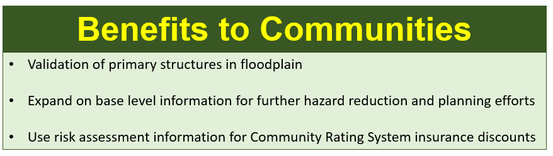

*Methodology:* The statewide building-level risk assessment will be updated with building characteristics (building value, occupancy class, area, stories, etc.) from a new data pull of the statewide tax assessment database that occurs once per year. The Center will use change detection along with remote sensing (aerial imagery, building footprints) and tax assessment records (compare with previous year) methods to identify new or removed structures from the floodplain. With new input data, revise the flood loss estimates using FEMA’s Flood Assessment Structure Tool (FAST). The Center will update and publish various risk assessment products for community engagement. Refer to the [BLRA Cycle](https://data.wvgis.wvu.edu/pub/RA/_engage/_IndexDocs/BLRA_cycle/) documents for more information.

* [BLRA Cycle Diagram](https://data.wvgis.wvu.edu/pub/RA/_engage/_IndexDocs/BLRA_cycle/WV_BLRA_cycle_20220114.pdf) of WV Building-Level Flood Risk Assessment procedures

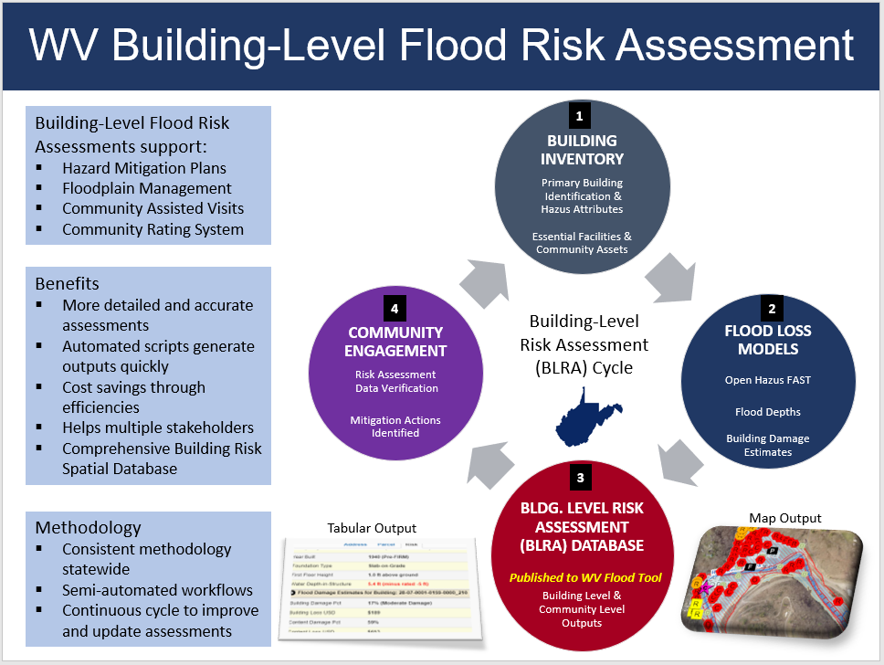

The processing/validation procedures of the WV Building Level Risk Assessment (BLRA) are more accurate and comprehensive than a typical Hazus Level 2 analysis (it is a step up and should be called a Hazus Level 3). The enhanced processing and verification steps include:

* Visual aerial photography checks of every primary structure using the highest temporal and spatial resolution imagery.
* Building attribute checks by detailed tax assessment records. Customized online tax assessment web reports provide a per structure breakdown including multiple buildings (one-to-many relationship) in a single parcel. Building sketch diagrams are available for residential properties to distinguish characteristics of multiple building in a single parcel.
* Building land use codes from the tax assessment database are converted to Hazus specific/generalized [occupancy classes](https://data.wvgis.wvu.edu/pub/RA/_resources/FRA/Occupancy_Class_Types_Reference.xlsx) including manufactured homes (RES2 occupancy class).
* The Building Year combined with the Initial FIRM Date determines the Pre/Post-FIRM status of each structure. (If the SFHA was not present when the structure was constructed, then a “Post-FIRM regulated to Pre-FIRM status” is tracked in the BLRA database).
* User-modified values for all Hazus input variables (Value, Occupancy Class, FFH, Area, Stories) can be entered to override building attributes compiled from tax assessment records.
* Each structure is assigned a unique [Building Identifier](https://data.wvgis.wvu.edu/pub/RA/_resources/FRA/FRA_Building_Identification.pdf) (Parcel ID + Address) to relate structures to other risk assessment and mitigation databases. In the WV Flood Tool, the user can zoom to the structure by entering the building identifier in the Search function.

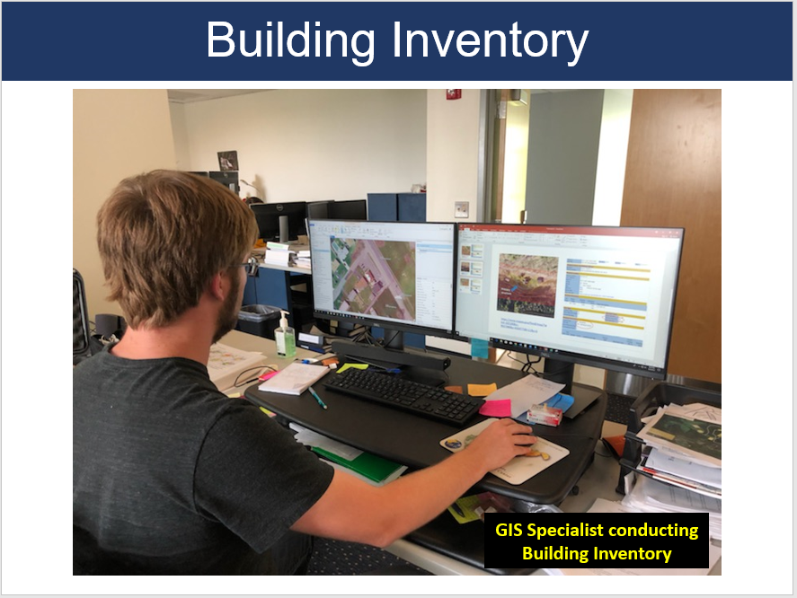

**WV Building Level Risk Assessment (BLRA) Data Sources:**

* [Statewide BLRA Geodatabase](https://data.wvgis.wvu.edu/pub/RA/State/BL/BLRA/WV/GIS/) (98,467 building points)
* [BLRA County Files](https://data.wvgis.wvu.edu/pub/RA/State/BL/BLRA/) organized by WV Planning & Development Regions
* [BLRA Data Extract Tables](https://data.wvgis.wvu.edu/pub/RA/State/BL/Extract/):  High Building Value, High Damage Loss, High Minus Ratings
* [BLRA Statewide Top Lists](https://data.wvgis.wvu.edu/pub/RA/State/BL/Top-List/Top100/):  Building Value, Flood Depth, Damage Loss $, Damage Loss %, Minus Rated, Mitigated Structures

*Refer to the* [*Index Guide*](https://data.wvgis.wvu.edu/pub/RA/_engage/_IndexDocs/) *spreadsheet named “RA_Info_Index.xlsx” to access various risk assessment products (products, reports, tables, graphics) published in support of FEMA’s Hazard Mitigation Plans and NFIP/CRS activities.*

Example building level risk assessment table with map links to WV Flood Tool

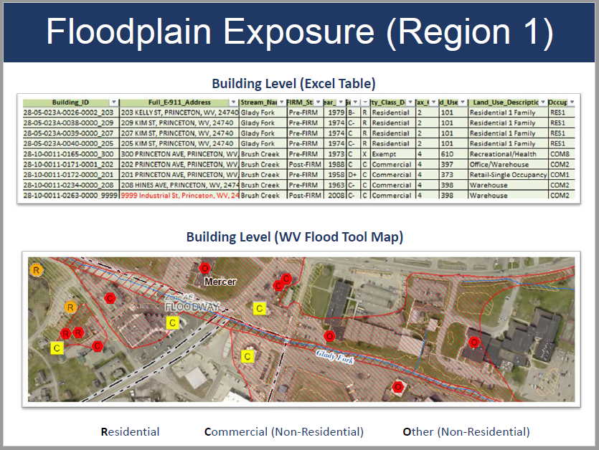

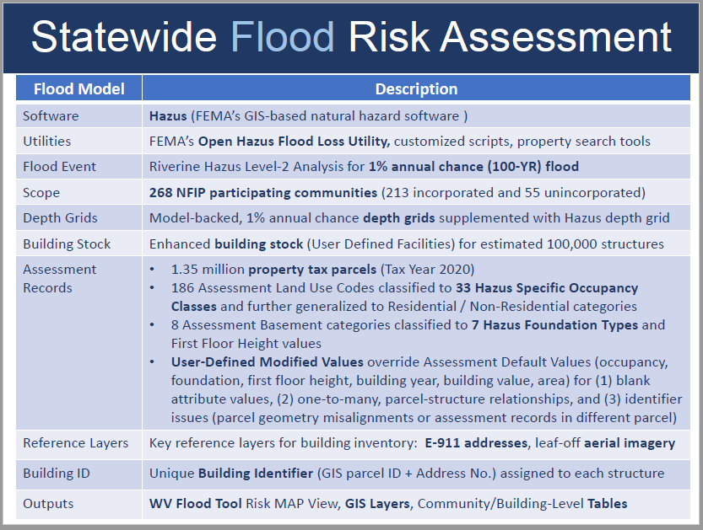

What is the project footprint and correlation with new Flood Studies availability?

* The project footprint is most of the counties in the State. New floodplains and depth grids are the result of active [FEMA flood studies](https://data.wvgis.wvu.edu/pub/RA/_resources/status/WV_FloodStudies.pdf) (17 counties) and [Updated Zone AE Redelineated Floodplains](https://data.wvgis.wvu.edu/pub/RA/_resources/Status/Updated_Zone_AE_Status.pdf) (38 counties) using the new [FEMA-purchased 1-meter elevation data](https://www.mapwv.gov/elevation) ([metadata](https://www.mapwv.gov/lidar-metadata)) that is now available statewide. As part of the current CTP 2020-21 activity, the WV GIS Technical Center is creating new Updated AE’s because of the final delivery of the QL2 LiDAR elevation data in fall 2021.
* Floodplain and depth grids from **FEMA restudies** take priority over **Updated AE Redelineation mapping** for enhancing the Building Level Risk Assessment (BLRA). Redelineated Updated AE floodplains and depth grids are being generated using the new LiDAR 1-meter that was delivered in fall 2020 and covers 38 counties. A major goal is for all flood risk products to be created from the newest topographic 1-meter grids.