**Open Space Preservation in Mount Hope, Fayette County, WV**

**Goals and Objectives**

The main goal of the open space preservation (OSP) activities of Community Rating System (CRS) is to reduce flood damages in areas that are prone to inundation by keeping them free of development including buildings and infrastructure. Consequently, the lands located in those areas will continue or resume their natural functions for flood and erosion control while protecting the biological resources.

Benefiting from the OSP activities, communities can collect credit points that are applicable to the National Flood Insurance Program (NFIP). Those activities have some of the highest maximum possible points. Every 500 credit points can change a class in the NFIP that will reward the community with a discount equal to 5% of flood insurance premium rates.

**Definitions and Conditions**

Open space is defined as a vacant land without any building, infrastructure, significant pavement, filling or any other elements affecting flood flows. To be qualified as a “preserved” open space, there must be a signed statement by a public or creditable private owner or some regulations on the parcel preventing from construction, fillings, or other encroachments on flood flows in the future.

The OSP credits can be given for the preserved open spaces located in the community’s regulatory floodplains including the SFHA as shown on the community’s Flood Insurance Rate Map (FIRM) or another floodplain with similar development regulations. In West Virginia, it can be considered just the same as Special Flood Hazard Area (SFHA) because there is no other regulatory floodplain. The impact adjusted SFHA must be used in the base maps and area calculations that means the exclusion of large waterbodies (larger than 10 acres) in addition to federal lands from the SFHA area.

**Study Area**

We worked on Mount Hope in Fayette County as a pilot study for investigating the achievable credit points for some of the OSP activities in West Virginia. The vast area of buyout by the county or the city as a part of the Dunloup Creek Voluntary Floodplain Buyout Program has made that community a proper study area.

**Base Map Preparation**

In this study, we used the data of Natural Resources Conservation Service (NRCS) to identify the buyout parcels with floodplain easements in the community (75 parcels). Then, 23 other parcels owned by the county or city were added as “unverified” parcels by observations on the WV Flood Tool. The above parcels were mapped along with the updated regulatory floodplains (SFHA).

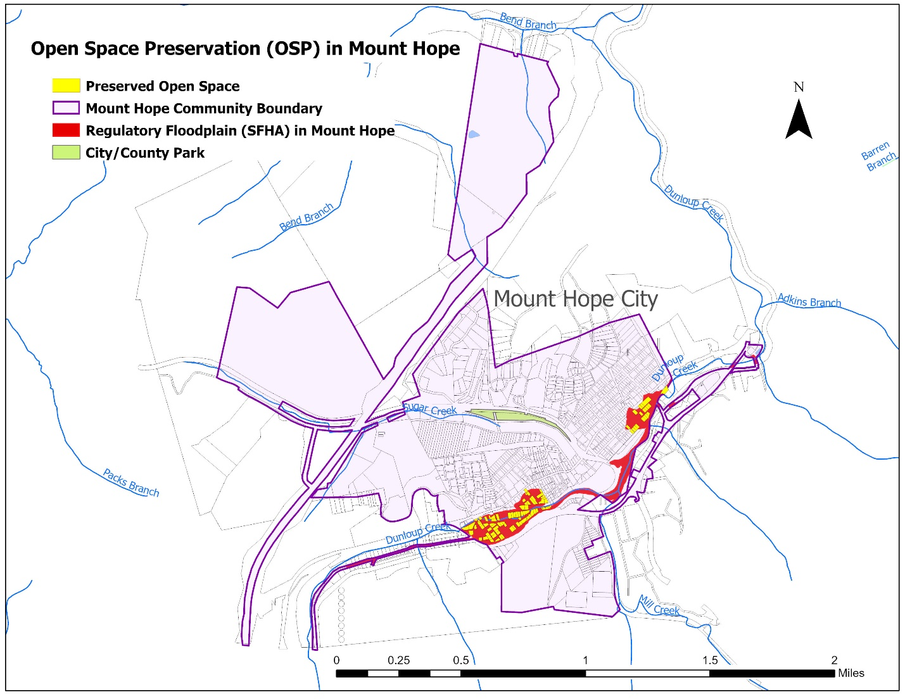

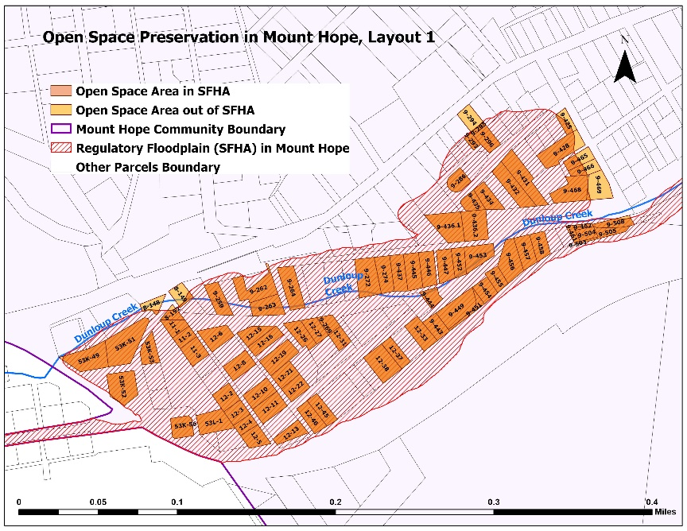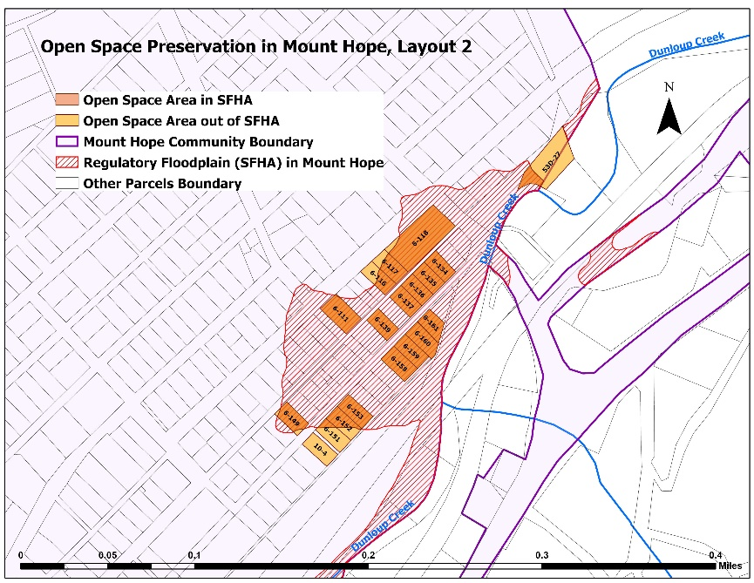

The prepared base maps for Mount Hope

**Assumptions**

The study considered the described parcels as the preserved open spaces in Mount Hope. It means that those lands were assumed not to be subject to any construction or encroachments on flood flows. In addition, all of the above parcels were assumed to be attached with relevant legal documents (deeds) indicating restrictions of sale and development in the future.

As there was no large waterbody or federal land in Mount Hope, the area of impact adjusted regulated floodplains (mSFHA) could be considered the same as the special flood hazard area (aSFHA).

Coordinate systems of the GIS environments can have effects on the dimensions and areas on maps. For this study, the projected coordinate system of NAD 1983, UTM Zone 17N was applied in the GIS files to calculate the areas in a more accurate way.

**Calculated Activity Elements**

Two types of activities were used in the credit calculations of Mount Hope. The first group (in CRS-400) included Open Space Preservation (OSP), Deed Restrictions (DR), Natural Functions Open Space (NFOS), and Freeboard (FRB). These activities were based on the special flood hazard area (aSFHA). The GIS measurements indicated 40.55 acres of lands as the total area of regulatory flood zones (aSFHA) in Mount Hope.

***Open Space Preservation (OSP)***

The maximum achievable credit for this element is 1,450 points for keeping flood-prone lands vacant. OSP credit (cOSP) is adjusted by the ratio of preserved open space area located in the regulatory floodplain (aOSP) to the area of the SFHA (aSFHA).

The area of open spaces owned by the county or city of Mount Hope located in the regulatory floodplains (aOSP) was measured as 10.72 acres. According to the following calculations, the OSP credit for Mount Hope was equal to 383.

$$aOSP=10.72 acres$$

$$aSFHA=40.55 acres$$

$$rOSP=\frac{aOSP}{aSFHA}=\frac{10.72}{40.55}=0.264$$

$$cOSP=rOSP×1450=0.264×1450=383$$

*\* Reference: CRS Coordinator's Manual 2017, 422.a, page 420-3*

***Deed Restrictions (DR)***

This element, with the maximum points of 50, can provide communities with extra credit for assuring that the parcels in the regulatory floodplain will always remain open spaces. This element only applies to the areas qualified for OSP, as a prerequisite.

There must be a deed with the explicit language indicating the following restrictions:

(a) No new buildings may be allowed on the property;

(b) The restriction runs with the land; and

(c) The restriction cannot be changed by a future owner; rather, it can only be amended by a court for just cause.

DR credit (cDR) is calculated based on the ratio of preserved open space areas with deed restrictions (aDR) to the area of the SFHA (aSFHA). Assuming that all of the OSP areas in Mount Hope can be attached with proper deeds, the DR credit was equal to 13.

$$aDR=10.72 acres$$

$$aSFHA=40.55 acres$$

$$rDR=\frac{aDR}{aSFHA}=\frac{10.72}{40.55}=0.264$$

$$cDR=rDR×50=0.264 ×50=13$$

*\* Reference: CRS Coordinator's Manual 2017, 422.b, page 420-12*

***Natural Functions Open Space (NFOS)***

If the natural functions of the qualified preserved open spaces (OSP) are preserved, communities can be rewarded with up to maximum 350 points. The logic is that natural open spaces can play an important role in flood controlling with lower costs compared to man-made systems. The credit for Natural Functions Open Space (cNFOS) is adjusted based on the ratio of preserved open space areas qualifying for each of the following sub-elements to the area of the SFHA.

NFOS1: 190 points (Max.), for having parcels that qualify as OSP in or restored to their undeveloped natural state

NFOS2: 50 points (Max.), for having parcels that qualify as NFOS1 designated in a natural floodplain functions protection plan

NFOS3: 50 points (Max.), for having parcels that qualify as NFOS1 designated as critical habitat for threatened or endangered species

NFOS4: 60 points (Max.), for having parcels that qualify as NFOS1 also in a designated open space corridor

According to the study, 77 credit points could be achieved as the total cNFOS in Mount Hope. (NFOS4 did not apply to the study area).

$$aNFOS1=10.72 acres$$

$$aNFOS2=10.72 acres$$

$$aNFOS3=10.69 acres$$

$$aSFHA=40.55 acres$$

$$rNFOS1=\frac{aNFOS1}{aSFHA}=\frac{10.72}{40.55}=0.264$$

$$rNFOS2=\frac{aNFOS2}{aSFHA}=\frac{10.72}{40.55}=0.264$$

$$rNFOS3=\frac{aNFOS3}{aSFHA}=\frac{10.69}{40.55}=0.264$$

$$cNFOS_1=rNFOS1×190= 0.264 ×190=50.16$$

$$cNFOS_2=rNFOS2×50= 0.264 ×50=13.2$$

$$cNFOS_3=rNFOS3×50= 0.264 ×50=13.2$$

$$cNFOS=cNFOS1+cNFOS2+cNFOS3=50.16+13.2+13.2≅77$$

*\* Reference: CRS Coordinator's Manual 2017, 422.c, page 420-14*

***Freeboard (FRB)***

According to the NFIP, the lowest floor of residential buildings must be elevated to or above the base flood elevation (BFE). Non-residential buildings can also be floodproofed to the same level, as an alternative. A freeboard requirement assures the above conditions by considering an extra height margin over the BFE to protect structures from waves, debris, miscalculations, changing weather patterns, or lack of data.

Assuming a 2-foot freeboard in Mount Hope, the maximum credit points could be 225. It was adjusted based on the area where the freeboard could be effective (aFRB) to the area of the SFHA. As mentioned in the CRS manual, the areas previously calculated in the open space preservation credit (cOSP) must be excluded from the freeboard area. As shown in the calculations, the credit of freeboard (cFRB) in Mount Hope was equal to 166 points.

$$aSFHA=40.55 acres$$

$$aOSP=10.72 acres$$

$$aFRB=aSFHA-aOSP=40.55-10.72=29.83 acres$$

$$rFRB=\frac{aFRB}{aSFHA}=\frac{29.83}{40.55}=0.736$$

$$cFRB=rFRB×225=0.736×225=166$$

*\* Reference: CRS Coordinator's Manual 2017, 432.b, page 430-11*

***Acquisition and Relocation***

The other type of activity applied to the study area was Acquisition and Relocation (CRS-c520) that dealt with the number of buildings in the community's special flood hazard area (bSF). The credit of this element depends on the number of primary buildings in the regulatory floodplain acquired or relocated since the effective date of the Flood Insurance Rate Map (FIRM).

Two options of calculation can be applied to this element. The first option is easier to apply but has the limitation of 190 points as the maximum. It can be more useful in large communities or a community with a small percentage of relocated buildings in floodplains. The second option, with the maximum points of 2,250, can be a better alternative in communities that have cleared a large percentage of the structures.

We applied both options to the study area to compare the results. In order to identify the number of the relocated buildings in floodplains of Mount Hope, the history of the parcels was investigated on WV Real Estate Assessment Data. Based on the observations, a list of the demolished primary structures in the flood zones was prepared. Consequently, 57 buildings were identified as acquired or relocated (bAR).

Option 1, calculated as below, could provide 171 points for the community.

$$bAR=57$$

$$c520_1=bAR×3=57×3=171$$

The first step of option 2 was based on the ratio of the demolished buildings (bAR) to all the buildings located in the regulatory floodplains before the acquisition and relocation. After adjusting the maximum points (1900) with this ratio, 1116 points could be achieved for this step.

Step1:

$$bAR=57$$

$$bSF=40$$

$$c520_2.1=1900×\frac{bAR}{bSF+bAR}=1900×\frac{57}{40+57}=1116$$

As the above ratio was larger than 30%, the second step of option 2 could be applied to add to the collected points. As the result, 144 bonus points were calculated according to the following formula. The total acquisition and relocation credit for Mount Hope applying option 2 was equal to 1260 points that was much higher compared to the result of the first option.

Step2:

$$rAR=\frac{bAR}{bSF+bAR}=\frac{57}{40+57}=0.59>0.3$$

$$bARSF=57$$

$$c520_2.2=\left(\frac{\left(bARSF×100\right)}{bSF+bARSF}-30\right)×5=\left(\frac{\left(57×100\right)}{40+57}-30\right)×5=144$$

$$c520_2=c520_2.1+c520_2.2=1116+144=1260$$

*\* Reference: CRS Coordinator's Manual 2017, 523.b, page 520-8*

**Conclusion**

Of the total community area of 995.5 acres, regulatory floodplains cover an area of 40.6 acres (4%) in Mount Hope. Ninety seven parcels owned by the county or city, as the result of the Dunloup Creek Voluntary Floodplain Buyout Program, that intersected the floodplains were investigated in this study. The area of preserved open spaces located in the regulated flood zones of the community provided by those parcels is equal to 10.7 acres. With the assumptions mentioned in the process, the total credit of the applied elements of CRS open space preservation in Mount Hope equals to 1899 points. It can be translated to three classes of enhancement in NFPI and, consequently, a discount equal to 15% of flood insurance premium rates. The credit may be increased by application of some other elements described in the CRS manual. The study showed that the activities under open space preservation can provide the communities in West Virginia with more flood resilience while potential benefits of discounts in the National Flood Insurance Program.

**Reference**

Federal Emergency Management Agency (FEMA). (2017). *National flood insurance program community rating system: Coordinator’s manual.*