February 7, 2024

To: FEMA Online LOMC Technical Evaluation Team   
ATTN: Matthew Van Wie

Technical Manager

LBYD Federal, LLC

Direct (703) 997-3152

mvanwie@lbyd.com

Dear Matthew and Online LOMC Team:

I am assisting the Mineral County Floodplain Manager, Philip G. Shepp, in submitting a single structure LiDAR LOMA for property owner name James Parsons who resides at 3964 Patterson Creek Village Pike, Ridgeley, WV, 26753, [Tax Map 15, Parcel 14](https://www.mapwv.gov/flood/map/?wkid=102100&x=-8764157&y=4802624&l=13&v=1), owner James R. Parsons, Deed Book 179, Pages 628-629.

**Parcel ID 29-04-0015-0014-0000**

County: 29 - Mineral

District: 4 - Frankfort District

Map: 0015

Parcel No.: 0014

Parcel Suffix: 0000

[Map Link](https://www.mapwv.gov/flood/map/?wkid=102100&x=-8764177&y=4802647&l=13&v=1) on WV Flood Tool. Expert View with FEMA LOMAs, Verified LOMAs, BFEs, and Parcels.

(1) **LOMA Application for Parcel 14, Tax Map 15 and Valid LOMA 12-03-1803A.**  Please note that the approximate coordinates (39.463, -78,730; only 3 significant coordinate digits) for FEMA LOMA [12-03-1803A](https://map1.msc.fema.gov/data/54/L/12-03-1803A-540129.pdf?LOC=5b3a57fd5ea7e8a4634dc59d10d9ef43) maps incorrectly to Mr. Parsons’ Parcel 14 when the LOMA point should instead display in Parcel 12. Unfortunately, the floodplain manager printed LOMA [12-03-1803A](https://map1.msc.fema.gov/data/54/L/12-03-1803A-540129.pdf?LOC=5b3a57fd5ea7e8a4634dc59d10d9ef43) and instructed Mr. Parsons to submit this LOMA to his lender; instead, Mr. Parsons needs a separate LOMA for the structure of Parcel 14 where he resides.

As stated previously, the FEMA LOMA displayed on the WV Flood Tool or NFHL View is not displayed accurately on the map because the approximate latitude/longitude (39.463, -78,730) of the property is only three significant coordinate digits) and thus does not pinpoint to the correct parcel. Because many of the FEMA LOMA prior to 2017 are approximate locations, the floodplain manager in this case should have used the Verified LOMAs on the WV Flood Tool, which provides more accurate geospatial locations of FEMA LOMAs. Or the floodplain manager should have verified the FEMA LOMA’s location based on other property identifiers such as the Deed Book / Page Number or the Tax Map Parcel Identifier.

Accurate coordinates for FEMA LOMA [12-03-1803A](https://map1.msc.fema.gov/data/54/L/12-03-1803A-540129.pdf?LOC=5b3a57fd5ea7e8a4634dc59d10d9ef43) places the LOMA on Tax Map 15, Parcel 12.

We know this to be the case because we can match this FEMA LOMA dated 15 January 2013 by three property identifiers:

* Deed Book 346, Page Number 364
* Tax Map 15, Tax Parcel 12
* Assessor address match (old E-911 address):  3226 PATTERSON CREEK VILLAGE PIKE

Like Parcel 12 and LOMA 12-03-1803A, the structure in Parcel 14 should qualify for a LOMA as well. Using the QL2 LiDAR-derived contours, the Closest Lower Contour (CLC) for Parcel 29-04-0015-0014-0000 is 580 ft. The CLC 580 ft. - 1 ft. = 579 ft. Lowest Adjacent Grade (LAG.) Therefore, the LAG 579 ft. > BFE 576 ft. and the determination should be “removal” from the SFHA.

(2) **Verified LOMA Geographic Locations.**  In 2021, as part of a Cooperating Technical Partners (CTP) grant, the WV GIS Technical Center mapped all the FEMA’s LOMA points to the correct parcel location using Deed Book/Page information, Parcel Identifiers, Assessor/E-911 Addresses, and other spatial identifiers.  West Virginia has excellent tax assessment data on the WV Flood Tool that allows us to verify the FEMA LOMA is assigned to the correct parcel. In 2021, we verified and corrected a majority of the FEMA LOMAs (53%) to the correct parcel. See statewide [Verified LOMA Status](https://data.wvgis.wvu.edu/pub/RA/_resources/Status/LOMAs_Verified.pdf) graphic.

***Request to FEMA LOMA Division for Consideration:*** It would be beneficial if FEMA would update their coordinates for LOMAs published prior to 2017 with West Virginia’s verified coordinate information that pinpoints the LOMA to the correct parcel. In addition, when new FEMA flood studies are conducted and LOMAs revalidated, this is another opportunity for FEMA to update the LOMA coordinates.

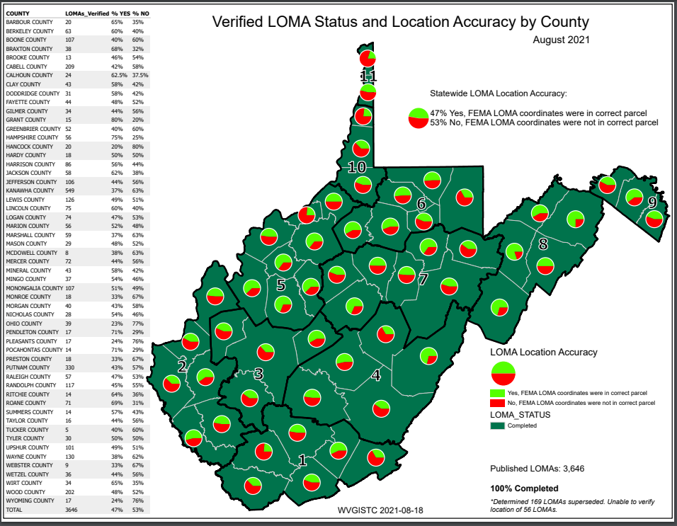**Figure 1. Verified LOMA Coordinates.** In 2021, all FEMA LOMAs in West Virginia were pinpointed to the correct parcel and the verified locations of FEMA LOMAs are published on the WV Flood Tool.

**Figure 2.** **Verified LOMAs pinpointed to correct parcel on WV Flood Tool.** FEMA LOMA [12-03-1803A](https://map1.msc.fema.gov/data/54/L/12-03-1803A-540129.pdf?LOC=5b3a57fd5ea7e8a4634dc59d10d9ef43) VERIFIED coordinates and assigned to the correct parcel on WV Flood Tool.  Use the VERIFIED LOMAs (LOMAs published prior to 2017) for correct geographic location.

Expert View of WV Flood Tool (Patterson Creek Village Pike, Mineral County, WV)

<https://www.mapwv.gov/flood/map/?wkid=102100&x=-8764177&y=4802647&l=13&v=1>

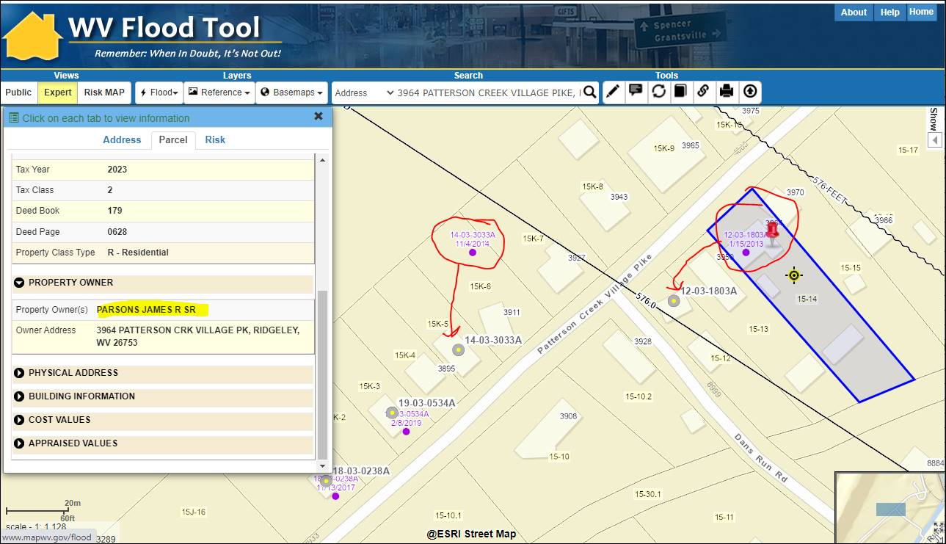

For example, the FEMA LOMA  [12-03-1803A](https://map1.msc.fema.gov/data/54/L/12-03-1803A-540129.pdf?LOC=5b3a57fd5ea7e8a4634dc59d10d9ef43) (purple dot) approximates the LOMA location to the parcel at 3964 PATTERSON CREEK VILLAGE PIKE, Ridgeley, WV, 26753. The correct physical location for this “removal” Verified LOMA (gray circle with yellow dot) is for the parcel with the structure at 3942 PATTERSON CREEK VILLAGE PIKE, Ridgeley, WV, 26753.  We know this to be the case because we can match this FEMA LOMA dated 15 January 2013 by three spatial identifiers:

•         Deed Book 346, Page Number 364

•         Tax Map 15, Tax Parcel 12

•         Old Tax Assessor’s address (old E-911 address):  3226 PATTERSON CREEK VILLAGE PIKE

**Figure 3. LOMA Coordinate and Address Inaccuracies.** Example FEMA LOMA [12-03-1803A](https://map1.msc.fema.gov/data/54/L/12-03-1803A-540129.pdf?LOC=5b3a57fd5ea7e8a4634dc59d10d9ef43) where geographic location is verified with property identifiers and updated with more accurate coordinates on the WV Flood Tool.

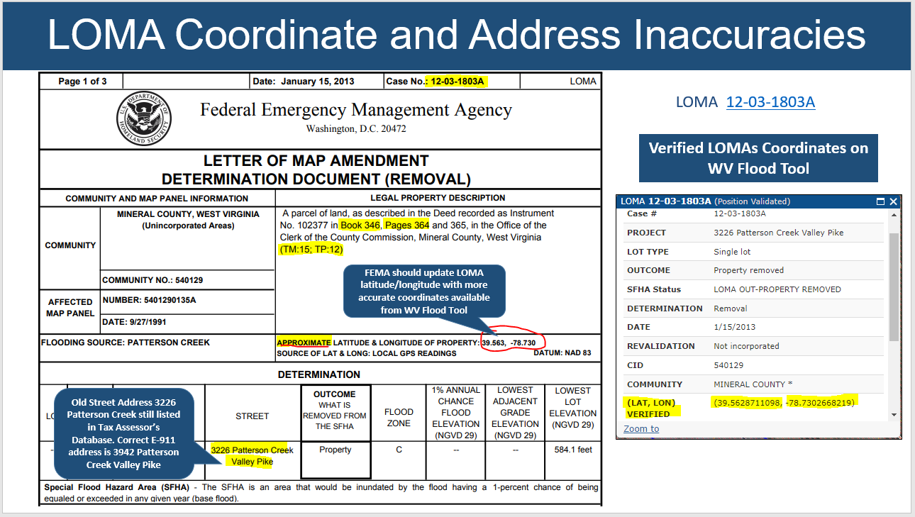

**Figure 4. Tax Assessment and E-911 Record for LOMA** [12-03-1803A](https://map1.msc.fema.gov/data/54/L/12-03-1803A-540129.pdf?LOC=5b3a57fd5ea7e8a4634dc59d10d9ef43).

Tax Assessment Record for Map 15, Parcel 12, pinpoints geographic location for LOMA [12-03-1803A](https://map1.msc.fema.gov/data/54/L/12-03-1803A-540129.pdf?LOC=5b3a57fd5ea7e8a4634dc59d10d9ef43)

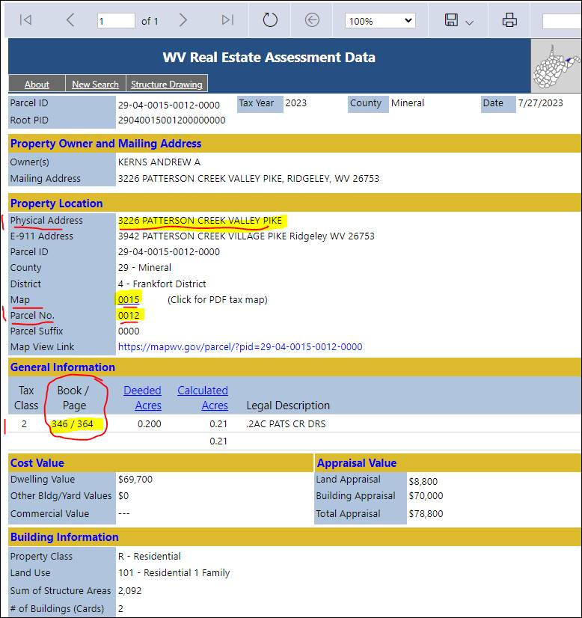[https://mapwv.gov/assessment//Detail/?PID=29040015001200000000](https://mapwv.gov/assessment/Detail/?PID=29040015001200000000)

Accurate coordinates for FEMA LOMA [12-03-1803A](https://map1.msc.fema.gov/data/54/L/12-03-1803A-540129.pdf?LOC=5b3a57fd5ea7e8a4634dc59d10d9ef43) places the LOMA on Tax Map 15, Parcel 12.

We know this to be the case because we can match this FEMA LOMA dated 15 January 2013 by three property identifiers from statewide Tax Assessment and E-911 databases:

* Deed Book 346, Page Number 364
* Tax Map 15, Tax Parcel 12
* Assessor address match (old E-911 address):  3226 PATTERSON CREEK VILLAGE PIKE

Please contact us if you have any questions.

Sincerely,

Kurt Donaldson, GISP, CFM

Manager

WV GIS Technical Center

West Virginia University

330 Brooks Hall, 98 Beechurst Avenue

PO Box 6300

Morgantown, WV  26506

(304) 293-9467

[http://wvgis.wvu.edu](http://wvgis.wvu.edu/)