Mapping of Metes and Bounds Area for LOMA [07-03-1267A](https://urldefense.com/v3/__https:/map1.msc.fema.gov/data/54/L/07-03-1267A-540139.pdf?LOC=5adf1d909e148ae16d8531391e68ccfd__;!!Dk1J5THn31mq9g!VtubwiU9bZq5uBL_kIk-MEM6XuRIqrB4o08skUJlv1TYbOiT6_s05P1bNhrd9s9cJYIabgYwgTs4Q9S3ctK5qiiwkcem$)

* Prepared by Kurt Donaldson, West Virginia University, 7/7/2023
* [WV Flood Tool](https://urldefense.com/v3/__https:/www.mapwv.gov/flood/map/?wkid=102100&x=-8899980&y=4817820&l=13&v=1__;!!Dk1J5THn31mq9g!VtubwiU9bZq5uBL_kIk-MEM6XuRIqrB4o08skUJlv1TYbOiT6_s05P1bNhrd9s9cJYIabgYwgTs4Q9S3ctK5qjfu82Hn$) location for Quadrilla/Tremont Street properties, Morgantown, WV (North Hills Subdivision)

**Findings:**

* Previous owner names and deed book/page numbers were used to reference the [2007 Plat Map](https://data.wvgis.wvu.edu/pub/RA/_resources/LOMA/LOMA07-03-1267A/LOMA%2007-03-1267A_2007_NorthHills_Plat.pdf) of the North Hills subdivision which correlates to the legal description for LOMA [07-03-1267A](https://urldefense.com/v3/__https:/map1.msc.fema.gov/data/54/L/07-03-1267A-540139.pdf?LOC=5adf1d909e148ae16d8531391e68ccfd__;!!Dk1J5THn31mq9g!VtubwiU9bZq5uBL_kIk-MEM6XuRIqrB4o08skUJlv1TYbOiT6_s05P1bNhrd9s9cJYIabgYwgTs4Q9S3ctK5qiiwkcem$). Since the plat map was created before all the structures on Quadrilla and Tremont Streets were built, the property parcels were later modified for tax assessment purposes as new homes were built.
* The LOMA has 12 building structures in its legal description. The LOMA boundary consists of a minimum total of 31 units that are primarily residential 2 or 3 unit townhouses or apartments.
* The utility pole that is the southeast corner plat marker, located on Tremont Avenue in front of 875 Tremont Avenue and 338 feet from Riddle Avenue, is viewable in [Google Street View](https://goo.gl/maps/e5MnsnfLS7LHG1ND6).
* The length of the LOMA parcel along Quadrilla Street is about 915 feet.
* Nearby single structure LOMAs on the southwest side of flood source West Run exist for [17-03-1206A](https://msc.fema.gov/portal/downloadProduct?productID=17-03-1206A-540139) (891 Tremont St.) and [17-03-0127A](https://msc.fema.gov/portal/downloadProduct?productID=17-03-0127A-540139) (899 Tremont St.) along the front site of Tremont Street and bask site of Quadrilla Street.

**Structures within LOMA** [**07-03-1267A**](https://urldefense.com/v3/__https:/map1.msc.fema.gov/data/54/L/07-03-1267A-540139.pdf?LOC=5adf1d909e148ae16d8531391e68ccfd__;!!Dk1J5THn31mq9g!VtubwiU9bZq5uBL_kIk-MEM6XuRIqrB4o08skUJlv1TYbOiT6_s05P1bNhrd9s9cJYIabgYwgTs4Q9S3ctK5qiiwkcem$)**:**

* By Street and Parcel:
* Northeast side of Quadrilla Street: From 865 Quadrilla Street (Parcel 4J-172.2) to 875 Quadrilla Street (Parcel 4J-126.58)
* Southwest side of 862 Quadrilla Street: From 822 Quadrilla Street (Parcel 4J-140.6) to 860 Quadrilla Street (Parcel 4J-172.3)
* Northeast side of Tremont Street: From 865 Tremont Street (Parcel 4J-127.21) to 875 Tremont Street (Parcel 4J-126.59).
* By E-911 Addresses (may be additional subunits not included):

1. 822-824-826 Quadrilla St.
2. 828-830-832 Quadrilla St.
3. 834-836-838 Quadrilla St.
4. 840-842-844 Quadrilla St.
5. 846-848-850 Quadrilla St.
6. 852-854-856 Quadrilla St.
7. 858-860-862 Quadrilla St.
8. 865-867 Quadrilla St.
9. 873-875 Quadrilla St.
10. 865-867 Tremont Street
11. 869-871 Tremont Street
12. 873-875 Tremont Street

**Figure 1.** [2007 North Hills Subdivision Plat Map](https://data.wvgis.wvu.edu/pub/RA/_resources/LOMA/LOMA07-03-1267A/LOMA%2007-03-1267A_2007_NorthHills_Plat.pdf) for LOMA [07-03-1267A](https://urldefense.com/v3/__https:/map1.msc.fema.gov/data/54/L/07-03-1267A-540139.pdf?LOC=5adf1d909e148ae16d8531391e68ccfd__;!!Dk1J5THn31mq9g!VtubwiU9bZq5uBL_kIk-MEM6XuRIqrB4o08skUJlv1TYbOiT6_s05P1bNhrd9s9cJYIabgYwgTs4Q9S3ctK5qiiwkcem$)

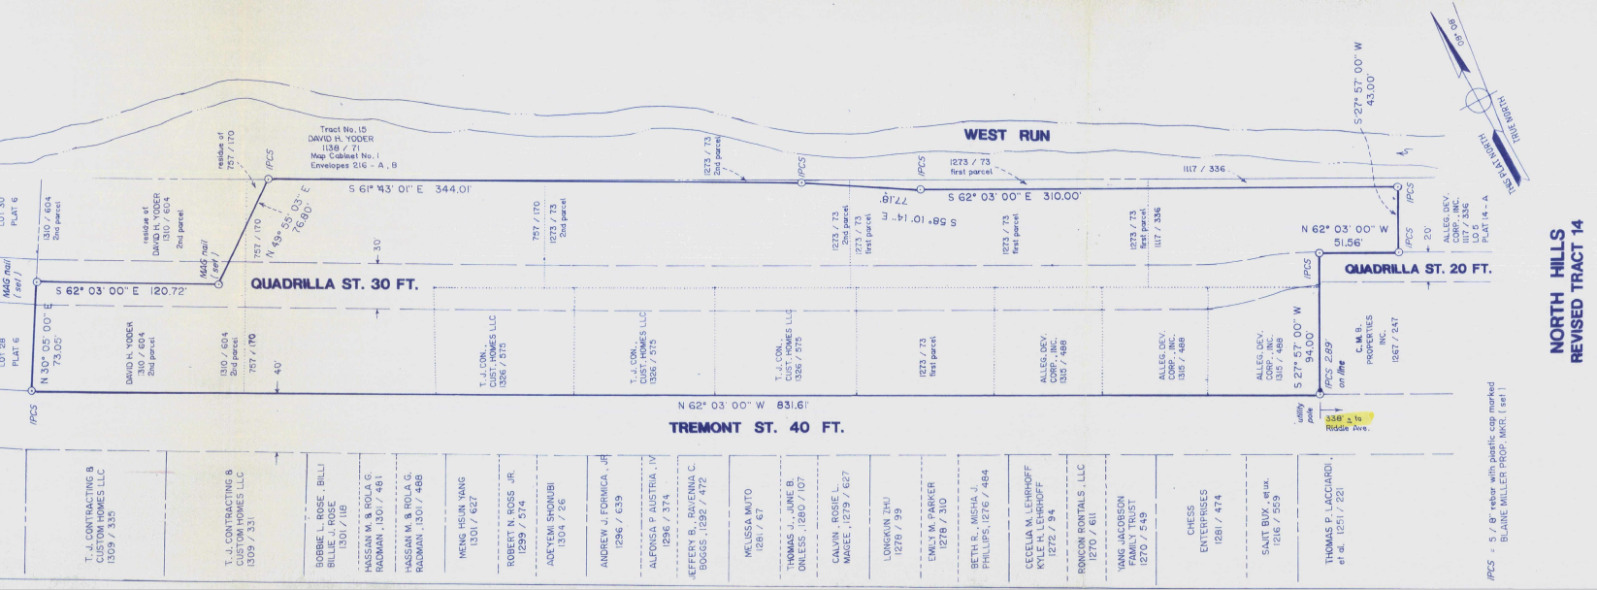

**Figure 2.** Map extent (green dashes) drawn on [WV Flood Tool](https://urldefense.com/v3/__https:/www.mapwv.gov/flood/map/?wkid=102100&x=-8899980&y=4817820&l=13&v=1__;!!Dk1J5THn31mq9g!VtubwiU9bZq5uBL_kIk-MEM6XuRIqrB4o08skUJlv1TYbOiT6_s05P1bNhrd9s9cJYIabgYwgTs4Q9S3ctK5qjfu82Hn$) of metes and bounds area shown on 2007 Plat Map for LOMA [07-03-1267A](https://urldefense.com/v3/__https:/map1.msc.fema.gov/data/54/L/07-03-1267A-540139.pdf?LOC=5adf1d909e148ae16d8531391e68ccfd__;!!Dk1J5THn31mq9g!VtubwiU9bZq5uBL_kIk-MEM6XuRIqrB4o08skUJlv1TYbOiT6_s05P1bNhrd9s9cJYIabgYwgTs4Q9S3ctK5qiiwkcem$). Magenta X’s show locations of two single structure LOMA applications for Case Numbers 23-03-0795A and 23-03-0796A (Quadrilla Street, Monongalia County, WV)

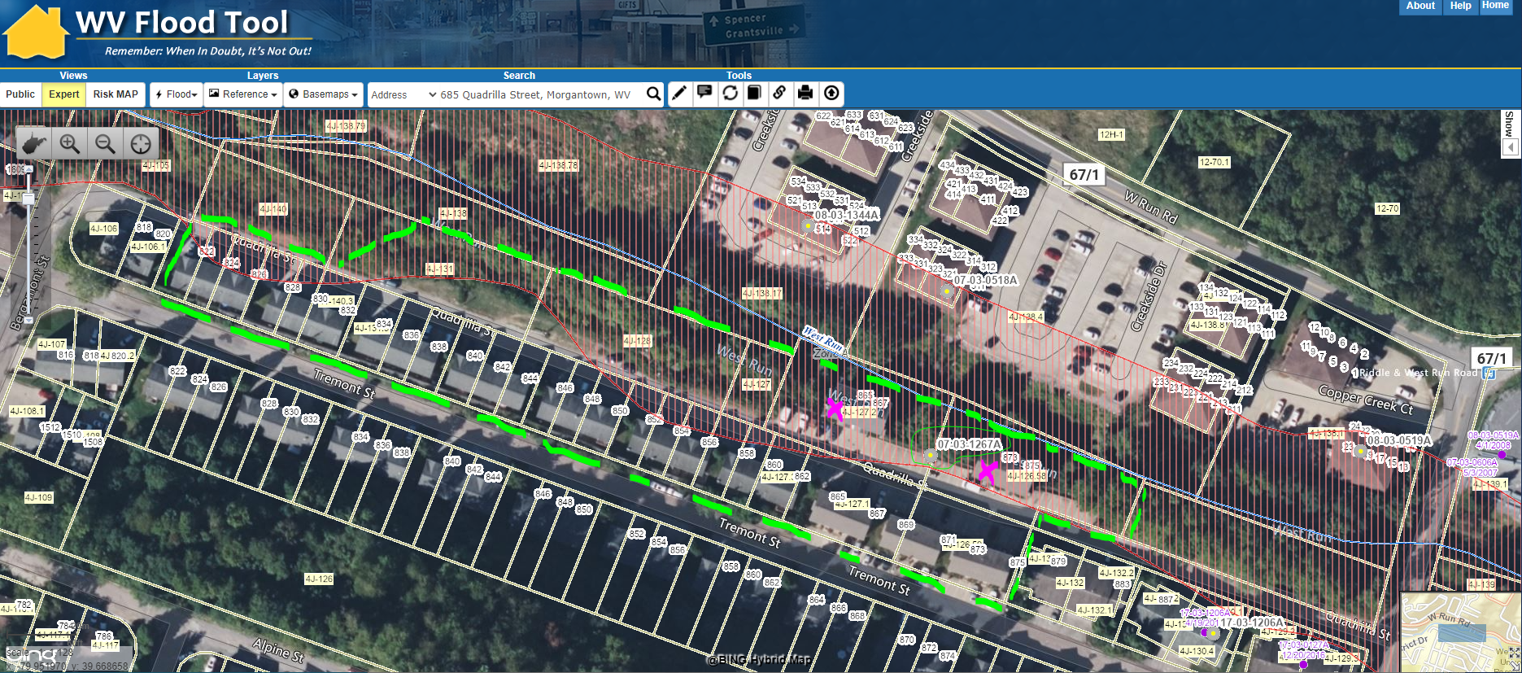

**Figure 3.** Map extent (green dashes) drawn on [Google View](https://www.google.com/maps/@39.6667729,-79.9499366,101a,35y,10.91h,45.01t/data=!3m1!1e3?entry=ttu) of metes and bounds area shown on 2007 Plat Map for LOMA [07-03-1267A](https://urldefense.com/v3/__https:/map1.msc.fema.gov/data/54/L/07-03-1267A-540139.pdf?LOC=5adf1d909e148ae16d8531391e68ccfd__;!!Dk1J5THn31mq9g!VtubwiU9bZq5uBL_kIk-MEM6XuRIqrB4o08skUJlv1TYbOiT6_s05P1bNhrd9s9cJYIabgYwgTs4Q9S3ctK5qiiwkcem$). Magenta X’s show locations of two single structure LOMA applications for Case Numbers 23-03-0795A and 23-03-0796A (Quadrilla Street, Monongalia County, WV)

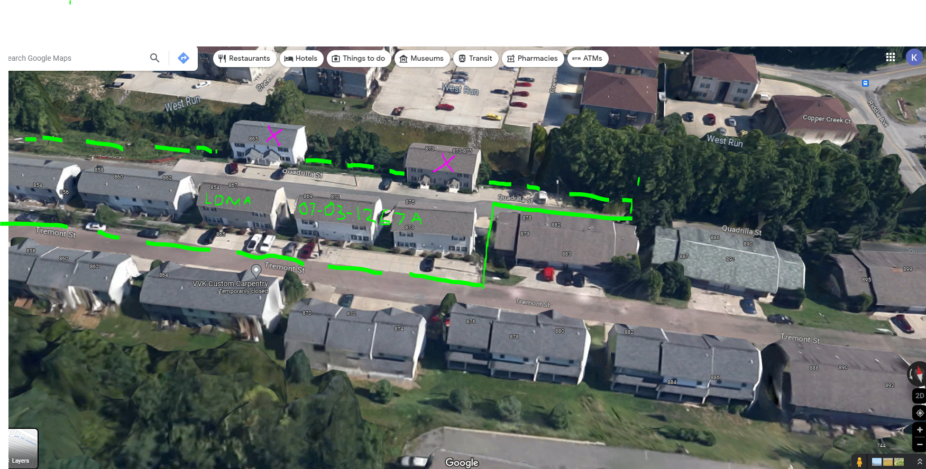

**Figure 4.** [Utility pole](https://goo.gl/maps/e5MnsnfLS7LHG1ND6) located on southeast corner of [2007 Map Plat](https://data.wvgis.wvu.edu/pub/RA/_resources/LOMA/LOMA07-03-1267A/LOMA%2007-03-1267A_2007_NorthHills_Plat.pdf) that is located 338 feet from Riddle St.

