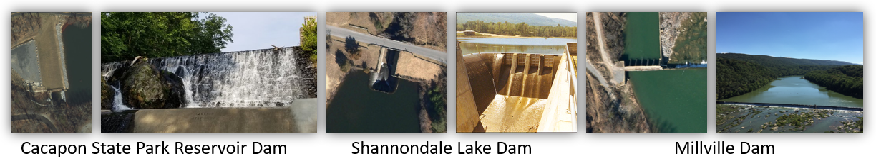

**DAMS AND LEVEES (Region 9)**

**Description:** **Dams and Levees** are crucial elements of the state’s infrastructure. Both may be subject to impact from natural hazards, man-made threats, and issues related to aging and maintenance.

The WVGISTC compiled forty-one (41) dams in Region 9 using state and federal resources. The following chart indicates the distribution among four hazard potential levels: **H**igh – loss of human life likely if dam fails; **S**ignificant – no probable loss of human life, but can cause economic loss, environmental damage, disruption of lifeline facilities or impact other concerns in the event of failure; **L**ow – no probable loss of human life, and low economic and/or environmental losses; and **U**nclassified – hazard potential not determined.

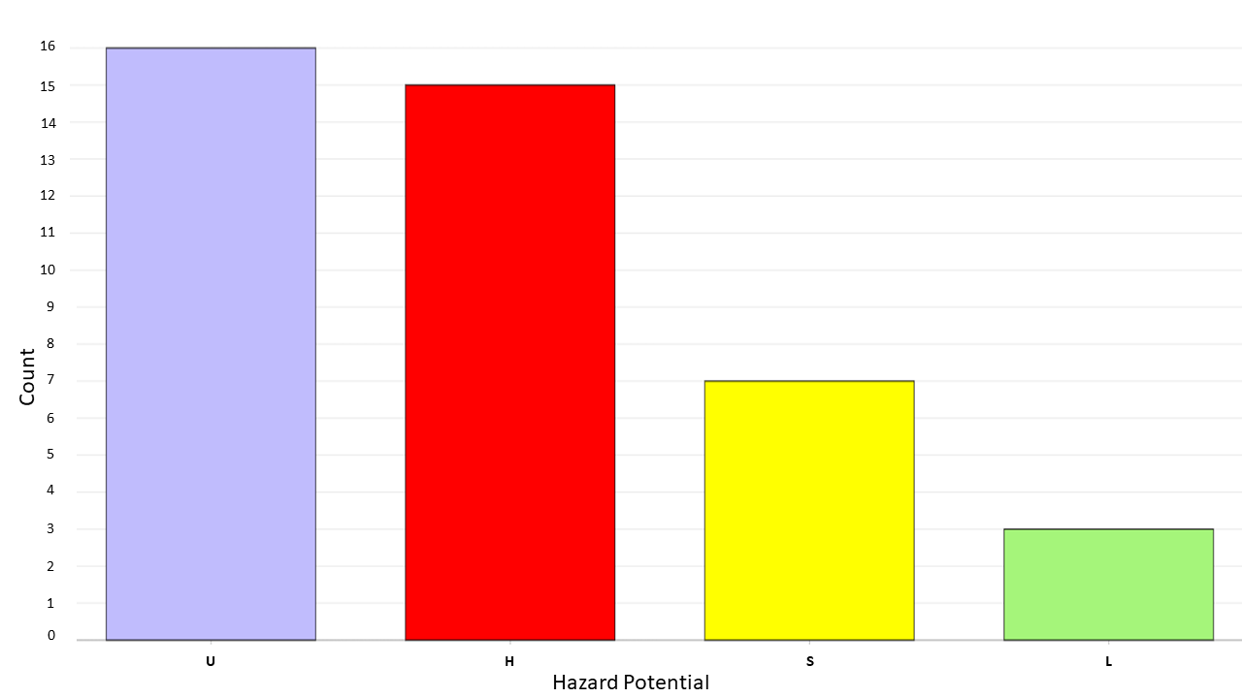

Note that at least one dam outside the state will have an impact on Region 9 in the event of failure or overtopping. The Lake Holiday Dam in Frederick County, Virginia is 102 feet high and stores 10,166 acre-feet of water. This dam is situate on Isaacs Creek, which is a tributary to Back Creek, a major stream running through Berkeley County.

**Community Engagement and Verification:**Review the accuracy and completeness of all ***dams***. Report any dams that are missing. Verify the dams by attributes and location using the [Table](http://data.wvgis.wvu.edu/pub/RA/Region9/Dams_and_Levees/Region_9_dams_2021.xlsx) and RiskMAP View of the [WV Flood Tool](https://www.mapwv.gov/flood/map/?wkid=102100&x=-9045599&y=4520591&l=3&v=2). Identify mitigation strategies for dams and potential downstream effects of overtopping or failure.

The Region 9 dams appear in a geographic context in **Figure 1.** The Lake Holiday Dam is not mapped, but is readily visible in e.g. Google Maps.

**Figure 1.**

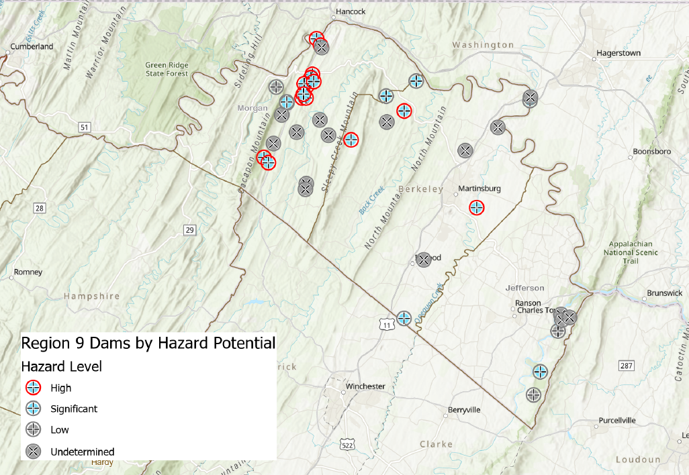

**Community Lifelines:** FEMA recently developed the [community lifelines](https://www.fema.gov/emergency-managers/practitioners/lifelines) construct to increase effectiveness in disaster operations and better position the Agency to respond to catastrophic incidents. Community lifelines cover seven sectors: Safety and Security; Food, Water, Shelter; Health and Medical; Energy; Communications; Transportation; and Hazardous Material. Dams and levees fall under the Community Safety - Flood Control element. Refer to other state risk assessment reports for additional information on housing, shelters, highways, railways, bridges, and other hazards (landslides).

**Other Related Risk Layers:** Primary Structures, Essential Facilities, Transportation

**Bringing Lifelines into Hazard Mitigation Planning:** [Slides](https://data.wvgis.wvu.edu/pub/RA/_resources/CF/Bringing_Lifelines_into_Hazard_Mitigation_Planning_Presentation.pdf) | [Audio](https://data.wvgis.wvu.edu/pub/RA/_resources/CF/Bringing_Lifelines_into_Hazard_Mitigation_Planning_Webinar.mp4) | [Fact Sheet](https://data.wvgis.wvu.edu/pub/RA/_resources/CF/LifelinesFactSheetandPosterv2_201911.pdf) | [BRIC](https://data.wvgis.wvu.edu/pub/RA/_resources/CF/FEMA_BRIC_Session-4_Community-Lifelines_20200722.pdf) | [FEMA Website](https://www.fema.gov/emergency-managers/practitioners/lifelines)

**Critical Facilities:** [Definition](https://www.fema.gov/glossary/critical-facility) | [Critical Facilities and Higher Standards](https://data.wvgis.wvu.edu/pub/RA/_resources/CF/FPM_1_Page_CriticalFacilities_and_Higher_Standards.pdf)

**Verification - WV Flood Tool Risk MAP:** The **WV Flood Tool Risk Map View** should be used to view and verify mapped essential facilities and other risk layers, such as the example below of Welch in McDowell County.

**Figure EF-5.** Essential Facilities in town of Welch displayed on [Risk MAP View](https://www.mapwv.gov/flood/map/?wkid=102100&x=-9081475&y=4499138&l=7&v=2) of the WV Flood Tool.

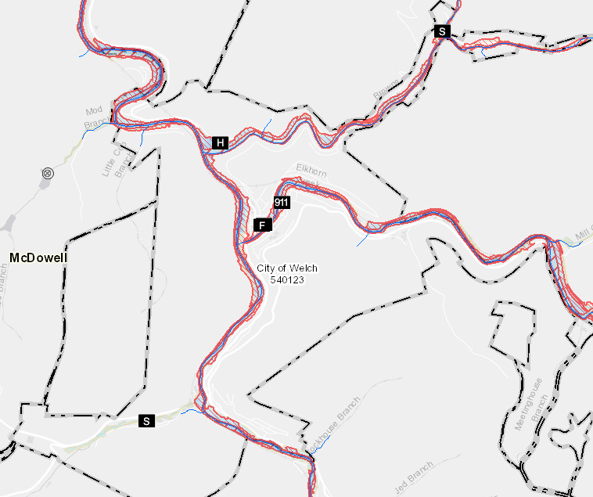

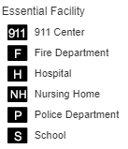

WV Flood Tool Map Link: <https://www.mapwv.gov/flood/map/?wkid=102100&x=-9081475&y=4499138&l=7&v=2>

**Verification - Tabular Report:** Dams can also be viewed and verified for each community by linking to the risk assessment **tabular report** (Excel spreadsheet). To verify the geographic location of each facility, the Excel table provides map view links. Dam feature data fields include Name, National Inventory of Dams (NID) identifier, longitude and latitude, Owner Type, Height, Purposes, Hazard, and Flood Tool Link.

* * *

**Statewide Risk Assessment Contacts:**

Statewide Risk Assessment Technical Support, WVU GIS Technical Center  
 - Kurt Donaldson ([kurt.donaldson@mail.wvu.edu](mailto:kurt.donaldson@mail.wvu.edu))  
 - Maneesh Sharma ([maneesh.sharma@mail.wvu.edu](mailto:maneesh.sharma@mail.wvu.edu))  
 - Eric Hopkins ([Eric.Hopkins@mail.wvu.edu](mailto:Eric.Hopkins@mail.wvu.edu))  
   
State NFIP Coordinator, WV Office of the Insurance Commissioner  
 - Chuck Grishaber ([Charles.C.Grishaber@wv.gov](mailto:Charles.C.Grishaber@wv.gov))  
  
WV Emergency Management Division

- Brian Penix, State Hazard Mitigation Specialist ([Brian.M.Penix@wv.gov](mailto:Brian.M.Penix@wv.gov))

- Tim Keaton, State Hazard Mitigation Planner ([Tim.W.Keaton@wv.gov](mailto:Tim.W.Keaton@wv.gov))  
 - Kevin Sneed, CTP Coordinator ([Kevin.L.Sneed@wv.gov](mailto:Kevin.L.Sneed@wv.gov))  
 - Nuvia E. Villamizar, GIS Manager ([nuvia.e.villamizar@wv.gov](mailto:nuvia.e.villamizar@wv.gov))