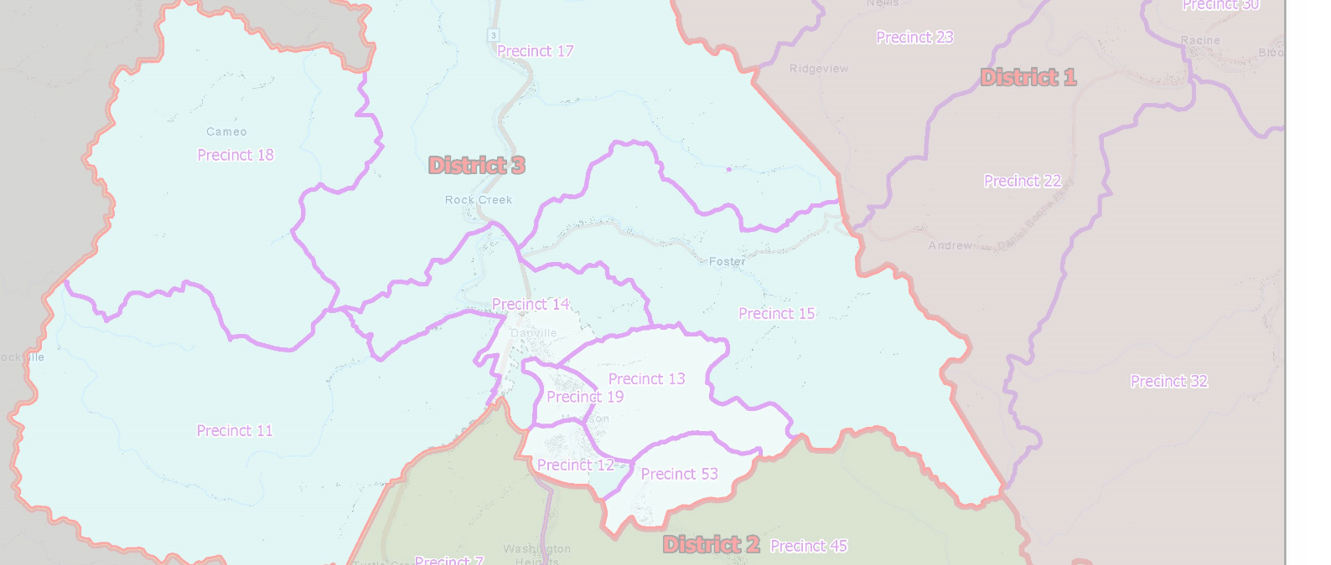

# **Johnna Murray**

## January 21, 2022

Boone County Redistricting 2022

Final Report

# Redistricting Summary

After redistricting, Boone County has 26 precincts. New state legislative boundaries required changes to Precinct 7, Precinct 2, Precinct 9, and Precinct 4. There were also boundary adjustments along Precinct 45, Precinct 15, and Precinct 17.

All Magisterial District boundaries were aligned to the new Precinct boundaries. The overall total population deviation for magisterial districts is 7.30%.

These redistricting changes impacted 582 voters (about 5% of the total registered voters in the county). There were 61 voters registered, but not physically located, in Boone County. The ideal percentage of addresses that were matched for reliable data is 95% and Boone County’s address match percentage was 100%.