,,

**WV GIS Technical Center**

WEST VIRGINIA UNIVERSITY

July 13, 2023

|  |  |
| --- | --- |
| Redistricting  Methods and Procedures | **DRAFT** |

Table of Contents

Summary 1

Introduction 1

Data Description 2

Project Setup 3

Start a Redistricting Plan 3

Project Workflow 11

Packets (v1-v4) 12

Final Packet (v5) 12

Resources 13

County Examples 17

# Summary

Redistricting methods and procedures for counties in West Virginia. Adjusting magisterial districts and voting precincts to meet state code.

# Introduction

Redistricting occurs in West Virginia every ten years, following the United State Census population publication. State legislature determines Senate and House of Delegates boundaries. There are many best practices to follow when redistricting. Align all boundaries to census block boundaries. Precincts should nest within magisterial districts. Magisterial districts should be equal in size and population. Voters should not have to drive an unreasonable amount of time to a polling location. Rural precincts should have at least 200 registered voters and no more than 700 registered voters. Urban precincts should have at least 300 registered voters and no more than 1200 registered voters. Some counties want their incorporated place(s) to be its own precinct and not include voters outside city limits. The counties are required to notify all voters that are affected by the redistricting changes.

# Data Description

**Magisterial District**: In West Virginia, counties are divided into three to ten magisterial districts. A magisterial district determines eligibility of candidates for the county commission. WV Code §7-1-1b (b): A candidate for the office of county commissioner shall be a resident from the magisterial district for which he or she is seeking election.

**Voting Precincts**: Counties are divided into many geographic entities for the purpose of conducting elections. Each precinct contains a polling location where registered voters must go to vote.

**V1**: The first version for redistricting packets. Represents the current boundaries for precincts and magisterial districts.

**V2**: The second version for redistricting packets. Used to show where precincts may need to be split due to new state legislative boundaries. Not all counties will have a v2.

**V3**: The third version for redistricting packets. This version needs to meet code so that it can be presented to the County Commission for approval. Populations should balance for magisterial districts and each precinct should have the appropriate number of registered voters.

**V4**: This version can be used if the County Commission requests changes to the v3 maps.

**V5**: This is the final version of the redistricting for the county. The maps have been approved by the County Commission.

**SVRS**: Statewide Voter Registration System; The counties use this system as a database for registered voters.

**Total**: A demographic variable representing total population.

**Total18**: A demographic variable representing all individual 18 years of age or older.

**Standard**: Demographic variables in the standard classifications are those that include 1) Hispanic or Latino and 2) Not Hispanic or Latino by race.

**Standard VAP**: Demographic variables in the standard classifications are those that include 1) Hispanic or Latino and 2) Not Hispanic or Latino by race and include only those individuals 18 years of age or older (that is, the voting age population for a given demographic).

**SVRS Mismatch Report**: A list of all of the geocoded registered voters in the county that will need to be registered to a different precinct according to the working version of the redistricting plan.

**Precinct Summary Report**: Geocoded voters and estimated registered voters broken down by precinct. Spatial data comes from the shapefile of the working version.

**Population Summary Report**: For magisterial districts, shows total population, target population, target deviation, and deviation percentage by district. It also shows the overall range in deviation percentage for the whole county.

**All District Summary Report**: Shows total population, population deviation and percentage for each district.

**District Statistics**: Gives a quick overview of total population, target population, and population deviation and percentage for each district.

**Geocoded voters**: Is the count of all site-matched geocoded voter registration points that intersect with the specified precinct. Ideally, at least 95% of all registered voters for the county would be geocoded.

**Total Estimated Voters Registered**: Is calculated by multiplying the precinct’s voting age population with a scale factor which varies by county. The scale factor is calculated by dividing the county’s total registered voters by the county’s total voting age population.

# Project Setup

1. Request SVRS data from state
2. Geocode addresses to voter registration for each county
3. Have county sign MOU
   1. https://www.mapwv.gov/redistricting/assets/docs/County_Redistricting_MOU_2021-10-21-FINAL.pdf

# Start a Redistricting Plan

1. Use ESRI Redistricting Software: <https://redistricting2.esri.com/redistricting/index.html>
   1. Start a new plan and choose to start with districts or precincts
   2. Set the number of districts or precincts
   3. Choose census year
   4. Set maximum deviation to 10%
   5. Select source geography under Counties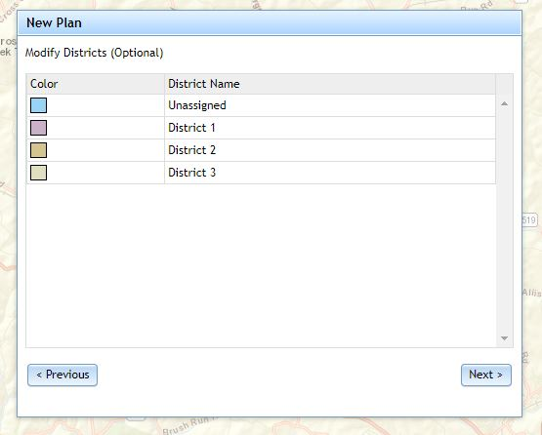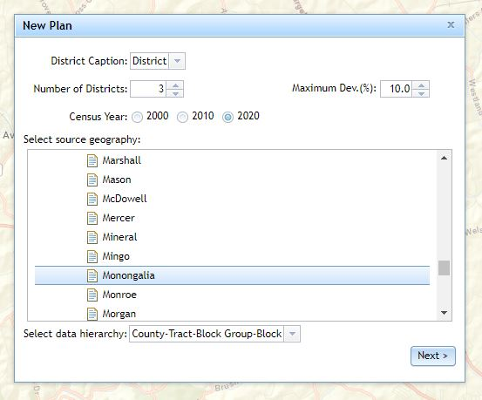 🡪 West_Virginia_YEAR 🡪 COUNTY
   6. Select demographics to use
      1. For magisterial districts
         1. Total
         2. Standard
      2. For precincts
         1. Total 18
         2. Standard VAP

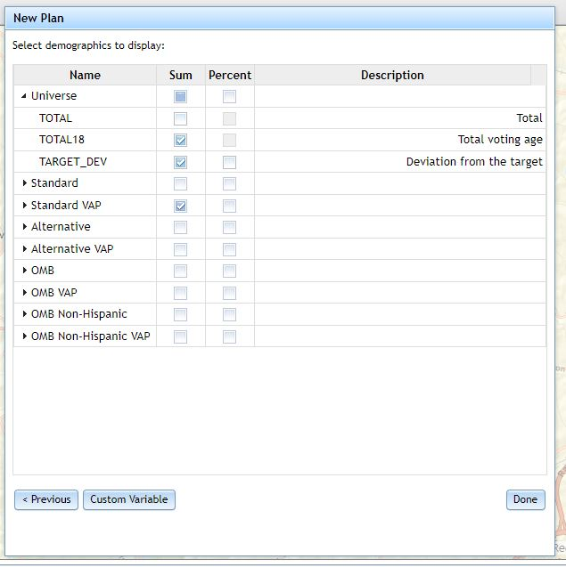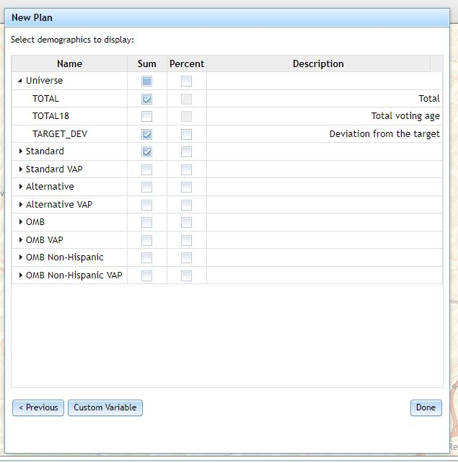

* 1. 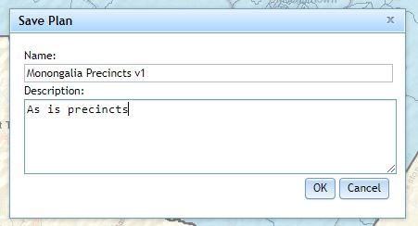Save plan as COUNTY Precincts v1 or COUNTY Magisterial v1

1. Add reference data to the map
   1. File 🡪 Search 🡪 URL 🡪 <https://services.wvgis.wvu.edu/arcgis/rest/services/Boundaries/WV_2021_Redistricting/MapServer>
   2. Create 🡪 Add content 🡪 shapefile 🡪 select county’s current shapefile

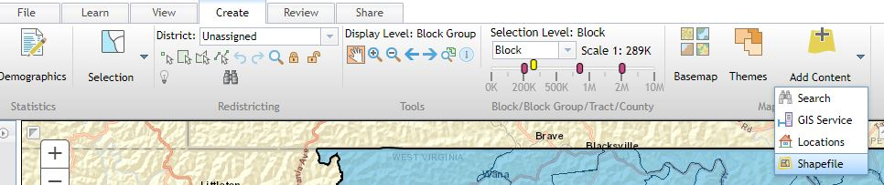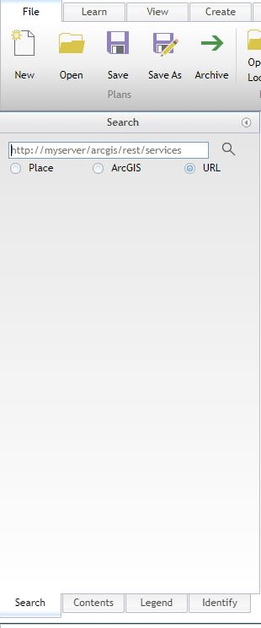

1. Start drawing districts or precincts
   1. Create tab
      1. 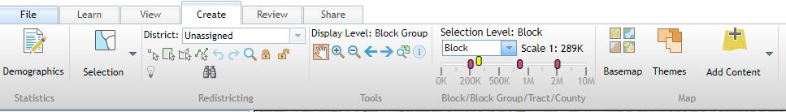Select a district or precinct to draw and then choose select geographies by rectangle (or preferred selection method) and start selecting census blocks to make up the polygon
      2. Repeat for remaining districts or precincts
   2. Confirm demographics fields are correct
      1. 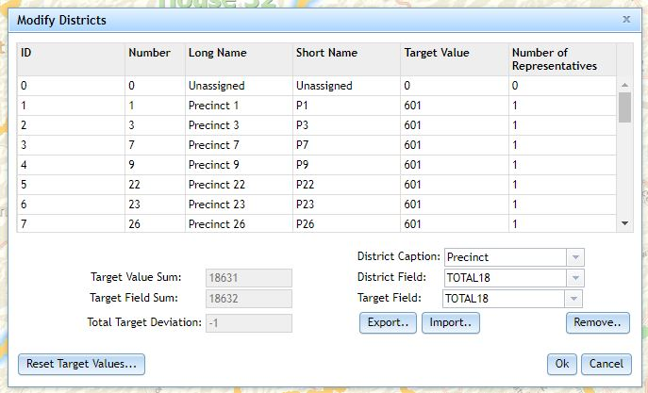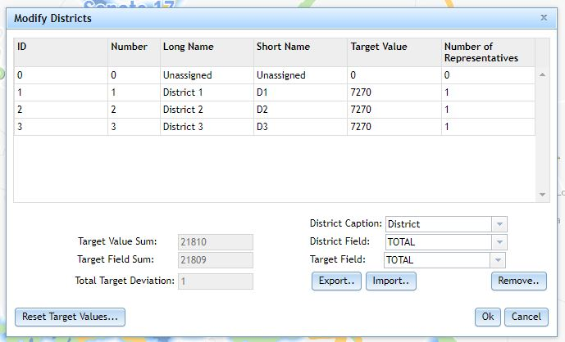View 🡪 Modify districts
2. Map View Modifications
   1. 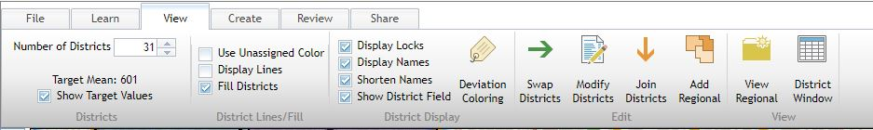View 🡪 Show Target Values, Display Names, Shorten Names (if preferred), Show District Field
   2. 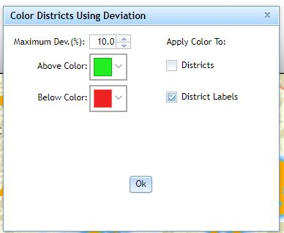For Magisterial Districts only: Turn on Deviation Coloring for District Labels
3. Review Plan
   1. Review 🡪 Check integrity
   2. 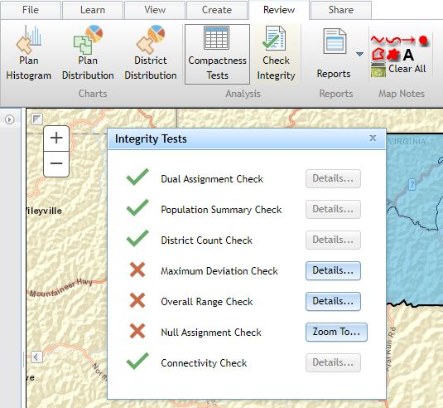Zoom to null assignments and add to the appropriate polygon
4. Print Maps and Export Shapefile
   1. File 🡪 Print
      1. Wall Map (ANSI E)
      2. Add a title and date to the map
   2. File 🡪 Plan Book
      1. Map series (ANSI A)
      2. 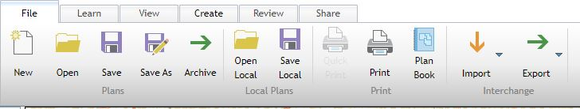Add title and date to first page only
   3. File 🡪 Export 🡪 Shapefile
5. Reports
   1. Review 🡪 Reports 🡪 Choose 🡪 Under universe, add Total field to reports
   2. Download (magisterial districts)
      1. Population Summary
      2. All Districts Summary
      3. 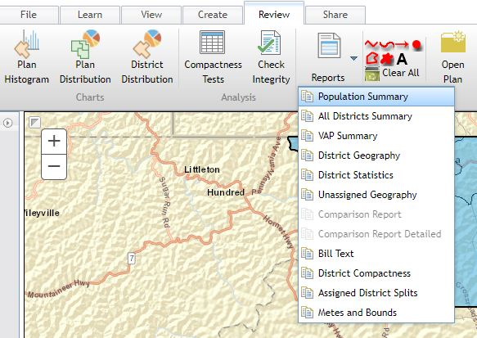District Statistics
   3. Script outputs (precincts)
      1. Mismatch Report
      2. Precinct Summary Report
6. Share plan with WVGISTC Group
   1. Share 🡪 Share Plan
   2. Access level: Read / Write

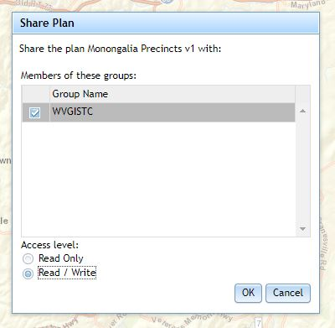

1. Create packets to send to county
   1. Save files in R:\Redistricting\Data\CountyWorking\COUNTYNAME
   2. Zip files into one folder and save here:

\\gistc-filesrv4\FTPDrive\pub\temp\redistricting\COUNTYNAME

* 1. Send to county using ftp link: <https://data.wvgis.wvu.edu/pub/temp/redistricting/COUNTYNAME/COUNTYNAME_v1.zip>
  2. In redistricting software, Save As v(n+1) to start the next version

# Project Workflow

1. Create V1
2. Create V2 for any splits due to new state legislative boundaries
   1. Increase the number of precincts
      1. View 🡪 Number of Districts 🡪 Use the up arrow to add new precincts as needed

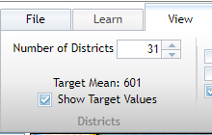

* 1. On the create tab, select one of the new precincts to draw a polygon for the split precinct
  2. View 🡪 Modify Districts to change the short name field of the new precinct to the original precinct name with a decimal at the end eg: Precinct 48 split into 3 polygons: 48, 48.1, 48.2
  3. Adjust magisterial districts so that no precinct is in multiple districts

1. Review v1 and v2 packets with county
2. Create V3
   1. Determine, with county input, what to do with any split precincts
      1. Make the split precinct a new precinct,
      2. Adjust boundaries around the split precinct, OR
      3. Combine the split precinct with a neighboring precinct in the same magisterial district
   2. Balance population in magisterial districts
      1. The total population in each district should have a deviation of less than 5%
      2. Overall total population deviation should be less than 10%
3. Work with county through v3 iterations to prepare maps for county commission approval
   1. Name each new v3 with a letter at the end (v3a, v3b, v3c, etc.)
   2. Use redistricting software for as long as possible
      1. Transition to ArcPro when counties have specific needs that justify not using census blocks as boundaries
   3. After the County Commission meeting(s)
      1. Commission requests changes – make v4
      2. Commission approves – make v5

# Packets (v1-v4)

* Precincts
  + 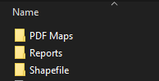PDF Maps
    - Wall map
    - Map series
  + Reports
    - SVRS Mismatch Report
    - Precinct Summary Report
  + Shapefile
* Magisterial districts
  + PDF Maps
    - Wall map
    - Map series
  + Reports
    - Population Summary Report
    - All Districts Summary
    - District Statistical Report
  + Shapefile

# Final Packet (v5)

* Final Report
* 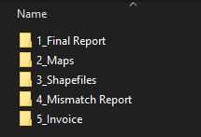Maps (made in ArcPro)
  + Precinct wall map
  + Precinct map series
  + Magisterial Districts wall maps
  + Magisterial Districts map series
* Shapefiles
  + Precincts
  + Magisterial Districts
* Mismatch Report
* Invoice

# Resources

## WVGISTC Redistricting Website

<https://www.mapwv.gov/redistricting/>

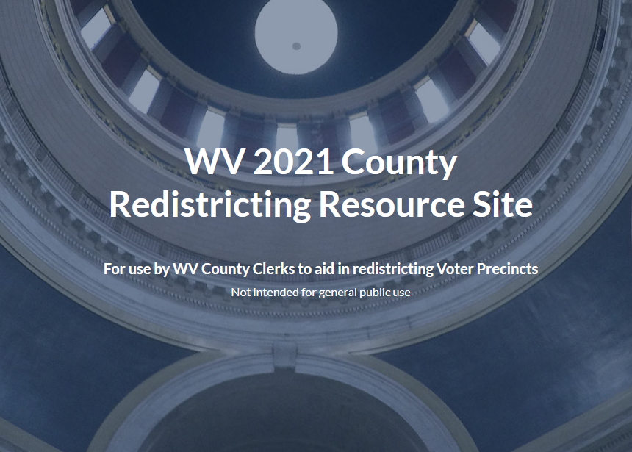

## WVGISTC Web Maps

<https://mapwv.gov/svrs/>

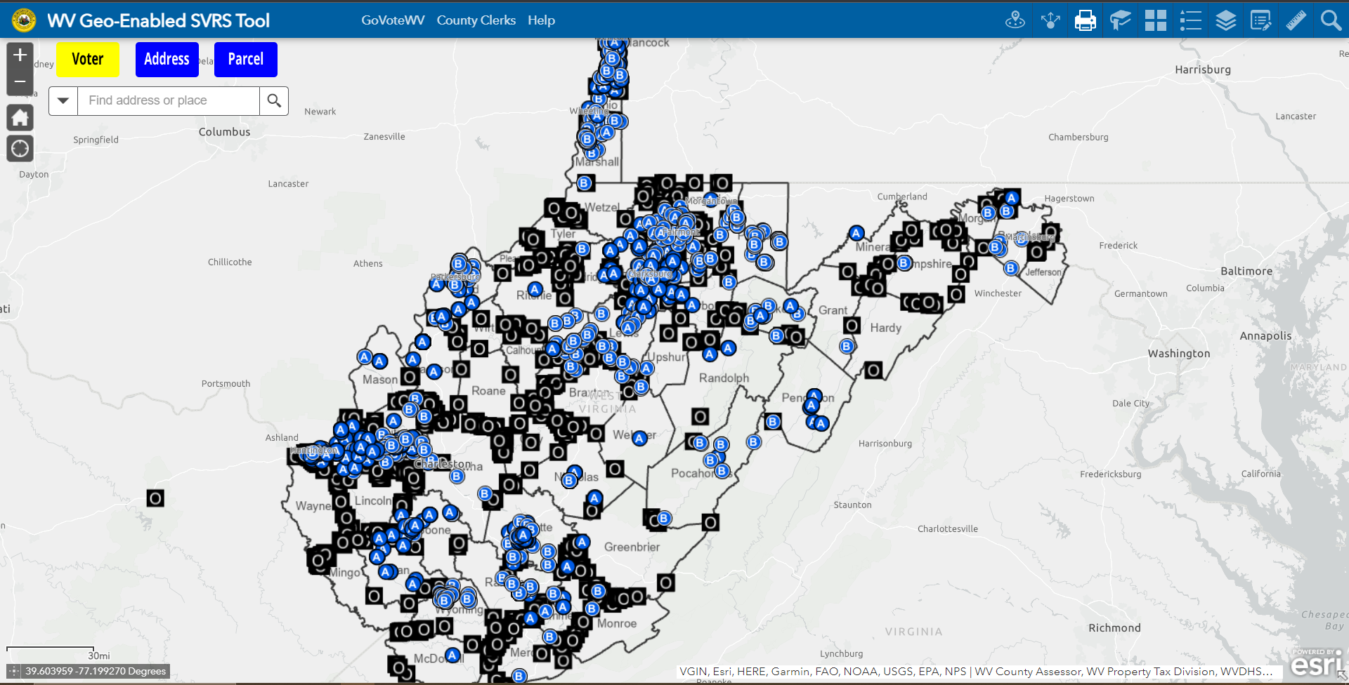

<https://mapwv.gov/vote/>

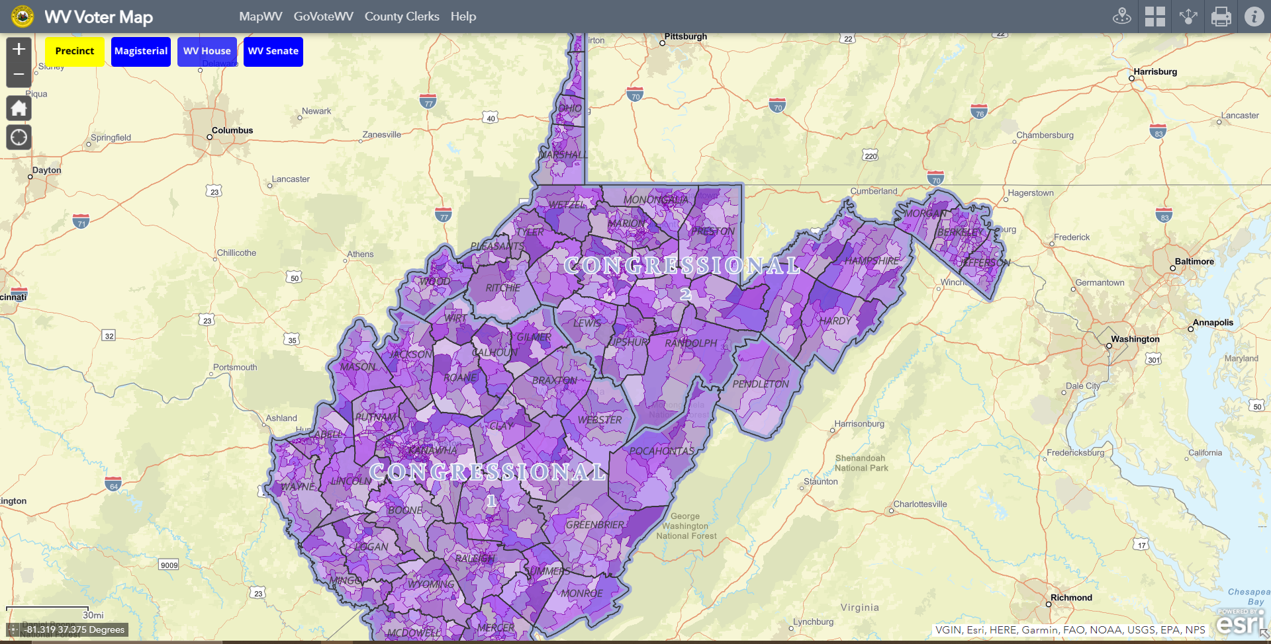

## WV Code Requirements 2021

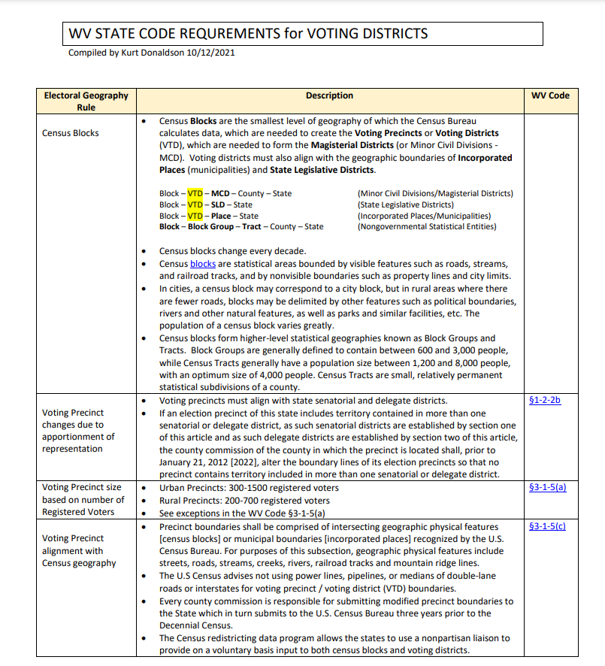<https://data.wvgis.wvu.edu/pub/VTD/resource/VTD_WV_Code_Requirements.pdf>

## Cartographic Reference for Final Maps

<https://data.wvgis.wvu.edu/pub/VTD/Docs/Redistricting_Map_Instructions.docx>

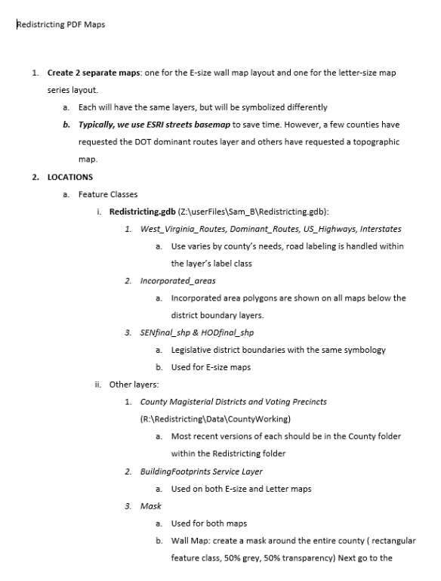

## Memorandum of Understanding

<https://www.mapwv.gov/redistricting/assets/docs/County_Redistricting_MOU_2021-10-21-FINAL.pdf>

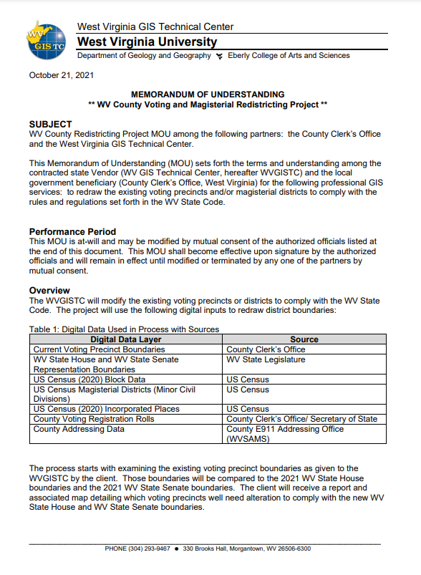

## Final Report Template

<https://data.wvgis.wvu.edu/pub/VTD/Docs/Boone_Redistricting_Final_Report_20220120_NEW.docx>

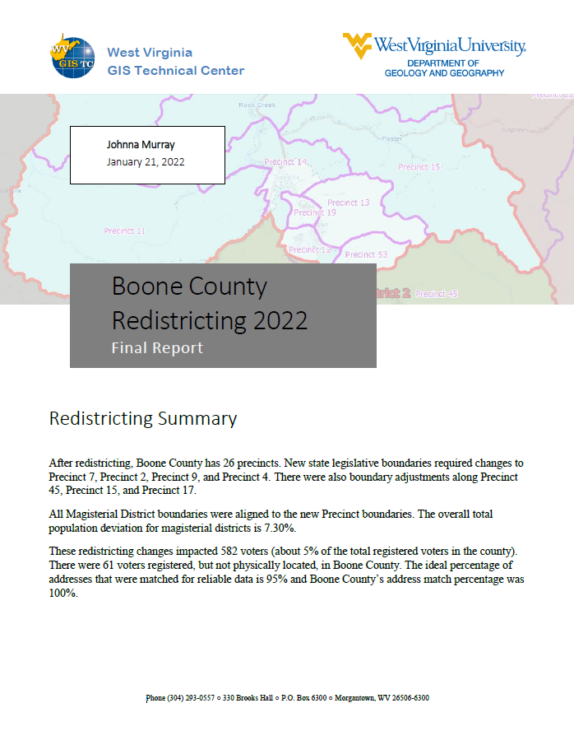

## Invoice Template

<https://data.wvgis.wvu.edu/pub/VTD/Docs/NEW%20Redistricting%20Invoice%20-%20Boone%20County.docx>

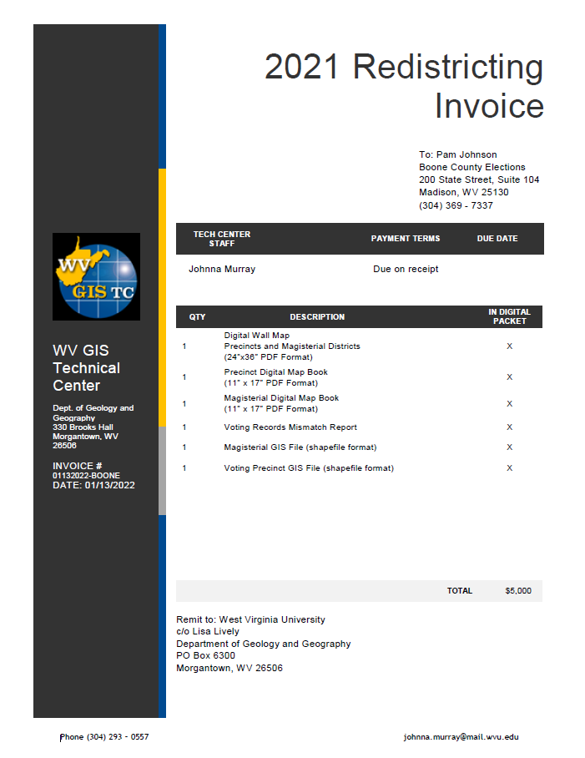

# County Examples

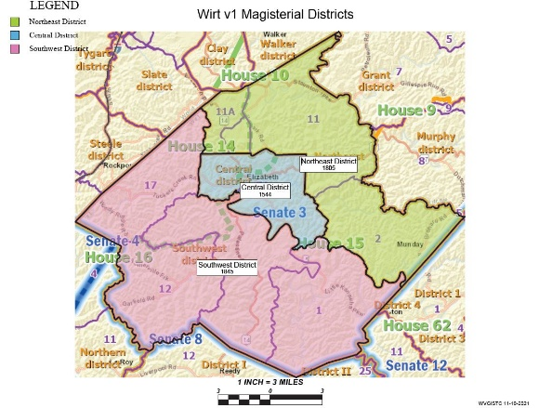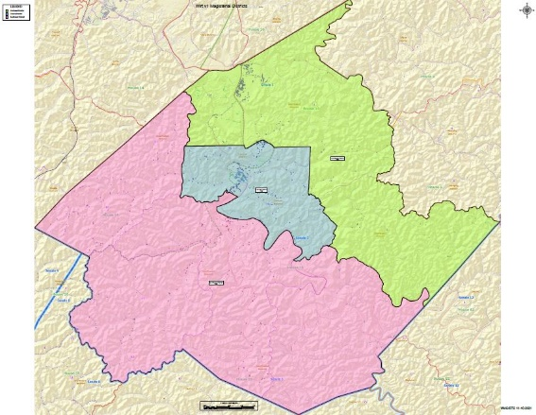V1 Magisterial Districts <https://data.wvgis.wvu.edu/pub/VTD/Docs/Wirt_Magisterial_v1_wallmap.pdf>  
<https://data.wvgis.wvu.edu/pub/VTD/Docs/Wirt_Magisterial_v1_mapbook.pdf>

## V2 Magisterial Districts

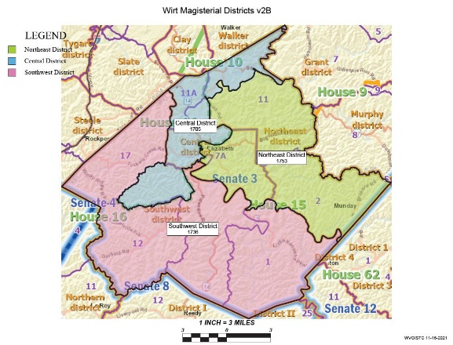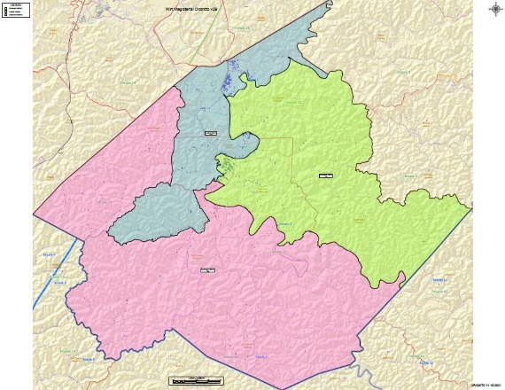<https://data.wvgis.wvu.edu/pub/VTD/Docs/Wirt_Magisterial_v2B_wallmap.pdf>  
[https://data.wvgis.wvu.edu/pub/VTD/Docs/Wirt_Magisterial_v2B_mapbook.pdf](https://data.wvgis.wvu.edu/pub/VTD/Docs/Wirt_Magisterial_v2B_mapbook.pdf%20)

## V3 Magisterial Districts

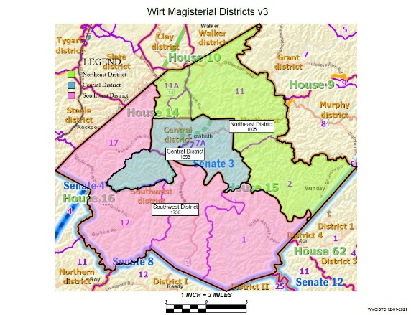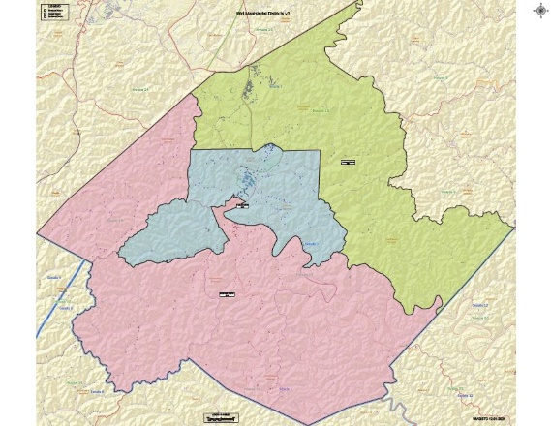<https://data.wvgis.wvu.edu/pub/VTD/Docs/Wirt_Magisterial_v3_wallmap.pdf>  
<https://data.wvgis.wvu.edu/pub/VTD/Docs/Wirt_Magisterial_v3_mapbook.pdf>

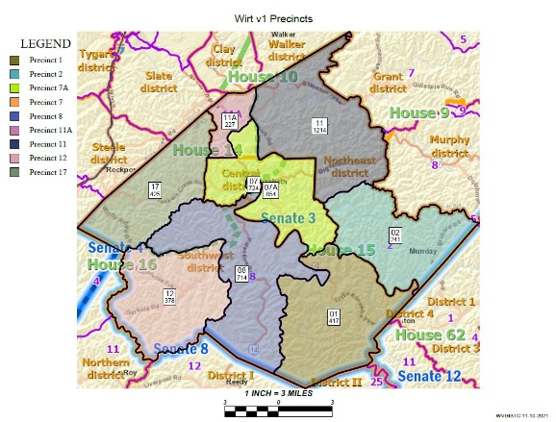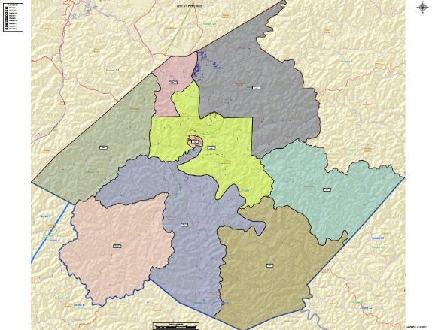V1 Precincts  
<https://data.wvgis.wvu.edu/pub/VTD/Docs/Wirt_Precinct_v1_wallmap.pdf>  
<https://data.wvgis.wvu.edu/pub/VTD/Docs/Wirt_Precinct_v1_mapbook.pdf>

## V2 Precincts

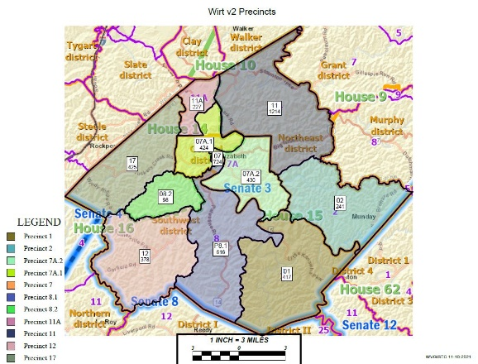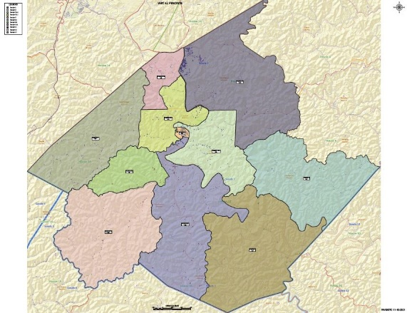<https://data.wvgis.wvu.edu/pub/VTD/Docs/Wirt_Precinct_v2_wallmap.pdf>  
[https://data.wvgis.wvu.edu/pub/VTD/Docs/Wirt_Precinct_v2_mapbook.pdf](https://data.wvgis.wvu.edu/pub/VTD/Docs/Wirt_Precinct_v2_mapbook.pdf%20%20)

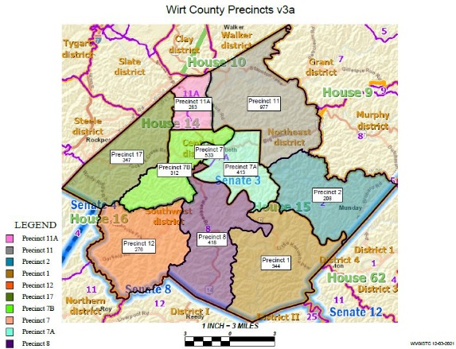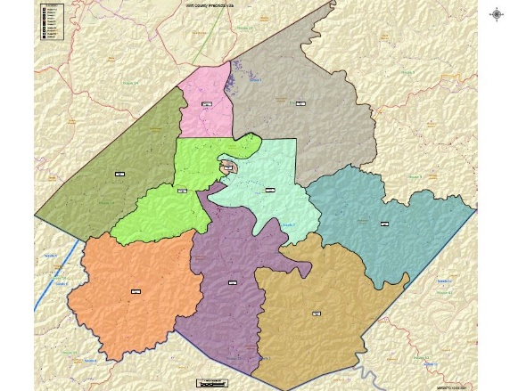V3 Precincts (in redistricting software)  
<https://data.wvgis.wvu.edu/pub/VTD/Docs/Wirt_Precincts_v3a_wallmap.pdf>  
<https://data.wvgis.wvu.edu/pub/VTD/Docs/Wirt_Precincts_v3a_mapbook.pdf>

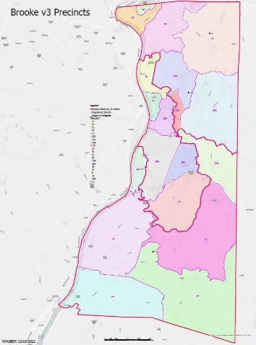V3 Precincts (in ArcPro)  
<https://data.wvgis.wvu.edu/pub/VTD/Docs/Brooke_Precincts_v3a_wallmap_gray.pdf>

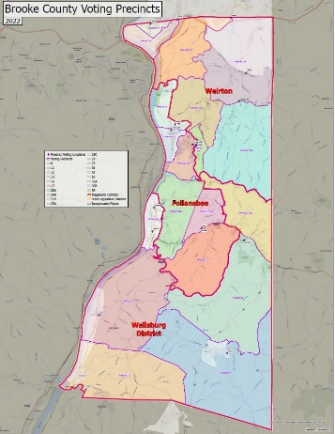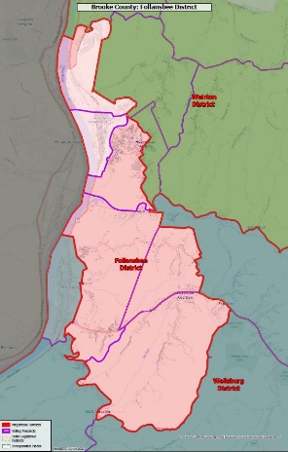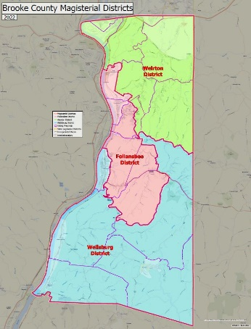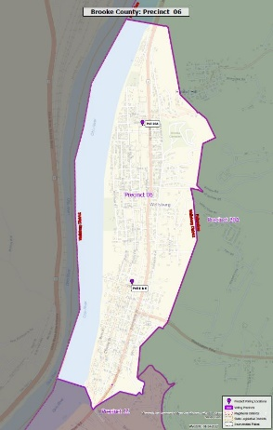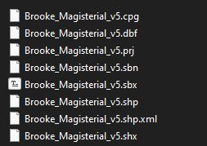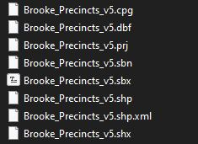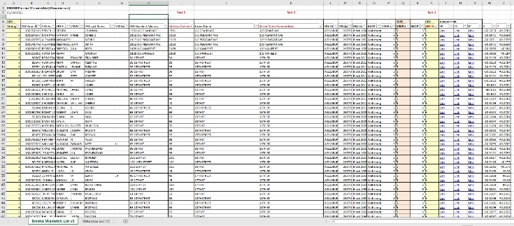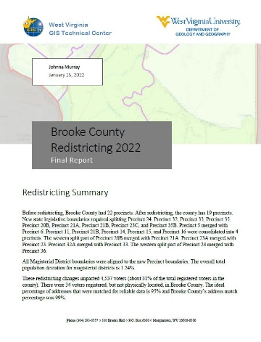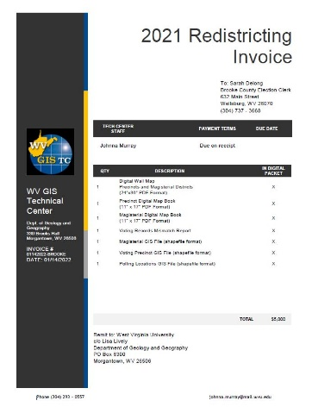V5 Final Packet  
<https://data.wvgis.wvu.edu/pub/VTD/Docs/Brooke_2021_Redistricting_COMPLETED.zip>

## Tables

### Geocode Summary and Error Lists

<https://data.wvgis.wvu.edu/pub/VTD/Docs/Geocode%20Summary%20and%20Error%20Lists.docx>

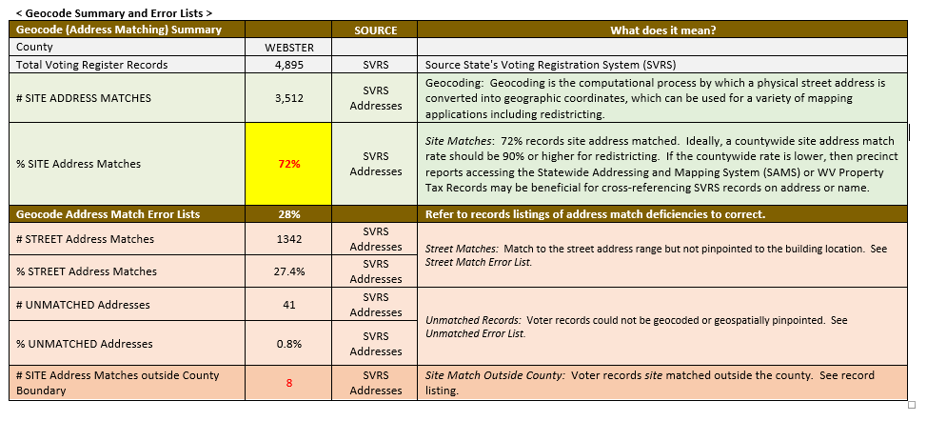

### Pre-Redistricting Precinct Summary and Mismatch List (v1)

<https://data.wvgis.wvu.edu/pub/VTD/Docs/Pre-Redistricting%20Precinct%20Summary%20and%20Mismatch%20List%20(V1).docx>

