# Hierarchy of Census Geographic Entities

<https://www.census.gov/programs-surveys/geography/guidance/hierarchy.html>

<https://www2.census.gov/geo/pdfs/reference/geodiagram.pdf>

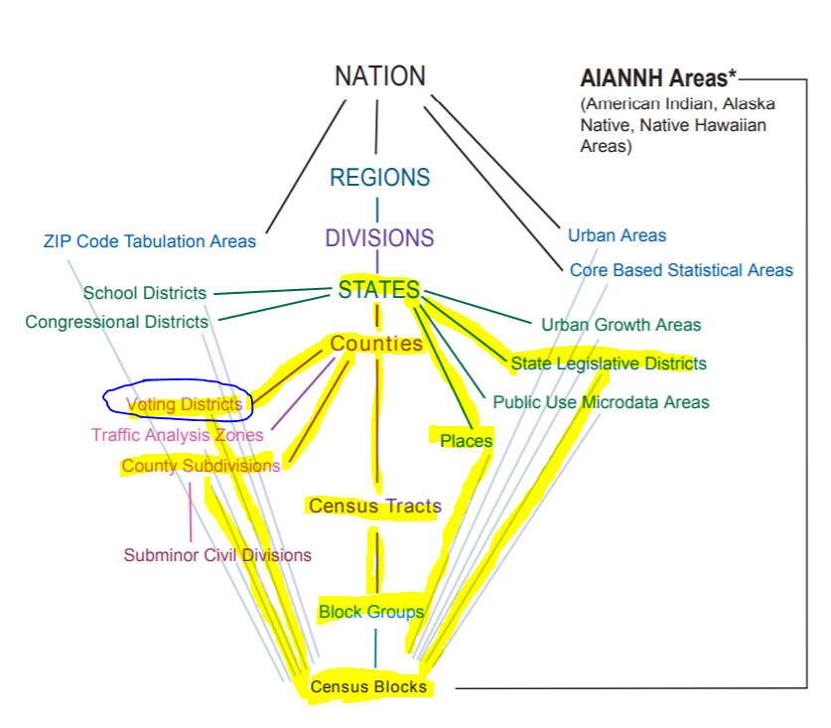

# Hierarchy of Census Geographic Entities

Block – VTD – **MCD** – County – State (Minor Civil Divisions/Magisterial Districts)

Block – VTD – **SLD** – State (State Legislative Districts)

Block – VTD – **Place** – State (Incorporated Places)

**Block** – **Block Group** – **Tract** – County – State (Census Nongovernmental Statistical Entities)



Census Block = Smallest nongovernmental statistical entity

MCD = Minor Civil Division or Magisterial District

Place = Incorporated Place or Municipality

SLD = State Legislative District (Senate or Delegate)

VTD = **Voting District** of **Precinct**

1 Apportioned by registered voters

2 Apportioned by decennial census population

Notes:

In West Virginia, **Voting Districts** (VTDs) or Precincts conform to county subdivision **Magisterial Districts**, also known as Minor Civil Divisions (MCDs).

State and county boundaries always are census tract boundaries in the standard census geographic hierarchy. Refer to documentation on [Census Geographic Relationships](https://www2.census.gov/geo/pdfs/maps-data/data/tiger/tgrshp2020pl/TGRSHP2020PL_TechDoc_Ch4.pdf).  
 *Compiled by Kurt Donaldson 10/12/2021*