**SUBJECT: GEO Precinct 114 Mismatch Errors – Spatial Data Assessment**4/8/2022

* A minimum of 123 Voters in SVRS Precincts (105, 106, 107, 109, 111, 112) *mismatch* with GEO Precinct 114
* Voters correctly assigned to Precinct 114 are in State House District 34 and not House District 36.

**Significance:** Many Voter Points located in the newly redistricted Precinct 114 in northwest McDowell County appear to be assigned to the wrong precinct and state house district. Consequently, these SVRS-GEO precinct mismatches could result in the voters in this location receiving the wrong ballot for the House of Delegates.

|  |
| --- |
| **Precinct 114 has a minimum of 123 voter points assigned to different precincts** |

**Validation:** Review the SVRS-GEOgraphic Precinct Mismatches using the attached Precinct Mismatch Excel Table (SVRS Data Extract 4/1/2022) and the G-SVRS Tool to validate Voter Points are in the correct precinct. Red dots on the G-SVRS Tool represent precinct mismatches between the SVRS and GIS files. [Click here](https://www.mapwv.gov/svrs/?marker=-81.830974%3B37.485622%3B&level=11&extent=-9122625.3015%2C4506088.6984%2C-9104356.8517%2C4517592.4711%2C102100) to view mismatched SVRS points for this area of interest.

According to E-911 Address and Tax Parcel *geographic* reference data, the SVRS Voter Points in this location are not in the correct Precinct 114 and State House District 34.

**(1) Spatial Data Assessment of Voter Point 100256179.**

**Table 1.** Voter ID 100256179. SVRS mismatch with E-911 and Tax Parcel geographic reference layers.  
Voter ID Map Link: <https://www.mapwv.gov/svrs/?marker=-81.830974;37.485622;&level=11>

|  |  |  |  |
| --- | --- | --- | --- |
| **IDENTIFIER** | **SVRS Voter Point** | **E-911 Address (GIS)** | **Parcel (GIS)** |
| ID | [100256179](https://www.mapwv.gov/svrs/?marker=-81.830974;37.485622;&level=11) |  | [27-13-0164-0012-0000](https://mapwv.gov/parcel/?pid=27-13-0164-0012-0000) |
| ADDRESS | 12 CLINE ST, IAEGER, WV 24844 | 12 CLINE ST, Iaeger, WV 24844 | NEGRO BR |
| NAME | MELIENE LYNN ROWE |  | ROWE MELIENE |
| PRECINCT NO. | 107 | 114 | 114 |
| HOUSE DISTRICT NO. | 36 | 34 | 34 |
| *NOTES:*  Location Verification of SVRS Voter Point: The E-911 Address matches the SVRS Voter Address of **12 Cline Street**. The tax parcel Owner Name (**Meliene Rowe**) matches the SVRS Voter Name. The E-911 Address should be the authoritative address of the resident and match the SVRS voter address. Backup verification is with tax parcel information.  Action Required: Voter Point 100256179 (Meliene Rowe) should be in Precinct 114 and not Precinct 107.  Click on [map link](https://www.mapwv.gov/svrs/?marker=-81.830974;37.485622;&level=11) to view voter point in Geo-SVRS Tool. Red dots on the online map represent precinct mismatches between the SVRS and GIS files.  Latitude/Longitude Coordinate of Voter Point: 37.485622 -81.830974 | | | |
| **Voter ID 100256179 should be in Precinct 114** | | | |
| **Voter ID 100256179 should be in Precinct 114** | | | |

**(2) Spatial Data Assessment of Voter Point 501582.**

**Table 2.** Voter ID 501582. SVRS mismatch with E-911 and Tax Parcel geographic reference layers.  
Voter ID Map Link: <https://www.mapwv.gov/svrs/?marker=-81.809963;37.490971;&level=12>

|  |  |  |  |
| --- | --- | --- | --- |
| IDENTIFIER | SVRS Voter Point | E-911 Address (GIS) | Parcel (GIS) |
| ID | [501582](https://www.mapwv.gov/svrs/?marker=-81.809963;37.490971;&level=12) |  | [27-13-0165-0002-0000](https://mapwv.gov/parcel/?pid=27-13-0165-0002-0000) |
| ADDRESS | 79 TRAIL HLW RD, IAEGER, WV 24844 | 79 TRAIL HOLLOW RD, Iaeger, WV 24844 | TRAIL HOLW |
| NAME | RITA ANN BLANKENSHIP |  | BLANKENSHIP DAVID & RITA |
| PRECINCT NO. | 107 | 114 | 114 |
| HOUSE DISTRICT NO. | 36 | 34 | 34 |
| *NOTES:*  Location Verification of SVRS Voter Point: The E-911 Address matches the SVRS Voter Address of **79 Trail Hollow Road**. The tax parcel Owner Name (**Rita Blankenship**) matches the SVRS Voter Name. The E-911 Address should be the authoritative address of the resident and match the SVRS voter address. Backup verification is with tax parcel information.  Action Required: Voter Point 501582 should be in Precinct 114 and not Precinct 107.  Click on [map link](https://www.mapwv.gov/svrs/?marker=-81.809963;37.490971;&level=12) to view voter point in Geo-SVRS Tool. Red dots on the online map represent precinct mismatches between the SVRS and GIS files.  Latitude/Longitude Coordinate of Voter Point: 37.490971 -81.809963 | | | |
| **Voter ID 501582 should be in Precinct 114** | | | |
| **Voter ID 501582 should be in Precinct 114** | | | |

**(3) Spatial Data Assessment of Voter Point 100058843.**

**Table 3.** Voter ID 100058843. SVRS mismatch with E-911 and Tax Parcel geographic reference layers.  
Voter ID Map Link: <https://www.mapwv.gov/svrs/?marker=-81.830136;37.486565;&level=12>

|  |  |  |  |
| --- | --- | --- | --- |
| IDENTIFIER | SVRS Voter Point | E-911 Address (GIS) | Parcel (GIS) |
| ID | [100058843](https://www.mapwv.gov/svrs/?marker=-81.830136;37.486565;&level=12) |  | [27-13-0164-0015-0000](https://mapwv.gov/parcel/?pid=27-13-0164-0015-0000) |
| ADDRESS | 633 SPLENDER VALLEY RD., IAEGER, WV 24844 | 633 SPLENDOR VALLEY RD, Iaeger, WV 24844 | NEGRO BR |
| NAME | ROBERT C CLINE |  | CLINE ROBERT & BRENDA |
| PRECINCT NO. | 107 | 114 | 114 |
| HOUSE DISTRICT NO. | 36 | 34 | 34 |
| *NOTES:*  Location Verification of SVRS Voter Point: The E-911 Address matches the SVRS Voter Address of **633 Splender Valley Road**. The tax parcel Owner Name (**Robert Cline**) matches the SVRS Voter Name. The E-911 Address should be the authoritative address of the resident and match the SVRS voter address. Backup verification is with tax parcel information.  Action Required: Voter Point 100058843 should be in Precinct 114 and not Precinct 107.  Click on [map link](https://www.mapwv.gov/svrs/?marker=-81.809963;37.490971;&level=12) to view voter point in Geo-SVRS Tool. Red dots on the online map represent precinct mismatches between the SVRS and GIS files.  Latitude/Longitude Coordinate of Voter Point: 37.486565 -81.830136 | | | |
| **Voter ID 100058843 should be in Precinct 114** | | | |
| **Voter ID 100058843 should be in Precinct 114** | | | |

**(4) SVRS Street Address Entry.** Make sure addresses components (house number, street name, city name) are input in the correct data fields. The City Name should not be part of the Street Name (e.g., IAEGAER 87 LILLAC LANE, IAEGER, WV 24844). Incorrect and incomplete city-style addresses make it more difficult geocode to a map coordinate.

**Table 4. SVRS Address Input Issues**

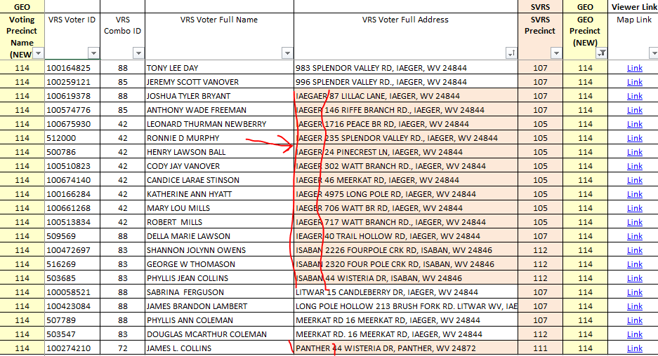

Please contact us if you have any questions or need assistance.

Sincerely,

Kurt Donaldson, GISP, CFM

Manager

WV GIS Technical Center

West Virginia University

(304) 293-9467

<https://wvgis.wvu.edu>