SUBJECT: GEO Precinct 49 Mismatch Errors – Spatial Data Assessment
4/8/2022
- SVRS Precinct 48 mismatches with GEO Precinct 49
- SVRS State House District 34 mismatches with GEO State House District 29
Significance: Many Voter Points north of U.S. 119 along Trace Fork and near the community of Myrtle in Mingo County appear to be assigned to the wrong precinct and state house district. Consequently, these SVRS-GEO precinct mismatches could result in the voters in this location receiving the wrong ballot for the House of Delegates.
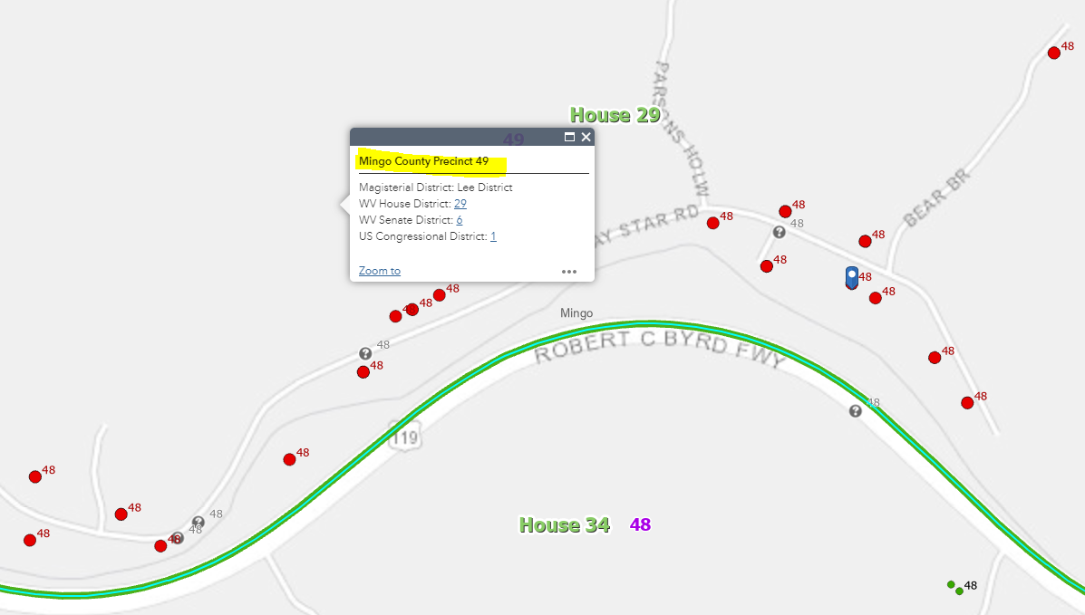
Voter ID 579588 should be in Precinct 49

Validation: Review the SVRS-GEOgraphic Precinct Mismatches using the attached Precinct Mismatch Excel Table (SVRS Data Extract 4/1/2022) and the G-SVRS Tool to validate Voter Points are in the correct precinct. Red dots on the G-SVRS Tool represent precinct mismatches between the SVRS and GIS files. Click here to view mismatched SVRS points for this area of interest.
According to E-911 Address and Tax Parcel geographic reference data, the SVRS Voter Points in this location are in the wrong Precinct 48 and thus the wrong State House District 34. The correct Precinct is 49 and correct State House District 29.

(1) Spatial Data Assessment of Voter Point 579588.
Table 1. Voter ID 579588. SVRS mismatch with E-911 and Tax Parcel geographic reference layers.
Voter ID 579588 Map Link: https://www.mapwv.gov/svrs/?marker=-82.217189;37.775171;&level=12
IDENTIFIER | SVRS Voter Point | E-911 Address (GIS) | Parcel (GIS)
ID | 579588 |  | 30-03-0305-0051-0001
ADDRESS | 29 DELMER SADIE DRIVE, DELBARTON, WV | 29 DELMARSADIE DR, BELO, WV, 25670 | 29 DELMARSADIE DR, BELO, WV, 25670
NAME | BARBARA SUE FARLEY |  | Barbara Sue Farley
PRECINCT NO. | 48 | 49 | 49
HOUSE DISTRICT NO. | 34 | 29 | 29
NOTES:

Location Verification of SVRS Voter Point: Both the E-911 and Parcel Address match the SVRS Voter Address of 29 Delmarsadie Drive. The tax parcel Owner Name (Barbara Farley) matches the SVRS Voter Name for ID 579588. The E-911 Address should be the authoritative address of the resident and match the SVRS voter address. Backup verification is with tax parcel information.

Action Required: Voter Point 579588 (Barbara Farley) should be in Precinct 49 and not Precinct 48.

Click on map link to view voter point in Geo-SVRS Tool. Red dots on the online map represent precinct mismatches between the SVRS and GIS files.

Latitude/Longitude Coordinate of Voter Point: 37.775171, -82.217189
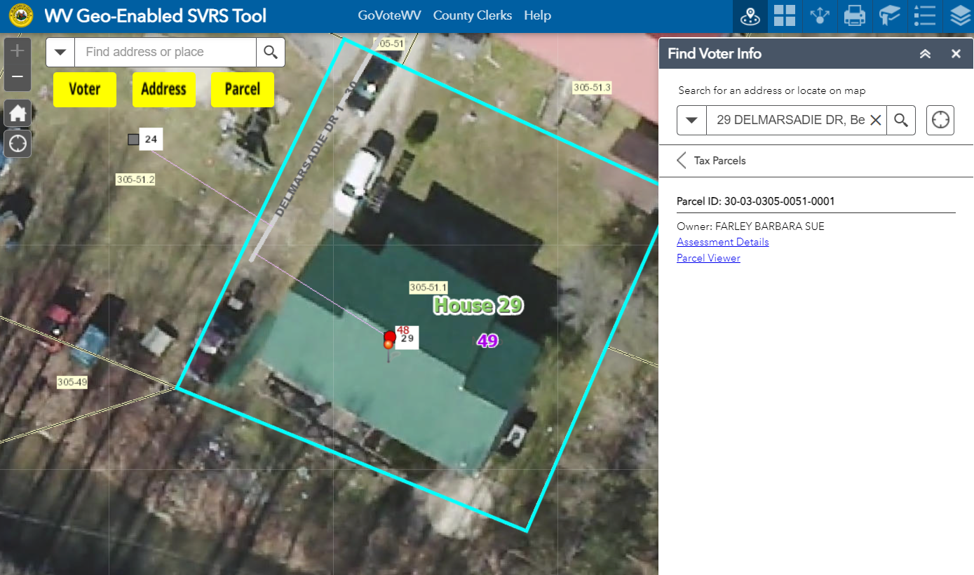
Voter ID 579588 should be in Precinct 49

(2) Spatial Data Assessment of Voter Point 100022277.
Table 2. Voter ID 100022277. SVRS mismatch with E-911 and Tax Parcel geographic reference layers.
Map Link: https://www.mapwv.gov/svrs/?marker=-82.244231;37.784205;&level=12

IDENTIFIER | SVRS Voter Point | E-911 Address (GIS) | Parcel (GIS)
ID | 100022277 |  | 30-03-0304-0024-0006
ADDRESS | 42 PINE RIDGE RD, WILLIAMSON, WV 25661 | 42 PINE RDG, Lenore, WV, 25661 | 42 PINE RDG, LENORE, WV, 25661
NAME | WETZEL DAVIS |  | DAVIS WETZEL SHERMAN ET UX
PRECINCT NO. | 48 | 49 | 49
HOUSE DISTRICT NO. | 34 | 29 | 29
NOTES:

Location Verification of SVRS Voter Point: Both the E-911 and Parcel Address match the SVRS Voter Address of 42 Pine Ridge Road. The tax parcel Owner Name (Wetzel Davis) matches the SVRS Voter Name for ID 100022277. The E-911 Address should be the authoritative address of the resident and match the SVRS voter address. Backup verification is with tax parcel information.

Action Required: Voter Point 100022277 should be in Precinct 49 and not Precinct 48.

Click on map link to view voter point in Geo-SVRS Tool. Red dots on the online map represent precinct mismatches between the SVRS and GIS files.

Latitude/Longitude Coordinate of Voter Point: 37.784205 -82.244231
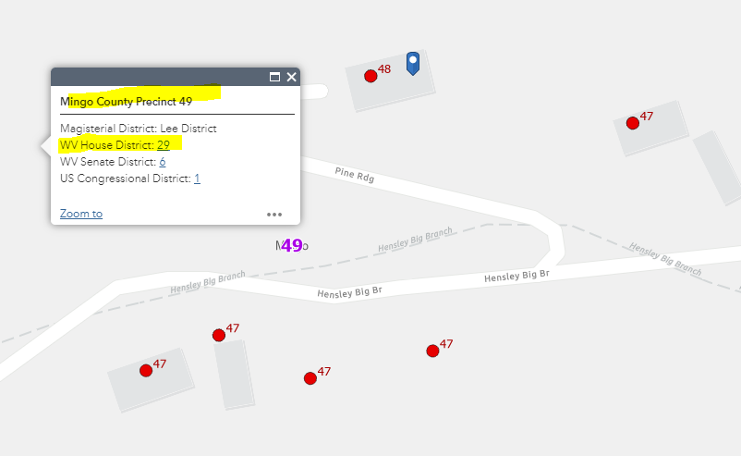
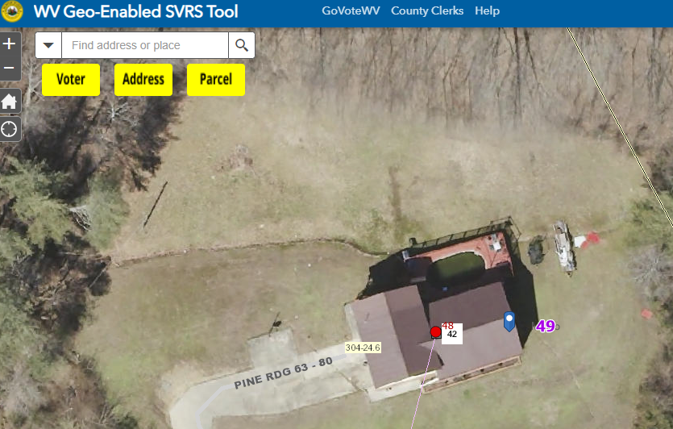

If you have already made these redistricting changes in the SVRS, then please disregard this message. An updated Precinct Mismatch Report with a new SVRS data pull should be available next week.
Sincerely,

Kurt Donaldson, GISP, CFM
Manager
WV GIS Technical Center
West Virginia University
(304) 293-9467
https://wvgis.wvu.edu

