Geometry changes recommended for Wetzel County’s Voting Precinct Boundaries to match voting record assignments in State’s Voter Registration System (SVRS).
- Based on 9/11/2023 SVRS Data Extract
- Recommendations Compiled by Kurt Donaldson 9/25/2023

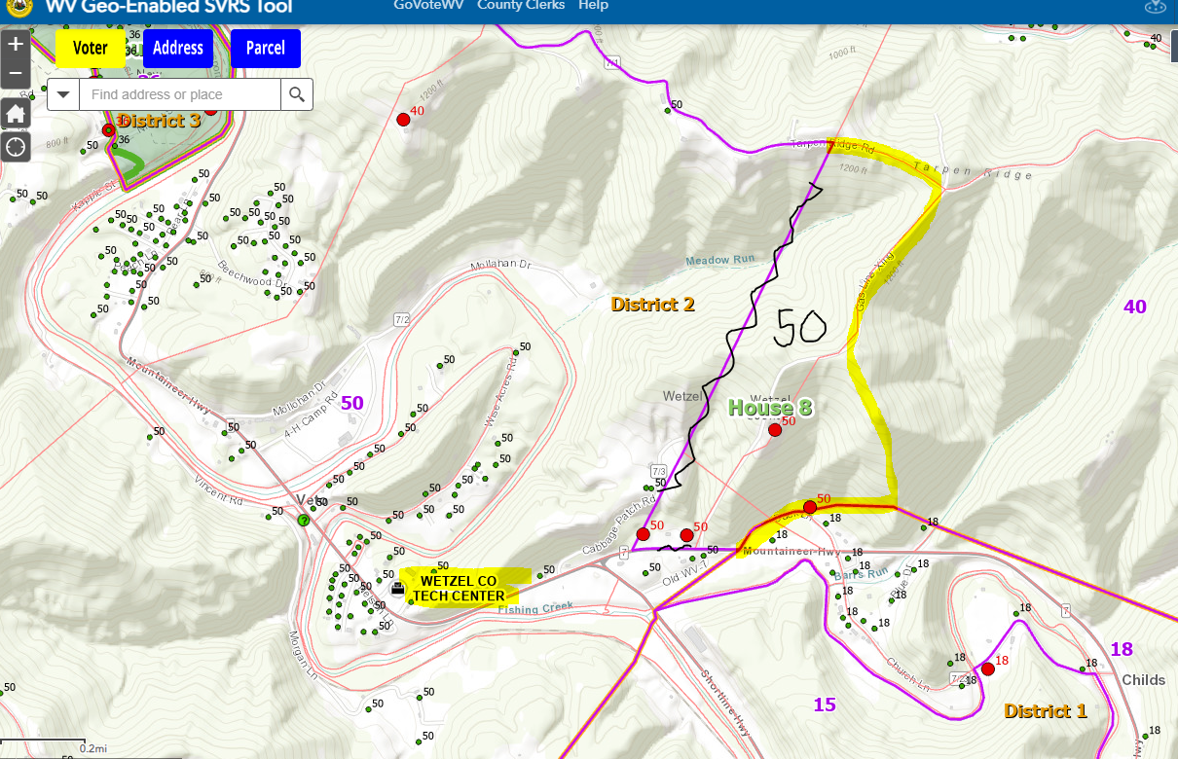
PRECINCT 50
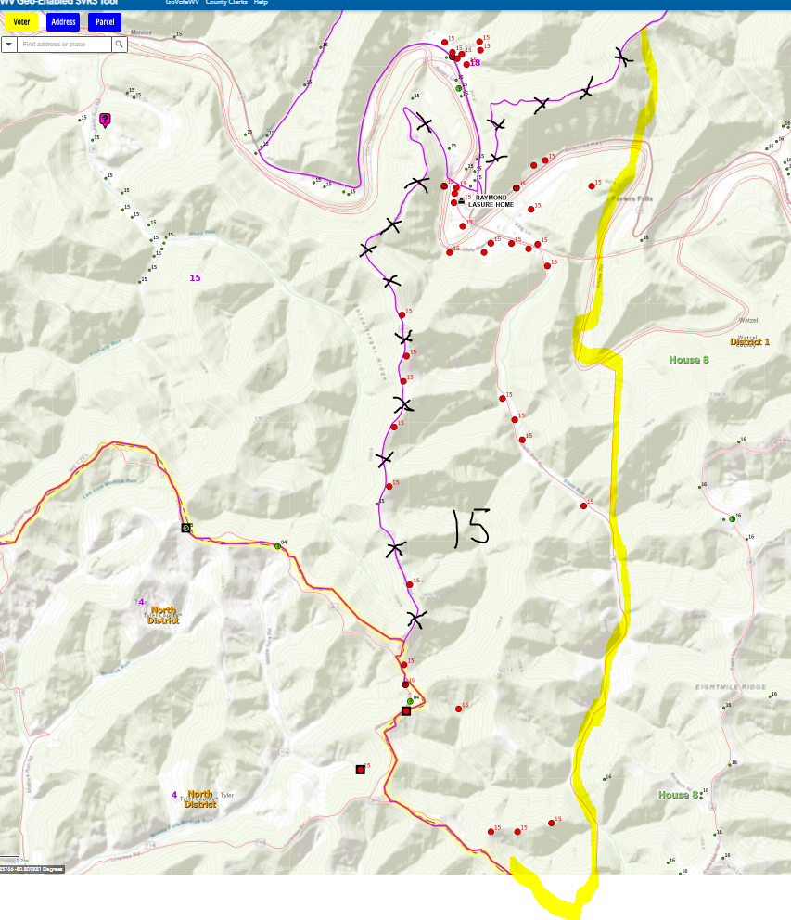
PRECINCT 15
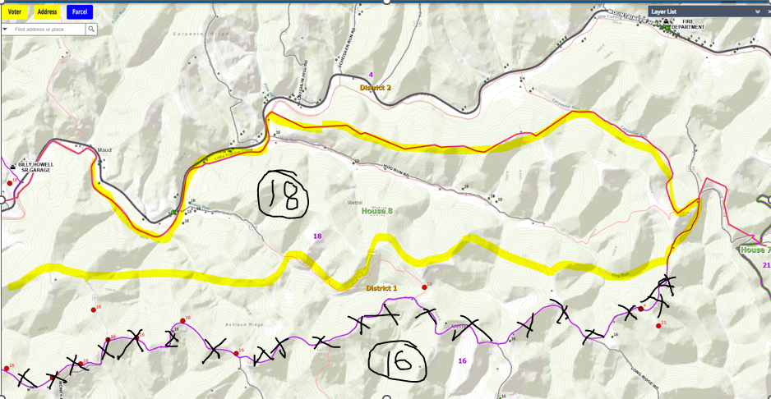
PRECINCT 18 & PRECINCT 16
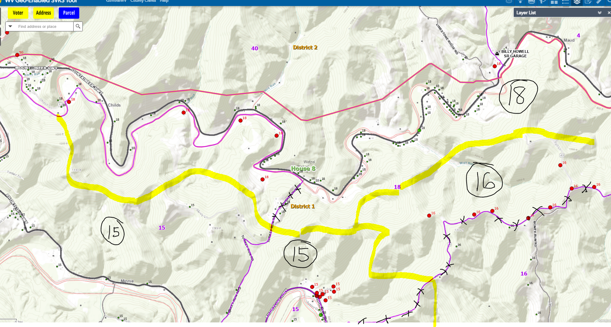
PRECINCTS 15, 16, 18
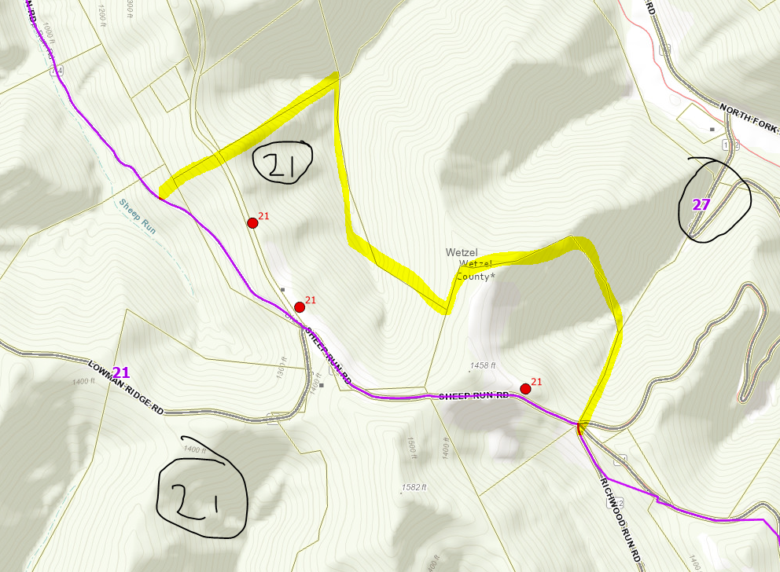
PRECINCT 21
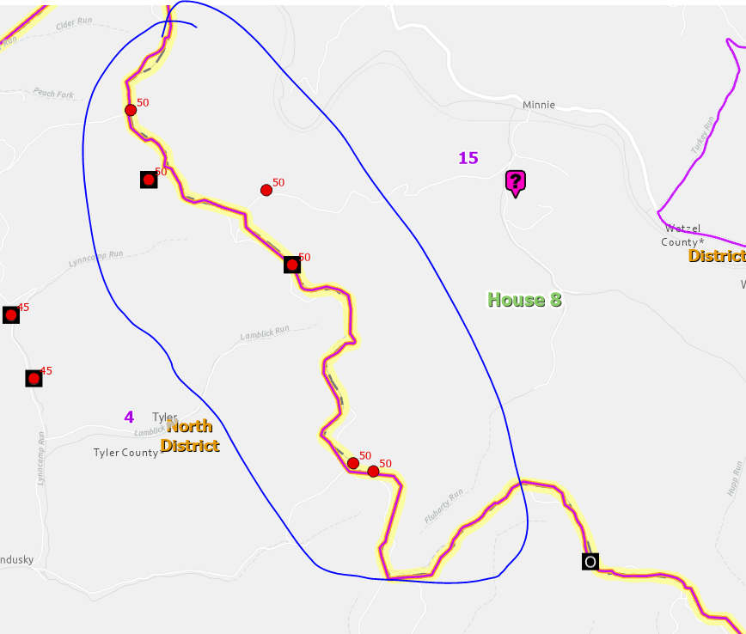
Wetzel Precinct 15 and Tyler Precinct 5 boundary needs to be coincidental to county boundary
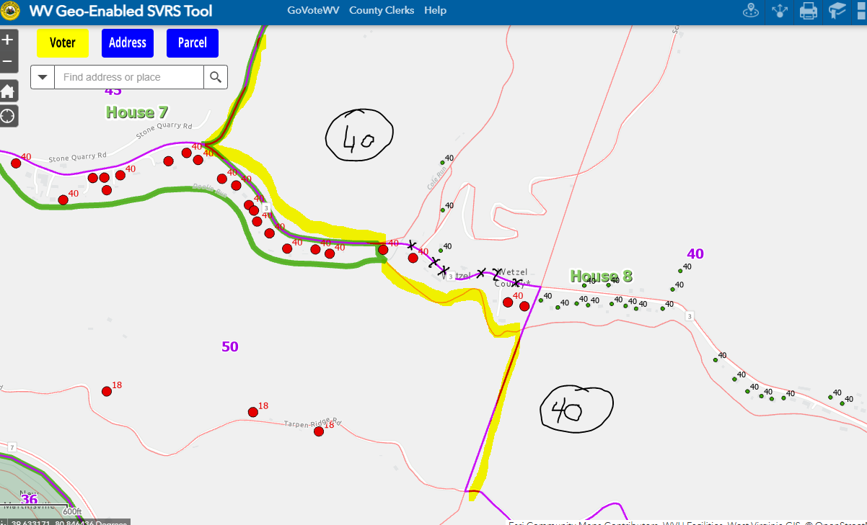
Precinct 40
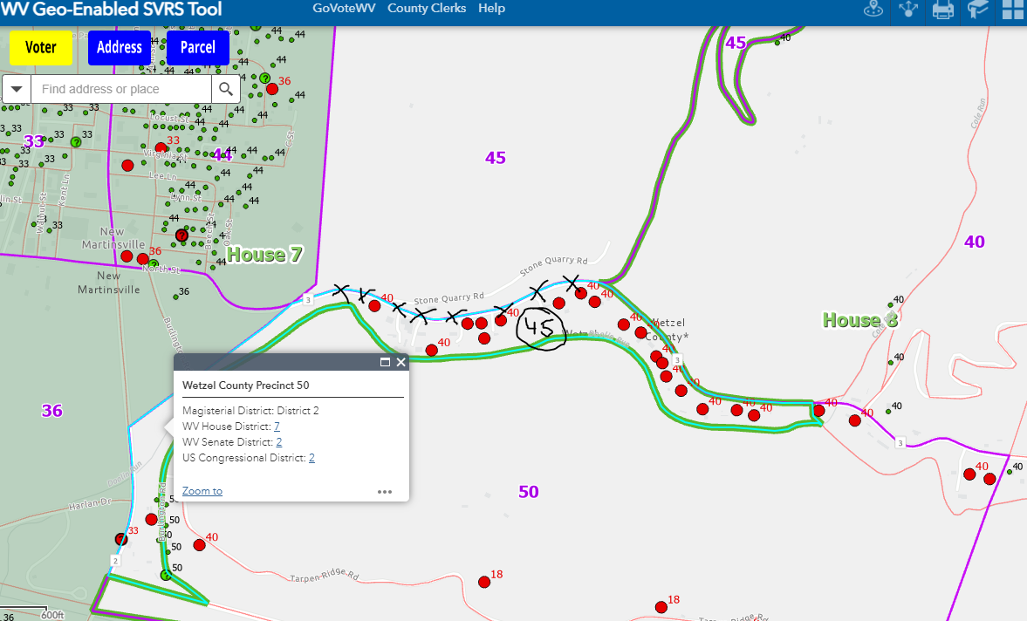
Precinct 45

