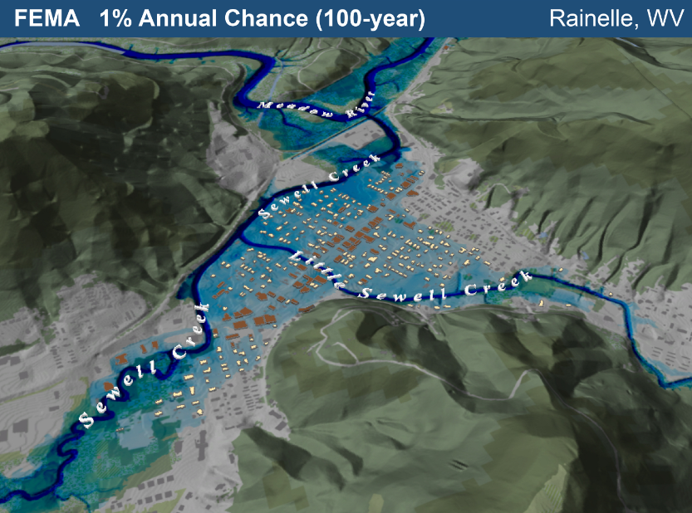

WV Emergency Management Division
COOPERATING TECHNICAL PARTNERS
FEMA-APPROVED COMMUNITY OUTREACH AND MITIGATION STRATEGIES (COMS)
STATEMENT OF WORK
COMS SOW No. 3

Fiscal Year 2024


This page intentionally left blank
Table of Contents
1. Part 1 – Custom Statement of Work Information 1
1.1. Project and Point of Contact Information 1
1.2. Tasks and Deliverables to be Completed Under this SOW 3
1.3. Schedule and Performance 11
1.4. Guidelines and Standards 13
1.5. Use of Contractors 13
1.6. Reporting and Performance 14
1.7. Privacy and Protection of Personally Identifiable Information 15
Authorized Representative Signatures 16
APPENDIX A: Scope of State NFIP Office COMS Tasks A-1
APPENDIX B: Scope of WVU Led COMS Tasks B-1

  - Part 1 – Custom Statement of Work Information
In accordance with the CTP Partnership Agreement referenced in Table 1 between the WV Emergency Management Division / State NFIP Office (herein referred to as “CTP”) and FEMA, the following subsections explain the scope to be undertaken to enhance communication and coordination detailed within this COMS SOW No. 3.
    - Project and Point of Contact Information
Instructions: Complete Table 1 with the basic project information and points of contact for both the CTP and FEMA staff.
Table 1. Project and Point of Contact Information
Information Type | Insert Information
Project Name/Title (if applicable) | WVEMD CTP COMS 2024-25
CTP Organization Name: | WV Emergency Management Division
CTP Contractor Working on the activities in this SOW:  Optional, only if contractors have already been identified; contractor support may be engaged for all activities except Staffing and Mentoring, which must be completed by the CTP | WVU GIS Technical Center, West Virginia University
Sub-Recipient Working on the activities in this SOW:  Optional, only if sub-recipients have already been identified; contractor support may be engaged for all activities except Staffing and Mentoring, which must be completed by the CTPs | N/A
CTP Partnership Agreement Date: | 7/2023
Period of Performance: | 10/1/2024 to 9/30/2025
CTP Project Manager: | Timothy W. Keaton, CFM
FEMA Regional Project Officer:  When necessary, ask for FEMA assistance through the FEMA Regional Project Officer | Kristen Jones (primary contact)  Senior Risk Analysis Management and Program Analyst | Mitigation | Region 3
FEMA Funding to Complete this COMS SOW: | $250,000
CTP Estimated Leverage:  Final leverage dollars or units will be entered as applicable in the Manage Data Development Task Workflow in the Mapping Information Platform (MIP). The leverage noted here is an estimate of leverage available at the time when the scope is prepared. It may be refined at any time in the project. See Estimating the Value of Partner Contributions to Flood Mapping Projects “Blue Book” (Blue Book) | N/A
Project Team Coordination Activities:  During the project, all members of the Project Team will coordinate, as needed, to see that activities, products and deliverables meet FEMA requirements and contain accurate, up-to-date information. | - Meetings, teleconferences, and video conferences with FEMA Region III, WVEMD, and other Project Team members biannually at a minimum with additional meetings scheduled as necessary.  - Telephone conversations with FEMA and other Project Team members on a scheduled monthly basis and ad hoc basis, as required.  - Email as needed

    - Tasks and Deliverables to be Completed Under this SOW
      - Narrative and Audience
Table 2. Narrative and Audience
Information Type | Insert Information
SOW Narrative: | This CTP project focuses on mitigation support, communication and outreach to communities, and mitigation planning technical assistance activities as well as support for the WV Flood Tool. Specifically, the tasks for this year’s CTP COMS grant will:  - Update the COMS Engagement Plan.  - Promote risk awareness and mitigation actions at the community level by way of training and outreach events.  - Provide Global Outreach Services for the WV Flood Tool  - Update the WV Building Level Risk Assessment (BLRA) from New Data Sources (e.g., Flood Studies, Building Characteristics)  - Develop, verify, and publish flood risk profiles at eight geographic scale levels: State, Regional, County, Community, Unincorporated Area, Incorporated Place, Watershed, and Streams. Perform Building Cluster Analysis for CNMS Identification of Potential Approximate A Zones for Upgrade to Zone AE Detailed Mapping  - Create flood visualizations at the viewshed and building level scales to communicate flood risk to the public more effectively.  - Organize and publish an online WV Hazard Library of resources related to flood resiliency research, hazard risk assessments, floodplain management, and mitigation activities.  - Support Local Hazard Mitigation Plans with Flood/Landslide Risk Assessment Data  This project includes mitigation, outreach, and technical services that support the goals of FEMA’s NFIP/CRS and Risk MAP programs. It also includes technical assistance activities that will produce and disseminate products and materials to the state and local jurisdictions to develop, evaluate, update, and implement their mitigation plans and strategies. This CTP COMS Project supports statewide global outreach services that process and integrate new flood and reference GIS layers, tool enhancements, flood risk information, etc. for the WV Flood Tool (www.mapwv.gov/Flood). In addition, an overarching goal of this CTP COMS project is to more proactively engage flood-prone communities to use the new statewide building-level risk assessment data for their floodplain management and mitigation planning activities.  The major scoping activities are divided by WV NFIP Office Led (Appendix A) and WVU GIS Technical Center led (Appendix B). Refer to Appendices A and B for detailed statements of work.
Intended Audience: | Target Audience: Floodplain Managers, Community Planners, Emergency Preparedness Officials, and Citizens of affected communities.  Project Footprint: State of West Virginia  Through collaboration with Local, State, and Federal entities, the WV Flood Tool delivers quality data that increases public awareness and leads to actions that reduce risk to life and property. To manage the wealth of available data and better communicate flood risk, the WV Flood Tool has maintained a public facing outreach tool for the public, communities, engineering/surveying companies, and others (Insurance companies, lending institutions, real estate companies, etc.) that has provided effective floodplain models, supporting datasets, water-surface elevations, floodplain boundaries, and additional enhanced flood risk information. During the past decade, the functionality and quality of data layers of the WV Flood Tool have progressed, resulting in an increased use of the application. Over time, the WV Flood Tool has become more than just a flood determination tool, and today is routinely used by floodplain managers for building permit applications, floodplain regulations enforcement, pre- and post-disaster assessments, and Community Rating System discounts. For community and emergency planners, the Risk MAP View of the WV Flood Tool now includes structure-level risk assessments and mitigated properties to aid in flood reduction efforts.
      - Project Tasks and Deliverables
The following 11 tasks can be accomplished under this COMS SOW:
- COMS Engagement Plan (Required).
- Strategic Planning for Community Engagement.
- Meetings and Process Facilitation.
- Mitigation Support.
- Communication and Outreach to Communities.
- Training and Community Capability Development.
- Mitigation Planning Technical Assistance.
- Internal Partner Support Activities:
  - Directly Funded Staffing.
  - Mentoring.
- Pilot Projects.
- CTP Symposium. Task 1 – Develop COMS Engagement Plan (Required)
This task is required as a condition of COMS funding – see Part 2.1.
Table 3. Task 1 – Develop COMS Engagement Plan
COMS Task | Mark “X” if task will be done under this SOW | (A) FEMA Contribution | (B) Partner Contribution |  | (A+B) Total Project Cost
COMS Engagement Plan (required as a condition of COMS funding) (see Part 2.1) | ☒ | $5,000 | $0 |  | $5,000
Deliverable |  |  |  | Mark “X” if deliverable will be done under this task
COMS Engagement Plan (required) (Task 1) |  |  |  | ☒
Custom Scope Elements
COMS Engagement Plan ($5K)
- Complete a COMS Engagement. Update the COMS Engagement Plan for delivery to FEMA Region III that advances the NFIP/CRS and Risk MAP programs in West Virginia. The COMS Engagement Plan will adhere to the guiding principles detailed in Appendix C of the NOFO FY24 CTP Program.

        - Task 4 – Mitigation Support
Table 6. Task 4 – Mitigation Support
COMS Task | Mark “X” if task will be done under this SOW | (A) FEMA Contribution | (B) Partner Contribution |  | (A+B) Total Project Cost
Mitigation Support | ☒ | $199,000 | $0 |  | $199,000
Deliverable |  |  |  | Mark “X” if deliverable will be done under this task
Action Identification and Advancement Strategy (i.e., a summary of the partners’ approach to encourage mitigation action by community) |  |  |  | ☐
Quarterly projections indicating the potential collection of Actions Identified and Advanced Strategy |  |  |  | ☐
Summary of new Actions Advanced or status updates on existing Actions Advanced through this coordination |  |  |  | ☒
Other Task A: Provide Global Outreach Services for the WV Flood Tool. ($112K) |  |  |  | ☒
Other Task B: Update the WV Building Level Risk Assessment (BLRA) from New Data Sources (e.g., Flood Studies, Building Characteristics. ($24K) |  |  |  | ☒
Other Task C: Develop, verify, and publish flood risk profiles at eight geographic scale levels: State, Regional, County, Community, Unincorporated Area, Incorporated Place, Watershed, and Streams. ($28K) |  |  |  | ☒
Other Task D: Create flood visualizations at the viewshed and building-level scales to communicate flood risk to the public more effectively. ($17K) |  |  |  | ☒
Other Task E: Organize and publish an online WV Hazard Library of resources related to flood resiliency research, hazard risk assessments, floodplain management, and mitigation activities. ($18K) |  |  |  | ☒
Custom Scope Elements
Mitigation Support WVU Led Tasks - $199K (See Appendix B for more details)
- Provide Global Outreach Services for the WV Flood Tool. Statewide global outreach services that process and integrate new flood and reference GIS layers, tool enhancements, flood and landslide risk information, etc. for the WV Flood Tool (www.mapwv.gov/Flood). Services include computer programming, data development/geo-processing, customized mapping, technical support and training services. This task includes developing outreach materials along with in-person and remote training courses for the WV Flood Tool. Customized training often focuses on features that distinguishes the WV Flood Tool from FEMA’s NFHL Viewer and Flood Insurance Rate Maps (FIRMs). For example, the WV Flood Tool provides BFEs for Approximate A Zones and high-resolution elevation date for qualifying LIDAR LOMAs. FEMA does not provide these map services. In addition, the WV Flood Tool publishes Elevation Certificates, Verified LOMA locations, HEC-RAS stream models, and 1%-annual-chance advisory floodplains / BFE’s / depth grids not available by FEMA maps services. (WVU Task A)

- Update the WV Building Level Risk Assessment from New Data Sources (e.g., Flood Studies, Building Characteristics). Update building-level flood risk assessments for structures in the high-risk flood zones using the best available Risk MAP data and products. New Risk MAP studies always trigger updating the identification and risk assessment of all structures in high-risk flood zones. Publish updated building-level assessments to the Risk MAP View of the WV Flood Tool. (WVU Task B)

- Develop, verify, and publish flood risk profiles at eight geographic scale levels: State, Regional, County, Community, Unincorporated Area, Incorporated Place, Watershed, and Streams. A new risk tool named the WV Risk Explorer will allow communities to quickly view risk factors affecting their jurisdictions. Risk dashboards for risk assessment data shall be developed as well, all part of a suite of risk assessment and visualization tools for building community flood resilience in West Virginia. (WVU Task C).

- Create flood visualizations at the viewshed and building level scales to communicate flood risk to the public more effectively. Incorporate high water marks of previous major flood disasters in flood models. Additionally, compare flood frequency flood depths between FEMA and First Street Foundation flood models. (WVU Task D). The online WV Hazard Library (WVU Task E) will allow users to access the flood visualizations, a collection of movies, animations, story maps, and other visualization media available at the building and community levels for communicating and understanding flood risk in West Virginia.
- WV Hazard Library. Organize and publish an online WV Hazard Library of resources related to flood resiliency research, hazard risk assessments, floodplain management, and mitigation activities. A Hazard Library specific to West Virginia is being organized and populated into a database in which the public can search online resources. The library contains web links to various risk assessment and mitigation resources, to include studies, graphics, reports, plans, model ordinances/regulations, movies, maps, presentations, best practice guides, training courses, publications, meeting notes, relevant data sets, etc. Users can search the Hazard Library by subject, spatial extent, geographic scale, or document type. The Hazard Library consists of major collections for risk assessments, flood events, and mitigation reduction efforts (mitigation measures, hazard planning, floodplain management, Risk MAP studies, flood models, etc.) The classification system of the Hazard Library is flexible in that additional subjects can be added. (WVU Task E)

        - Task 6 – Training and Community Capability Development
Table 8. Task 6 – Training and Community Capability Development
COMS Task | Mark “X” if task will be done under this SOW | (A) FEMA Contribution | (B) Partner Contribution |  | (A+B) Total Project Cost
Training and Community Capability Development (see Part 2.6) | ☒ | $33,000 | $0 |  | $33,000
Deliverable |  |  |  | Mark “X” if deliverable will be done under this task
Copies of draft training materials for FEMA review |  |  |  | ☒
Copies of final training materials |  |  |  | ☒
A list of training instructors |  |  |  | ☒
A list of all participants and completed course evaluations (such as pre- and post-knowledge surveys) after each training course |  |  |  | ☒
Report on outreach activities as part of training and community capability development. |  |  |  | ☐
A description of how training will benefit the public and accomplish the Risk Mapping, Assessment, and Planning (Risk MAP) goals of awareness and action |  |  |  | ☒
A narrative including how it was determined that the training was needed and how communities that received training were prioritized |  |  |  | ☐
Other Task 2: Promote risk awareness and mitigation actions at the community level by way of training and outreach events. ($33K) (WV EMD/State NFIP Office) |  |  |  | ☒
Custom Scope Elements
Training and Community Capability Development - $33K (See Appendix A for more details)
- Complete a COMS Engagement. Update the COMS Engagement Plan for delivery to FEMA Region III that advances the NFIP/CRS and Risk MAP programs in West Virginia. The COMS Engagement Plan will adhere to the guiding principles detailed in Appendix C of the NOFO FY24 CTP Program. (WV EMD/State NFIP Office)

        - Task 7 – Mitigation Planning Technical Assistance
Table 9. Task 7 – Mitigation Planning Technical Assistance
COMS Task | Mark “X” if task will be done under this SOW | (A) FEMA Contribution | (B) Partner Contribution |  | (A+B) Total Project Cost
Mitigation Planning Technical Assistance (see Part 2.7) | ☒ | $13,000 | $0 |  | $13,000
Deliverable |  |  |  | Mark “X” if deliverable will be done under this task
Copies of all technical data provided to local, state and tribal communities |  |  |  | ☒
A report detailing the technical assistance provided including date(s) of technical assistance, type of assistance and communities’ stakeholders supported |  |  |  | ☒
Other Task F: Support Local Hazard Mitigation Plans with Flood/Landslide Risk Assessment Data. ($13K) |  |  |  | ☒
Custom Scope Elements
Mitigation Planning Technical Assistance - $13K (See Appendix B for more details)
- Support Local Hazard Mitigation Plans with Flood/Landslide Risk Assessment Data. This mitigation planning technical assistance task supports mitigation planners and consultants with various risk assessment products for updating their local hazard mitigation plans. The risk assessment and mitigation products were generated from the HMGP Statewide Multi-Hazard Risk Assessment Project and select data sets are updated each year. The multi-hazard data includes riverine flooding, landslides, and dam failure. Refer to the catalog or Risk Information Index to access various risk assessment products (reports, tables, graphics, risk dashboards, etc.) published in support of FEMA’s Hazard Mitigation Plans and NFIP/CRS activities. See the 2022 TEIF-TEAL Close-out Report about risk assessment and mitigation products as well.

    - Schedule and Performance
Table 16. COMS Deliverables Schedule
SOW Activities | Deliverable | Deliverable Due Date | Submitted To
COMS Engagement Plan (required) | COMS Engagement Plan | 9 months from Award date | FEMA Regional Project Officer
Training and Community Capability Development | Reporting on Outreach Activities | Quarterly | FEMA Regional Project Officer
Mitigation Support | Reporting on MS Activities | Quarterly | FEMA Regional Project Officer
Mitigation Planning Technical Assistance | Reporting on TA Activities | Quarterly | FEMA Regional Project Officer
The activities documented in this SOW will be completed in accordance with Table 16. COMS Deliverables Schedule. If this schedule needs to change, the CTP will coordinate with the FEMA Regional Project Officer and other necessary Mapping Partners as soon as possible. Deliverables must be uploaded to the MIP unless otherwise approved by the FEMA Regional Project Officer. The CTP must upload final deliverables in the MIP before the period of performance ends.

Table 17. Performance Measures Targets

Outcome1 | Output Measurement2 (with customized Target) | Recorded Unit/Scale
Update COMS Plan | COMS Plan Updated | Achieved / Not Achieved
Training and outreach events | Scheduled training and outreach events achieved | Achieved / Not Achieved
Update WV Flood Tool with new hazard data | Flood hazard, risk assessment, and key reference layers updated on the WV Flood Tool (www.mapwv.gov/flood). | Achieved / Not Achieved
WV Flood Tool training | - Develop and publish training materials.  - Provide in-person and remote training. | Achieved / Not Achieved
WV Risk Explorer | Online interactive WV Risk Explorer for community risk assessments released | Achieved / Not Achieved
WV Hazard Library | Organize and publish an online WV Hazard Library for users to search hazard resources. | Achieved / Not Achieved
Flood Visualizations | Complete flood visualizations at the building and viewshed scales. Catalog visualizations in the Hazard Library for user access. | Achieved / Not Achieved
Support Local Hazard Mitigation Plans | Provide access to various risk assessment products (reports, tables, graphics, risk dashboards, etc.) | Achieved / Not Achieved
Update the WV Building Level Risk Assessment (BLRA) from New Data Sources | Update Hazus flood loss models and risk assessment products associated with inventoried floodplain buildings. New model inputs consist of:  - Depth Grids: Incorporate 1-meter resolution depth grids from regulatory (Risk MAP) and non-regulatory (Updated AE Redelineation, Advisory Flood Heights) flood studies. Incorporate flood depths for nearly all 55 counties.  - Tax Year 2024 Building Characteristics: Updated building replacement values, occupancy class, stories, etc. from 1.4 million tax assessment data parcels.  - Mitigated Structures: Incorporate elevated first-floor heights and foundation types (open, closed) from mitigated structure datasets: elevation certificates, building pictures, etc. | Update BLRA of 98,000 flood-prone structures in State from new data sources (e.g., depth grids, tax assessment records, mitigated structures)  Achieved / Not Achieved
    - Guidelines and Standards
The standards relevant to this SOW are presented in FEMA Policy 204-078-1 Standards for Flood Risk Analysis and Mapping, Revision 14.
This Policy supersedes all previous standards in the Guidelines and Specifications for Flood Hazard Mapping Partners. This includes all related appendices and procedure memoranda. Find more information and links to guidance documents, technical references, templates, and other resources that support these standards on the FEMA Guidelines and Standards website. This is at: Guidelines and Standards for Flood Risk Analysis and Mapping Activities Under the Risk MAP Program. FEMA reviews standards each year. Please use the most current version of the policy.
CTPs and their sub-awardees must also comply with the regulations in Title 44 of the Code of Federal Regulations (CFR). They must also comply with the appropriate year CTP funding opportunity and Agreement Articles. CTPs should work with their regional office to determine any additional requirements.
    - Use of Contractors
Check the applicable statement in Table 18.
Table 18. Use of Contractors
Select One | Description of Contractor Options
☒ | Contractor support may be engaged for all activities within this SOW, except staffing and mentoring, which must be completed by the CTP. Guidance provided in this part includes, but is not limited to, contract administration and recordkeeping, notification requirements, review procedures, competition, methods of procurement, and cost and pricing analysis. For more information, refer to the online resource, Title 2 Code of Federal Regulations (CFR) Part 200 - Uniform Administrative Requirements, Cost Principles, and Audit Requirements for Federal Awards. Additionally, contractors must not pose a conflict-of-interest issue or be active in writing the SOW.  Contractors support will be provided by the WV GIS Technical Center, West Virginia University
☐ | The CTP does not intend to engage the services of a contractor for this SOW. No transfer of funds to agencies other than those identified in the approved cooperative agreement application will be made without prior approval from FEMA. The CTP will identify the name of the CTP contractor for services engaged as part of this SOW. The CTP will ensure that the procurement for all contractors engaged for this COMS Activity complies with the requirements of 2 CFR Part 200.  Guidance provided in this part includes, but is not limited to, contract administration and recordkeeping, notification requirements, review procedures, competition, methods of procurement, and cost and pricing analysis. Additionally, contractors must not pose a conflict-of-interest issue.
    - Reporting and Performance
Financial Reporting: Because FEMA has provided funding to the CTP, financial reporting requirements for the CTP will be set by the terms of the funding opportunity, Articles of Agreement, or Award Notice for this SOW. The CTP will also refer to 2 CFR Part 200. The CTP will provide financial reports to the FEMA Regional Project Officer and Assistance Officer per the terms of the signed Cooperative Agreement for this SOW.
Performance Reporting: CTPs must provide a signed performance report (using the list of required information shown in the funding opportunity). The CTP will submit the report quarterly during the period of performance. Reports will be required for partial calendar quarters and periods when no grant award activity occurs. An old Standard Form-Performance Progress Report (SF-PPR) may be substituted for the performance report, if preferred. The CTP will refer to 2 CFR Part 200 for the minimum requirements for progress reporting. The FEMA Regional Project Officer, as needed, may request additional information on progress.
The CTP will meet with FEMA and/or its contractor(s) as frequently as needed to review the progress of the project. These meetings are in addition to the quarterly financial and status submittals. These meetings may alternate between the FEMA Regional Office, the CTP office and conference calls as necessary.
The CTP must report performance of the grant along with the progress reports. Table 17. Performance Measures Targets shows which performance measures the CTPs will use to track performance. If you are completing a COMS project alongside a Flood Risk Project MAS, use the relevant measures in the 2024 CTP Performance Measures Matrix. Quantitative Targets for performance measures are defined using the 2024 CTP Performance Measures Matrix in conjunction with your FEMA Regional Project Officer and those defined in Table 17.
CTPs are responsible for entering their quarterly performance of each measure into the CTP Performance Measures Reporting Tool (Tool) each quarter, unless otherwise directed by their FEMA Regional Project Officer. Each output measurement identified above must have a quarterly performance reported in the Tool within one month of the end of the quarter. Quarterly performance data can be exported from the Tool and attached to the Quarterly Report that must be uploaded to FEMA GO.
Earned Value Data Entry:
The CTP must report on the earned value of projects that are in the MIP each month. They must explain variances outside of the tolerance defined in Table 17. Performance Measures Targets The FEMA Regional Offices must initiate and create a Corrective Action Plan (CAP) when a CTP is outside of the tolerance. The CTP is required to implement this CAP as instructed by their FEMA Regional Office. A CAP must define the reason for the variance and the intended resolution. FEMA Regional Offices will coordinate with FEMA Headquarters when CAPs are developed.
COMS SOW/PM SOW tasks are now tracked in the MIP. Cost and schedule performance measures are defined in this SOW. These measures will be used to monitor CTP performance and to determine future funding eligibility. Earned Value data entry involves the CTP updating cost, schedule and performance (physical % complete) in the MIP each month for each assigned task. The CTP may contact the FEMA Regional Office to obtain additional guidance (as needed) for updating COMS/PM efforts in the MIP.
    - Privacy and Protection of Personally Identifiable Information
A CTP’s organizational access to the MIP provides you access to PII. Please have your organization coordinate with the FEMA Regional Office. Each user must currently meet the new Risk Analysis Management (RAM) Access Portal (RAP) process requirements. Please contact your FEMA Regional Project Officer for more information.

Authorized Representative Signatures
Each party has caused this SOW to be executed by its duly authorized representative.

_____________________________________________________________________________________
Timothy Keaton Date
Project Manager
WV Emergency Management Division

_____________________________________________________________________________________
Kristen Jones Date
Regional Project Officer
Federal Emergency Management Agency, Region, Region 3

APPENDIX A: Scope of State NFIP Office COMS Tasks
2024-25 CTP COMS Scope: WV Focused Flood Reduction and Mitigation Engagement Activities
State: West Virginia
Total Cost: $38,000
Performance Period: October 1, 2024, to September 30, 2025 (12 months)
Plan by Tim Keaton, State NFIP Coordinator, WV Emergency Management Division. Technical support from the WVU GIS Technical Center.
7/16/2024
The State NFIP Office led COMS tasks will consist of updating the COMS Engagement Plan and for training and community development in support of flood reduction and mitigation programs.
- Update COMS Engagement Plan
- Training and Community Capability Development. Promote risk awareness and mitigation actions at the community level by way of training and outreach events.

COMS Engagement Plan ($5K) WVEMD Task 1
- Complete a COMS Engagement. Update the COMS Engagement Plan for delivery to FEMA Region III that advances the NFIP/CRS and Risk MAP programs in West Virginia. The COMS Engagement Plan will adhere to the guiding principles detailed in Appendix C of the NOFO FY24 CTP Program.
Training and Community Capability Development ($33K) WVEMD Task 2
- Promote risk awareness and mitigation actions at the community level by way of training and outreach events. These training and outreach meetings -- coordinated with FEMA Region -- focus on community engagement, risk communication, floodplain management, flood study coordination, and identifying and advancing mitigation actions. This task also includes the creation of customized floodplain management resources for the state. Targeted audiences include the public while specialized training and outreach activities focus on the community development of stakeholders that include floodplain managers, emergency preparedness officials, risk planners, and elected officials. Refer to the COMS Engagement Plan for previous and future training/outreach events.

Elements of this the training and community development task include:
- Maintain and/or utilize personnel to support COMS activities (such as attending Risk MAP meetings or meetings hosted by FEMA Regions).
- Create a climate of understanding and ownership of the WV Flood Tool in support of the Risk MAP flood risk study phases among stakeholders.
- Promoting new training resources for State and Local Officials. Sponsored by the State NFIP Office, a new standardized Permit Application is being created by the company TETRA TECH for the local floodplain managers.
- Provide supplemental training and technical outreach services to:
  - Increase CRS participation by communities in the state. The Community Rating System (CRS) is a voluntary incentive program that recognizes and encourages community floodplain management practices to exceed the minimum requirements of the National Flood Insurance Program (NFIP).
  - Reduce repetitive loss structures via the submission of Repetitive Loss (RL) AW-501 Worksheets and FMA grant applications
  - Meet the new requirements of FEMA’s Redesigned NFIP Compliance Audit Program which include the National Violation Tracker (NVT) property database.

`

APPENDIX B: Scope of WVU Led COMS Tasks

2024-25 CTP COMS Services and Projects performed by West Virginia University
State: West Virginia
Total Cost: $212,000
Performance Period: October 1, 2024, to September 30, 2025 (12 months)
Plan by Tim Keaton, State NFIP Coordinator, WV Emergency Management Division. Subcontract work to WVU GIS Technical Center.
7/16/2024
Special Community Outreach Mitigation Strategies (COMS) projects performed by the WVU GIS Technical Center, to include:

The WVU led COMS tasks are organized by four scoping activities, to include:
- Provide Global Outreach Services for the WV Flood Tool
- Update the WV Building Level Risk Assessment (BLRA) from New Data Sources (e.g., Flood Studies, Building Characteristics)
- Develop, verify, and publish flood risk profiles at eight geographic scale levels: State, Regional, County, Community, Unincorporated Area, Incorporated Place, Watershed, and Streams. Perform Building Cluster Analysis for CNMS Identification of Potential Approximate A Zones for Upgrade to Zone AE Detailed Mapping
- Create flood visualizations at the viewshed and building level scales to communicate flood risk to the public more effectively.
- Organize and publish an online WV Hazard Library of resources related to flood resiliency research, hazard risk assessments, floodplain management, and mitigation activities.
- Support Local Hazard Mitigation Plans with Flood/Landslide Risk Assessment Data

Mitigation Support ($199K) (WVU Tasks A through E)
- WV Flood Tool. Provide Global Outreach Services for the WV Flood Tool. Statewide global outreach services that process and integrate new flood and reference GIS layers, tool enhancements, flood and landslide risk information, etc. for the WV Flood Tool (www.mapwv.gov/Flood). Services include computer programming, data development/geo-processing, customized mapping, technical support and training services. This task includes developing outreach materials along with in-person and remote training courses for the WV Flood Tool. Customized training often focuses on features that distinguishes the WV Flood Tool from FEMA’s NFHL Viewer and Flood Insurance Rate Maps (FIRMs). For example, the WV Flood Tool provides BFEs for Approximate A Zones and high-resolution elevation date for qualifying LIDAR LOMAs. FEMA does not provide these map services. In addition, the WV Flood Tool publishes Elevation Certificates, Verified LOMA locations, HEC-RAS stream models, and 1%-annual-chance advisory floodplains / BFE’s / depth grids not available by FEMA maps services. See Table B-1 below for more details and for the scope of these services. (WVU Task A)

Table B-1. Detailed task description for WV Flood Tool.
Task Description
[GLOBAL OUTREACH SERVICES FOR WV FLOOD TOOL]
The WV Flood Tool and global outreach services support stakeholders in pre-disaster actions around adaptation, resilience, and mitigation. The global outreach supports FEMA’s NFIP/CRS Program objectives to:
- Maintain consistent national standards while interjecting a tailored, local focus
- Use local data and integrate at state level to facilitate floodplain management
- Utilize local experience and knowledge
- Provide training and technical assistance
- Provide communities with state-based CRS credits
- Support Risk MAP Program Goals of Flood Hazard Data, Public Awareness and Outreach, Risk Planning, Enhanced Digital Platform, and Alignment and Synergies

Through collaboration with Local, State, and Federal entities, the WV Flood Tool delivers quality data that increases public awareness and leads to actions that reduce risk to life and property
To manage the wealth of available data and better communicate flood risk, the WV Flood Tool has maintained a public facing outreach tool for the public, communities, engineering/surveying companies, and others (Insurance companies, lending institutions, real estate companies, etc.) that has provided effective floodplain models, supporting datasets, water-surface elevations, floodplain boundaries, and additional enhanced flood risk information. During the past decade, the functionality and quality of data layers of the WV Flood Tool have progressed, resulting in an increased use of the application. Over time the WV Flood Tool has become more than just a flood determination tool, and today is routinely used by floodplain managers for building permit applications, floodplain regulations enforcement, pre- and post-disaster assessments, Community Rating System discounts, and flood risk planning. For risk assessment and planning, the Risk MAP View includes structure-level risk assessments and mitigated properties to aid in flood reduction efforts. This CTP activity enables the website and the WV Flood Tool's global outreach program to adapt and remain relevant as both the datasets and technology continue to evolve.
Specific tasks under global outreach services in support of the WV Flood Tool include:
New Flood Map Products:
- Incorporate new regulatory and non-regulatory flood hazard layers into the WV Flood Tool. Publish all the flood layers, query layers, geoprocessing layers, models, and attributes according to standardized procedures and cartographic design.

- Effective and Preliminary National Flood Hazard Layers (e.g., Countywide RiskMAP Studies, 2016 Flood PRM Reaches in Southeastern WV, Advisory Flood Heights)
  - Add effective or draft/preliminary NFHL, WSEL, and Flood Depth
  - Advisory Flood Heights and Base Flood Elevations
  - For Preliminary Flood Heights, in Flood Query Results Panel link Preliminary Flood Zones to FEMA’s Map Changes Viewer
- Flood Study Status Graphics
  - Active Flood Studies
  - Advisory Flood Heights
  - FEMA R3 Project Status Graphic
- Floodplain Boundary, WSEL, Depth Layers
  - Floodplain Boundary: Regulatory and Non-Regulatory Advisory Zones (Preliminary/Draft NFHL; Updated AE or Advisory A Zones)
  - WSEL: Base flood Elevations and Advisory Flood Heights
  - Depth Grid: Model-Backed (HEC-RAS) Advisory A Depth Grids
- Other Flood or Flood-Related Layers
  - Cross-Sections
  - BFE Lines
  - Panel Index (Geo-Index)
  - LOMAs, LOMRs (including Location-Verified LOMAs to correct parcel or structure)
  - Flood Study Profiles for Detailed AE Zones
  - Flood Query Results Layers: Flood Zone Designation, Stream Name/Flood Source, HEC-RAS Engineering Model Download
  - USGS High Water Marks and Stream Gages
  - H&H Hydrologic/Hydraulic Downloadable Models
  - Structure (bridges, culverts, etc.)
  - Mitigated Buyout Properties
  - Elevation Certificates
  - Flood Manager List on WV Flood Tool
- Other Flood or Flood-Related Layers
  - Upgraded cartography to support new FEMA Flood Risk products for Approximate A Zones that include unlabeled cross-sections and HEC-RAS models.
- Model-Backed Studies. The statewide Hazus depth grid created in 2010 is inaccurate and thus has a negative impact on building-level flood risk assessments and flood visualizations. Adding model-backed depth grids from flood studies improves the coverage and accuracy of the statewide depth grid, a flood risk assessment priority of attaining model-backed, gridded flood-risk depth grids for all 1-percent flood zones in West Virginia. In addition, model-backed Base Flood Height values provide important information for the Flood Query Results Panel and for processing LiDAR LOMAs using the Print Function of the WV Flood Tool. Lastly, depth grid errors associated with mapping issues identified from anomalous building level risk assessments are forwarded to Region 3 for CNMS problem area tracking and for Risk MAP Discovery phase.

- Procedural Documentation. Maintain and update technical documentation.
  - Updating Flood Layers on WV Flood Tool. Follow standardized procedures for processing and publishing new flood layers to WV Flood Tool.
  - Updated AE Redelineation. Follow WV GIS Technical Center’s procedural guide for creating Flood Depth/Water Surface Elevation Grids and Redelineated AE Floodplains. The methodology creates a Water Surface TIN from the NHFL X-Sections, converts the WSEL TIN to a grid, and then subtracts the Ground Elevation Grid from the WSEL Grid to create the Water Depth Grid.
Application Programming Development:
- Execute software programming updates for desktop and mobile versions. Modify programming code of JavaScript application (www.mapwv.gov/flood) to enhance tool functions, messages, data layers, and cartography. Update flood risk information to the WV Property Search Tool, a companion product of the WV Flood Tool, to allow users to identify, for example, new structures built in flood zones. Make other tool enhancements based on requests from WV NFIP Coordinator.

Desktop Version: https://www.mapwv.gov/flood
Mobile Version: https://www.mapwv.gov/flood/mmap
Property Search and Report: https://www.mapwv.gov/property
- Enhance tool functions based on feedback or new opportunities. Program other application enhancements to include synchronizing with FEMA’s National Flood Hazard Layer (NFHL) web services and FEMA Map Store products. Evaluate consuming NFHL web services with performance testing and other suitability measures. Program failover protocols for external web map services consumed by the Flood Tool.
- Enhance the WV Flood Tool to leverage the statewide building-level flood risk assessments generated from a Hazard Mitigation Grant.
- Incorporate 3D flood building visualizations for mitigated structures.

Update Flood Query Panel:
Maintain all functions and support for Flood Query Results Panel to include updating flood zone query logic for countywide studies. Follow standard operating procedures for incorporating floodplain layers, water surface elevation and depth grids. Update and publish all the flood layers, query layers (flood zone, stream name, HEC-RAS model) and geoprocessing layers (WSEL, Depth). Ensured the proper flood regulatory and flood risk attribute values are displayed properly in the Flood Query Results Panel. Upgrade flood zone query programming logic to support new FEMA Flood Risk products for Approximate A Zones that include unlabeled cross-sections and HEC-RAS models.
<< Query Results Panel >>
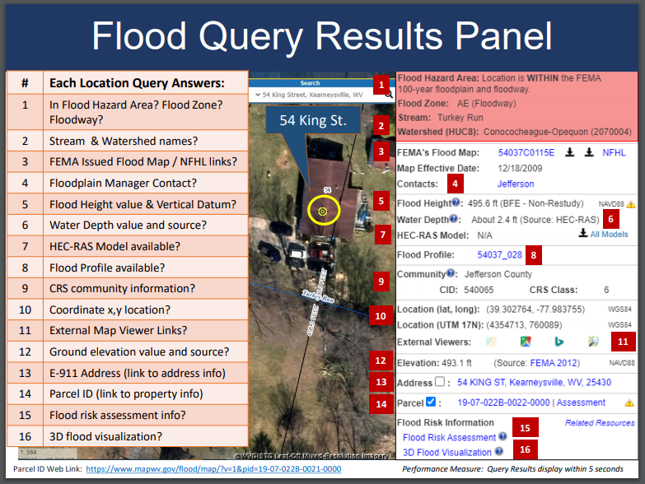

Reference Data Layers:
- Key reference data sets are ground elevation, parcels/assessment records, E-911 addresses, and aerial imagery. Process and integrate new reference data to make the WV Flood Tool more accurate and current and for which communities can receive FEMA CRS credits. This task includes the publishing and caching of web map services that support the Flood Tool. Data processing includes caching of aerial imagery and elevation contours at 15 display levels from 1: 4,622,324 to 1:282 map scales. Besides the WV Flood Tool, there are no FEMA web applications or other publicly accessible web services in the Nation that allow users to view aerial imagery and 1-foot contours for West Virginia at the largest map scale of 1:282. The new FEMA-purchased LiDAR and derived elevation products are quite large in file size and require extensive computer processing and quality control checks before being published to the WV Flood Tool.

- HI-RESOLUTION TOGPOGRAPHIC DATA: Maintain and process new Elevation Products for Flood Tool. This includes the LiDAR derived elevation products to include DEMs and contours. Accurate, high-resolution LiDAR-derived elevation products such as one-foot contours and one-meter DEMS that are incorporated into the WV Flood Tool are beneficial for floodplain determinations, LIDAR LOMAs, LAGs, water depth flood visualizations, flood risk studies, etc.
    - Elevation Products
    - 1- or 2-foot contours (published to the highest zoom level 1:282 on Flood Tool)
    - 1-meter DEM (1-meter DEM elevation sources)
    - 1-meter Hillshade (1-meter DEM elevation sources)
    - Metadata
    - Metadata: https://www.mapwv.gov/lidar-metadata
    - Elevation Download Site: https://data.wvgis.wvu.edu/elevation/
    - FEMA-Purchased LiDAR Projects: Project coverage graphic

- PROPERTY PARCELS AND ASSESSMENT RECORDS: Published Tax Year 2024 parcel geometry and assessment attributes (1.4 million records) to WV Flood Tool. Accurate and current parcels and assessment attributes are essential to identifying flood risk structures in the WV Flood Tool
- Statewide Parcel Products (annual update) for Flood tool:
  - Master surface parcel file and standardized assessment attributes
  - Integrate surface parcel geometry for all 55 West Virginia counties
  - Join assessment records for commercial and residential properties for current tax year
  - Sketch diagrams for building identification of residential properties
  - Parcel history (20 years) to search previous owners or deed book numbers. Important for improving positional accuracy of LOMAs and Buyout Properties.
  - Intersect statewide parcels/assessment records with flood hazard zones for display on the WV Flood Tool. Associating flood risk information with property parcels allows users to perform queries of parcels by the degree of flood risk using the WV Property Search Tool (Advanced Search Option).
- Intersect parcels/assessment records with flood zones and classify according to risk (high, moderate, low) for display on the WV Property Viewer, a gateway application of the WV Flood Tool
- E-911 ADDRESSES: Perform quarterly updates of E-911 site (1 million address points) and street addressing layers and address matching geocoding services for Flood Tool. Accurate and current E-911 site addresses are essential to identifying flood risk structures in the WV Flood Tool.
- AERIAL PHOTOGRAPHY: Add new 2024 county leaf-off aerial photography for multiple counties to Flood Tool. Coordinate with county, state, and federal agencies through West Virginia’s Orthoimagery Program. Accurate and current leaf-off aerial photography is essential to identifying flood risk structures in the WV Flood Tool.
- BUILDING FOOTPRINTS: Maintain 2018 Microsoft and 2018-23 WVGISTC footprints on the WV Flood Tool. Building footprints are used for identifying flood risk structures and for 3D flood visualizations on the WV Flood Tool.

- OTHER LAYERS: Update other reference layers (e.g., community boundaries, wetlands, public lands) that support FEMA CRS/NFIP programs and the WV Flood Tool. Accurate and current reference layers are important to Communities for state-base CRS credits and for users referencing features of interest.
- RESOURCE LINK: WV Flood Tool’s Reference Layers

Technical Services:
- Perform outreach and training services to include developing print and online educational materials, delivering presentations, administering email listserv, and participating in Flood Tool coordination meetings and data exchange with State NFIP, FEMA, USACE, NRCS, and other cooperators. Provide technical support to the Flood Hazard community like specifications (e.g., HEC-RAS downloadable model specifications) for contracts and other technical queries associated with flood and reference data. Enhance the WV Flood Tool to effectively increase flood risk communications for the public and communities. Educate and outreach to counties about submitting their locally produced address, parcel, imagery, and elevation data for inclusion in the Flood Tool.
- Technical Services include:
  - Promotional materials (flyers, videos, etc.)
  - Presentations (webinars, meetings, etc.)
  - Update content and resources sections of Flood Tool launch page
  - Update listserv and contact list of community floodplain managers
  - Coordination meetings and project scoping for USACE WV Silver Jackets projects that support WV Flood Tool
  - Standardized Data Exchange
  - Instructional videos for Flood Tool and WV Building Level Risk Assessment (BLRA)
  - Maintain WV Flood Tool and Flood Risk Assessment Glossary
- Update various WV Flood Tool Resources web pages and links
- Bundle FEMA and other agency risk assessment and mitigation resources for the WV floodplain management community (Permits, Elevation Certificates, Mitigation Resources, Model Floodplain Management Ordinance, etc.).

SFHA Change Letters for RiskMAP Studies:
- Communicate SFHA Map Changes to Affected Property Owners. Template mail merge documents from the FEMA Region 3 "Local Officials Toolkit: What to Do Before and After Your Flood Maps are Finalized" have been created to send to property owners with new flood mapping updates during the appeal period for the restudy. Mailing addresses of affected property owners are retrieved from the statewide tax assessment database. This activity qualifies for FEMA’s Community Rating System credits. See SFHA Mail Merge Template and Instructions.

Example Outreach Letters. Mapped Out SFHA, Mapped In SFHA, Mapped in Floodway
  - Clendenin, WV
  - White Sulphur Springs, WV

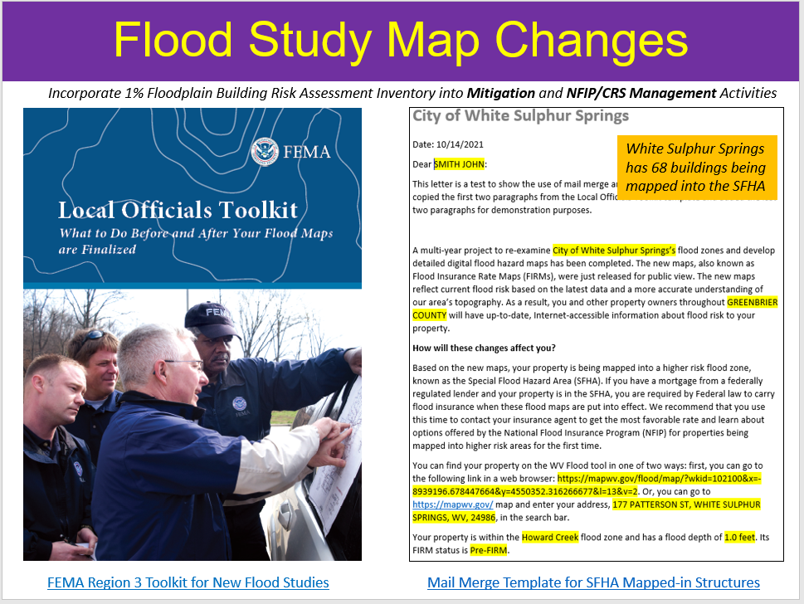
<< SFHA Change Letters using FEMA Local Officials Toolkit >>

SFHA Change Letters for RiskMAP Studies:
Deliver Technical Support Services for LiDAR LOMAs. West Virginia now has statewide coverage of QL2 LiDAR data and LiDAR-derived elevation products of one-meter DEMs and 1-foot contours. LiDAR LOMAs can be submitted for qualifying structures using FEMA’s Online LOMA portal. The Flood Tool’s Print Function generates map layouts for the LiDAR submissions using either the contour or point elevation methods. To save disadvantaged communities and homeowners the cost of needing a site elevation survey, this activity will communicate to these constituents how the "mapped out" structures (primary building structures symbolized by yellow squares where future map conditions exist) displayed on the RiskMAP View of the WV Flood Tool may qualify for removal of the structure from the SFHA. The only information required for an Online LOMA submission are a map layout from the Flood Tool and a copy of the deed. The WVU GIS Technical Center will support the state and local floodplain management community with the submission of LiDAR LOMAs when a field survey is not required, to include assisting floodplain managers with the online submissions to FEMA.
LiDAR LOMA Documentation.
- WV Flood Tool LiDAR LOMA: Instructions | Overview Slides and Guide
- WV LIDAR LOMA Map Layout Examples

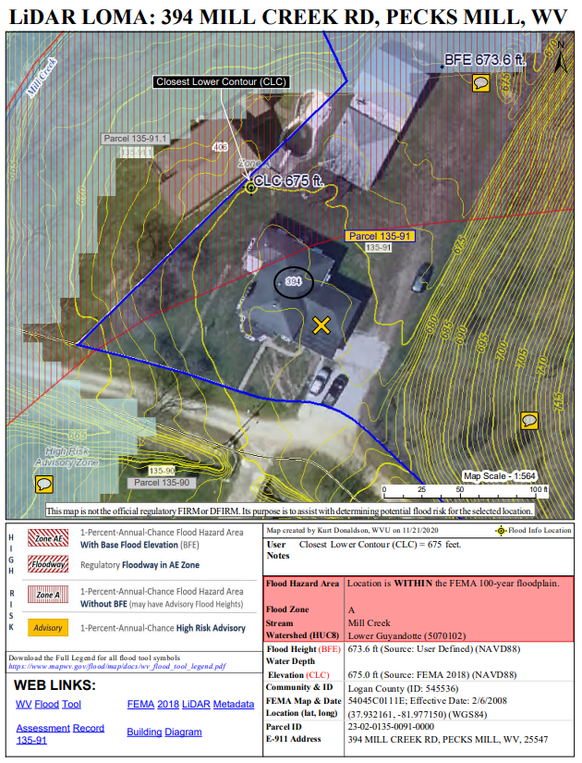
<< Example LiDAR LOMA Print Layout generated from WV Flood Tool. >>

- Building-Level Risk Assessments (BLRA). Update the WV Building Level Risk Assessment from New Data Sources (e.g., Flood Studies, Building Characteristics). Update building-level flood risk assessments for structures in the high-risk flood zones using the best available Risk MAP data and products. New Risk MAP studies always trigger updating the identification and risk assessment of all structures in high-risk flood zones. Publish updated building-level assessments to the Risk MAP View of the WV Flood Tool. (WVU Task B)

Most floodprone communities in West Virginia are disadvantaged in one or more environmental, climate, or other burdens, and (2) at or above the threshold for an associated socioeconomic burden. In addition, the findings of the First Street Foundation’s October 2021 risk assessment report states that West Virginia's built environment of critical facilities tops all other states for being vulnerable to flooding in current and future climate changing conditions. Consequently, for the built environment susceptible to riverine flooding, it is important to update the statewide building level risk assessment when new data sources become available (new flood studies, advisory flood height mapping, mitigated structures, elevation certificates - elevated building diagrams 5-8, LOMAS, etc.) so more accurate Hazus flood loss models and risk assessment products can be published in support of the state’s flood reduction activities, especially those communities which are socially vulnerable in the State.

- Benefits to communities include the continued validation of primary floodplain structures, expansion on base level risk assessment information for further hazard reduction and planning efforts, and the use of risk assessment information for Community Rating System (CRS) insurance discounts. Besides technical support for hazard mitigation plans, updates from the Building Level Risk Assessment contribute to other CTP tasks such as SFHA Change Letter Communication Outreach, CNMS Discovery Mapping, Detailed Flood Studies, LiDAR LOMAs, Mitigation Plans, SDE Building Pre-loading, and other RiskMAP initiatives.
- BUILDING LEVEL RISK CYCLE. Refer to this directory for detailed documentation about how the building level risk assessment cycle (BLRA) creates the building-level risk assessments. See Task 1 of the Data Development tasks for community-wide building inventory which is required for the landslide hazard risk assessment. The building attributes can be updated annually when a new statewide tax assessment database is published.
- PRESENTATION. Flood Risk Assessment Presentation (2022) PDF | PPTX

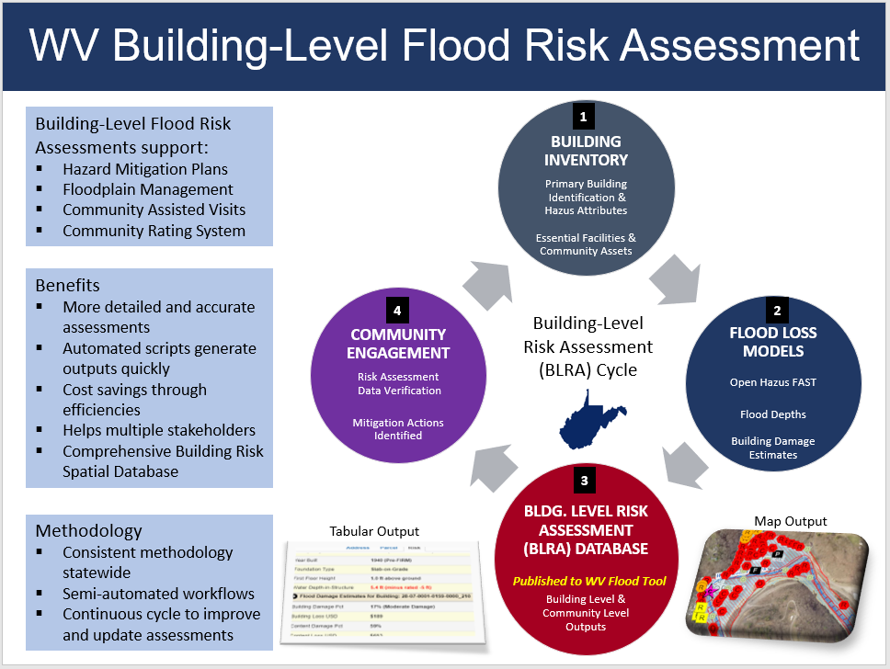
Figure B-2. Building-Level Risk Assessment Cycle (updated annually)

- WV Risk Explorer. Develop, verify, and publish flood risk profiles at eight geographic scale levels: State, Regional, County, Community, Unincorporated Area, Incorporated Place, Watershed, and Streams. A new risk tool named the WV Risk Explorer will allow communities to quickly view risk factors affecting their jurisdictions. Risk dashboards for risk assessment data shall be developed as well, all part of a suite of risk assessment and visualization tools for building community flood resilience in West Virginia. (WVU Task C).
An online WV Risk Explorer will use the building level-risk assessments to organize and curate community flood risk profiles at various geographic scales to support mitigation measures and risk planning to make communities more resilient. The interactive Community risk assessments aggregate structure-level risk data (flood hazard characteristics, exposure, vulnerability, loss estimates). Along with risk assessment data, the flood reduction and mitigation community assessment information (mitigated properties, opens space preservation, loss avoidance, etc.) will be part of website hub tools that maximize engagement, communication, collaboration, and data sharing.

Interactive online community flood risk profiles on the WV Risk Explorer will be beneficial for Risk MAP projects planned and implemented at the federal, state, and local levels. The community risk and mitigation profiles shall supplement FEMA’s Flood Risk Dashboards, a snapshot of a community’s flood risk statistics published at the time the community is participating in Risk MAP projects. Importantly, the community risk dashboards include social vulnerability factors to identify disadvantaged communities in the state that may be at higher risk due to climate change impacts and thus require additional focus and support in their flood protection measures. Lastly, this mitigation support activity supports the WV Flood Resilience Framework initiative advocated by the State Resiliency Office.
- Example Community Risk Assessment Matrices, Dashboards, Rankings.
- Flood Risk Factor Matrices | Flood Risk Dashboards | Community Risk Rankings
- Example Detailed Risk Assessment Report for Building Counts at 8 Geographic Scales
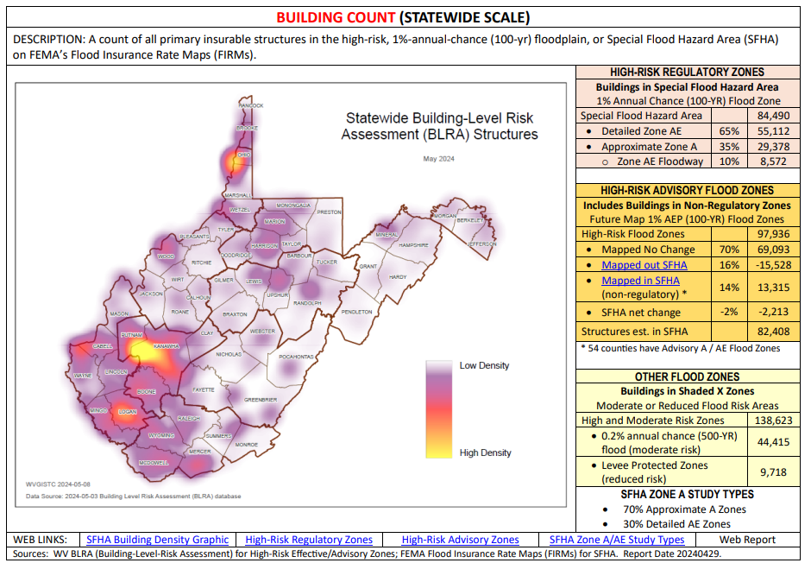
Figure B-3. Example detailed building-level risk assessment

Figure B-4. Riverine flood risk factors for new WV Risk Explorer tool.
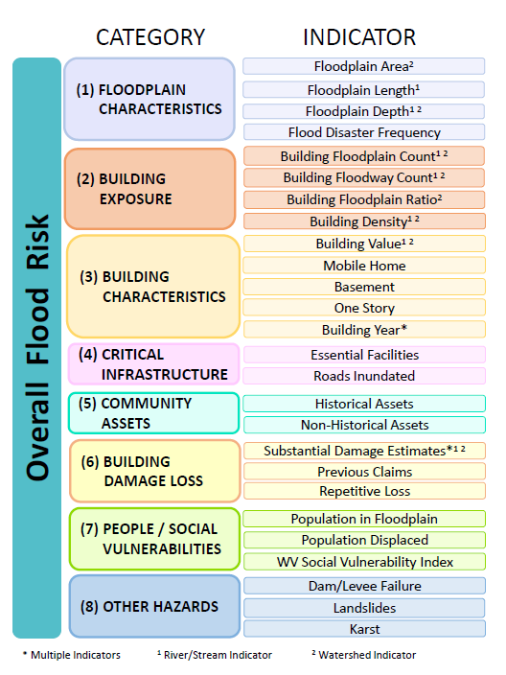

- WV Flood Visualizations. Create flood visualizations at the viewshed and building level scales to communicate flood risk to the public more effectively. Incorporate high water marks of previous major flood disasters in flood models. Additionally, compare flood frequency flood depths between FEMA and First Street Foundation flood models. (WVU Task D). The online WV Hazard Library (WVU Task E) will allow users to access the flood visualizations, a collection of movies, animations, story maps, and other visualization media available at the building and community levels for communicating and understanding flood risk in West Virginia.
- Building-Level Visualizations
  - Building Flood Profiles for different sized storms (includes High Water Marks)
  - Building Flood Depth and Damage Assessment (WV Flood Tool)
- Community-Level Visualizations
- Story Maps (graphic or narrated movies at community or viewshed levels)
- Other multimedia (static graphics, videos)
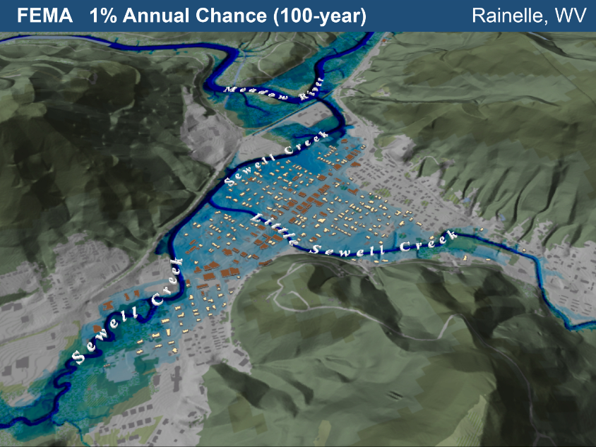
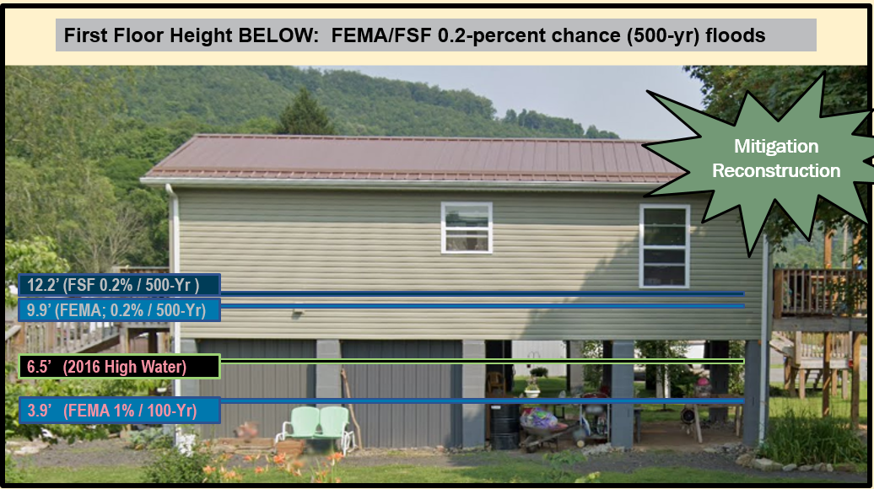
Figure B-5. Building-level and viewshed flood visualizations.
- WV Hazard Library. Organize and publish an online WV Hazard Library of resources related to flood resiliency research, hazard risk assessments, floodplain management, and mitigation activities. A Hazard Library specific to West Virginia is being organized and populated into a database in which the public can search online resources. The library contains web links to various risk assessment and mitigation resources, to include studies, graphics, reports, plans, model ordinances/regulations, movies, maps, presentations, best practice guides, training courses, publications, meeting notes, relevant data sets, etc. Users can search the Hazard Library by subject, spatial extent, geographic scale, or document type. The Hazard Library consists of major collections for risk assessments, flood events, and mitigation reduction efforts (mitigation measures, hazard planning, floodplain management, Risk MAP studies, flood models, etc.) The classification system of the Hazard Library is flexible in that additional subjects can be added. (WVU Task E).

Mitigation Planning Technical Assistance ($13K) (WVU Task F)

- Support Local Hazard Mitigation Plans with Flood/Landslide Risk Assessment Data. This mitigation planning technical assistance task supports mitigation planners and consultants with various risk assessment products for updating their local hazard mitigation plans. The risk assessment and mitigation products were generated from the HMGP Statewide Multi-Hazard Risk Assessment Project and select data sets are updated each year. The multi-hazard data includes riverine flooding, landslides, and dam failure. Refer to the catalog or Risk Information Index to access various risk assessment products (reports, tables, graphics, risk dashboards, etc.) published in support of FEMA’s Hazard Mitigation Plans and NFIP/CRS activities. See the 2022 TEIF-TEAL Close-out Report about risk assessment and mitigation products as well. (WVU Task F)

Resources Available: Technical support for local and state hazard mitigation plan updates. Accessed by an Index Guide spreadsheet named “RA_Info_Index.xlsx,” the risk assessment products include GIS layers, tables, subject reports, 3D Visualizations, and community profile risk matrices to supplement FEMA’s Community Flood Risk Dashboards.

Figure B-10. Risk Assessment Information Index provides access to risk assessment and mitigation data products in support of local hazard mitigation plans and other Risk MAP activities.
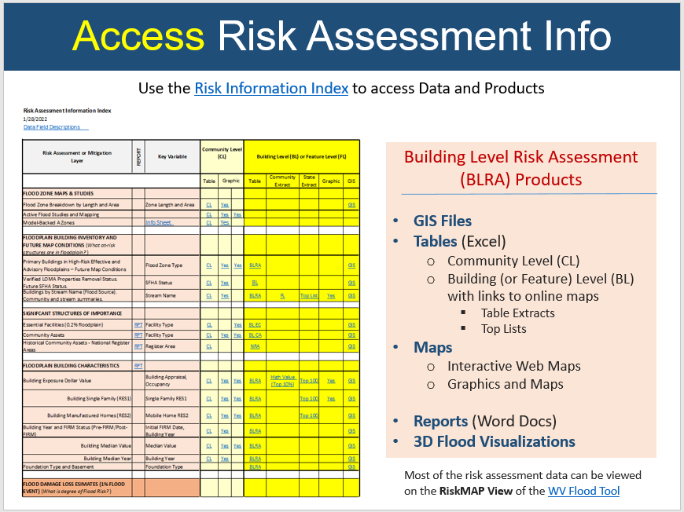

Figure B-6. Example Community Risk Assessment and Mitigation Dashboards.
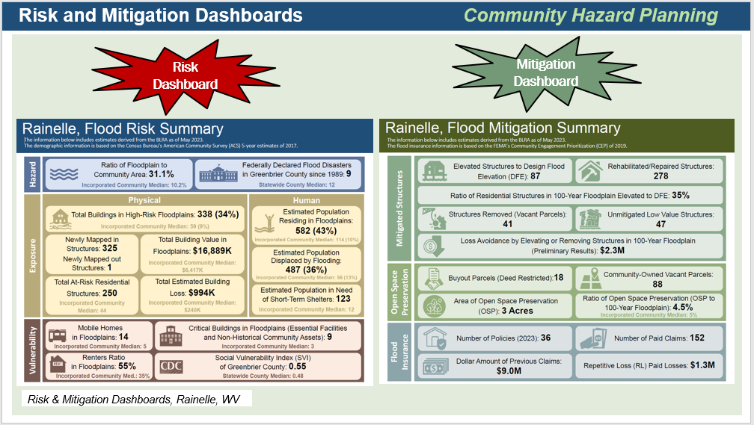

Figure B-7. Risk Indicator Tables and Matrices.
