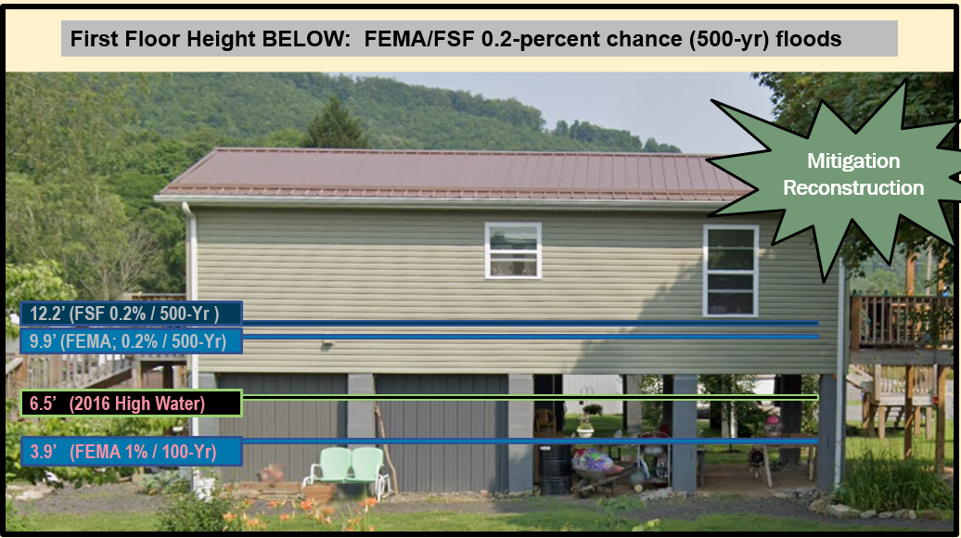



WV Emergency Management Division

COOPERATING TECHNICAL PARTNERS (CTP)

FEMA-APPROVED COMMUNITY OUTREACH AND MITIGATION STRATEGIES (COMS)

STATEMENT OF WORK (SOW)

COMS SOW No. 2

Fiscal Year 2023

This page intentionally left blank

Table of Contents

1. Part 1 – Custom Statement of Work Information 4

1.1. Project and Point of Contact Information 4

1.2. Tasks and Deliverables to be Completed Under this SOW 6

1.3. Schedule and Performance 12

1.4. Standards 13

1.5. Use of Contractors 14

1.6. Reporting and Performance 14

1.7. Privacy and Protection of Personally Identifiable Information 15

Authorized Representative Signatures 16

**APPENDIX A:**  Scope of WVU Led COMS Category 2 Tasks A-1

**APPENDIX B:**  WV Equity and Climate Change Statements B-1

# Part 1 – Custom Statement of Work Information

## Project and Point of Contact Information

#### Table 1. Project and Point of Contact Information

|  |  |
| --- | --- |
| Information Type | Insert Information |
| Project Name/Title (if applicable) | **WVEMD CTP COMS 2023-24** |
| CTP Organization Name: | **WV Emergency Management Division** |
| CTP Contractor Working on the activities in this SOW:  *Optional, only if contractors have already been identified; contractor support may be engaged for all activities except Staffing and Mentoring, which must be completed by the CTP* | **WVU GIS Technical Center, West Virginia University** |
| Sub-Recipient Working on the activities in this SOW:  *Optional, only if sub-recipients have already been identified; contractor support may be engaged for all activities except Staffing and Mentoring, which must be completed by the CTPS* | **N/A** |
| CTP Partnership Agreement Date: | **7/2023** |
| Period of Performance: | **10/1/2023 to 9/30/2024** |
| CTP Project Manager: | **Timothy W. Keaton, CFM** |
| FEMA Regional Project Officer (PO):  *When necessary, ask for FEMA assistance through the FEMA Regional PO* | **Kristen Jones (primary contact) Senior Risk Analysis Management and Program Analyst | Mitigation | Region 3** |

|  |  |
| --- | --- |
| Information Type Insert Information | |
| FEMA Funding to Complete this PM SOW: | **$100,000** |
| CTP Estimated Leverage:  *Final leverage dollars or units will be entered as applicable in the Manage Data Development Task Workflow in the Mapping Information Platform (MIP). The leverage noted here is an estimate of leverage available at the time when the scope is prepared. It may be refined at any time in the project. See* [*Estimating the Value of*](https://www.fema.gov/flood-maps/cooperating-technical-partners/become-partner/apply-grants#%3A%7E%3Atext%3DThe%20Blue%20Book%20is%20an%2CMapping%20Activity%20Statement%20(MAS))[*Partner Contributions to Flood Mapping*](https://www.fema.gov/flood-maps/cooperating-technical-partners/become-partner/apply-grants#%3A%7E%3Atext%3DThe%20Blue%20Book%20is%20an%2CMapping%20Activity%20Statement%20(MAS))[*Projects “Blue Book” (Blue Book)*](https://www.fema.gov/flood-maps/cooperating-technical-partners/become-partner/apply-grants#%3A%7E%3Atext%3DThe%20Blue%20Book%20is%20an%2CMapping%20Activity%20Statement%20(MAS)) | **N/A** |
| Project Team Coordination Activities:  *During the project, all members of the Project Team will coordinate, as needed, to see that activities, products and deliverables meet FEMA requirements and contain accurate, up- to-date information.* | * **Meetings, teleconferences, and video conferences with FEMA Region III, WVEMD, and other Project Team members biannually at a minimum with additional meetings scheduled as necessary.** * **Telephone conversations with FEMA and other Project Team members on a scheduled monthly basis and ad hoc basis, as required** * **Email as needed** |

## Tasks and Deliverables to be Completed Under this SOW

### NARRATIVE AND AUDIENCE

#### Table 2. Narrative and Audience

|  |  |
| --- | --- |
| Information Type | Insert Information |
| SOW Narrative: | This project focuses on mitigation support, communication and outreach to communities, and mitigation planning technical assistance activities. Specifically, the tasks for this year’s CTP COMS grant will:   * Develop and Verify Flood Risk Profiles at State, Regional, Community, and Watershed/Stream Levels. * Update the WV Building Level Risk Assessment (BLRA) from New Data Sources (e.g., Flood Studies, Building Characteristics). * Communicate SFHA Map Changes to Affected Property Owners. * Perform Detailed Riverine Flood Impact and Mitigation Studies or Vulnerably Disadvantaged Communities using recently published FEMA and First Street Foundation Flood Models. These activities advance community hazard mitigation actions through technical assistance that supports the Mitigation Planning Process and Risk MAP projects. See Appendix A for a more detailed statement of work. |
| Intended Audience: | **Target Audience:** Floodplain Managers, Community Planners, Emergency Preparedness Officials, and Citizens of affected communities.  **Project Footprint:** State of West Virginia |

### PROJECT TASKS AND DELIVERABLES

The following 10 tasks can be accomplished under this COMS SOW:

* COMS Engagement Plan (Required).
* Strategic Planning for Community Engagement.
* Meetings and Process Facilitation.
* Mitigation Support.
* Communication and Outreach to Communities.
* Training and Community Capability Development.
* Mitigation Planning Technical Assistance.
* Pilot Projects.
* Internal Partner Support Activities:
  + Mentoring.
  + Staffing.

### Task 1 – Develop COMS Engagement Plan (Required)

#### Table 3. Task 1 – Develop COMS Engagement Plan

|  |  |  |  |  |  |
| --- | --- | --- | --- | --- | --- |
| COMS Task | Mark “X” if task will be done under this SOW | (A) FEMA Contribution | (B) Partner Contribution | | (A+B) Total Project Cost |
| COMS Engagement Plan (required as a condition of COMS funding) | ☒ | $0 | $0 | | $0 |
| Deliverable | | | | Mark “X” if deliverable will be done under this task | |
| COMS Engagement Plan (required) | | | | ☒ | |
| Combined COMS Engagement and Business Plan | | | | ☒ | |
| Other: {Insert additional details} | | | | ☐ | |
| Custom Scope Elements | | | | | |
| A comprehensive Business Plan will be a single deliverable for both the Community Outreach and Mitigation Strategies (COMS) Engagement Plan and PM Business Plan. Plan cost covered in PM Statement of Work. | | | | | |

### Task 4 – Mitigation Support

#### Table 6. Task 4 – Mitigation Support

|  |  |  |  |  |  |
| --- | --- | --- | --- | --- | --- |
| COMS Task | Mark “X” if task will be done under this SOW | (A) FEMA Contribution | (B) Partner Contribution | | (A+B) Total Project Cost |
| Mitigation Support | ☒ | $42,000 | $0 | | $42,000 |
| Deliverable | | | | Mark “X” if deliverable will be done under this task | |
| Action Identification and Advancement Strategy (i.e., a summary of the partners’ approach to encourage mitigation action by community) | | | | ☐ | |
| Quarterly projections indicating the potential collection of Actions Identified and Advanced Strategy | | | | ☐ | |
| Summary of new Actions Advanced or status updates on existing Actions Advanced through this coordination | | | | ☒ | |
| Other: Develop and Verify Flood Risk Profiles at State, Regional, Community, and Watershed/Stream Levels. ($9K) | | | | ☒ | |
| Other: Update the WV Building Level Risk Assessment (BLRA) from New Data Sources (e.g., Flood Studies, Building Characteristics) ($33K) | | | | ☒ | |
| Custom Scope Elements | | | | | |
| Mitigation Support   * **Develop and Verify Flood Risk Profiles at State, Regional, Community, and Watershed/Stream Levels.** Use the building level-risk assessments to organize and curate community flood risk profiles at various geographic scales: state, regional, county, community (incorporated/unincorporated), watershed, stream, and user-defined Area of Mitigation Interest (AoMI) in support of hazard mitigation plans and other Risk MAP activities. Aggregate key risk factors Risk/Loss indicators (hazard, exposure, vulnerability, loss estimates) and by mitigation measures (mitigated properties, opens space preservation, loss avoidance, etc.). These community flood risk profiles will be beneficial for Risk MAP projects planned and implemented at the federal, state, and local levels. The community risk and mitigation profiles shall supplement FEMA’s Flood Risk Dashboards, a snapshot of a community’s flood risk statistics published at the time the community is participating in Risk MAP projects. Importantly, the community risk dashboards include social vulnerability factors to identify disadvantaged communities in the state that may be at higher risk due to climate change impacts and thus require additional focus and support in their flood protection measures. This mitigation support activity supports the WV Flood Resilience Framework initiative advocated by the State Resiliency Office. Landslide hazard community profiles will be considered in future CTP grant cycles. Refer to Appendix A for more information.      * **Update the WV Building Level Risk Assessment (BLRA) from New Data Sources (e.g., Flood Studies, Building Characteristics)** so more accurate Hazus flood loss models and risk assessment products can be published in support of the state’s flood reduction activities, especially those communities which are socially vulnerable in the state. Appendix B lists equity and climate change statements and resources that show the majority of communities West Virginia are disadvantaged. That is, these communities are at or above the threshold for one or more environmental, climate, or other burdens, and (2) at or above the threshold for an associated socioeconomic burden. In addition, the findings of the First Street Foundation’s October 2021 risk assessment report states that West Virginia's built environment of critical facilities tops all other states for being vulnerable to flooding in current and future climate changing conditions. Consequently, for the built environment susceptible to riverine flooding, it is important to update the statewide building level risk assessment when new data sources become available ([new flood studies](https://data.wvgis.wvu.edu/pub/RA/_resources/status/WV_FloodStudies.pdf), [advisory flood height mapping](https://data.wvgis.wvu.edu/pub/RA/_resources/status/Advisoy_A_and_AFH_Status.pdf), [mitigated structures](https://data.wvgis.wvu.edu/pub/RA/State/BL/Graphic/BL_Mitigated_Structures.pdf), [elevation certificates - elevated building diagrams 5-8](https://data.wvgis.wvu.edu/pub/RA/_resources/status/BL_Elevation_Certificates.pdf), [LOMAS](https://data.wvgis.wvu.edu/pub/RA/_resources/status/LOMAs_Verified.pdf), etc.) so more accurate Hazus flood loss models and risk assessment products can be published in support of the state’s flood reduction activities, especially those communities which are socially vulnerable in the State. Specifically, the project footprint is a majority of the state as defined where new flood models from FEMA and First Street Foundation intersect with disadvantaged/distressed areas identified by the CEJST Screening Tool and [ARC Map](https://www.arc.gov/classifying-economic-distress-in-appalachian-counties/). In addition, updates to critical facilities and other structures of significance shall be a priority in quantifying the degree of flood risk. Benefits to communities include the continued validation of primary floodplain structures, expansion on base level risk assessment information for further hazard reduction and planning efforts, and the use of risk assessment information for Community Rating System (CRS) insurance discounts. Besides technical support for hazard mitigation plans, updates from the Building Level Risk Assessment contribute to other CTP tasks such as SFHA Change Letter Communication Outreach, CNMS Discovery Mapping, Detailed Flood Studies, WV Flood Resiliency Framework, LiDAR LOMAs, Mitigation Plans, SDE Building Pre-loading, and other RiskMAP initiatives. | | | | | |

### Task 5 – Communication and Outreach to Communities

#### Table 7. Task 5 – Communication and Outreach to Communities

|  |  |  |  |  |  |
| --- | --- | --- | --- | --- | --- |
| COMS Task | Mark “X” if task will be done under this SOW | (A) FEMA Contribution | (B) Partner Contribution | | (A+B) Total Project Cost |
| Communication and Outreach to Communities | ☒ | $8,000 | $0 | | $8,000 |
| Deliverable | | | | Mark “X” if deliverable will be done under this task | |
| Newly developed messaging and outreach materials that frame flood risk in a manner that is accessible for all communities identified for this task | | | | ☒ | |
| Newly developed outreach materials that help community officials connect with their constituents to inform them of flood risk and ways to reduce their risk | | | | ☒ | |
| Report on outreach activities | | | | ☒ | |
| Other: Communicate SFHA Map Changes to Affected Property Owners ($8K) | | | | ☒ | |
| Custom Scope Elements | | | | | |
| Communication and Outreach to Communities   * **Communicate SFHA Map Changes to Affected Property Owners.**  Template mail merge documents from the FEMA Region 3 "Local Officials Toolkit: What to Do Before and After Your Flood Maps are Finalized" have been created to send to property owners with new flood mapping updates during the appeal period for the restudy. Information about changes in floodplain risk and base floodplain elevation can be communicated to individual homeowners. The base flood elevation is increasing 6 feet, for example, for the highly flood vulnerable and disadvantaged community of Camden-on-Gauley on the Gauley River in Webster County; and more than 3 feet in Marlinton on the Greenbrier River in Pocahontas County. Mailing addresses of affected property owners are retrieved from the statewide tax assessment database. This activity qualifies for FEMA’s Community Rating System credits. See [SFHA Mail Merge Template](https://data.wvgis.wvu.edu/pub/RA/_engage/Local/SFHA_Change/) and Instructions. Refer to Appendix A for more information. | | | | | |

### Task 7 – Mitigation Planning Technical Assistance

#### Table 9. Task 7 – Mitigation Planning Technical Assistance

|  |  |  |  |  |  |
| --- | --- | --- | --- | --- | --- |
| COMS Task | Mark “X” if task will be done under this SOW | (A) FEMA Contribution | (B) Partner Contribution | | (A+B) Total Project Cost |
| Mitigation Planning Technical Assistance *(see* *Part 2.7**)* | ☒ | $50,000 | $0 | | $50,000 |
| Deliverable | | | | Mark “X” if deliverable will be done under this task | |
| Copies of all technical data provided to local, state and tribal communities | | | | ☒ | |
| A report detailing the technical assistance provided including date(s) of technical assistance, type of assistance and communities’ stakeholders supported | | | | ☒ | |
| Other: Perform Detailed Riverine Flood Impact and Mitigation Studies of Vulnerably Disadvantaged Communities using recently published FEMA and First Street Foundation Flood Models ($50K) | | | | ☒ | |
| Custom Scope Elements | | | | | |
| Mitigation Planning Technical Assistance  **Perform Detailed Riverine Flood Impact and Mitigation Studies or Vulnerably Disadvantaged Communities using recently published FEMA and First Street Foundation Flood Models.**  The USACE forecast models predict higher stream flows in the future for central and southern West Virginia. In addition to forecasted higher stream flows, many of the disadvantaged communities in this region have a moderate to high Social Vulnerability Index. Small, incorporated communities in which large tracts of the community are in the Special Flood Hazard Area are especially vulnerable to climate change riverine flood impacts. Many of the vulnerable communities were established in the early-20th century along narrow river valleys and steep mountainsides during the boom of coal mining and timbering extraction industries. Specifically, this project will map the riverine flood impacts of five vulnerably disadvantaged communities facing higher stream flow change forecast models using recently published FEMA and First Street Foundation Flood Models. The targeted five disadvantaged communities will be in the distressed areas of southern West Virginia where [active FEMA flood studies](https://data.wvgis.wvu.edu/pub/RA/_resources/status/WV_FloodStudies.pdf) have generated new flood map products. Both 2D and 3D maps will show changes in the floodplain forecast models and substantial damage impact on the built environment, including critical facilities, for the following scenarios: (1) Base Flood, (2) 500-YR Flood, and (3) Climate Change Flood Model. This past year First Street Foundation flood depth and climate data were purchased for the entire state to support this task. This project will support an NSF CIVIC grant that incorporates the social science impacts of devastating floods and recommendations for making communities more resilient, along with the development of a new statewide initiative called the [WV Flood Resiliency Framework](https://data.wvgis.wvu.edu/pub/NSF/_GreenbrierStudy/CTP/WV_Flood_Resilience_Framework_20230222.pdf). Community engagement in the form of presenting the risk vulnerability analysis/recommendations and receiving feedback from community stakeholders is an important element of this activity. | | | | | |

## Schedule and Performance

Instructions: Identify each deliverable for all activities included in this COMS SOW in Table 15. COMS Deliverables Schedule. Examples are provided in italics in the first row. Deliverables can be listed individually or grouped by a single date. Add more rows to the table as needed. Due dates will be discussed with the FEMA Regional PO.

#### Table 15. COMS Deliverables Schedule

|  |  |  |  |
| --- | --- | --- | --- |
| SOW Activities | Deliverable | Deliverable Due Date | Submitted To |
| COMS Engagement Plan (required) | COMS Engagement Plan | 9 months from Award date | FEMA Regional Project Officer |
| Mitigation Support (MS) | Reporting on MS Activities | Quarterly | FEMA Regional Project Officer |
| Communication and Outreach to Communities | Reporting on Outreach Activities | Quarterly | FEMA Regional Project Officer |
| Mitigation Planning Technical Assistance (TA) | Reporting on TA Activities | Quarterly | FEMA Regional Project Officer |

#### Table 16. Performance Measures Targets

|  |  |  |
| --- | --- | --- |
| Outcome1 | Output Measurement2 (with customized Target) | Recorded Unit/Scale |
| Perform Detailed Riverine Flood Impact and Mitigation Studies of Vulnerably Disadvantaged Communities | Create 2D and 3D maps for five disadvantaged communities that will show changes in the floodplain forecast models and substantial damage impact on the built environment, including critical facilities, for the following scenarios: (1) Base Flood, (2) 500-YR Flood, and (3) Climate Change Flood Models. | Complete detailed flood impact studies for five disadvantaged communities with new FEMA and First Street Foundation Flood Models  Achieved / Not Achieved |
| Update the WV Building Level Risk Assessment (BLRA) from New Data Sources | Update Hazus flood loss models and risk assessment products associated with inventoried floodplain buildings. New model inputs consist of:   * Depth Grids: Incorporate 1-meter resolution depth grids from regulatory (Risk MAP) and non-regulatory (Updated AE Redelineation, Advisory Flood Heights) flood studies. Incorporate flood depths for nearly all 55 counties. * Tax Year 2023 Building Characteristics: Updated building replacement values, occupancy class, stories, etc. from 1.4 million tax assessment data parcels. * Mitigated Structures: Incorporated elevated first-floor heights and foundation types (open, closed) from mitigated structure datasets: elevation certificates, building pictures, etc. | Update BLRA of 98,000 flood-prone structures in State from new data sources (e.g., depth grids, tax assessment records, mitigated structures)  Achieved / Not Achieved |
| Communicate SFHA Map Changes to Affected Property Owners | Customized for communities with new Risk MAP updates. | Achieved / Not Achieved |
| Develop and Verify Flood Risk Profiles at State, Regional, Community, and Watershed/Stream Levels. | Update flood risk assessment and mitigation indicators. Flood profiles published in report and web formats. | Achieved / Not Achieved |

## Standards

The standards relevant to this SOW are presented in [FEMA Policy 204-078-1 Standards for Flood](https://www.fema.gov/flood-maps/guidance-reports/guidelines-standards/standards-flood-risk-analysis-and-mapping-public-review) [Risk Analysis and Mapping, Revision 13](https://www.fema.gov/flood-maps/guidance-reports/guidelines-standards/standards-flood-risk-analysis-and-mapping-public-review) (dated December 2022).

This Policy supersedes all previous standards in the Guidelines and Specifications for Flood Hazard Mapping Partners. This includes all related appendices and procedure memoranda. Find more information and links to guidance documents, technical references, templates, and other resources that support these standards on the FEMA Guidelines and Standards website. This is at: [Guidelines](https://www.fema.gov/guidelines-and-standards-flood-risk-analysis-and-mapping) [and Standards for Flood Risk Analysis and Mapping Activities Under the Risk MAP Program](https://www.fema.gov/guidelines-and-standards-flood-risk-analysis-and-mapping). FEMA reviews standards each year. Please use the most current version of the policy.

CTPs and their sub-awardees must also comply with the regulations in Title 44 of the Code of Federal Regulations (CFR). They must also comply with the appropriate year CTP Notice of Funding Opportunity (NOFO) and Agreement Articles. CTPs should work with their regional office to determine any additional requirements.

1 An outcome is an observable and measurable change of knowledge, behavior, skills and/or efficiency as a result of a CTP project.

2 An output is a direct, specific and quantifiable product of CTP activities that lead to/indicate success of the intended outcome. Outputs are expressed in units of measure that enable quantifiable recording of performance.

## Use of Contractors

Check the applicable statement in Table 17.

#### Table 17. Use of Contractors

|  |  |
| --- | --- |
| Select One | Description of Contractor Options |
| ☒ | Contractor support may be engaged for all activities within this SOW, except staffing and mentoring, which must be completed by the CTP. Guidance provided in this part includes, but is not limited to, contract administration and recordkeeping, notification requirements, review procedures, competition, methods of procurement, and cost and pricing analysis. 2 CFR Part 200 may be viewed online at: [Part 200 - Uniform](http://www.ecfr.gov/cgi-bin/text-idx?SID=cc011f4fb962e68cb0da4bc91e8fbb43&mc=true&node=pt2.1.200&rgn=div5) [Administrative Requirements, Cost Principles, and Audit Requirements for Federal](http://www.ecfr.gov/cgi-bin/text-idx?SID=cc011f4fb962e68cb0da4bc91e8fbb43&mc=true&node=pt2.1.200&rgn=div5) [Awards](http://www.ecfr.gov/cgi-bin/text-idx?SID=cc011f4fb962e68cb0da4bc91e8fbb43&mc=true&node=pt2.1.200&rgn=div5)  Additionally, contractors must not pose a conflict-of-interest issue or be active in writing the SOW.  Contractors support will be provided by the WV GIS Technical Center, West Virginia University |
| ☐ | The CTP does not intend to engage the services of a contractor for this SOW. No transfer of funds to agencies other than those identified in the approved cooperative agreement application shall be made without prior approval from FEMA. The CTP will identify the name of the CTP contractor for services engaged as part of this SOW. The CTP shall ensure that the procurement for all contractors engaged for this COMS Activity complies with the requirements of 2 CFR Part 200.  Guidance provided in this part includes, but is not limited to, contract administration and recordkeeping, notification requirements, review procedures, competition, methods of procurement, and cost and pricing analysis. Additionally, contractors must not pose a conflict-of-interest issue. |

## Reporting and Performance

Financial Reporting: Because FEMA has provided funding to the CTP, financial reporting requirements for the CTP will be set by the terms of the NOFO, Articles of Agreement, or Award Notice for this SOW. The CTP shall also refer to [2 CFR Part 200.](http://www.ecfr.gov/cgi-bin/text-idx?SID=cc011f4fb962e68cb0da4bc91e8fbb43&mc=true&node=pt2.1.200&rgn=div5) The CTP shall provide financial reports to the FEMA Regional PO and Assistance Officer per the terms of the signed Cooperative Agreement for this SOW.

Performance Reporting: CTPs must provide a signed performance report (using the list of required information shown in the NOFO). The CTP will submit the report quarterly during the period of performance. Reports will be required for partial calendar quarters and periods when no grant award activity occurs. An old Standard Form-Performance Progress Report (SF-PPR) may be substituted for the performance report, if preferred. The CTP shall refer to [2 CFR Part 200](http://www.ecfr.gov/cgi-bin/text-idx?SID=cc011f4fb962e68cb0da4bc91e8fbb43&mc=true&node=pt2.1.200&rgn=div5) for the minimum requirements for progress reporting. The FEMA Regional PO, as needed, may request additional information on progress.

The CTP will meet with FEMA and/or its contractor(s) as frequently as needed to review the progress of the project. These meetings are in addition to the quarterly financial and status submittals. These meetings may alternate between the FEMA Regional Office, the CTP office and conference calls as necessary.

The CTP must report performance of the grant along with the progress reports. Table 16. Performance Measures Targets shows which performance measures the CTPs will use to track performance. If you are completing a COMS project alongside a Flood Risk Project MAS, use the relevant measures in the 2023 CTP Performance Measures Matrix. Quantitative Targets for performance measures are defined using the 2023 CTP Performance Measures Matrix in conjunction with your FEMA Regional PO and those defined in Table 16.

CTPs are responsible for entering their quarterly performance of each measure into the CTP Performance Measures Reporting Tool (Tool) each quarter, unless otherwise directed by their FEMA Regional PO. Each output measurement identified above must have a quarterly performance reported in the Tool within one month of the end of the quarter. Quarterly performance data can be exported from the Tool and attached to the Quarterly Report that must be uploaded to FEMA GO.

Earned Value Data Entry:

The CTP must report on the earned value of projects that are in the MIP each month. They must explain variances outside of the tolerance defined in Table 16. Performance Measures Targets. The FEMA Regional Offices must implement a Corrective Action Plan (CAP) when a CTP is outside of the tolerance. A CAP must define the reason for the variance and the intended resolution. FEMA Regional Offices shall coordinate with FEMA Headquarters (HQ) when CAPs are developed.

COMS SOW/PM SOW tasks are now tracked in the MIP. Cost and schedule performance measures are defined in this SOW. These measures will be used to monitor CTP performance and to determine future funding eligibility. Earned Value data entry involves the CTP updating cost, schedule and performance (physical % complete) in the MIP each month for each assigned task. The CTP may contact the FEMA Regional Office to obtain additional guidance (as needed) for updating COMS/PM efforts in the MIP.

## Privacy and Protection of Personally Identifiable Information

A CTP’s organizational access to the MIP provides you access to PII. Please have your organization coordinate with the FEMA Regional Office. Each user must currently meet the new Risk Analysis Management Access Portal (RAP) process requirements.

Please contact your FEMA Regional PO for more information.

# Authorized Representative Signatures

Each party has caused this SOW to be executed by its duly authorized representative.

Timothy Keaton Date

Project Manager

WV Emergency Management Division

Kristen Jones Date

Regional Project Officer

Federal Emergency Management Agency, Region, Region 3

# **APPENDIX A:** Scope of WVU Led COMS Category 2 Tasks

**2023-24 CTP PM Services and Projects performed by West Virginia University**State: West Virginia  
Total Cost: $100,000

Performance Period: October 1, 2023, to September 30, 2024 (12 months)  
Plan by Tim Keaton, State NFIP Coordinator, **WV Emergency Management Division.** Subcontract work to **WVU GIS Technical Center.**   
6/14/2023

**Special Community Outreach Mitigation Strategies (COMS) projects performed by the WVU GIS Technical Center, to include:**

1. Develop and Verify Flood Risk Profiles at State, Regional, Community, and Watershed/Stream Levels
2. Update the WV Building Level Risk Assessment (BLRA) from New Data Sources (e.g., Flood Studies, Building Characteristics)
3. Communicate SFHA Map Changes to Affected Property Owners
4. Perform Detailed Riverine Flood Impact and Mitigation Studies or Vulnerably Disadvantaged Communities using recently published FEMA and First Street Foundation Flood Models

Mitigation Support ($42K)

* **Develop and Verify Flood Risk Profiles at State, Regional, Community, and Watershed/Stream Levels.** Use the building level-risk assessments to organize and curate community flood risk profiles at various geographic scales: state, regional, county, community (incorporated/unincorporated), watershed, stream, and user-defined Area of Mitigation Interest (AoMI) in support of hazard mitigation plans and other Risk MAP activities. Aggregate key risk factors Risk/Loss indicators (hazard, exposure, vulnerability, loss estimates) and by mitigation measures (mitigated properties, opens space preservation, loss avoidance, etc.). These community flood risk profiles will be beneficial for Risk MAP projects planned and implemented at the federal, state, and local levels. The community risk and mitigation profiles shall supplement FEMA’s Flood Risk Dashboards, a snapshot of a community’s flood risk statistics published at the time the community is participating in Risk MAP projects. Importantly, the community risk dashboards include social vulnerability factors to identify disadvantaged communities in the state that may be at higher risk due to climate change impacts and thus require additional focus and support in their flood protection measures. This mitigation support activity supports the WV Flood Resilience Framework initiative advocated by the State Resiliency Office. Landslide hazard community profiles will be considered in future CTP grant cycles.

**Example Community Risk Assessment Matrices, Dashboards, Rankings:**

* [Flood Risk Factor Matrices](https://data.wvgis.wvu.edu/pub/RA/State/CL/Risk_Matrices/)
* [Flood Risk Dashboards](https://data.wvgis.wvu.edu/pub/RA/State/CL/Risk_Dashboards/)
* [Greenbrier Study Dashboards](https://data.wvgis.wvu.edu/pub/NSF/_GreenbrierStudy/Dashboards/)
* [Community Risk Rankings](https://data.wvgis.wvu.edu/pub/RA/State/CL/Risk_Rankings/)

**Figure A-1.** Example Community Risk Assessment and Mitigation Dashboards.

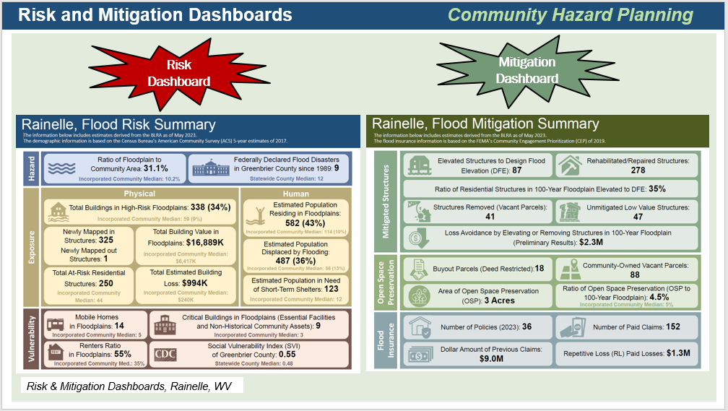

**Figure A-2.** Risk Indicator Tables and Matrices.

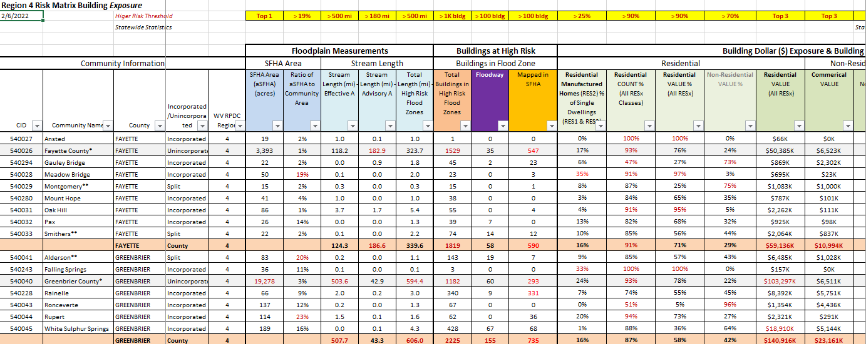

* **Update the WV Building Level Risk Assessment (BLRA) from New Data Sources (e.g., Flood Studies, Building Characteristics)** so more accurate Hazus flood loss models and risk assessment products can be published in support of the state’s flood reduction activities, especially those communities which are socially vulnerable in the state. Appendix B lists equity and climate change statements and resources that show the majority of communities West Virginia are disadvantaged. That is, these communities are at or above the threshold for one or more environmental, climate, or other burdens, and (2) at or above the threshold for an associated socioeconomic burden. In addition, the findings of the First Street Foundation’s October 2021 risk assessment report states that West Virginia's built environment of critical facilities tops all other states for being vulnerable to flooding in current and future climate changing conditions. Consequently, for the built environment susceptible to riverine flooding, it is important to update the statewide building level risk assessment when new data sources become available ([new flood studies](https://data.wvgis.wvu.edu/pub/RA/_resources/status/WV_FloodStudies.pdf), [advisory flood height mapping](https://data.wvgis.wvu.edu/pub/RA/_resources/status/Advisoy_A_and_AFH_Status.pdf), [mitigated structures](https://data.wvgis.wvu.edu/pub/RA/State/BL/Graphic/BL_Mitigated_Structures.pdf), [elevation certificates - elevated building diagrams 5-8](https://data.wvgis.wvu.edu/pub/RA/_resources/status/BL_Elevation_Certificates.pdf), [LOMAS](https://data.wvgis.wvu.edu/pub/RA/_resources/status/LOMAs_Verified.pdf), etc.) so more accurate Hazus flood loss models and risk assessment products can be published in support of the state’s flood reduction activities, especially those communities which are socially vulnerable in the State. Specifically, the project footprint is a majority of the state as defined where new flood models from FEMA and First Street Foundation intersect with disadvantaged/distressed areas identified by the CEJST Screening Tool and [ARC Map](https://www.arc.gov/classifying-economic-distress-in-appalachian-counties/). In addition, updates to critical facilities and other structures of significance shall be a priority in quantifying the degree of flood risk. Benefits to communities include the continued validation of primary floodplain structures, expansion on base level risk assessment information for further hazard reduction and planning efforts, and the use of risk assessment information for Community Rating System (CRS) insurance discounts. Besides technical support for hazard mitigation plans, updates from the Building Level Risk Assessment contribute to other CTP tasks such as SFHA Change Letter Communication Outreach, CNMS Discovery Mapping, Detailed Flood Studies, WV Flood Resiliency Framework, LiDAR LOMAs, Mitigation Plans, SDE Building Pre-loading, and other RiskMAP initiatives.
* Resources:
* BUILDING LEVEL RISK CYCLE. Refer to this [directory](https://data.wvgis.wvu.edu/pub/RA/_engage/_IndexDocs/BLRA_cycle/) for detailed documentation about how the [building level risk assessment cycle](https://data.wvgis.wvu.edu/pub/RA/_engage/_IndexDocs/BLRA_cycle/) (BLRA) creates the building-level risk assessments. See Task 1 of the Data Development tasks for *community-wide* building inventory which is required for the landslide hazard risk assessment. The building attributes can be updated annually when new statewide tax assessment database is published.
* PRESENTATION. Flood Risk Assessment Presentation (2022) [PDF](https://data.wvgis.wvu.edu/pub/RA/_engage/Presentation/Flood/FloodAssessment_HMGP_Meeting_WVU_20220419.pdf) | [PPTX](https://data.wvgis.wvu.edu/pub/RA/_engage/Presentation/Flood/FloodAssessment_HMGP_Meeting_WVU_20220419.PPTX)

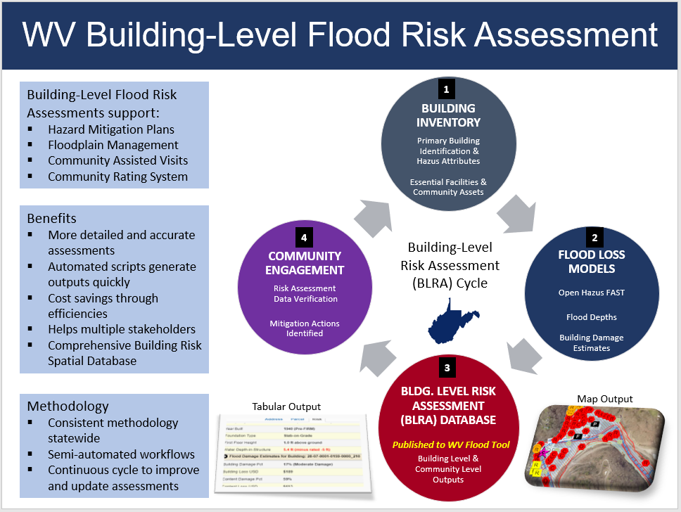**Figure A-3.** Building-Level Risk Assessment Cycle (updated annually)

**Figure A-4.** Statewide Building-Level Flood Risk Assessment (BLRA) using FEMA Hazus Methodology

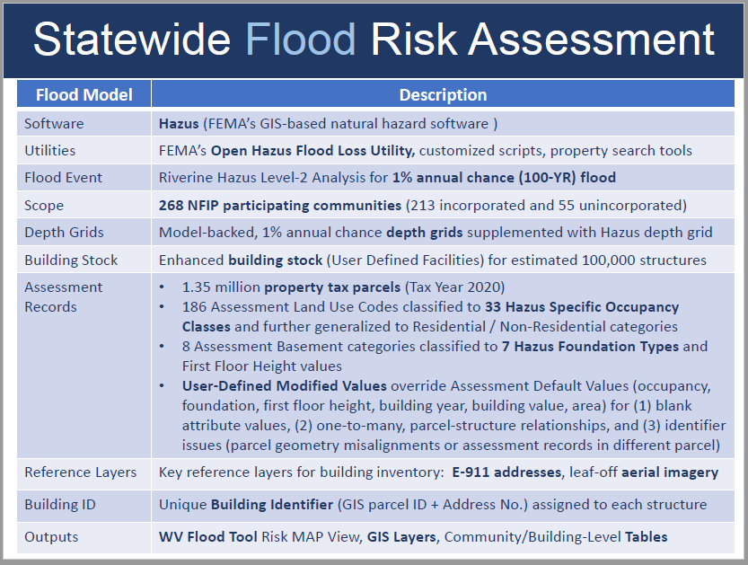

**Figure A-5.** Building-Level Risk Assessment: Tabular and Graphical (WV Flood Tool) Outputs

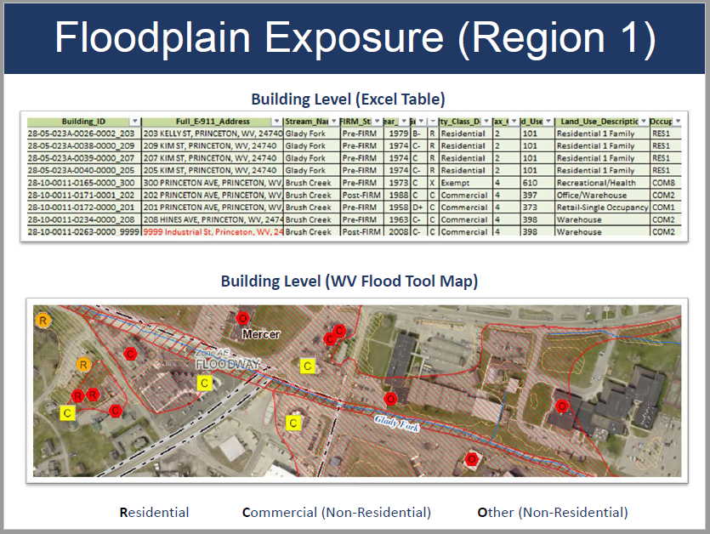

Communication and Outreach to Communities ($8K)

* **Communicate SFHA Map Changes to Affected Property Owners.**  Template mail merge documents from the FEMA Region 3 "Local Officials Toolkit: What to Do Before and After Your Flood Maps are Finalized" have been created to send to property owners with new flood mapping updates during the appeal period for the restudy. Information about changes in floodplain risk and base floodplain elevation can be communicated to individual homeowners. The base flood elevation is increasing 6 feet, for example, for the highly flood vulnerable and disadvantaged community of Camden-on-Gauley on the Gauley River in Webster County; and more than 3 feet in Marlinton on the Greenbrier River in Pocahontas County. Mailing addresses of affected property owners are retrieved from the statewide tax assessment database. This activity qualifies for FEMA’s Community Rating System credits. See [SFHA Mail Merge Template](https://data.wvgis.wvu.edu/pub/RA/_engage/Local/SFHA_Change/) and Instructions.
* Example Outreach Letters. Mapped Out SFHA, Mapped In SFHA, Mapped in Floodway
  + [Clendenin, WV](https://data.wvgis.wvu.edu/pub/RA/_engage/Local/SFHA_Change/Kanawha/Merged_Letters/z_Clendenin_Examples/)
  + [White Sulphur Springs, WV](https://data.wvgis.wvu.edu/pub/RA/_engage/Local/SFHA_Change/Greenbrier/Merged_Letters/z_WhiteSulphurSprings_Examples/)

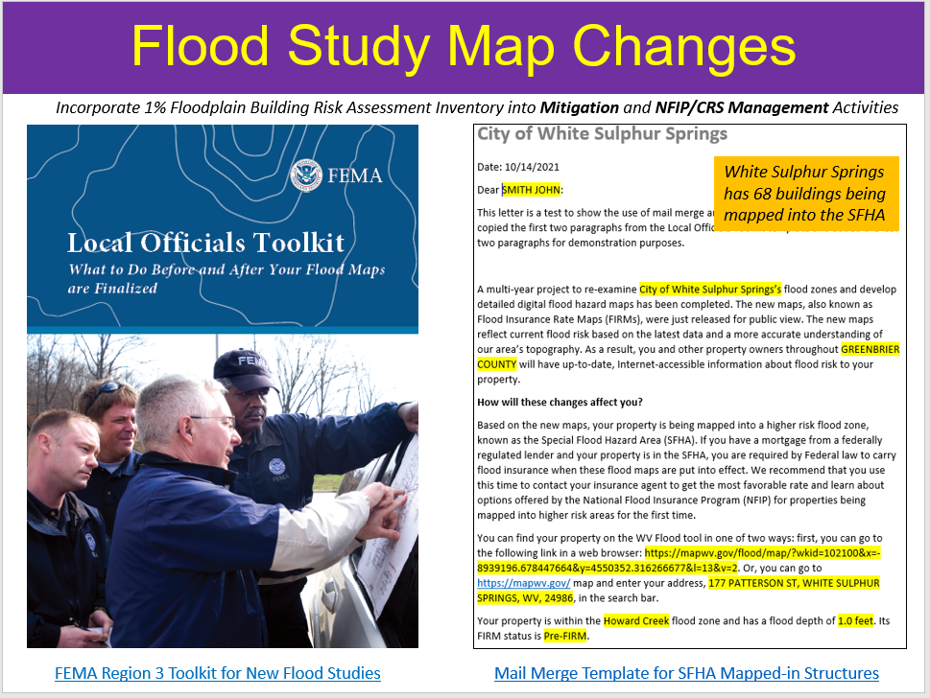**Figure A-6.** SFHA Change Letters using FEMA Local Officials Toolkit

**Figure A-7.** Example SFHA Change Letter instructions to Community

Enclosed are examples of outreach letters for your communities to notify owners of structures that are being “mapped in” the Special Flood Hazard Area (SFHA), "mapped in floodway" or “mapped out” of the SFHA for the new FEMA flood maps becoming effective July 5, 2023.  Both Word and PDF formats are provided.  Please use the links below to access the letters, map attachments, and address lists.  Please review and let us know if any changes have to be made before your mailing.

The text for these template letters was modified from [FEMA’s R3 Local Officials Toolkit](https://data.wvgis.wvu.edu/pub/RA/_engage/Local/SFHA_Change/Documentation/FEMA_R3_Local_Officials_Toolkit.pdf).   We also generated a map layout of each structure with a change in SFHA status; this printed map layout identified by a unique building identifier can be included with the 2-page information letter.

(1) **Merged Letters** (Word Doc and PDF).

* [Rainelle Mapped-In SFHA, Mapped-In Floodway, and Mapped-Out SFHA](https://data.wvgis.wvu.edu/pub/RA/_engage/Local/SFHA_Change/Greenbrier/Merged_Letters/Rainelle/)
* [Rupert Mapped-In SFHA and Mapped-Out SFHA](https://data.wvgis.wvu.edu/pub/RA/_engage/Local/SFHA_Change/Greenbrier/Merged_Letters/Rupert/)
* [White Sulphur Springs Mapped-In SFHA, Mapped-In Floodway, and Mapped-Out SFHA](https://data.wvgis.wvu.edu/pub/RA/_engage/Local/SFHA_Change/Greenbrier/Merged_Letters/White_Sulphur_Springs/)
* [Greenbrier Unincorporated Mapped-In SFHA, Mapped-In Floodway, and Mapped-Out SFHA](https://data.wvgis.wvu.edu/pub/RA/_engage/Local/SFHA_Change/Greenbrier/Merged_Letters/Greenbrier_Unincorporated/)

(2) **Map Attachments** for each property organized by “In”, “Floodway”, and “Out” folders (for inclusion with letters).  Properties are identified by a unique [building Identifier](https://data.wvgis.wvu.edu/pub/RA/_resources/FRA/FRA_Building_Identification.pdf) consisting of the Parcel Identifier and Address Number.     
[Rainelle](https://data.wvgis.wvu.edu/pub/RA/_engage/Local/SFHA_Change/Greenbrier/Maps/Rainelle_Maps/) | [Rupert](https://data.wvgis.wvu.edu/pub/RA/_engage/Local/SFHA_Change/Greenbrier/Maps/Rupert_Maps/)| [White Sulphur Springs](https://data.wvgis.wvu.edu/pub/RA/_engage/Local/SFHA_Change/Greenbrier/Maps/White_Sulphur_Springs_Maps/) | [Greenbrier Unincorporated](https://data.wvgis.wvu.edu/pub/RA/_engage/Local/SFHA_Change/Greenbrier/Maps/Greenbrier_Unincorporated_Maps/)

(3) **Address Lists** sorted by owner name (let us know if you want us to create mailing labels).  The address lists are combinations of tax assessment owner addresses and E-911 resident addresses.

<https://data.wvgis.wvu.edu/pub/RA/_engage/Local/SFHA_Change/Greenbrier/Address_Lists/>

(4)**Summary table** of letters:

|  |  |  |  |  |  |  |
| --- | --- | --- | --- | --- | --- | --- |
| Community Name | Letters & Attachments Status | Letter Date | Mapped-In Letters Count | Mapped-In Floodway* Letters Count | Mapped-Out Letters Count | Total Letter Count |
| Greenbrier Unincorporated | Completed | 6/5/2023 | 268 | 70 | 173 | 511 |
| Rainelle | Completed | 5/30/2023 | 284 | 38 | 1 | 323 |
| Rupert | Completed | 6/6/2023 | 35 | 0 | 5 | 40 |
| White Sulphur Springs | Completed | 5/30/2023 | 61 | 54 | 116 | 231 |
| Letter Count Sum: | | | 648 | 162 | 295 | 1,105 |

* Also including mapped from SFHA to new Floodway

(5) **The LOMAs** were revalidated with the issuance of new flood maps and may be superseded.  The final Summary of Map Actions (SOMA) for the county can be viewed here:  [Greenbrier County](https://data.wvgis.wvu.edu/pub/RA/_engage/Local/SFHA_Change/Greenbrier/SOMA/WV_SOMA_Greenbrier_LFDLetters_Return_Receipts.pdf)

Since the WV GIS Technical Center generated the mail merge letters for all mapped in/in floodway/out SFHA structures shown on the WV Flood Tool’s RiskMAP View ([www.mapwv.gov/Flood](http://www.mapwv.gov/Flood)), all the communities have to do is **download the files, then print, validate, and mail the letters**.

Please contact us if you have any questions or need assistance.

Mitigation Planning Technical Assistance ($50K)

* **Perform Detailed Riverine Flood Impact and Mitigation Studies of Vulnerably Disadvantaged Communities using recently published FEMA and First Street Foundation Flood Models.**  The USACE forecast models predict higher stream flows in the future for central and southern West Virginia. In addition to forecasted higher stream flows, many of the disadvantaged communities in this region have a moderate to high Social Vulnerability Index. Small, incorporated communities in which large tracts of the community are in the Special Flood Hazard Area are especially vulnerable to climate change riverine flood impacts. Many of the vulnerable communities were established in the early-20th century along narrow river valleys and steep mountainsides during the boom of coal mining and timbering extraction industries. Specifically, this project will map the riverine flood impacts of five vulnerably disadvantaged communities facing higher stream flow change forecast models using recently published FEMA and First Street Foundation Flood Models. The targeted five disadvantaged communities will be in the distressed areas of southern West Virginia where [active FEMA flood studies](https://data.wvgis.wvu.edu/pub/RA/_resources/status/WV_FloodStudies.pdf) have generated new flood map products. Both 2D and 3D maps will show changes in the floodplain forecast models and substantial damage impact on the built environment, including critical facilities, for the following scenarios: (1) Base Flood, (2) 500-YR Flood, and (3) Climate Change Flood Model. This past year First Street Foundation flood depth and climate data were purchased for the entire state to support this task. This project will support an NSF CIVIC grant that incorporates the social science impacts of devastating floods and recommendations for making communities more resilient, along with the development of a new statewide initiative called the [WV Flood Resiliency Framework](https://data.wvgis.wvu.edu/pub/NSF/_GreenbrierStudy/CTP/WV_Flood_Resilience_Framework_20230222.pdf). Community engagement in the form of presenting the risk vulnerability analysis/recommendations and receiving feedback from community stakeholders is an important element of this activity.

Examples of Detailed Greenbrier Study (Rainelle and White Sulphur Springs) Resources

* View [NSF Video](https://data.wvgis.wvu.edu/pub/NSF/_GreenbrierStudy/CTP/CIVIC_Video_Subtitles_Final.mp4) of Greenbrier Community Flood Studies (supported by FEMA FY22 CTP Project)
* Greenbrier Study [Report](https://data.wvgis.wvu.edu/pub/NSF/_GreenbrierStudy/CTP/NSF_CIVIC_Stage_1_Report_202305.pdf) | [Appendix](https://data.wvgis.wvu.edu/pub/NSF/_GreenbrierStudy/CTP/NSF_CIVIC_Research_Report_Appendix_202305.pdf) | [Community Slide Presentation](https://data.wvgis.wvu.edu/pub/NSF/_GreenbrierStudy/CTP/Greenbrier_Study_Findings_WVUGIS_CTPFY22.pdf) (May 2023). *FEMA CTP Report in development.*
* [Greenbrier Study Resources](https://data.wvgis.wvu.edu/pub/NSF/_GreenbrierStudy/CTP/Greenbrier_County_Flood_Study_Resources.pdf)
* WV Plan Implementation and Grants Development (PIGD) [Presentation](https://data.wvgis.wvu.edu/pub/NSF/_GreenbrierStudy/CTP/Donaldson_Slides_June_7_PIGD.pdf) June 2023

**Figure A-8.** Community Engagement Meetings for Rainelle and White Sulphur Springs, WV (Greenbrier County)

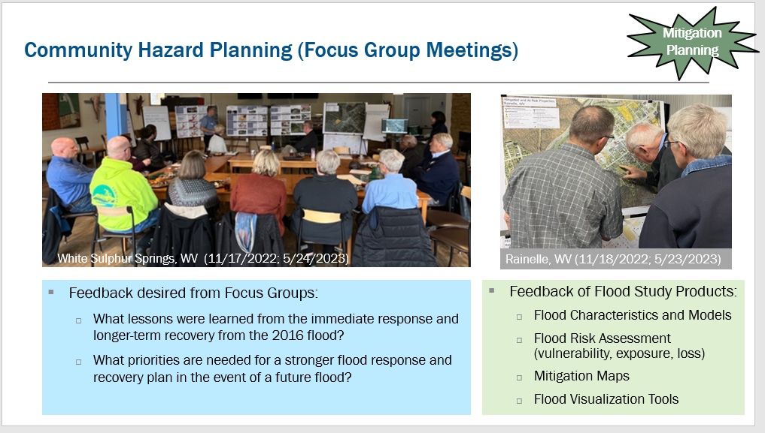

**Figure A-9.** Mitigation Reconstruction vulnerable to 0.2-percent annual chance flood

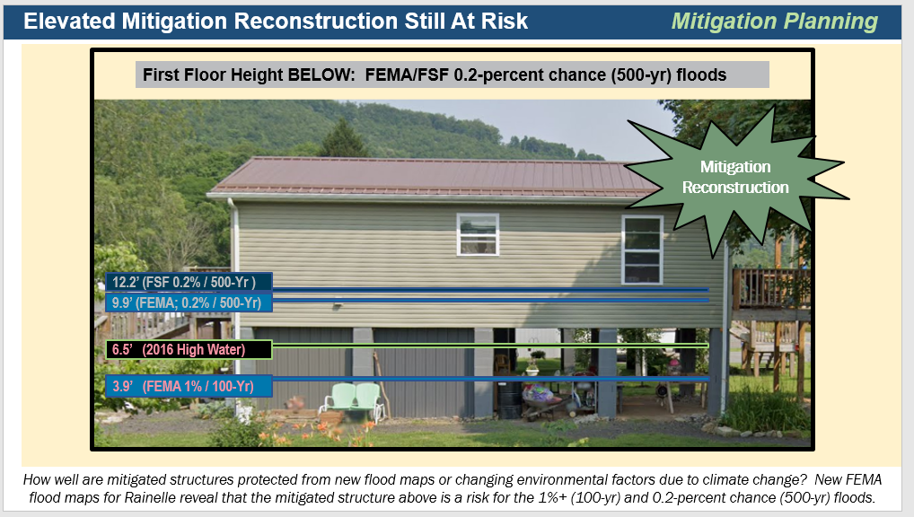

**Figure A-9.** First Street Foundation Flood Models for Rainelle, WV

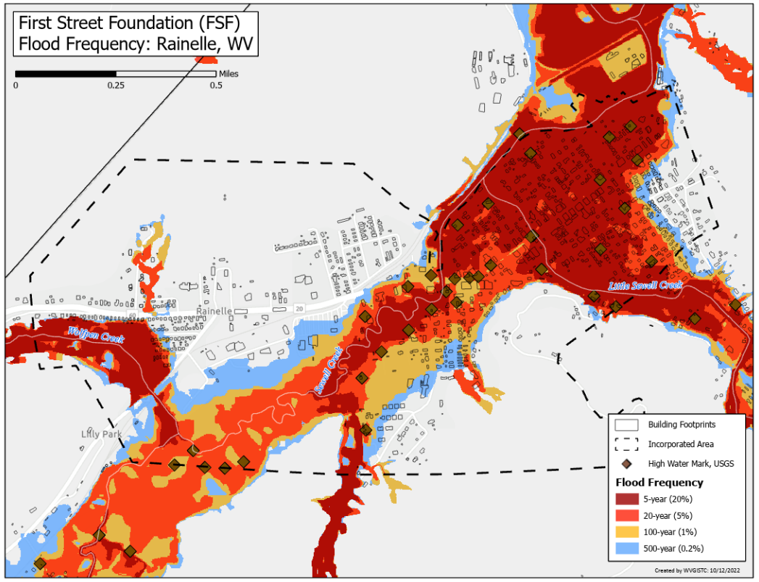

**Figure A-10.** New FEMA Flood Study Models

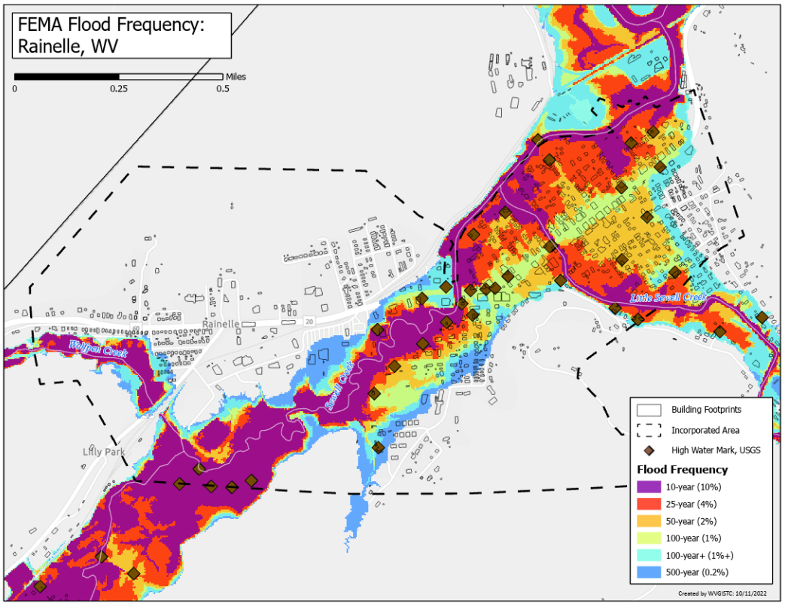

# **APPENDIX B:** WV Equity and Climate Change Statements

* The Climate and Economic Justice Screening Tool (CEJST) by the Council on Environmental Quality (CEQ) is an [interactive map](https://screeningtool.geoplatform.gov/en/#3/33.47/-97.5) and uses datasets that are indicators of burdens in eight categories: climate change, energy, health, housing, legacy pollution, transportation, water and wastewater, and workforce development. The tool uses this information to identify communities that are experiencing these burdens. These are the communities that are disadvantaged because they are overburdened and underserved. The majority of census tracts in West Virginia are considered disadvantaged. [CEJST Screening Tool](https://screeningtool.geoplatform.gov/en/#3/33.47/-97.5) | [Justice40 Analysis Disadvantaged](https://apps.cnt.org/justice40/)
* For FY 2023, The Appalachian Regional Commission released the [FY 2023 interactive map](https://www.arc.gov/classifying-economic-distress-in-appalachian-counties/) of county economic status and distressed areas in Appalachia. The classification system compares each county in the region to national averages to understand how counties are performing in areas such as unemployment rate, per capita market income, and poverty rates. 18 of West Virginia’s counties are labeled as “distressed,” meaning that they are in the worst 10% of US counties. Another 15 counties in the state are “at risk,” meaning they are in between the worst 10 to 25% of US counties. That means more than half of the state’s counties are either distressed or at-risk. Over the past several years, the number of distressed counties in West Virginia has been steadily increasing. [ARC Report](https://www.arc.gov/wp-content/uploads/2022/06/CountyEconomicStatusandDistressAreasFY2023WestVirginia.pdf) | [Online Map](https://www.arc.gov/classifying-economic-distress-in-appalachian-counties/)
* The 2020 CDC Social Vulnerability Index for West Virginia shows 14 counties with high vulnerability and 14 counties with moderate to high vulnerability. These social vulnerability factors may weaken a community’s ability to prevent human suffering and financial loss in a disaster. [CDC Online Map](https://svi.cdc.gov/map.html).
* West Virginia ranked 1st highest in the nation for the prevalence of poor physical health, poor mental health, and activity limitations due to poor physical or mental health. Source: [WV DHHR](https://dhhr.wv.gov/hpcd/Pages/default.aspx).
* A 2023 Census report says that eleven counties in West Virginia are in persistent poverty. The counties are Barbour, Braxton, Clay, Fayette, Lincoln, Logan, McDowell, Mingo, Monongalia, Summers, and Webster counties. According to the detailed report, 14.4% of West Virginians live in persistent poverty census tracts, and approximately 16.8% of West Virginians are considered impoverished. The report states that areas considered to be in persistent poverty have had a poverty rate of at least 20% for more than 30 years. Based U.S. Census Bureau data from 1989 to 2019, approximately 10.6% of counties in America and 6.1% of the country’s population lived in persistent poverty counties. [Census Release](https://www.census.gov/newsroom/press-releases/2023/persistent-poverty.html?utm_medium=email&utm_source=govdelivery) | [Report](https://www.census.gov/content/dam/Census/library/publications/2023/acs/acs-51%20persistent%20poverty.pdf) | [WV Census Tracts](https://www.census.gov/content/dam/Census/library/publications/2023/acs/acs-51%20persistent%20poverty.pdf#page=20)
* West Virginia has numerous small communities in which large tracts of the jurisdiction are in the Special Flood Hazard Area and thus especially vulnerable to climate change riverine flood impacts. Many of the vulnerable communities were established in the early-20th century along narrow river valleys and steep mountainsides during the boom of coal mining and timbering extraction industries.
* In West Virginia, according to nonprofit First Street Foundation’s October 2021 report titled "[The 3rd National Risk Assessment: Infrastructure on the Brink](https://assets.firststreet.org/uploads/2021/09/The-3rd-National-Risk-Assessment-Infrastructure-on-the-Brink.pdf#page=155)," 46 percent of the roads in the state and 51 percent of the state’s critical facilities — [the highest state-level figures in the Nation](https://www.eenews.net/articles/nearly-1-in-4-u-s-roads-vulnerable-to-flooding-report/) — would be closed by flooding. Using modeling that incorporates climate change, First Street’s risk assessment report quantifies the huge current and future number of critical facilities and road segments that would be shut down by an average flood.

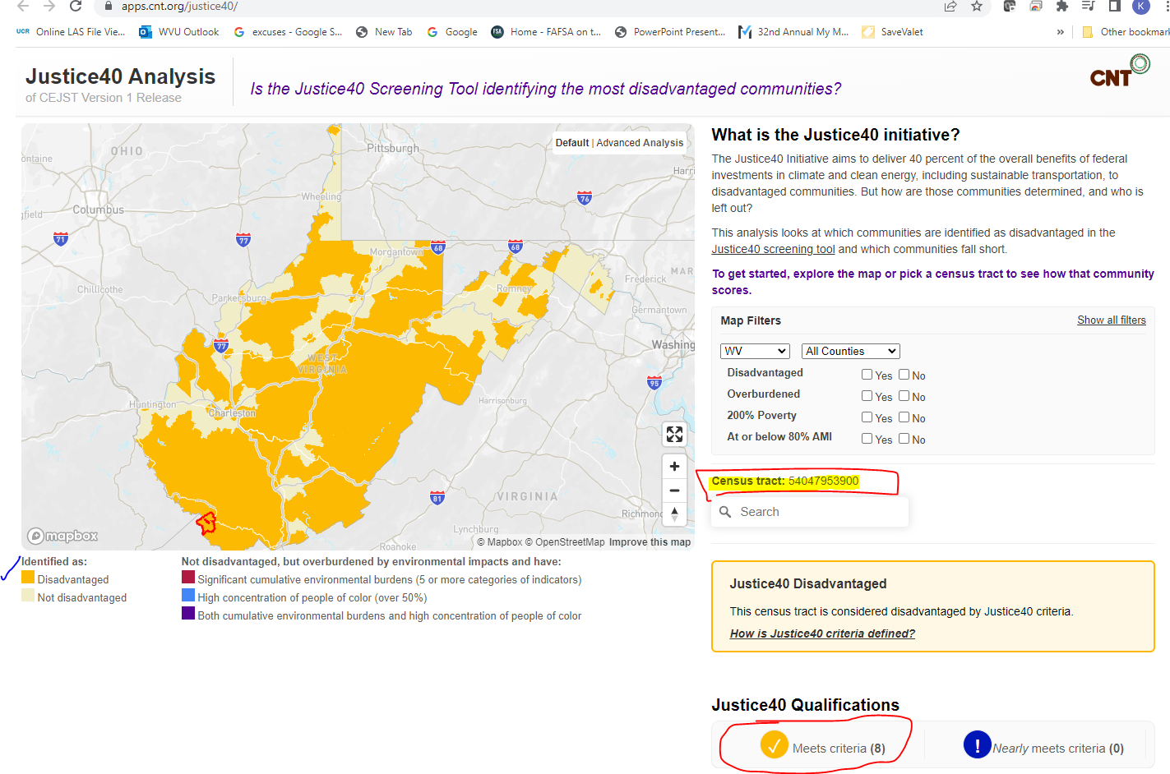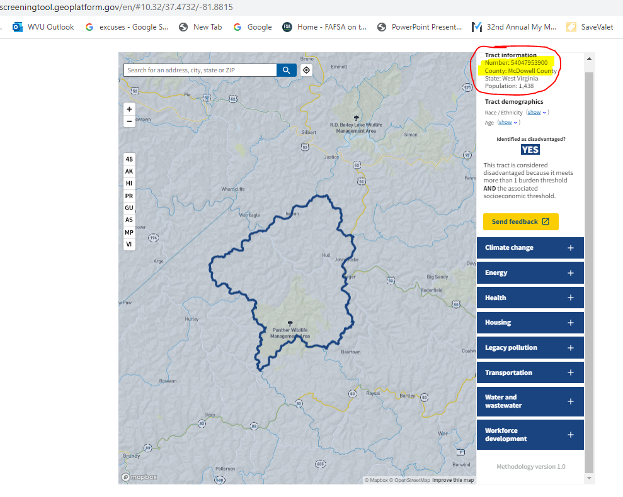

**Figure B-1.** CEJST Screen Tool utilized for Mitigation COMS FY23 Projects. Most of West Virginia is “disadvantaged.”

**Figure B-2**. Example of all 8 environmental, climate, and socioeconomic indicators impacted for census tract in McDowell County.

<https://screeningtool.geoplatform.gov/en/#10.32/37.4732/-81.8815>

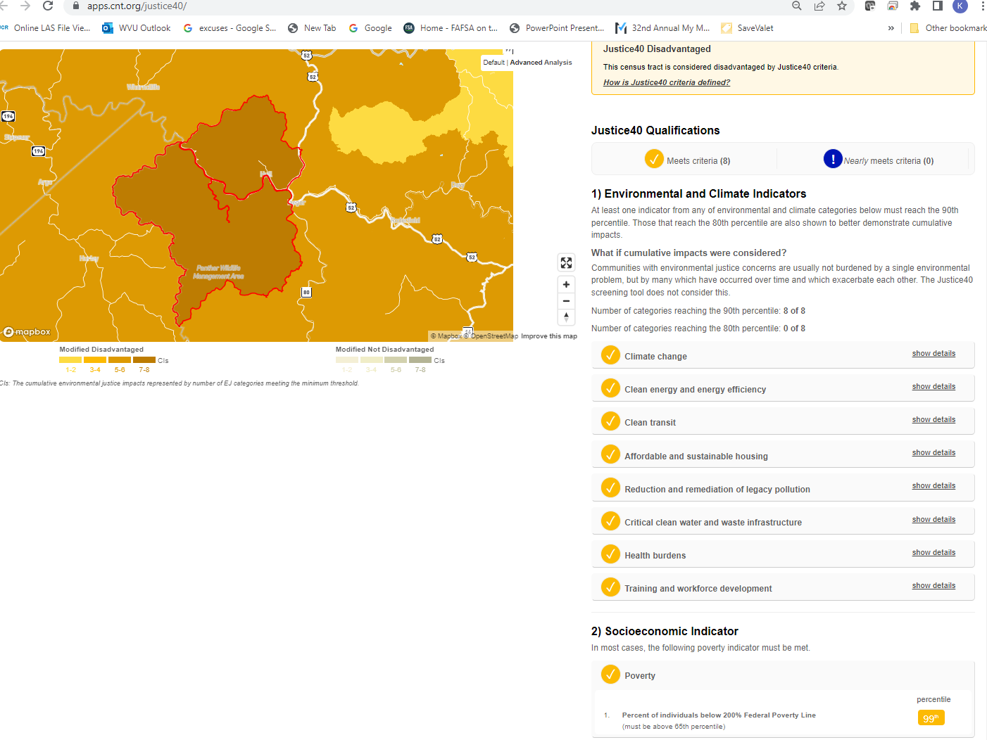

**Figure B-3**. All 8 environmental, climate, and socioeconomic indicators impacted for census tract in McDowell County.

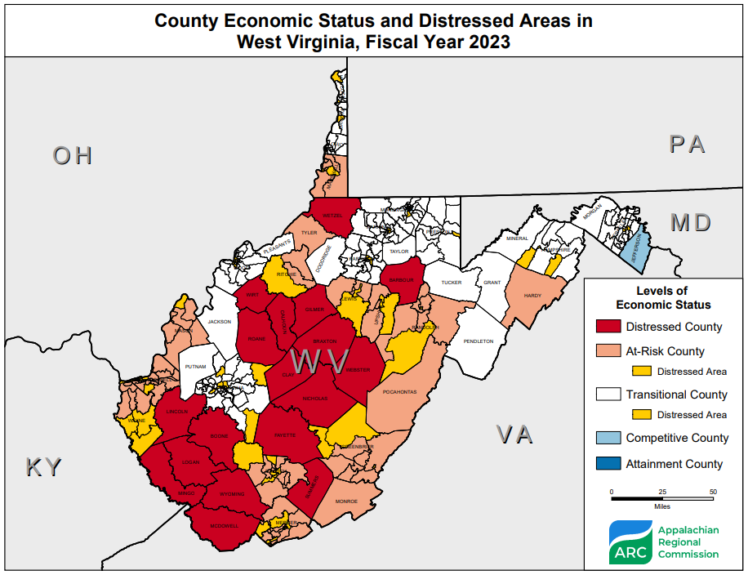

**Figure B-4**. 2023 ARC Distressed Areas in West Virginia

* [USACE Ohio River Basin Climate Change Models](https://cfpub.epa.gov/si/si_public_record_report.cfm?Lab=NRMRL&dirEntryId=339719) (Figure 1) forecast *substantial* stream flow increases for West Virginia. According to the report, watershed sub-basins located northeast, east, and south of the Ohio River are expected to experience greater precipitation and thus higher stream flows – up to 50% greater – during the period 2011-2099. See pages 15 and 16 of the report showing forecasted percent changes in Annual Mean Streamflow for three time periods: 2011-2040, 2041-2070, and 2071-2099. The potential impacts to infrastructure in these sub-basins where climate change models forecast higher stream flows is dramatic and potentially devastating.

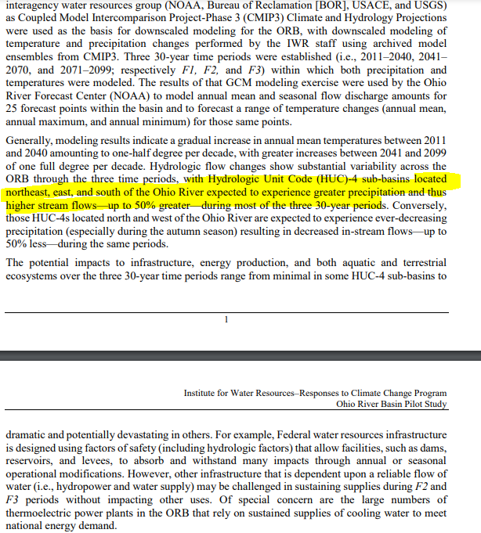

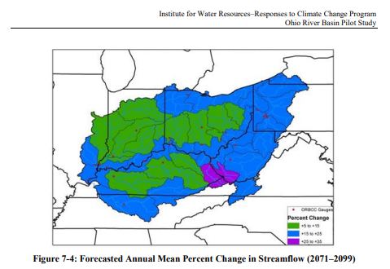

Extract from [Ohio River Basin Climate Change](https://cfpub.epa.gov/si/si_public_record_report.cfm?Lab=NRMRL&dirEntryId=339719) study in which West Virginia will experience greater precipitation and thus higher stream flows.

**Figure B-5**. USACE Climate Models indicate greater precipitation and higher stream flows

* A climate seminar hosted by FEMA Region 3 in July 2022 presented climate tools such as NOAA’s Climate and Hazard Mitigation Planning [CHaMP](https://champ.rcc-acis.org/) and [Climate Explorer](https://crt-climate-explorer.nemac.org/) Tools which show historical and future climate precipitation/temperature trends. For West Virginia, recorded climate data shows that average temperatures have increased over the last 50 years for the states in FEMA Region 3 by 2.5 to 3.5 degrees Fahrenheit. The climate model projections show an increase in precipitation and temperature for both Low and High Emission futures (2022 to 2099) for West Virginia.

**NOAA’s Climate and Hazard Mitigation Planning (CHaMP) Tool:** <https://champ.rcc-acis.org/>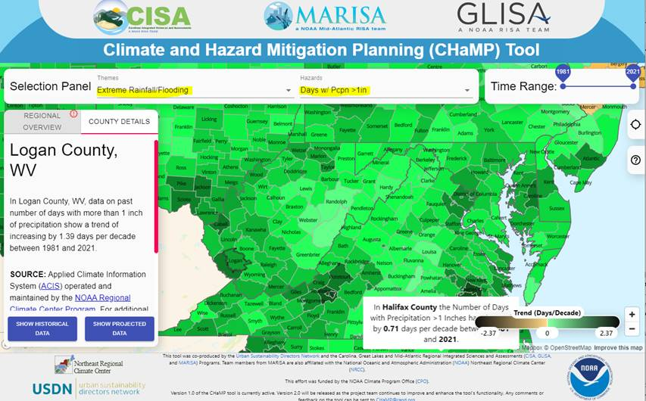

**Figure B-6**. NOAA’s Climate and Hazard Mitigation Planning (CHaMP) Tool

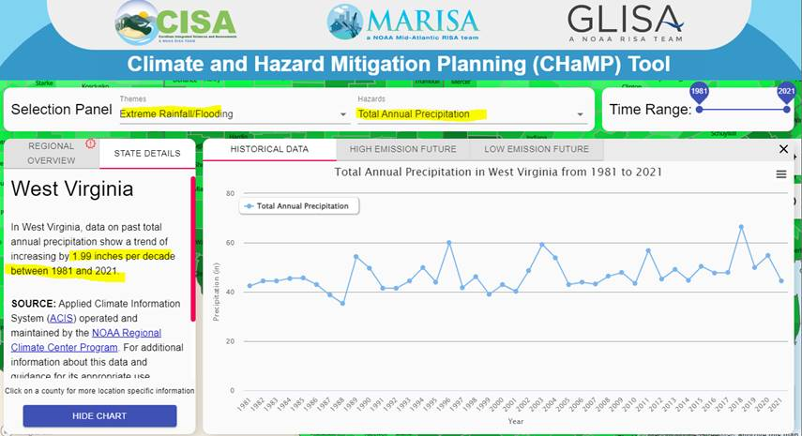

**Figure B-7**. NOAA’s Climate and Hazard Mitigation Planning (CHaMP) Tool

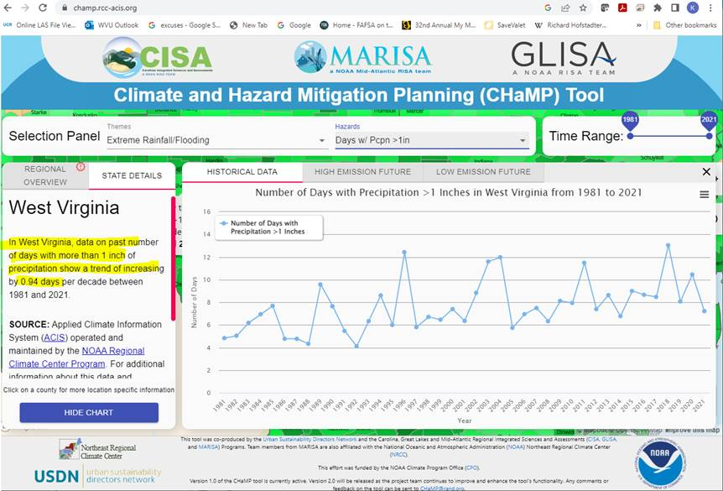

**Figure B-8**. NOAA’s Climate and Hazard Mitigation Planning (CHaMP) Tool

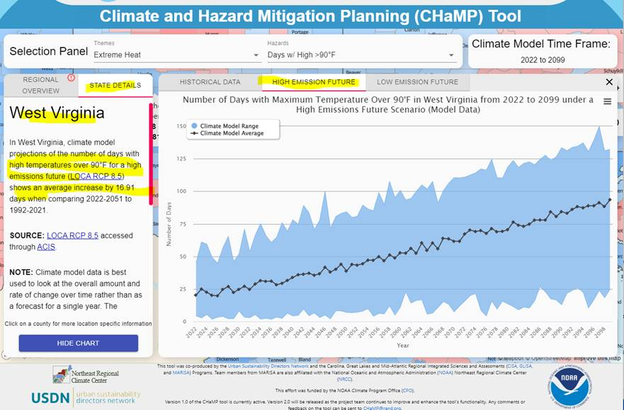

**Figure B-9**. NOAA’s Climate and Hazard Mitigation Planning (CHaMP) Tool

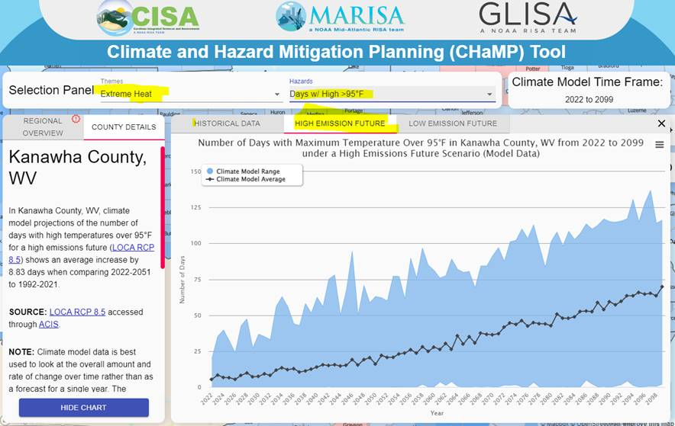

**Figure B-10**. NOAA’s Climate and Hazard Mitigation Planning (CHaMP) Tool

**Climate Explorer Tool:** <https://crt-climate-explorer.nemac.org/>

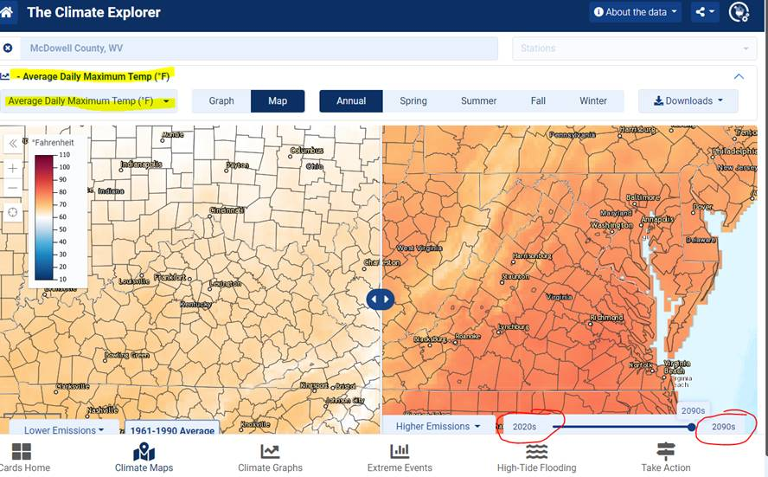

**Figure B-11**. NOAA’s Climate Explorer Tool

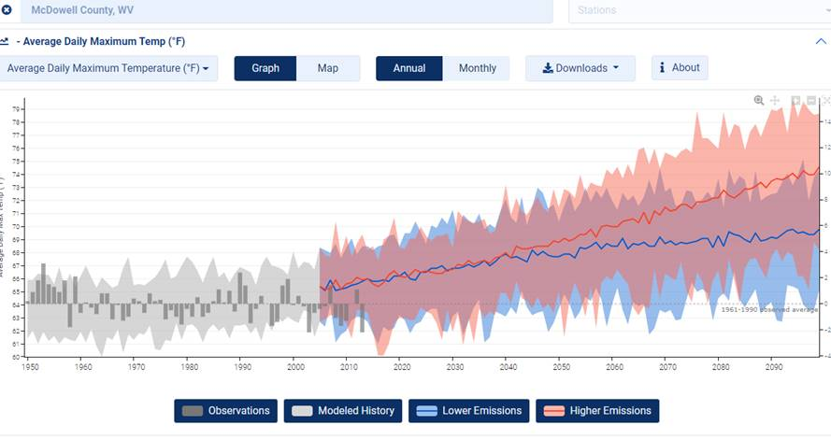

**Figure B-12**. NOAA’s Climate Explorer Tool

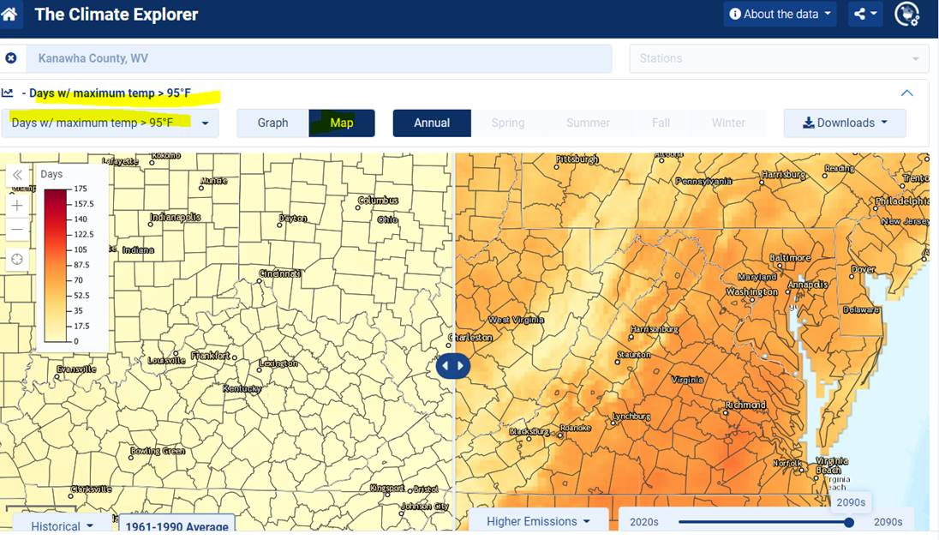

**Figure B-13**. NOAA’s Climate Explorer Tool

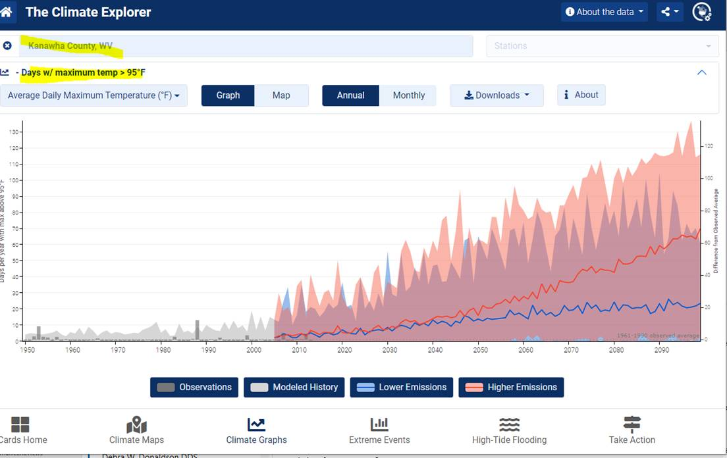

**Figure B-14**. NOAA’s Climate Explorer Tool

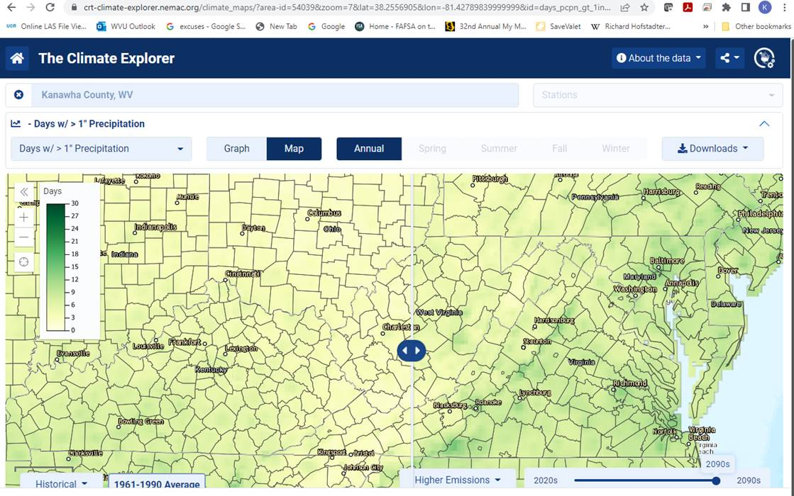

**Figure B-15**. NOAA’s Climate Explorer Tool

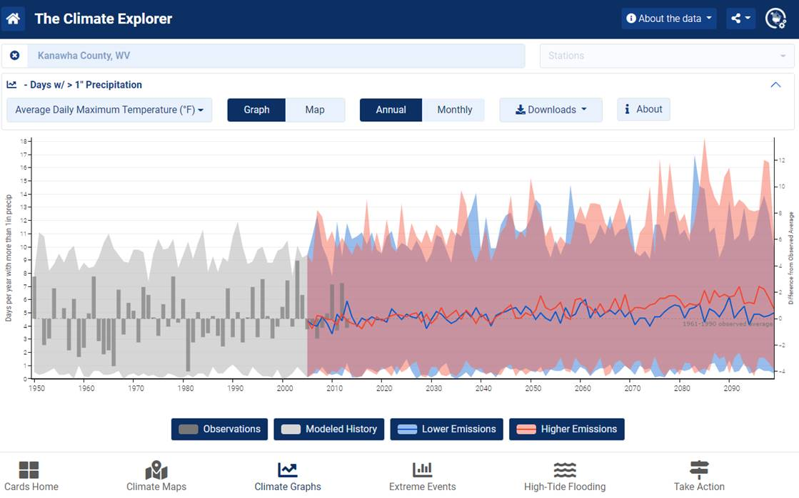

**Figure B-16**. NOAA’s Climate Explorer Tool