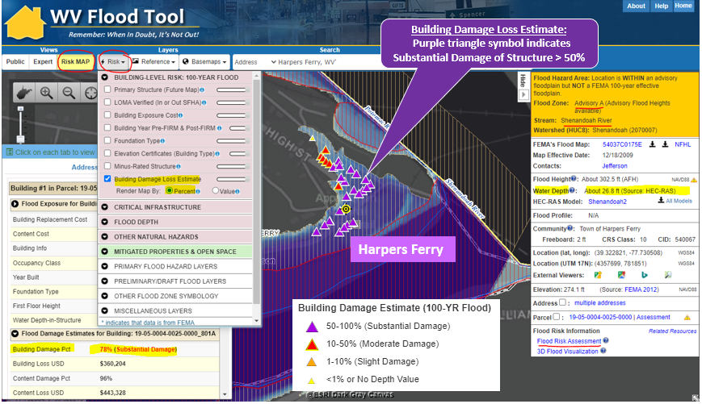



WV Emergency Management Division

COOPERATING TECHNICAL PARTNERS (CTP) PROGRAM MANAGEMENT (PM)

STATEMENT OF WORK (SOW)

PM SOW No. 8

Fiscal Year 2023

This page intentionally left blank

Table of Contents

1. Part 1 – Custom Statement of Work Information 4

1.1. Project and Point of Contact Information 4

1.2. Tasks and Deliverables to be Completed Under this SOW 6

1.3. Schedule and Performance 14

1.4. Standards 16

1.5. Use of Contractors 16

1.6. Reporting and Performance 17

1.7. Privacy and Protection of Personally Identifiable Information 18

Authorized Representative Signatures 19

**APPENDIX A:** Scope of State NFIP Office Led Project Management (PM) Category 1 Tasks A-1

**APPENDIX B:** Scope of WVU Led Project Management (PM) Category 1 Tasks B-1

# Part 1 – Custom Statement of Work Information

## Project and Point of Contact Information

#### Table 1. Project and Point of Contact Information

|  |  |
| --- | --- |
| Information Type | Insert Information |
| Project Name/Title (if applicable) | **WVEMD CTP PM 2023-24** |
| CTP Organization Name: | **WV Emergency Management Division** |
| CTP Contractor Working on the activities in this SOW:  *Optional, only if contractors have already been identified; contractor support may be engaged for all activities except Staffing and Mentoring, which must be completed by the CTP* | **WVU GIS Technical Center, West Virginia University** |
| Sub-Recipient Working on the activities in this SOW:  *Optional, only if sub-recipients have already been identified; contractor support may be engaged for all activities except Staffing and Mentoring, which must be completed by the CTPS* | **N/A** |
| CTP Partnership Agreement Date: | **7/2023** |
| Period of Performance: | **10/1/2023 to 9/30/2024** |
| CTP Project Manager: | **Timothy W. Keaton, CFM** |
| FEMA Regional Project Officer (PO):  *When necessary, ask for FEMA assistance through the FEMA Regional PO* | **Kristen Jones (primary contact) Senior Risk Analysis Management and Program Analyst | Mitigation | Region 3** |

|  |  |
| --- | --- |
| Information Type Insert Information | |
| FEMA Funding to Complete this PM SOW: | **$250,000** |
| CTP Estimated Leverage:  *Final leverage dollars or units will be entered as applicable in the Manage Data Development Task Workflow in the Mapping Information Platform (MIP). The leverage noted here is an estimate of leverage available at the time when the scope is prepared. It may be refined at any time in the project. See* [*Estimating the Value of*](https://www.fema.gov/flood-maps/cooperating-technical-partners/become-partner/apply-grants#%3A%7E%3Atext%3DThe%20Blue%20Book%20is%20an%2CMapping%20Activity%20Statement%20(MAS))[*Partner Contributions to Flood Mapping*](https://www.fema.gov/flood-maps/cooperating-technical-partners/become-partner/apply-grants#%3A%7E%3Atext%3DThe%20Blue%20Book%20is%20an%2CMapping%20Activity%20Statement%20(MAS))[*Projects “Blue Book” (Blue Book)*](https://www.fema.gov/flood-maps/cooperating-technical-partners/become-partner/apply-grants#%3A%7E%3Atext%3DThe%20Blue%20Book%20is%20an%2CMapping%20Activity%20Statement%20(MAS)) | **N/A** |
| Project Team Coordination Activities:  *During the project, all members of the Project Team will coordinate, as needed, to see that activities, products and deliverables meet FEMA requirements and contain accurate, up- to-date information.* | * **Meetings, teleconferences, and video conferences with FEMA Region III, WVEMD, and other Project Team members biannually at a minimum with additional meetings scheduled as necessary.** * **Telephone conversations with FEMA and other Project Team members on a scheduled monthly basis and ad hoc basis, as required** * **Email as needed** |

## Tasks and Deliverables to be Completed Under this SOW

### NARRATIVE AND AUDIENCE

#### Table 2. Narrative and Audience

|  |  |  |
| --- | --- | --- |
| Information Type | | Description |
| SOW Narrative: | This CTP PM Project supports statewide global outreach for mapping services that process and integrate new flood and reference GIS layers, tool enhancements, flood risk information, etc. for the WV Flood Tool ([www.mapwv.gov/Flood](http://www.mapwv.gov/Flood)). It also provides mitigation planning technical assistance through specific activities for all 268 flood-prone communities in the State. A comprehensive State Business Plan as a single deliverable for both the Community Outreach and Mitigation Strategies (COMS) Engagement Plan and PM Business Plan will be completed as well. The WV GIS Technical Center at West Virginia University and host of the WV Flood Tool will provide contracting support for all PM activities. An overarching goal of this CTP PM project is to more proactively engage flood-prone communities to use the new statewide building-level risk assessment data for their floodplain management and mitigation planning activities. In addition, a CNMS Discovery activity has been added that focuses using spatial building cluster analysis to identify Approximate A Zones for upgrade to Zone AE Detailed Studies. The major scoping activities are divided by WV NFIP Office Led (Appendix A) and WVU GIS Technical Center led (Appendix B).  This project includes outreach mapping activities that support the goals of FEMA’s NFIP/CRS flood mapping program, including flood risks and hazard identification. It also includes technical assistance activities that will produce and disseminate products and materials to the state and local jurisdictions to develop, evaluate, update, and implement their mitigation plans and strategies. *Refer to Appendices A and B for detailed statements of work.* | |
| Intended Audience: | **Target Audience:** Floodplain Managers, Community Planners, Emergency Preparedness Officials, Engineers/Surveyors, Realtors, Lenders, Community Leaders, Property Owners, etc. Supports stakeholders engaged at the state, regional, and community levels.  **Project Footprint:** State of West Virginia  *Through collaboration with Local, State, and Federal entities, the WV Flood Tool delivers quality data that increases public awareness and leads to actions that reduce risk to life and property. To manage the wealth of available data and better communicate flood risk, the WV Flood Tool has maintained a public facing outreach tool for the public, communities, engineering/surveying companies, and others (Insurance companies, lending institutions, real estate companies, etc.) that has provided effective floodplain models, supporting datasets, water-surface elevations, floodplain boundaries, and additional enhanced flood risk information. During the past decade, the functionality and quality of data layers of the WV Flood Tool have progressed, resulting in an increased use of the application. Over time, the WV Flood Tool has become more than just a flood determination tool, and today is routinely used by floodplain managers for building permit applications, floodplain regulations enforcement, pre- and post-disaster assessments, and Community Rating System discounts. For community and emergency planners, the RiskMAP View of the WV Flood Tool now includes structure-level risk assessments and mitigated properties to aid in flood reduction efforts.* | |

### PROJECT TASKS AND DELIVERABLES

The following 11 tasks can be accomplished under this PM SOW:

* State and Local Business Plans and/or Updates (required).
* Global Program Management Activities (completed under the PM SOW when the CTP is also funded for tasks in the Flood Risk Project Mapping Activity Statement [MAS]).
* Global Outreach for Mapping.
* Training to State, Tribal, Territory, and Local Officials.
* Mitigation Planning Technical Assistance.
* Staffing.
* Technical Pilot Projects.
* Mentoring and Best Practices.
* Minimal Map Printing.
* Coordinated Needs Management Strategy (CNMS).
* Programmatic Quality Assurance/Quality Control (QA/QC) Plans.

### Task 1 - State and Local Business Plans and/or Updates (Required)

#### Table 3. Task 1 – State and Local Business Plans and/or Updates

|  |  |  |  |  |  |
| --- | --- | --- | --- | --- | --- |
| PM Task | Mark “X” if task will be done under this SOW | (A) FEMA Contribution | (B) Partner Contribution | | (A+B) Total Project Cost |
| State and Local Business Plans and/or Updates *(required as a condition of PM funding)* |  | $5,000 | $0 | | $5,000 |
| Deliverable | | | | Mark “X” if deliverable will be done under this task | |
| Business Plan (required) | | | |  | |
| Custom Scope Elements | | | | | |
| WV NFIP PM TASK: State Business Plan. Cost $5,000. (See Appendix A)   1. **Complete a Comprehensive State Business Plan.** Complete a State Business Plan for delivery to FEMA Region III. The comprehensive Business Plan will be a single deliverable for both the Community Outreach and Mitigation Strategies (COMS) Engagement Plan and PM Business Plan. The comprehensive plan will advance the NFIP/CRS and Risk MAP programs in West Virginia. Both the PM Business Plan and COMS Engagement Plan will adhere to the guiding principles detailed in Appendix C of the [NOFO FY23 CTP Program](https://www.fema.gov/sites/default/files/documents/fema_ctp-nofo_fy2023.pdf). | | | | | |

### Task 3 – Global Outreach for Mapping

Task 3 can be selected under this task if there is no COMS SOW. If a COMS SOW is also completed, the Outreach Plan is required under the Strategic Planning for Community Engagement Task and should not be part of this PM SOW.

#### Table 5. Task 3 – Global Outreach for Mapping

|  |  |  |  |  |  |
| --- | --- | --- | --- | --- | --- |
| PM Task | Mark “X” if task will be done under this SOW | (A) FEMA Contribution | (B) Partner Contribution | | (A+B) Total Project Cost |
| Global Outreach for Mapping |  | $188,000 | $0 | | $188,000 |
| Deliverable | | | | Mark “X” if deliverable will be done under this task | |
| Outreach Plan (Refer to COM Program SOW) | | | | ☐ | |
| Report detailing outreach and coordination activities including backup or supplemental information used in writing the report | | | | ☐ | |
| Business Plan update describing (in detail) the outreach activities | | | |  | |
| Updates to CTP’s website | | | |  | |
| Other: Create a climate of understanding and ownership of the WV Flood Tool in support of the Risk MAP flood risk study process among stakeholders ($25K) | | | |  | |
| Other: Provide Global Outreach Services for the WV Flood Tool ($155k) | | | |  | |
| Other: Deliver Technical Support Services for LiDAR LOMAs ($8K) | | | |  | |
| Custom Scope Elements | | | | | |
| WV NFIP PM TASK: Global Outreach for Mapping Activities spearheaded by State NFIP Office. Support from WVU GIS Technical Center. Cost $25,000. (See Appendix A for more details)   1. **Create a climate of understanding and ownership of the WV Flood Tool in support of the Risk MAP flood risk study process among stakeholders.** Support training and educational activities that promote the WV Flood Tool to the public, floodplain managers, surveyors, disaster and mitigation planners, community leaders, insurance and real estate agents, etc. Educational activities shall focus on both the basic and more advanced mapping functions available on the WV Flood Tool. Targeted outreach activities shall include new advisory and regulatory map flood layers, base flood elevations and elevation certificates, LiDAR LOMAs, and various risk assessment and mitigation datasets. This global outreach for mapping task includes engaging communities to validate Areas of Mitigation Interest (AoMI) on the WV Flood Tool based on available flood characteristic and risk assessment datasets. In addition, this task tracks all the active and planned flood map studies funded by FEMA and incorporates this mapping information in the comprehensive business plan. This activity also compiles the most current local floodplain manger contact information which is periodically published to the WV Flood Tool. The WV Flood Tool and its risk assessment data sets also support Community Rating System (CRS) credits (mapping, open space preservation, bSF/aSFHA program variables, etc.).   WVU PM TASKS: Global Outreach for Mapping Activities for WV Flood Tool. Cost $163,000. (See Appendix B for more details).   1. **Provide Global Outreach Services for the WV Flood Tool.**  Statewide global outreach services that process and integrate new flood and reference GIS layers, tool enhancements, flood and landslide risk information, etc. for the WV Flood Tool ([www.mapwv.gov/Flood](http://www.mapwv.gov/Flood)). Services include computer programming, data development/geo-processing, customized mapping, and technical support services (Task A). This task includes developing outreach materials along with in-person and remote training courses for the WV Flood Tool. For this CTP year, the professional surveyors of West Virginia have requested training at their annual conference in February 2024 about the WV Flood Tool. Customized training for the surveyors will focus on what distinguishes the WV Flood Tool from FEMA’s NFHL Viewer and Flood Insurance Rate Maps (FIRMs). For example, the WV Flood Tool provides BFEs for Approximate A Zones and high-resolution elevation date for qualifying LIDAR LOMAs. FEMA does not provide these map services. In addition, the WV Flood Tool publishes Elevation Certificates, Verified LOMA locations, HEC-RAS stream models, and 1%-annual-chance advisory floodplains / BFE’s / depth grids not available by FEMA maps services. See Table B-1 of Appendix B for more details and scope of these services. 2. **Deliver Technical Support Services for LiDAR LOMAs.** West Virginia now has statewide coverage of QL2 LiDAR data and LiDAR-derived elevation products of one-meter DEMs and 1-foot contours. LiDAR LOMAs can be submitted for qualifying structures using FEMA’s Online LOMA portal. The Flood Tool’s Print Function generates map layouts for the LiDAR submissions using either the contour or point elevation methods. To save disadvantaged communities and homeowners the cost of needing a site elevation survey, this activity will communicate to these constituents how the "mapped out" structures (primary building structures symbolized by yellow squares where future map conditions exist) displayed on the RiskMAP View of the WV Flood Tool may qualify for removal of the structure from the SFHA. The only information required for an Online LOMA submission are a map layout from the Flood Tool and a copy of the deed. The WVU GIS Technical Center will support the state and local floodplain management community with the submission of LiDAR LOMAs when a field survey is not required, to include assisting floodplain managers with the online submissions to FEMA. | | | | | |

### Task 5 – Mitigation Planning Technical Assistance

#### Table 7. Task 5 – Mitigation Planning Technical Assistance

|  |  |  |  |  |  |
| --- | --- | --- | --- | --- | --- |
| PM Task | Mark “X” if task will be done under this SOW | (A) FEMA Contribution | (B) Partner Contribution | | (A+B) Total Project Cost |
| Mitigation Planning and Technical Assistance (TA) |  | $47,000 | $0 | | $47,000 |
| Deliverable | | | | Mark “X” if deliverable will be done under this task | |
| A report detailing the TA provided including date(s) of TA and type of assistance and state, tribal, or local community stakeholders supported | | | |  | |
| Copies of all technical data provided to local, state, and tribal communities | | | |  | |
| Other: Organize and Train Substantial Improvement / Substantial Damage Teams for Flood Disasters ($15K) | | | |  | |
| Other: Engage the Floodplain Management Community to Submit NFIP Repetitive Loss (RL) AW-501 Worksheets and FMA Grant Applications ($10K) | | | |  | |
| Other: Organize and Publish Resource Toolkit of Floodplain Management and Mitigation Documents ($5K) | | | |  | |
| Other: Document Mitigation Status of Statewide Flood-Prone Structures ($10K) | | | |  | |
| Other: Support Local Hazard Mitigation Plans with Flood/Landslide Risk Assessment Data ($7K) | | | |  | |
| Custom Scope Elements | | | | | |
| WV NFIP PM TASKS: Mitigation Planning Technical Assistance Activities spearheaded by State NFIP Office. Support from WVU GIS Technical Center. Cost $40,000. (See Appendix A for more details)   * **Organize and Train Substantial Improvement / Substantial Damage Teams for Flood Disasters.** For pre- and post-disaster planning, the State NFIP Office shall provide Substantial Improvement (SI) / Substantial Damage (SD) training to include organizing damage assessment teams for flood disasters. For pre-disaster planning and preparation, the detailed statewide floodplain building inventory on the WV Flood Tool can be preloaded into FEMA’s Substantial Estimator (SDE) Tool. With the changing climate, especially with the potentially increased building damage impacts from heavy precipitation events that fill rivers and river valleys, it is important that the state and flood-prone communities have their residential/non-residential structures from the WV Building Level Risk Assessment (BLRA) uploaded into FEMA's Substantial Damage Estimator tool. Where applicable, the WV Flood Tool can provide the specific flood map (flood zone, effective map date, BFE, etc.) and building information (appraisal value, building year, number of stories, residential/non-residential occupancy class, etc.) required for substantial damage inspections, determinations, letters, and appeals. The WV Flood Tool also has the ability to identify SI / SD fifty-percent damage thresholds from appraisal building values of tax assessment records compiled for the past 20 years. Training will be coordinated with the [Disaster Recovery Reform Act Section 1206](https://www.fema.gov/sites/default/files/documents/fema_drra-1206-companion-document.pdf). In addition to coordinated support from FEMA Region III and the floodplain management community, the WVU GIS Technical Center will provide technical assistance in pre-loading flood map and building data into FEMA’s SDE Tool for NFIP communities. * **Engage the Floodplain Management Community to Submit NFIP Repetitive Loss (RL) AW-501 Worksheets and FMA Grant Applications**. For mitigation technical assistance, the State NFIP Office will make a coordinated effort to improve the community submission of Repetitive Loss [AW-501](https://homelandsecurity.iowa.gov/wp-content/uploads/2022/01/2008-AW501-Form-OMB.pdf) worksheets and Flood Mitigation Assistance (FMA) grant applications for eligible NFIP structures. The WVU GIS Technical Center can provide technical assistance to include: (1) geocoding RL properties to the correct jurisdiction; (2) identifying if an RL building still exists based on aerial photography and tax assessment records, (3) and determining if the RL building is a historic building listed on the State or National Historic Registry. This task aligns with the NFIP Community Rating System (CRS) program requirements, and any FMA grant applications will be coordinated with the State Mitigation Office. * **Organize and Publish a Resource Toolkit of Floodplain Management and Mitigation Documents.** The State NFIP office will organize and publish basic floodplain management and mitigation documents into a useful resource toolkit for local floodplain managers. The WV Flood Tool and other websites will provide access to these technical assistance documents. FEMA Region III, State Resiliency Office, State Mitigation Office, and local floodplain managers will review the resource document toolkit, providing feedback and recommendations. The resource toolkit will complement scheduled training by the State NFIP Office to include WV Floodplain Management 101, CFM Refresher, and Basic/Advanced Floodplain Management courses. * **Document Mitigation Status of Statewide Flood-Prone Structures.** Conduct a comprehensive inventory of existing mitigated structures using the statewide building level risk assessments to determine how communities have applied flood adaptive measures in response to major flood events. In response to climate change impacts, evaluate if mitigation measures (elevation, barrier, wet floodproofing, dry floodproofing, etc.) along with flood development ordinance standards (e.g., freeboard) are adequate for changing environmental conditions. This activity will focus on the post-FIRM structures with a Minus 3 Rating (lowest floor 3 or more feet below the BFE) to determine if newly constructed properties are properly mitigated. Structure-level mitigated status information will be tracked by the unique building identifier (Parcel ID + Address Number) and WV Flood Tool shared map link. This activity will engage flood-prone communities, thereby providing outreach and training opportunities to encourage communities to adopt higher flood protection standards through ordinances as well as other flood adaptive measures. Furthermore, this mitigation verification activity will align with scheduled CAV’s (Community Assisted Visits) and CAC’s (Community Assisted Contacts) sponsored by the State NFIP Office and FEMA Region III. Lastly, the mitigation status review of high-value, high damage loss, or high minus-rated properties (including critical facilities) will be provided as a complimentary service for any NFIP communities in West Virginia.   WVU PM TASK: Mitigation Planning Technical Activity. Cost $7,000. (See Appendix B for more details).   * **Support Local Hazard Mitigation Plans with Flood/Landslide Risk Assessment Data.**  This mitigation planning technical assistance task supports mitigation planners and consultants with various risk assessment products for updating their local hazard mitigation plans. The risk assessment and mitigation products were generated from the HMGP Statewide Multi-Hazard Risk Assessment Project and select data sets are updated each year. The multi-hazard data includes riverine flooding, landslides, and dam failure. Refer to the catalog or [Risk Information Index](https://data.wvgis.wvu.edu/pub/RA/_engage/_IndexDocs/) to access various risk assessment products (reports, tables, graphics, risk dashboards, etc.) published in support of FEMA’s Hazard Mitigation Plans and NFIP/CRS activities. See the [2022 TEIF-TEAL Close-out Report](https://data.wvgis.wvu.edu/pub/RA/_engage/Project/WVU_HMGP_TEIF-TEAL_Closeout.pdf) about risk assessment and mitigation products as well. | | | | | |

### Task 10 – Coordinated Needs Management Strategy

#### Table 12. Task 10 – Coordinated Needs Management Strategy

|  |  |  |  |  |  |
| --- | --- | --- | --- | --- | --- |
| PM Task | Mark “X” if task will be done under this SOW | (A) FEMA Contribution | (B) Partner Contribution | | (A+B) Total Project Cost |
| Coordinated Needs Management Strategy (CNMS) |  | $10,000 | $0 | | $10,000 |
| Deliverable | | | | Mark “X” if deliverable will be done under this task | |
| Interim deliverables for the mapping project along its life cycle (funded, Preliminary, Letter of Final Determination [LFD]) | | | | ☐ | |
| Supporting documentation for new determinations | | | |  | |
| A self-certification document outlining the funded scope and comments per region discretion | | | | ☐ | |
| A self-certified CNMS spatial database using the CNMS QC tool | | | | ☐ | |
| Other: Perform Building Cluster Analysis for CNMS Discovery of Potential Approximate A Zones for Upgrade to Zone AE Detailed Mapping ($10K) | | | |  | |
| Custom Scope Elements | | | | | |
| WVU PM TASK: Coordinated Needs Management Strategy. Cost $10,000. (See Appendix B for more details).   * **Perform Building Cluster Analysis for CNMS Discovery of Potential Approximate A Zones for Upgrade to Zone AE Detailed Mapping.** A [statewide Approximate Zone A cluster analysis](https://data.wvgis.wvu.edu/pub/RA/State/CL/Stream_Name/Zone_A_Structure_Analysis/) was performed in February 2022 from the statewide Building-Level Risk Assessment project in which Approximate A Zone candidates were identified and entered by a FEMA contractor (WSP USA) into FEMA’s Coordinated Needs Management Strategy ([CNMS](https://www.fema.gov/flood-maps/tools-resources/risk-map/coordinated-needs-management-strategy)) geospatial database. A more refined study will be done for the Kanawha River Basin watersheds and other watersheds in the state where future Risk MAP Discovery activities are scheduled. This information is beneficial for the initial [Discovery Phase](https://www.fema.gov/sites/default/files/documents/fema_risk-map-phase-1-factsheet.pdf) of the Risk MAP process. Refer to FEMA’s [Guidance for Flood Risk Analysis and Mapping](https://www.fema.gov/sites/default/files/2020-02/Discovery_Guidance_Nov_2019.pdf).   *Methodology and Rankings:* A detailed analysis for building clusters will be conducted for flood depths ≥ 5 feet and ranked accordingly to 12 evaluation factors. Physical building factors are based on (1) building counts, (2) building dollar exposure, (3) building damage dollar exposure estimates, (4) substantially damaged estimates, and (5) building types. Depth grids factors are (6) extreme flood depths ≥ 10 feet and (7) depth grid accuracy. Mapping cost-effectiveness factors are the (8) stream length of building clusters for Zone AE, (9) building density per square mile, (10) estimated Zone AE study cost per mile, (11) Zone A building cluster adjacent an existing Zone AE study, and (12) legacy county boundary mapping issues. | | | | | |

## Schedule and Performance

Instructions: Insert each deliverable for all activities included in this PM SOW in Table 16. PM Task Deliverables Schedule. Examples are provided in italics in the first row. Deliverables can be listed individually or grouped by a single deliverable date. Add more rows to the table as needed. Due dates will be discussed with the FEMA Regional PO.

#### Table 16. PM Task Deliverables Schedule

|  |  |  |  |
| --- | --- | --- | --- |
| SOW Activities | Deliverable | Deliverable Due Date | Submitted To |
| Business Plan (required) | Business Plan | 9 months from Award date | FEMA Regional Project Officer |
| Global Outreach for Mapping | Reporting on Outreach Website updates/enhancements | Quarterly | FEMA Regional Project Officer |
| Mitigation Planning Technical Assistance (TA) | Reporting on TA Activities | Quarterly | FEMA Regional Project Officer |
| Coordinated Needs Management Strategy | Reporting on CNMS Activity | Quarterly | FEMA Regional Project Officer |

#### Table 17. Performance Measures Targets

|  |  |  |
| --- | --- | --- |
| Outcome1 | Output Measurement2 (with customized Target) | Recorded Unit/Scale |
| Update WV Flood Tool with new hazard data | Flood hazard, risk assessment, and key reference layers updated on the WV Flood Tool (www.mapwv.gov/flood). | Achieved / Not Achieved |
| WV Flood Tool training | * Develop and publish training materials * Provide in-person and remote training | Achieved / Not Achieved |
| Deliver Technical Support Services for LiDAR LOMAs | Provide technical support and training for LiDAR LOMA function on WV Flood Tool | Achieved / Not Achieved |
| SI / SD Training including SDE Software | * Training scheduled and executed. * SDE Teams organized and disaster simulated * Pre-load community flood map and building level data into SDE software | Achieved / Not Achieved |
| NFIP Repetitive Loss (RL) AW-501 Worksheet Submissions | Engage 10 or more NFIP communities | Achieved / Not Achieved |
| Floodplain Management Resource Toolkit | Organize and publish resource toolkit to website | Achieved / Not Achieved |
| Document Mitigation Status of Statewide Flood-Prone Structures | Activity aligned with CAV’s and CAC’s. | Achieved / Not Achieved |
| Support Local Hazard Mitigation Plans | Provide access to various risk assessment products (reports, tables, graphics, risk dashboards, etc.) | Achieved / Not Achieved |
| Identify Approximate A Zones for upgrade to Detailed AE Zones | Perform analysis and submit to CNMS contractor for Risk MAP Discovery. | Achieved / Not Achieved |

1 An outcome is an observable and measurable change of knowledge, behavior, skills, and/or efficiency as a result of a CTP project.

2 An output is a direct, specific, and quantifiable product of CTP activities that lead to/indicate success of the intended outcome, expressed in units of measure that enable quantifiable recording of performance.

## Standards

The standards relevant to this SOW are presented in [FEMA Policy 204-078-1 Standards for Flood](https://www.fema.gov/flood-maps/guidance-reports/guidelines-standards/standards-flood-risk-analysis-and-mapping-public-review) [Risk Analysis and Mapping, Revision 13](https://www.fema.gov/flood-maps/guidance-reports/guidelines-standards/standards-flood-risk-analysis-and-mapping-public-review) (dated December 2022).

This Policy supersedes all previous standards in the Guidelines and Specifications for Flood Hazard Mapping Partners. This includes all related appendices and procedure memoranda. Find more information and links to guidance documents, technical references, templates, and other resources that support these standards on the FEMA Guidelines and Standards website. This is at: [Guidelines](https://www.fema.gov/guidelines-and-standards-flood-risk-analysis-and-mapping) [and Standards for Flood Risk Analysis and Mapping Activities Under the Risk MAP Program](https://www.fema.gov/guidelines-and-standards-flood-risk-analysis-and-mapping). FEMA reviews standards each year. Please use the most current version of the policy.

For any Mitigation Planning Technical Assistance activities, coordinate with the FEMA Regional PO to confirm compliance with regional requirements. Additional information is available in FEMA’s Incorporating Mitigation Planning Technical Assistance guidance document, available on the FEMA Guidelines and Standards website at: [Guidance for FEMA's Risk Mapping, Assessment and Planning.](https://www.fema.gov/flood-maps/guidance-reports/guidelines-standards/guidance-femas-risk-mapping-assessment-and-planning)

For CNMS activities, all work shall be performed in accordance with the requirements specified in the most recent Coordinated Needs Management Strategy (CNMS) Technical Reference available at: [Technical References for Flood Risk Analysis and Mapping.](https://www.fema.gov/flood-maps/guidance-reports/guidelines-standards/technical-references-flood-risk-analysis-and-mapping)

## Use of Contractors

Check the applicable statement in Table 18.

#### Table 18. Use of Contractors

|  |  |
| --- | --- |
| Select One | Description of Contractor Options |
|  | Contractor support may be engaged for all activities within this SOW, except staffing and mentoring, which must be completed by the CTP. The CTP will identify the name of the CTP contractor for services engaged as part of this SOW. The CTP shall ensure that the procurement for all contractors used for this Program Management Activity complies with the requirements of 2 Code of Federal Regulations (CFR) Part 200.  Guidance provided in this part includes, but is not limited to, contract administration and recordkeeping, notification requirements, review procedures, competition, methods of procurement, and cost and pricing analysis. 2 CFR Part 200 may be viewed online at: [Part 200 - Uniform Administrative Requirements, Cost Principles,](http://www.ecfr.gov/cgi-bin/text-idx?SID=cc011f4fb962e68cb0da4bc91e8fbb43&mc=true&node=pt2.1.200&rgn=div5) [and Audit Requirements for Federal Awards.](http://www.ecfr.gov/cgi-bin/text-idx?SID=cc011f4fb962e68cb0da4bc91e8fbb43&mc=true&node=pt2.1.200&rgn=div5)  Additionally, contractors must not pose a conflict-of-interest issue.  Contractors support will be provided by the WV GIS Technical Center, West Virginia University |

|  |  |
| --- | --- |
| Select Description of Contractor Options One | |
| ☐ | The CTP does not intend to engage the services of a contractor for this SOW. No transfer of funds to agencies, other than those identified in the approved cooperative agreement application, shall be made without prior approval from FEMA. The CTP shall ensure that the procurement for all contractors, if any are engaged for this SOW, complies with the requirements of 2 CFR Part 200.  Guidance provided in this part includes, but is not limited to, contract administration and recordkeeping, notification requirements, review procedures, competition, methods of procurement, and cost and pricing analysis. 2 CFR Part 200 may be viewed online at: “[Part 200 - Uniform Administrative Requirements, Cost Principles,](http://www.ecfr.gov/cgi-bin/text-idx?SID=cc011f4fb962e68cb0da4bc91e8fbb43&mc=true&node=pt2.1.200&rgn=div5) [and Audit Requirements for Federal Awards](http://www.ecfr.gov/cgi-bin/text-idx?SID=cc011f4fb962e68cb0da4bc91e8fbb43&mc=true&node=pt2.1.200&rgn=div5).” |

## Reporting and Performance

Financial Reporting: Because FEMA has provided funding to the CTP, financial reporting requirements for the CTP will be set by the terms of the NOFO, Articles of Agreement, or Award Notice for this SOW. The CTP shall also refer to [2 CFR Part 200.](http://www.ecfr.gov/cgi-bin/text-idx?SID=cc011f4fb962e68cb0da4bc91e8fbb43&mc=true&node=pt2.1.200&rgn=div5) The CTP shall provide financial reports to the FEMA Regional PO and Assistance Officer per the terms of the signed Cooperative Agreement for this SOW.

Performance Reporting: CTPs must provide a signed performance report (using the list of required information shown in the NOFO). The CTP will submit the report quarterly during the period of performance. Reports will be required for partial calendar quarters and periods when no grant award activity occurs. An old Standard Form-Performance Progress Report (SF-PPR) may be substituted for the performance report, if preferred. The CTP shall refer to [2 CFR Part 200](http://www.ecfr.gov/cgi-bin/text-idx?SID=cc011f4fb962e68cb0da4bc91e8fbb43&mc=true&node=pt2.1.200&rgn=div5) for the minimum requirements for progress reporting. The FEMA Regional PO, as needed, may request additional information on progress.

The CTP will meet with FEMA and/or its contractor(s) as frequently as needed to review the progress of the project. These meetings are in addition to the quarterly financial and status submittals. These meetings may alternate between the FEMA Regional Office, the CTP office and conference calls as necessary.

The CTP must report performance of the grant along with the progress reports. Table 17. Performance Measures Targets shows which performance measures the CTPs will use to track performance. If you are completing a COMS project alongside a Flood Risk Project MAS, use the relevant measures in the 2023 CTP Performance Measures Matrix. Quantitative Targets for performance measures are defined using the 2023 CTP Performance Measures Matrix in conjunction with your FEMA Regional PO and those defined in Table 17.

CTPs are responsible for entering their quarterly performance of each measure into the CTP Performance Measures Reporting Tool (Tool) each quarter, unless otherwise directed by their FEMA Regional PO. Each output measurement identified above must have a quarterly performance

reported in the Tool within one month of the end of the quarter. Quarterly performance data can be exported from the Tool and attached to the Quarterly Report that must be uploaded to FEMA GO.

Earned Value Data Entry:

The CTP must report on the earned value of projects that are in the MIP each month. They must explain variances outside of the tolerance defined in Table 17. The FEMA Regional Offices must implement a Corrective Action Plan (CAP) when a CTP is outside of the tolerance. A CAP must define the reason for the variance and the intended resolution. FEMA Regional Offices shall coordinate with FEMA Headquarters (HQ) when CAPs are developed

COMS SOW/PM SOW tasks are now tracked in the MIP. Cost and schedule performance measures are defined in this SOW. These measures will be used to monitor CTP performance and to determine future funding eligibility. Earned Value data entry involves the CTP updating cost, schedule and performance (physical % complete) in the MIP each month for each assigned task. The CTP may contact the FEMA Regional Office to obtain additional guidance (as needed) for updating COMS/PM efforts in the MIP.

## Privacy and Protection of Personally Identifiable Information

A CTP’s organizational access to the MIP provides you access to PII. Please have your organization coordinate with the FEMA Regional Office. Each user must currently meet the new Risk Analysis Management Access Portal (RAP) process requirements.

Please contact your FEMA Regional PO for more information.

# Authorized Representative Signatures

Each party has caused this SOW to be executed by its duly authorized representative.

Timothy Keaton Date

Project Manager

WV Emergency Management Division

Kristen Jones Date

Regional Project Officer

Federal Emergency Management Agency, Region, Region 3

# **APPENDIX A:** Scope of State NFIP Office Led Project Management (PM) Category 1 Tasks

**2023-24 CTP PM Scope: WV Focused Flood Reduction and Mitigation Engagement Activities**State: West Virginia  
Total Cost: $70,000   
Performance Period: October 1, 2023, to September 30, 2024 (12 months)  
Plan by Tim Keaton, State NFIP Coordinator, **WV Emergency Management Division.** Technical support from the **WVU GIS Technical Center.**   
6/14/2023

**The State NFIP Office led project management (PM) tasks will consist of six focused outreach, training, planning, and community engagement activities in support of flood reduction and mitigation programs, to include:**

1. Complete a Comprehensive State Business Plan
2. Create a climate of understanding and ownership of the WV Flood Tool in support of the Risk MAP flood risk study process among stakeholders.
3. Organize and Train Substantial Improvement / Substantial Damage Teams for Flood Disasters. Document Mitigation Status of Flood-Prone Structures
4. Engage the Floodplain Management Community to Submit NFIP Repetitive Loss (RL) AW-501 Worksheets and FMA Grant Applications
5. Organize and Publish a Resource Toolkit of Floodplain Management and Mitigation Documents
6. Document Mitigation Status of Statewide Flood-Prone Structures

State Business Plan ($5K)

1. **Complete a Comprehensive State Business Plan.** Complete a State Business Plan for delivery to FEMA Region III. The comprehensive Business Plan will be a single deliverable for both the Community Outreach and Mitigation Strategies (COMS) Engagement Plan and PM Business Plan. The comprehensive plan will advance the NFIP/CRS and Risk MAP programs in West Virginia. Both the PM Business Plan and COMS Engagement Plan will adhere to the guiding principles detailed in Appendix C of the [NOFO FY23 CTP Program](https://www.fema.gov/sites/default/files/documents/fema_ctp-nofo_fy2023.pdf).

Global Outreach for Mapping ($25K)

1. **Create a climate of understanding and ownership of the WV Flood Tool in support of the Risk MAP flood risk study process among stakeholders.** Support training and educational activities that promote the WV Flood Tool to the public, floodplain managers, surveyors, disaster and mitigation planners, community leaders, insurance and real estate agents, etc. Educational activities shall focus on both the basic and more advanced mapping functions available on the WV Flood Tool. Targeted outreach activities shall include new advisory and regulatory map flood layers, base flood elevations and elevation certificates, LiDAR LOMAs, and various risk assessment and mitigation datasets. This global outreach for mapping task includes engaging communities to validate Areas of Mitigation Interest (AoMI) on the WV Flood Tool based on available flood characteristic and risk assessment datasets. In addition, this task tracks all the active and planned flood map studies funded by FEMA and incorporates this mapping information in the comprehensive business plan. This activity also compiles the most current local floodplain manger contact information which is periodically published to the WV Flood Tool. The WV Flood Tool and its risk assessment data sets also support Community Rating System (CRS) credits (mapping, open space preservation, bSF/aSFHA program variables, etc.).

Mitigation Planning Technical Assistance ($40K)

1. **Organize and Train Substantial Improvement / Substantial Damage Teams for Flood Disasters.** For pre- and post-disaster planning, the State NFIP Office shall provide Substantial Improvement (SI) / Substantial Damage (SD) training to include organizing damage assessment teams for flood disasters. For pre-disaster planning and preparation, the detailed statewide floodplain building inventory on the WV Flood Tool can be preloaded into FEMA’s Substantial Estimator (SDE) Tool. With the changing climate, especially with the potentially increased building damage impacts from heavy precipitation events that fill rivers and river valleys, it is important that the state and flood-prone communities have their residential/non-residential structures from the WV Building Level Risk Assessment (BLRA) uploaded into FEMA's Substantial Damage Estimator tool. Where applicable, the WV Flood Tool can provide the specific flood map (flood zone, effective map date, BFE, etc.) and building information (appraisal value, building year, number of stories, residential/non-residential occupancy class, etc.) required for substantial damage inspections, determinations, letters, and appeals. The WV Flood Tool also has the ability to identify SI / SD fifty-percent damage thresholds from appraisal building values of tax assessment records compiled for the past 20 years. Training will be coordinated with the [Disaster Recovery Reform Act Section 1206](https://www.fema.gov/sites/default/files/documents/fema_drra-1206-companion-document.pdf). In addition to coordinated support from FEMA Region III and the floodplain management community, the WVU GIS Technical Center will provide technical assistance in pre-loading flood map and building data into FEMA’s SDE Tool for NFIP communities.

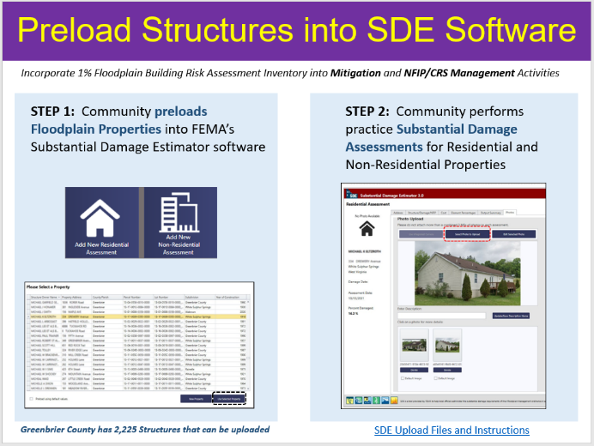**Figure A-1**. New data products developed from the statewide risk assessment project include pre-loading the entire statewide flood risk inventory of 98,000 structures into FEMA’s Substantial Damage Estimator Tool.  See [WV SDE Data Import and Instructions](https://data.wvgis.wvu.edu/pub/RA/_engage/Local/SDE/) along with example community SDE imports for Greenbrier County, Charleston, and Rowlesburg.

1. **Engage the Floodplain Management Community to Submit NFIP Repetitive Loss (RL) AW-501 Worksheets and FMA Grant Applications**. For mitigation technical assistance, the State NFIP Office will make a coordinated effort to improve the community submission of Repetitive Loss [AW-501](https://homelandsecurity.iowa.gov/wp-content/uploads/2022/01/2008-AW501-Form-OMB.pdf) worksheets and Flood Mitigation Assistance (FMA) grant applications for eligible NFIP structures. The WVU GIS Technical Center can provide technical assistance to include: (1) geocoding RL properties to the correct jurisdiction; (2) identifying if an RL building still exists based on aerial photography and tax assessment records, (3) and determining if the RL building is a historic building listed on the State or National Historic Registry. This task aligns with the NFIP Community Rating System (CRS) program requirements, and any FMA grant applications will be coordinated with the State Mitigation Office.

Repetitive Loss (RL) Properties have data quality issues: Of 3,132 RL structures evaluated in 2019, only 73% could be geocoded. In addition, some RL structures have been removed and parcels are vacant. Statewide RL Graphics: [RL Community](https://data.wvgis.wvu.edu/pub/RA/State/CL/Graphic/CEP/CEP2019_repetitive_loss_structures_20220301.pdf) | [RL Structures](https://data.wvgis.wvu.edu/pub/RA/State/BL/Graphic/RL_structures.pdf)

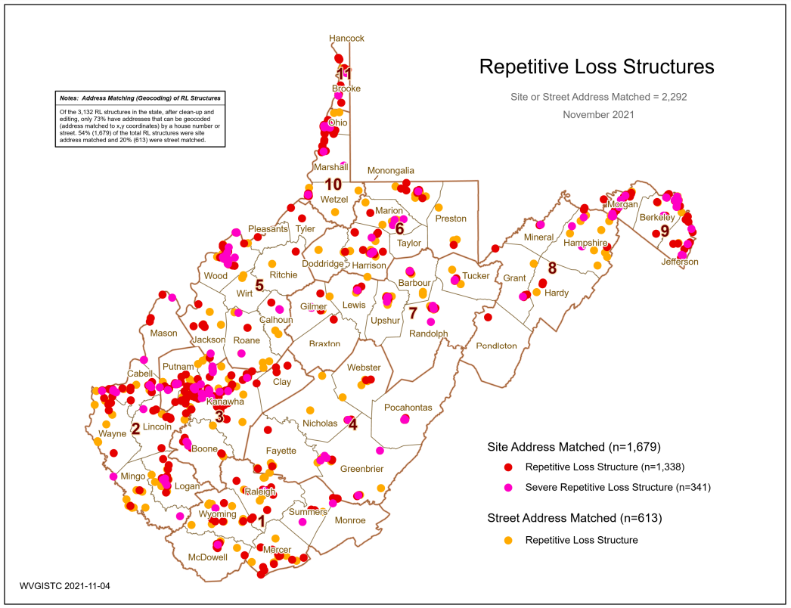

**Figure A-2.** RL Structures geocoded for West Virginia

1. **Organize and Publish a Resource Toolkit of Floodplain Management and Mitigation Documents.** The State NFIP office will organize and publish basic floodplain management and mitigation documents into a useful resource toolkit for local floodplain managers. The WV Flood Tool and other websites will provide access to these technical assistance documents. FEMA Region III, State Resiliency Office, State Mitigation Office, and local floodplain managers will review the resource document toolkit, providing feedback and recommendations. The resource toolkit will complement scheduled training by the State NFIP Office to include WV Floodplain Management 101, CFM Refresher, and Basic/Advanced Floodplain Management courses.

**Figure A-3.** The Resources Document Toolkit on the WV Flood Tool has not been updated since 2017. Other WV CTP resource sites need to be updated as well.

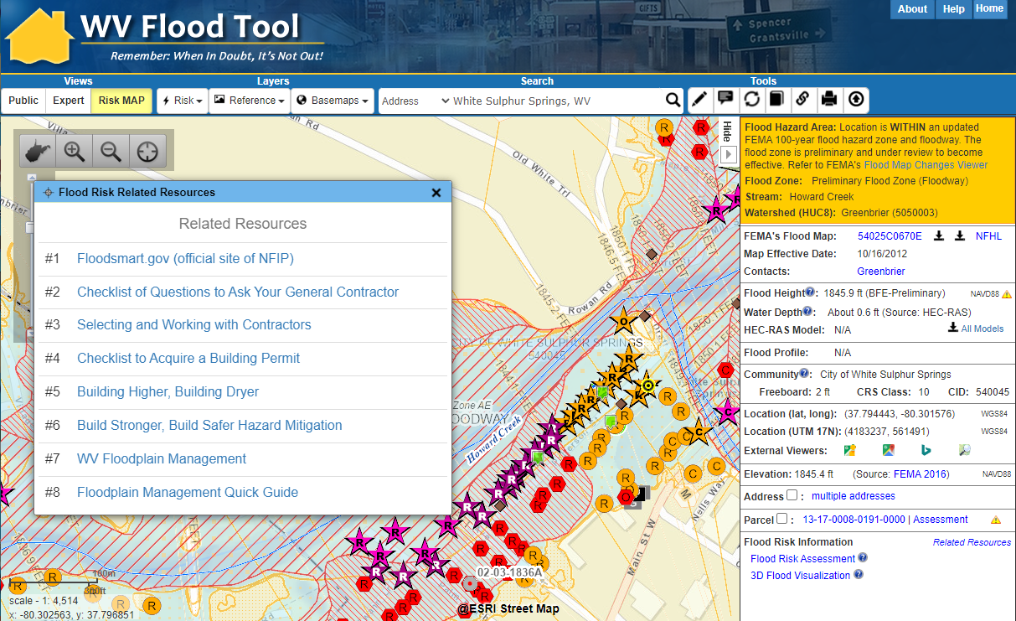

1. **Document Mitigation Status of Statewide Flood-Prone Structures.** Conduct a comprehensive inventory of existing mitigated structures using the statewide building level risk assessments to determine how communities have applied flood adaptive measures in response to major flood events. In response to climate change impacts, evaluate if mitigation measures (elevation, barrier, wet floodproofing, dry floodproofing, etc.) along with flood development ordinance standards (e.g., freeboard) are adequate for changing environmental conditions. This activity will focus on the post-FIRM structures with a Minus 3 Rating (lowest floor 3 or more feet below the BFE) to determine if newly constructed properties are properly mitigated. Structure-level mitigated status information will be tracked by the unique building identifier (Parcel ID + Address Number) and WV Flood Tool shared map link. This activity will engage flood-prone communities, thereby providing outreach and training opportunities to encourage communities to adopt higher flood protection standards through ordinances as well as other flood adaptive measures. Furthermore, this mitigation verification activity will align with scheduled CAV’s (Community Assisted Visits) and CAC’s (Community Assisted Contacts) sponsored by the State NFIP Office and FEMA Region III. Lastly, the mitigation status review of high-value, high damage loss, or high minus-rated properties (including critical facilities) will be provided as a complimentary service for any NFIP communities in West Virginia.

Minus Rated Structures in West Virginia requiring Mitigation Status (first floor height) Verification.

* 1. [Minus Rated with FIRM Status](https://data.wvgis.wvu.edu/pub/RA/State/CL/Graphic/Bldg_MinusRated_FIRMStatus.pdf)  (20% Post-FIRM, 71% Pre-FIRM, 9% Unknown)
  2. [Top Minus-Rated Post-FIRM Structures](https://data.wvgis.wvu.edu/pub/RA/State/BL/Graphic/BL_Top_Minus-Rated_Post-FIRM_greater_3ft.pdf). Structures >= 3 ft. Water Depth-in-Structure. Table on graphic lists top 20 Post-FIRM structures with water depth values >= 17 ft.
     + Total Post-FIRM (n=4,223)
     + 3-5 ft. (n=1,111)
     + 10-15 ft. (n=187)
     + >= 15 ft. (n=46)

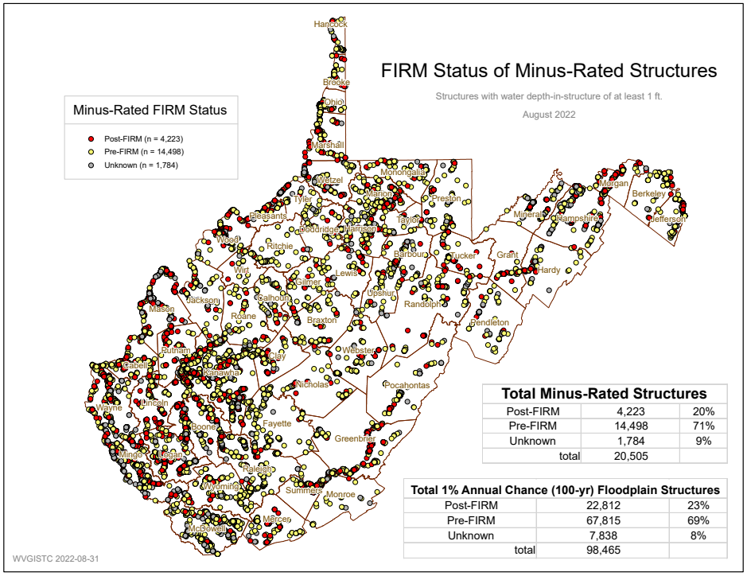 **Figure A-4.** Minus Rated Structures with FIRM Status

# **APPENDIX B:** Scope of WVU Led Project Management (PM) Category 1 Tasks

**2023-24 CTP PM Services and Projects performed by West Virginia University**State: West Virginia  
Total Cost: $180,000 Base CTP Funding

Performance Period: October 1, 2023, to September 30, 2024 (12 months)  
Plan by Tim Keaton, State NFIP Coordinator, **WV Emergency Management Division.** Subcontract work to **WVU GIS Technical Center.**   
6/14/2023

**The WVU led project management (PM) tasks are organized by four scoping activities, to include:**

1. Provide Global Outreach Services for the WV Flood Tool
2. Deliver Technical Support Services for LiDAR LOMAs
3. Support Local Hazard Mitigation Plans with Flood/Landslide Risk Assessment Data
4. Perform Building Cluster Analysis for CNMS Identification of Potential Approximate A Zones for Upgrade to Zone AE Detailed Mapping

Global Outreach for Mapping ($163K)

1. **Provide Global Outreach Services for the WV Flood Tool.**  Statewide global outreach services that process and integrate new flood and reference GIS layers, tool enhancements, flood and landslide risk information, etc. for the WV Flood Tool ([www.mapwv.gov/Flood](http://www.mapwv.gov/Flood)). Services include computer programming, data development/geo-processing, customized mapping, and technical support services (Task A). This task includes developing outreach materials along with in-person and remote training courses for the WV Flood Tool. For this CTP year, the professional surveyors of West Virginia have requested training at their annual conference in February 2024 about the WV Flood Tool. Customized training for the surveyors will focus on what distinguishes the WV Flood Tool from FEMA’s NFHL Viewer and Flood Insurance Rate Maps (FIRMs). For example, the WV Flood Tool provides BFEs for Approximate A Zones and high-resolution elevation date for qualifying LIDAR LOMAs. FEMA does not provide these map services. In addition, the WV Flood Tool publishes Elevation Certificates, Verified LOMA locations, HEC-RAS stream models, and 1%-annual-chance advisory floodplains / BFE’s / depth grids not available by FEMA maps services. See Table B-1 below for more details and scope of these services.

**Table B-1.** Detailed task description for WV Flood Tool.

| **Task Description** |
| --- |
| **[GLOBAL OUTREACH SERVICES FOR WV FLOOD TOOL]**  The WV Flood Tool and global outreach services support stakeholders in pre-disaster actions around adaptation, resilience, and mitigation. The global outreach supports FEMA’s NFIP/CRS Program objectives to:   * Maintain consistent national standards while interjecting a tailored, local focus * Use local data and integrate at state level to facilitate floodplain management * Utilize local experience and knowledge * Provide training and technical assistance * Provide communities with state-based CRS credits * Support Risk MAP Program Goals of Flood Hazard Data, Public Awareness and Outreach, Risk Planning, Enhanced Digital Platform, and Alignment and Synergies   *Through collaboration with Local, State, and Federal entities, the WV Flood Tool delivers quality data that increases public awareness and leads to actions that reduce risk to life and property*  To manage the wealth of available data and better communicate flood risk, the WV Flood Tool has maintained a public facing outreach tool for the public, communities, engineering/surveying companies, and others (Insurance companies, lending institutions, real estate companies, etc.) that has provided effective floodplain models, supporting datasets, water-surface elevations, floodplain boundaries, and additional enhanced flood risk information. During the past decade, the functionality and quality of data layers of the WV Flood Tool have progressed, resulting in an increased use of the application. Over time the WV Flood Tool has become more than just a flood determination tool, and today is routinely used by floodplain managers for building permit applications, floodplain regulations enforcement, pre- and post-disaster assessments, Community Rating System discounts, and flood risk planning. For risk assessment and planning, the RiskMAP View includes structure-level risk assessments and mitigated properties to aid in flood reduction efforts. This initiative enables the website and the WV Flood Tool's global outreach program to adapt and remain relevant as both the datasets and technology continue to evolve.  Specific tasks under *global outreach services* in support of the WV Flood Tool include:  **New Flood Map Products:**   * Incorporate new regulatory and [non-regulatory flood hazard layers](https://data.wvgis.wvu.edu/pub/RA/_resources/FloodTool/WV_Flood_Tool_High-Risk_Advisory_Zones.pdf) into the WV Flood Tool. Publish all the flood layers, query layers, geoprocessing layers, models, and attributes according to standardized procedures and cartographic design. * Effective and Preliminary National Flood Hazard Layers (e.g., Countywide RiskMAP Studies, 2016 Flood PRM Reaches in Southeastern WV, Advisory Flood Heights)   + Add effective or draft/preliminary NFHL, WSEL, and Flood Depth   + Advisory Flood Heights and Base Flood Elevations   + For Preliminary Flood Heights, in Flood Query Results Panel link Preliminary Flood Zones to FEMA’s Map Changes Viewer * Flood Study Status Graphics   + [Active Flood Studies](https://data.wvgis.wvu.edu/pub/RA/_resources/status/WV_FloodStudies.pdf)   + [Advisory Flood Heights](https://data.wvgis.wvu.edu/pub/RA/_resources/status/Advisoy_A_and_AFH_Status.pdf)   + [FEMA R3 Project Status Graphic](https://www.arcgis.com/apps/MinimalGallery/index.html?appid=e92a4667e598426d8052f20daa57a190#viewer=f3bb86e451d74093a0bd46e4501aa9f1) * Floodplain Boundary, WSEL, Depth Layers   + Floodplain Boundary: Advisory A Zones   + WSEL: Advisory A Flood Heights (Advisory Base Flood Elevations)   + Depth Grid: Model-Backed (HEC-RAS) Advisory A Depth Grids * Other Flood or Flood-Related Layers   + [Elevation Certificates](https://data.wvgis.wvu.edu/pub/RA/_resources/status/BL_Elevation_Certificates.pdf)   + LOMAs, LOMRs (including [Location-Verified LOMAs](https://data.wvgis.wvu.edu/pub/RA/_resources/status/LOMAs_Verified.pdf) to correct parcel or structure)   + Panel Index (GeoIndex)   + Flood Profiles (Detailed Studies only)   + Mitigated Buyout Properties   + Flood Query Results Layers: Flood Zone Designation, Stream Name/Flood Source, Model Download   + USGS High Water Marks and Stream Gages   + H&H Hydrologic/Hydraulic Downloadable Models   + Structure (bridges, culverts, etc.) Data Files (data files are needed)   + Flood Manager List on WV Flood Tool * Model-Backed Studies. The statewide Hazus depth grid created in 2010 is inaccurate and thus has a negative impact on building-level flood risk assessments and flood visualizations. Adding model-backed depth grids from flood studies improves the coverage and accuracy of the statewide depth grid, a flood risk assessment priority of attaining model-backed, gridded flood-risk depth grids for all 1-percent flood zones in West Virginia. In addition, model-backed Base Flood Height values provide important information for the Flood Query Results Panel and for processing LiDAR LOMAs using the Print Function of the WV Flood Tool. Lastly, depth grid errors associated with mapping issues identified from anomalous building level risk assessments are forwarded to Region 3 for CNMS problem area tracking. * Follow WV GIS Technical Center’s procedural guide for creating Flood Depth/Water Surface Elevation Grids and Redelineated AE Floodplains. The methodology creates a Water Surface TIN from the NHFL X-Sections, converts the WSEL TIN to a grid, and then subtracts the Ground Elevation Grid from the WSEL Grid to create the Water Depth Grid.   **Application Programming Development:**   * Execute software programming updates for desktop and mobile versions. Modify programming code of JavaScript application (www.mapwv.gov/flood) to enhance tool functions, messages, data layers, and cartography. Update flood risk information to the WV Property Search Tool, a companion product of the WV Flood Tool, to allow users to identify, for example, new structures built in flood zones. Make other tool enhancements based on requests from WV NFIP Coordinator.   **Desktop Version:** <https://www.mapwv.gov/flood> **Mobile Version:** <https://www.mapwv.gov/flood/mmap> **Property Search and Report**: <https://www.mapwv.gov/property>   * Enhance tool functions based on feedback or new opportunities. Program other application enhancements to include synchronizing with FEMA’s National Flood Hazard Layer (NFHL) web services and FEMA Map Store products. Evaluate consuming NFHL web services with performance testing and other suitability measures. Program failover protocols for external web map services consumed by the Flood Tool. Enhance the WV Flood Tool to leverage the statewide building-level flood risk assessments generated from a Hazard Mitigation Grant. * Incorporate 3D flood building visualizations for mitigated structures. * In addition, the application programming development will include application updates to enhance tool functions, messages, data layers, and cartography.   **Update Flood Query Panel with New Flood Risk Data:**   * Develop and publish new risk assessment and mitigated layers to the WV Flood Tool, specifically * Mitigated Structures (wet floodproofing, dry floodproofing) * Elevation Certificates (focus on elevated Building Diagrams 5-8) * Dam Inundation Zones (for query purposes only) * 500-Year Depth Grids from new flood studies (both AE and A zones)   **Update Flood Query Panel with New Flood Risk Data:**   * Maintain and enhance Flood Query Results Panel with Dam Inundation Zones and 500-year flood depth values. * **Dam Inundation Zones:** The WV Flood Tool’s query result panel for the RiskMAP View can be updated to alert a location that falls within a failed dam inundation zone. New flood inundations zones have been made available by the WV Conservation Agency and USACE for select dams. In addition, risk assessments can be done by performing an intersection between the built-up environment and flood inundation zones. * [WV Dam Inundation Viewer](https://www.mapwv.gov/dams) of 168 High Risk Dams from the WV Conservation Agency * USACE Dam Inundation Viewer: <https://nid.usace.army.mil/viewer/index.html> * Summersville Dam Example: <https://nid.sec.usace.army.mil/viewer/index.html?dsLibrary=NID-MD00069,NID-WV06702&x=-80.901&y=38.223&z=15> * **500-Year Flood Zone Depth Values:**  FEMA’s new RiskMAP studies are generating 500-year depth grids for riverine flooding. This information can be added to the RiskMAP View of the WV Flood Tool. The only way now to determine 500-year depths on the Flood Tool are by viewing the Flood Profiles of detailed studies.   << Query Results Panel >>    **Reference Data:**   * Process and integrate new reference data to make the WV Flood Tool more accurate and current and for which communities can receive FEMA CRS credits. This task includes the publishing and caching of web map services that support the Flood Tool. The new FEMA-purchased LiDAR and derived elevation products are quite large in file size and require extensive computer processing and quality control checks before being published to the WV Flood Tool. Key reference data sets are ground elevation, parcels/assessment records, E-911 addresses, and aerial imagery. * HI-RESOLUTION TOGPOGRAPHIC DATA: Processed FEMA LiDAR is published to the WV Elevation Download Tool. This includes the LiDAR derived elevation products to include DEMs and contours. All new elevation data has been published on the WV Flood Tool as part of the Cooperating Technical Partners (CTP) program. *Accurate, high-resolution LiDAR-derived* ***elevation*** *products such as one-foot contours and one-meter DEMS that are incorporated into the WV Flood Tool are beneficial for floodplain determinations, LIDAR LOMAs, LAGs, water depth flood visualizations, flood risk studies, etc.*   + - Metadata: <https://www.mapwv.gov/lidar-metadata>     - Elevation Download Site:  <https://data.wvgis.wvu.edu/elevation/>     - FEMA-Purchased LiDAR Projects: [Project coverage graphic](https://data.wvgis.wvu.edu/pub/RA/_resources/Status/FEMA-purchased_LidarCoverage.pdf) * PROPERTY PARCELS AND ASSESSMENT RECORDS: Update statewide parcel layer and assessment records to WV Flood Tool. *Accurate and current* ***parcels and assessment attributes*** *are essential to identifying flood risk structures in the WV Flood Tool* * Statewide Parcel Products (annual update) for Flood tool:   + Master surface parcel file and standardized assessment attributes   + Sketch diagrams for building identification of residential properties   + Parcel history (17 years) to search previous owners or deed book numbers. Important for improving positional accuracy of LOMAs and Buyout Properties. * Integrate surface parcel geometry for all 55 West Virginia counties * Join assessment records for commercial and residential properties for current tax year * Join parcels to more than 20,000 full-version tax maps * Coordinate parcel development with WV Property Tax Division and county assessors * Intersect parcels/assessment records with flood zones and classify according to risk (high, moderate, low) * E-911 ADDRESSES: Update E-911 site and street addressing layers and address matching geocoding services for Flood Tool. *Accurate and current* ***E-911 site addresses*** *are essential to identifying flood risk structures in the WV Flood Tool.* * AERIAL PHOTOGRAPHY: Add new 2023 county leaf-off aerial photography for multiple counties to Flood Tool. Coordinate with county, state, and federal agencies through West Virginia Orthoimagery Program. Add 2020 and 2022 leaf-on map services on WVU Servers to increase zoom in levels on WV Flood Tool for users. *Accurate and current* ***leaf-off aerial photography*** *is essential to identifying flood risk structures in the WV Flood Tool.* * BUILDING FOOTPRINTS: Building footprints are being created from the statewide aerial imagery as an alternate product to the 2018 Microsoft building footprints. These new building footprints will be published to the WV Flood Tool. ***Building footprints*** *are used for identifying flood risk structures and for 3D flood visualizations on the WV Flood Tool.* * OTHER LAYERS: Update other reference layers (e.g., community boundaries, wetlands, public lands) that support FEMA CRS/NFIP programs and the WV Flood Tool. *Accurate and current* ***reference layers*** *are important to Communities for state-base CRS credits and for users referencing features of interest.* * RESOURCE LINK: WV Flood Tool’s [Reference Layers](https://data.wvgis.wvu.edu/pub/RA/_resources/FloodTool/WV_Flood_Tool_Reference_Layers.pdf)   **Technical Services:**   * Perform outreach and training services to include developing print and online educational materials, delivering presentations, administering email listserv, and participating in Flood Tool coordination meetings and data exchange with State NFIP, FEMA, USACE, NRCS, and other cooperators. Provide technical support to the Flood Hazard community like specifications (e.g., HEC-RAS downloadable model specifications) for contracts and other technical queries associated with flood and reference data. Enhance the WV Flood Tool to effectively increase flood risk communications for the public and communities. Educate and outreach to counties about submitting their locally produced address, parcel, imagery, and elevation data for inclusion in the Flood Tool. * Technical Services include:   + Promotional materials (flyers, videos, etc.)   + Presentations (webinars, meetings, etc.)   + Update content and [resources sections](https://mapwv.gov/flood/resources.html) of Flood Tool launch page   + Update listserv and contact list of community floodplain managers   + Coordination meetings and project scoping for USACE WV Silver Jackets projects that support WV Flood Tool   + Standardized Data Exchange   + Instructional videos for Flood Tool and WV Building Level Risk Assessment (BLRA)   + Maintain [WV Flood Tool and Flood Risk Assessment Glossary](https://data.wvgis.wvu.edu/pub/RA/_resources/FloodTool/WV-Flood-Tool_FRA_Glossary.pdf) * Update various [WV Flood Tool Resources](https://mapwv.gov/flood/resources.html) web pages and links * Bundle FEMA and other agency risk assessment and mitigation resources for the WV floodplain management community (Permits, Elevation Certificates, Mitigation Resources, Model Floodplain Management Ordinance, etc.). |

1. **Deliver Technical Support Services for LiDAR LOMAs.** West Virginia now has statewide coverage of QL2 LiDAR data and LiDAR-derived elevation products of one-meter DEMs and 1-foot contours. LiDAR LOMAs can be submitted for qualifying structures using FEMA’s Online LOMA portal. The Flood Tool’s Print Function generates map layouts for the LiDAR submissions using either the contour or point elevation methods. To save disadvantaged communities and homeowners the cost of needing a site elevation survey, this activity will communicate to these constituents how the "mapped out" structures (primary building structures symbolized by yellow squares where future map conditions exist) displayed on the RiskMAP View of the WV Flood Tool may qualify for removal of the structure from the SFHA. The only information required for an Online LOMA submission are a map layout from the Flood Tool and a copy of the deed. The WVU GIS Technical Center will support the state and local floodplain management community with the submission of LiDAR LOMAs when a field survey is not required, to include assisting floodplain managers with the online submissions to FEMA.

LiDAR LOMA Documentation.

* WV Flood Tool LiDAR LOMA: [Instructions](https://data.wvgis.wvu.edu/pub/RA/_resources/LOMA/WV_Flood_Tool-LIDAR_for_LOMA_instructions.pdf) | [Overview Slides and Guide](https://data.wvgis.wvu.edu/pub/RA/_resources/LOMA/WV_Flood_Tool_LiDAR_for_LOMA_Guide.pdf)
* [WV LIDAR LOMA Map Layout Examples](https://data.wvgis.wvu.edu/pub/RA/_resources/LOMA/examples/)

**Figure B-2.** Example [LiDAR LOMA Print Layout](https://data.wvgis.wvu.edu/pub/RA/_resources/LOMA/examples/LOMA_23-02-0135-0091-0000_394_(Studied_Zone_A)_anno.pdf) generated from WV Flood Tool.

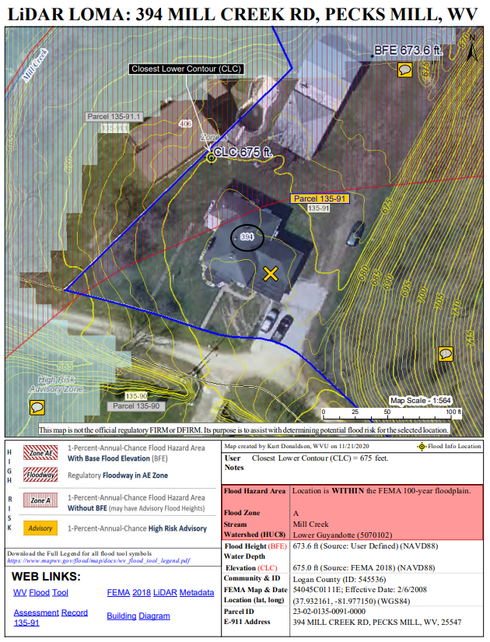

Mitigation Planning Technical Assistance ($7K)

1. **Support Local Hazard Mitigation Plans with Flood/Landslide Risk Assessment Data.**  This mitigation planning technical assistance task supports mitigation planners and consultants with various risk assessment products for updating their local hazard mitigation plans. The risk assessment and mitigation products were generated from the HMGP Statewide Multi-Hazard Risk Assessment Project and select data sets are updated each year. The multi-hazard data includes riverine flooding, landslides, and dam failure. Refer to the catalog or [Risk Information Index](https://data.wvgis.wvu.edu/pub/RA/_engage/_IndexDocs/) to access various risk assessment products (reports, tables, graphics, risk dashboards, etc.) published in support of FEMA’s Hazard Mitigation Plans and NFIP/CRS activities. See the [2022 TEIF-TEAL Close-out Report](https://data.wvgis.wvu.edu/pub/RA/_engage/Project/WVU_HMGP_TEIF-TEAL_Closeout.pdf) about risk assessment and mitigation products as well.

Resources Available: Technical support for local and state hazard mitigation plan updates. Accessed by an [Index Guide](https://data.wvgis.wvu.edu/pub/RA/_engage/_IndexDocs/) spreadsheet named “RA_Info_Index.xlsx,” the risk assessment products include GIS layers, tables, subject reports, [3D Visualizations](https://data.wvgis.wvu.edu/pub/RA/_resources/3Dflood/), and community profile risk matrices to supplement FEMA’s Community Flood Risk Dashboards.

**Figure B-3.** Risk Assessment Information Index provides access to risk assessment and mitigation data products in support of local hazard mitigation plans and other Risk MAP activities.

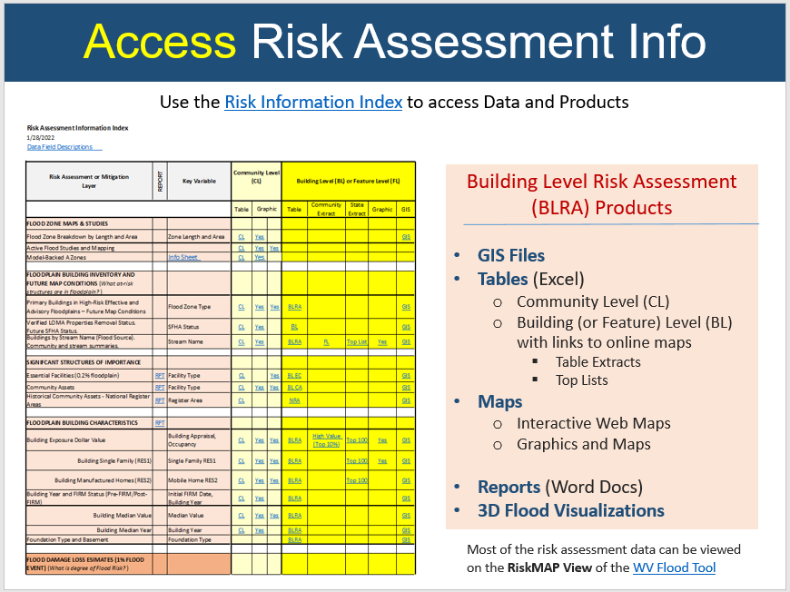

Coordinated Needs Management Strategy ($10K)

1. **Perform Building Cluster Analysis for CNMS Discovery of Potential Approximate A Zones for Upgrade to Zone AE Detailed Mapping.** A [statewide Approximate Zone A cluster analysis](https://data.wvgis.wvu.edu/pub/RA/State/CL/Stream_Name/Zone_A_Structure_Analysis/) was performed in February 2022 from the statewide Building-Level Risk Assessment project in which Approximate A Zone candidates were identified and entered by a FEMA contractor (WSP USA) into FEMA’s Coordinated Needs Management Strategy ([CNMS](https://www.fema.gov/flood-maps/tools-resources/risk-map/coordinated-needs-management-strategy)) geospatial database. For this specific activity, a more refined and detailed study will be done for the Kanawha River Basin watersheds and other watersheds in the state where future Risk MAP Discovery activities are scheduled. This information is beneficial for the initial [Discovery Phase](https://www.fema.gov/sites/default/files/documents/fema_risk-map-phase-1-factsheet.pdf) of the Risk MAP process. Refer to FEMA’s [Guidance for Flood Risk Analysis and Mapping.](https://www.fema.gov/sites/default/files/2020-02/Discovery_Guidance_Nov_2019.pdf)

*Need Justification:* In West Virginia, nearly [70% of WV floodplains](https://data.wvgis.wvu.edu/pub/RA/_resources/status/WVFloodHazardZonesSummary.pdf) are Approximate A Zones and not detailed studies. Advantages of detailed studies are

**Specifications: Detailed Studies versus Approximate A Studies**

* Detailed studies use more refined hydrologic modeling in a lot of cases instead of just using regression equations.
* Detailed studies includes floodway and a hydraulic model with structure survey and bathymetric survey.
* Detailed studies have extra FEMA products such as a “floodway data table” and “flood profiles” in the FIS reports.
* FEMA can’t publish BFE’s on their products unless it is “a detailed study” per federal regulations.  Consequently, FEMA utilizes States’ websites to display BFE’s for Approximate A Zones.

*Methodology and Rankings:* A detailed analysis for building clusters will be conducted for flood depths ≥ 5 feet and ranked accordingly to 12 evaluation factors. Physical building factors are based on (1) building counts, (2) building dollar exposure, (3) building damage dollar exposure estimates, (4) substantially damaged estimates, and (5) building types. Depth grids factors are (6) extreme flood depths ≥ 10 feet and (7) depth grid accuracy. Mapping cost-effectiveness factors are the (8) stream length of building clusters for Zone AE, (9) building density per square mile, (10) estimated Zone AE study cost per mile, (11) Zone A building cluster adjacent an existing Zone AE study, and (12) legacy county boundary mapping issues.

**Figure B-4.** Evaluation Factors for Upgrading Approximate A Zones to Detailed Zone AE

**12 Evaluation Factors for Ranking Zone A Building Clusters with High Flood Depths**

* **Physical Building Factors: Type, Exposure, & Damage**
  1. Building Count
  2. Building Dollar ($) Exposure
  3. Building Damage Dollar ($) Loss Estimates
  4. Substantially Damaged Loss (%) Estimates
  5. Building Types
     + Residential versus Non-Residential
     + Essential facilities and Community Assets
* **Depth Grids** **Factors:** **Extreme Flood Depths, Depth Grid Accuracy**

1. Extreme flood depths of structures ≥ 10 feet (verify not flood study error)
2. Depth Grid Accuracy
   * + Model-backed HEC-RAS depth grid (more accurate)
     + 2010 Hazus depth grid (less accurate)

* **Mapping Cost Effectiveness Factors**

1. Stream length of building clusters for Zone AE conversion
2. Building density per square mile (Building Count / Cluster Stream Length)
3. Estimated Zone AE study cost per mile ($2,500 per mile)
4. Zone A building cluster adjacent to existing Zone AE
5. Legacy county boundary mapping issue (Zone AE mapping stopped at county border)

*Example Statewide Study of Zone A Structure Cluster Analysis*: A broad Zone A structure vulnerability and spatial density analyses were performed for three flood depths at ≥ 5 feet, ≥ 10 feet, and ≥ 15 feet. More detailed studies at the watershed level are proposed for this CNMS activity in support of Risk MAP Discovery phases.

* [Zone A Cluster Analysis Graphics](https://data.wvgis.wvu.edu/pub/RA/State/CL/Stream_Name/Zone_A_Structure_Analysis/): Flood Depths for ≥ 5 feet, ≥ 10 feet, and ≥ 15 feet
* [Spreadsheet Flood Source Tables](https://data.wvgis.wvu.edu/pub/RA/State/CL/Stream_Name/Zone_A_Structure_Analysis/): Summary Building-Level Risk Assessment Factors per River/Stream Cluster and Top Building Flood Depths per River/Stream
* [Report](https://data.wvgis.wvu.edu/pub/RA/State/CL/Stream_Name/Zone_A_Structure_Analysis/): Methodology and map links to potential candidates for AE Zone Detailed Studies
* [BLRA](https://data.wvgis.wvu.edu/pub/RA/State/BL/BLRA/WV/): Statewide Building-Level Risk Assessment (BLRA) source geodatabase for cluster analysis

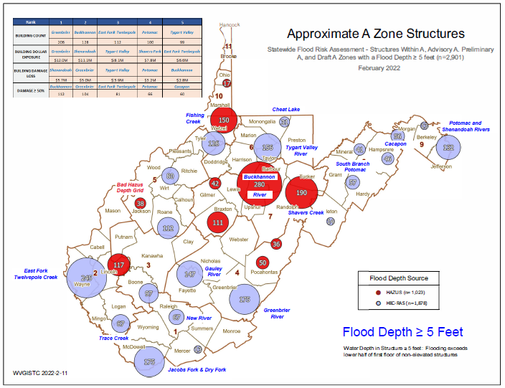 **Figure B-5.** Zone A Building Cluster Analysis for Upgrading Approximate A Zones to Detailed Zone AE

*WV Flood Tool’s Risk MAP View – Building Damage Loss Estimate Percent Layer:*  In the Risk MAP View of the WV Flood Tool, the risk assessment layer, **Building Damage Loss Estimate (%)**, provides a relationship between high flood depths and flood loss estimates of substantially damaged structures (> 50% damage). High building-level damage percentages typically correlate to structures in Approximate A Zones with high base flood depths for a 1% annual chance flood. This risk assessment layer assists in viewing graphically stream candidates for Zone A to Zone AE conversion.

**Figure B-6.** WV Flood Tool’s 1%-Annual Chance Damage Loss Layer generated from FEMA Hazus is used for graphically viewing clusters of high-damage structures and potential candidates for Zone AE upgrade mapping.