2022-23 CTP: Focused Flood Reduction and Mitigation Engagement Activities
State: West Virginia
Total Cost: $70,000
Performance Period: October 1, 2022, to September 30, 2023 (12 months)
Plan by Tim Keaton, State CTP Coordinator/Mitigation Planner, WV Emergency Management Division
2/13/2022
The CTP Project will consist of seven focused outreach, training, and community engagement activities for in support of flood reduction and mitigation programs, to include:

- Document Mitigation Status of Flood-Prone Structures
- Develop and Verify Community Flood Risk Profiles
- Preload At-Risk Buildings from Statewide Flood Risk Assessment into FEMA’s Substantial Damage Estimator Tool
- Communicate SFHA Map Changes to Affected Property Owners
- Promote LiDAR LOMAs Print Function on the WV Flood Tool
- Model Potential Mitigation Measures and Communicate to Communities
- Engage Flood-Prone Communities to Validate Areas of Mitigation (AOMI) on WV Flood Tool

- Document Mitigation Status of 98,467 Flood-Prone Structures: Conduct a comprehensive inventory of existing mitigated structures using the statewide building level risk assessments to determine how communities have applied flood adaptive measures in response to major flood events. In response to climate change impacts, evaluate if mitigation measures (elevation, barrier, wet floodproofing, dry floodproofing, etc.) along with flood development ordinance standards (e.g., freeboard) are adequate for changing environmental conditions. Focus on the post-FIRM structures with a Minus 3 Rating (lowest floor 3 or more feet below the BFE) to determine if newly constructed properties are properly mitigated. Structure-level mitigated status information will be tracked by the unique building identifier (Parcel ID + Address Number) and WV Flood Tool shared map link. This activity will engage flood-prone communities, thereby providing outreach and training opportunities to encourage communities to adopt higher flood protection standards through ordinances as well as other flood adaptive measures.
- Develop and Verify Community Flood Risk Profiles: Use the building level-risk assessments to create community risk profiles at the regional and state scales. Aggregate key risk factors into Exposure and Flood Model matrices. A Mitigation Matrix of mitigated properties, open space preservation, etc. can be developed as well. The community risk profiles would supplement FEMA’s Flood Risk Dashboards, a snapshot of a community’s flood risk statistics at the time the community is going through a flood mapping update. These community flood risk profiles can be incorporated into the 2023 State Hazard Mitigation Plan Update. It is important to identify disadvantaged communities in the State that may be at higher risk due to climate change impacts and thus require additional focus and support in their flood protection measures.

- Preload At-Risk Buildings from Statewide Flood Risk Assessment into FEMA’s Substantial Damage Estimator Tool: For pre-disaster planning and preparation, the detailed statewide floodplain building inventory can be preloaded into FEMA’s Substantial Estimator Tool. With the changing climate, especially with the potentially increased building damage impacts from heavy precipitation events that fill rivers and river valleys, it is important that the State and flood-prone communities have their residential/non-residential structures from the WV Building Level Risk Assessment (BLRA) uploaded into FEMA's Substantial Damage Estimator tool.

- Communicate SFHA Map Changes to Affected Property Owners: Template mail merge documents from the FEMA Region 3 "Local Officials Toolkit: What to Do Before and After Your Flood Maps are Finalized" have been created to send to property owners with new flood mapping updates during the appeal period for the restudy. Information about changes in floodplain risk and base floodplain elevation can be communicated to individual homeowners. The base flood elevation is increasing 6 feet, for example, for the highly flood vulnerable and disadvantaged community of Camden-on-Gauley on the Gauley River in Webster County. Mailing addresses of affected property owners are retrieved from the statewide tax assessment database. This activity qualifies for FEMA’s Community Rating System credits. See SFHA Mail Merge Template and Instructions.

- Promote LiDAR LOMAs Print Function on the WV Flood Tool: West Virginia now has statewide coverage of QL2 LiDAR data and LiDAR-derived elevation products of one-meter DEMs and 1-foot contours. LiDAR LOMAs can be submitted for qualifying structures using FEMA’s Online LOMA portal. The Flood Tool’s Print Function generates map layouts for the LiDAR submissions using either the contour or point elevation methods. To save disadvantaged communities and homeowners the cost of needing a site elevation survey, communicate to these constituents how the "mapped out" structures (primary building structures symbolized by yellow squares) displayed on the RiskMAP View of the WV Flood Tool may qualify for removal of the structure from the SFHA. The only information required for an Online LOMA submission are a map layout from the Flood Tool and a copy of the deed.

- Model Potential Mitigation Measures and Communicate to Communities: Use model-backed depth grids and the building-level risk assessment inventory (BLRA) to identify mitigation measures for properties. For example, identify buildings with solid wall crawl spaces which would qualify for flood vents, one of the cheapest mitigation solutions for existing structures. Communicate this mitigation information to communities where types of building foundations are prevalent and would qualify for flood vents. Communicate the cost in savings in flood insurance by installing flood vents and adjusting the lowest floor elevation. Identify grants or other funding sources to help disadvantaged communities with increased flood risk from climate change.

- Engage Communities to Validate Areas of Mitigation (AOMI) on WV Flood Tool: Engage communities to validate AoMIs identified from the statewide risk assessment. Areas of Mitigation (AoMI) are identified by Repetitive Loss structures, Substantial Damage Estimates, Mitigated Properties, Floodway Structures, Flood Depths, High-Water Marks, and Similar Topography. AoMIs support the community prioritization of identifiable measures for hazard reduction planning and actionable mitigation projects. AoMIs are published on the RiskMAP View of the WV Flood Tool.
Table 1 below provides more detailed information about the seven tasks and resource links.
Table 1. 2022-23 CTP Work Tasks. Cost $70,000.
Task Descriptions
[FOCUSED OUTREACH, TRAINING, AND COMMUNITY ENGAGEMENT PROJECTS]
Community engagement activities with 296 flood-prone communities. Key stakeholders at the local level are floodplain managers, emergency management officials, community planners, etc. Coordinate closely with WV GIS Technical Center and other state and federal partners.
(1) Document Mitigation Status of 98,467 Flood-Prone Structures: A comprehensive inventory of existing mitigated structures results in more accurate building level risk assessments and shows how communities have applied flood adaptive measures in response to major flood events. Coordinate closely with the State NFIP Coordinator and other partners to incorporate a mitigation status data field into the Building-Level Risk Assessment Inventory and WV Flood Tool to determine which structures have been mitigated. A data management field will identify the type of mitigation (elevation, barrier, wet floodproofing, dry floodproofing, etc.). Initial focus will target new construction Post-FIRM Minus-3 Rating structures, about 2% of the statewide building inventory of high-risk flood-prone buildings, to determine if these structures are compliant and properly mitigated to the community’s floodplain management development standards. Other tracking data management fields could include if a permit and elevation certificate exist. This activity requires community engagement with the floodplain managers to validate mitigated structures where no elevation certificates, building pictures, or other mitigation project data exists. A data management tracking system will be developed to log contacts and building mitigation status initiated by the State NFIP Office (and its agents) and other interested partners (CRS/ISO Specialist) partners. This information will be shared with partners who monitor or audit floodplain management programs. Structure-level mitigated status information will be tracked by the unique building identifier (Parcel ID + Address No.) and the WV Flood Tool shared map link. This activity will engage flood-prone communities, thereby providing outreach and training opportunities to encourage communities to adopt higher flood protection standards through ordinances as well as other flood adaptive measures.
Top Building Most Vulnerable Lists
Engage the communities with the most vulnerable lists to validate mitigation statuses of buildings.
- BLRA Data Extract Tables: High Building Value, High Damage Loss, High Minus Ratings
- BLRA Statewide Top Lists: Building Value, Flood Depth, Damage Loss $, Damage Loss %, Minus Rated, Mitigated Structures
Mitigated Structures
A comprehensive inventory of mitigated structures results in more accurate building level risk assessments and shows how communities have applied flood adaptive measures in response to major flood events. Sources for verifying first floor heights of elevated structures are elevation certificates, building pictures (step 7” rise, cinder block 8”), and major post-disaster mitigation reconstruction projects (1977 and 2016 floods) described below.

- Post-FIRM Minus Rated Structures
- Mitigated Structures where First Floor Heights > 5 feet
- WV Building Pictures of Mitigated Structures
June 2016 Flood of Central West Virginia: The devastating floods from the June 2016 flood have resulted in the largest regional mitigation project since the historic April 1977 flood in the Tug Fork River Basin. From the June 2016 flood, thousands of buildings were destroyed or damaged, at least 23 people were killed, and communities throughout West Virginia were inundated with floodwaters. A state of emergency was declared in 44 of West Virginia’s 55 counties, and 12 of these counties received a Presidential Disaster Declaration. The National Oceanic and Atmospheric Administration (NOAA) estimated that overall damages from the storm system amounted to over $1 billion (FEMA 2016 Flood Report). A news article dated December 7, 2021, in The Intelligencer / Wheeling News-Register newspaper, reported that as of November 2021, the WV RISE program had completed 350 housing projects and 42 bridges. According to RISE, 90% of its housing projects were complete, with 78% of bridge projects completed. Combined with the 47 demolition projects, $82.4 million has been spent for mitigation measure associated with the June 2016 flood.

Mitigated structures from major June 2016 Flood
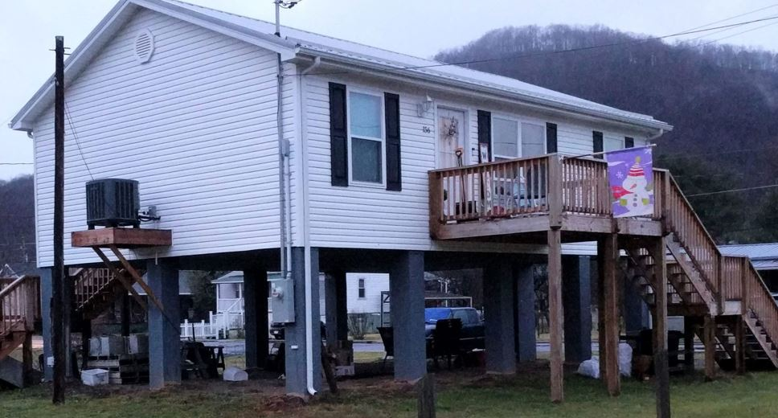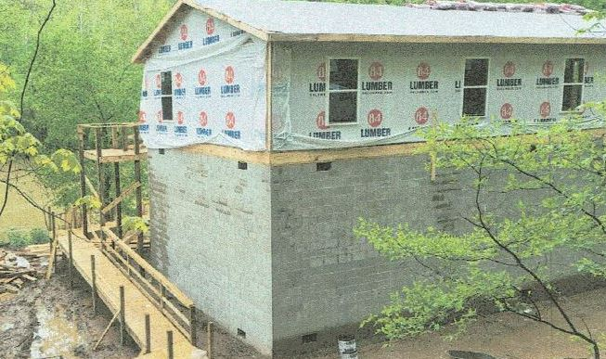

April 1977 Flood of Tug Fork Basin: The Tug Fork Basin was devasted in April 1977 by the flood record of the basin, causing an estimated $698.7 million (October 1996 Price Level) in damages. Comparing the WV RISE mitigation program to the 1977 flood reconstruction program, the USACE Section 202 Non-Structural Project resulted in an estimated 397 housing projects 257 buyout property acquisitions completed for Mingo and Wayne counties. A significant number of property acquisitions occurred in McDowell County as well. The mitigation projects including high-water marks, close-out reports, and operation manuals were and were completed by 2008.

- USACE Nonstructural Projects from 1977 Flood:
  - Wayne County Nonstructural Project (2006)
  - Upper Mingo County Nonstructural Project (2007)
  - Lower Mingo County Nonstructural Project (2008)

Community Engagement Diagram: 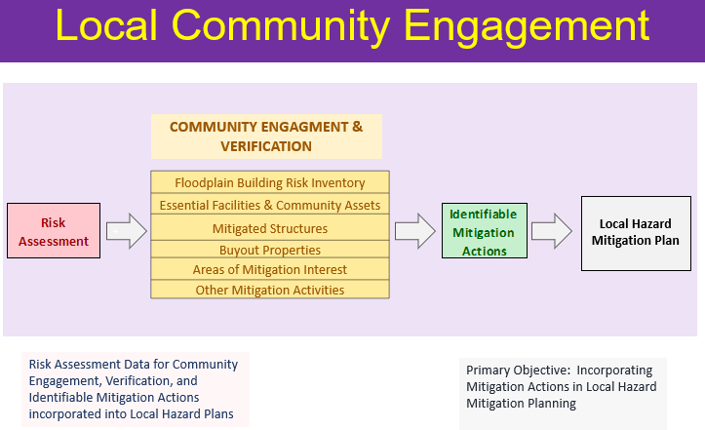

(2) Develop and Verify Community Flood Risk Profiles: Use the building level-risk assessments to create community risk profiles at the regional and state scales. Aggregate key risk factors into Exposure and Flood Model matrices. A Mitigation Matrix of mitigated properties, open space preservation, etc. can be developed as well. The community risk profiles would supplement FEMA’s Flood Risk Dashboards, a snapshot of a community’s flood risk statistics at the time the community is going through a flood mapping update. The profiles are done at the County, Unincorporated, and Incorporated levels (including eight split municipalities across county boundary lines). Risk communities will be compared to statewide mean/medium/maximum statistics. Incorporate WV Building Level Risk Assessment (BLRA) information to FEMA’s Jurisdictional Flood Risk Dashboard templates, web community risk tables, etc. These community flood risk profiles can be incorporated into the 2023 State Hazard Mitigation Plan Update. It is important to identify disadvantaged communities in the State that may be at higher risk due to climate change impacts and thus require additional focus and support in their flood protection measures.

Example Region 4 Community-Level Risk Matrices for Exposure and Flood Loss Models.
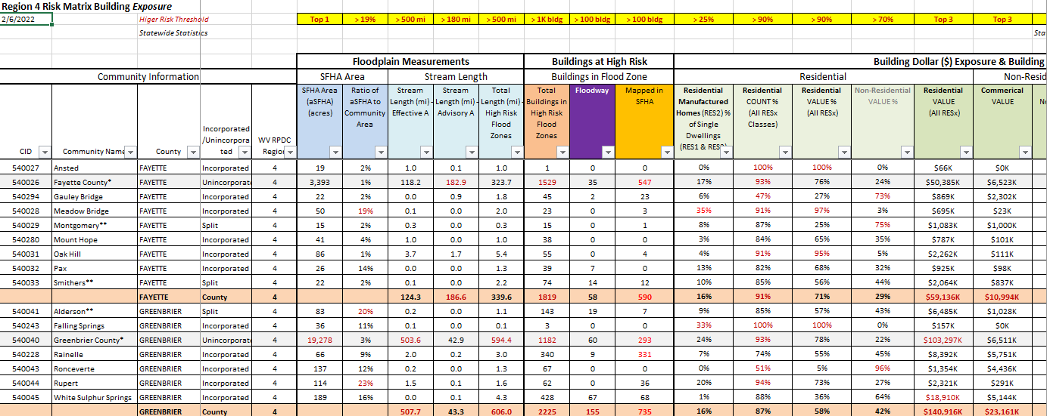

Supplement FEMA’s Jurisdictional Disaster Dashboards with supplemental risk assessment information from the statewide building level risk assessment (BLRA).
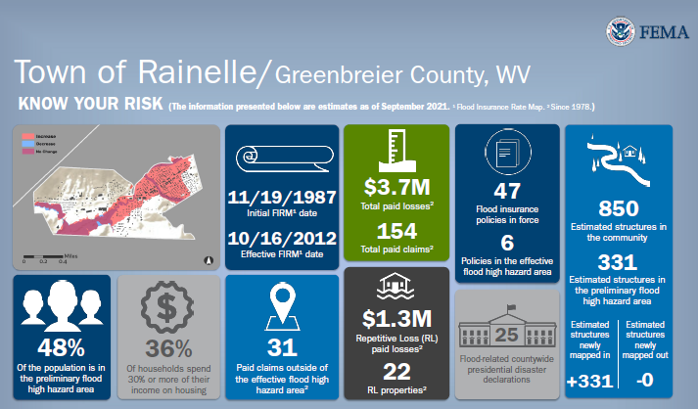
Example Jurisdictional Dashboards

(3) Preload At-Risk Buildings from Statewide Flood Risk Assessment into FEMA’s Substantial Damage Estimator Tool: For pre-disaster planning and preparation, the detailed statewide floodplain building inventory can be preloaded into FEMA’s Substantial Damage Estimator Tool. The upload of residential/non-residential structures in the 1% annual chance floodplain can be done at the community, county, or state scales. With the changing climate, especially with the potentially increased building damage impacts from heavy precipitation events that fill rivers and river valleys, it is important that the State and flood-prone communities have their residential/non-residential structures from the WV Building Level Risk Assessment (BLRA) uploaded into FEMA's Substantial Damage Estimator tool. This activity qualifies for FEMA’s Community Rating System credits.
Building Counts for High-Risk Floodplains (August 2021 report)
High-Risk Effective Floodplains (Special Flood Hazard Areas)
SFHA (Effective only) | 5,486
Approximate A | 2,598
Detailed AE | 2,306
Detailed AE Floodway | 582
High-Risk Effective and Advisory Floodplains
SFHA | 5,486
Mapped in Advisory A / AE | 1,636
Total High-Risk (Effective & Advisory) 1% Floodplains | 7,122
New data products developed from the statewide risk assessment project include pre-loading the entire statewide flood risk inventory of 98,000 structures into FEMA’s Substantial Damage Estimator Tool. See WV SDE Data Import and Instructions.
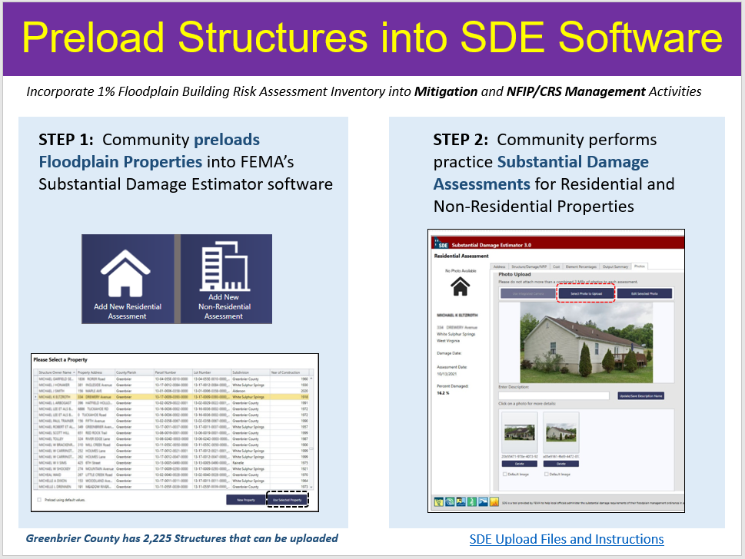

(4) Communicate SFHA Map Changes to Affected Property Owners: Template mail merge documents from the FEMA Region 3 "Local Officials Toolkit: What to Do Before and After Your Flood Maps are Finalized" have been created to send to property owners with new flood mapping updates during the appeal period for the restudy. Information about changes in floodplain risk and base floodplain elevation can be communicated to individual homeowners. The base flood elevation is increasing 6 feet, for example, for the highly flood vulnerable and economically disadvantaged community of Camden-on-Gauley on the Gauley River in Webster County. Mailing addresses of affected property owners are retrieved from the statewide tax assessment database. This activity qualifies for FEMA’s Community Rating System credits. See SFHA Mail Merge Template and Instructions.
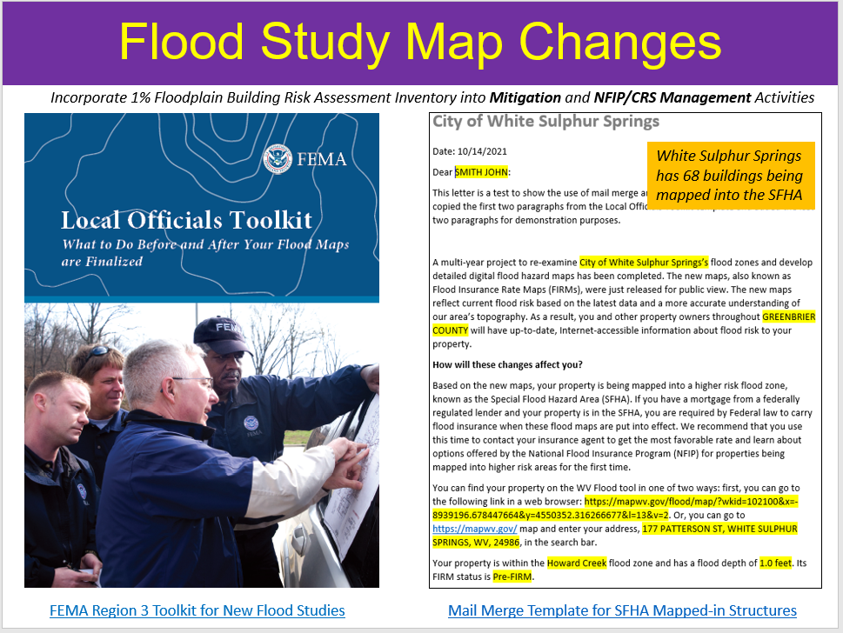

(5) Promote LiDAR LOMAs Function WV Flood Tool: West Virginia now has statewide coverage of QL2 LiDAR data and LiDAR-derived elevation products of one-meter DEMs and 1-foot contours. LiDAR LOMAs can be submitted for qualifying structures using FEMA’s Online LOMA portal. The Flood Tool’s Print Function generates map layouts for the LiDAR submissions using either the contour or point elevation methods. To save disadvantaged communities and homeowners the cost of needing a site elevation survey, communicate to these constituents how the "mapped out" structures (primary building structures symbolized by yellow squares) displayed on the RiskMAP View of the WV Flood Tool may qualify for removal of the structure from the SFHA. The only information required for an Online LOMA submission are a map layout from the Flood Tool and a copy of the deed.
LiDAR LOMA Documentation:
- WV Flood Tool LiDAR LOMA: Instructions | Overview Slides and Guide
- WV LIDAR LOMA Map Layout Examples
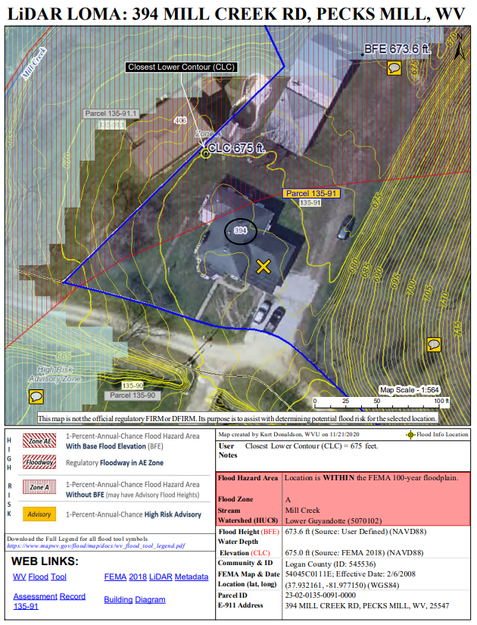

Example LiDAR LOMA Print Layout generated from WV Flood Tool.

(6) Model Potential Mitigation Measures and Communicate to Communities: Use model-backed depth grids and the building-level risk assessment inventory (BLRA) to identify mitigation measures for properties. For example, identify buildings with solid wall crawl spaces which would qualify for flood vents, one of the cheapest mitigation solutions for existing structures. Communicate this mitigation information to communities where types of building foundations are prevalent and would qualify for flood vents. Communicate the cost in savings in flood insurance by installing flood vents and adjusting the lowest floor elevation.
- 4,716 Non-Residential Structures to consider for Dry Floodproofing. Dry Floodproofing Criteria: Building Non-Residential (Commercial and Other Residential), Not in floodway (velocity not > 10 feet/sec), Flood Depth < 3 feet

- 10,038 Residential Structures to consider for Wet Floodproofing. Wet Floodproofing Criteria > Building Residential (Occupancy Class (RES1, RES3A, RES3B), Foundation Code = Perimeter Wall (Crawl Space), Not in floodway, Flood Depth < 12 feet

USACE Nonstructural Flood Risk Management Matrix:
https://usace.contentdm.oclc.org/digital/collection/p16021coll11/id/708/
Heat maps show the Kanawha River Valley as a high potential target area for residential mitigation.
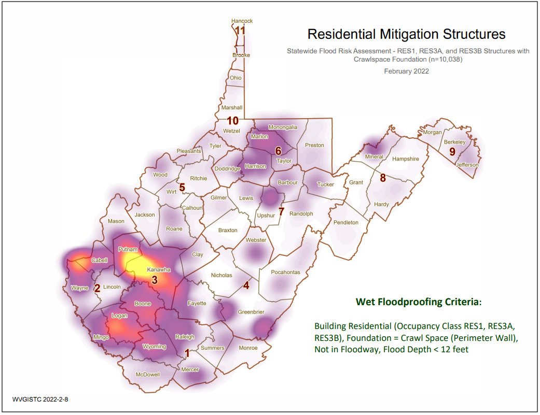
The RiskMAP View of the WV Flood Tool shows a high-risk advsisory flood zone in the city of St. Albans (Kanawha County) where are large number of residential “mapped-in” structures (orange circles) with elevated crawl space foundations (green diamonds) would be eligible for flood vents, one of the cheapest wet floodproofing mitigation measures for homeowners to considers. Vew online map of area for mitigation consideration.
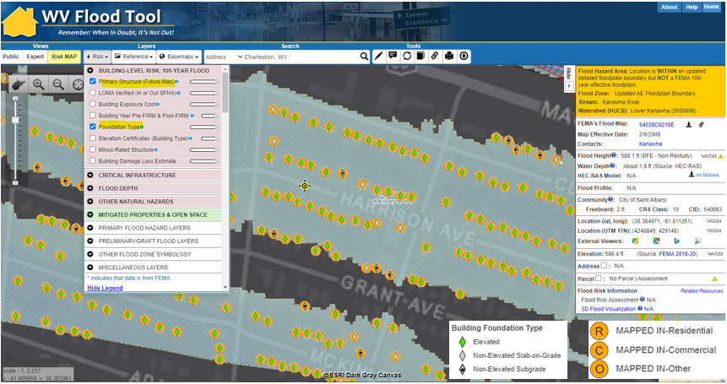
Flood-prone residential structures in St. Albans in which crawl space foundations and the flood depth would qualify for flood vents. See Google Street/3D Map View of structures.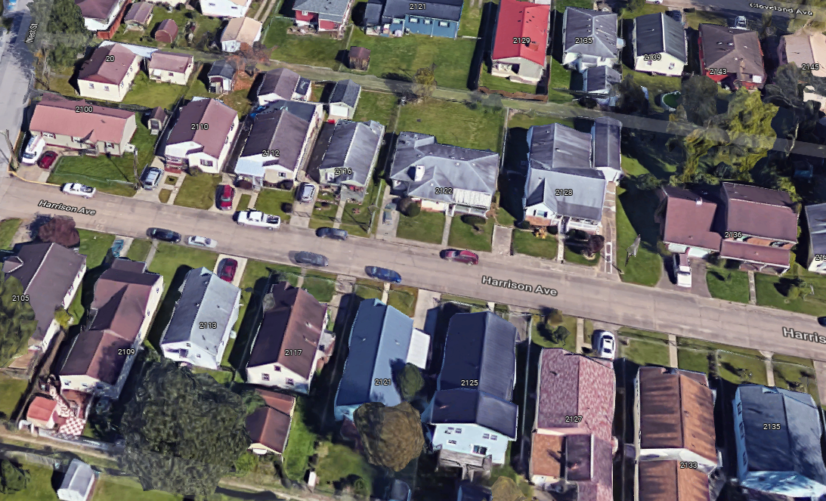
- (7) Engage Communities to Validate Areas of Mitigation (AOMI) on WV Flood Tool.
Engage communities to validate AoMIs identified from the statewide risk assessment. Areas of Mitigation (AoMI) are identified by Repetitive Loss structures, Substantial Damage Estimates, Floodway Structures, Mitigated Properties, Flood Depths, High-Water Marks, and Similar Topography. See statewide graphic of Areas of Mitigation Interest (AoMI) mapped to date. AoMIs support the community prioritization of identifiable measures for hazard reduction planning and actionable mitigation projects. AoMIs are published on the RiskMAP View of the WV Flood Tool.
AoMI determination layers may include:
- Buyout Properties
- High Flood Depths or Water Depths-in-Structure
- High-Water Marks
- Non-Residential |Residential building dollar damage estimates
- Substantial Damage Estimates
Area of Mitigation Interest (AoMI) for Rainelle, WV. Area of interest includes buyout properties, high-water marks, building damage estimates, and structures in the floodway. View map link on WV Flood Tool.
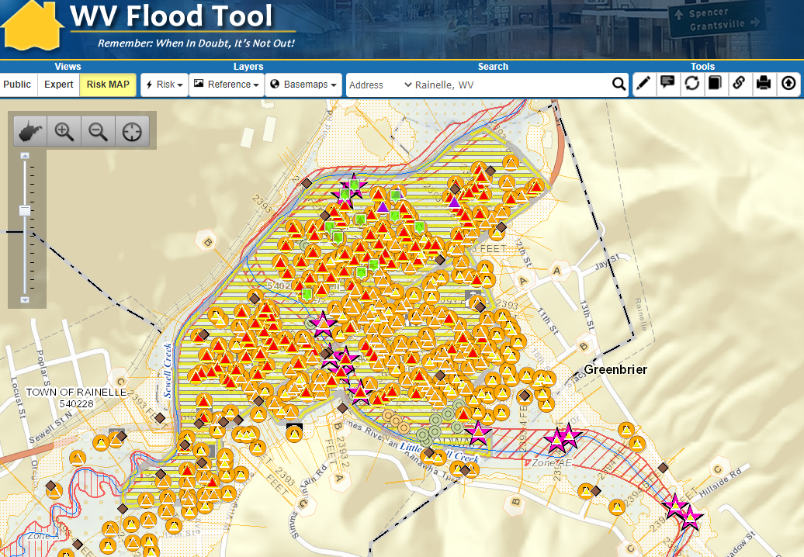

Project Total: $70,000

