**1.           *Option 1 - Map Riverine Flood Impacts on Vulnerably Disadvantaged Communities with Higher Stream Flow Change Forecast Models,***

**1.1.        Is there any social quantitative index or value for the selected disadvantaged community?**

* The communities are located in counties which have a moderately high [Social Vulnerability Index](https://data.wvgis.wvu.edu/pub/RA/State/CL/Graphic/SV/CDC_SVI_county_20220225.pdf).
* All five disadvantaged communities had a negative population growth rate between the 2010 and 2020 censuses. FEMA's report [Community Resilience Indicator Analysis: County-Level Analysis of Commonly Used Indicators from Peer-Reviewed Research](https://www.fema.gov/sites/default/files/2020-11/fema_community-resilience-indicator-analysis.pdf#page=80) uses population change as a risk factor. A reduction in population reduces local tax income and community resources to respond to a disaster.

|  |  |  |
| --- | --- | --- |
| **Municipality** | **Community Type** | **Population Growth Rate** |
| Rainelle town | Incorporated | **-20.9%** |
| White Sulphur Springs city | Incorporated | **-9.1%** |
| Clendenin town | Incorporated | **-30.4%** |
| Richwood city | Incorporated | **-19.1%** |
| Camden-on-Gauley town | Incorporated | **-25.4%** |

* WVU Geography [Professor Jamie Shinn](http://pages.geo.wvu.edu/~jshinn/) has long-term and ongoing research in Greenbrier County on the impacts of the flood (Shinn and Caretta 2020; Caretta et al. 2021), including on the intersections of flood recovery and the COVID-19 pandemic (Shinn, under review). Her current research focuses on three towns in Greenbrier County heavily impacted by the 2016 floods, which span the length of the county – Rainelle, Ronceverte, and White Sulphur Springs – and the resulting socio-economic hardships these communities face today. Like the communities of Greenbrier County, the other disadvantaged communities of Clendenin (Kanawha County), Richwood (Nicholas County), and Camden-on-Gauley (Webster County) face similar socio-economic challenges.

**1.2.        For the climate change map scenario, will there be physical climate model run or just adding constant (2’ and 3’) values?**

* Both. We will evaluate both FEMA flood map BFE plus constant (2’ and 3’ values) and the [First Street Foundation climate model](https://firststreet.org/research-lab/published-research/flood-model-methodology_overview/). The First Street Foundation Flood model is a nationwide probabilistic flood model at 3-meter resolution that shows the risk of flooding at any location in the contiguous 48 states due to rainfall (pluvial), riverine flooding (fluvial), and coastal surge flooding. The First Street Foundation Flood Model takes changing environmental factors into account by applying global climate model projections to forecast how flood risk will change over the next 30 years. Specifically, the climate model outputs flood depth in centimeters at the low, medium, and high CMIP 4.5 climate scenarios for the 2, 5, 20, 100, and 500 year storms this year, in 15 years and in 30 years.

**2.           *Option 2 - Update the WV Building Level Risk Assessment (BLRA) from New Flood Studies and Stakeholder Inputs***

**2.1.        Where is the update?  Better definition of project footprint and correlation with new Flood Studies availability?**

The project footprint is a majority of the counties in the State. New floodplains and depth grids are the result of active [FEMA flood studies](https://data.wvgis.wvu.edu/pub/RA/_resources/status/WV_FloodStudies.pdf) (17 counties) and [Updated Zone AE Redelineated Floodplains](https://data.wvgis.wvu.edu/pub/RA/_resources/Status/Updated_Zone_AE_Status.pdf) (38 counties) using the new [FEMA-purchased 1-meter elevation data](https://www.mapwv.gov/elevation) ([metadata](https://www.mapwv.gov/lidar-metadata)) that is now available statewide. As part of the current CTP 2020-21 activity, the WV GIS Technical Center is creating new Updated AE’s because of the final delivery of the QL2 LiDAR elevation data in fall 2021.

Floodplain and depth grids from **FEMA restudies** take priority over **Updated AE Redelineation mapping** for enhancing the Building Level Risk Assessment (BLRA). Redelineated Updated AE floodplains and depth grids are being generated using the new LiDAR 1-meter that was delivered in fall 2020 and covers 38 counties. A major goal is for all flood risk products to be created from the newest topographic 1-meter grids.

**2.2.        Are the seven counties with high SVI covered in this BLRA?**

Yes, this special project covers all counties in the State including the [seven counties](https://data.wvgis.wvu.edu/pub/RA/State/CL/Graphic/SV/CDC_SVI_county_20220225.pdf) (Gilmer, Fayette, Mingo, McDowell, Mercer, Raleigh, and Summers counties) with high SVI. New Draft NFHL depth grids just became available for Summers County. McDowell, Mercer, and Mingo counties are active [flood studies](https://data.wvgis.wvu.edu/pub/RA/_resources/status/WV_FloodStudies.pdf) and draft depth grids should be available in the near future. As these products become available, the WV GIS Technical Center will coordination will FEMA’s mapping contractors (AECOM, Wood Group) to obtain new floodplain and depth grids.

***Option 2:* CAMP DAWSON EXAMPLE OF UPDATED BUILDING LEVEL RISK ASSESSMENT (BLRA) – NEW REDELINDATED AE FLOODPLAINS AND DEPTH GRIDS**

Camp Dawson, Preston County, a military complex on the Cheat River, has one of the highest cumulative [building dollar exposures](https://data.wvgis.wvu.edu/pub/RA/State/BL/Graphic/BL_Top_Bldg_Exposure.pdf) ($276M) and [building damage loss estimates](https://data.wvgis.wvu.edu/pub/RA/State/BL/Graphic/BL_Top_Damage_Loss_Estimate.pdf) ($20M) in the State. A hydrograph on March 1, 2021, predicted major riverine flooding at 22.2 ft. (8 feet above flood stage of 16 feet); however, fortunately the flooding forecast for major flooding did not occur.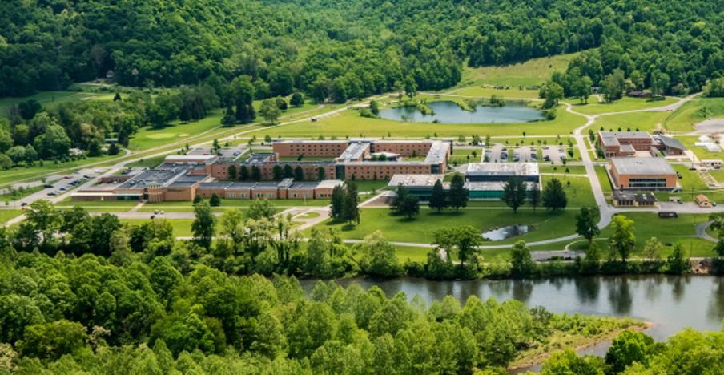

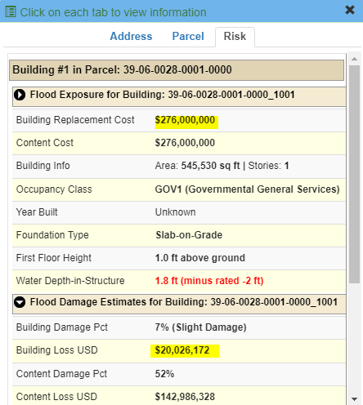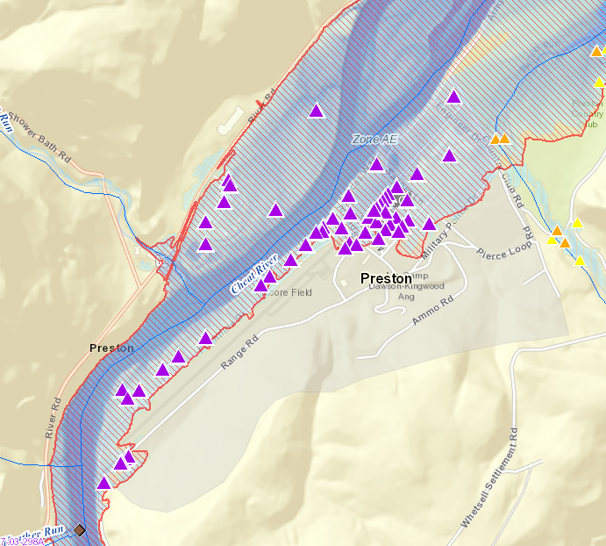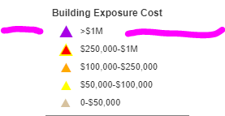High value building exposure of Camp Dawson structures in AE Zone ([WV Flood Tool Risk Map View](https://www.mapwv.gov/flood/map/?wkid=102100&x=-8868186&y=4786467&l=9&v=2))

Major Riverine Flooding Forecasted for Camp Dawson on 1 March 2021.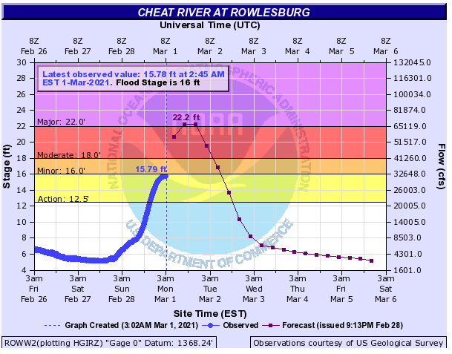

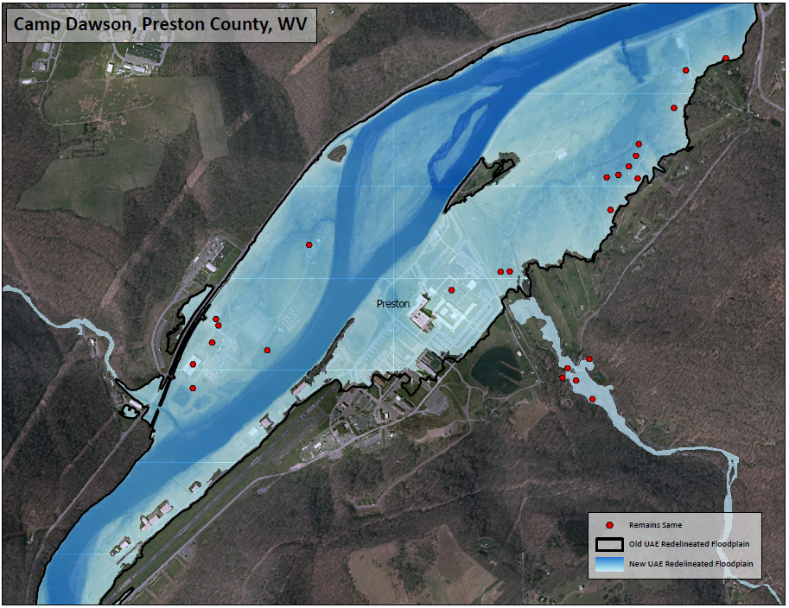Using the new FEMA LiDAR elevation data, an **Updated AE Floodplain Boundary** and **Depth Grid** were created for this location. Although the 1%-annual-chance floodplain boundary does not change much for this location, the depth grid values changed almost a foot in certain locations. To quantify the degree of flood risk, the new depth grid will be used to update the building level damage loss estimates for Camp Dawson to quantify the degree of risk.

***Option 2:* EXAMPLE FEMA RESTUDY (DRAFT NFHL) FOR SUMMERS COUNTY.**The recently released Draft BFE increased 1 foot along Greenbrier River at the town of Glenray near the Summers-Greenbrier county border. The buildings (blue circles) in the Draft floodplain need to be added to the Building Level Risk Assessment and the flood loss estimates for a 1%-annual chance flood event updated with the new Draft depth grid. [LOMA 17-03-1031A](https://map1.msc.fema.gov/data/54/L/17-03-1031A-540186.pdf?LOC=21e16c0f025d3d6040a81faa8cbf2deb) will need to be revalidated and most likely will not be valid anymore because of the increased BFE.

Draft NFHL, Summer County, Greenbrier River  
<https://www.mapwv.gov/flood/map/?wkid=102100&x=-8979620&y=4541333&l=11&v=2>  
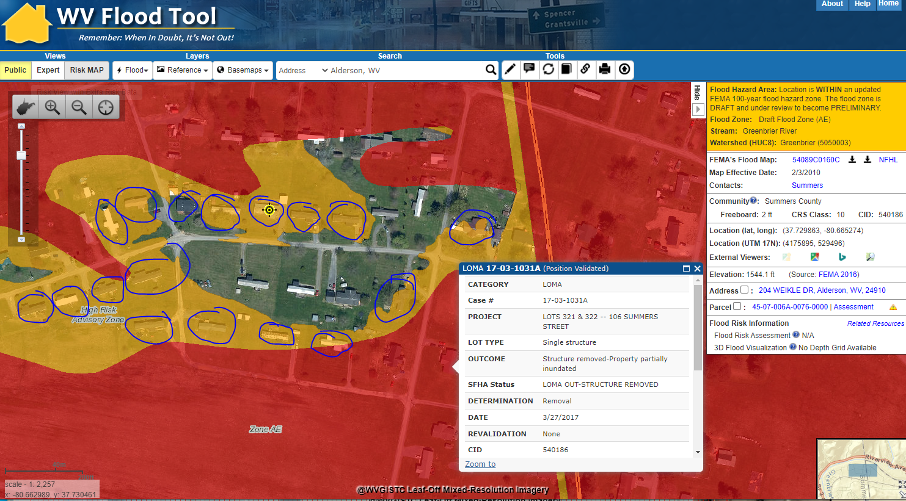

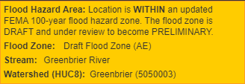

***Option 2:* EXAMPLE FEMA RESTUDY FOR RAINELLE, GREENBRIER COUNTY**

Example of mapped in structures to new SFHA from Preliminary Flood Study of Rainelle, WV. Mapped in structures (orange circles) and flood loss estimates are updated in the statewide Building Level Risk Assessment (BLRA).

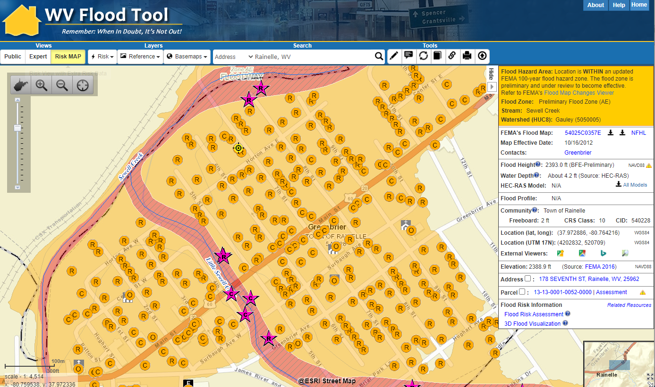Rainelle, WV (Greenbrier County)  
<https://www.mapwv.gov/flood/map/?wkid=102100&x=-8990631&y=4575596&l=10&v=2>

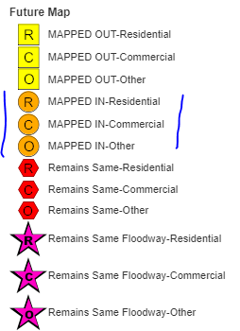

**3.           *Option 3 - Map landslide incidents from the new FEMA lidar for 38 counties***

**3.1.        Is climate change (precipitation) part of the plan for this special project option?**

* Previous research like the [Geomorphic studies of the storm and flood of November 3-5, 1985, in the upper Potomac and Cheat River basins in West Virginia and Virginia](https://pubs.er.usgs.gov/publication/b1981) provides precipitation and landslide trigger rates that can be incorporated into climate change precipitation models.
* More than 3,000 landslides were triggered by heavy rainfall in the central Appalachian Mountains of West Virginia and Virginia, November 3-5, 1985.
* Ninety-five percent of the landslides triggered by the November storm were slides, slide flows, slumps, or slump flows; the remaining 5 percent can be classified as debris avalanches and slide flows transitional to avalanches.
* The spatial distribution of landslides triggered by the storm was controlled primarily by rainfall, bedrock lithology, surficial lithology, land cover, and slope morphology.
* The triggering rainfall was of moderate intensity and long duration. Two-day storm totals varied from 170 mm (6.7 inches) to more than 240 mm (9.4 inches) in the study area. Most landslides occurred at the northeast end of the study area, where 48-h rainfall totals were more than 200 mm (7.9 inches).
* Intensity and rainfall duration of storms responsible for triggering landslides in the central Appalachians. <https://pubs.usgs.gov/bul/1981/report.pdf#page=70>
* WVU Geology Professor [Charlie Shobe](https://www.geo.wvu.edu/faculty-and-staff/faculty/charlie-shobe) would assist with the climate change data for predictive landslide mapping/modeling.