(D-R-A-F-T)
Prepared by:
WV GIS Technical Center
Department of Geology & Geography
West Virginia University
330 Brooks Hall, PO Box 6300
Morgantown, WV 26506

Supplement to 2017 County Multi-Hazard Risk Assessment and Mitigation Plan
June 9, 2016

Flood Risk Analysis Report
Berkeley County, WV


Special thanks for support from FEMA, WV DHSEM, and
The Polis Center at Indiana University–Purdue University Indianapolis

CONTENT
Overview 1
Key Flood Analysis Findings 2
General Description of County and Communities 3
Building Inventory 3
Creating the Building Inventory from Tax Assessor Data 3
Generating Hazus GBS and UDF from Building Inventory 5
Building Exposure to Potential Hazards 6
Building Exposure - General Building Stock (GBS) 6
Building Exposure in Floodplain - User Defined Facilities (UDF) 8
Inventory of Facilities and Community Assets 9
Essential Facilities 9
Critical Facilities 10
Community Assets 11
Inventory of Mitigated Properties 11
Flood Layer Inputs for Flood Model 12
100-Year Flood Hazard Area 12
Water Depth Grid 12
Riverine Flood Hazards Analysis 13
Riverine 1% Flood Building Damages 13
Riverine 1% Flood Debris Generation 17
Riverine 1% Flood Shelter Requirements 18
Data Deliverables to County 20
Maps 20
GIS Data 20
Integration of County Flood Risk Results in the State Hazard Mitigation Plan 21
Appendix A: Building Inventory Processing 23
Appendix B: Work Flow Diagram for Flood Analysis 24

TABLES
Table 1: Local Building Inventory 4
Table 2A: Countywide Building Number and Exposure ($) from updated General Building Stock 6
Table 2B: Countywide Building Number and Exposure ($) from CAMA Building Appraisal Values 7
Table 3A: Berkeley County Flood Hazard Building Exposure in 100-year Floodplain. 8
Table 3B: Martinsburg Flood Hazard Building Exposure in 100-year Floodplain. 8
Table 4: Essential Facilities 10
Table 5: Critical Facilities 10
Table 7: Mitigated Properties 11
Table 8: Berkeley County Riverine Floodplain (1% Flood) Related Losses 14
Table 9: Top 5 Flooded Structures by Replacement Cost 14
Table 10: Buildings, Facilities, and Mitigated Properties 14
Table 11: State Level Integration of Food Risk Data. 22
Table A-1: CAMA Records Query of February 2016 23
Table A-2: Building Inventory Processing performed on 2015 data 23
Table A-3: E-911 Addressable Structures 23

FIGURES
Figure 1: Flood Model Overview. 1
Figure 2: Hazus GBS and UDF Inventory Data. 5
Figure 3: Sample Map of Countywide General Building Stock Exposure by Census Block 7
Figure 4: Zoomed-in View of Spatially Enhanced UDF Structures in Flood Zone 9
Figure 5: Zoomed-in View of Water Depth Grid 12
Figure 6A: Berkeley County (1% Flood) Damaged Building Losses 15
Figure 6B: Martinsburg Community (1% Flood) Damaged Building Losses 15
Figure 7: Facilities and Community Assets in 100-year Floodplain 16
Figure 8: Mitigated or Buyout Properties in Berkeley County 16
Figure 9: Riverine 1% Flood Debris Weight (Tons) 19
Figure 10: Riverine 1% Flood Shelter Requirements 19

Berkeley County
Flood Risk Analysis Report

Overview
A riverine flood risk analysis was conducted to assist Berkeley County to quantify and visualize the potential loss resulting from a 100-year flood event. First, all the buildings and critical facilities in the county exposed to potential hazards were inventoried. From tax parcel and assessment data a detailed building inventory with engineered replacements costs was created for the entire county. Within the 100-year flood hazard area the parcel-based building inventory was further refined spatially by adjusting the parcel centroids to building structures using E-911 addressable sites, building footprints, aerial photography, and other reference layers. Next the site-specific building inventories along with the water depth grid and flood hazard inundation area were imported in the Hazus-MH (Version 2.2) Flood Model software to estimate building damages, debris, and people displaced (Figure 1). Flood Model results of each county will be integrated in the 2018 State Hazard Mitigation Plan and the Risk MAP View of the WV Flood Tool (www.mapwWV.gov/Flood).

Figure 1: Flood Model Overview. The Flood Model uses the best available site-specific building data, flood hazard area, and water depth grid to estimate building damages, debris, and people displaced for a 100-year flood event. A more detailed flow diagram is available in Appendix B.

Key Flood Analysis Findings
Using Hazus modeling software, the flood risk analysis for a 100-year flood event for Berkeley County resulted in the following findings:
EXPOSURE OF BUILDINGS & PROPERTIES TO FLOODING

- Building Exposure in County: In Berkeley County a minimum of 39,219 parcels with buildings have an aggregate total replacement value of 8.6 billion (2010 dollars).
- Building Exposure in Flood Hazard Area: A total of 1,115 buildings in the flood hazard area are exposed to flood damage which have an aggregate total replacement value of 280 million dollars.
- Facilities Exposure: A total of 52 essential facilities, 91 critical facilities, and 76 community assets are exposed to flooding. No replacement costs were computed for facilities.
- Mitigated Properties: A total of 39 mitigated properties in the county exist in the flood hazard areas.
FLOOD MODEL RESULTS

- Countywide Flood Loss Estimates
  - Physical Building Damage: Based on the water depth and inundation area, the Hazus Flood Model estimates physical damage to 1,002 buildings in Berkeley County at a replacement cost of 102 million dollars. Commercial properties have the highest loss ratio of 6.7%. No essential or critical facilities are located in the flood hazard area.
  - Building Debris Generation: An estimated 13,555 tons of building debris would be generated and require 542 truckloads (@25 tons/truck) to remove.
  - Direct Social Losses: Displaced households due to loss of housing habitability represent 3,038 individuals, of which 1,496 will require short term publicly provided shelter.

- Martinsburg Community Building Damage: The Flood Model estimates physical damage to 37 buildings in Berkeley County at a replacement cost of 777,040 dollars. Commercial properties have the highest loss ratio of 11.4%. No essential or critical facilities are located in the flood hazard area.
- Individual Building Damage: The structure in the flood hazard zone with the highest total replacement cost is an industrial property of 1.9 million located at 100-102 Pennsylvania Avenue, Martinsburg, WV 25404.

General Description of County and Communities
County Description: The geographical size of Berkeley County is 322 square miles and contains 2,749 census blocks. The region contains over 40 thousand households and has a total population of 104,169 people (2010 Census Bureau data). There is an estimated minimum of 39,219 parcels with buildings in the region with a total building replacement value (excluding contents) of 8,625 million dollars (2010 dollars). Approximately 90.9% of the buildings (and 83.9% of the building value) are associated with residential housing.
Martinsburg Description: The city of Martinsburg is an incorporated community exposed to periodic flooding. The geographical size of the region is seven square miles and contains 590 census blocks. The region contains over seven thousand households and has a total population of 17,227 people (2010 Census Bureau data). There are an estimated 6,162 parcels with buildings in the region with a total building replacement value (excluding contents) of 1,392 million dollars (2010 dollars).

Building Inventory
Two locally produced GIS data sets – county assessor tax surface parcels and E-911 addressable structures – were used to create and validate the local building inventory. From tax parcel and assessment data a detailed building inventory with engineered replacements costs was created for the entire county. The parcel-based building inventory identified 32,219 structures while the E-911 database listed 49,296 addressable structures. Table 1 identifies the number of structures in the county and city of Martinsburg. More information about the building inventory is described below.

Creating the Building Inventory from Tax Assessor Data
The building inventory for Berkeley County was created from assessor records and GIS parcels. The CAMA records were extracted from the centralized State Tax Department’s Integrated Assessment System while the GIS parcels were provided by the Berkeley County Assessor’s Office. Key inventory attributes to model flood damage included occupancy class or land use (LUC), construction type (GRADE and EXTWALL), foundation type (BASMT), stories, year built (YRBLT), structure area (AREASUM) and replacement costs (DWELVAL, COMVAL, OBYVAL).
Before the CAMA records are joined to the GIS parcels, a number of processing steps were performed on the CAMA records. First, all the CAMA records were reduced to single, unique record associated with the primary structure of the particular parcel. Note that this action eliminated multiple valued structures or trailer courts listed on the same parcel. Second, the CAMA records were classified by the LAND USE as residential, commercial, industrial, agricultural, religious, government, education, and unknown buildings. Unknown records typically represent land use codes for vacant or exempt properties, although some of these records may contain appraisal values. In addition, parcel records with invalid land use codes were deleted. During this processing step the CAMA records with null values for key engineering values were dropped. For example, since assessor records may not have values for the parcels that are not taxable, certain parcels with tax-exempt government, religious, education, or other non-profits structures may have been deleted. For Berkeley County this refinement process resulted in the source CAMA records of 54,650 being decreased to 44,650 records (Tables 1 and A-2). Lastly, the “improved” or “processed” 44,650 CAMA records were then joined by the unique parcel identifier with the centroids of each parcel polygon to create the spatially referenced building inventory.
Table 1: Local Building Inventory
Assessor Records and Parcels |  |  |  |  |  | E-911 Sites
Category | Parcel CAMA Records  (unique) | Improved or Processed CAMA Records  (attributes) | Assessor Parcels  (parcel polygons) | Building Inventory  (parcel centroids + CAMA replacement cost attributes) |  | E-911 Addressable Structures  (points on structure)
Martinsburg | - | - | 7,403 | 6,162 |  | 9,164
Unincorporated | - | - | 45,700 | 33,057 |  | 40,132
Total | 54,650 | 44,650 | 53,103 | 39,219 |  | 49,296
Based on the spatial join of the GIS parcels and CAMA records, the match rate between the GIS parcel-based building inventory (39,219) and the processed CAMA records (44,650) for Berkeley County was 88%. Further research should be conducted to improve the match rate between the assessor CAMA records and GIS parcels.
As a cross-reference check for the completeness of the parcel-based building inventory, the E-911 addressable structures for Berkeley County were extracted from the Statewide Addressing and Mapping System maintained by WV DHSEM. The match rate between the GIS parcel-based building inventory (39,219) and E-911 addressable structures (49,296) was 80%. See Appendix A for more information about the match rates and other statistics in creating the building inventory.

`

Generating Hazus GBS and UDF from Building Inventory

To import the building inventory into the Hazus-MH loss estimation software, the building inventory data is processed for two formats: General Building Stock (aggregate data) and User Defined Facilities (site-specific data). The General Building Stock (GBS) contains the least amount of detail and is stored as data that has been aggregated by census tract or block, whereas User Defined Facilities (UDF) contain basic characteristics about individual buildings. Both the GBS and UDF data layers contain building characteristics (occupancy class, square footage, building type, foundation, year built, etc.) to determine the building replacement costs. Note that the replacement costs for both the GBS inventory and UDF inventory should match. Lastly, the GBS is used for the debris and people evacuation models while the UDF is needed for the detail flood loss analysis of structures in the 100-year flood hazard area.

Figure 2: Hazus GBS and UDF Inventory Data. The General Building Stock (aggregate buildings) and User Defined Facilities (individual buildings) are derived from the Building Inventory.

Building Exposure to Potential Hazards

Building Exposure - General Building Stock (GBS)
The General Building Stock (GBS) is updated in Hazus-MH with the local building inventory prior to running the Flood Model loss analysis scenarios. Table 2A lists all the buildings in the county that are exposed to potential hazards. The number of buildings and full replacement costs based on standardized engineering cost calculations are listed by specific occupancy classes. Table 2B lists similar information but was derived from the appraised building values directly queried from the assessor records database.
Based on engineering calculation estimates there are 39,219 parcels with buildings in the county which have an aggregate total replacement value of 8.6 billion dollars (2010 dollars). Note that this cost was calculated for one primary structure per parcel and does not account for multiple valued structures in the same parcel. Figure 3 shows a map representation by census block geographical units of the GBS building assets exposed to potential hazards.
Table 2A: Countywide Building Number and Exposure ($) from updated General Building Stock
Occupancy Classification | Building Count | Total Building Exposure ($) | Percent of Total
Berkeley County (including all jurisdictions)
Residential | 35,667 | $7,232,609,000 | 83.9%
Commercial | 3,418 | $1,231,879,000 | 14.3%
Industrial | 94 | $143,923,000 | 1.7%
Agricultural | 31 | $7,338,000 | 0.1%
Religious | 6 | $4,614,000 | 0.1%
Government | 1 | $249,000 | 0.0%
Education | 2 | $4,847,000 | 0.1%
TIOTAL | 39,219 | $8,625,459,000 | 100%
Martinsburg
Residential | 5,644 | $1,167,904,000 | 83.9%
Commercial | 496 | $199,408,000 | 14.3%
Industrial | 19 | $22,158,000 | 1.6%
Agricultural | 0 | $0 | 0.0%
Religious | 3 | $2,307,000 | 0.2%
Government | 0 | $0 | 0.0%
Education | 0 | $0 | 0.0%
TOTAL | 6,162 | $1,391,777,000 | 100.0%

Table 2B: Countywide Building Number and Exposure ($) from CAMA Building Appraisal Values
General Occupancy | Count | Appraised Building Costs | CAMA Land Use Codes
Agricultural | 2,722 | $158,580,700 | 112-113
Commercial | 3,693 | $838,966,700 | 109-110, 310, 319-360, 362-390, 393-99, 602, 610-11, 630, 640, 670, 690, 701-706, 710-723
Education | 83 | $166,616,900 | 612-13
Government | 25 | $9,779,800 | 603,660
Industrial | 103 | $168,208,900 | 391-92, 400-471, 707
Religious | 234 | $85,713,100 | 361, 620, 680
Residential | 42,646 | $3,975,876,900 | 101-108, 115, 201-213, 301, 314-318
Unknown | 10,376 | $28,009,400 | 100, 114, 123, 200, 300, 600, 601, 604, 700
Invalid Codes | 4 | $283,600 | 41, 135, 191, 210, 605
Total | 59,886 | $5,432,036,000

In Table 2B The CAMA building appraisal values (APRBLG) were also categorized by occupancy class and for the county summed to 5.4 billion dollars. The appraised building layer is for reference purposes only and not used in the Flood Model analysis.

Figure 3: Sample Map of Countywide General Building Stock Exposure by Census Block. Replacement building costs are aggregated to Census Blocks.

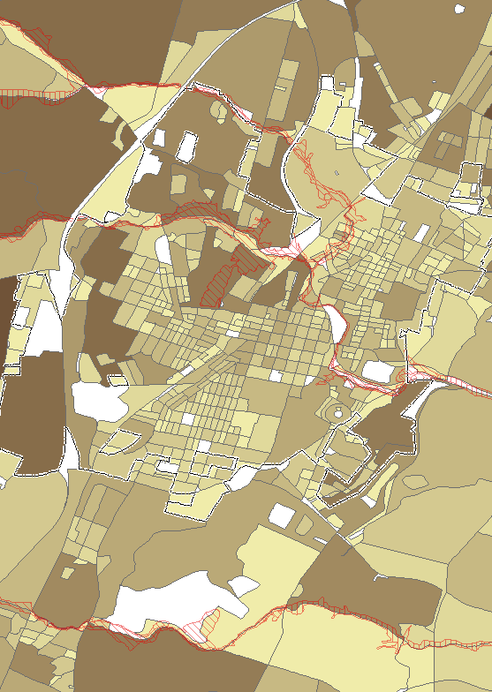

Building Exposure in Floodplain - User Defined Facilities (UDF)
Only the User Defined Facilities that are in the 100-year flood zone were imported into the Hazus-MH Flood Model. Before the UDF structures were imported into Hazus-MH to execute the Flood Model, the site-specific data was further refined by spatially adjusting the parcel centroids to building structures using E-911 addressable sites, building footprints, leaf-off aerial photography, or other reference layers. In addition to pin-pointing the structures in the flood zone, complete street addresses from the E-911 sites were copied to corresponding records in the UDF. Figure 4 shows a zoomed-in view of the spatially enhanced UDF structures in the flood hazard zone.
Table 3A: Berkeley County Flood Hazard Building Exposure in 100-year Floodplain. Data input of choice is User Defined Facilities.
General Occupancy | UDF  Count | Exposure in Floodplain  (Total Replacement Costs using UDF)
Agricultural | 2 | 632,397
Commercial | 613 | 196,804,576
Education | 0 | 0
Government | 0 | 0
Industrial | 1 | 1,889,497
Religious | 0 | 0
Residential | 499 | 80,371,337
TOTAL | 1,115 | 279,697,807

A total of 1,115 buildings at a cost of $279,697,807 are exposed to a 100-year flood event in Berkeley County (Table 3A). The flood loss estimates are calculated from the building inventory modeled in Hazus as User Defined Facilities, or site-specific points. During the flood model runs the flood damage is estimated in percent and is weighted by the area of inundation at a given depth for an individual structure. Refer to Table 8 to view the estimated building damages resulting from the Flood Model.
Table 3B: Martinsburg Flood Hazard Building Exposure in 100-year Floodplain. Data input of choice is User Defined Facilities.
General Occupancy | UDF  Count | Exposure in Floodplain  (Total Replacement Costs using UDF)
Agricultural | 0 | 0
Commercial | 14 | 6,913,630
Education | 0 | 0
Government | 0 | 0
Industrial | 1 | 1,889,497
Religious | 0 | 0
Residential | 30 | 6,503,482
TOTAL | 45 | 15,306,609
A total of 45 buildings at a cost of $15,306,609 are exposed to a 100-year flood event in Martinsburg (Table 3B). Refer to Table 8 to view the estimated building damages resulting from the Flood Model.

Figure 4: Zoomed-in View of Spatially Enhanced UDF Structures in Flood Zone
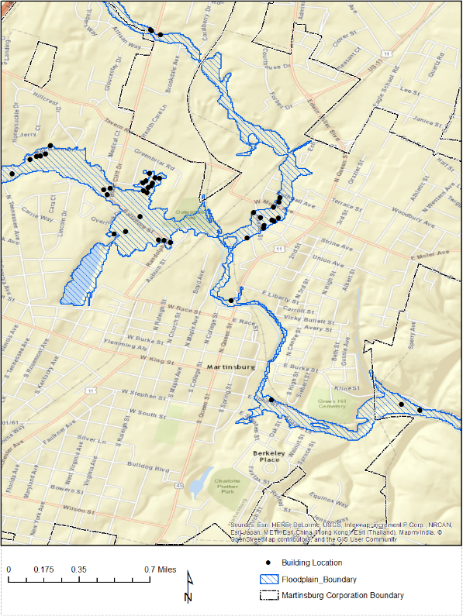

Inventory of Facilities and Community Assets

Essential facilities, critical facilities, and community assets were compiled from various GIS stewards and should be validated with the local communities. Replacement costs were not computed for facilities and community assets for this study. If replacement costs of non-profit buildings are unavailable, then costs may be obtained from:
• Various websites for some facilities
• Insurance records for individual buildings
• Calculated from square footage by using RS Means replacement

Essential Facilities
Essential facilities are defined as those that are vital to the county in the event of a hazard. These include police departments, fire stations, schools, health care facilities, and emergency service zones. The WV DHSEM compiles essential facilities from various local, state, and federal data sources.

Table 4: Essential Facilities
Category | Number of Facilities
Police Stations | 3
Fire Stations | 12
Emergency Service Centers | 1
Health Care Facilities | 2
Schools | 34
TOTAL | 52

Critical Facilities

Critical facilities are buildings that are deemed economically or socially viable to the county and is a superset of essential facilities. The following critical facilities were inventoried and mapped for Berkeley County.

Table 5: Critical Facilities
Category | Number of Facilities | Description
Governmental Facilities | n/a | Essential for the delivery of critical services and crisis management including data and communication centers and key government complexes.
Dams | 9 | Source: USACE
Transportation Systems  - Airports  - Railroads  - Bridges | 5  1  8 | Necessary for transport of people and resources including airports, highways, railways. Source: GNIS
Lifeline Utility Systems  - Wastewater Treatment Plants  - Potable Water Systems  - Communication Facilities  - Electric Substations  - Electric Power Facilities  - Natural Gas Facilities | 45  n/a  n/a  7  0  n/a | Vital to public health and safety including potable water, wastewater, oil, natural gas, electric power, and communication systems.
Hazardous Material Facilities | 16 | Involved in the production, storage, and/or transport of corrosives, explosives, flammable materials, radioactive materials, and toxins.
TOTAL | 91

Community Assets
The Berkeley County Mitigation Planning team may identify facilities that are significant to the county; for example, historic landmarks or significant tourist attractions. These facilities or structures are referred to as community assets.
Table 6: Community Assets
Category | Number of Facilities | Notes
Churches | 76 | GNIS
Government Office | n/a
Hazmat Non Facility | n/a
Mobile Home and Campground | n/a
Polling Place | n/a
Emergency Shelter | n/a
Water Tower | n/a
Poultry Slaughtering Stations | n/a
TOTAL | 76

Inventory of Mitigated Properties
Both FEMA and WVDHSEM have worked together to identify buyouts of repetitive flood properties since the inception of FEMA HMA grant programs during the past two decades. Berkeley County has a total of 39 mitigated properties.
Table 7: Mitigated Properties
Category | Mitigated Properties
Martinsburg | 0
Unincorporated | 39
TOTAL | 39

Flood Layer Inputs for Flood Model
Important flood layers for the Flood Model include the 100-year flood hazard area and water depth grid.

100-Year Flood Hazard Area
The 100-year floodplain in Berkeley County was used to run all the flood model scenarios. The flood hazard area was downloaded from FEMA’s National Flood hazard Layer (NFHL) digital database.

Water Depth Grid
A water depth grid was required to estimate the percentage of physical damage to a structure weighted by the area of inundation at a given depth. The Hazus Enhanced Quick Look tool was used to generate a depth grid for the flood analysis based on the FEMA National Flood Hazard Layer and the digital elevation model at 1/3 arc-second (approximately 10 m) resolution downloaded from the USGS National Elevation Dataset (NED). Although certain counties in West Virginia may have more accurate depth grids generated from HEC-RAS computer modeling software for the Approximate A Zones, these HEC-RAS depth grids were not available for Berkeley County.
Figure 5: Zoomed-in View of Water Depth Grid. Overlain with UDF individual building structures
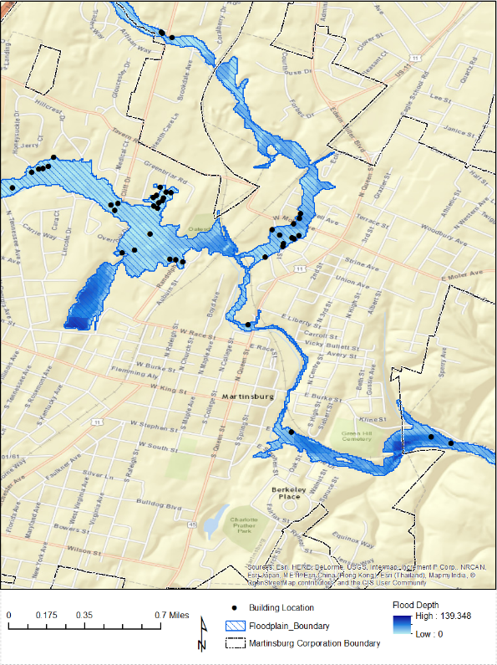
The depth grid range for Berkeley County is from 0 to 139 feet.

Riverine Flood Hazards Analysis
Riverine flooding is the number one natural hazard risk in West Virginia. Riverine floodplains range from narrow, confined channels in the steep valleys of hilly and mountainous areas, to wide flat areas in the Plains States and low-lying coastal regions. The volume of water in the floodplain is a function of the size of the contributing watershed and topographic characteristics such as watershed shape and slope, and climatic and land-use characteristics.
Both Hazus-MH and GIS software were used to model flood building damages, debris estimations, and the number of shelters required for the displaced population. Below are the tables and maps from running the Flood Model for a 100-year flood event. Hazus-MH loss estimates may be impacted by certain assumptions and process variances made in this flood risk analysis. The Berkeley County analysis used Hazus Version 2.2 and the population counts were derived from the 2010 Census. During the flood model runs the flood damage is estimated in percent and is weighted by the area of inundation at a given depth for a given census block (GBS input) or user-defined structure (UDF input).

Riverine 1% Flood Building Damages
Buildings in Berkeley County are vulnerable to flooding from the 1% Riverine Flood (also known as the 100-year flood) and the cost to rebuild may have significant consequences to the community. Hazus-MH estimated the 1%-annual-chance flood would physically damage 1,002 buildings at a replacement cost of 103 million dollars. In the Martinsburg community the Flood Model estimated damage to 37 buildings at a replacement cost of 770 thousand dollars.
The flood loss estimates for damaged buildings by community and occupancy class are listed in Table 8. Table 8 also provides the loss ratios (Total Loss / Total Exposure) for the county and jurisdictions. The loss ratios were computed by dividing the Total Building Loss (Table 8) by the Total Building Exposure (Table 2a). Commercial properties have the highest loss ratio of 6.7% and 11.4% for Berkeley County and the Martinsburg community, respectively.
The structure in the flood hazard zone with the highest total replacement cost is an industrial property of 1.9 million located at 100-102 Pennsylvania Avenue, Martinsburg, WV 25404. Table 9 lists the top five individual damaged structures in the county based on replacement costs.
Table 10 lists all the buildings, essential facilities, critical facilities, and community assets damaged in a 100-year flood event. Figures 6A and 6B are maps of the flood damaged buildings in Berkeley County and the Martinsburg community. A large-format county map of the flood damaged buildings is provided with this report. Figures 7 and 8 are flood maps of facilities /community assets and mitigated properties, respectively.

Table 8: Berkeley County Riverine Floodplain (1% Flood) Related Losses
Classification | Number of Buildings Damaged | Total Building Loss ($) | Loss Ratio
Berkeley County (including all jurisdictions)
Residential | 400 | $ 20,439,548 | 0.3%
Commercial | 599 | $ 82,092,330 | 6.7%
Industrial | 1 | $ 70,570 | 0.0%
Agricultural | 2 | $ 396,336 | 5.4%
Religious | 0 | $0 | 0.0%
Government | 0 | $0 | 0.0%
Education | 0 | $0 | 0.0%
TOTAL | 1,002 | 102,998,784
Martinsburg
Residential | 24 | $549,236 | 4.7%
Commercial | 12 | $227,804 | 11.4%
Industrial | 1 | $0 | 0.0%
Agricultural | 0 | $0 | 0.0%
Religious | 0 | $0 | 0.0%
Government | 0 | $0 | 0.0%
Education | 0 | $0 | 0.0%
TOTAL | 37 | $777,040

Table 9: Top 5 Flooded Structures by Replacement Cost
UDF ID | E-911 Street Address | Parcel ID | Building Type | Building Replacement Cost¹
Building 1 | 100-102 Pennsylvania Ave | 06 5005500000000 | Industrial | $1,889,497
Building 2 | 2279 Winchester Ave | 01 10B002100010000 | Commercial | $1,064,186
Building 3 | 750 Baltimore St | 06 5007300000000 | Commercial | $946,568
Building 4 | 703 Baltimore St | 06 5007600000000 | Commercial | $946,568
Building 5 | 210 Adams St | 06 5005600000000 | Commercial | $946,568
¹ Building 3 content replacement cost is $1,150,755.
Table 10: Buildings, Essential Facilities, Critical Facilities, and Community Assets Damaged (1% Flood)
Category | Building Inventory | Essential Facilities | Critical  Facilities |  | Community  Facilities | Total
Martinsburg | 37 | 0 | - |  | 0 | 37
Unincorporated | 965 | 0 | - |  | 0 | 965
TOTAL | 1,002 | 0 | - |  | 0 | 1,002

Figure 6A: Berkeley County (1% Flood) Damaged Building Losses
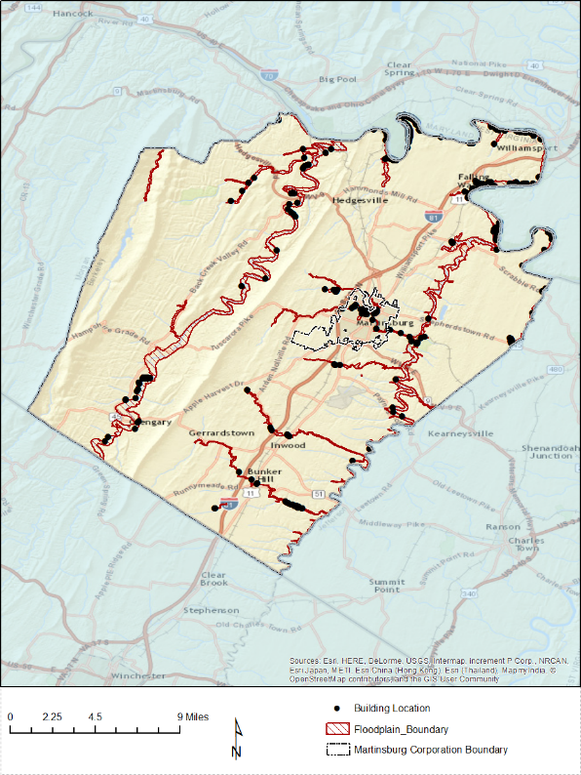

Figure 6B: Martinsburg Community (1% Flood) Damaged Building Losses
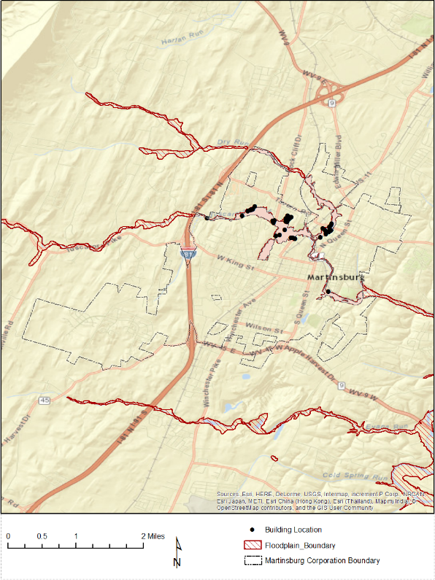

Figure 7: Facilities and Community Assets in 100-year Floodplain
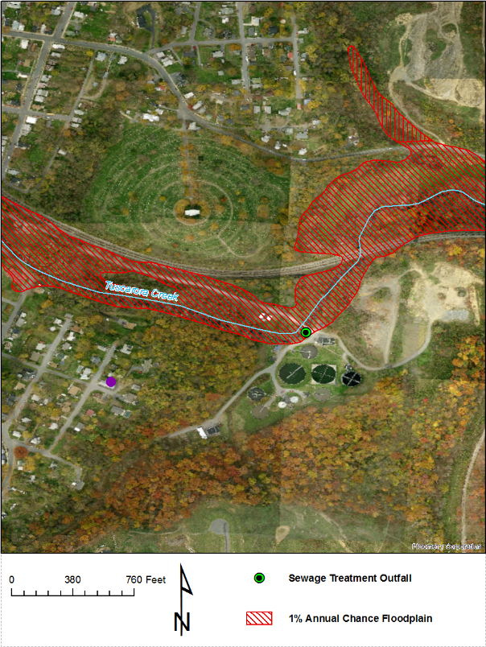

Figure 8: Mitigated or Buyout Properties in Berkeley County
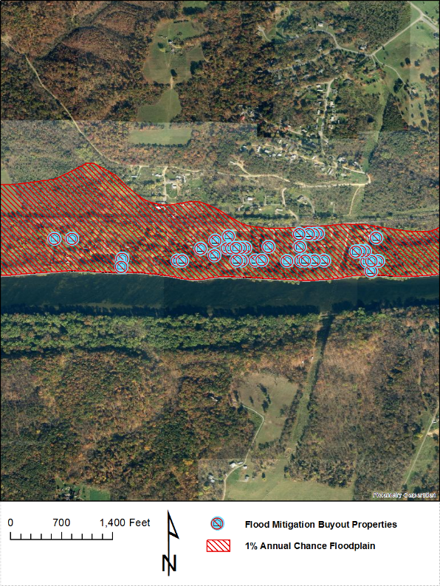

Riverine 1% Flood Debris Generation
Debris disposal can be a significant issue following floods. The Hazus Flood Model estimates debris from building damage during floods, including building finishes, and structural components. The physical damage estimates are not made for building contents, or for bridges or other lifelines.
The Hazus Flood Model debris estimation methodology determines the expected amounts of debris generated at various depths of water and reported at the census block level. Output from this module is the debris weight (in tons). The classes of debris are defined as follows: (1) building finishes (carpeting, dry wall, insulation, etc.), (2) structural components (wood, brick, etc.) and (3) foundation materials (concrete slab, concrete block, rebar, etc.). This distinction is made because of the different types of material handling equipment required to handle the debris. For more information about the Hazus Flood Model debris estimation methodology refer to the Hazus-MH Technical Manual.
The Flood Model estimates that a total of 13,555 tons of debris will be generated. Of the total amount, Finishes comprises 24% of the total, Structure comprises 35% of the total. If the debris tonnage is converted into an estimated number of truckloads, it will require 542 truckloads (@25 tons/truck) to remove the debris generated by the flood. The results are mapped in Figure 9.

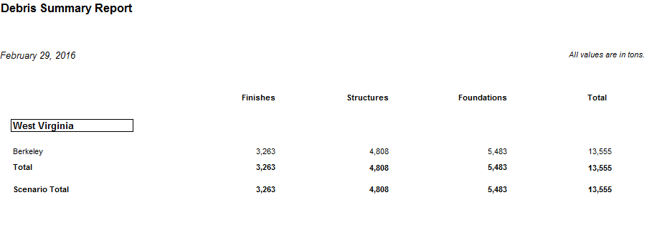

Riverine 1% Flood Shelter Requirements
A significant part of any planning scenario is to estimate the number of individuals who will need to be sheltered in the short-term. The direct social loss of the displaced population is based on the inundation area and depth of flooding. Flood sheltering needs are based on the displaced population, not the damage state of the structure.
The Hazus-MH Flood Model determines the number of individuals likely to use government-provided short-term shelters through determining the number of displaced households as a result of the flooding. To determine how many of those households and the corresponding number of individuals will seek shelter in government-provided shelters the number is modified by factors accounting for income and again by factors accounting for age. For more information about the Hazus Flood Model shelter estimation methodology refer to the Hazus-MH Technical Manual.
Hazus 2.2 Report: For Berkeley County, displaced households represent 3,038 individuals, of which 1,496 will require short term publicly provided shelter. The results are mapped in Figure 10.
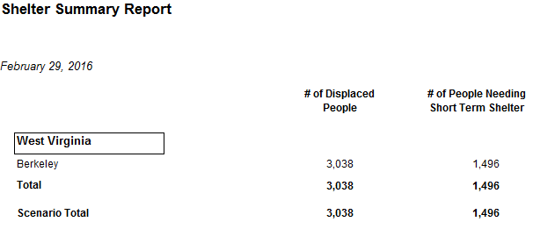

Figure 9: Riverine 1% Flood Debris Weight (Tons)
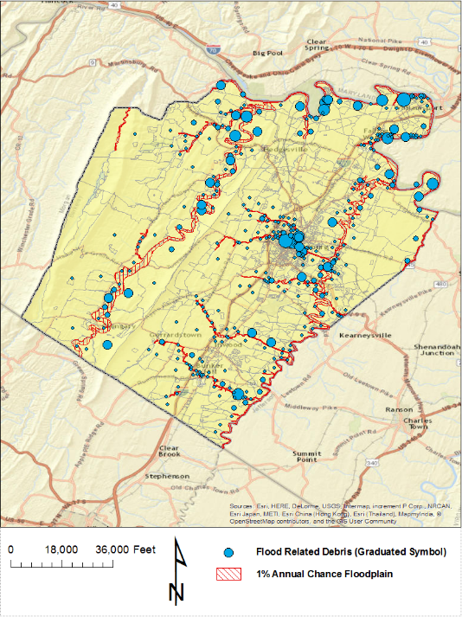

Figure 10: Riverine 1% Flood Shelter Requirements
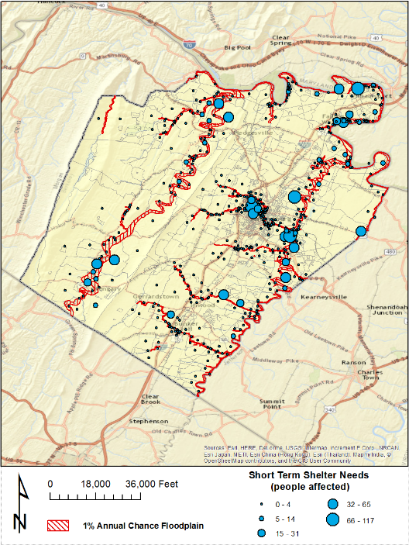

Data Deliverables to County
In addition to this report, the following maps and GIS data layers are available to the counties.

Maps
- Building Exposure
- Physical damage map of buildings and facilities (large size)
- Debris map
- Population Displacement / Shelter map
- Select 3D maps (if building footprints available)
- Miscellaneous maps

GIS Data
- GIS parcel polygons
- E-911 Addressable Structures
- Building Inventory
- UDF Floodplain Structures
- Essential Facilities
- Critical Facilities
- Community Assets
- Mitigated Properties
- Hazus-MH .hpr files (available on request)

Integration of County Flood Risk Results in the State Hazard Mitigation Plan
Results of the county flood risk analysis will be used to update the 2018 State Hazard Mitigation Plan and the Risk MAP View of the WV Flood Tool (www.mapWV.gov/Flood). Table 11 lists the flood risk data layers involved in integrating county flood risk studies to regional and state levels.
Figure 11: Hazus Level 1 Food Risk Layers in WV Flood Tool
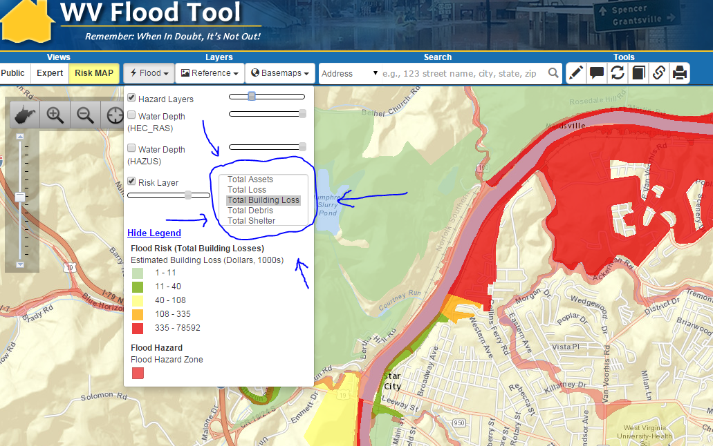

Table 11: State Level Integration of Food Risk Data. The following hazard risk information from counties can be integrated at the regional and state levels for the State Hazard Mitigation Plan. The boldfaced loss estimates are currently in the WV Flood Tool and based on a statewide Hazus Level 1 analysis performed several years ago.
Flood Risk Data | Inventory Type | Spatial Representation
** Flood Model INPUTS **
Total Assets: Number and exposure ($) of all buildings | Building Inventory | Parcel Centroids or Census Tracts/Blocks
Floodplain Exposure: Number and exposure of buildings located in the Special Flood Hazard Area (SFHA) | UDF | Parcel centroids can be spatially adjusted with E-911 addressable structures
Facilities Exposure: Essential Facilities, Critical Facilities, Community Assets | GIS Infrastructure Databases | Usually Points
Mitigated Properties: (shown currently in Expert View of WV Flood Tool) | Mitigated Properties | Polygons
Water Depth Grid | - Hazus-generated (EQL)  - Advisory Flood Height  - Detailed Flood Zone | Raster
Flood Hazard Area | DFIRMs | Polygons
** Flood Model OUTPUTS **
Total Loss: Number and value ($) of Buildings and Contents damaged in Hazus Level 2 analysis | UDF & GBS | - Points  - Census Tracts/Blocks  - Watersheds
Total Building Loss: Number and value ($) of damaged buildings in Hazus Level 2 analysis.  Loss Ratios as calculated from the Hazus Analysis | UDF & GBS | - Points  - Census Tracts/Blocks  - Watersheds
Total Debris costs ($) | GBS | Census Tracts/Blocks
Total Shelter: People requiring shelter | GBS | Census Tracts/Blocks

Appendix A: Building Inventory Processing
Table A-1: CAMA Records Query of February 2016
CAMA Field | Value
County ID | 2
Name | Berkeley
Appraised Land Value | 2,450,724,700
Appraised Building Value | 5,432,036,000
Appraised Total Value | 7,882,760,700
Total Unique Parcel Records | 59,886
Appraised Bldg > 0 | 41,714
Table A-2: Building Inventory Processing performed on 2015 data
File Type | Count | Notes
CAMA Records (attributes) | 54,650 | CAMA records are reduced to a single, unique primary property record
Improved CAMA Records  (attributes) | 44,650 | CAMA codes transformed to values recognized by Hazus. For Berkeley County the source CAMA data included 54,650 records. The destination data – Improvements records included 44,650 records. This means that that there were 10,000 failed records and research by Polis showed that these included records without DWELVAL, COMVAL and OBYVAL values. It also included records with LUC values (100, 114, 123, 200, 300, 600, 601 604,700) for vacant and exempt lands which were deemed inappropriate for the desired modeling purposes.
Assessor Parcels  (parcel polygons) | 53,061 | GIS parcel polygon file provided by county and converted to parcel centroid points. Total parcel polygons equals 53,061.
Building Inventory  (parcel centroids + attributes) | 39,219 | Join between parcel centroid points and Improved CAMA records yielded 39,219 building points
CAMA - parcel match rate | 88% | Building Inventory (39,219) divided by Improved CAMA record attributes (44,650) = 88%

Table A-3: E-911 Addressable Structures
File Type | Count | Notes
Addressable Sites | 49,296 | Addressable structures for Berkeley County from Statewide Addressing and Mapping System (SAMS).
E-911 – parcel match rate | 80% | Parcel-centroid building inventory (39,219) divided by Addressable sites (49,296) = 80%

Appendix B: Work Flow Diagram for Flood Analysis

