Prepared by:
WV GIS Technical Center
Department of Geology & Geography
West Virginia University
330 Brooks Hall, PO Box 6300
Morgantown, WV 26506

Supplement to 2017 County Multi-Hazard Risk Assessment and Mitigation Plan
October 26, 2016

Flood Risk aSSESSMENT Report
Berkeley County, WV


Special thanks for support from FEMA, WV DHSEM, and
The Polis Center at Indiana University–Purdue University Indianapolis

CONTENT
Overview 1
Key Flood Analysis Findings 2
General Description of County and Communities 3
Building Inventory 3
Creating the Building Inventory from Tax Assessor Data 3
Generating Hazus GBS and UDF from Building Inventory 5
Building Exposure to Potential Hazards 6
Building Exposure - General Building Stock (GBS) 6
Building Exposure in Floodplain - User Defined Facilities (UDF) 8
Inventory of Facilities and Community Assets 10
Essential Facilities 10
Critical Facilities 10
Community Assets 11
Inventory of Mitigated Properties 12
Flood Layer Inputs for Flood Model 13
1% Annual Chance Flood Hazard Area 13
Water Depth Grid 13
Riverine Flood Hazards Analysis 14
Riverine 1% Flood Building Damages 14
Riverine 1% Flood Debris Generation 20
Riverine 1% Flood Shelter Requirements 21
Data Deliverables to County 24
Maps 24
GIS Data 24
Integration of County Flood Risk Results in the State Hazard Mitigation Plan 25
Appendix A: Building Inventory Processing 27
Appendix B: Work Flow Diagram for Flood Analysis 28
Appendix C: Data Gap Analysis 29
Appendix D: Statewide Risk Assessment Objectives 30
Appendix E: Multi-Hazard Risk Assessment Lifecycle 32
Appendix F: Statewide Spatial Integration of Surface Tax Parcels 34
Appendix G: 3D Flood Risk Visualization 35
Appendix H: Glossary of Risk Assessment Terminology 38

TABLES
Table 1: Local Building Inventory 4
Table 2A: Countywide Building Number and Exposure ($) from updated General Building Stock 6
Table 2B: Countywide Building Number and Exposure ($) from CAMA Building Appraisal Values 7
Table 3A: Berkeley County Flood Hazard Building Exposure in 1% Annual Chance Floodplain. 8
Table 3B: Martinsburg Flood Hazard Building Exposure in 1% Annual Chance Floodplain. 8
Table 4: Essential Facilities 10
Table 5: Critical Facilities 11
Table 7: Mitigated Properties 12
Table 8: Berkeley County Riverine Floodplain (1% Flood) Related Losses 15
Table 9: High Potential Loss Structures 15
Table 10: Buildings, Essential Facilities, Critical Facilities, and Community Assets Damaged (1% Flood) 15
Table 11: State Level Integration of Food Risk Data. 26
Table A-1: CAMA Records Query of February 2016 27
Table A-2: Building Inventory Processing performed on 2015 data 27
Table A-3: E-911 Addressable Structures 27
Table C-1: Data Gap Analysis for Region 9 PDC Counties 29

FIGURES
Figure 1: Flood Model Overview. 1
Figure 2: Hazus GBS and UDF Inventory Data. 5
Figure 3: Sample Map of Countywide General Building Stock Exposure by Census Block 7
Figure 4: Zoomed-in View of Spatially Enhanced UDF Structures in Flood Zone 9
Figure 5: Zoomed-in View of Water Depth Grid 13
Figure 6A: Berkeley County (1% Flood) Damaged Building Losses 16
Figure 6B: Martinsburg Community (1% Flood) Damaged Building Losses 17
Figure 7: Facilities and Community Assets in 1% Annual Chance Floodplain 18
Figure 8: Mitigated or Buyout Properties in Berkeley County 19
Figure 9: Riverine 1% Flood Debris Weight (Tons) 22
Figure 10: Riverine 1% Flood Shelter Requirements 23
Figure E-1: Multi-Hazard Risk Assessment Lifecycle. 33
Figure F-1: Statewide Spatial Integration of Surface Tax GIS Parcels for Agency and Public Benefit. 34
Figure G-1: WV Flood Tool information for Sample 3D Site 36
Figure G-2: Google Earth View of Sample 3D Site 37
Figure G-3: 3D Rendering Showing Flood Depth and Flooded Structures 37

Berkeley County
Flood Risk Assessment Report

Overview
A riverine flood risk assessment was conducted to assist Berkeley County to quantify and visualize the potential loss resulting from a 1% annual chance flood event.¹ First, all buildings and critical facilities in the county exposed to potential hazards were inventoried. From tax parcel and assessment data a detailed building inventory with engineered replacements costs was created for the entire county. A user defined facilities (UDF) data set was created by filtering the countywide building inventory to exclude points outside the 1% annual chance flood area. The parcel-based UDF data were further refined spatially by adjusting the parcel centroids to building structures using E-911 addressable sites, building footprints, aerial photography, and other reference layers. Next, the general and UDF building inventories, digital elevation model (DEM) and flood hazard inundation area were imported into the Hazus-MH (Version 2.2) flood risk modeling software. A flood depth raster layer was generated within Hazus and analyzed with the building inventories, DEM and flood hazard area to estimate building damages, debris, and people displaced (Figure 1). Flood Model results for each county will be integrated into the 2018 State Hazard Mitigation Plan and the Risk MAP View of the WV Flood Tool (www.mapwWV.gov/Flood).
Figure 1: Flood Model Overview. The Flood Model uses the best available site-specific building data, flood hazard area, elevation and water depth grid to estimate building damages, debris, and people displaced for a 1% annual chance flood event. A more detailed flow diagram is available in Appendix B.

Key Flood Analysis Findings
Using Hazus modeling software, the flood risk analysis for a 1% annual chance flood event for Berkeley County resulted in the following findings:
EXPOSURE OF BUILDINGS & PROPERTIES TO FLOODING

- Building Exposure in County: In Berkeley County a minimum of 39,219 parcels with buildings have an aggregate total replacement value of 8.6 billion (2010 dollars).
- Building Exposure in Flood Hazard Area: A total of 1,115 buildings in the flood hazard area are exposed to flood damage which have an aggregate total replacement value of 280 million dollars.
- Facilities Exposure: A minimum of 52 essential facilities, 91 critical facilities, and 76 community assets are exposed to potential hazards. No replacement costs were computed for facilities.
- Mitigated Properties: A total of 39 Berkeley County mitigated buyout properties exist in the flood hazard areas.
FLOOD MODEL RESULTS

- Countywide Flood Loss Estimates
  - Physical Building Damage: Based on the water depth and inundation area, the Hazus Flood Model estimates physical damage to 1,002 buildings in Berkeley County at a replacement cost of 102 million dollars. Commercial properties have the highest loss ratio of 6.7%. No essential or critical facilities are located in the flood hazard area. The highest building damage costs to individual structures occur in the community of Berkeley Springs.
Building Debris Generation: An estimated 13,555 tons of building debris would be generated and require 542 truckloads (@25 tons/truck) to remove.
  - Direct Social Losses: Displaced households due to loss of housing habitability represent 3,038 individuals, of which 1,496 will require short term publicly provided shelter.

- Martinsburg Community Building Damage: The Flood Model estimates physical damage to 37 buildings in Berkeley County at a replacement cost of 1.5 million dollars. Industrial properties have the highest loss ratio of 1.4%. No essential or critical facilities are located in the flood hazard area.
- Individual Building Damage: The structure in the Berkeley County flood hazard zone with the highest building loss is a commercial property located at 100 Exchange Place, Martinsburg, WV 25404 with building loss estimated at 430 thousand dollars.

General Description of County and Communities
County Description: The geographical size of Berkeley County is 322 square miles and contains 2,749 census blocks. The region contains over 40 thousand households and has a total population of 104,169 people (2010 Census Bureau data). There is an estimated minimum of 39,219 parcels with buildings in the region with a total building replacement value (excluding contents) of 8,625 million dollars (2010 dollars). Approximately 90.9% of the buildings (and 83.9% of the building value) are associated with residential housing.
Martinsburg Description: The city of Martinsburg is an incorporated community exposed to periodic flooding. The geographical size of the region is seven square miles and contains 590 census blocks. The region contains over seven thousand households and has a total population of 17,227 people (2010 Census Bureau data). There are an estimated 6,162 parcels with buildings in the region with a total building replacement value (excluding contents) of 1,392 million dollars (2010 dollars).

Building Inventory
Two locally produced GIS data sets – county assessor tax surface parcels and E-911 addressable structures – were used to create and validate the local building inventory. From tax parcel and assessment data a detailed building inventory with engineered replacements costs was created for the entire county. The parcel-based building inventory identified 32,219 structures while the E-911 database listed 49,296 addressable structures. Table 1 identifies the number of structures in the county and city of Martinsburg. More information about the building inventory is described below.

Creating the Building Inventory from Tax Assessor Data
The building inventory for Berkeley County was created from assessor records and GIS parcels. The CAMA records were extracted from the centralized State Tax Department’s Integrated Assessment System while the GIS parcels were provided by the Berkeley County Assessor’s Office. Key inventory attribute fields for modeling flood damage included occupancy class or land use (LUC), building condition (GRADE), construction type (EXTWALL), foundation type and first floor height (BASMT), stories (STORIES), year built (YRBLT), structure area (AREASUM) and building costs (DWELVAL, COMVAL, OBYVAL).
Before the CAMA records are joined to the GIS parcels, a number of processing steps were performed on the CAMA records. First, all the CAMA records were reduced to single, unique record associated with the primary structure of the particular parcel. Note that this action eliminated multiple valued structures or trailer courts listed on the same parcel. Second, the CAMA records were classified by the LAND USE as residential, commercial, industrial, agricultural, religious, government, education, and unknown buildings. Unknown records typically represent land use codes for vacant or exempt properties, although some of these records may contain appraisal values. In addition, parcel records with invalid land use codes were deleted. During this processing step the CAMA records with null values for key engineering values were dropped. For example, since assessor records may not have values for the parcels that are not taxable, certain parcels with tax-exempt government, religious, education, or other non-profits structures may have been deleted. For Berkeley County this refinement process resulted in the source CAMA records of 54,650 being decreased to 44,650 records (Tables 1 and A-2). Lastly, the “improved” or “processed” 44,650 CAMA records were then joined by the unique parcel identifier with the centroids of each parcel polygon to create the spatially referenced building inventory.
Table 1: Local Building Inventory
Assessor Records and Parcels |  |  |  |  |  | E-911 Sites
Category | Parcel CAMA Records  (unique) | Improved or Processed CAMA Records  (attributes) | Assessor Parcels  (parcel polygons) | Building Inventory  (parcel centroids + CAMA replacement cost attributes) |  | E-911 Addressable Structures  (points on structure)
Martinsburg | - | - | 7,403 | 6,162 |  | 9,164
Unincorporated | - | - | 45,700 | 33,057 |  | 40,132
Total | 54,650 | 44,650 | 53,103 | 39,219 |  | 49,296
Based on the spatial join of the GIS parcels and CAMA records, the match rate between the GIS parcel-based building inventory (39,219) and the processed CAMA records (44,650) for Berkeley County was 88%. Further research should be conducted to improve the match rate between the assessor CAMA records and GIS parcels.
As a cross-reference check for the completeness of the parcel-based building inventory, the E-911 addressable structures for Berkeley County were extracted from the Statewide Addressing and Mapping System maintained by WV DHSEM. The match rate between the GIS parcel-based building inventory (39,219) and E-911 addressable structures (49,296) was 80%. See Appendix A for more information about the match rates and other statistics in creating the building inventory.

`

Generating Hazus GBS and UDF from Building Inventory

To import the building inventory into the Hazus-MH loss estimation software, the building inventory data is processed for two formats: General Building Stock (aggregate data) and User Defined Facilities (site-specific data). The General Building Stock (GBS) contains the least amount of detail and is stored as data that has been aggregated by census tract or block, whereas User Defined Facilities (UDF) contain basic characteristics about individual buildings. Both the GBS and UDF data layers contain building characteristics (occupancy class, square footage, building type, foundation, year built, etc.) to determine the building replacement costs. Note that the replacement costs for both the GBS inventory and UDF inventory should match. Lastly, the GBS is used for the debris and people evacuation models while the UDF is needed for the detail flood loss analysis of structures in the 1% annual chance flood hazard area.

Figure 2: Hazus GBS and UDF Inventory Data. The General Building Stock (aggregate buildings) and User Defined Facilities (individual buildings) are derived from the Building Inventory.

Building Exposure to Potential Hazards

Building Exposure - General Building Stock (GBS)
The General Building Stock (GBS) is updated in Hazus-MH with the local building inventory prior to running the Flood Model loss analysis scenarios. Table 2A lists all the buildings in the county that are exposed to potential hazards. The number of buildings and full replacement costs based on standardized engineering cost calculations are listed by specific occupancy classes. Table 2B lists similar information but was derived from the appraised building values directly queried from the assessor records database.
Based on engineering calculation estimates there are 39,219 parcels with buildings in the county which have an aggregate total replacement value of 8.6 billion dollars (2010 dollars). Note that this cost was calculated for one primary structure per parcel and does not account for multiple valued structures in the same parcel. Figure 3 shows a map representation by census block geographical units of the GBS building assets exposed to potential hazards.
Table 2A: Countywide Building Number and Exposure ($) from updated General Building Stock
Occupancy Classification | Building Count | Total Building Exposure ($) | Percent of Total
Berkeley County (including all jurisdictions)
Residential | 35,667 | $7,232,609,000 | 83.9%
Commercial | 3,418 | $1,231,879,000 | 14.3%
Industrial | 94 | $143,923,000 | 1.7%
Agricultural | 31 | $7,338,000 | 0.1%
Religious | 6 | $4,614,000 | 0.1%
Government | 1 | $249,000 | 0.0%
Education | 2 | $4,847,000 | 0.1%
TIOTAL | 39,219 | $8,625,459,000 | 100%
Martinsburg
Residential | 5,644 | $1,167,904,000 | 83.9%
Commercial | 496 | $199,408,000 | 14.3%
Industrial | 19 | $22,158,000 | 1.6%
Agricultural | 0 | $0 | 0.0%
Religious | 3 | $2,307,000 | 0.2%
Government | 0 | $0 | 0.0%
Education | 0 | $0 | 0.0%
TOTAL | 6,162 | $1,391,777,000 | 100.0%

Table 2B: Countywide Building Number and Exposure ($) from CAMA Building Appraisal Values
General Occupancy | Count | Appraised Building Costs | CAMA Land Use Codes
Agricultural | 2,722 | $158,580,700 | 112-113
Commercial | 3,693 | $838,966,700 | 109-110, 310, 319-360, 362-390, 393-99, 602, 610-11, 630, 640, 670, 690, 701-706, 710-723
Education | 83 | $166,616,900 | 612-13
Government | 25 | $9,779,800 | 603,660
Industrial | 103 | $168,208,900 | 391-92, 400-471, 707
Religious | 234 | $85,713,100 | 361, 620, 680
Residential | 42,646 | $3,975,876,900 | 101-108, 115, 201-213, 301, 314-318
Unknown | 10,376 | $28,009,400 | 100, 114, 123, 200, 300, 600, 601, 604, 700
Invalid Codes | 4 | $283,600 | 41, 135, 191, 210, 605
Total | 59,886 | $5,432,036,000

In Table 2B The CAMA building appraisal values (APRBLG) were also categorized by occupancy class and for the county summed to 5.4 billion dollars. The appraised building layer is for reference purposes only and not used in the Flood Model analysis.

Figure 3: Sample Map of Countywide General Building Stock Exposure by Census Block. Replacement building costs are aggregated to Census Blocks. The 1% annual chance flood extent is shown in red.

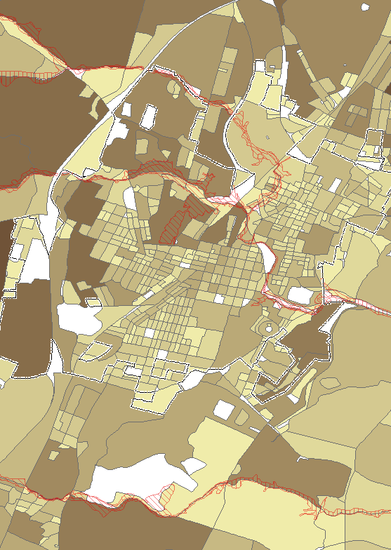

Building Exposure in Floodplain - User Defined Facilities (UDF)
Only the User Defined Facilities that are in the 1% annual chance flood zone were imported into the Hazus-MH Flood Model. Before the UDF structures were imported into Hazus-MH to execute the Flood Model, the site-specific data was further refined by spatially adjusting the parcel centroids to building structures using E-911 addressable sites, building footprints, leaf-off aerial photography, or other reference layers. In addition to pin-pointing the structures in the flood zone, complete street addresses from the E-911 sites were copied to corresponding records in the UDF. Figure 4 shows a zoomed-in view of the spatially enhanced UDF structures in the flood hazard zone.
Table 3A: Berkeley County Flood Hazard Building Exposure in 1% Annual Chance Floodplain. Data input of choice is User Defined Facilities.
General Occupancy | UDF  Count | Exposure in Floodplain  (Total Replacement Costs using UDF)
Agricultural | 2 | 632,397
Commercial | 613 | 196,804,576
Education | 0 | 0
Government | 0 | 0
Industrial | 1 | 1,889,497
Religious | 0 | 0
Residential | 499 | 80,371,337
TOTAL | 1,115 | 279,697,807

A total of 1,115 buildings at a cost of $279,697,807 are exposed to a 1% annual chance flood event in Berkeley County (Table 3A). The flood loss estimates are calculated from the subset of building inventory modeled in Hazus as User Defined Facilities, or site-specific points. During the flood model runs the flood damage is estimated in percent and is weighted by the area of inundation at a given water depth for an individual structure. Refer to Table 8 to view the estimated building damages resulting from the Flood Model.
Table 3B: Martinsburg Flood Hazard Building Exposure in 1% Annual Chance Floodplain. Data input of choice is User Defined Facilities.
General Occupancy | UDF  Count | Exposure in Floodplain  (Total Replacement Costs using UDF)
Agricultural | 0 | 0
Commercial | 14 | 6,913,630
Education | 0 | 0
Government | 0 | 0
Industrial | 1 | 1,889,497
Religious | 0 | 0
Residential | 30 | 6,503,482
TOTAL | 45 | 15,306,609
A total of 45 buildings at a cost of $15,306,609 are exposed to a 1% annual chance flood event in Martinsburg (Table 3B). Refer to Table 8 to view the estimated building damages resulting from the Flood Model.

Figure 4: Zoomed-in View of Spatially Enhanced UDF Structures in Flood Zone
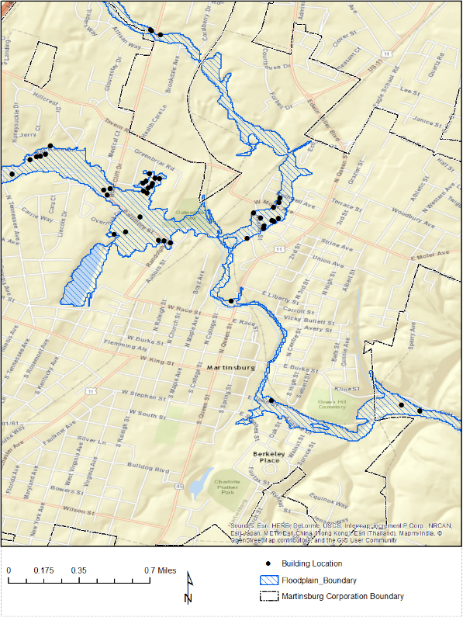

Inventory of Facilities and Community Assets

Essential facilities, critical facilities, and community assets were compiled from various GIS stewards and should be validated with the local communities. Replacement costs were not computed for facilities and community assets for this study. If replacement costs of non-profit buildings are unavailable, then costs may be obtained from:
• Various websites for some facilities
• Insurance records for individual buildings
• Calculated from square footage by using RS Means replacement

Essential Facilities
Essential facilities are defined as those that are vital to the county in the event of a hazard. These include police departments, fire stations, schools, health care facilities, and emergency service zones. The WV DHSEM compiles essential facilities from various local, state, and federal data sources.

Table 4: Essential Facilities
Category | Number of Facilities
Police Stations | 3
Fire Stations | 12
Emergency Service Centers | 1
Health Care Facilities | 2
Schools | 34
TOTAL | 52

Critical Facilities

Critical facilities are buildings that are deemed economically or socially viable to the county and is a superset of essential facilities. The following critical facilities were inventoried for Berkeley County.

Table 5: Critical Facilities
Category | Number of Facilities | Description
Governmental Facilities | n/a | Essential for the delivery of critical services and crisis management including data and communication centers and key government complexes.
Dams | 9 | Source: USACE
Transportation Systems  - Airports  - Railroads  - Bridges | 5  1  8 | Necessary for transport of people and resources including airports, highways, railways. Source: GNIS
Lifeline Utility Systems  - Wastewater Treatment Plants  - Potable Water Systems  - Communication Facilities  - Electric Substations  - Electric Power Facilities  - Natural Gas Facilities | 45  n/a  n/a  7  0  n/a | Vital to public health and safety including potable water, wastewater, oil, natural gas, electric power, and communication systems.
Hazardous Material Facilities | 16 | Involved in the production, storage, and/or transport of corrosives, explosives, flammable materials, radioactive materials, and toxins.
TOTAL | 91

Community Assets
The Berkeley County Mitigation Planning team may identify facilities that are significant to the county; for example, historic landmarks or significant tourist attractions. These facilities or structures are referred to as community assets.
Table 6: Community Assets
Category | Number of Facilities | Notes
Churches | 76 | GNIS
Government Office | n/a
Hazmat Non Facility | n/a
Mobile Home and Campground | n/a
Polling Place | n/a
Emergency Shelter | n/a
Water Tower | n/a
Poultry Slaughtering Stations | n/a
TOTAL | 76

Inventory of Mitigated Properties
Both FEMA and WVDHSEM have worked together to identify buyouts of repetitive flood properties since the inception of FEMA HMA grant programs during the past two decades. Berkeley County has a total of 39 mitigated properties.
Table 7: Mitigated Properties
Category | Mitigated Properties
Martinsburg | 0
Unincorporated | 39
TOTAL | 39

Flood Layer Inputs for Flood Model
Important flood layers for the Flood Model include the 1% annual chance flood hazard area and water depth grid.

1% Annual Chance Flood Hazard Area
The 1% annual chance floodplain in Berkeley County was used to run all the flood model scenarios. The flood hazard area was downloaded from FEMA’s National Flood hazard Layer (NFHL) digital database.

Water Depth Grid
A water depth grid was required to estimate the percentage of physical damage to a structure weighted by the area of inundation at a given depth. The Hazus Enhanced Quick Look tool was used to generate a depth grid for the flood analysis based on the FEMA National Flood Hazard Layer and the digital elevation model at 1/3 arc-second (approximately 10 m) resolution downloaded from the USGS National Elevation Dataset (NED). Although certain counties in West Virginia may have more accurate depth grids generated from HEC-RAS computer modeling software for the Approximate A Zones, these HEC-RAS depth grids were not available for Berkeley County.
Figure 5: Zoomed-in View of Water Depth Grid. Overlain with UDF individual building structures
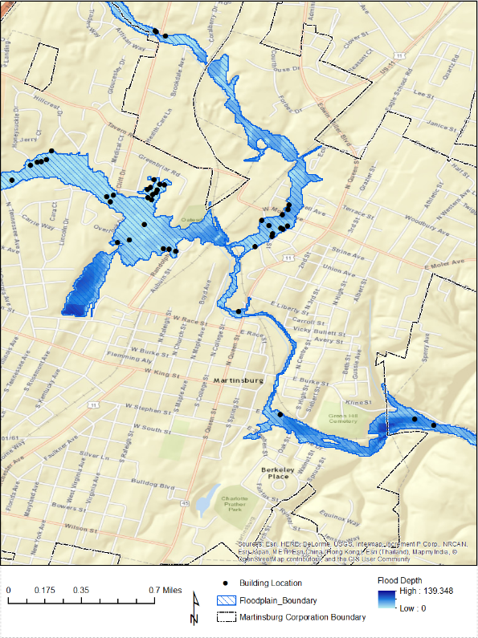
The depth grid range for Berkeley County is from 0 to 139 feet.

Riverine Flood Hazards Analysis
Riverine flooding is the number one natural hazard risk in West Virginia. Riverine floodplains range from narrow, confined channels in the steep valleys of hilly and mountainous areas, to wide flat areas in the Plains States and low-lying coastal regions. The volume of water in the floodplain is a function of the size of the contributing watershed and topographic characteristics such as watershed shape and slope, and climatic and land-use characteristics.
Both Hazus-MH and GIS software were used to model flood building damages, debris estimations, and the number of shelters required for the displaced population. Below are the tables and maps from running the Flood Model for a 1% annual chance flood event. Hazus-MH loss estimates may be impacted by certain assumptions and process variances made in this flood risk analysis. The Berkeley County analysis used Hazus Version 2.2 and the population counts were derived from the 2010 Census. During the flood model runs the flood damage is estimated in percent and is weighted by the area of inundation at a given depth for a given census block (GBS input) or user-defined structure (UDF input).

Riverine 1% Flood Building Damages
Buildings in Berkeley County are vulnerable to flooding from the 1% Riverine Flood (also known as the 100-year flood) and the cost to rebuild may have significant consequences to the community. Hazus-MH estimated the 1%-annual-chance flood would physically damage 1,002 buildings at a replacement cost of 103 million dollars for Berkeley County. In the Martinsburg community the Flood Model estimated damage to 37 buildings at a replacement cost of 1.5 million dollars.
The flood loss estimates for damaged buildings by community and occupancy class are listed in Table 8. Table 8 also provides the percent loss ratios (Total Building Loss / Total Building Exposure) for the county and jurisdictions. The loss ratios were computed by dividing the Total Building Loss (Table 8) by the Total Building Exposure (Table 2A). Commercial properties have the highest loss ratio of 6.7% for Berkeley County, and industrial properties have the highest loss ratio of 1.4% for the Martinsburg community.
The structure in the flood hazard zone with the highest building loss is a commercial property valued at 947 thousand dollars located at 100 Exchange Place, Martinsburg, WV 25404. The Hazus estimated loss for this property is 431 thousand dollars. Table 9 lists a sample of five individual damaged structures in the county based on building losses.
Table 10 lists all the buildings, essential facilities, critical facilities, and community assets damaged in a 1% annual chance flood event. Figures 6A and 6B are maps of the flood damaged buildings in Berkeley County and the Martinsburg community. A large-format county map of the flood damaged buildings is provided with this report. Figures 7 and 8 are flood maps of facilities /community assets and mitigated properties, respectively.
3D Flood Risk Visualization: A key aspect of Risk Assessment and Mitigation is effective communication of hazards. As part of the Flood Risk Assessment for Berkeley County, 3D map products were created in order to help convey the impact of the 1% annual chance flood on structures in the floodplain. See Appendix C for sample maps and additional information.
Table 8: Berkeley County Riverine Floodplain (1% Flood) Related Losses
Classification | Number of Buildings Damaged | Total Building Loss ($) | Total Building Exposure in Jurisdiction | Loss Ratio
Berkeley County (including all jurisdictions)
Residential | 400 | 20,439,548 | 7,233,756,128 | 0.28%
Commercial | 599 | 82,092,330 | 1,232,221,195 | 6.66%
Industrial | 1 | 70,570 | 143,949,150 | 0.05%
Agricultural | 2 | 396,336 | 7,354,680 | 5.39%
Religious | 0 | 0 | 4,615,104 | 0.00%
Government | 0 | 0 | 249,979 | 0.00%
Education | 0 | 0 | 4,847,398 | 0.00%
TOTAL | 1,002 | $102,998,784 | $8,625,459,000
Martinsburg
Residential | 24 | 549,236 | $1,167,904,000 | 0.05%
Commercial | 12 | 608,985 | $199,490,922 | 0.31%
Industrial | 1 | 301,260 | $22,164,947 | 1.36%
Agricultural | 0 | 0 | $0 | 0.00%
Religious | 0 | 0 | $2,307,552 | 0.00%
Government | 0 | 0 | $0 | 0.00%
Education | 0 | 0 | $0 | 0.00%
TOTAL | 37 | $1,459,481 | $1,391,867,421

Table 9: High Potential Loss Structures
# | E-911 Street Address | City | Parcel ID | Building Type | Building Loss¹
Building 1 | Exchange PL | Martinsburg | 06 10036700000000 | Commercial | $430,813
Building 2 | 442 Slim LN | Falling Waters | 02 11005800000000 | Commercial | $346,365
Building 3 | 309 Temple DR | Falling Waters | 02 3G009400000000 | Commercial | $329,622
Building 4 | WR Caskey Dr | Martinsburg | 08 8001300000000 | Residential | $281,839
Building 5 | 197 Rodeo Dr | Martinsburg | 04 37M001300000000 | Residential | $261,354
¹ Building Content Loss often exceeds Building Loss.
Table 10: Buildings, Essential Facilities, Critical Facilities, and Community Assets Damaged (1% Flood)
Category | Building Inventory | Essential Facilities | Critical  Facilities | Community  Facilities | Total  Structures
Martinsburg | 37 | 0 | - | 0 | 37
Unincorporated | 965 | 0 | - | 0 | 965
TOTAL | 1,002 | 0 | - | 0 | 1,002

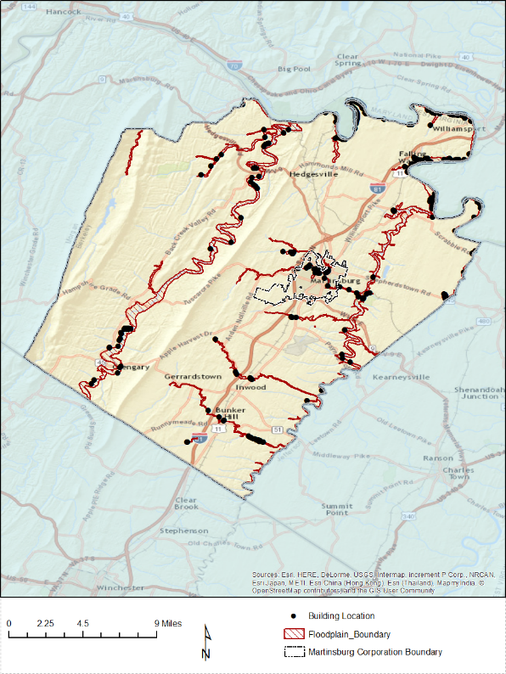
Figure 6A: Berkeley County (1% Flood) Damaged Building Losses

Figure 6B: Martinsburg Community (1% Flood) Damaged Building Losses
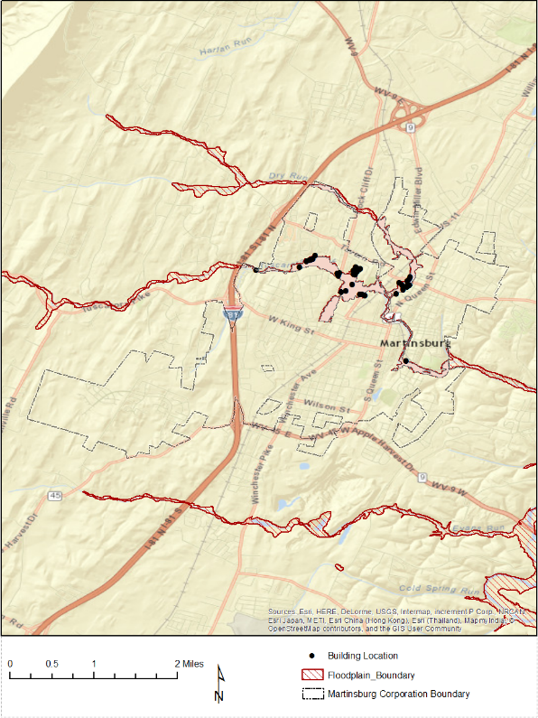

Figure 7: Facilities and Community Assets in 1% Annual Chance Floodplain
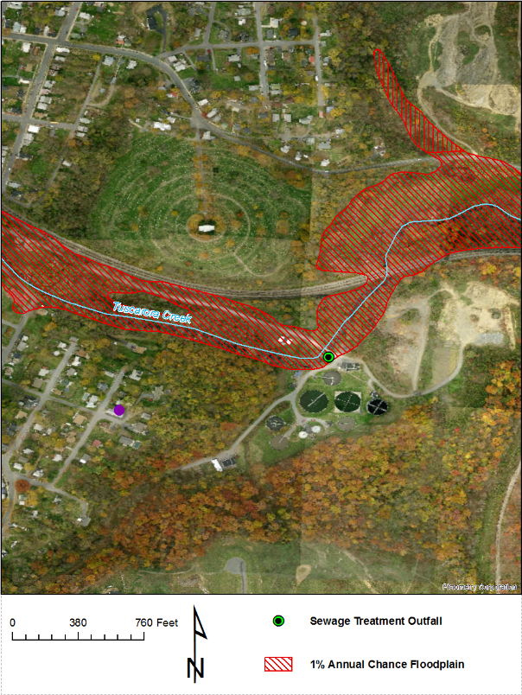

Figure 8: Mitigated or Buyout Properties in Berkeley County
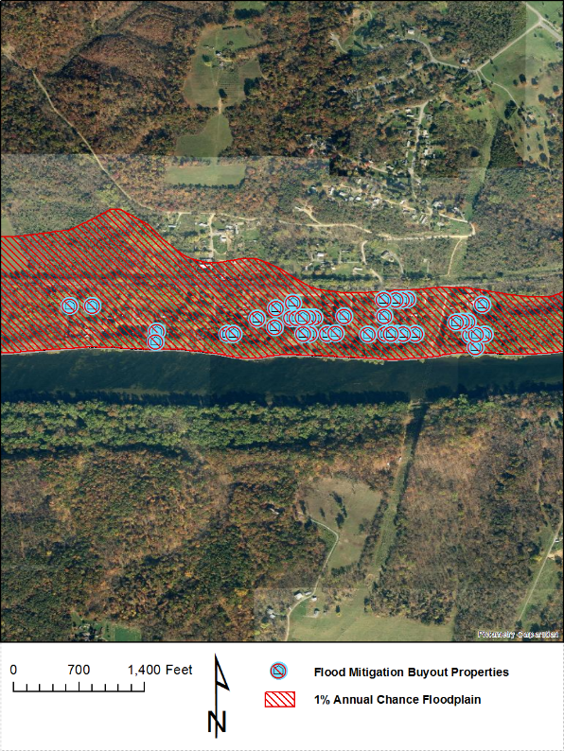

Riverine 1% Flood Debris Generation
Debris disposal can be a significant issue following floods. The Hazus Flood Model estimates debris from building damage during floods, including building finishes, and structural components. The physical damage estimates are not made for building contents, or for bridges or other lifelines.
The Hazus Flood Model debris estimation methodology determines the expected amounts of debris generated at various depths of water and reported at the census block level. Output from this module is the debris weight (in tons). The classes of debris are defined as follows: (1) building finishes (carpeting, dry wall, insulation, etc.), (2) structural components (wood, brick, etc.) and (3) foundation materials (concrete slab, concrete block, rebar, etc.). This distinction is made because of the different types of material handling equipment required to handle the debris. For more information about the Hazus Flood Model debris estimation methodology refer to the Hazus-MH Technical Manual.
The Flood Model estimates that a total of 13,555 tons of debris will be generated. Of the total amount, Finishes comprises 24% of the total, Structure comprises 35% of the total. If the debris tonnage is converted into an estimated number of truckloads, it will require 542 truckloads (@25 tons/truck) to remove the debris generated by the flood. The results are mapped in Figure 9.

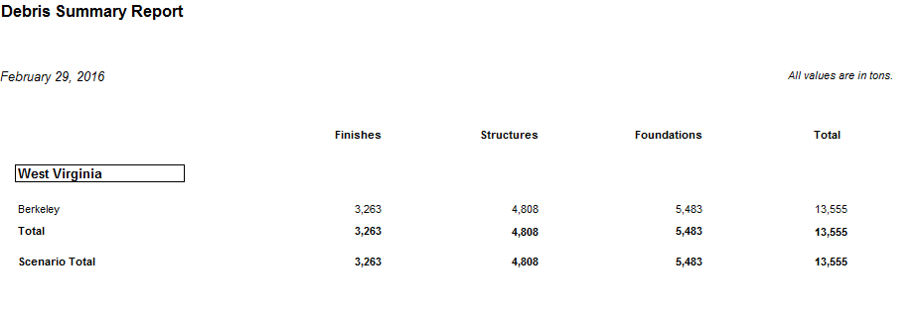

As can be expected, the results of the debris flood model reflect that in the event of a 1% annual chance flood, emergency response officials will need to target resources for removing debris along the flooded waterways in proximity to populated places. Refer to the debris map for more specific information and for mitigation planning.

Riverine 1% Flood Shelter Requirements
A significant part of any planning scenario is to estimate the number of individuals who will need to be sheltered in the short-term. The direct social loss of the displaced population is based on the inundation area and depth of flooding. Flood sheltering needs are based on the displaced population, not the damage state of the structure.
The Hazus-MH Flood Model determines the number of individuals likely to use government-provided short-term shelters through determining the number of displaced households as a result of the flooding. To determine how many of those households and the corresponding number of individuals will seek shelter in government-provided shelters the number is modified by factors accounting for income and again by factors accounting for age. For more information about the Hazus Flood Model shelter estimation methodology refer to the Hazus-MH Technical Manual.
Hazus 2.2 Report: For Berkeley County, displaced households represent 3,038 individuals, of which 1,496 will require short term publicly provided shelter. The results are mapped in Figure 10.
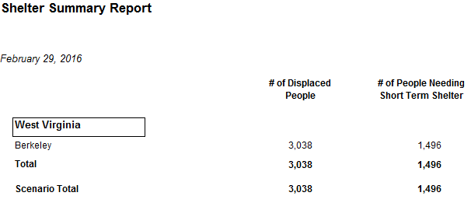

The results of the shelters requirements model reflect that in the event of a 1% annual chance flood, emergency response officials will need to organize shelters near the flooded communities. Refer to the flood shelter requirements map for more specific information and for planning temporary housing needs.

Figure 9: Riverine 1% Flood Debris Weight (Tons)
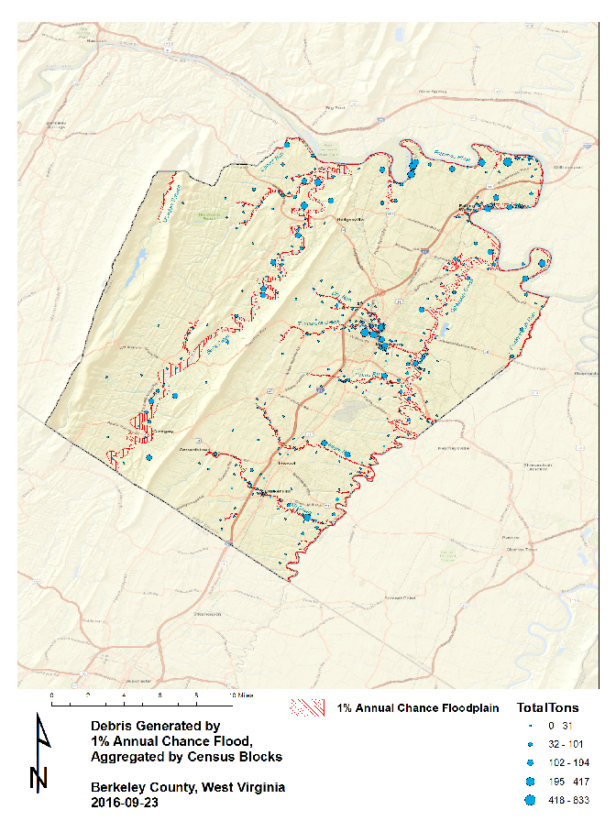

Figure 10: Riverine 1% Flood Shelter Requirements
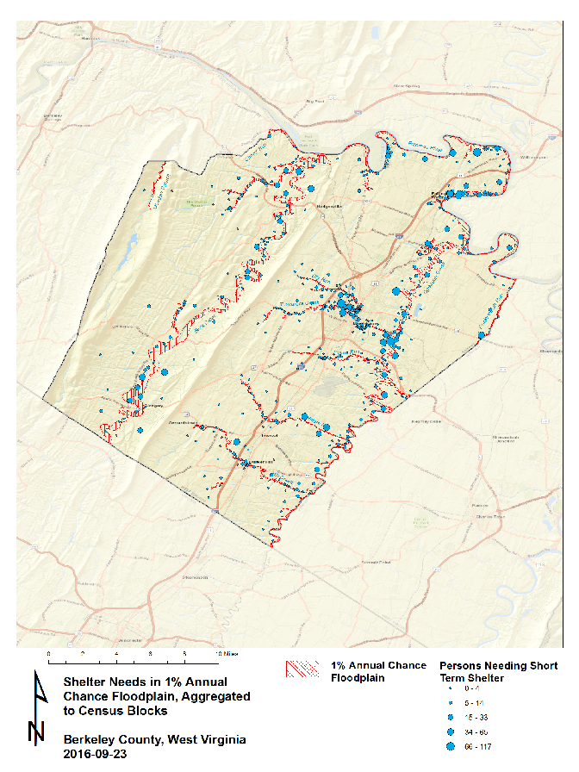

Data Deliverables to County
In addition to this report, the following maps and GIS data layers are available to the counties.

Maps
- Building Exposure
- Physical damage map of buildings and facilities (large size)
- Debris map
- Population Displacement / Shelter map
- Select 3D maps (if building footprints available)
- Miscellaneous maps

GIS Data
- GIS parcel polygons
- E-911 Addressable Structures
- Building Inventory
- UDF Floodplain Structures
- Essential Facilities
- Critical Facilities
- Community Assets
- Mitigated Properties
- Hazus-MH .hpr files (available on request)

Integration of County Flood Risk Results in the State Hazard Mitigation Plan
Results of the county flood risk assessment will be used to update the 2018 State Hazard Mitigation Plan and the Risk MAP View of the WV Flood Tool (www.mapWV.gov/Flood). Table 11 lists the flood risk data layers involved in integrating county flood risk studies to regional and state levels.
Figure 11: Hazus Level 1 Food Risk Layers in WV Flood Tool
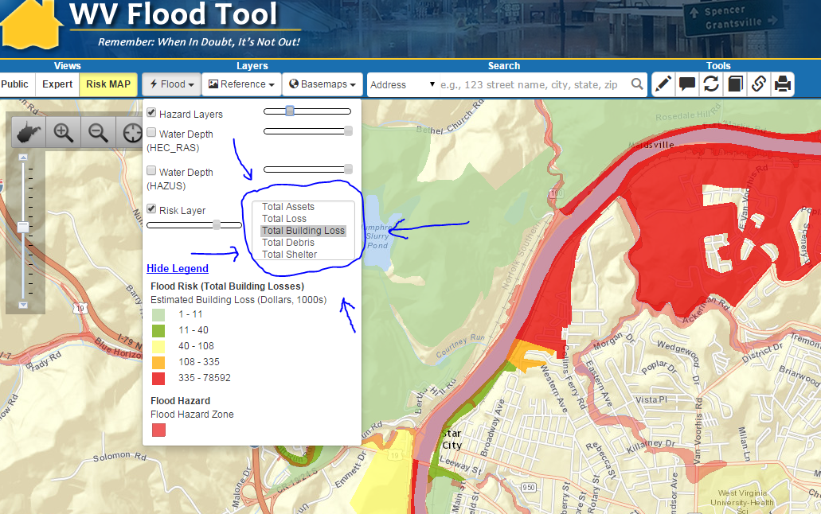

Table 11: State Level Integration of Food Risk Data. The following hazard risk information from counties can be integrated at the regional and state levels for the State Hazard Mitigation Plan. The boldfaced loss estimates are currently in the WV Flood Tool and based on a statewide Hazus Level 1 analysis performed several years ago.

Flood Risk Data | Inventory Type | Spatial Representation
** Flood Model INPUTS **
Total Assets Exposed: Number and exposure ($) of all buildings | Building Inventory | Parcel Centroids or Census Tracts/Blocks
Floodplain Exposure: Number and exposure of buildings located in the Special Flood Hazard Area (SFHA) | UDF | Parcel centroids can be spatially adjusted with E-911 addressable structures
Facilities Exposure: Essential Facilities, Critical Facilities, Community Assets | GIS Infrastructure Databases | Usually Points
Mitigated Properties: (shown currently in Expert View of WV Flood Tool) | Mitigated Properties | Polygons
Water Depth Grid | - Hazus-generated (EQL)  - Advisory Flood Height  - Detailed Flood Zone | Raster
Flood Hazard Area | DFIRMs | Polygons
** Flood Model OUTPUTS **
Total Loss: Number and value ($) of Buildings and Contents damaged in Hazus Level 2 analysis | UDF & GBS | - Points  - Census Tracts/Blocks  - Watersheds
Total Building Loss: Number and value ($) of damaged buildings in Hazus Level 2 analysis.  Loss Ratios as calculated from the Hazus Analysis | UDF & GBS | - Points  - Census Tracts/Blocks  - Watersheds
Total Debris costs ($) | GBS | Census Tracts/Blocks
Total Shelter: People requiring shelter | GBS | Census Tracts/Blocks

Appendix A: Building Inventory Processing
Table A-1: CAMA Records Query of February 2016
CAMA Field | Value
County ID | 2
Name | Berkeley
Appraised Land Value | 2,450,724,700
Appraised Building Value | 5,432,036,000
Appraised Total Value | 7,882,760,700
Total Unique Parcel Records | 59,886
Appraised Bldg > 0 | 41,714
Table A-2: Building Inventory Processing performed on 2015 data
File Type | Count | Notes
CAMA Records (attributes) | 54,650 | CAMA records are reduced to a single, unique primary property record
Improved CAMA Records  (attributes) | 44,650 | CAMA codes transformed to values recognized by Hazus. For Berkeley County the source CAMA data included 54,650 records. The destination data – Improvements records included 44,650 records. This means that that there were 10,000 failed records and research by Polis showed that these included records without DWELVAL, COMVAL and OBYVAL values. It also included records with LUC values (100, 114, 123, 200, 300, 600, 601 604,700) for vacant and exempt lands which were deemed inappropriate for the desired modeling purposes.
Assessor Parcels  (parcel polygons) | 53,061 | GIS parcel polygon file provided by county and converted to parcel centroid points. Total parcel polygons equals 53,061.
Building Inventory  (parcel centroids + attributes) | 39,219 | Join between parcel centroid points and Improved CAMA records yielded 39,219 building points
CAMA - parcel match rate | 88% | Building Inventory (39,219) divided by Improved CAMA record attributes (44,650) = 88%

Table A-3: E-911 Addressable Structures
File Type | Count | Notes
Addressable Sites | 49,296 | Addressable structures for Berkeley County from Statewide Addressing and Mapping System (SAMS).
E-911 – parcel match rate | 80% | Parcel-centroid building inventory (39,219) divided by Addressable sites (49,296) = 80%

Appendix B: Work Flow Diagram for Flood Analysis

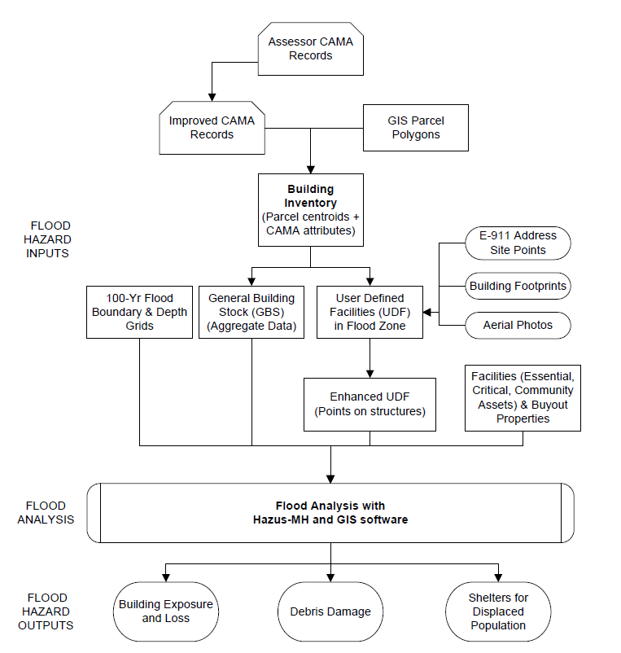

Appendix C: Data Gap Analysis

The spatial “framework” base layers for Berkeley County are satisfactory. The spatial E-911 addresses for Morgan County are not accurate or complete and should be prioritized for future data improvement efforts. In addition, the aerial imagery for Morgan County is more than five years old and thus should be updated. It would also be beneficial if Morgan County had building footprints to generate photorealistic 3D flood visualization maps. More coordination is required with local and state emergency offices to identify available geodatabases for essential facilities, critical facilities, and community assets.

Table C-1: Data Gap Analysis for Region 9 PDC Counties
DATA LAYERS | Berkeley County | Morgan County | Jefferson County
IAS/CAMA Tables | 2014 | 2015 | 2015
Tax Parcels | 2015 | 2016 | 2016
E-911 | 2013 | 2015 (FAIL) | 2016
Building Footprints | 2008 | None | 2015
Aerial Imagery | 2016 | 2010 (POOR) | 2016
Water Depth Grid | No Advisory Flood Heights | No Advisory Flood Heights | Advisory Flood Heights available
Elevation | No complete Lidar coverage | No complete Lidar coverage | Complete Lidar Coverage
Critical Infrastructure | Incomplete | Incomplete | Incomplete

Appendix D: Statewide Risk Assessment Objectives

Long-term objectives for risk assessments in West Virginia:

- Establish a communication and training network for exchanging risk assessment information and technical skills among local, state, federal, and other entities. Multi-agency coordination and data exchange among organizations allow for comprehensive risk assessment for communities. A multi-hazard Risk Assessment Lifecycle should be applied to regularly evolving risk assessment studies.
- Exchange the best available risk assessment data among local, state, and federal geo-platforms. Incorporate historical flood data into risk assessment studies. Use online map validation tools for local communities to validate risk assessment data.
- Create a statewide inventory of all buildings and facilities exposed (with replacement costs) in flood hazard, dam/levee failure, and landslide susceptibility zones.
- Create a consistent statewide water depth grid (FEMA Risk MAP Studies + Model-Backed Zone A Studies + FIS conversion / water surface elevations from x-sections of detailed studies) using available high-resolution elevation data for 1% Annual Chance Floods. The depth grids are important for (1) water depth visualization in the WV Flood Tool and for (2) calculating physical building damage costs using Hazus-MH flood loss software.

- Perform county-level risk assessments for 55 counties:
  - Flood risk assessments for riverine 1% annual chance flood based on Hazus-MH flood loss estimates using water depth and flood inundation area inputs
    - Physical Building Damage Assessments: Create a statewide inventory of structures at risk to physical building damage
    - Flood Debris Generated (debris removal)
    - Flood Shelter Requirements (temporary housing)
  - Dam and levee failure flood inundation assessments (USACE led)
    - Prioritize dam inspections in accordance with risk and those that do not have an EAP digitized
    - Integrate Dam and Levee safety action class (class 1 - 5) for every USACE dam and levee into HIRA and THIRA.
    - Produce documentaries about/on aging dam structures around endangered communities (Develop a list of potential dams on which to focus).
    - Create a task force to address levee safety in West Virginia (Coordination between NRCS and USACE on levee safety issues).
  - Landslide susceptibility studies
    - Generate county-level landslide risk maps and structures at risk
    - With partners create a statewide landslide incident inventory

- Review and identify data gaps for key GIS data layers for risk assessment studies (parcels, addresses, imagery, elevation, flood layers, critical infrastructure, etc.). Provide recommendations to the appropriate organizations to improve data management and governance.

- Publish risk assessment reports for local and state hazard mitigation plans.
- Publish input and output model data associated with risk assessments on state and federal geo-platforms.
- Upload 2D/3D flood risk and dam failure maps to the RiskMAP View of the WV Flood Tool (www.mapWV.gov/Flood). Provide a web planning tool to estimate physical building damage, debris removal, and temporary shelter needs. This flood risk assessment information permits communities or individual property owners to decide how to allocate resources for the most effective and efficient response and recovery, and to prioritize mitigation measures to reduce future loss.

Appendix E: Multi-Hazard Risk Assessment Lifecycle

Multi-Hazard Risk Assessment Lifecycle for West Virginia:

- Data Management and Governance
  - Govern organizations and procedures to develop statewide data layers and web services (parcels, addresses, imagery, elevation, levee/dams, water depth grids, critical infrastructure, etc.). Periodically publish WV Framework Report about status of State’s Spatial Data Infrastructure.
  - Manage data flows of key local data sets from county assessor offices (parcels and CAMA) and E-911 offices (addresses).
  - Oversee timely integration of local data (parcels, E-911) to state-level geodatabases by data stewards.
  - Manage statewide GIS parcel integration with CAMA data extracts and site addresses for Building Inventory and other risk assessment products.
  - Coordinate development of landslide hazard occurrence database with appropriate agencies.
  - Determine feasibility of GIS data development projects through State Hazard Mitigation Office.
  - Govern risk assessment studies through State Hazard Mitigation Office and Regional Planning and Development Councils.
- Coordination
  - Identify key stakeholders (geographers, geologists, engineers, planners, soil scientists, GIS specialists, decision makers, private consultants) at county, state, and federal agencies and other organizations. Maintain an experts’ knowledge database.
  - Set up communication services: email listserv, web portal, etc.
  - Organize and conduct risk assessment training.
  - Coordinate closely data and project priorities with federal (FEMA, USACE, USGS, NRCS, EPA), state (WV DHSEM, WV OGC, WV Tax), region (PDCs), and local (assessor, E-911) offices. Leverage stakeholders to prioritize and rectify critical data gaps.
  - Continuously review and amend Hazard Mitigation Grant applications to development consistent and comprehensive risk assessment products at the local level which in turn can be integrated into regional and statewide assessments.
  - Encourage regions to begin the actual process of updating their hazard mitigation plans a minimum of one year in advance, preferably two years before the expiration date.
- Data Collection
  - Collect data inputs for risk assessment studies.
  - Review historical flood data resources.
  - Utilize online web viewers for collecting and validating building inventory and critical infrastructure data sets.
- Data Processing
  - Create general and specific building inventories (total assets exposed) inputs.
  - Develop accurate water depth grids and flood inundation boundaries.
- Analysis
  - Execute Flood Risk Models for each county and community.
    - Flood Risk Models using Hazus-MH software
      - Building Damage Flood Model
      - Debris Model
      - Shelter Model
    - Dam/Levee Failure Flood Inundation Models
  - Execute Geological Hazard Models for each county and community.
    - Landslide Susceptibility
    - Karst Hazards
- Interpret and Publish Results
  - Publish supplemental risk assessment reports (flood, landslides, etc.) for each county.
  - Publish results to state and federal geo-platforms: WV Flood Tool, FEMA RiskMAP, state and federal data clearinghouses, etc.
  - Integrate county risk assessments to regional and state level.
  - Identify and prioritize GIS data and risk assessment strategies at county, region, and state levels.
- Inform Local Decisions
  - Provide knowledge transfer services via reports, data exchange, meetings, conferences, etc.
  - Provide regions with the technical skills to perform their own risk assessment analysis studies so don’t have to depend on outside consultants.

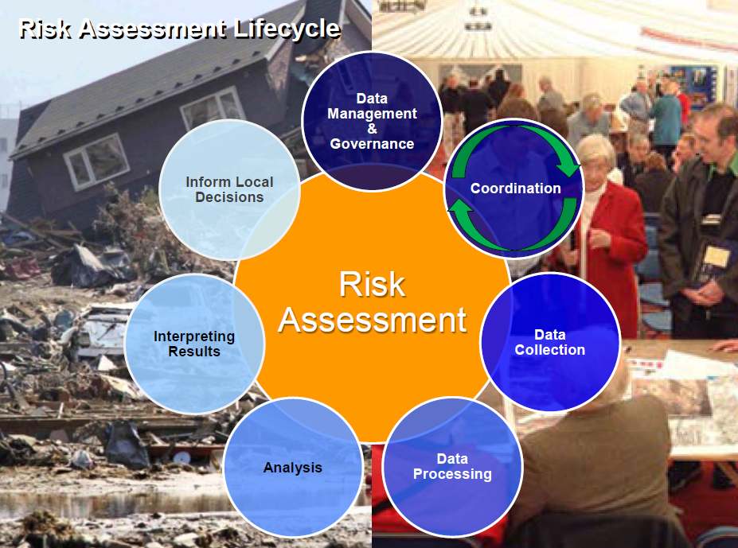
Figure E-1: Multi-Hazard Risk Assessment Lifecycle. Courtesy of Cynthia McCoy, FEMA Region 10.

Appendix F: Statewide Spatial Integration of Surface Tax Parcels

The surface tax GIS parcels are an integral part multi-hazard risk assessments since the GIS parcels combined with building characteristics of the assessment data generate the estimated building replacement costs. E-911 addresses can be joined to the tax parcels to further pin-point the structure’s site location and physical address.
Tax assessor data is formatted in ArcGIS software before updating the GBS and UDF inventories. The primary spatial field should be addresses instead of parcel polygon centroids unless a parcel has multiple addresses such as a trailer court.

Figure F-1: Statewide Spatial Integration of Surface Tax GIS Parcels for Agency and Public Benefit.
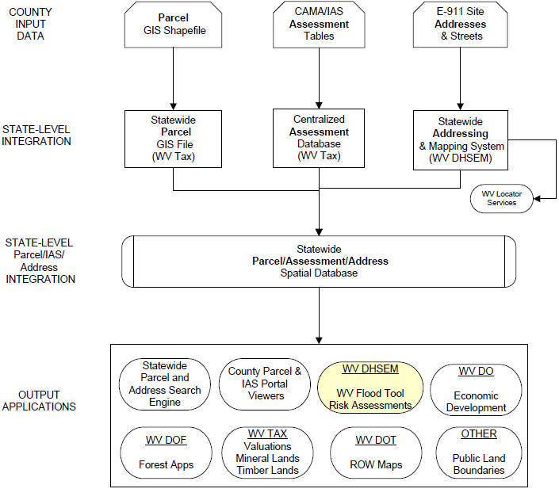

Appendix G: 3D Flood Risk Visualization
3D map products were created for a test location in Berkeley County in order to enhance the communication of flood risk to structures in the 1% annual chance floodplain.
Figure G-1 shows the results of a query in the West Virginia Flood Tool (WV Flood Tool) for the sample site on Baltimore Street in Martinsburg. The ground elevation and 1% annual chance flood Base Flood Elevation (BFE) indicate a depth of at least 1 foot of flood water at the site. How this will affect the building depends on whether or not the foundation is elevated above local BFE, and, if so, by how much.
A Google Earth view of the site is shown in Figure G-2 for reference. Vertical representation is poor and buildings appear flattened or otherwise distorted. The use of solid shapes will reduce this problem.
The 3D rendering in Figure G-3 shows the site structure highlighted in light blue surrounded by the anticipated depth of the 1% annual chance flood. Affected structures are indicated in red. Attributes for the highlighted structure appear at the bottom of the screen.

Figure G-1: WV Flood Tool information for Sample 3D Site
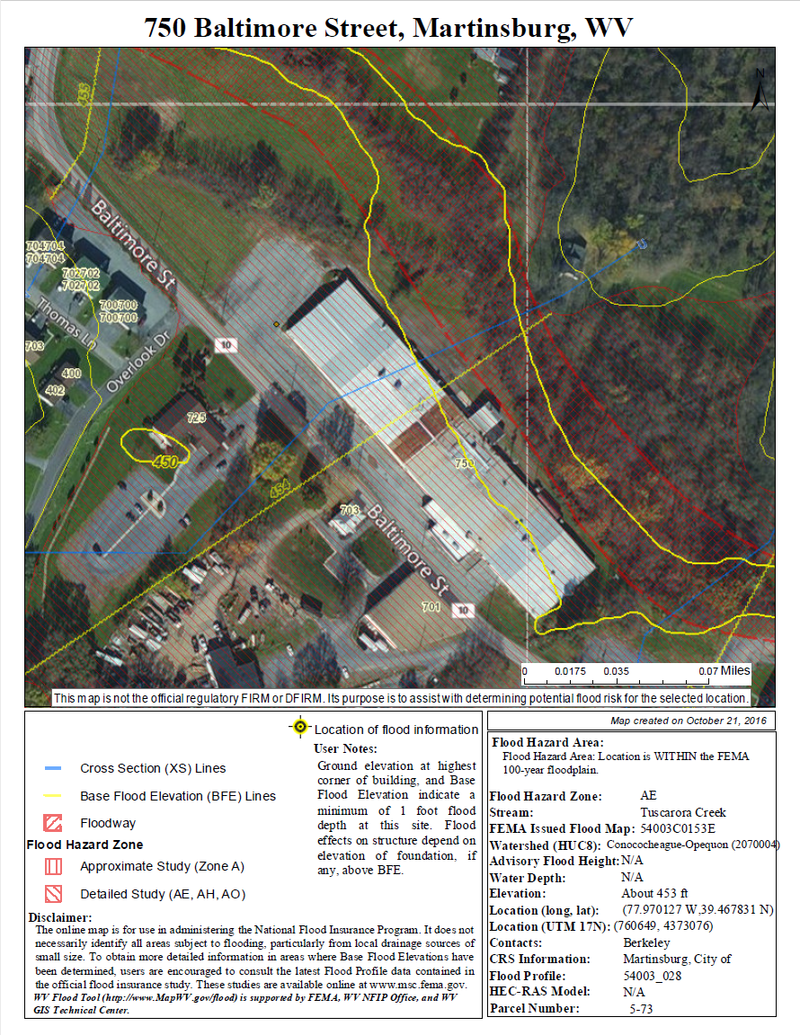

Figure G-2: Google Earth View of Sample 3D Site (Looking northwest)
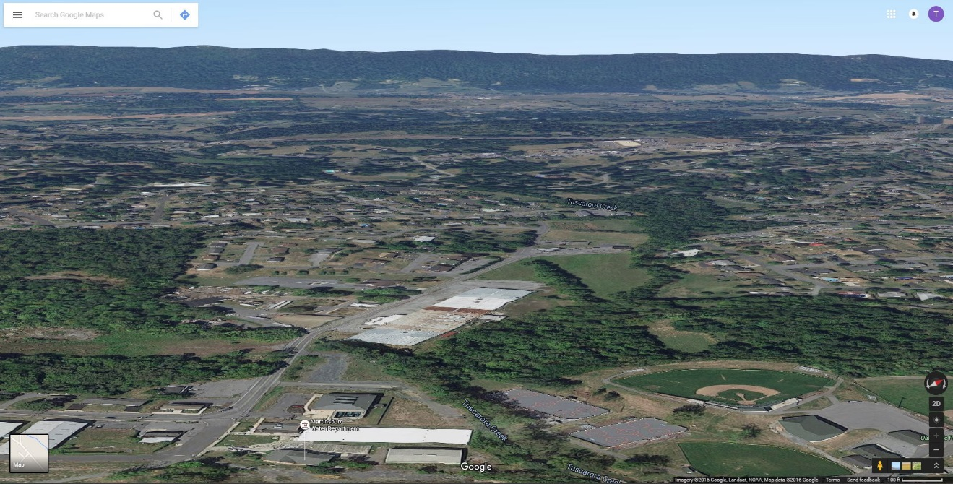

Figure G-3: 3D Rendering Showing Flood Depth and Flooded Structures (Red)
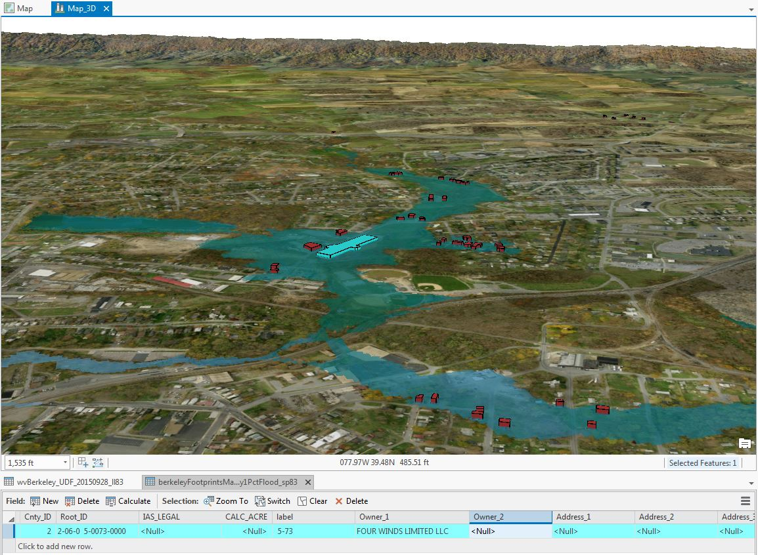

Appendix H: Glossary of Risk Assessment Terminology

1% Annual Chance Flood: A one percent annual chance flood event (a.k.a. 100-year flood) has a one percent (1 in 100) chance of being equaled or exceeded during any given year. The one percent annual chance flood was selected in the early 1970s when the National Flood Insurance Program was tasked with mapping all floodplains in the U.S. It was considered a reasonable balance of protection and cost between the 0.5% (1 in 200) to 0.2% (1 in 500) variable reference used at the time by the U.S. Army Corps of Engineers for floodwater control structure design. The term 100 year (or 5 year or 500 year) refers to the expected frequency of return of a given flood event. The area of inundation associated with a given flood event is called the floodplain (e.g. 1% floodplain, etc.).
Source: The 100 Year Flood Myth, Federal Emergency Management Agency, Region 10, handout.

CAMA/IAS: Computer Assisted Mass Appraisal (CAMA) is the process of using a computer to assist in property tax appraisal and equity evaluation. Administered by the Tax Commissioner, the CAMA system for West Virginia is a centralized Oracle database also known as the Integrated Assessment System (IAS). A number of years ago the State Tax Department purchased real estate mass appraisal software called IAS. This software is installed on the network server in Charleston and is accessed through computers in each County Assessor's Office.

Advisory Flood Heights: The water surface elevation (WSEL), in feet, of the 1% annual chance (100-year) flood at a given location, as determined using hydrology and hydraulics (H&H) analysis and the best available elevation data. Add 5 feet to this value to allow for accuracy issues. This information is currently available for approximately 12% of the West Virginia counties.
http://www.mapwv.gov/flood/content/documents/AFHhandout.pdf

Mitigated Properties: Properties and land parcels located within floodplains that experience frequent flooding and damage due to flood events, may be altered, purchased, or have deed restrictions placed upon them by FEMA, in an effort to prevent loss of life and property damage. Property owners/communities with public lands in floodplains are compensated for their land, and the land usually becomes public green space. ( FEMA link)
(Youtube)

See more flood definitions at http://mapwv.gov/flood/resources.html

