April 25, 2017

Assessor

Address 1

Address 2

email

Dear _________:

The WV GIS Technical Center respectfully requests an updated countywide tax parcel shapefile and recent aerial imagery of ___________**County** to support state-sponsored mapping applications such as the WV Flood Tool ([www.MapWV.gov/flood](http://www.MapWV.gov/flood)) and E-911 Statewide Addressing and Mapping System ([www.mapWV.gov/wvsams](http://www.mapWV.gov/wvsams)). **For these Web map applications your county data is for “viewing only” purposes and will not be redistributed.**

The tax parcels are an important reference layer in the WV Flood Tool that allow home owners, floodplain managers, insurance agents, developers, real estate agents, and local planners to make informed decisions about the degree of flood risk for specific properties. Below are benefits for making your county’s digital parcel files available for the WV Flood Tool:

* Protect property owners
* Avoid unnecessary insurance premiums
* Streamline flood determination process
* More refined flood risk assessments and mitigation plans. All flood-risk derived data layers and map products for community risk assessments will be shared with the local governments for their benefit.
* More info: <http://www.mapwv.gov/flood/content/documents/Parcels_Flyer_2016.pdf>

The WV Flood Tool is recognized by FEMA and the WV Division of Homeland Security and Emergency Management as the principal online tool to make flood determinations in the State. In 2016 the county assessor should have received a parcel data request for the WV Flood Tool from Kevin Sneed, the National Flood Insurance Program Coordinator for West Virginia. To date we have 22 counties that have their parcel data in the WV Flood Tool and 8 counties are currently being added. The parcels are for “viewing only” in the WV Flood Tool and cannot be downloaded or edited.

* + Parcels are now shown on the Flood Tool for the following 30 counties: Parcels are now shown on the Flood Tool for the following 30 counties: **Barbour, Berkeley, Brooke, Cabell, Clay, Fayette, Greenbrier, Hampshire, Hancock, Harrison, Jefferson, Kanawha, Lincoln, Logan (rural tax districts only), Marion, Marshall, Mineral, Monongalia, Morgan, Pendleton, Pocahontas, Putnam, Raleigh, Randolph, Roane, Taylor, Upshur, Wayne, Wetzel and Wood.**

If you would like a signed Data Use Agreement, I have attached a sample document for your review. We already have the parcel boundary file from the State Tax Department so we just need you permission to upload it to the WV Flood Tool. Again, the parcels or other locally acquired data from counties (aerial photography, addresses, contours, etc.) will not be re-distributed without authorization from the data stewards.

Please contact me if you have any questions and thank you for considering this request.

Sincerely,

Kevin Sneed

NFIP Coordinator  
State Capitol Complex

1900 Kanawha Blvd., East

Building 1, Room EB-80

Charleston, WV 25305-0360

Phone (304) 957-2571

Cell (304) 545-2864

Fax (304) 558-5813

## APPENDIX A: PARCEL REQUEST BY STATE NFIP COORDINATOR

June 2, 2016

Jack Hayes  
P.O.Box 2

Middlebourne, WV 26149  
jhayes@assessor.state.wv.us

Dear Mr. Hayes,

The West Virginia Division of Homeland Security and Emergency Management (WVDHSEM), National Flood Insurance Program (NFIP) Section, has teamed up with the West Virginia University Geographic Information Systems (WV GIS) Technical Center to create a free, public program called the WV Flood Tool. This program, created in 2007, is used by state officials, floodplain managers, citizens and others to assess local flood zones and potential flood risks. The WV Flood Tool is ever growing and adapting to improve the functionality for its users.

We invite you to explore the WV Flood Tool (www.mapWV.gov/flood) and its features by following the included instructions.

As you have now seen, the Flood Tool has a variety of capabilities. Yet, information is lacking in some areas. That’s where you come in! We are requesting that you voluntarily provide a digital copy of your parcel data to be incorporated into the Flood Tool. By comparing the data shown at your residence to the data in the example address, you can see the difference that having parcel data makes. This data can be crucial for decision makers. Some of the benefits of having parcel data within the Flood Tool include: determining flood risks to properties, addressing flood insurance requirements, reviewing and determining building sites, and assisting citizens in receiving better insurance rates. Having parcel data built into the Flood Tool has proven to be an invaluable resource in communities where it is available.

Take this example for instance: Someone in your community wants to build a house on their property. The building site is directly in the floodplain and will require extensive work to comply with NFIP regulations. When reviewing the permit, the Floodplain Administrator pulls up the Flood Tool with parcel data. They find that a portion of the land is out of the floodplain. They advise the landowner that by moving the house to a different section of the property unnecessary work and expense can be avoided. The landowner sees the benefit and agrees to change the building site. This not only improved public services for the community, but also reduced the community’s impact on the floodplain, making it safer for current structures in the floodplain and allowing for more development to occur in the future.

Our hope is that by working together and sharing information, we can update the Flood Tool to better equip decision makers at all levels, and improve the services provided to your citizens. Parcel data which is incorporated into the WV Flood Tool is an excellent resource for floodplain management decisions made around the state. Help us to help your community develop more wisely.

Attached you will find the answers to many of the frequently asked questions about sharing your community’s parcel data. If you have further questions, please contact us at 304-957-2571. If you choose to share your parcel data, please call us to discuss the next steps in the process. We thank you for your time and consideration and look forward to hearing from you soon!

Sincerely,

Kevin Sneed

NFIP Coordinator  
State Capitol Complex

1900 Kanawha Blvd., East

Building 1, Room EB-80

Charleston, WV 25305-0360

Phone (304) 957-2571

Cell (304) 545-2864

Fax (304) 558-5813

**Frequently Asked Questions**

**What data is WV DHSEM asking for?**

We are requesting a digital shape file of your parcel data to be added as a layer to the WV Flood Tool.

**How will our parcel data be used?**

Parcel data will used as a GIS layer on the WV Flood Tool to determine what portions of a property are within a Special Flood Hazard Area. It is also used for Flood Risk Assessment and Mitigation purposes.

**If our community charges for tax maps, won’t this give the public that information or free?**

While data does become publicly available online, it is by no means a replacement for the tax maps purchased in your office. The parcel data is not advertised or distributed, and is produced with a disclaimer, which can be found on our Flood Tool. Also, it is important for citizens to understand that this information is for reference only. It may not be current, accurate or complete. The only way to get official parcel/tax information is to contact your office.

**If we share our parcel data, who will have access to the shape files?**

Shape files will be given directly to our contractor, WVU GIS Technical Center, to be added to the Flood Tool. Files will not be re-distributed or shared.

**We want to participate, but we don’t want all of our information out there. Can we limit the details of the data?**

Yes! You can choose to share as much or as little of the data as you want. The most important thing for our purpose is the parcel boundaries and parcel numbers. Some counties choose to include more information, such as name and address. Others choose to limit details. The choice is ultimately yours!

**What if the data isn’t yet digitized?**

No worries! We understand that some areas are still creating digitized versions of their data. If you want to help us out, just let us know when you have the files completed, and we’ll incorporate them then!

**Am I required to share the data?**

No. Sharing your parcel data is voluntary. Though we do urge you to highly consider it! A lack of data impedes public interest, and creates more costly and time-consuming work for floodplain professionals.

**What will parcel data look like on the WV Flood Tool?**

See the attachment for instructions on viewing parcel data on the WV Flood Tool.

## APPENDIX B: LOCAL GIS DATA LAYERS FOR WV FLOOD TOOL

GIS data layers (parcels, addresses, elevation contour lines, building footprints, etc.) produced at the county level are important for statewide mapping applications such as the WV Flood Tool and Statewide Addressing and Mapping System. These local map layers can be integrated into a standardized, state-level GIS database that benefit a range of applications for emergency response, risk assessments, economic development, natural resources, transportation planning, etc. In turn the statewide applications benefit the local officials and citizens who reside in the counties. Below are more detailed descriptions of essential local GIS layers and integration at the state level.

# SURFACE TAX PARCELS

The parcel layer provides building characteristic data for various flood risk products and 3D visualizations to help enhance the understanding of flood risk and its potential impact on communities and individuals. These products also enable communities to take proper mitigation actions to reduce the risk.

See examples below where counties have incorporated their parcels in the WV Flood Tool to display flood risk information and 3D flood visualizations. 

* Berkeley County:  <http://www.mapwv.gov/flood/Map/?v=1&pid=02-04-037M-0020-0000>
* Morgan County:  <http://www.mapwv.gov/flood/Map/?v=0&pid=33-03-0002-0160-0000>
* Logan County:  <https://www.mapwv.gov/flood/map/?v=0&pid=23-04-0071-0009-0000>
* Monongalia County: <https://www.mapwv.gov/flood/map/?v=1&pid=31-05-0019-0046-0000>

The tax parcel centroids and associated building characteristic data (YRBLT, STYLE, STORIES, EXTWALL, GRADE, BSMT, AREASUM) from the Integrated Assessment System, along with the RS Means building construction cost values, are used by Hazus Flood Model software to estimate flood damages to each structure for a riverine 1% annual flood event based on the flood inundation areas and flood water heights.

Importantly, the GIS parcel outlines and assessment records are necessary for counties to conduct detailed flood risk studies for their communities. All flood-risked derived data layers, map products, and reports developed for the WV Flood Tool are available to the local governments for their benefit. Below are examples of flood risk assessment studies for Berkeley and Morgan counties:

* Berkeley County, WV  
  <ftp://ftp.wvgis.wvu.edu/pub/temp/FEMA/FRA/Berkeley_FloodRiskRpt_20161026.pdf>
* Morgan County, WV  
  <ftp://ftp.wvgis.wvu.edu/pub/temp/FEMA/FRA/Morgan_FloodRiskRpt_20161026.pdf>

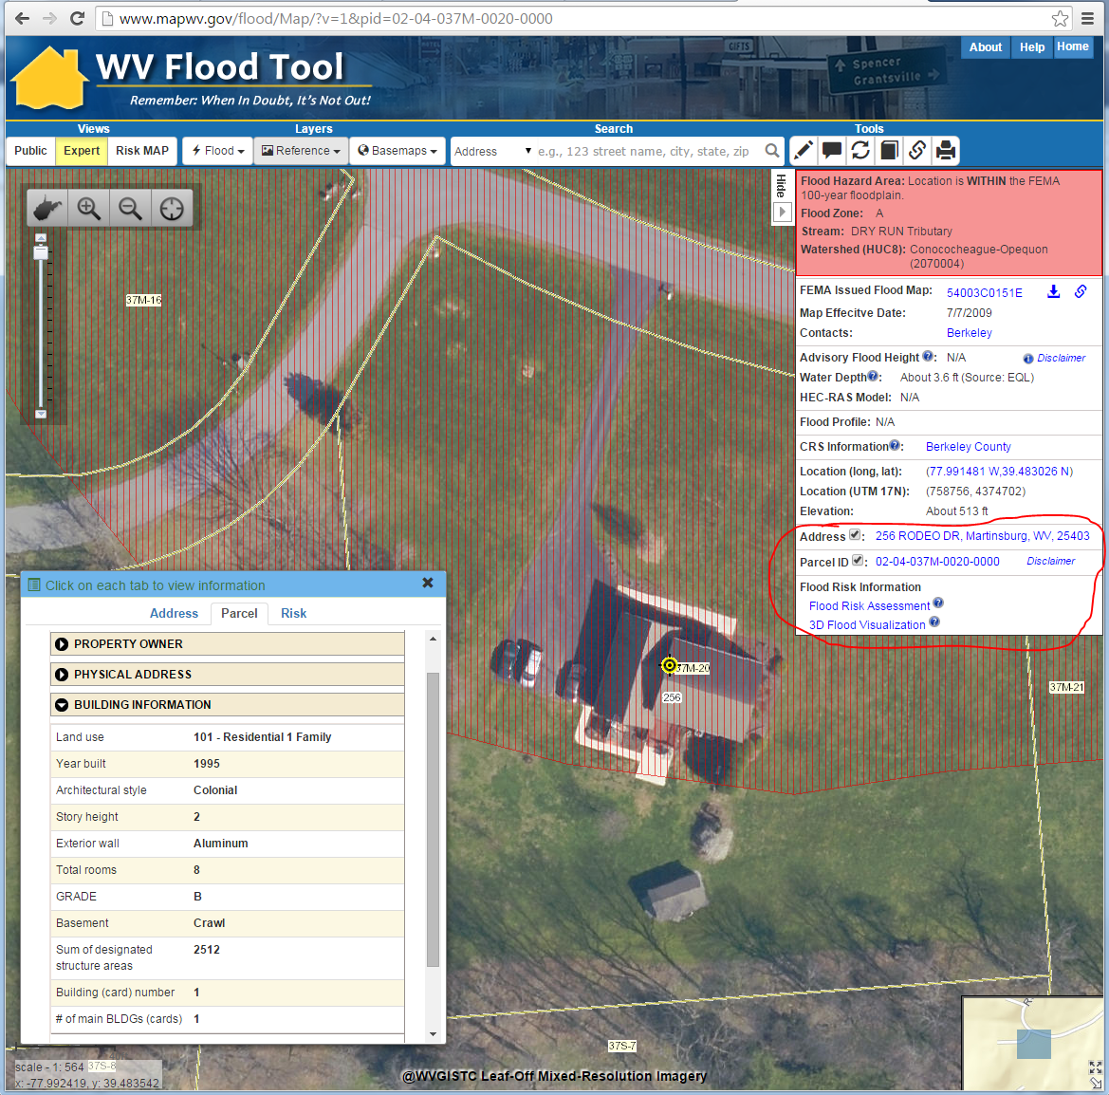

Surface Tax Parcel and Building Information

Web Link: <http://www.mapwv.gov/flood/Map/?v=1&pid=02-04-037M-0020-0000>

**Figure 1.** Example flood determination of home located at 256 Rodeo Drive, Martinsburg, WV, that is within the 1% annual chance (100-year event) floodplain.

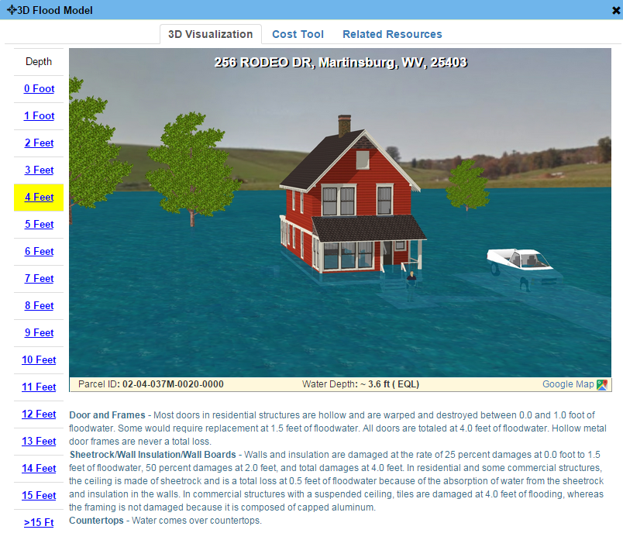

Flood Risk Assessment & Visualization

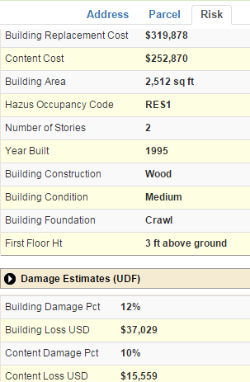

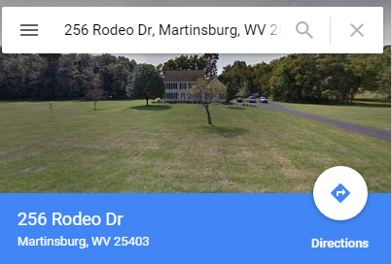

**Figure 2.** Example flood risk assessment information including 3d Flood Visualization for 256 Rodeo Drive.

# AERIAL IMAGERY

Current leaf-off imagery is an important background layer for the WV Flood Tool and other map applications that benefit the citizens of West Virginia. Since the last statewide leaf-off imagery acquisition occurred in 2010 and no future statewide acquisitions are planned for the future, the counties are an important contributor to the imagery web map service.

Presently the best statewide leaf-off imagery web service is the statewide 2010-12 Sheriffs Association imagery updated with more current leaf-off imagery from county sources. To date twenty-six counties have been mosaicked into this statewide imagery web map service. The imagery web service is for viewing only and aerial imagery from county sources is not redistributed without authorization.

Click here to view imagery service:   
<http://services.wvgis.wvu.edu/arcgis/rest/services/ImageryBaseMaps/wv_aerial_photos_mixed_resolutions_wm/MapServer?f=jsapi>

**Figure 3.** Statewide Leaf-Off Imagery mosaic of 2010-12 Sheriffs Association imagery and newer aerial imagery from county sources.

Statewide Leaf-Off Aerial Imagery

Web Map Service

# TOPOGRAPHY (Elevation Contours)

Higher-resolution topography is an important layer for the WV Flood Tool. Various federal, state, and county agencies acquire high-resolution elevation data and make it available for public use. It is recommended that high-resolution elevation data collected meet USGS National Elevation Dataset (NED) and FEMA LiDAR standards according to the minimum Quality Level 2 (QL2) specifications which support 1-foot elevation contour accuracies. LiDAR deliverables should include a hydro-flattened bare-earth digital elevation model (DEM) in which the raster cell size is no greater than 1.0 meter and in accordance with USGS LiDAR Base Specification Guidelines. Specifically, for the WV Flood Tool the high-resolution topographic data is important for:

* More accurate ground elevations represented as contours or elevation value queries
* Improved flood zone delineations, flood water heights, and depth grids
* More accurate flood risk assessments and realistic
* More realistic 3D flood visualizations

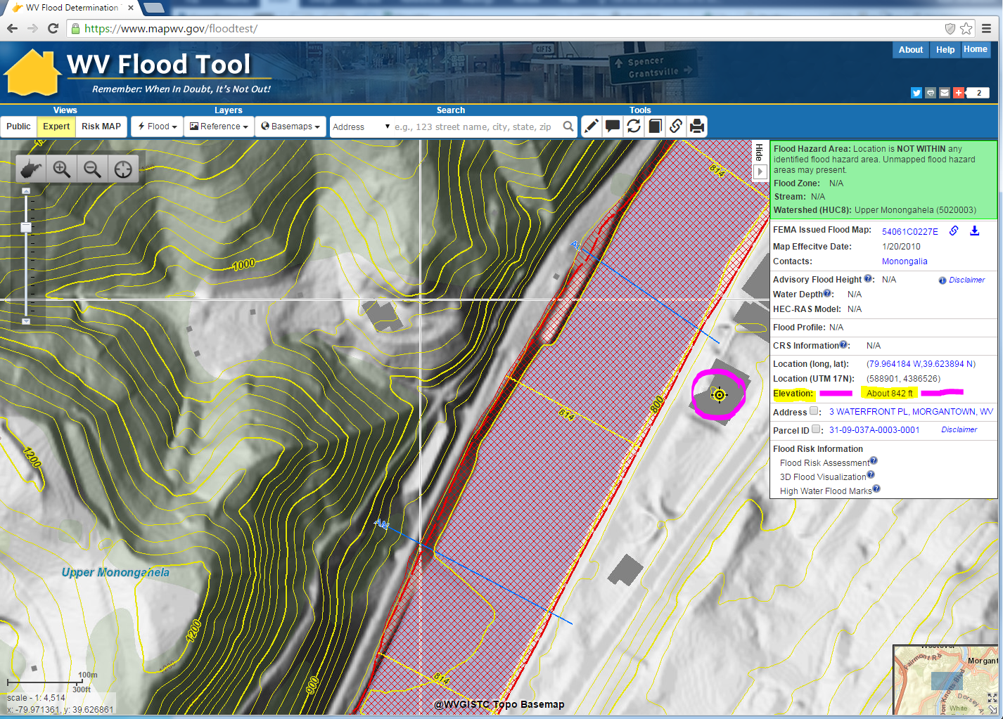

**Figure 4.** Detailed 2-foot elevation contours provided by county for WV Flood Tool.

# BUILDING FOOTPRINTS

The building footprints are an important map layer for generating 3d flood visualizations. The visualizations are incorporated into local mitigation plans required by the Disaster Act of 2000 for communities to receive disaster funds.

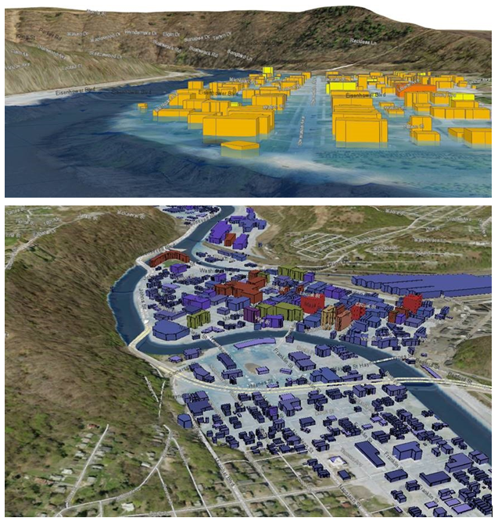

**Figure 5.** Building footprints are useful for creating 3D flood models of communities.

# SITE AND STREET ADDRESSES

The building addresses are maintained by the local E-911 offices and integrated into the statewide addressing and mapping system (SAMS) by the WV Division of Homeland Security and Emergency Management. The addresses provide numerous benefits to include:

* Creating statewide geocoding service for matching addresses to locations (e.g., zoom to address)
* Linking multiple site addresses with other data sources like tax parcels
* Allowing for external links to other applications like Google Maps Street View and Zillow.com
* 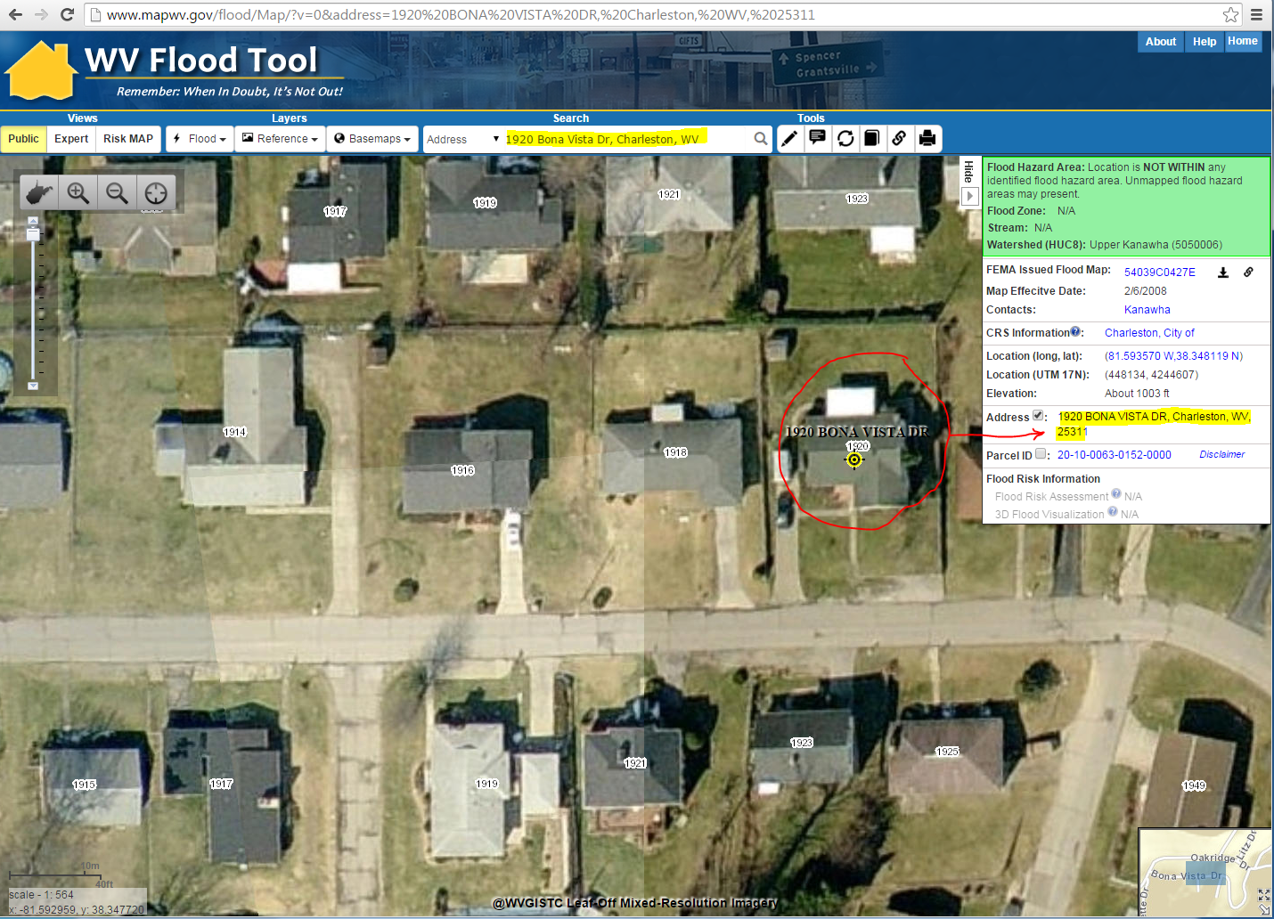Exchanging URL links with others by incorporating the site address in the web address

Building Site Addresses  
Web Link: <http://www.mapwv.gov/flood/Map/?v=0&address=1920%20BONA%20VISTA%20DR,%20Charleston,%20WV,%2025311>

**Figure 6.** Building site address for 1920 Bona Vista Drive, Charleston, WV.