Prepared by:  
  
**WV GIS Technical Center**  
Department of Geology & Geography  
West Virginia University

330 Brooks Hall, PO Box 6300  
Morgantown, WV 26506

Supplement to 2017 Region 9 Planning and Development Council Multi-Hazard Risk Assessment and Mitigation Plan

**October 31, 2016**

Flood Risk aSSESSMENT Report  
Morgan County, WV

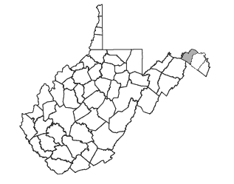



Special thanks for support from **FEMA, WV DHSEM,** and  
 **The Polis Center** at Indiana University–Purdue University Indianapolis



**CONTENT**

Overview 1

Key Flood Analysis Findings 2

General Description of County and Communities 3

Building Inventory 3

Creating the Building Inventory from Tax Assessor Data 4

Generating Hazus GBS and UDF from Building Inventory 5

Building Exposure to Potential Hazards 6

Building Exposure - General Building Stock (GBS) 6

Building Exposure in Floodplain - User Defined Facilities (UDF) 9

Inventory of Facilities and Community Assets 11

Essential Facilities 11

Critical Facilities 11

Community Assets 12

Inventory of Mitigated Properties 13

Flood Layer Inputs for Flood Model 14

1% Annual Chance Flood Hazard Area 14

Water Depth Grid 14

Riverine Flood Hazards Assessment 15

Riverine 1% Flood Building Damages 15

Riverine 1% Flood Debris Generation 22

Riverine 1% Flood Shelter Requirements 24

Data Deliverables to County 26

Maps 26

GIS Data 26

Integration of County Flood Risk Results in the State Hazard Mitigation Plan 27

Appendix A: Building Inventory Processing 29

Appendix B: Work Flow Diagram for Flood Risk Assessments 30

Appendix C: Data Gap Analysis 31

Appendix D: Statewide Risk Assessment Objectives 32

Appendix E: Multi-Hazard Risk Assessment Lifecycle 34

Appendix F: Statewide Spatial Integration of Surface Tax Parcels 36

Appendix G: 3D Flood Risk Visualization 37

Appendix H: Glossary of Risk Assessment Terminology 40

**TABLES**

Table 1: Local Building Inventory 4

Table 2A: Countywide/Community Building Count and Exposure ($) from General Building Stock 6

Table 2B: Countywide Building Count and Exposure ($) from CAMA Building Appraisal Values 7

Table 3A: Morgan County Flood Hazard Building Exposure in 1% Annual Chance Floodplain. 9

Table 3B: Berkeley Springs Flood Hazard Building Exposure in 1% Annual Chance Floodplain. 9

Table 3C: Paw Paw Flood Hazard Building Exposure in 1% Annual Chance Floodplain. 10

Table 4: Essential Facilities 11

Table 5: Critical Facilities 12

Table 6: Community Assets 12

Table 7: Mitigated Properties 13

Table 8: Morgan County Riverine Floodplain (1% Flood) Related Losses 16

Table 9: High Potential Loss Structures 16

Table 10: Buildings, Essential Facilities, Critical Facilities, and Community Assets Damaged (1% Flood) 17

Table 11: Debris Summary Report 22

Table 12: Shelter Requirements Summary Report 24

Table 13: State Level Integration of Food Risk Data. 28

Table A-1: CAMA Records Query of February 2016 29

Table A-2: Building Inventory Processing performed on 2015 data 29

Table A-3: E-911 Addressable Structures 29

Table C-1: Data Gap Analysis for Region 9 PDC Counties 31

**FIGURES**

Figure 1: Flood Model Overview. 1

Figure 2: Hazus GBS and UDF Inventory Data. 5

Figure 3: Sample Map of Countywide General Building Stock Exposure by Census Block 8

Figure 4: Zoomed-in View of parcel centroid based UDF Structures (blue dots) in Flood Zone 10

Figure 5: Zoomed-in View of Water Depth Grid 14

Figure 6A: Morgan County (1% Flood) Damaged Building Losses 18

Figure 6B: Berkeley Springs Community (1% Flood) Damaged Building Losses 19

Figure 6C: Paw Paw Community (1% Flood) Damaged Building Losses 20

Figure 7: Facilities and Community Assets in 1% Annual Chance Floodplain 21

Figure 8: Riverine 1% Flood Debris Weight (Tons) 23

Figure 9: Riverine 1% Flood Shelter Requirements (individual short term needs) 25

Figure 10: Hazus Level 1 Food Risk Layers in WV Flood Tool 27

Figure B-1: Work Flow Diagram for Flood Risk Assessments 30

Figure E-1: Multi-Hazard Risk Assessment Lifecycle. 35

Figure F-1: Statewide Spatial Integration of Surface Tax GIS Parcels for Agency and Public Benefit. 36

Figure G-1: WV Flood Tool information for Sample 3D Site 38

Figure G-2: Google Earth View of Sample 3D Site 39

Figure G-3: 3D Rendering Showing Flood Depth and Flooded Structures 39

Morgan County  
 Flood Risk Assessment Report

# Overview

A riverine flood risk assessment was conducted to assist Morgan County to quantify and visualize the potential loss resulting from a 1% annual chance flood event.1 First, all buildings and critical facilities in the county exposed to potential hazards were inventoried. From tax parcel and assessment data a detailed building inventory with engineered replacements costs was created for the entire county. A user defined facilities (UDF) data set was created by filtering the countywide building inventory to exclude points outside the 1% annual chance flood area. Next, the general and UDF building inventories, digital elevation model (DEM) and flood hazard inundation area were imported into the Hazus-MH (Version 2.2) flood risk modeling software. A flood depth raster layer was generated within Hazus and analyzed with the building inventories, DEM and flood hazard area to estimate building damages, debris, and people displaced (Figure 1). Flood Model results for each county will be integrated into the 2018 State Hazard Mitigation Plan and the Risk MAP View of the WV Flood Tool (www.mapwWV.gov/Flood).

Figure 1: Flood Model Overview. The Flood Model uses the best available site-specific building data, flood hazard area, elevation and water depth grid to estimate building damages, debris, and people displaced for a 1% annual chance flood event. A more detailed flow diagram is available in Appendix B.

# Key Flood Analysis Findings

Using Hazus modeling software, the flood risk analysis for a 1% annual chance flood event for Morgan County resulted in the following findings:

EXPOSURE OF BUILDINGS & PROPERTIES TO FLOODING

* **Building Exposure in County:** In Morgan County a minimum of 9,735 parcels with buildings have an aggregate total replacement value of 2 billion (2010 dollars).
* **Building Exposure in Flood Hazard Area:** A total of 625 buildings in the flood hazard area are exposed to flood damage which have an aggregate total replacement value of 152 million dollars.
* **Facilities Exposure:** A total of 19 essential facilities, 26 critical facilities, and 32 community assets are exposed to potential hazards. Replacement costs were generally not computed for essential, critical or community asset facilities. At least one school building, and several church buildings are located within the 1% annual chance flood area. Only those facilities for which spatial data are available from the West Virginia Division of Homeland Security and Emergency Management were analyzed.
* **Mitigated Properties:** None shown in Morgan County in current data.

FLOOD MODEL RESULTS

* Countywide Flood Loss Estimates  
  + **Physical Building Damage**: Based on the water depth and inundation area, the Hazus Flood Model estimates physical damage to 615 buildings in Morgan County at a replacement cost of 60 million dollars. Commercial properties have the highest loss ratio of 6.9%. Two critical facilities (school and fire station) and four churches are located in the 1% annual chance flood hazard area. The community of Berkeley Springs has the highest potential loss structures.
  + **Building Debris Generation**: An estimated 16,350 tons of building debris would be generated and require 654 truckloads (@25 tons/truck) to remove.
  + **Direct Social Losses**: Displaced households due to loss of housing habitability represent 984 individuals, of which 229 will require short term publicly provided shelter.
* **Berkeley Springs Community Building Damage:** The Hazus Flood Model estimates physical damage to 91 buildings in Berkeley Springs at a replacement cost of 7.7 million dollars. Commercial properties have the highest loss ratio of 11.8%. At least one essential facility, a fire department, is located in the 1% annual chance flood hazard area.
* **Paw Paw Community Building Damage:** The Flood Model estimates physical damage to 34 buildings in Morgan County at a replacement cost of 3 million dollars. Agricultural properties have the highest loss ratio of 17.6%. No essential or critical facilities are located in the flood hazard area.
* **Individual Building Damage:** The structure in the flood hazard zone with the highest building loss is a **commercial property** located at Harrison Avenue and Independence Street, Berkeley Springs. The Hazus estimated building loss for this property is **672 thousand dollars**.

# General Description of County and Communities

*County Description*: The geographical size of **Morgan County** is 230 square miles and contains 1,206 census blocks. The region contains over 7,000 households and has a total population of 17,541 people (2010 Census Bureau data). There are an estimated 9,735 parcels in the region with a total building replacement value (excluding contents) of 2,059 million dollars (2010 dollars). Approximately 81.9% of the buildings (and 66.8% of the building value) are associated with residential housing.

*Berkeley Springs Description*: The town of **Berkeley Springs** is an incorporated community exposed to periodic flooding. The geographical size of the community is less than one square mile and contains 70 census blocks. The region is home to 624 people (2010 Census Bureau data). There are an estimated 411 parcels with buildings in the region with a total building replacement value (excluding contents) of 115 million dollars (2010 dollars).

*Paw Paw Description*: The town of **Paw Paw** is an incorporated community exposed to periodic flooding. The geographical size of the community is 1 square mile and contains 44 census blocks. Paw Paw has a total population of 508 people (2010 Census Bureau data). There are an estimated 34 parcels with buildings in the region with a total building replacement value (excluding contents) of 10 million dollars (2010 dollars).

# Building Inventory

Two locally produced GIS data sets – county assessor tax surface parcels and E-911 addressable structures – were used to create and validate the local building inventory. From tax parcel and assessment data a detailed building inventory with engineered replacements costs was created for the entire county. The parcel-based building inventory identified **9,735** structures while the E-911 database listed **16,491** addressable structures. Table 1 identifies the number of structures in the county and towns of Berkeley Springs and Paw Paw. More information about the building inventory is described below.

## Creating the Building Inventory from Tax Assessor Data

The building inventory for Morgan County was created from assessor records and GIS parcels. The CAMA records were extracted from the centralized State Tax Department’s Integrated Assessment System while the GIS parcels were provided by the Morgan County Assessor’s Office. Key inventory attribute fields for modeling flood damage included occupancy class or land use (LUC), building condition (GRADE), construction type (EXTWALL), foundation type and first floor height (BASMT), stories (STORIES), year built (YRBLT), structure area (AREASUM) and building costs (DWELVAL, COMVAL, OBYVAL).

Before the CAMA records are joined to the GIS parcels, a number of processing steps were performed on the CAMA records. First, all the CAMA records were reduced to single, unique records associated with the primary structure of the particular parcel. *Note that this action eliminated multiple valued structures or trailer courts listed on the same parcel.*  Second, the CAMA records were classified by the LAND USE as residential, commercial, industrial, agricultural, religious, government, education, and unknown buildings. Unknown records typically represent land use codes for vacant or exempt properties, although some of these records may contain appraisal values. In addition, parcel records with invalid land use codes were deleted. During this processing step the CAMA records with null values for key engineering values were dropped. For example, since assessor records may not have values for the parcels that are not taxable, certain parcels with tax-exempt government, religious, education, or other non-profits structures may have been deleted. For Morgan County this refinement process resulted in the source CAMA records of 15,454 being decreased to 10,828 records (Tables 1 and A-2). Lastly, the “improved” or “processed” 10,828 CAMA records were then joined by the unique parcel identifier with the centroids of each parcel polygon to create the spatially referenced **building inventory**.

Table 1: Local Building Inventory

|  |  |  |  |  |  |  |
| --- | --- | --- | --- | --- | --- | --- |
| Assessor Records and Parcels | | | | |  | E-911 Sites |
| **Category** | **Parcel CAMA Records** (unique**)** | **Improved or Processed CAMA Records** (attributes) | **Assessor Parcels**  (parcel polygons) | **Building Inventory** (parcel centroids + CAMA replacement cost attributes) |  | **E-911 Addressable Structures** (points on structure) |
| Berkeley Springs | - | - | 527 | 411 |  | 511 |
| Paw Paw |  |  | 99 | 259 |  | 351 |
| Unincorporated | - | - | 14,828 | 9,065 |  | 15,629 |
| **Total** | 15,454 | **10,828** | 15,039 | **9,735** |  | **16,491** |

Based on the spatial join of the GIS parcels and CAMA records, the match rate between the GIS parcel-based building inventory (9,736) and the processed CAMA records (10,828) for Morgan County was **90%**. Further research should be conducted to improve the match rate between the assessor CAMA records and GIS parcels.

As a cross-reference check for the completeness of the parcel-based building inventory, the E-911 addressable structures for Morgan County were extracted from the Statewide Addressing and Mapping System maintained by WV DHSEM. The match rate between the GIS parcel-based building inventory (9,736) and E-911 addressable structures (16,491) was **59%, a low rate because numerous structures in the E-911 database are uninhabitable structures and have no address**. See Appendix A for more information about the match rates and other statistics in creating the building inventory.

## Generating Hazus GBS and UDF from Building Inventory

To import the building inventory into the Hazus-MH loss estimation software, the building inventory data is processed for two formats: **General Building Stock** (aggregate data) and **User Defined Facilities** (site-specific data). The General Building Stock (GBS) contains the least amount of detail and is stored as data that has been aggregated by census tract or block, whereas User Defined Facilities (UDF) contain basic characteristics about individual buildings. Both the GBS and UDF data layers contain building characteristics (occupancy class, square footage, building type, foundation, year built, etc.) to determine the **building replacement costs.** Note that the replacement costs for both the GBS inventory and UDF inventory should match. Lastly, the GBS is used for the debris and people evacuation models while the UDF is needed for the detail flood loss analysis of structures in the 1% annual chance flood hazard area.

Figure 2: Hazus GBS and UDF Inventory Data. The General Building Stock (aggregate buildings) and User Defined Facilities (individual buildings) are derived from the Building Inventory.

# Building Exposure to Potential Hazards

## Building Exposure - General Building Stock (GBS)

The **General Building Stock** (GBS) is updated in Hazus-MH with the local building inventory prior to running the Flood Model loss analysis scenarios. Table 2A lists all the buildings in the county that are exposed to potential hazards. The number of buildings and full replacement costs based on standardized engineering cost calculations are listed by specific occupancy classes. Table 2B lists similar information but was derived from the appraised building values directly queried from the assessor records database.

Based on engineering calculation estimates there are **9,735 parcels with buildings** in the county which have an aggregate total replacement value of **2 billion dollars** (2010 dollars). *Note that this cost was calculated for one primary structure per parcel and does not account for multiple valued* *structures in the same parcel.* Figure 3 shows a map representation by census block geographical units of the GBS building assets exposed to potential hazards.

Table 2A: Countywide/Community Building Count and Exposure ($) from General Building Stock

|  |  |  |  |
| --- | --- | --- | --- |
| **Occupancy Classification** | **Building Count** | **Total Building Exposure ($)** | **Percent of Total** |
| Morgan County (including all jurisdictions) | | | |
| Residential | 7,971 | 1,375,697,425 | 66.79% |
| Commercial | 877 | 308,882,657 | 15.00% |
| Industrial | 86 | 145,824,422 | 7.08% |
| Agricultural | 713 | 159,486,816 | 7.74% |
| Religious | 74 | 53,230,099 | 2.58% |
| Government | 8 | 1,987,453 | 0.10% |
| Education | 6 | 14,542,194 | 0.71% |
| TOTAL | **9,735** | **$2,059,651,066** | 100.00% |
| Berkeley Springs | | | |
| Residential | 288 | 58,654,641 | 51.06% |
| Commercial | 107 | 44,533,677 | 38.77% |
| Industrial | 0 | 0 | 0.00% |
| Agricultural | 0 | 0 | 0.00% |
| Religious | 13 | 8,759,736 | 7.63% |
| Government | 2 | 499,958 | 0.44% |
| Education | 1 | 2,423,699 | 2.11% |
| TOTAL | **411** | **$114,871,711** | 100.0% |
| Paw Paw | | | |
| Residential | 195 | 33,549,178 | 83.9% |
| Commercial | 44 | 16,585,541 | 14.3% |
| Industrial | 6 | 11,336,982 | 1.6% |
| Agricultural | 3 | 742,641 | 0.0% |
| Religious | 8 | 5,115,848 | 0.2% |
| Government | 2 | 499,958 | 0.0% |
| Education | 1 | 2,423,699 | 0.0% |
| TOTAL | **259** | **$70,253,847** | 100.0% |

Table 2B: Countywide Building Count and Exposure ($) from CAMA Building Appraisal Values

|  |  |  |  |
| --- | --- | --- | --- |
| **General Occupancy** | **Count** | **Appraised**  **Building Costs** | **CAMA Land Use Codes** |
| Agricultural | 807 | 53,918,900.00 | 112-113 |
| Commercial | 939 | 82,314,800.00 | 109-110, 310, 319-360, 362-390, 393-99, 602, 610-11, 630, 640, 670, 690, 701-706, 710-723 |
| Education | 8 | 30,834,500.00 | 612-13 |
| Government | 9 | 1,587,900.00 | 603,660 |
| Industrial | 98 | 7,446,600.00 | 391-92, 400-471, 707 |
| Religious | 79 | 17,394,900.00 | 361, 620, 680 |
| Residential | 8,857 | 988,522,400.00 | 101-108, 115, 201-213, 301, 314-318 |
| Unknown | 4,656 | 16,685,600.00 | 100, 114,123, 300, 600, 601, 604, 700 |
| Invalid Codes | 1 |  | 900 |
| **Total** | **15,454** | **$1,198,705,600** |  |

In Table 2B The CAMA building appraisal values (APRBLG) were also categorized by occupancy class and for the county summed to 1.2 billion dollars. The appraised building layer is for reference purposes only and not used in the Flood Model analysis.

Figure 3: Sample Map of Countywide General Building Stock Exposure by Census Block. Replacement building costs are aggregated to Census Blocks. Darker block fill color indicates higher exposure amount. Floodplain (1% annual chance) in black hatch. Building Inventory points are represented as blue squares.

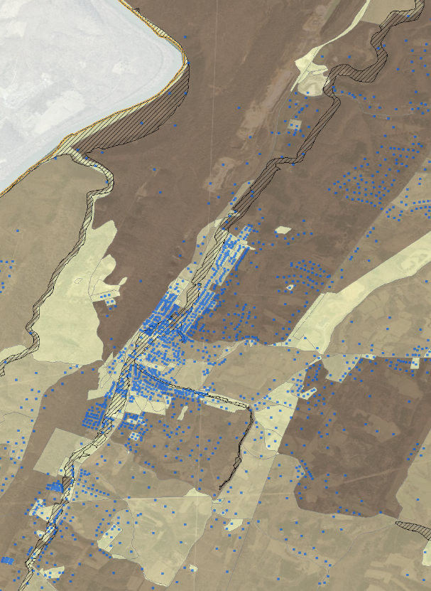

## Building Exposure in Floodplain - User Defined Facilities (UDF)

**User Defined Facilities (UDF)**, point representations of buildings that are in the 1% annual chance flood zone, were imported into the Hazus-MH Flood Model. Before the UDF structures are imported into Hazus-MH to execute the Flood Model, it is possible to adjust the site-specific data, visually or through GIS analysis, to building structures using E-911 addressable sites, building footprints, leaf-off aerial photography, or other reference layers. This step was not carried out in Morgan County due to time and data constraints. The high number of address points in Table 1, when compared with CAMA derived improvements, indicate that some structures with E-911 addresses are not dwellings, businesses or other structures normally considered in flood risk assessment. A random visual check of address points and structure type appears to confirm this suggestion.

Table 3A: Morgan County Flood Hazard Building Exposure in 1% Annual Chance Floodplain. Data input of choice is User Defined Facilities.

|  |  |  |
| --- | --- | --- |
| **General Occupancy** | **UDF**  **Count** | **Exposure in Floodplain** (Total Replacement Costs using UDF) |
| Agricultural | 34 | 7,675,869 |
| Commercial | 158 | 60026829 |
| Education | 0 | 0 |
| Government | 1 | 249979 |
| Industrial | 10 | 16989562 |
| Religious | 5 | 3013700 |
| Residential | 417 | 63746525 |
| TOTAL | **625** | **151,702,464** |

A total of **625 buildings** at a replacement cost of **$151,702,464** are exposed to a 1% annual chance flood event in **Morgan County** (Table 3A). The flood loss estimates are calculated from the subset of building inventory modeled in Hazus as User Defined Facilities, or site-specific points. During the flood model runs the flood damage is estimated in percent and is weighted by the area of inundation at a given water depth for an individual structure. Refer to Table 8 to view the estimated building damages resulting from the Flood Model.

Table 3B: Berkeley Springs Flood Hazard Building Exposure in 1% Annual Chance Floodplain. Data input of choice is User Defined Facilities.

|  |  |  |
| --- | --- | --- |
| **General Occupancy** | **UDF**  **Count** | **Exposure in Floodplain** (Total Replacement Costs using UDF) |
| Agricultural | 0 | 0 |
| Commercial | 48 | 20,460,683 |
| Education | 0 | 0 |
| Government | 0 | 0 |
| Industrial | 0 | 0 |
| Religious | 4 | 2,736,784 |
| Residential | 39 | 8,067,094 |
| TOTAL | **91** | **31,264,561** |

Table 3C: Paw Paw Flood Hazard Building Exposure in 1% Annual Chance Floodplain. Data input of choice is User Defined Facilities.

|  |  |  |
| --- | --- | --- |
| **General Occupancy** | **UDF**  **Count** | **Exposure in Floodplain** (Total Replacement Costs using UDF) |
| Agricultural | 2 | 495,094 |
| Commercial | 14 | 6,139,708 |
| Education | 0 | 0 |
| Government | 0 | 0 |
| Industrial | 0 | 0 |
| Religious | 0 | 0 |
| Residential | 18 | 3,436,036 |
| TOTAL | **34** | **10,070,838** |

A total of **91 buildings** at a cost of **$31,264,561** are exposed to a 1% annual chance flood event in **Berkeley Springs** (Table 3B). Refer to Table 8 to view the estimated building damages resulting from the Flood Model.

A total of **34 buildings** at a cost of **$10,070,838** are exposed to a 1% annual chance flood event in **Paw Paw** (Table 3C). Refer to Table 8 to view the estimated building damages resulting from the Flood Model.

### Figure 4: Zoomed-in View of parcel centroid based UDF Structures (blue dots) in Flood Zone

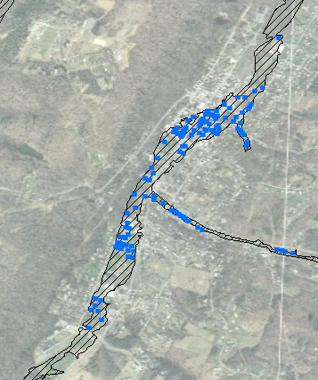

# Inventory of Facilities and Community Assets

Essential facilities, critical facilities, and community assets were compiled from various GIS stewards and should be validated with the local communities. Replacement costs were not computed for facilities and community assets for this study. If replacement costs of non-profit buildings are unavailable, then costs may be obtained from:

• Various websites for some facilities

• Insurance records for individual buildings

• Calculated from square footage by using RS Means replacement

## Essential Facilities

**Essential facilities** are defined as those that are vital to the county in the event of a hazard. These include police departments, fire stations, schools, health care facilities, and emergency service zones. The WV DHSEM compiles essential facilities from various local, state, and federal data sources.

Table 4: Essential Facilities

|  |  |
| --- | --- |
| **Category** | **Number of Facilities** |
| Police Stations | 4 |
| Fire Stations | 4 |
| Emergency Service Centers | 1 |
| Health Care Facilities | 1 |
| Schools | 9 |
| TOTAL | **19** |

## Critical Facilities

**Critical facilities** are buildings that are deemed economically or socially viable to the county and is a superset of essential facilities. The following critical facilities were inventoried and mapped for Morgan County.

Table 5: Critical Facilities

|  |  |  |
| --- | --- | --- |
| **Category** | **Number of Facilities** | **Description** |
| *Governmental Facilities*   * *Courthouses* | 1 | Essential for the delivery of critical services and crisis management including data and communication centers and key government complexes. |
| *Dams* | 18 | Source: USACE, GNIS. Holiday Lake Dam in VA not included. |
| *Transportation Systems*   * Airports * Railroads * Bridges | 1  1 5 | Necessary for transport of people and resources including airports, highways, railways. Source: GNIS |
| *Lifeline Utility Systems*   * Wastewater Treatment Plants * Potable Water Systems * Communication Facilities * Electric Substations * Electric Power Facilities * Natural Gas Facilities | n/a  n/a  n/a  n/a  n/a  n/a | Vital to public health and safety including potable water, wastewater, oil, natural gas, electric power, and communication systems. |
| *Hazardous Material Facilities* | n/a | Involved in the production, storage, and/or transport of corrosives, explosives, flammable materials, radioactive materials, and toxins. |
| TOTAL | **26** |  |

## Community Assets

The Morgan County Mitigation Planning team may identify facilities that are significant to the county; for example, historic landmarks or significant tourist attractions. These facilities or structures are referred to as **community assets**.

Table 6: Community Assets

| **Category** | **Number of Facilities** | **Notes** |
| --- | --- | --- |
| Churches | 32 | GNIS |
| Government Office | n/a |  |
| Hazmat Non Facility | n/a |  |
| Mobile Home and Campground | n/a |  |
| Polling Place | n/a |  |
| Emergency Shelter | n/a |  |
| Water Tower | n/a |  |
| Poultry Slaughtering Stations | n/a |  |
| TOTAL | **32** |  |

# Inventory of Mitigated Properties

Both FEMA and WVDHSEM have worked together to identify buyouts of repetitive flood properties since the inception of FEMA HMA grant programs during the past two decades. Morgan County has no **mitigated properties** shown in currently available data.

Table 7: Mitigated Properties

|  |  |
| --- | --- |
| **Category** | **Mitigated Properties** |
| Berkeley Springs | 0 |
| Paw Paw | 0 |
| Unincorporated | 0 |
| TOTAL | **0** |

# Flood Layer Inputs for Flood Model

Important flood layers for the Flood Model include the 1% annual chance flood hazard area and water depth grid.

## 1% Annual Chance Flood Hazard Area

The 1% annual chance floodplain in Morgan County was used to run all the flood model scenarios. The **flood hazard area** was downloaded from FEMA’s National Flood hazard Layer (NFHL) digital database.

## Water Depth Grid

A **water depth grid** was required to estimate the percentage of physical damage to a structure weighted by the area of inundation at a given depth. The Hazus Enhanced Quick Look tool was used to generate a depth grid for the flood analysis based on the FEMA National Flood Hazard Layer and the digital elevation model at 1/3 arc-second (approximately 10 m) resolution downloaded from the USGS National Elevation Dataset (NED). Although certain counties in West Virginia may have more accurate depth grids generated from HEC-RAS computer modeling software for the Approximate A Zones, these HEC-RAS depth grids were not available for Morgan County. New depth grids are expected to be available statewide over the next several years.

Figure 5: Zoomed-in View of Water Depth Grid. Overlain with UDF individual building structures

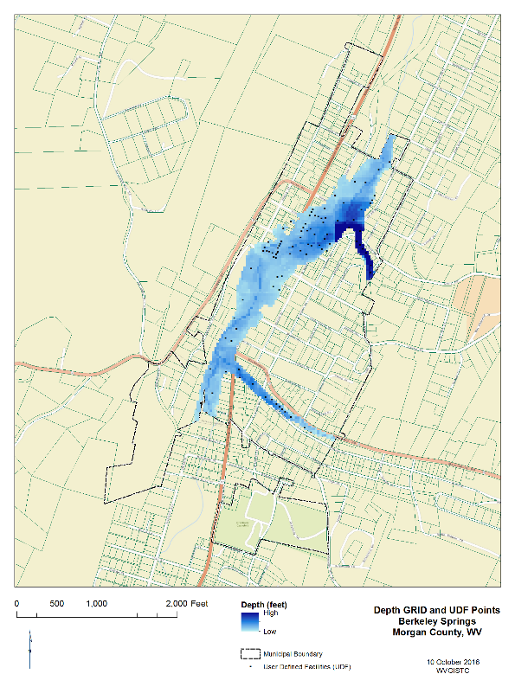

The depth grid range for Morgan County is from 0 to 47 feet.

# Riverine Flood Hazards Assessment

Riverine flooding is the number one natural hazard risk in West Virginia. Riverine floodplains in the State typically are narrow, confined channels in the steep valleys of hilly and mountainous areas. The volume of water in the floodplain is a function of the size of the contributing watershed and topographic characteristics such as watershed shape and slope, and climatic and land-use characteristics.

Both Hazus-MH and GIS software were used to model flood building damages, debris estimations, and the number of shelters required for the displaced population. Below are the tables and maps from running the Flood Model for a 1% annual chance flood event. Hazus-MH loss estimates may be impacted by certain assumptions and process variances made in this flood risk assessment. The Morgan County analysis used Hazus Version 2.2 and the population counts were derived from the 2010 Census. During the flood model runs the flood damage is estimated in percent and is weighted by the area of inundation at a given depth for a given census block (GBS input) or user-defined structure (UDF input).

## Riverine 1% Flood Building Damages

Buildings in Morgan County are vulnerable to flooding from the 1% Riverine Flood (also known as the 1% annual chance flood) and the cost to rebuild may have significant consequences to the community. Hazus-MH estimated the 1%-annual-chance flood would physically damage **615 buildings** at a replacement cost of **59.8 million dollars** for Morgan County. In the Berkeley Springs community, the Flood Model estimated damage to **91 buildings** at a replacement cost of **7.7 million dollars.** In Paw Paw an estimated **34 buildings** will be damaged at a replacement cost of **2.9 million dollars**.

The flood loss estimates for damaged buildings by community and occupancy class are listed in Table 8. Table 8 also provides the loss ratios (Total Building Loss / Total Building Exposure) for the county and jurisdictions. The loss ratios were computed by dividing the Total Building Loss (Table 8) by the Total Building Exposure (Table 2A). **Commercial properties** have the highest loss ratio of **6.9%** and **11.8%** for Morgan County and the Berkeley Springs community, respectively. In the Paw Paw community, **agricultural properties** have the highest loss ratio at **17.6%**.

The structure in the flood hazard zone with the highest total replacement cost is a **commercial property** valued at **947 thousand dollars** located at Harrison Avenue and Independence Street, Berkeley Springs. The Hazus estimated loss for this property is **672 thousand dollars**. Table 9 lists a sample of five individual damaged structures in the county based on replacement costs.

Table 10 lists all the buildings, essential facilities, critical facilities, and community assets damaged in a 1% annual chance flood event. Figures 6A through 6C are maps of the flood damaged buildings in Morgan County and the communities of Berkeley Springs and Paw Paw. A large-format county map of the flood damaged buildings is provided with this report. Figure 7 is a map of facilities /community assets of Berkeley Springs community affected by the 1% annual chance flood. There are a total of **six facilities** located in the 1% flood hazard area: 1 school, 1 courthouse, 1 fire department and 4 churches.

Table 8: Morgan County Riverine Floodplain (1% Flood) Related Losses

|  |  |  |  |  |
| --- | --- | --- | --- | --- |
| **Classification** | **Number of Buildings Damaged** | **Total Building Loss ($)** | **Total Building Exposure ($) in Jurisdiction** | **Loss Ratio** |
| Morgan County (including all jurisdictions) | | | | |
| Residential | 413 | 27,562,062 | 1,375,697,425 | 2.00% |
| Commercial | 158 | 21,353,161 | 308,882,657 | 6.91% |
| Industrial | 10 | 8,171,979 | 145,824,422 | 5.60% |
| Agricultural | 29 | 2,551,472 | 159,486,816 | 1.60% |
| Religious | 4 | 199,033 | 53,230,099 | 0.37% |
| Government | 1 | 3,828 | 1,987,453 | 0.19% |
| Education | 0 | 0 | 14,542,194 | 0.00% |
| **TOTAL** | **615** | **$59,841,535** | **$2,059,651,066** |  |
| Berkeley Springs | | | | |
| Residential | 38 | 2,330,862 | 58,654,641 | 3.97% |
| Commercial | 48 | 5,244,835 | 44,533,677 | 11.78% |
| Industrial | 1 | 0 | 0 | 0.00% |
| Agricultural | 0 | 0 | 0 | 0.00% |
| Religious | 4 | 161,452 | 8,759,736 | 1.84% |
| Government | 0 | 0 | 499,958 | 0.00% |
| Education | 0 | 0 | 2,423,699 | 0.00% |
| **TOTAL** | **91** | **$7,737,149** | **$114,871,711** |  |
| Paw Paw | | | | |
| Residential | 18 | 1,366,114 | 33,549,178 | 4.07% |
| Commercial | 14 | 1,502,459 | 16,585,541 | 9.06% |
| Industrial | 0 | 0 | 11,336,982 | 0.00% |
| Agricultural | 2 | 130,479 | 742,641 | 17.57% |
| Religious | 0 | 0 | 5,115,848 | 0.00% |
| Government | 0 | 0 | 499,958 | 0.00% |
| Education | 0 | 0 | 2,423,699 | 0.00% |
| **TOTAL** | **34** | **$2,999,052** | **$70,253,847** |  |

Table 9: High Potential Loss Structures

|  |  |  |  |  |  |  |
| --- | --- | --- | --- | --- | --- | --- |
| **#** | **E-911 Street Address** | **City** | **Zip Code** | **Parcel ID** | **Building Type** | **Building Loss1** |
| Building 1 | Harrison Ave & Independence St | Berkeley Springs | 25411 | 03 1A003300000000 | Commercial | $671,628 |
| Building 2 | N Mercer St & Independence St | Berkeley Springs | 25411 | 03 1A003200000000 | Commercial | $373,585 |
| Building 3 | 3077 Valley Rd | Berkeley Springs | 25411 | 02 11000900010000 | Commercial | $342,009 |
| Building 4 | Independence & Mercer Streets | Berkeley Springs | 25411 | 03 1A001700000000 | Commercial | $287,123 |
| Building 5 | 167 Indian Run Ln (New home) | Berkeley Springs | 25411 | 08 2A005900000000 | Residential | $253,600 |

1 Building Content Loss often exceeds Building Loss.

Table 10: Buildings, Essential Facilities, Critical Facilities, and Community Assets Damaged (1% Flood)

|  |  |  |  |  |  |
| --- | --- | --- | --- | --- | --- |
| **Category** | **Building Inventory** | **Essential Facilities** | **Critical  Facilities** | **Community Facilities** | **Total Structures** |
| Berkeley Springs | 37 | 0 | 1 | 43 | 38 |
| Paw Paw | 34 |  |  |  | 34 |
| Unincorporated | 544 | 12 | 0 | 0 | 545 |
| TOTAL STRUCTURES | 615 | 1 school | 1 courthouse | 4 churches | 617 |

1Note that while one fire department building is located in the floodplain, damages for the structure were not modeled.  
2At least one school facility, south of Berkeley Springs, lies in the 1% chance flood area.  
3Churches are not part of the total tally since they are included in the “religious” category of the building inventory (Table 8).

There are **617 structures** in the 1% Annual Chance flood, including 1 school, 1 courthouse, and 4 churches. The building and facility inventories should be verified by local authorities.

### Figure 6A: Morgan County (1% Flood) Damaged Building Losses

### Figure 6B: Berkeley Springs Community (1% Flood) Damaged Building Losses

## 

### Figure 6C: Paw Paw Community (1% Flood) Damaged Building Losses

### Figure 7: Facilities and Community Assets in 1% Annual Chance Floodplain

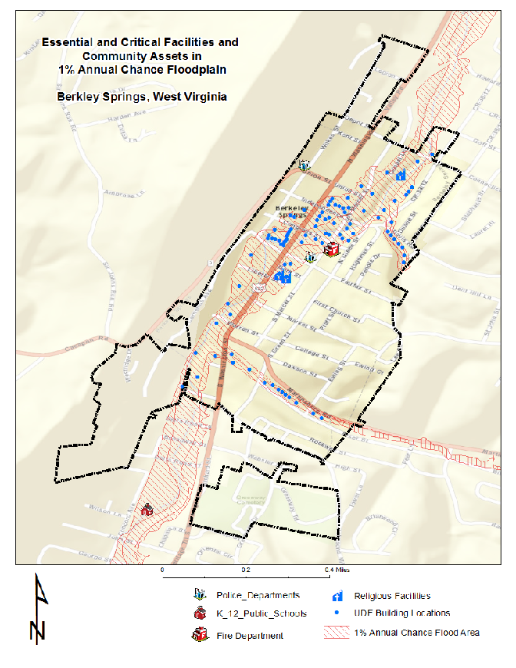

## Riverine 1% Flood Debris Generation

Debris disposal can be a significant issue following floods. The Hazus Flood Model estimates debris from building damage during floods, including building finishes, and structural components. The physical damage estimates are not made for building contents, or for bridges or other lifelines.

The Hazus Flood Model debris estimation methodology determines the expected amounts of debris generated at various depths of water and reported at the census block level. Output from this module is the debris weight (in tons). The classes of debris are defined as follows: (1) building finishes (carpeting, dry wall, insulation, etc.), (2) structural components (wood, brick, etc.) and (3) foundation materials (concrete slab, concrete block, rebar, etc.). This distinction is made because of the different types of material handling equipment required to handle the debris. For more information about the Hazus Flood Model debris estimation methodology refer to the Hazus-MH Technical Manual.

The Flood Model estimates that a total of **16,350 tons** of debris will be generated. Of the total amount, Finishes comprises 19% of the total, Structure comprises 40% of the total (Table 11). If the debris tonnage is converted into an estimated number of truckloads, it will require **654 truckloads** (@25 tons/truck) to remove the debris generated by the flood. The results are mapped in Figure 8.

Table 11: Debris Summary Report

|  |  |  |  |  |
| --- | --- | --- | --- | --- |
| Morgan County | Finishes | Structures | Foundations | Total Tons |
| Debris Tons | 3,157 | 6,467 | 6,727 | 16,350 |

As can be expected, the results of the debris flood model reflect that in the event of a 1% annual chance flood, emergency response officials will need to target resources for removing debris along the flooded waterways in proximity to populated places. Refer to the debris map for more specific information and for mitigation planning.

### Figure 8: Riverine 1% Flood Debris Weight (Tons)

## Riverine 1% Flood Shelter Requirements

A significant part of any planning scenario is to estimate the number of individuals who will need to be sheltered in the short-term. The direct social loss of the displaced population is based on the inundation area and depth of flooding. Flood sheltering needs are based on the displaced population, not the damage state of the structure.

The Hazus-MH Flood Model determines the number of individuals likely to use government-provided short-term shelters through determining the number of displaced households as a result of the flooding. To determine how many of those households and the corresponding number of individuals will seek shelter in government-provided shelters the number is modified by factors accounting for income and again by factors accounting for age. For more information about the Hazus Flood Model shelter estimation methodology refer to the Hazus-MH Technical Manual.

*Hazus 2.2 Report:* For Morgan County, **984** individuals will be displaced, **229** of whom require short term publicly provided shelter (Table 12). The results are mapped in Figure 9.

Table 12: Shelter Requirements Summary Report

|  |  |  |
| --- | --- | --- |
| Morgan County | Number of Displaced People | Number of People Needing Short Term Shelter |
|  | 984 | 229 |

The results of the shelters requirements model reflect that in the event of a 1% annual chance flood, emergency response officials will need to organize shelters near the flooded communities. Refer to the flood shelter requirements map for more specific information and for planning temporary housing needs.

### Figure 9: Riverine 1% Flood Shelter Requirements (individual short term needs)

# Data Deliverables to County

In addition to this report, the following maps and GIS data layers are available to the counties.

## Maps

* Building Exposure
* Physical damage map of buildings and facilities (large size)
* Debris map
* Population Displacement / Shelter map
* Select 3D maps (if building footprints available)
* Miscellaneous maps

## GIS Data

* GIS parcel polygons
* E-911 Addressable Structures
* Building Inventory
* UDF Floodplain Structures
* Essential Facilities
* Critical Facilities
* Community Assets
* Mitigated Properties (not available for Morgan County at this time)
* Hazus-MH .hpr files (available on request)

# Integration of County Flood Risk Results in the State Hazard Mitigation Plan

Results of the county flood risk assessment will be used to update the 2018 State Hazard Mitigation Plan and the Risk MAP View of the WV Flood Tool (www.mapWV.gov/Flood). Table 11 lists the flood risk data layers involved in integrating county flood risk studies to regional and state levels.

### Figure 10: Hazus Level 1 Food Risk Layers in WV Flood Tool

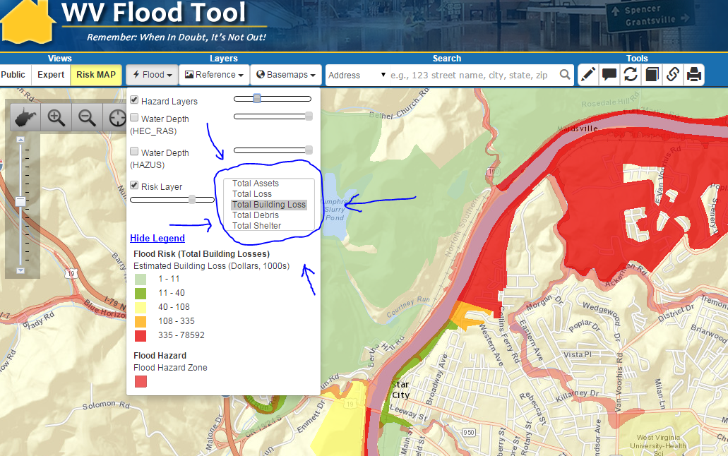

Table 13: State Level Integration of Food Risk Data. The following hazard risk information from counties can be integrated at the regional and state levels for the State Hazard Mitigation Plan. The **boldfaced** loss estimates are currently in the WV Flood Tool and based on a statewide Hazus Level 1 analysis performed several years ago.

|  |  |  |
| --- | --- | --- |
| **Flood Risk Data** | **Inventory Type** | **Spatial Representation** |
| **\*\* Flood Model INPUTS \*\*** | | |
| **Total Assets Exposed:**  Number and exposure ($) of all buildings | Building Inventory | Parcel Centroids or Census Tracts/Blocks |
| Floodplain Exposure: Number and exposure of buildings located in the Special Flood Hazard Area (SFHA) | UDF | Parcel centroids can be spatially adjusted with E-911 addressable structures |
| Facilities Exposure: Essential Facilities, Critical Facilities, Community Assets | GIS Infrastructure Databases | Usually Points |
| Mitigated Properties: (shown currently in Expert View of WV Flood Tool) | Mitigated Properties | Polygons |
| Water Depth Grid | * Hazus-generated (EQL) * Advisory Flood Height * Detailed Flood Zone (FIS) | Raster |
| Flood Hazard Area | DFIRMs | Polygons |
| **\*\* Flood Model OUTPUTS \*\*** | | |
| **Total Loss:** Number and value ($) of Buildings and Contents damaged in Hazus Level 2 analysis | UDF & GBS | * Points * Census Tracts/Blocks * Watersheds |
| **Total Building Loss:** Number and value ($) of damaged buildings in Hazus Level 2 analysis.  Loss Ratios as calculated from the Hazus Analysis | UDF & GBS | * Points * Census Tracts/Blocks * Watersheds |
| **Total Debris** costs ($) | GBS | Census Tracts/Blocks |
| **Total Shelter:** People requiring shelter | GBS | Census Tracts/Blocks |

# Appendix A: Building Inventory Processing

Table A-1: CAMA Records Query of February 2016

|  |  |
| --- | --- |
| **CAMA Field** | **Value** |
| County ID | 33 |
| Name | Morgan |
| Appraised Land Value | 498,611,400 |
| Appraised Building Value | 1,198,705,600 |
| Appraised Total Value | 1,697,317,000 |
|  |  |
| Total Unique Parcel Records | 15,454 |
|  |  |
|  |  |

Table A-2: Building Inventory Processing performed on 2015 data

|  |  |  |
| --- | --- | --- |
| **File Type** | **Count** | **Notes** |
| CAMA Records (attributes) | 15,454 | CAMA records are reduced to a single, unique primary property record |
| Improved CAMA Records (attributes) | 10,828 | CAMA codes transformed to values recognized by Hazus. For Morgan County the source CAMA data included 15,454 records. The destination data – Improvements records included 10,828 records. This means that that there were 4,626 failed records and research by Polis showed that these included records without DWELVAL, COMVAL and OBYVAL values. It also included records with LUC values (100, 114, 123, 200, 300, 600, 601 604,700) for vacant and exempt lands which were deemed inappropriate for the desired modeling purposes. |
| Assessor Parcels (parcel polygons) | 15,039 | GIS parcel polygon file provided by county and converted to parcel centroid points. Total parcel polygons equals 15,039. |
| Building Inventory (parcel centroids + attributes) | 9,735 | Join between parcel centroid points and Improved CAMA records yielded 9,735 building points |
| CAMA - parcel match rate | 90% | Building Inventory (9,735) divided by Improved CAMA record attributes (10,828) = 90% |

Table A-3: E-911 Addressable Structures

|  |  |  |
| --- | --- | --- |
| **File Type** | **Count** | **Notes** |
| Addressable Sites | 16,491 | Addressable structures for Morgan County from Statewide Addressing and Mapping System (SAMS). |
| E-911 – parcel match rate | 59% | Parcel-centroid building inventory (9,735) divided by Addressable sites (16,491) = 59% |

# Appendix B: Work Flow Diagram for Flood Risk Assessments

Figure B-1: Work Flow Diagram for Flood Risk Assessments.

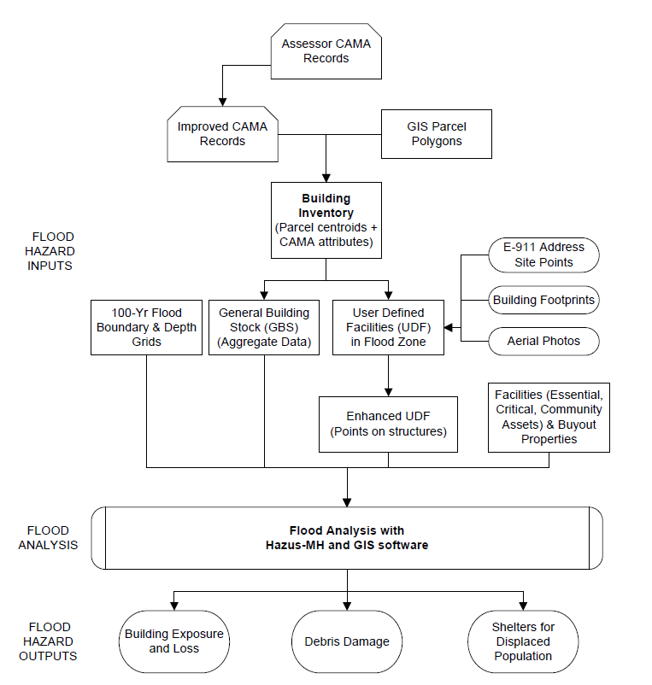

# Appendix C: Data Gap Analysis

The spatial E-911 addresses for Morgan County are not accurate or complete and should be prioritized for future data improvement efforts. In addition, the aerial imagery for Morgan County is more than five years old and thus should be updated. It would also be beneficial if Morgan County had building footprints to generate photorealistic 3D flood visualization maps. More coordination is required with local and state emergency offices to identify available geodatabases for essential facilities, critical facilities, and community assets.

Table C-1: Data Gap Analysis for Region 9 PDC Counties

|  |  |  |  |
| --- | --- | --- | --- |
| **DATA LAYERS** | **Berkeley County** | **Morgan County** | **Jefferson County** |
| *IAS/CAMA Tables* | 2014 | 2015 | 2015 |
| *Tax Parcels* | 2015 | 2016 | 2016 |
| *E-911* | 2013 | 2015 (FAIL) | 2016 |
| *Building Footprints* | 2008 | NONE | 2015 |
|  |  |  |  |
| *Aerial Imagery* | 2016 | 2010 (POOR) | 2016 |
|  |  |  |  |
| *Water Depth Grid* | No Advisory Flood Heights | No Advisory Flood Heights | Advisory Flood Heights available |
| *Elevation* | No complete Lidar coverage | No complete Lidar coverage | Complete Lidar Coverage |
|  |  |  |  |
| *Critical Infrastructure* | Incomplete | Incomplete | Incomplete |

# Appendix D: Statewide Risk Assessment Objectives

**Long-term objectives for risk assessments in West Virginia:**

1. Establish a **communication and training network** for exchanging risk assessment information and technical skills among local, state, federal, and other entities. **Multi-agency coordination** and data exchange among organizations allow for comprehensive risk assessment for communities. A multi-hazard **Risk Assessment Lifecycle** should be applied to regularly evolving risk assessment studies.
2. Exchange the **best available risk assessment data** among local, state, and federal geo-platforms. Incorporate **historical flood data** into risk assessment studies. Use **online map validation tools** for local communities to validate risk assessment data.
3. Create a statewide inventory of all **buildings and facilities exposed** (with replacement costs) in flood hazard, dam/levee failure, and landslide susceptibility zones.
4. Create a consistent **statewide water depth grid** (FEMA Risk MAP Studies + Model-Backed Zone A Studies + FIS conversion / water surface elevations from x-sections of detailed studies) using available high-resolution elevation data for 1% Annual Chance Floods. The depth grids are important for (1) water depth visualization in the WV Flood Tool and for (2) calculating physical building damage costs using Hazus-MH flood loss software.
5. Perform **county-level risk assessments** for 55 counties:  
   1. **Flood risk assessments** for riverine 1% annual chance flood based on Hazus-MH flood loss estimates using water depth and flood inundation area inputs
      1. *Physical Building Damage Assessments*: Create a statewide inventory of structures at risk to physical building damage
      2. *Flood Debris Generated* (debris removal)
      3. *Flood Shelter Requirements* (temporary housing)
   2. **Dam and levee failure flood inundation assessments (USACE led)**
      1. Prioritize dam inspections in accordance with risk and those that do not have an EAP digitized
      2. Integrate Dam and Levee safety action class (class 1 - 5) for every USACE dam and levee into HIRA and THIRA.
      3. Produce documentaries about/on aging dam structures around endangered communities (Develop a list of potential dams on which to focus).
      4. Create a task force to address levee safety in West Virginia (Coordination between NRCS and USACE on levee safety issues).
   3. **Landslide susceptibility studies**
      1. Generate county-level landslide risk maps and structures at risk
      2. With partners create a statewide landslide incident inventory
6. Review and identify **data gaps** for key GIS data layers for risk assessment studies (parcels, addresses, imagery, elevation, flood layers, critical infrastructure, etc.). Provide recommendations to the appropriate organizations to improve data management and governance.
7. Publish **risk assessment reports** for local and state hazard mitigation plans.
8. Publish **input and output model data** associated with risk assessments on state and federal geo-platforms.
9. Upload **2D/3D flood risk and dam failure maps to the RiskMAP View of the WV Flood Tool** ([www.mapWV.gov/Flood](http://www.mapWV.gov/Flood)).  Provide a **web planning tool** to estimate physical building damage, debris removal, and temporary shelter needs. This flood risk assessment information permits communities or individual property owners to decide how to **allocate resources** for the most effective and efficient response and recovery, and to **prioritize mitigation measures** to reduce future loss.

# Appendix E: Multi-Hazard Risk Assessment Lifecycle

Multi-Hazard **Risk Assessment Lifecycle** for West Virginia:

1. **Data Management and Governance**
   1. Govern organizations and procedures to develop statewide data layers and web services (parcels, addresses, imagery, elevation, levee/dams, water depth grids, critical infrastructure, etc.). Periodically publish WV Framework Report about status of State’s Spatial Data Infrastructure.
   2. Manage data flows of key local data sets from county assessor offices (parcels and CAMA) and E-911 offices (addresses).
   3. Oversee timely integration of local data (parcels, E-911) to state-level geodatabases by data stewards.
   4. Manage statewide GIS parcel integration with CAMA data extracts and site addresses for Building Inventory and other risk assessment products.
   5. Coordinate development of landslide hazard occurrence database with appropriate agencies.
   6. Determine feasibility of GIS data development projects through State Hazard Mitigation Office.
   7. Govern risk assessment studies through State Hazard Mitigation Office and Regional Planning and Development Councils.
2. **Coordination**
   1. Identify key stakeholders (geographers, geologists, engineers, planners, soil scientists, GIS specialists, decision makers, private consultants) at county, state, and federal agencies and other organizations. Maintain an experts’ knowledge database.
   2. Set up communication services: email listserv, web portal, etc.
   3. Organize and conduct risk assessment training.
   4. Coordinate closely data and project priorities with federal (FEMA, USACE, USGS, NRCS, EPA), state (WV DHSEM, WV OGC, WV Tax), region (PDCs), and local (assessor, E-911) offices. Leverage stakeholders to prioritize and rectify critical data gaps.
   5. Continuously review and amend Hazard Mitigation Grant applications to development consistent and comprehensive risk assessment products at the local level which in turn can be integrated into regional and statewide assessments.
   6. Encourage regions to begin the actual process of updating their hazard mitigation plans a minimum of one year in advance, preferably two years before the expiration date.
3. **Data Collection**
   1. Collect data inputs for risk assessment studies.
   2. Review historical flood data resources.
   3. Utilize online web viewers for collecting and validating building inventory and critical infrastructure data sets.
4. **Data Processing** 
   1. Create general and specific building inventories (total assets exposed) inputs.
   2. Develop accurate water depth grids and flood inundation boundaries.
5. **Analysis**
   1. Execute Flood Risk Models for each county and community.
      1. Flood Risk Models using Hazus-MH software
         1. Building Damage Flood Model
         2. Debris Model
         3. Shelter Model
      2. Dam/Levee Failure Flood Inundation Models
   2. Execute Geological Hazard Models for each county and community.
      1. Landslide Susceptibility
      2. Karst Hazards
6. **Interpret and Publish Results**
   1. Publish supplemental risk assessment reports (flood, landslides, etc.) for each county.
   2. Publish results to state and federal geo-platforms: WV Flood Tool, FEMA RiskMAP, state and federal data clearinghouses, etc.
   3. Integrate county risk assessments to regional and state level.
   4. Identify and prioritize GIS data and risk assessment strategies at county, region, and state levels.
7. **Inform Local Decisions**
   1. Provide knowledge transfer services via reports, data exchange, meetings, conferences, etc.
   2. Provide regions with the technical skills to perform their own risk assessment analysis studies so don’t have to depend on outside consultants.

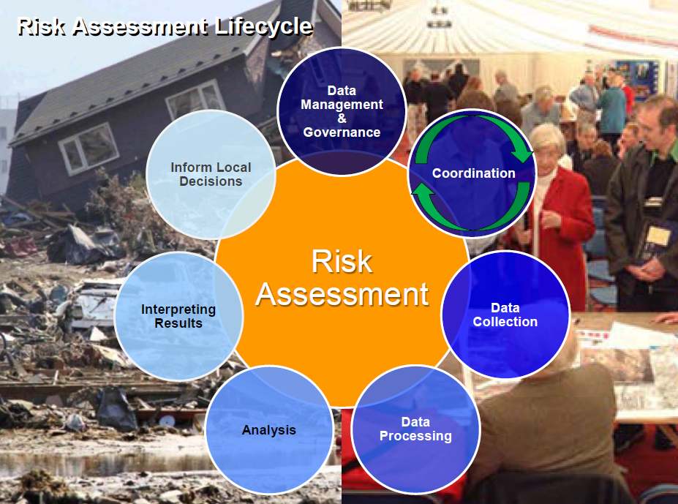Figure E-1: Multi-Hazard Risk Assessment Lifecycle. Courtesy of Cynthia McCoy, FEMA Region 10.

# Appendix F: Statewide Spatial Integration of Surface Tax Parcels

The surface tax GIS parcels are an integral part multi-hazard risk assessments since the GIS parcels combined with building characteristics of the assessment data generate the estimated building replacement costs. E-911 addresses can be joined to the tax parcels to further pin-point the structure’s site location and physical address.

Tax assessor data is formatted in ArcGIS software before updating the GBS and UDF inventories. The primary spatial field should be addresses instead of parcel polygon centroids unless a parcel has multiple addresses such as a trailer court.

### Figure F-1: Statewide Spatial Integration of Surface Tax GIS Parcels for Agency and Public Benefit.

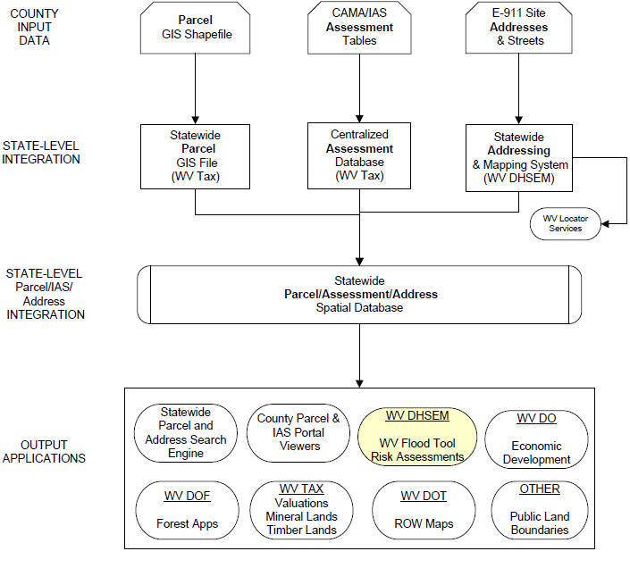

# Appendix G: 3D Flood Risk Visualization

3D map products were created for a test location in Berkeley County in order to enhance the communication of flood risk to structures in the 1% annual chance floodplain. Similar 3D maps can also be created for Morgan County if building footprints are available.

**Figure G-1** shows the results of a query in the West Virginia Flood Tool (WV Flood Tool) for the sample site on Baltimore Street in Martinsburg. The ground elevation and 1% annual chance flood Base Flood Elevation (BFE) indicate a depth of at least 1 foot of flood water at the site. How this will affect the building depends on whether or not the foundation is elevated above local BFE, and, if so, by how much.

A Google Earth view of the site is shown in **Figure G-2** for reference. Vertical representation is poor and buildings appear flattened or otherwise distorted. The use of solid shapes will reduce this problem.

The 3D rendering in **Figure G-3** shows the site structure highlighted in light blue surrounded by the anticipated depth of the 1% annual chance flood. Affected structures are indicated in red. Attributes for the highlighted structure appear at the bottom of the screen.

### Figure G-1: WV Flood Tool information for Sample 3D Site

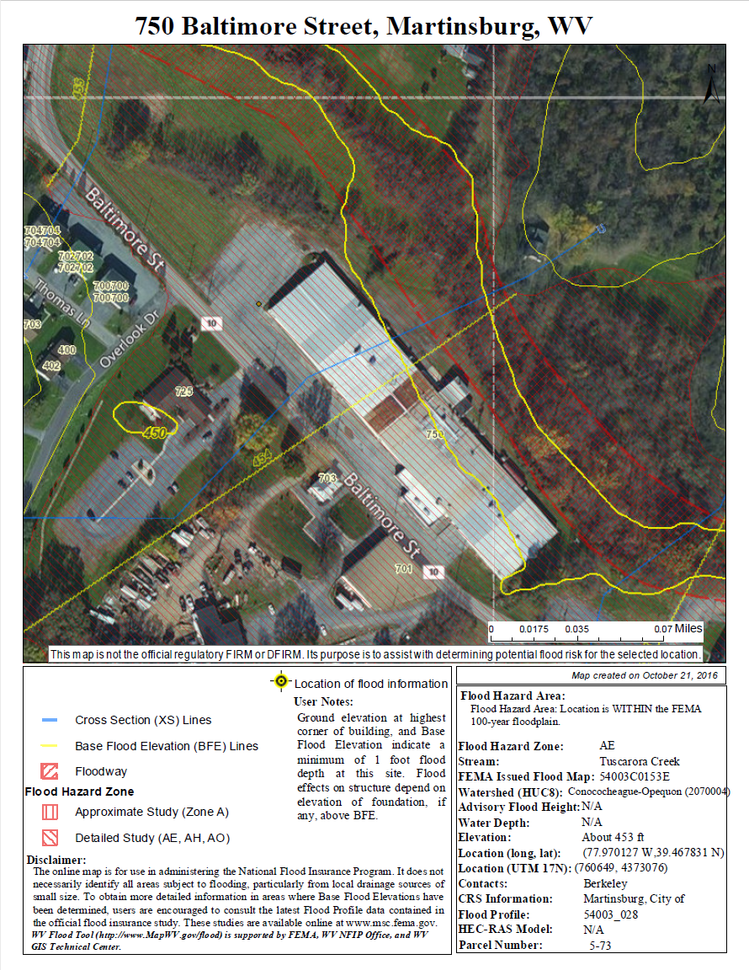

Figure G-2: Google Earth View of Sample 3D Site (Looking northwest)

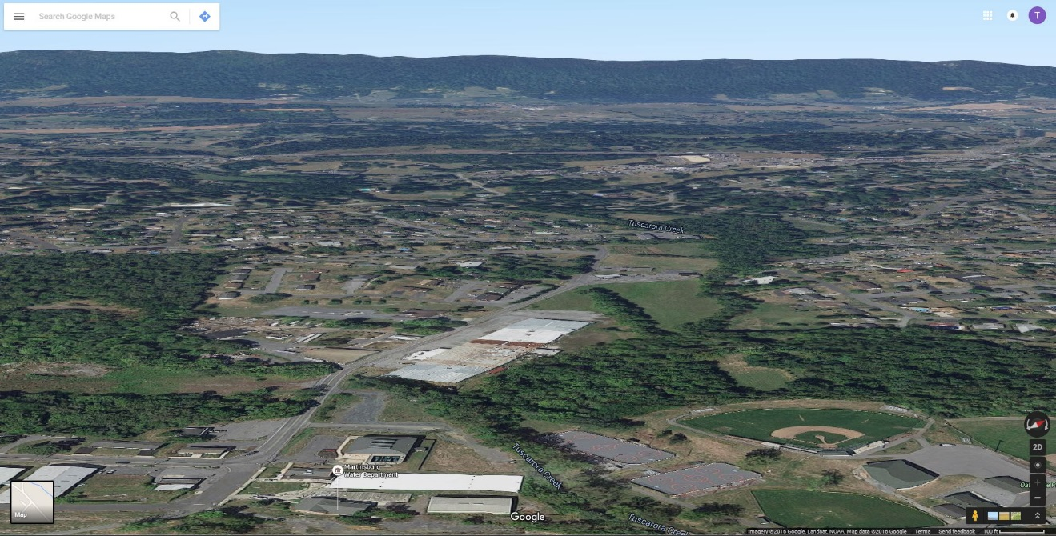

Figure G-3: 3D Rendering Showing Flood Depth and Flooded Structures (Red)

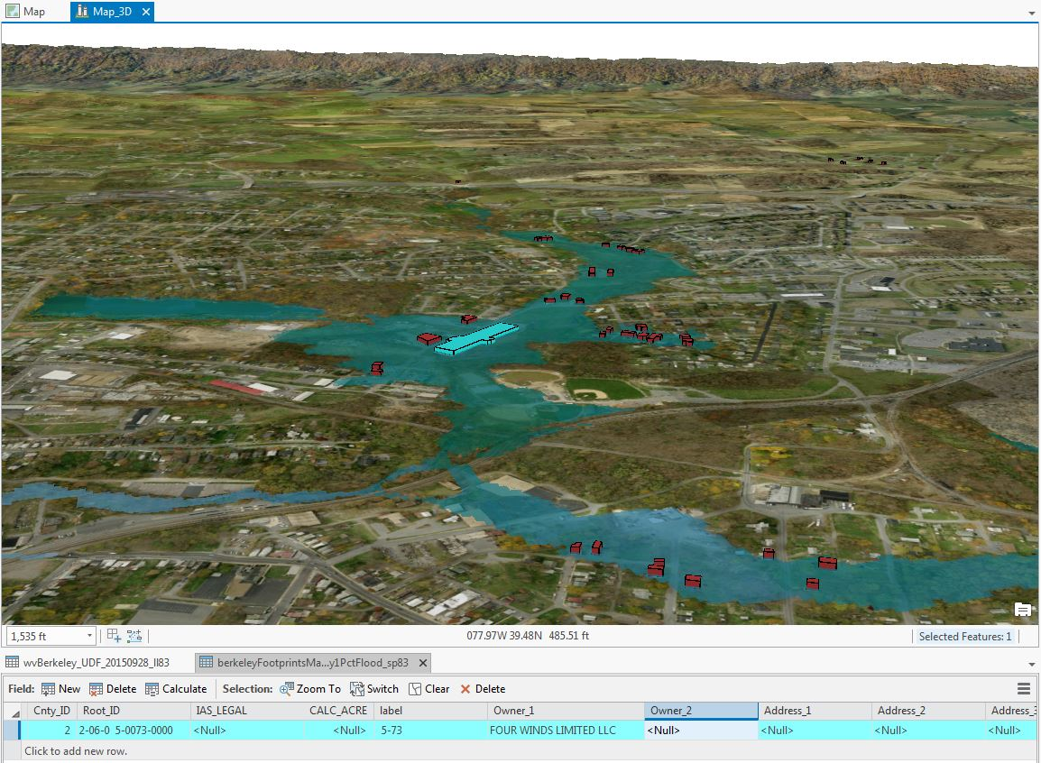

# Appendix H: Glossary of Risk Assessment Terminology

**1% Annual Chance Flood:** A one percent annual chance flood event (a.k.a. 100-year flood) has a one percent (1 in 100) chance of being equaled or exceeded during any given year. The one percent annual chance flood was selected in the early 1970s when the National Flood Insurance Program was tasked with mapping all floodplains in the U.S. It was considered a reasonable balance of protection and cost between the 0.5% (1 in 200) to 0.2% (1 in 500) variable reference used at the time by the U.S. Army Corps of Engineers for floodwater control structure design. The term 100 year (or 5 year or 500 year) refers to the expected frequency of return of a given flood event. The area of inundation associated with a given flood event is called the **floodplain** (e.g. 1% floodplain, etc.).

*Source:* [The 100 Year Flood Myth](https://training.fema.gov/hiedu/docs/hazrm/handout%203-5.pdf)*, Federal Emergency Management Agency, Region 10, handout.*

**CAMA/IAS:** Computer Assisted Mass Appraisal (CAMA) is the process of using a computer to assist in property tax appraisal and equity evaluation. Administered by the Tax Commissioner, the CAMA system for West Virginia is a centralized Oracle database also known as the Integrated Assessment System (IAS). A number of years ago the State Tax Department purchased real estate mass appraisal software called IAS. This software is installed on the network server in Charleston and is accessed through computers in each County Assessor's Office.

**Advisory Flood Heights:** The water surface elevation (WSEL), in feet, of the 1% annual chance (100-year) flood at a given location, as determined using hydrology and hydraulics (H&H) analysis and the best available elevation data. Add 5 feet to this value to allow for accuracy issues. This information is currently available for approximately 12% of the West Virginia counties.

<http://www.mapwv.gov/flood/content/documents/AFHhandout.pdf>

**Mitigated Properties:** Properties and land parcels located within floodplains that experience frequent flooding and damage due to flood events, may be altered, purchased, or have deed restrictions placed upon them by FEMA, in an effort to prevent loss of life and property damage. Property owners/communities with public lands in floodplains are compensated for their land, and the land usually becomes public green space. ([FEMA link](http://www.fema.gov/what-mitigation))  
([Youtube](http://www.youtube.com/watch?v=0UeWWoCNhcc&feature=youtube_gdata))

See more flood definitions at <http://mapwv.gov/flood/resources.html>