September 11, 2017

Brian Penix

State Hazard Mitigation Officer

WV Department of Military Affairs and Public Safety, Division of Homeland Security and Emergency Management

1900 Kanawha Blvd. East, Bldg. 1, Room EB-80

Charleston, WV 25305-0360

Phone: (304) 558-5380

E-Mail: Brian.M.Penix@wv.gov  
  
**Re:** Project Application for *Statewide Multi-Hazard Risk Assessments for West Virginia*

Dear Brian,

Enclosed is the HMGP application for site-specific risk assessments focused on flood and landslide hazards to be conducted for all 55 counties and 232 incorporated communities in West Virginia to supplement local and state hazard mitigation plans. The State Hazard Mitigation Officer refers to these studies for assessing and mitigating risks to communities in West Virginia as the Total Exposure in Floodplain (TEIF) and Total Exposure Area Landslide (TEAL). This statewide approach to multi-hazard risk assessments at the building or structure level for every community in the State and for a geographic area over 24,000 square miles may constitute one of the largest risk assessment studies ever undertaken in the Nation.

The HMGP project implementation and monitoring are for a period of three years at a total cost of three million dollars.

If you have any questions, or need clarifications, please do not hesitate to call.

Sincerely,

KurtD_signature_100

Kurt Donaldson  
Project Manager  
WV GIS Technical Center

West Virginia University  
e-mail: [kdonalds@wvu.edu](mailto:kdonalds@wvu.edu)



**State of West Virginia**

**Hazard Mitigation Grant Program Application**

**West Virginia Division of Homeland Security**

**& Emergency Management (WV DHSEM)**

**PROJECT NARRATIVE**

Applicant Name: **West Virginia University Research Corporation, on behalf of West Virginia University and its WV Geographic Information Systems Technical Center (WVGISTC)**

Principal Investigator: **Mr. Kurt Donaldson**  Position: **WVGISTC Manager**

Address: **98 Beechurst Avenue, 330 Brooks Hall, PO Box 6300, Morgantown, WV 26505-6300**

Phone Number: **(304) 293-9467** Email: **kdonalds@wvu.edu**

Organizational DUNS: **191510239**  **Employer Identification (FEIN): 550665758**

FIPS Code: **54 – West Virginia**

Communities Covered by This Application: **Statewide (55 counties and 272 communities)**

Contents

[PROJECT ABSTRACT SUMMARY 1](#_Toc491701665)

[BACKGROUND 4](#_Toc491701666)

[FLOOD RISK ASSESSMENT– SCOPE OF WORK 5](#_Toc491701667)

[LANDSLIDE RISK ASSESSMENT – SCOPE OF WORK 14](#_Toc491701668)

[GIS DATA DEVELOPMENT – SCOPE OF WORK 19](#_Toc491701669)

[RESPONSIBILITIES 26](#_Toc491701670)

[PROFESSIONAL SERVICES 27](#_Toc491701671)

[VENDOR DATA SUBCONTRACTS 28](#_Toc491701672)

[DELIVERABLES 29](#_Toc491701673)

[PERFORMANCE PERIOD 33](#_Toc491701674)

[BUDGET 33](#_Toc491701675)

[PROJECT TIMELINE/MILESTONES 34](#_Toc491701676)

[PERSONNEL 35](#_Toc491701677)

[CONTACT INFORMATION 37](#_Toc491701678)

[APPENDIX A: Resources 41](#_Toc491701679)

[APPENDIX B: Workflow for Building Inventory Tool and Flood Risk Assessment 45](#_Toc491701680)

[APPENDIX C: Composite Effective and Advisory Flood Products 49](#_Toc491701681)

[APPENDIX D: Landslide Literature Review and Proposed Methodology 50](#_Toc491701682)

[APPENDIX E: USACE Support Letter 58](#_Toc491701683)

[APPENDIX F: Local Hazard Mitigation Plan Deadlines 60](#_Toc491701684)

[APPENDIX G: Correlation To State Mitigation Plan Actions 62](#_Toc491701685)

# PROJECT ABSTRACT SUMMARY

*Overview:* Site-specific risk assessments focused on flood and landslide hazards will be conducted for all 55 counties and 232 incorporated communities in West Virginia to supplement local and state hazard mitigation plans. The State Hazard Mitigation Officer refers to these studies for assessing and mitigating risks to communities in West Virginia as the Total Exposure in Floodplain (TEIF) and Total Exposure Area Landslide (TEAL). This statewide approach to multi-hazard risk assessments at the building or structure level for every community in the State and for a geographic area over 24,000 square miles may constitute one of the largest risk assessment studies ever undertaken in the Nation.

*Mitigation Actions:* This project will implement priority statewide mitigation actions specified in the 2010 and 2013 State Hazard Mitigation Plan Updates (Appendix G) to include: (1) develop a standardized, comprehensive building exposure inventory that includes critical facilities and state-owned properties; (2) create a statewide parcel file for hazard identification and risk assessments; (3) standardize the data analysis process so that future local and state plan updates are consistent and utilize comparable methodologies; (4) conduct a statewide Hazus Level 2 flood risk analysis with more accurate local building inventories (user-defined facilities), effective DFIRM floodplains, and high-resolution elevation data; and (5) build a statewide landslide incident database for improving landslide susceptibility assessments. Standardized risk assessments for flood and landslide hazards will be made available to integrate into local and state hazard mitigation plan updates. The project team will coordinate with the USACE and other partners on supplementing hazard mitigation plans with dam/levee failure risk assessments.

*3 Major Work Tasks:* Because this project is quite large in scope, it is subdivided into three major work tasks: flood risk assessments, landslide risk assessments, and data development focused on building inventories and reference layers that are necessary for achieving quality hazard risk assessments at the structure level. Where possible the work tasks will be automated to improve efficiencies and reduce costs. In-house personnel will be assigned to specific work tasks according to their expertise and experience, while professional services and mapping contractors are required for certain aspects of the project.

*Flood Risk Assessments:* Structure-specific flood risk assessments to determine economic and social losses for 287 jurisdictions will be conducted for a riverine 1% annual chance flood event and with a Hazus Level 2 analysis. The Hazus flood loss models will use the best available building inventory and flood water depth to estimate physical building damage and content loss at the structure level, while computing debris removal and shelter requirements for people displaced at the aggregate level or from the general building stock. Building exposure values and loss estimates will be calculated using the same methodology for each local mitigation plan and therefore will allow for comparative studies of flood loss estimates among jurisdictions. Flood risk loss data, tables, and maps will be summarized at the community level and integrated into regional and state hazard mitigation plans. Pilot flood risk studies were completed for Berkeley and Morgan Counties with the preliminary building-specific risk data viewable on the WV Flood Tool. The USACE has provided a Letter of Support for this project and is the lead agency in providing dam/levee risk assessments for communities.

*3D Flood Visualizations:* 3D flood visualizations allow non-technical users to better understand flood risks to their property in feet of water rather than comprehending the adjacent base flood elevation. Consequently, where flood water depths exist the WV Flood Tool will display 3D flood visualizations at the individual building and neighborhood viewing scales. Individual Sketchup building models are pre-drawn with the appropriate flood visualization picture displayed according to the parcel building attributes (building use, stories, exterior type, etc.) and water depth value. The public not only can visualize the flood height for a specific structure but also link to interactive depth-damage tools for measuring the cost of damage. The second type of flood visualization occurs at the neighborhood scale for select communities. It requires extruding building footprints to known story heights and then symbolizing the sugar-cube or photo-textured 3D buildings according to the amount of physical damage. In addition, the project team will pursue innovative research applicable to the project and tap into the expertise of Dr. Trevor Harris, an Eberly Distinguished Professor of Geography at West Virginia University with research interests in 3D modeling, geovisualization, and exploratory spatial data analysis. All flood risk data and flood visualizations shall be shared with the local communities and published on federal and state geo-platforms such as the Risk MAP View of the WV Flood Tool ([www.mapwv.gov/Flood](http://www.mapwv.gov/Flood)).

*Landslide Risk Assessments:* County-level resolution landslide hazard risk assessments will be completed for all 55 counties and validated with a statewide inventory of known landslides. A more detailed and accurate landslide susceptibility model for West Virginia will be developed to include regional variations in geology, soils, and terrain. The scientific team for developing the landslide susceptibility model will include Dr. J. Steven Kite, an Associate Professor at West Virginia University Associate and a skilled geomorphologist who has conducted research on the many aspects of landslides. An interactive web map application named the WV Landslide Tool ([www.mapwv.gov/Landslide](http://www.mapwv.gov/Landslide)) will allow public access to the landslide incident inventory and landslide susceptibility maps. To demonstrate a more detailed landslide susceptibility map and quantitative risk analysis of buildings exposed to landslide hazards, a county-level scale pilot study was completed for Berkeley County. County-level resolution landslide hazard risk assessment maps and reports similar to the preliminary Berkeley County landslide study will be incorporated into the local and state hazard mitigation plans.

*Data Development for Quality Risk Assessments:* The first major data development activity includes creating a structure-level inventory of buildings and facilities in West Virginia exposed to multi-hazards. Although the primary focus of the project is to create more detailed flood and landslide risk assessments, the statewide building inventory can be valuable for other natural or man-made disasters to include dam or levee failures. The second principal data development activity involves the filling in the critical GIS reference layer data gaps that are preventing West Virginia from achieving detailed hazard identification and quality risk assessments: parcels, addresses, lidar, leaf-off imagery, and building-specific datasets.

*Building Inventories:* An important aspect of risk assessment studies involves creating inventories of all buildings and facilities exposed to multi-hazards in the State. Building replacement costs for an estimated 1.1 million structures will be computed from 1.5 million parcel centroids and tax assessment attributes. Replacement costs for tax-exempt properties such as educational, religious, and governmental buildings may have to be calculated from other national and state databases (e.g., Infogroup’s ReferenceUSA, WV Board of Risk) to generate a comprehensive structure-specific inventory of total building assets for West Virginia. A Building Inventory Tool funded by FEMA and developed by the Polis Center for pilot risk assessment studies in West Virginia will serve as a foundation for streamlining the building inventory process. All structures within effective and advisory floodplains shall be further pinpointed to the building footprint for more detailed flood risk analysis using the best available depth grids.

*GIS Reference Layers:*  A repository of high-quality reference data layers will result in more accurate risk assessments for communities. Consequently, the development of GIS data is necessary to fulfill the above requirements of county and state hazard risk assessments and products. Specifically, this project will focus on data gaps that are preventing West Virginia from achieving detailed hazard identification and risk assessments: parcels, addresses, lidar, leaf-off imagery, and building specific datasets. First, a complete and current statewide parcel layer is necessary to generate replacement values and 3D flood visualizations for individual buildings. Second, a complete statewide addressing and mapping file is required for pinpointing and identifying flood-risk structures in the flood hazard zones. Addresses are valuable for validating physical addresses in assessment databases and for identifying multiple structures within a property. A statewide addressing file is also important in that postal addresses of critical facilities and buildings can be geocoded to geographic coordinates for spatial analysis. Third, the acquisition of lidar data can generate high-resolution elevation surfaces which can result in more accurate floodplain boundary delineations and depth grids. Purchasing lidar should be a consideration for flood-risk communities which have a large number of structures in flood hazard areas exist and where high-resolution topography would result in better flood risk products. Fourth, the acquisition of new leaf-of imagery of 6-inch resolution or better should be considered for counties where properly identifying at-risk properties is essential. Since forests cover 78% of the State, leaf-off imagery without the forest canopy is required for identifying at-risk structures. Fifth, establishment level business data should be acquired if critical data gaps exist in the building inventory for computing replacement costs. A steering committee composed of members of the WV Division of Homeland Security and Emergency Management will assist in determining the data gaps and priorities. If there are no data restrictions then all digital data acquired from this project will reside in the public domain.

# BACKGROUND

This proposed HMGP project has been in the scoping and development stages for almost three years, with the project concept initiated by Cynthia McCoy when she was a Risk Analyst for FEMA Region III. Almost all the concepts of this proposal have been tested through pilot studies.

**Table 1.** Events associated with proposal development

|  |  |
| --- | --- |
| 2014 | Project concept initiated by Cynthia McCoy, FEMA Region III Risk Analyst |
| 2015 | West Virginia selected by FEMA to fund Building Inventory Tool for hazard assessments |
| 2015 | The Polis Center at IUPUI Completes Project Workflow for Hazus-MH Model Building Inventory for West Virginia |
| 2016 | WV GIS Technical Center (WVGISTC) completes flood and landslide risk assessments for pilot counties |
| 2016 | State Hazard Mitigation Office accepts preliminary proposals by WVGISTC for performing flood and landslide risk assessments for both local and state hazard mitigation plan updates for West Virginia |
| 2016 | WVGISTC presents to National Capitol Region HAZUS User Group (NCRHUG) about West Virginia’s statewide approach to multi-hazard risk studies |
| 2017 | WVGISTC provides a preliminary proposal to State Hazard Mitigation Officer regarding the development of GIS data necessary to fulfill the requirements of county and state hazard risk assessments and products |
| 2017 | WVGISTC processes nearly 1.5 million property records for Tax Year 2017 which included previously missing building specific data for commercial and industrial properties. This statewide building exposure data is published on the WV Flood Tool. |
| 2017 | WVGISTC publishes preliminary flood risk assessment data and 3D flood visualizations on the WV Flood Tool (www.mapwvw.gov/flood) and creates a precursor of the WV Landslide Inventory Tool (www.mapwv.gov/landslide) |
| 2017 | Project Submission |

# FLOOD RISK ASSESSMENT– SCOPE OF WORK

**Principal Contacts:** (WV GIS Technical Center , West Virginia University):

* Mr. Kurt Donaldson, principal investigator
* Mr. Eric Hopkins, co-investigator and task leader
* Dr. Maneesh Sharma, co-investigator
* Dr. Trevor Harris, co-investigator

**Purpose:** Create site-specific flood risk studies for 287 jurisdictions to supplement local and state hazard mitigation plans.

**Unit of Work:** The primary unit of work for flood risk assessments shall be the 55 counties unincorporated and 232 municipalities. The use of standardized methodologies for all jurisdictions allows for the risk assessments completed at the local level to be vertically aggregated into regional and state level flood studies.

**Pilot Studies:** Site-specific flood risk assessments were completed for Berkeley and Morgan Counties to exhibit flood risk deliverables and products. For demonstration purposes, the building-specific loss estimates for flood risk structures in these two counties were published to the RiskMAP View of the WV Flood Tool.

* Berkeley County Flood Risk Assessment:

<http://data.wvgis.wvu.edu/pub/temp/FEMA/FRA/P/Berkeley_FloodRiskRpt_20161031.pdf>

* Morgan County Flood Risk Assessment:

<http://data.wvgis.wvu.edu/pub/temp/FEMA/FRA/P/Morgan_FloodRiskRpt_20161031.pdf>

**Scope of Work:** Structure-specific flood risk assessments to determine economic and social losses for 287 jurisdictions will be conducted for a riverine 1% annual chance flood event and with a Hazus Level 2 analysis. The Hazus flood loss models will use the best available building inventory and flood water depth to estimate physical building damage and content loss at the structure level, while computing debris removal and shelter requirements for people displaced at the aggregate level or from the general building stock. Building exposure values and loss estimates will be calculated using the same methodology for each local mitigation plan and therefore will allow for comparative studies of flood loss estimates among jurisdictions.

A statewide geodatabase of site-specific flood risk structures (called “User-Defined Facilities”, or UDFs, in Hazus) located in the Effective/Advisory Floodplains will be created for flood loss models. Flood risk loss data, tables, and maps will be summarized at the community level and integrated into regional and state hazard mitigation plans. Pilot flood risk studies were completed for Berkeley and Morgan Counties with the preliminary building-specific risk data viewable on the WV Flood Tool. In addition, 3D flood risk visualizations will be created for flood-risk structures at both the individual building and neighborhood community viewing scales. Lastly, the USACE has provided a Letter of Support for this project and is the lead agency in providing dam/levee failure flood inundation assessments for communities.

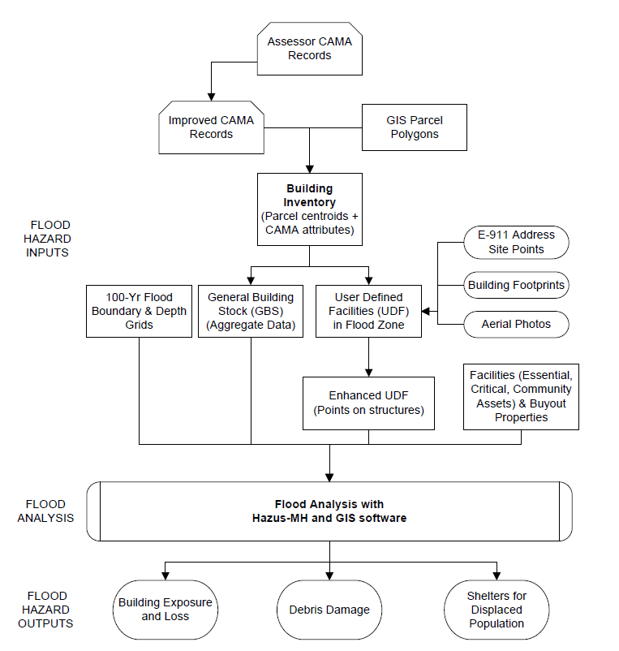

**Figure 1.** Workflow Diagram for Flood Risk Assessments

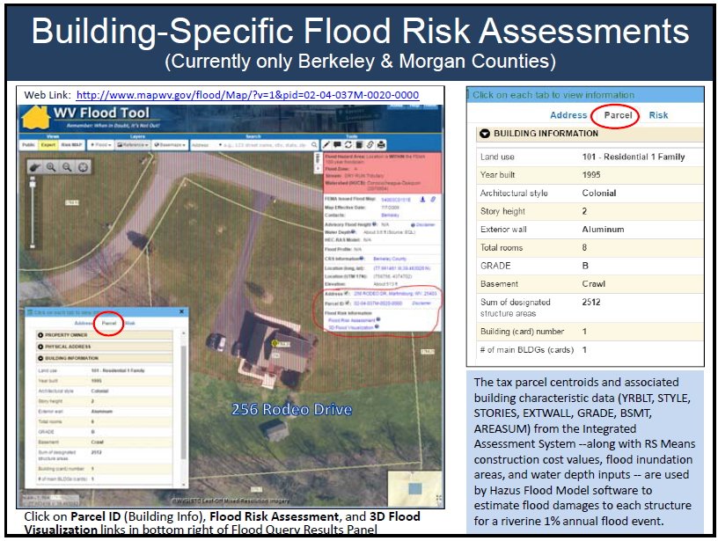

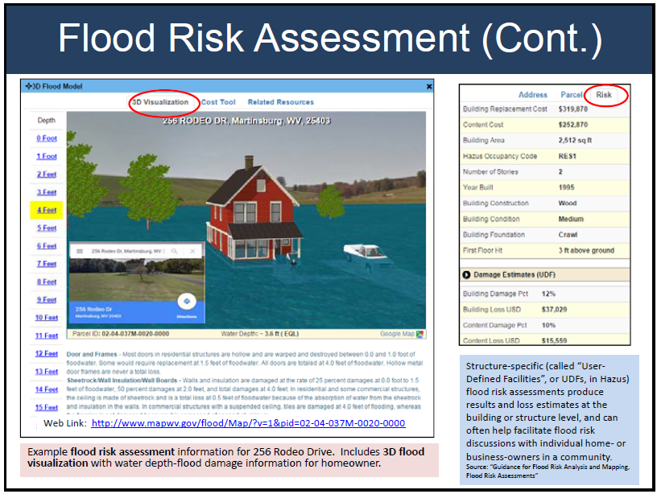

**Figure 2.** Building-specific flood risk assessments published on WV Flood Tool. More info: [http://data.wvgis.wvu.edu/pub/temp/FEMA/FRA/P/WV\_Flood\_Tool\_upgrades 20170716.pdf](http://data.wvgis.wvu.edu/pub/temp/FEMA/FRA/P/WV_Flood_Tool_upgrades%2020170716.pdf)

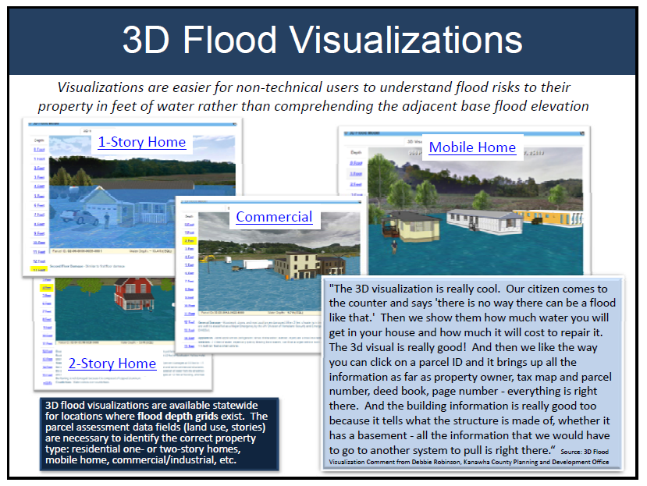

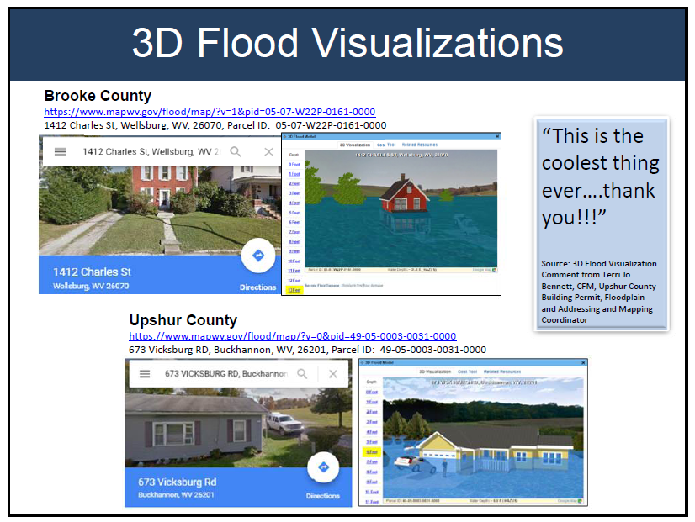

**Figure 3.** 3D building flood visualizations viewable in WV Flood Tool. More info: [http://data.wvgis.wvu.edu/pub/temp/FEMA/FRA/P/WV\_Flood\_Tool\_upgrades 20170716.pdf](http://data.wvgis.wvu.edu/pub/temp/FEMA/FRA/P/WV_Flood_Tool_upgrades%2020170716.pdf)

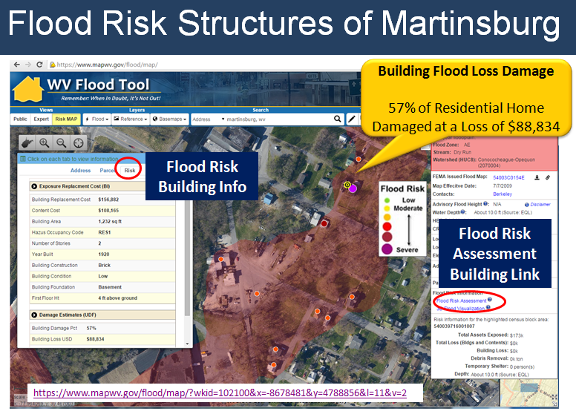

**Figure 4.** The Risk MAP View of the WV Flood Tool allows for viewing “User-Defined Facility” flood loss estimates at the building or structure level for a 1%-annual-chance flood event. Web link: <https://www.mapwv.gov/flood/map/?wkid=102100&x=-8678481&y=4788856&l=11&v=2>

**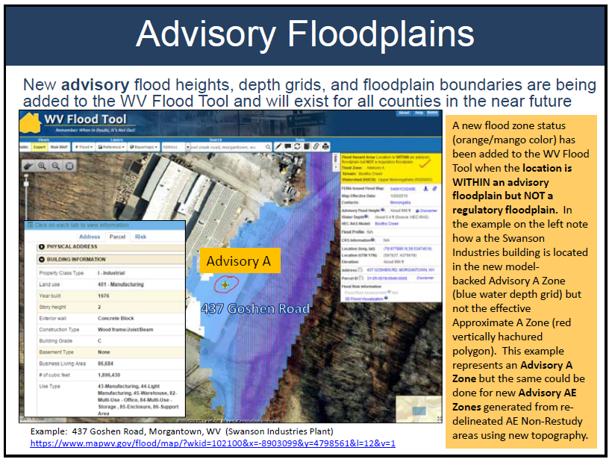**

**Figure 5.** Model-backed Advisory A Zone flood heights and depth grids exist for 27 West Virginia counties, with the remainder 28 counties to be completed in several years.

**Work Tasks:**

1. *Flood Risk Assessments for 322 Jurisdictions.* Site-specific flood risk assessments for 55 counties and 232 incorporated communities to supplement Local and State Hazard Mitigation Plans.
2. *Statewide Geodatabase of Site-Specific Flood Risk Structures.* Create a statewide geodatabase of site-specific flood risk structures (called “User-Defined Facilities”, or UDFs, in Hazus) located in the Effective/Advisory Floodplains.
3. *3D flood risk visualizations* for every individual at-risk structure and select communities.
4. *Assemble statewide composite flood risk products* to include a statewide advisory floodplain from Advisory A and Advisory AE flood zones, statewide flood depth and water surface elevation grids.
5. *Update State Hazard Mitigation Plan.* Integrate county flood assessment data and reports into state hazard mitigation plan. A standardized data analysis process will ensure that future local and state plan updates are consistent and utilize comparable methodologies.
6. *Publish flood risk data and products* on state (www.MapWV.gov/flood) and FEMA’s federal geo-platforms according to required specifications. Flood risk deliverables for every county include Flood Risk Assessment Report, maps, and GIS data.

**Table 2**. Work Tasks Descriptions for Flood Risk Assessments

| **Task** | **Work Task Description** | **Goals** |
| --- | --- | --- |
| Site-Specific Flood Risk Assessments | **TASK 1: [Site-specific flood risk assessments]** Complete Hazus Level 2 flood risk assessments for 55 counties and 232 incorporated communities to supplement Local and State Hazard Mitigation Plans] The flood risk assessments for the 287 study areas are calculated for a riverine 1% annual chance flood event with Hazus flood loss models using as inputs the flood inundation area and composite of the best available depth grids.   * Conduct Hazus Level 2 flood loss analysis using the best available building inventory and water depth grids to estimate physical building damage and content losses at the structure level. Execute Hazus models for flood debris and flood shelter requirements. Summarize inventory and loss data at the community level, stream name, flood zone, etc. * See Appendix B for more detailed procedures for creating flood risk assessments * Prototype Flood Risk Supplemental Reports: * Berkeley County (October 2016)   <http://data.wvgis.wvu.edu/pub/temp/FEMA/FRA/P/Berkeley_FloodRiskRpt_20161031.pdf>     * Morgan County (October 2016)   <http://data.wvgis.wvu.edu/pub/temp/FEMA/FRA/P/Morgan_FloodRiskRpt_20161031.pdf>   * Obtain best available data from county and state sources * Coordinate meetings with state, regional, and county hazard planners and GIS data stewards regarding risk assessments. | Goal F1 |
| Statewide Geodatabase of Site-Specific Flood Risk Structures | **TASK 2: [Statewide Geodatabase of Site-Specific Flood Risk Structures]** Create a statewide geodatabase of site-specific flood risk structures (called “User-Defined Facilities”, or UDFs, in Hazus) located in the Effective/Advisory Floodplains attributed with building exposure and flood loss values.   * Spatially pinpoint Building Inventory parcel centroids to the building centroids using the best available data: E-911 addresses, building footprints, aerial imagery, and other reference data. Use manual or semi-automated methods to execute this task. * Attributes to include:   + Building exposure values and flood loss values   + Building specific information (year built, square footage, construction type, stories, etc.)   + Property classification and property/building address information. * Add missing structures not captured in parcel database. | Goal F2 |
| 3D Flood Risk Visualizations | **TASK 3: [3D flood risk visualizations]** 3D visualizations for every individual flood-risk structure and neighborhood scale flood visualizations for select communities.   * Create 3D flood visualizations for every flood-risk structure in 100-year floodplain. Data requirements:   + Building specific data (building use, exterior wall, number of stories)   + Flood Layers: Flood Hazard Area, Depth Grid, WSEL Grid   + Sketchup Building Models * Generate 3D flood neighborhood visualizations for select communities. Data requirements:   + Building specific data (building use, exterior wall, number of stories)   + Flood Layers: Flood Hazard Area, Depth Grid, WSEL Grid   + Building footprints to generate sugar-cube or photo-textured 3D buildings | Goal F3 |
| Statewide Composite Flood Risk Products | **TASK 4: [Assemble statewide composite flood risk products]** Composite flood risk products include a statewide advisory floodplain from Advisory A and Advisory AE flood zones, statewide flood depth and water surface elevation grids. The target cell resolution for the composite flood risk grids is 5 feet. | Goal F4 |
| Update State Hazard Mitigation Plan. | **TASK 5: [Update State Hazard Mitigation Plan]** Integrate county flood assessment data and reports into state hazard mitigation plan. A standardized data analysis process will ensure that future local and state plan updates are consistent and utilize comparable methodologies. | Goal F5 |
| Publish Flood Risk Data and Products | **TASK 6: [Publish flood risk data and products]** Publish flood risk data and products on state (www.MapWV.gov/flood) and FEMA’s federal geo-platforms according to required specifications. Flood risk deliverables for every county include Flood Risk Assessment reports, maps, and GIS data.   * Reports   + Publish risk data in county reports to WV Flood Tool   + Integrate county flood risk studies into regional and state hazard mitigation plan updates. * Maps   + Building Exposure   + Physical damage map of buildings and facilities (large size)   + Debris map   + Population Displacement / Shelter map   + Select 3D maps (if building footprints available)   + Miscellaneous maps * GIS Data   + Building Inventory replacement costs   + User Defined Facilities loss estimates   + GIS parcel polygons   + E-911 Addressable Structures   + Essential Facilities   + Critical Facilities   + Community Assets   + Mitigated Properties   + Hazuus-MH .hpr files (available on request) | Goal F6 |
| System Admin Tasks for Flood Risk Assessments | **TASK 7: [PROVIDE SYSTEM ADMINISTRATION SERVICES] Maintain application and web map services for Flood Risk Assessments work task**   * Project Management, Specifications, Standards, Contract Scope of Work, Data Integration, Quality Assurance, Progress Reports. * Perform system administration and maintenance of applications. Technical support services include hardware and software operating system upgrades. Maintain backup system with virtual servers. Maintain a high level of performance of application including the processing of troubleshooting calls regarding system issues. Update monthly security patches on all servers. Install and maintain all necessary hardware and software licenses. * Publish and maintain all local web map services that support flood risk assessments work task. |  |

**Table 3.** Timeline for Flood Risk Assessments

|  |  |  |  |
| --- | --- | --- | --- |
| Year  Tasks | **Year 1** | **Year 2** | **Year 3** |
| **TASK 1:** [Site-specific flood risk assessments] | 9 counties | 22 counties | 22 counties |
| **TASK 2:** [Statewide geodatabase of site-specific flood risk structures] |  |  |  |
| **TASK 3:** [3D flood risk visualizations] |  |  |  |
| **TASK 4:** [Assemble statewide composite flood risk products] |  |  |  |
| **TASK 5:** [Update State Hazard Mitigation Plan] |  |  |  |
| **TASK 6:** [Publish flood risk data and products] |  |  |  |

# LANDSLIDE RISK ASSESSMENT – SCOPE OF WORK

**Principal Contacts:** (West Virginia University):

* Mr. Kurt Donaldson, principal investigator
* Dr. Maneesh Sharma, co-investigator and task leader
* Dr. Steven Kite, co-investigator

**Purpose:** To create 55 county-scale landslide risk assessments to supplement local and state hazard mitigation plans.

**Pilot Study:** A pilot landslide risk assessment was created for Berkeley County. The assessment included a county-scale landslide susceptibility map and building exposure statistics.

* Berkeley County Landslide Risk Assessment: <http://data.wvgis.wvu.edu/pub/temp/FEMA/FRA/P/Landslide_Susceptibility_Pilot_Study_BerkleyCounty_20160408.pdf>

**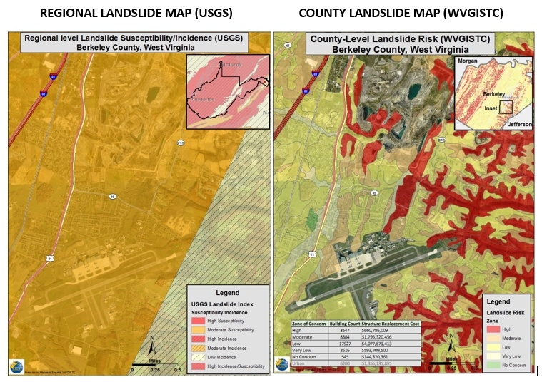Background:** The present West Virginia Statewide hazard mitigation plan provides statewide guidance to reduce loss and prevent injury from natural and man-made hazards. The landslide risks addressed in the 2013 West Virginia Statewide hazard mitigation plan are mainly based on USGS work on “Landslide overview map of Conterminous United States” (Radbruch-Hall et.al., 1982). The study delineates areas of reported landslides and areas which are susceptible to landslide. The focus of the USGS study was to identify areas of landslide risk at the regional level (digitized polygons from the study are at a scale of 1:3,750,000). In this study, most of the West Virginia is displayed as a high-risk area. However, this generalized delineation of potential landslide areas does not help in hazard mitigation planning on local and county scales. For better land-use planning, there is a strong need to develop a better methodology that can show more granularity in landslide hazard identification at the sub-county level, and help identify the slopes that are most susceptible to landslide at a higher resolution.

This project will develop the methodology and update landslide risk and hazard assessment at county scale. Landslides may be controlled by the topography (inclination and shape of the slope), the lithology (physical and geomechanical characteristics), the geological structure (dip, fault, discontinuity), the hillslope hydrology (pore pressures, water contents) or a combination of all these factors. Apart from this, they are also controlled by triggering factors such as static or dynamic load, change in land use, rainfall, etc. Different areas in West Virginia have different geomorphology, geology and land use pattern. We have created a prototype county-level landslide susceptibility report for Berkley county. Figure 6 shows the difference in Landslide susceptibility between USGS and WVGISTC maps

**Figure 6.** Landslide susceptibility map showing generalized USGS map and detailed WVGISTC map

**Scope of Work:** County-level resolution landslide hazard risk assessments will be completed for all 55 counties and validated with a statewide inventory of known landslides. A more detailed and accurate landslide susceptibility model for West Virginia will be developed to include regional variations in geology, soils, and terrain. The scientific team for developing the landslide susceptibility model will include Dr. J. Steven Kite, an Associate Professor at West Virginia University and a skilled geomorphologist who has conducted research on the many aspects of landslides. An interactive web map application named the WV Landslide Tool ([www.mapwv.gov/Landslide](http://www.mapwv.gov/Landslide)) will allow public access to the landslide incident inventory and landslide susceptibility maps. To demonstrate a more detailed landslide susceptibility map and quantitative risk analysis of buildings exposed to landslide hazards, a county-level scale pilot study was completed for Berkeley County. County-level resolution landslide hazard risk assessment maps and reports similar to the preliminary Berkeley County landslide study will be incorporated into the local and state hazard mitigation plans.

**Methodology:** We propose to research heuristic and statistical methods for landslide susceptibility and hazard analysis for counties in West Virginia. Previous studies by Professor Kite in Horse Shoe Run Watershed, Lower New River George and by the West Virginia Geological and Economic Survey will help us in refining our methodology. In addition, the research will investigate how regional geological, soil, and terrain variations affect the landslide risk assessment models. Lastly, the building assets exposed to landslide hazards will be included in the landslide assessments. See Appendix D for a detailed explanation by Dr. Maneesh Sharma of the proposed methodology and literature review.

**Work Tasks:**

1. A *statewide landslide incident inventory* from various sources: WVGES, WVDOT, USGS, FEMA landslide buy-out properties, etc.
2. A more detailed and accurate *landslide susceptibility model* for West Virginia which includes regional variations in geology, soils, and terrain.
3. *55 county-level resolution landslide susceptibility maps and reports* to supplement local hazard mitigation plans.
4. *A Landslide Tool* (www.mapwv.gov/landslides), an interactive web map application that provides online access to landslide incidents and landslide susceptibility zones.
5. *Update State Hazard Mitigation Plan* with current and landslide hazard identification and risk assessment.

**Table 4**. Work Task Descriptions for Landslide Risk Assessments

| **Task** | **Work Task Description** | **Cost** |
| --- | --- | --- |
| Landslide  Inventory | **TASK 1: [LANDSLIDE INVENTORY] – Data Collection**   * Digitize historical landslide records. Digitize historical landslide data in ESRI feature class format. WVGISTC already houses geo-referenced landslide maps from Landslide study done in 1976 by State Geological Survey. Maps can be found at <http://wvgis.wvu.edu/data/dataset.php?ID=277> * Inventory and collect existing landslide data from various agencies (WVGES, WV DOT, WV DHSEM, USGS, etc.). Publish landslide incidences to an online interactive inventory (www.mapwv.gov/landslide). * Outreach and coordinate with city engineers, planners, emergency responders, etc. for local knowledge about landslides * Employ high-resolution imagery and lidar for verification of known landslides. | Goal L1 |
| Landslide  Method  Development | **TASK 2: [LANDSLIDE METHOD DEVELOPMENT] – Methodology and validation of landslide susceptibility models**   * *Literature review.* Conduct a literature review to identify different landslide methodologies * *Research methodology to assess landslide risk.* Research various landslide methodologies for different geological regions of West Virginia. Determine the appropriate methodology for specific sub-regions within the state * *Validation.* Validate the different landslide methods with the inventory of existing landslide incidences * *Consultations.* Consult on the methodology development and validation of landslide models with landslide experts to include the State Geological Survey, WV DOT, and other stakeholders. The lead landslide expert is Professor Steve Kite, a geomorphologist in the Department of Geology and Geography at WVU. | Goal L2 |
| County level landslide map and report generation | **TASK 3: [COUNTY LEVEL LANDSLIDE MAP AND REPORT GENERATION] – Generation of landslide County maps**   * Create programming scripts to automate the generation of county landslide risk maps * Tweak and re-run models based on local feedback * Review , validate, and publish county-scale landslide risk hazard maps. For all 55 counties a landslide maps will be created. * Compute building exposure values by landslide susceptibility zones | Goal L3 |
| Web Application | **TASK 4: [WEB APPLICATION] – Interactive web application of landslide incidents and susceptibility zones**   * Create an interactive web application for viewing known landslide incidence and susceptibility in West Virginia (www.mapwv.gov/landslide) * Users will be able to query information from these model layers | Goal L4 |
| Update State Hazard Mitigation Plan | **TASK 5: [UPDATE STATE PLAN] – Update State Hazard mitigation plan**   * Write description of landslide section for State hazard mitigation master plan that includes regional geomorphological and geological variations in West Virginia. * Create a statewide landslide hazard map * Create digital print-ready landslide risk maps on topographic or imagery base layer * Summarize building exposure values according to landslide susceptibility zones for counties and municipalities | Goal L5 |
| System Admin for Landslide Assessments Work Task | **TASK 6: [PROVIDE SYSTEM ADMINISTRATION SERVICES] – Maintain application and web map services for Landslide Risk Assessments work task**   * Project Management, Specifications, Standards, Contract Scope of Work, Data Integration, Quality Assurance, Progress Reports. * Perform system administration and maintenance of applications. Technical support services include hardware and software operating system upgrades. Maintain backup system with virtual servers. Maintain a high level of performance of application including the processing of troubleshooting calls regarding system issues. Update monthly security patches on all servers. Install and maintain all necessary hardware and software licenses. * Publish and maintain all local web map services that support WV Landslide Inventory web application |  |

**Table 5.** Timeline for Landslide Risk Assessments

|  |  |  |  |
| --- | --- | --- | --- |
| Year  Tasks | **Year 1** | **Year 2** | **Year 3** |
| **TASK 1:** [Landslide Inventory] |  |  |  |
| **TASK 2:** [Landslide Method Development] |  |  |  |
| **TASK 3:** [County Level Landslide Map Generation] |  | 25 counties | 30 counties |
| **TASK 4:** [Web Application] |  |  |  |
| **TASK 5:** [Update State Plan] |  |  |  |
| **TASK 6: [**Provide System Administration Services**] =** |  |  |  |

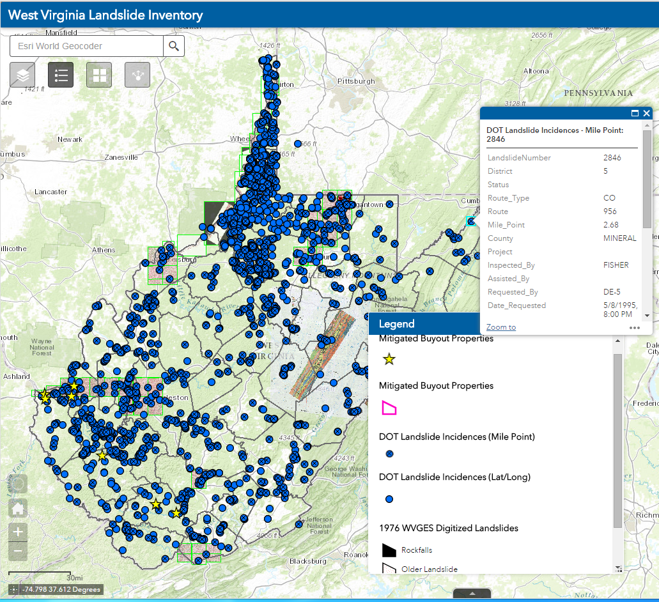

**Figure 7.** Prototype web application for viewing landslide incidence and susceptibility in West Virginia (www.mapwv.gov/landslide)

# GIS DATA DEVELOPMENT – SCOPE OF WORK

**Principal Contacts:**

* Mr. Kurt Donaldson, principal investigator
* Mr. Kevin Kuhn, co-investigator and task leader
* Mr. Frank LaFone, co-investigator

**Purpose:** To develop building inventory and GIS reference data necessary to fulfill the requirements of county and state hazard risk assessments and products.

**Scope of Work:** The scope of work is subdivided into developing (1) *building inventories* with replacement or resell values and (2) *reference data* to include parcels, addresses, lidar, imagery, and building-specific data.

*Building Inventories:* An important aspect of risk assessment studies involves creating inventories of all buildings and facilities exposed to multi-hazards in the State. Building replacement costs for an estimated 1.1 million structures will be computed from 1.5 million parcel centroids and tax assessment attributes. Replacement costs for tax-exempt properties such as educational, religious, and governmental buildings may have to be calculated from other national and state databases (e.g., Infogroup ReferenceUSA, WV Board of Risk) to generate a comprehensive structure-specific inventory of total building assets for West Virginia. A Building Inventory Tool funded by FEMA and developed by the Polis Center for pilot risk assessment studies in West Virginia will serve as a foundation for streamlining the building inventory process. All structures within effective and advisory floodplains shall be further pinpointed to the building footprint for more detailed flood risk analysis using the best available depth grids.

*GIS Reference Layers:*  A repository of high-quality reference data layers will result in more accurate risk assessments for communities. Consequently, the development of GIS data is necessary to fulfill the above requirements of county and state hazard risk assessments and products. Specifically, this project will focus on data gaps that are preventing West Virginia from achieving detailed hazard identification and risk assessments: parcels, addresses, lidar, leaf-off imagery, and building specific datasets. First, a complete and current statewide parcel layer is necessary to generate replacement values and 3D flood visualizations for individual buildings. Second, a complete statewide addressing and mapping file is required for pinpointing and identifying flood-risk structures in the flood hazard zones. Addresses are valuable for validating physical addresses in assessment databases and for identifying multiple structures within a property. A statewide addressing file is also important in that postal addresses of critical facilities and buildings can be geocoded to geographic coordinates for spatial analysis. Third, the acquisition of lidar data can generate high-resolution elevation surfaces which can result in more accurate floodplain boundary delineations and depth grids. Purchasing lidar should be a consideration for flood-risk communities which have a large number of structures in flood hazard areas exist and where high-resolution topography would result in better flood risk products. Fourth, the acquisition of new leaf-off imagery of 6-inch resolution or better should be considered for counties where properly identifying at-risk properties is essential. Since forests cover 78% of the State, leaf-off imagery without the forest canopy is required for identifying at-risk structures. Fifth, establishment level business data should be acquired if critical data gaps exist in the building inventory for computing replacement costs. West Virginia University has an account with the Infogroup company’s Reference USA database that allows search access to about 800,000 business (n=78,030), healthcare (n=6,433), and white page (n=780,169) addresses in West Virginia. However, the current WVU user account is limited to 250 record downloads per search. To assist in determining the data gaps and priorities listed above, a pro tem committee composed of members of the WV Division of Homeland Security and Emergency Management will be formed. If there are no data restrictions then all digital data acquired from this project will reside in the public domain.

**Work Tasks:**

1. Create a *structure-level inventory* of all buildings and facilities in West Virginia exposed to multi-hazards.
2. Fill in the *GIS data gaps* that are preventing West Virginia from achieving detailed hazard identification and quality risk assessments: parcels, addresses, lidar, leaf-off imagery, and building specific datasets.
3. Report *data gaps* at the county level for key geodatabase reference layers (parcels, addresses/geocoding, imagery, elevation, building footprints, critical infrastructure, etc.) that are hindering quality risk assessments.
4. Exchange the *best available risk assessment information* among local, state, and federal geo-platforms.

**Table 6**. Work Task Descriptions for Data Development

| **Task** | **Work Task Description** | **Goal** |
| --- | --- | --- |
| Create Statewide Building Inventory | **TASK 1: [Statewide Building Inventory] –**  Create a *structure-level inventory* of all buildings and facilities exposed to multi-hazards. The inventory includes each building’s replacement or resell value and allows for site-specific risk analysis. A *Building Inventory Tool* will streamline the process of identifying buildings assets exposed to multi-hazards and for executing Hazus flood loss models at the building or structure level. The Building Inventory Tool requires further refinements like updating the building construction tables for commercial/industrial properties and including building information from non-assessment sources. In addition, the Building Inventory Tool should be upgraded to the most current Hazus 4.0 full versioned software release.   * Develop a standardized, comprehensive building exposure inventory that includes critical facilities and state-owned properties. * Building exposure values will be computed from building specific information or acquired from other sources like appraisal and insurance databases. These replacement values are used by loss estimation models, such as Hazus, to derive building and content loss values. * Taxable properties are organized by occupancy or land use categories: Residential, Agricultural, Commercial, Industrial, Government, Education, and Religion. Information for tax-exempt properties are collected from national and state databases (e.g., Infogroup ReferenceUSA, WV Board of Risk) to generate a comprehensive structure-specific inventory of total building assets for West Virginia. * All critical facilities and individual structures located in the Regulatory/Advisory floodplains are spatially adjusted to the building centroid and not the parcel centroid. If available, building footprints are used to further enhance the process of building identification. * Data sources for developing and validating the building replacements costs and building location: property parcels and assessor attributes, E-911 addresses, leaf-off imagery, and building footprints. Supplemental sources for non-taxable structures include school and insurance databases. * Update State Hazard Mitigation Plan with detailed building exposure information | Goal D1 |
| Fill in Critical GIS Data Gaps for Quality Risk Assessments | * **TASK 2: [Fill in GIS Data Gaps**] – Fill in the GIS data gaps that are preventing West Virginia from achieving detailed hazard identification and quality risk assessments: parcels, addresses, lidar, leaf-off imagery, and building specific datasets. * A continuously maintained statewide digital parcel boundary file with building-specific attributes for determining building exposure costs (Priority 1).   + A *statewide digital parcel boundary file* by mapping missing or obsolete parcels for 12 counties (Priority 1a).   + All 55 county assessors have *digital tax maps statewide* by funding select counties with paper-to-digital conversion. This objective assists counties still producing tax maps manually in migrating to a sustained digital maintenance program so that the capital investment of the paper-to-digital parcel boundary conversion – or the primary objective of a current statewide parcel boundary file -- is not lost over time. A cost share may be required by select counties (Priority 1b).   + The parcels and addresses are the most critical data layers for achieving quality hazard risk assessments. Creation of a statewide parcel file is a high priority mitigation action (# 2013-16) of the 2013 WV State Hazard Mitigation Plan. It is estimated 33 of the 606 tax districts (5%) in West Virginia have not been digitized or have obsolete/erroneous digital parcels. * A *statewide address and mapping file* by mapping missing or incorrect addresses for 3 counties (Priority 2). * Acquire *lidar elevation data* to construct water surface elevation and depth grids (Priority 3) for select flood hazard areas. * Collect *leaf-off imagery* for an estimated 3,000 square miles in West Virginia. Targeted areas are based on repeated disaster declarations, cost-share, benefits to other data collection projects, etc. (Priority 4). * Acquire *business level data* from vendors if critical data gaps exist in the building inventory for computing replacement costs. (Priority 5). WVU has an account with the Infogroup company’s Reference USA database that allows search access to 8000,000 business (n=78,030), healthcare (n=6,433), and white page (n=780,169) addresses in West Virginia. However, the current WVU user account is limited to 250 record downloads per search. | Goal D2 |
| Report Data Gaps to Stakeholders | **TASK 3: [Report Data Gaps**] – Report data gaps at the county level for key geodatabase reference layers (parcels, addresses/geocoding, imagery, elevation, building footprints, critical infrastructure, etc.) that are hindering quality risk assessment studies. Provide recommendations to the appropriate organizations to improve data management and governance. | Goal D3 |
| Exchange Risk Assessment Information | **TASK 4: [Exchange Risk Assessment Information**] – Exchange the best available risk assessment information among local, state, and federal geo-platforms.   * Incorporate historical hazard data into risk assessment studies. * Use online map validation tools such as ArcGIS online viewer applications for local communities and floodplain managers to validate risk assessment data. * Assist State Hazard Mitigation Office in updating Local HMGP applications so that hazard data collections and analysis are consistent and utilize comparable methodologies for both local and state plan updates. Serve as Data Clearinghouse for Statewide Hazard Data | Goal D4 |
| System Admin for Data Development Work Task | **TASK 5: [PROVIDE SYSTEM ADMINISTRATION SERVICES] Maintain application and web map services for Data Development work task**   * Project Management, Specifications, Standards, Contract Scope of Work, Data Integration, Quality Assurance, Progress Reports. * Perform system administration and maintenance of applications. Technical support services include hardware and software operating system upgrades. Maintain backup system with virtual servers. Maintain a high level of performance of application including the processing of troubleshooting calls regarding system issues. Update monthly security patches on all servers. Install and maintain all necessary hardware and software licenses. * Publish and maintain all local web map services that support data development activities |  |

**Table 7.** Priority Data Collections

|  |  |
| --- | --- |
| **Priority** | **Data Theme** |
|  |  |
| 1 | Continuously maintained Surface Tax Parcels   * Statewide Digital Parcel Boundary File (Priority 1A) * Sustained Digital Parcel Maintenance by Assessor Offices (Priority 1B) |
| 2 | Site Addresses |
| 3 | Lidar Elevation Data |
| 4 | Leaf-Off Aerial Imagery |
| 5 | Business Level Data |

**Table 8.** Timeline for GIS Data Development

|  |  |  |  |
| --- | --- | --- | --- |
| Year  Tasks | **Year 1** | **Year 2** | **Year 3** |
| **TASK 1:** [Statewide Building Inventory] |  |  |  |
| **TASK 2:** [Fill in GIS Data Gaps] |  |  |  |
| **TASK 3:** [Report Data Gaps] |  |  |  |
| **TASK 4:** [Exchange Risk Assessment Information] |  |  |  |
| **TASK 5:** [Provide System Administrative Services] |  |  |  |

**Targeted Collection Areas** (Data Development Goal #2)

Data collection efforts to fill in GIS data gaps for accurate hazard risk assessments are further prioritized by data theme, funding availability, potential hazard risk, and local cost share.

**Table 9.** Targeted Areas

|  |  |  |  |  |  |  |
| --- | --- | --- | --- | --- | --- | --- |
| **#** | **Missing or Obsolete Data Parcels** | **Finished digital tax maps for sustained digital parcels** | **Missing or Incorrect Addresses** | **Lidar for Flood Risk Grids** | **Leaf-Off Imagery** | **Business Level Data** |
|  | **Priority 1A** | **Priority 1B** | **Priority 2** | **Priority 3** | **Priority 4** | **Priority 5** |
| 1 | Boone | Boone | Morgan | Select flood hazard areas TBD | Select counties TBD | Statewide building classes such as churches, govt. bldgs., etc. |
| 2 | Braxton | Braxton | Roane |
| 3 | Calhoun | Calhoun | City of Elkins |
| 4 | Clay | Clay |  |
| 5 | Jackson | Jackson |  |
| 6 | Logan | Logan |  |
| 7 | McDowell | McDowell |  |
| 8 | Roane | Roane |  |
| 9 | Tucker | Tucker |  |
| 10 | Tyler | Tyler |  |
| 11 | Wirt | Wirt |  |
| 12 | Wyoming | Wyoming |  |
|  |  |  |  |
| **Price** | $2.30 per parcel | $3.50 per parcel (requires county assessor’s participation) | $2.43 per address | $230 per square mile – prices vary depending on lidar specifications and delivered products | $70 per square mile | Not to exceed $10K purchase |

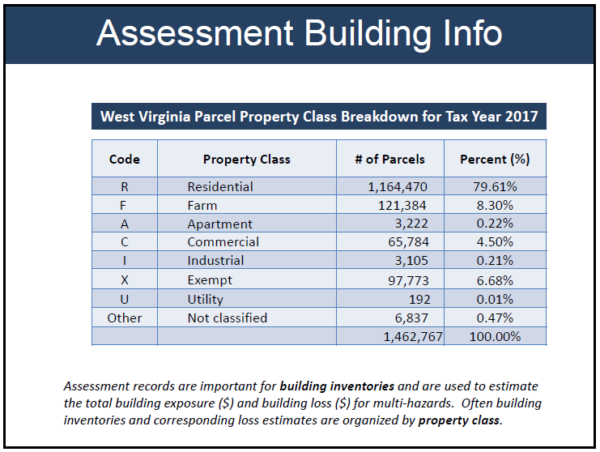

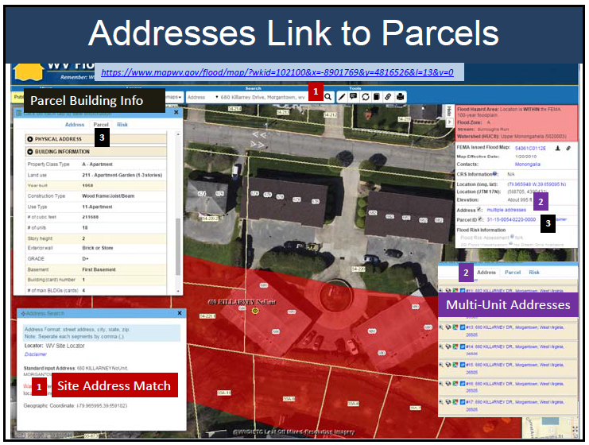

**Figure 9.** Data Development Example 2: Addresses are valuable for validating physical addresses in assessment databases and for identifying multiple structures within a property.

**Figure 8.** Data Development Example 1: Parcel attributes are important for determining building replacement values for taxable properties.

# RESPONSIBILITIES

**Table 10.** Responsibilities of FEMA, SHMO, WVGISTC, and RPDC’s.

|  |  |
| --- | --- |
| ***Entity*** | ***General Responsibilities*** |
| *FEMA* | * *High-level coordination* * *Marketing and educational component* * *Solicit state and local data participation* |
| *WV State Hazard Mitigation Officer* | * *Administer grants and funding* * *Oversee local and state hazard mitigation plan updates* * *Publish local HMGP application template that conforms to WV statewide approach to multi-hazard risk assessments set forth in this project proposal* * *Ensure local hazard mitigation plans are aligned with project goals* * *Monitor project milestones and deliverables* * *Provide necessary training and support to regions* * *Solicit state and local data participation* * *WV DHSEM agency support for critical facility datasets* |
| *WV GIS Technical Center, West Virginia University* | * *Create statewide building inventories* * *Perform county-level flood and landslide risk assessments* * *Publish risk assessment data on the web-based WV Flood Tool and WV Landslide Inventory* * *Serve as Data Clearinghouse for Statewide Risk Assessment Data* * *Provide knowledge transfer and GIS expertise to FEMA, State, and Regional Planning and Development Councils* * *Assist State Hazard Mitigation Office in updating Local HMGP applications so that hazard data collections and analysis are consistent and utilize comparable methodologies for both local and state plan updates.* |
| *Regional Planning & Development Councils* | * *Submit application grants to SHMO* * *Assist with the collection and validation of building inventories and risk assessment data* * *Update mitigation plan strategies* * *Start Early is the Best Practice! Data collection and exchange efforts for Local Hazard Mitigation Plan updates should begin a minimum of one year in advance, preferably two years before the expiration date* |

# PROFESSIONAL SERVICES

**Professional Services:** The WV GIS Technical Center will contract with other professional organizations for the following expert services:

* Upgrade the Hazus-MH Building Inventory Tool
* Technical support for Hazus Flood Hazard Loss Estimation Software and Workflows
* Support for creating landslide susceptibility maps

**Table 11.** Work Task Descriptions for Professional Services

|  |  |  |
| --- | --- | --- |
| **Services** | **Work Task Description** | **Goal** |
| Upgrade Building Inventory Tool | **SERVICE 1: [Upgrade Hazus-MH Building Inventory Tool]** – Upgrade the data inputs and programming scripts for Building Inventory Tool for flood and landslide risk assessments.   * Upgrade of the Building Inventory Tool that the Polis Center created for FEMA Region III/West Virginia to Hazus release version 4.0 * Modify the Building Inventory Tool to include commercial/industrial attributes. Modify the FME toolkit to allow for the use of building footprints or E-911 address points to move parcel centroids to structural centroids * Update the Building Inventory Tool workflow to reflect updates and modifications * Provide algorithms for determining building footprints for individual structures with limited building specific information * See the current Building Inventory Tool procedures and workflow by the Polis Center. This workflow needs to be modified for future risk assessments: <http://data.wvgis.wvu.edu/pub/temp/FEMA/FRA/P/WV_BI_Workflow_1.0-052215.pdf> | D1  F1  F2  F5  L3  L5 |
| Support for Hazus Flood Loss Estimation | **SERVICE 2: [Technical Support for Hazus Software**] – Support by Hazus Experts for calculating building exposure costs and flood loss estimates at the structure level.   * Validate proper Hazus inputs and outputs are generated correctly * Verify correct damage-depth equations are utilized in flood loss models * Develop and automate workflows for data inputs/outputs for Hazus flood loss estimates | D1  F1 |
| Consulting services for landslide maps | **SERVICE 3: [Consulting Services for Landslide Susceptibility Map**] – Consulting services for creating and publishing landslide susceptibility maps. | L1 L2 L3 |

# VENDOR DATA SUBCONTRACTS

**Vendor Subcontracts:** The WV GIS Technical Center will subcontract to vendors for mapping services or for purchasing existing data required to achieve quality risk assessments.

* Mapping services for parcels, addresses, lidar, or leaf-off imagery
* Purchase existing lidar data or business level datasets

If feasible the subcontracts with the mapping vendors will be set up for multi-county data acquisition projects to increase savings and data collection efficiencies. A committee of representatives from WVU, WV DHSEM, and State Tax Department will prioritize and coordinate data collection efforts with vendors. Standard procurement guidelines will be used to select vendors based on costs, qualifications, and experience with state mapping procedures.

**Table 12.** Mapping Contracts

|  |  |  |
| --- | --- | --- |
| **Contracts** | **Work Task Description** | **Goal** |
| Fill in data gaps needed for risk assessments | **Various Contracts: [Fill in data gaps for quality risk assessments**] – Subcontract mapping services for the following data priorities:   1. Surface Parcels    1. Statewide Digital Parcel Boundary File    2. Sustained Digital Parcel Maintenance by Assessor Offices 2. Site Addresses 3. Lidar Elevation Data 4. Leaf-Off Aerial Imagery 5. Business Level Data | D2 |

# DELIVERABLES

The deliverables are organized the same as the work tasks and corresponding goals. There are a total of 15 deliverables that align with the work tasks or goals: 6 flood risk assessment, 5 landslide risk assessment, and 4 data development.

**Table 13.** Deliverables organized by three major work tasks

|  |  |  |
| --- | --- | --- |
| Major Work Tasks | Designation Letter | # Deliverables |
|  |  |  |
| Flood Risk Assessments | F | 6 |
| Landslide Risk Assessments | L | 5 |
| Data Development | D | 4 |

1. FLOOD RISK ASSESSMENTS AND PRODUCTS
   1. **Site-specific flood risk assessments** for 55 counties and 232 incorporated communities to supplement Local and State Hazard Mitigation Plans. The flood risk assessments for the 287 study areas are calculated for a riverine 1% annual chance flood event with Hazus flood loss models using as inputs the flood inundation area and composite of the best available depth grids.
   * Physical Building Damage Assessments. Losses are categorized as building losses associated with damage to the fixed elements of a structure, such as the foundation, walls, or floors; and contents losses associated with damage to structural elements not permanently fixed within a structure, such as furniture, appliances, and personal possessions.
     + - Flood Debris Generated
       - Flood Shelter Requirements
       - Additional tables that summarize inventory and loss data at the community level, stream name, flood zone, etc. and can be incorporated in the Flood Risk Assessment dataset.
   1. A statewide geodatabase of **site-specific flood risk structures** (called “User-Defined Facilities”, or UDFs, in Hazus) located in the Regulatory/Advisory Floodplains.
      * + The Flood Risk Assessment dataset reflects potential loss estimates (damages) resulting from a 1-percent annual chance flood.
        + The loss estimates are derived at the individual building/structure level.
   2. **3D flood risk visualizations** for *every* individual at-risk structure and select communities. Requires flood inundation zone boundaries, depth grids, and building footprints.
   3. **Assemble statewide composite flood risk products** to include a statewide advisory floodplain from Advisory A and Advisory AE flood zones, statewide flood depth and water surface elevation grids. See Appendix C.
   4. **Update State Hazard Mitigation Plan.** Integrate county flood assessment data and reports into state hazard mitigation plan. A standardized data analysis process will ensure that future local and state plan updates are consistent and utilize comparable methodologies.
   5. **Published flood risk data and products** on state (www.MapWV.gov/flood) and FEMA’s federal geo-platforms according to required specifications. Flood risk deliverables for every county include:

* Reports
  + Publish risk data in county reports to WV Flood Tool
  + Integrate county flood risk studies into regional and state hazard mitigation plan updates.
* Maps
  + Building Exposure
  + Physical damage map of buildings and facilities (large size)
  + Debris map
  + Population Displacement / Shelter map
  + Select 3D maps (if building footprints available)
  + Miscellaneous maps
* GIS Data
  + Building Inventory replacement costs
  + User Defined Facilities loss estimates
  + GIS parcel polygons
  + E-911 Addressable Structures
  + Essential Facilities
  + Critical Facilities
  + Community Assets
  + Mitigated Properties
  + Hazuus-MH .hpr files (available on request)

1. LANDSLIDE RISK ASSESSMENTS AND PRODUCTS
   1. A **statewide landslide incident inventory** from various sources: WV GES, WV DOT, USGS, FEMA landslide buy-out properties, etc.
   2. A more detailed and accurate **landslide susceptibility model** for West Virginia which includes regional variations in geology, soils, and terrain.
   3. **55 county-level resolution landslide susceptibility maps and reports** to supplement local hazard mitigation plans.
   4. An interactive web map application named the **WV Landslide Tool** (www.mapwv.gov/landslides) of landslide incidents and landslide susceptibility zones
   5. Update the landslide hazard identification and risk assessment for the **State Hazard Mitigation Plan**.

1. DATA DEVELOPMENT & EXCHANGE OF RISK ASSESSMENTS AND PRODUCTS
   1. A **structure-level inventory** of all buildings and facilities *exposed* to multi-hazards. The inventory includes each building’s replacement or resell value and allows for site-specific risk analysis. A **Building Inventory Tool** will streamlines the process of identifying buildings assets exposed to multi-hazards and for executing Hazus flood loss models at the building or structure level. The Building Inventory Tool requires further refinements like updating the building construction tables for commercial/industrial properties and including building information from non-assessment sources. In addition, the Building Inventory Tool should be upgraded to be compatible with the Hazus Release 4.0 full versioned software release.
   * Develop a standardized, comprehensive building exposure inventory that includes critical facilities and state-owned properties.
   * Building exposure values will be computed from building specific information or acquired from other sources like appraisal and insurance databases.
   * Taxable properties are organized by occupancy or land use categories: Residential, Agricultural, Commercial, Industrial, Government, Education, and Religion. Information for tax-exempt properties is collected from national and state databases (e.g., Infogroup ReferenceUSA, WV Board of Risk) to generate a comprehensive structure-specific inventory of total building assets for West Virginia.
   * Data sources for developing and validating the building replacements costs and building location: property parcels and assessor attributes, E-911 addresses, leaf-off imagery, and building footprints. Supplemental sources for non-taxable structures include school and insurance databases.
   * All critical facilities and individual structures located in the Regulatory/Advisory floodplains are spatially adjusted to the building centroid and not the parcel centroid. Where available building footprints are used to further enhance the process of building identification.
   * The inventory data are based on estimates of total assets for building and contents replacement values. These replacement values are used by loss estimation models, such as Hazus, to derive building and content loss values.
   1. Fill in **critical data gaps** for statewide parcels, address, leaf-off imagery, and business level data.
      1. A statewide digital parcel boundary file that is a high priority mitigation action according to the 2013 State Hazard Mitigation Plan.
         1. A **statewide digital parcel boundary file** by mapping missing or obsolete parcels for 12 counties (Priority 1a).
         2. All 55 county assessors have **digital tax maps statewide** by funding select counties with paper-to-digital conversion. This objective assists counties still producing tax maps manually in migrating to a sustained digital maintenance program so that the capital investment of the paper-to-digital parcel boundary conversion – or the primary objective of a current statewide parcel boundary file – is not lost over time. A cost share may be required by select counties (Priority 1b).
      2. A **statewide address and mapping file** by mapping missing or incorrect addresses for three counties (Priority 2).
      3. Acquire **lidar elevation data** to construct water surface elevation and depth grids (Priority 3).
      4. Collect **leaf-off imagery** for an estimated 3,000 square miles in West Virginia. Targeted areas are based on repeated disaster declarations, cost-share, benefits to other data collection projects, etc. (Priority 4).
      5. Acquire **business level data** from vendors if critical data gaps exist in the building inventory for computing replacement costs. (Priority 5)
   2. Report **data gaps** at the county level for key geodatabase reference layers (parcels, addresses/geocoding, imagery, elevation, building footprints, critical infrastructure, etc.) that hinder the attainment of quality risk assessment studies. Provide recommendations to the appropriate organizations to improve data management and governance.
   3. Exchange the **best available risk assessment information** among local, state, and federal geo-platforms.  Incorporate **historical hazard data** into risk assessment studies.  Use **online map validation tools** such as ArcGIS online viewer applications for local communities and floodplain managers to validate risk assessment data. Assist State Hazard Mitigation Office in updating **Local HMGP applications** so that hazard data collections and analysis are consistent and utilize comparable methodologies for both local and state plan updates.
      * + Multi-agency coordination and data exchange among organizations allow for comprehensive risk assessment for communities.  A multi-hazard Risk Assessment Lifecycle should be applied to regularly evolving risk assessment studies.
        + Start Early is the Best Practice! Data collection and exchange efforts for Local Hazard Mitigation Plan updates should begin a minimum of one year in advance, preferably two years before the expiration date

* Other external projects and products that enhance deliverables listed above
  + FEMA/WV NFIP
    - Risk MAP products from new Flood Insurance Studies for select watersheds
    - Floodplain Redelineation and Flood Risk Products (WSEL & Depth Grids) for Flood Hazard Zones AE & A using existing LiDAR-derived elevation data
    - Building footprints from Region III pilot by ORNL
  + USACE/NRCS
    - Dam and levee failure flood inundation assessments
    - Labor support for project proposal via Silver Jacket Program
  + USGS
    - Historical Flood Inundation Maps
    - Landslide Consultation Services
  + State Tax Department
    - Detailed assessment reports for both residential and commercial properties that include assessment information for multiple structures. Reports linked to online flood risk maps.
  + WV Department of Transportation
    - Create geodatabase from bridge and road closure reports due to flooding and landslides
  + WV Voluntary Organizations Active in Disaster (VOAD)
    - Inventory of private bridges susceptible to flooding
  + Other Agencies – cost share for data development efforts of parcels, addresses, and imagery

# PERFORMANCE PERIOD

The performance period is three years from the contract start date.

# BUDGET

See the budget narrative document.

# PROJECT TIMELINE/MILESTONES

**Table 14:**  Project Timeline/Milestones

|  |  |  |
| --- | --- | --- |
| **Task/Activity** | **Timeline** | **Task Milestones** |
| Execute Grantee-Sub grantee Agreement for Proposed Project | 1 month |  |
| County Flood Risk Assessments | 4 months | F1 |
| Statewide geodatabase of site-specific flood risk structures | 2 months | F2 |
| 3D Flood risk Visualizations completed | 1 month | F3 |
| Assemble statewide composite flood risk products | 1 month | F4 |
| Updates for State Hazard Mitigation Plan (flood hazards) | 1 month | F5 |
| Publish flood risk data and products | 1 month | F6 |
| Landslide Inventory | 2 months | L1 |
| Landslide Methodology | 2 months | L2 |
| County Landslide Risk Assessments | 3 months | L3 |
| Landslide Web Application | 2 months | L4 |
| Updates for State Hazard Mitigation Plan (landslides) | 1 month | L5 |
| Statewide Building Inventory | 3 months | D1 |
| Fill in GIS Reference Data Gaps via Subcontracts | 3 months | D2 |
| Report Data Gaps | 1 month | D3 |
| Exchange Risk Assessment Information | 1 month | D4 |
| Reimbursement | 3 months |  |
| Project Close Out | 4 months |  |

F = Flood Risk

L = Landslide Risk

D = Data Development

# PERSONNEL

**Project Management:** The WV GIS Technical Center has the staff capacity and resources to manage all the goals and deliverables for this project. Mr. Kurt Donaldson is responsible for the administrative oversight and budget of this project. The project is organized and managed by the fifteen goals/deliverables in which the major task leaders for Flood Risk Assessments, Landslide Risk Assessments, and Data Development are Mr. Eric Hopkins, Dr. Maneesh Sharma, and Mr. Kevin Kuhn, respectively. Vendors will be subcontracted for assistance with the Building Inventory/Hazus software and mapping services. More information about key personnel is listed below.

Principal Investigator: Kurt Donaldson

Mr. Kurt Donaldson is the manager of the West Virginia GIS Technical Center, located in the Department of Geology and Geography at West Virginia University. Mr. Donaldson has 22 years of GIS management experience in which he has completed over 160 funded grant and service projects worth 13 million dollars. Every year since 2003 Mr. Donaldson has supervised FEMA-related projects involving the data development and viewing applications of flood hazard data. In 2016 the Center received a Geospatial Excellence Award from the National States Geographic Information Council for the WV Flood Tool web application that has garnered national acclaim. Mr. Donaldson is a charter member and past president of the WV Association of Geospatial Professionals and in 2012 was awarded a GIS Professional Lifetime Achievement Award. In 2007 he was appointed as a citizen member of the Property Valuation Training & Procedures Commission in which has been active in modernizing the digital tax map guidelines. He has a B.S. in Computer Science from Augusta University and an M.S. in Geology from West Virginia University. For project information and GIS services provided by the Center, please refer to the 2016 Annual Report. <http://www.wvgis.wvu.edu/about/WVGISTC_2016_annual_report.pdf>

Co-Investigator: Maneesh Sharma, Ph.D.

Dr. Maneesh Sharma is a Research Associate at WVGISTC. He has a PhD in Geology, GISP certification, and 19 years of GIS experience. He has worked as technical lead on US Department of Agriculture’s carbon storage project CarbonScapes ([www.carbonscapes.org](http://www.carbonscapes.org)), NRCS’s Interagency Coordination Tool for West Virginia and Kentucky (<http://ict.mapwv.org/ict_ci/index.php/> ; <http://kict.mapwv.org/kict/index.php>). Sharma is also technical lead on the current Exchange network grant on “Accounting for hydrologic change in West Virginia due to surface disturbances.” He has been national coordinator and lead of several national web-based initiatives like US Department of Energy’s Unconventional Gas Resources Database ([www.unconventionalenergyresources.org](http://www.unconventionalenergyresources.org)), National Carbon Sequestration Database Interactive Viewer ([www.natcarbviewer.org](http://www.natcarbviewer.org)).

Co-Investigator: Eric Hopkins

Mr. Eric Hopkins earned a Bachelor of Science degree in geology in 1983, and a Master of Arts in geography in 2006, both from West Virginia University. Eric began working at WVU in 1991 as a research assistant in a materials analysis group in the Department of Physics. In 1998 he experienced a homecoming of sorts when he returned to the Department of Geology and Geography and the West Virginia GIS Technical Center, where he has worked since. Eric contributes to multiple Tech Center projects, and is the primary point of contact and lead analyst for the development of flood hazard data published on the West Virginia Flood Tool website and flood risk data used for county, regional and statewide preparedness response planning.

Co-Investigator: Kevin Kuhn

Mr. Kevin Kuhn has over 15 years of experience developing a strong technical background in applied GIS science, spatial theory and application, proven by a history of successfully completed projects. He has knowledge and capabilities in applying cartographic design principals, implemented through multiple media formats, which convey complex data, concepts, and relationships to a variety of users. He has worked with multiple state and local agencies to provide solutions that incorporate GIS technologies that improve workflows that increase data accessibility and analysis capabilities. Mr. Kuhn is also a GIS instructor, and has taught hundreds of new GIS users in the state of WV and beyond. He also serves on the WVAGP executive board.

Co-Investigator: Yibing Han

Mr. Yibing Han is a GIS programmer with WVGISTC and has over two years of experience. He has extensive skills and experience in GIS programming with Python and web programming with JavaScript. He has worked on a web-based GIS application for the West Virginia State Historic Preservation Office (SHPO) and a web-based LiDAR data download tool for West Virginia View. Recently, he has been working on interactive web mapping application for the WV Division of Natural Resources Hunting and Fishing Tool. Han has a B.S. in Urban and Rural Planning and M.S. in GIS for Development and Environment.

Co-Investigator: Frank LaFone

Frank Lafone has been working with WV GIS Technical Center for the last 16 years. He is Senior Programming coordinator, Applications Engineer, and Systems Architect and Administrator. He has Master’s degrees in Political Science and International Relations as well as Bachelor’s degrees in International Studies and Computer Science.  He has been a professional software engineer for the last 20 years, the last 15 of which have focused upon Internet Mapping, GIS Applications, and Web based GIS.  At the WV GIS Technical Center, he has worked on diverse federal projects including NRCS Interagency Coordination Tool, USDA’s CarbonScapes Application, the National Energy Technology Laboratory Carbon Sequestration Atlas, and US Dept. of Energy Marcellus Shale Energy and Environment Laboratory.  Furthermore, he has developed or overseen development on a host of state based projects, such as WV Division of Natural Resources Hunting and Fishing Tool, WV Dept. of Energy Carbon Tool, and WV DEP Water Resources Tool.

Co-Investigator: J. Steven Kite, Ph.D.  
Dr. Steven Kite is an Associate Professor at West Virginia University and a skilled geomorphologist who has conducted research on the many aspects of landslides.  
More information: <http://www.geology.wvu.edu/people/faculty/steven-kite>

Co-Investigator: Trevor Harris, Ph.D.

Dr. Trevor Harris is an Eberly Distinguished Professor of Geography at West Virginia University with research interests in 3D modeling, geovisualization, and exploratory spatial data analysis.

More information: <http://www.geography.wvu.edu/people/faculty/trevor-harris>

# CONTACT INFORMATION

The following individuals may sever as contacts or technical liaisons for this project:

|  |  |
| --- | --- |
| WV Division of Homeland Security & Emergency Management (WV DHSEM) | |
| **Brian Pennix** State Hazard Mitigation Officer WV Division of Homeland Security and Emergency Management   1900 Kanawha Blvd. East, Bldg. 1, Room EB-80 Charleston, WV 25305-0360 Phone: (304) 558-5380 [Brian.M.Penix@wv.gov](mailto:Brian.M.Penix@wv.gov) | **Jonathan D. “JD” Whitesel** Assistant State Hazard Mitigation Officer WV Division of Homeland Security and Emergency Management  1900 Kanawha Blvd. East, Bldg. 1, Room EB-80 Charleston, WV 25305-0360 Phone: (304) 558-5380 [Jonathan.D.Whitesel@wv.gov](mailto:Jonathan.D.Whitesel@wv.gov) |
| **Jennings Starcher** GIS Manager WVDHSEM  1900 Kanawha Blvd. East, Bldg. 1, Room EB-80 Charleston, WV 25305-0360 Phone: (304) 558-5380 [Brian.M.Penix@wv.gov](mailto:Brian.M.Penix@wv.gov) | **Kevin L. Sneed**, CFM FM  National Flood Insurance Program Coordinator  WV Floodplain Management Program  State Capitol Complex  1900 Kanawha Blvd. East, Bldg. 1, Room EB-80 Charleston, WV 25305-0360 Phone: (304) 558-5380 [Kevin.L.Sneed@wv.gov](mailto:Kevin.L.Sneed@wv.gov) |

|  |  |
| --- | --- |
| WV National Guard ([Organizational Chart](http://wv.ng.mil/pages/about/organization/orgchart/orgchart.html)) | |
| **Randall Isom**, Colonel Commander  Joint Interagency Training and Education Center (JITEC)  WV National Guard 5 Armory Drive  St. Albans, WV 25177  304-201-3122  [Randall.D.Isom@wv.gov](mailto:Randall.D.Isom@wv.gov) | **R. Anthony “Tony” Frame**  Technical Writer WV Military Authority  WV National Guard Mobile: (304) 859-6027  [Ralph.A.Frame@wv.gov](mailto:Ralph.A.Frame@wv.gov) |

|  |  |
| --- | --- |
| WV National Guard | WV Voluntary Organizations Active in Disaster (VOAD) |
| **Amy Pauley**  Technical Writer WV Military Authority  WV National Guard 304-881-1013  Amy.S.Pauley@wv.gov | **Benjamin Cisco**  Operations Officer  WV VOAD  815 Alderson Street  Williamson, WV 25661  Office: 304-235-2692 x8  Cell: 304-928-0210  www.wvvoad.org  benjamin.cisco@wvvoad.org |

|  |  |
| --- | --- |
| WV Department of Transportation | |
| **Hussein Elkhansa**  GIS Section Head  Geospatial Transportation Information Section  Planning Division WV Division of Highways  1900 Kanawha Blvd. East, Bldg. 5 Charleston, WV 25305-430  Phone: (304) 558-9657 [Hussein.S.Elkhansa@wv.gov](mailto:Hussein.S.Elkhansa@wv.gov) | **Yueming Wu**  GIS Manager  Geospatial Transportation Information Section  Planning Division WV Division of Highways  1900 Kanawha Blvd. East, Bldg. 5 Charleston, WV 25305-430  Phone: (304) 558- 7437  Yueming.Wu@wv.gov |

|  |  |
| --- | --- |
| FEMA Region III | |
| **Robert Pierson**  Civil Engineer  Federal Emergency Management Agency  Address: 615 Chestnut Street, 6th Floor  One Independence Mall  Philadelphia, PA 19106  Phone: (215) 931-5650  [robert.pierson@dhs.gov](mailto:robert.pierson@dhs.gov) | **Lee Brancheau**  Regional Project Monitor / Geographer  FEMA Region III, Mitigation Division, Risk Analysis Branch  One Independence Mall, 615 Chestnut Street, 6th Floor, Philadelphia, PA 19106-4404  (267) 240-2865  [Legrande.brancheau@fema.dhs.gov](mailto:Legrande.brancheau@fema.dhs.gov) |
| **Gerard “Gerry” Aiken**  Risk Analysis – GIS  FEMA Region III  Philadelphia, Pa  215-931-5709  [Gerard.Aiken@fema.dhs.gov](mailto:Gerard.Aiken@fema.dhs.gov) | **Susan Jones**  HMGP Specialist  Region - 3  DR-4273-WV  505-603-9145  [Susan.Jones@fema.dhs.gov](mailto:Susan.Jones@fema.dhs.gov) |

|  |  |
| --- | --- |
| USACE | USACE |
| **Joe Trimboli**, MSc CFM  Community Planner/ Geographer  Floodplain Management  Services Technical Lead  US Army Corps of Engineers – Huntington District  502 Eighth Street  Huntington, WV 25701-2070  304-399-5837 (direct)  866-401-3980 (free) [Joseph.K.Trimboli@usace.army.mil](mailto:Joseph.K.Trimboli@usace.army.mil) | **David Humphreys**, PE  WV State Liaison  US Army Corps of Engineers – Huntington District  502 Eighth Street  Huntington, WV 25701-2070  304-399-5146  [david.w.humprhreys@usace.army.mil](mailto:Joseph.K.Trimboli@usace.army.mil)  **Steven Spagna**, PG, CFM Levee Safety Program Manager 304-399-5805  steven.s.spagna@ usace.army.mil |

|  |  |
| --- | --- |
| USGS | USGS |
| **Craig Neidig**  USGS NGP Liaison  U.S. Geological Survey, Water Science Center  11 Dunbar St.  Charleston, WV 25301  (304) 347-5130 x 237  cneidig@usgs.gov | **Jon Janowicz**, PE  USGS NJ Water Science Center  Desk Phone - 609-771-3941 jjanowicz@usgs.gov *\* NJ team assisting Shaun Wicklein (smwickle@usgs.gov) in mapping inundated areas from high water marks of June 2016 flood* |

|  |  |
| --- | --- |
| NRCS | EPA |
| **Andy Deichert**, PE  State Conservation Engineer  United States Department of Agriculture  Natural Resources Conservation Service  West Virginia State Office  1550 Earl Core Road, Suite 200  Morgantown, WV  26505  304-284-7563  [andy.deichert@wv.usda.gov](mailto:andy.deichert@wv.usda.gov) | **Ken Hendrickson, MLA**  Green Infrastructure Lead  Office of State and Watershed Partnerships  Water Protection Division (3WP10)  U.S. EPA Region 3  1650 Arch St.  Philadelphia, PA 19103  215-814-2753 |

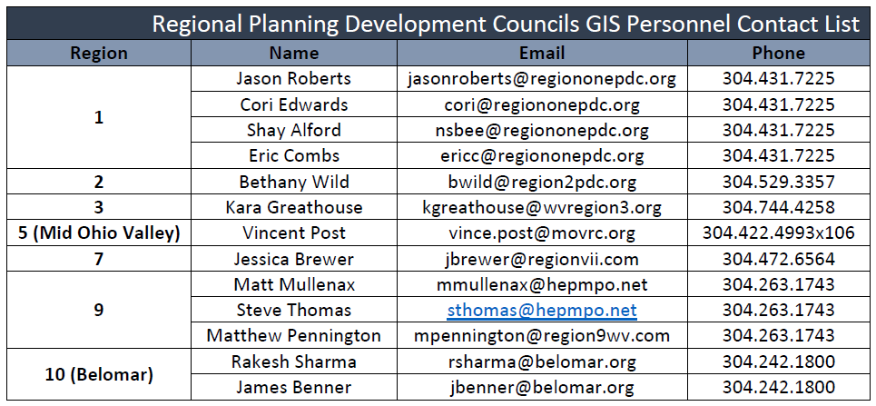

|  |  |
| --- | --- |
| West Virginia University | |
| **Kurt Donaldson**  GIS Manager West Virginia University  West Virginia GIS Technical Center  98 Beechurst Avenue  330 Brooks Hall, PO Box 6300  Morgantown, WV 26505-6300  Phone: (304) 293-9467  [kdonalds@wvu.edu](mailto:kdonalds@wvu.edu) | **Eric Hopkins**  GIS Analyst  West Virginia University  West Virginia GIS Technical Center  98 Beechurst Avenue  330 Brooks Hall, PO Box 6300  Morgantown, WV 26505-6300  Phone: (304) 293-9463  [ehopkins@wvu.edu](mailto:ehopkins@wvu.edu) |
| **Maneesh Sharma, PhD**  Geoscientist / GIS Analyst West Virginia University  West Virginia GIS Technical Center  98 Beechurst Avenue  330 Brooks Hall, PO Box 6300  Morgantown, WV 26505-6300  Phone: (304) 293-6694  [maneesh.sharma@mail.wvu.edu](mailto:maneesh.sharma@mail.wvu.edu) | **Frank LaFone** Technical Lead / System Administrator West Virginia University  West Virginia GIS Technical Center  98 Beechurst Avenue  330 Brooks Hall, PO Box 6300  Morgantown, WV 26505-6300  Phone: (304) 293-9466  [frank.lafone@mail.wvu.edu](mailto:frank.lafone@mail.wvu.edu) |
| **Trevor Harris, PhD**  Eberly Distinguished Professor of Geography Co-director State GIS Technical Center Department of Geology and Geography West Virginia University 98 Beechurst Avenue  330 Brooks Hall, PO Box 6300  Morgantown, WV 26506-6300 Phone: (304) 293-3171  [Trevor.Harris@mail.wvu.edu](mailto:Trevor.Harris@mail.wvu.edu) | **Steve J. Kite, PhD**  Associate Professor of Geology and Geography  Department of Geology and Geography West Virginia University 98 Beechurst Avenue  330 Brooks Hall, PO Box 6300  Morgantown, WV 26506-6300  (304) 293-9819  [Steve.Kite@mail.wvu.edu](mailto:Steve.Kite@mail.wvu.edu) |

# APPENDIX A: Resources

**\*\* STATEWIDE APPROACH TO MULTI-HAZARD RISK ASSESSMENTS \*\***

**Project Overview Presentation to National Capitol Region HAZUS User Group (October 2016)**

* <http://www.usehazus.com/uploads/forum/October272016__NationalCapitolRegionHUG_Presentation_FINAL.pdf>
* <http://data.wvgis.wvu.edu/pub/temp/FEMA/FRA/P/WV_Statewide_Approach_Risk_Studies_20161027.pdf>

**\*\* WV HAZARD MITIGATION PLANS \*\***

* **2013 WV State Hazard Mitigation Plan**

<http://www.dhsem.wv.gov/MitigationRecovery/Documents/2013%20WV%20Statewide%20Hazard%20Mitigation%20Plan%20Update.pdf>

* **Regional Planning and Development Councils – Local Hazard Mitigation Plans**

<http://www.dhsem.wv.gov/MitigationRecovery/Pages/Hazard-Mitigation-Planning.aspx>

* **Local Hazard Mitigation Plan Application**<http://data.wvgis.wvu.edu/pub/temp/FEMA/FRA/P/WV_HMGP_Local_Application_v1_201602.docx>

**\*\* FLOOD RISK \*\***

**WV County Flood Risk Assessment Reports**

* Berkeley County (October 2016)

<http://data.wvgis.wvu.edu/pub/temp/FEMA/FRA/P/Berkeley_FloodRiskRpt_20161031.pdf>

* Morgan County (October 2016)

<http://data.wvgis.wvu.edu/pub/temp/FEMA/FRA/P/Morgan_FloodRiskRpt_20161031.pdf>

**WV Flood Tool**

<http://www.mapwv.gov/flood/>

**WV Flood Tool Recent Upgrades (August 2017):**

[http://data.wvgis.wvu.edu/pub/temp/FEMA/FRA/P/WV\_Flood\_Tool\_upgrades 20170828.pdf](http://data.wvgis.wvu.edu/pub/temp/FEMA/FRA/P/WV_Flood_Tool_upgrades%2020170828.pdf)

**WV Flood Tool Future Directions (July 2017)**<http://data.wvgis.wvu.edu/pub/temp/FEMA/FRA/P/FutureFloodToolDirection20170715.pdf>

**\*\* LANDSLIDE RISK \*\***

**WV Landslide Inventory**

<http://www.mapwv.gov/landslide>

**Prototype Landslide Risk Assessment Report (April 2016)**

<http://data.wvgis.wvu.edu/pub/temp/FEMA/FRA/P/Landslide_Susceptibility_Pilot_Study_BerkleyCounty_20160408.pdf>

**\*\* WV BUILDING INVENTORY TOOL \*\***

**Building Inventory Workflow** (IUPUI Polis Center)

<http://data.wvgis.wvu.edu/pub/temp/FEMA/FRA/P/WV_BI_Workflow_1.0-052215.pdf>

**WVU Access to Infogroup Company’s Reference USA Database**

<https://lib.wvu.edu/databases/AtoZ/?id=R&status>=

**\*\* WV GIS DATA STATUS MAPS \*\***

**Parcels**

Parcel Boundary Digital Conversion

<http://data.wvgis.wvu.edu/pub/temp/FEMA/FRA/P/graphics/DigitalParcelBoundary_20170519.pdf>

Parcel Management by Counties <http://data.wvgis.wvu.edu/pub/temp/FEMA/FRA/P/graphics/Parcel_Management_03142017.pdf>

Parcel Vendors

<http://data.wvgis.wvu.edu/pub/temp/FEMA/FRA/P/graphics/Parcel_vendor_assistance_05042017.pdf>

**Addresses**

<http://data.wvgis.wvu.edu/pub/temp/FEMA/FRA/P/graphics/SAMS_county_status_20170804.pdf>

**Aerial Imagery (leaf-off)**

<http://data.wvgis.wvu.edu/pub/temp/FEMA/FRA/P/graphics/LeafOffAerialPhotography_06022017.pdf>

**Building Footprints**

<http://data.wvgis.wvu.edu/pub/temp/FEMA/FRA/P/graphics/BuildingFootprints_20151207.pdf>

**Dams/Levees**

<http://data.wvgis.wvu.edu/pub/temp/FEMA/FRA/P/graphics/USACE_District_Divisions_WV_Dams-Levees_20160817.pdf>

**Flood Hazard Zones**

Detailed versus Approximate Flood Hazard Zones

<http://data.wvgis.wvu.edu/pub/temp/FEMA/FRA/P/graphics/WVFloodHazardZones_20170731.pdf>

Advisory A Flood Zones Acquisition Status

<http://data.wvgis.wvu.edu/pub/temp/FEMA/FRA/P/graphics/Advisory_A_Status_20170630.pdf>

Proposed Future FEMA-Sponsored Flood Studies

<http://data.wvgis.wvu.edu/pub/temp/FEMA/FRA/P/graphics/ProposedStudies_Status_20170630.pdf>

**\*\* FEMA GUIDELINES \*\***

**Guidelines and Standards for Flood Risk Analysis and Mapping**

<https://www.fema.gov/guidelines-and-standards-flood-risk-analysis-and-mapping>

**Hazard Mitigation Grant Program**

<https://www.fema.gov/hazard-mitigation-grant-program>

**Hazard Mitigation Assistance Guidance**

<https://www.fema.gov/media-library-data/1424983165449-38f5dfc69c0bd4ea8a161e8bb7b79553/HMA_Guidance_022715_508.pdf>

**Hazard Mitigation Assistance Guidance Addendum**

<https://www.fema.gov/media-library-data/1424983165449-38f5dfc69c0bd4ea8a161e8bb7b79553/HMA_Addendum_022715_508.pdf>

**\*\* FINANCIAL GUIDELINES \*\***

**OMB 2 CFR 200 - Uniform Administrative Requirements, Cost Principles, and Audit Requirements for Federal Awards**

<https://www.gpo.gov/fdsys/pkg/CFR-2014-title2-vol1/pdf/CFR-2014-title2-vol1-part200.pdf>

**\*\* MISCELLANEOUS \*\***

**Missouri State Hazard Mitigation Plan Update Overview (2017)** (Amec Foster Wheeler)

<http://data.wvgis.wvu.edu/pub/temp/FEMA/FRA/P/Missouri_State_Hazard_Mitigation_Plan_Update_2017.pdf>

**Hazus-MH Analyses for City of Beverly, MA: Hazard Mitigation Plan Update (Flood UDF) (2017)** (Dewberry)

<http://www.usehazus.com/uploads/main/JUN_2017_NCRHUG_Presentation.pdf>

**Data Creation Geared to the World as We Know it! (2016)**– Steve Kocsis, Cambria County, PA GIS Center; Visualization of the Month – 3D Flood Impact

<http://www.usehazus.com/uploads/forum/March312016_NationalCapitolRegionHUG_Presentaiton.pdf>

**Multi-Hazard Risk Assessment Lifecycle Cradle-to-Cradle - Rethinking the Way We Use Risk Assessments (2016)** – Cynthia McCoy, FEMA Region X

<http://www.usehazus.com/uploads/forum/February252016_NationalCapitolRegionHUG_Presentaiton2.pdf>

**Upper Monongahela Watershed Flood Risk Review Meeting (2016)**

<http://data.wvgis.wvu.edu/pub/temp/FEMA/FRA/P/FRR_Presentation_Upper_Monogahela.pdf>

**Regional Planning and Development Councils Graphic (2015)**

<http://data.wvgis.wvu.edu/pub/temp/FEMA/FRA/P/graphics/WV_Regional_Planning&Development_Councils_052115.pdf>

**Cook County HMP Risk Assessment (2015)** – Carol Bauman, Tetra Tech <http://www.usehazus.com/uploads/forum/March262015_NationalCapitolRegionHUG_Presentaiton.pdf>

**Total Exposure in Floodplain (TEIF) 2.0 (2013)** – Glenn Locke, Tetra Tech

<http://www.usehazus.com/uploads/forum/December192013_NationalCapitolRegionHUG_Presentaiton_FINAL.pdf>

# APPENDIX B: Workflow for Building Inventory Tool and Flood Risk Assessment

**Building Inventory Tool and Flood Risk Assessment Workflow** (Refer to Figure 1 diagram) **1/11/2017**

1. **Prepare County Data Sources**
   1. FEMA National Flood Hazard Layer (NFHL) Floodplains and related features
      1. 1 Pct Floodplain polygons (S\_Fld\_Haz\_Ar)
      2. Cross Section lines (S\_XS) for flood water surface and depth grid
   2. CAMA records with necessary attributes
      1. County extract from statewide CAMA db.
      2. Duplicate/Multiple Improvements/Structures
         1. Multiple addresses in same parcel
         2. Multiple structures (e.g. outbuildings) filtered
   3. GIS Parcel Polygon File with necessary attributes
      1. Parcel ID (PID, PAR\_ID, ROOT\_ID)
   4. Building footprints
      1. Multiple footprints within single parcels identified/filtered
   5. E-911 Structures
   6. Aerial Imagery – most recent, highest resolution, leaf-off
   7. Elevation
      1. Local Resolution / DEM Mosaic
      2. USGS NED
   8. Depth Grid – best available from the following ranked list:
      1. Advisory
      2. Detailed Re-Study
      3. Detailed Re-Delineation using XS lines
      4. Hazus L1 2010 Study
      5. EQL
   9. Critical Infrastructure Data
      1. Emergency Service Centers
      2. Fire Stations
      3. Health Care Facilities
      4. Police Stations
      5. Schools
   10. Community Assets
       1. Campgrounds
       2. Churches
       3. Emergency Shelters
       4. Government Offices
       5. Hazmat Non-Facility
       6. Mobile Home Parks
       7. Polling Places
       8. Poultry Slaughtering Stations
       9. Water Towers
       10. Other Features as determined by the community
2. **Create Building Inventory from Parcel Data using FME Tool**
   1. Gather county parcel and assessment data
   2. Prepare County Inventory Data
      1. Prepare Hazus Boundaries
         1. County (Hazus-MH)
         2. 100-year floodplain (FEMA NFHL 1% S\_Fld\_Haz\_ar)
         3. Census blocks or tracts (Hazus-MH)
      2. Convert parcel polygons to parcel centroids
   3. Prepare Building Inventory
      1. Prepare matrices and domains to convert CAMA codes recognized by Hazus. The Improvements table consists of domains where the CAMA codes are converted to descriptive attributes. In addition, CAMA cost values are aggregated by the occupancy classes.
   4. Run cama to CAMA tool (TOOL #1)
      1. Pre-process CAMA data to enhance the LUC tables so that data can be pre-processed based on the Hazus occupancy classes. The Hazus occupancy codes/classes serve as a guide to convert the existing CAMA attributes to Hazus specific attributes. Codes that are unmatchable with Hazus occupancy class are assigned “UNK”.
   5. Convert CAMA to Improvements (TOOL #2)
      1. Filter out CAMA records that are unlikely associated with a building structure. For example, vacant lands (LU Codes), other building and yard improvements (OBYVAL), dwelling codes (DWELVAL).
   6. Convert CAMA Improvements to Building Points (TOOL #3)
      1. Join GIS building points with Hazus-ready CAMA records
      2. Tools:
         1. Year Built creator
         2. Dollar Per Square foot creator
   7. Convert Building Points to Building Inventory (TOOL #4)
      1. Tools written to generate a Building Inventory feature class based on the domains and matrix as well as the Building Points created earlier in workflow
      2. Domains: Year\_built, FirstFloorHt, BldgCondition, BldgFoundation, BldgConstruction
         1. Domains are tables created in Access geodatabase which give descriptions of the codes
      3. Matrices: BldgCondition, BldgConstruction, BldgFoundation
         1. Matrix are Access tables that convert the CAMA codes into Hazus compliant codes so that features can be imported into Hazus for analysis
      4. XFactors: DOLqFt
         1. This table is created to calculate Average Dollar per Square Foot using the Improvements table.
      5. RS Means Table
         1. The replacement values of the buildings in Hazus database are developed by applying the RS Means for typical building floor areas for each occupancy class.
   8. Output building inventory GBS and UDF files
   9. **Table 1:** Local Building Inventory
   10. **Appendix A:** Building Inventory Process
3. **Calculate Building Exposure for County and Communities using GBS Inventory**
   1. Update Hazus GBS Inventory
      1. USE CDMS to update the GBS for <County\_Name> and <Community\_Name>
      2. Create a Flood Study Region for the county to be modeled
      3. Verify Building Inventory count is uploaded into Hazus
   2. **Table 2a:** Countywide Building Number and Exposure ($) from updated General Building Stock
   3. **Table 2b:** Countywide Building Number and Exposure ($) from CAMA Building Appraisal Values
   4. **Figure 3:** Sample Map of Countywide General Building Stock Exposure by Census Block. Replacement building costs are aggregated to Census Blocks.
   5. **Figure 4:** Zoomed-in View of Spatially Enhanced UDF Structures in Flood Zone
4. **Calculate Building Exposure in Floodplain using UDF Inventory**
   1. Update Hazus UDF Inventory
      1. Spatially adjust parcel centroids to structure center.
      2. Create a Flood Study Region for the county to be modeled.
      3. Verify Building Inventory count is uploaded into Hazus
   2. Import UDF within Flood Hazard Area directly into the study region (must be < 10,000 facilities)
      1. Create Building Inventory by processing the building points to fit the Hazus database structure and domains
      2. Link populated Access tables to Study Region SQL tables
      3. Review UDFs in Hazus (page 19)
         1. UDF Count should match the BI count
         2. UDFs should not be outside the county/study region boundaries
         3. UDF locations should be the same as the BI locations
   3. **Table 3a:** County Flood Hazard Building Exposure in 100-year Floodplain. Data input of choice is User Defined Facilities
   4. **Table 3b**: Community Building Exposure in 100-year Floodplain. Data input of choice is User Defined Facilities.
   5. **Figure 4:** Zoomed-in View of Spatially Enhanced UDF Structures in Flood Zone
5. **Inventory of Facilities and Community Assets**
   1. **Table 4:** Essential Facilities
   2. **Table 5:** Critical Facilities
   3. **Table 6:** Community Assets
6. **Inventory Mitigated Properties**
   1. **Table 7 :** Mitigated Properties
7. **Setup Model Scenario for Riverine Flood Assessments for 1% event. Derive Flood Layer Inputs**
   1. Select 1% floodplain boundaries
   2. Select User-Defined Water Depth Grid
      1. Enhanced Quick Look (Hazus MH)
      2. User-Defined Flood Depth Grid
         1. WV Depth Grids for Approximate A Zones
            1. HEC-RAS models available
         2. HEC-RAS Depth Grids
         3. **Figure 5:** Zoomed-in View of Water Depth Grid. Overlain with UDF individual building structures.
      3. Flood Information Tool extension - Generate grid from x-sections
8. **Perform Riverine Flood Hazus Analysis**
   1. Riverine 1% Flood Building Damages
      1. **Table 8:** County Riverine Floodplain (1% Flood) Related Losses
      2. **Table 9:** Top 5 Flooded Structures by Replacement Cost
      3. **Table 10:** Building and Facility Damages
         1. Building Inventory
         2. Essential Facilities
         3. Critical Facilities
         4. Community Facilities
      4. **Figure 6A:** County (1% Flood) Damaged Building Losses
      5. **Figure 6B:** Community (1% Flood) Damaged Building Losses
      6. **Figure 7:** Facilities and Community Assets in 100-year Floodplain
      7. **Figure 8:** Mitigated or Buyout Properties in County
   2. Riverine 1% Flood Debris Generation
      1. Debris Summary Report from Hazus
      2. **Figure 9:** Riverine 1% Flood Debris Weight (Tons)
   3. Riverine 1% Flood Shelter Requirements
      1. Shelter Summary Report from Hazus
      2. **Figure 10:** Riverine 1% Flood Shelter Requirements
9. **Data Deliverables to County (QC & Delivery)**
   1. Maps
      1. Building Exposure
      2. Physical damage map of buildings and facilities (large size)
      3. Debris map
      4. Population Displacement / Shelter map
      5. Select 3D maps (if building footprints available)
      6. Miscellaneous maps
   2. GIS Data
      1. GIS parcel polygons
      2. E-911 Addressable Structures
      3. Building Inventory
      4. UDF Floodplain Structures
      5. Essential Facilities
      6. Critical Facilities
      7. Community Assets
      8. Mitigated Properties
      9. Hazus-MH .hpr files (available on request)
10. **Integration of County Flood Risk Results in the State Hazard Mitigation Plan**

# APPENDIX C: Composite Effective and Advisory Flood Products

Statewide flood risk assessments require assembling composites of the following regulatory and advisory flood layers:

* Floodplains
* Depth Grids
* Water Surface Elevation Grids

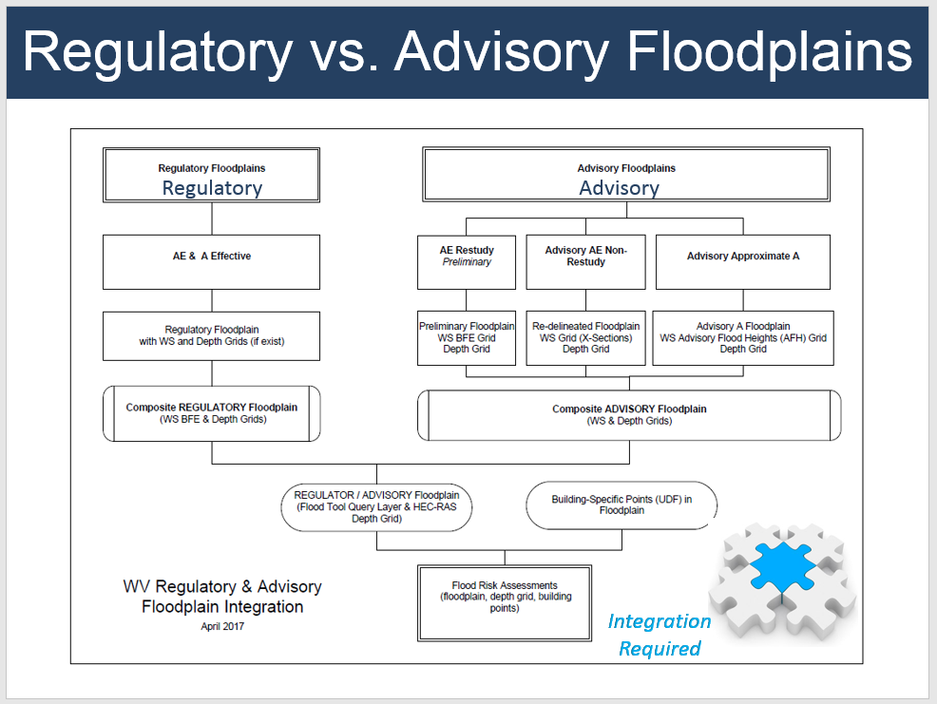

# APPENDIX D: Landslide Literature Review and Proposed Methodology

**LANDSLIDE LITERATURE REVIEW AND PROPOSED METHODOLOGY**

**Author:** Dr. Maneesh Sharma, Geoscientist and GIS Analyst, WV GIS Technical Center, West Virginia University

**Published Date:** May 1, 2017

**Introduction:** The West Virginia GIS Technical Center proposes to perform landslide susceptibility study for West Virginia. We will research and implement a valid methodology for landslide susceptibility. We also propose to generate 55 county-level resolution and a state level landslide susceptibility maps and supplemental reports for local and state hazard mitigation plans.

1. **Collaborations with potential partners**

West Virginia GIS Technical Center will work closely with West Virginia Geological and Economic Survey, WV Department of Transportation, United States Geological Survey etc. Additionally, WVGISTC will work closely with Professor Steve Kite in the department of Geology and Geography, West Virginia University, who is a landslide expert in the state of West Virginia.

1. **Literature Review**

West Virginia is physiographically divided into different major provinces (Lessing et al., 1976). Table 1 shows different physiographic divisions and subdivisions in West Virginia. The Appalachian Plateau forms the eastern most physiographic province and covers the western two-thirds portion of the state. A study by USGS (Outerbridge, 1987) identified Logan Plateau as a major physiographic subdivision within the Appalachian Plateau. The area consists of sandstones, silts and shales. Shallow earth flows in soil and weathered bedrock are more common in this region. Folded Allegheny Mountains and Front are to the east of the plateau. This area consists of orthoquartzite, sandstone, shale and is dominated by slumps and debris flows. The Valley and Ridge province covers eastern one-third of the state and has folded and faulted rocks. This area is dominated by quartzite, sandstone, siltstone, shale and limestone. Debris avalanche, flow and slump dominate this area. The eastern part of Valley and Ridge is the Great Valley Area. This area is relatively flat and dominated by limestone and shale. The eastern most section of state consists of Blue Ridge province. This area has the oldest rocks in the state. This area contains sandstone, silt and shale and is dominated by debris slides, flows and slumps.

**Table 1**. Different physiographic regions of West Virginia (<http://www.wvgs.wvnet.edu/www/geology/geolphyp.htm>, <https://pubs.usgs.gov/bul/1620/report.pdf>)

|  |  |  |  |  |  |
| --- | --- | --- | --- | --- | --- |
| Region | Structure | Bedrock type | Slope | Relief ( m) | Landslides |
| Appalachian Plateau | Flat | Sandstone, shale and siltstone | Gentle to steep |  | Abundant slumps and flows |
| Logan Plateau (subregion of Appalachian Plateau) | Flat | Subgraywacke sandstone, siltstone and shale | Steep | 150-750 | Debris avalanches, debris flows |
| Alleghany plateau and mountain | Flat | Orthoquartzite, sandstone and shale | Gentle to steep | 100-400 | Few slumps and debris flows |
| Valley and Ridge | Folded and Faulted | Quartzite, sandstone, siltstone, shale and limestone | Flat to steep | 0-750 | Debris avalanches, flow and slump |
| Great Valley | Flat | Limestone and shale | Flat |  | Few flows and slump |
| Blue Ridge | Folded and Faulted | Sandstone, silt and shale | Flat to steep |  | Debris slide, flow and slumps |

**Figure 1.** Different physiographic provinces of West Virginia (WVGES; http://www.wvgs.wvnet.edu/www/geology/geolphyp.htm)

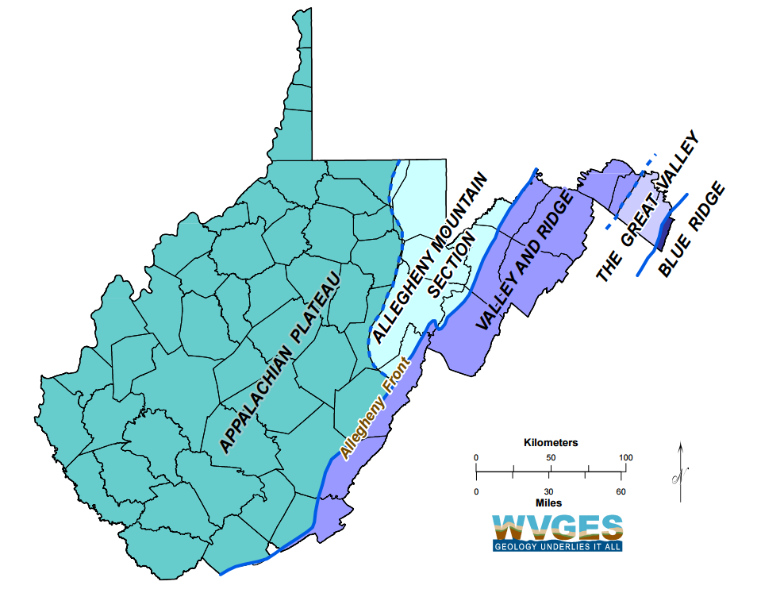

**Figure 2.** Figure showing generalized outline for Logan plateau (https://cwva.org/research\_reports/romney\_bridge/romney\_bridge\_ph1b.htm)

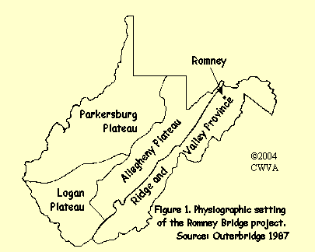

In a landslide study conducted by USGS (Radbruch-Hall et al., 1982), all of West Virginia is a high-risk region for landslides. The USGS study was done at a scale of 1:3,750,000.

Kish (2004) conducted a study on the factors controlling landslide initiation in a section of lower New River Gorge, West Virginia. Results of the study show that landslides preferentially initiated within the colluvium and mine spoil units, and the transport network also show spatial correlation. In this area, northeast and east facing slopes had a correlation with slope failures. Slope failures occurred between 15°-35° in DEM measured landslides and between 35°-50° in field measured slope angles. Hillside hollows produced most slides as compared to the nose and planar slopes. The three physical factors of transport networks, slopes greater than 35° and hillslope hollow geometry were used to create landslide hazard risk maps. In the hazard risk map, a moderate risk was deemed as an area where two factors were encountered and high-risk areas where hillslope hollows coincide with road networks and slope angle greater than 35°.

Konoser and Kite (2014) studied slope failure in Horseshoe Run watershed (part Preston and Tucker counties), West Virginia using application of LiDAR and discriminant analysis. This study is very detailed and distinguished planar slides, rotational slumps, debris flows, debris fans, debris slides and active slopes. The study used several criteria such as elevation, slope angle, slope aspect, distance from roads, distance from streams, plan curvature and profile curvature. Results show that differences between varying classes of failure and slope angle, aspect, curvature and proximity to streams were factors influencing the type of failure. According to the authors, these are most likely related to structural geology and microclimate of the area. Results indicate that slope angle, elevation, plan and profile curvature, and aspect are the dominant factors influencing the slope failure. The majority of failures occurred within Foreknobs formation that contains interbedded sandstone and shale.

The West Virginia Geological and Economic Survey (Lessing et al., 1976) conducted a landslide-mapping program in 1976. The effort focused on seven urban areas: Morgantown, Fairmont, Clarksburg, Charleston, Huntington, Parkersburg, Wheeling, and some additional work along parts of Ohio River. Most landslides in Alleghany plateau do not involve bedrock. Slides are confined to the soil, colluvium or weathered rock veneer. A dominant triggering factor for a landslide is the presence of subsurface water. Rock falls are common on cliff faces where bedrock is exposed. This is most common where sand blocks fall from a natural cliff or steep excavated slopes along highways. Mostly underlying weak shale rock gets weathered thus removing support from overlying sand blocks and thus triggering a rockfall.

According to the study, several factors that contribute to landslide are i) Surface and subsurface water condition – Heavy precipitation or cumulative heavy precipitation in short to medium time is a trigger for slides. The increase in groundwater saturation adds weight to slope material, increases water pressure and lowers cohesion of unconsolidated material. These factors decrease frictional resistance to sliding. The study also found that the effect of groundwater increased where highways and construction site required large excavation and fill. This modification changed drainage resulting in more discharge of groundwater at excavation face. ii) Slope configuration – 69% of landslides occur on concave slopes and 81% of slopes occur on slopes between 15-35%. iii) Loading – Loading a slope by improper placement of material during construction results in slides or failures especially in areas where loading has occurred in response to surface and deep mining. iv) Undercutting – Removal of slope support by undercutting is one of the most common factors for instability and slide activity. Undercutting can be either natural or man-made. v) Bedrock factors – Many slides occur because rock and soil are weak and incompetent. Red shales in Dunkard, Monongahela and Conemaugh group bedrock weather rapidly and are prone to landslides. vi) Soil factors – Most landslide are confined to shallow soils. There is a good correlation between soil and landslide. The thicker the colluvium, the more probability for landslide. Slide activity enhances where clay-rich layers are present in soil or colluvium mass. These type of soils when inclined downslope facilitates sliding. Since clays have low permeability they decrease groundwater infiltration and cause saturation of soils above. vii) Removal of vegetation – Trees promote slope stability through deep and extensive root system. Once trees are cut in a susceptible area it increases the chances of a potential landslide.

Another factor analyzed by WVGES study was an Overdip factor. Overdip occurs where land surface slopes in the same general direction but at a higher angle than the dip of the underlying rock. No correlation of overdip to landslide was found and is questionable in Alleghany Plateau area. However, Konoser, 2014 found overdip to be a factor in eastern part of the state.

1. **Landslide Data Inventory**

Existing landslide data will be collected from the Lessing et al., 1976 landslide susceptibility study. This study consists of 26 quads centered around Morgantown, Fairmont, Clarksburg, Charleston, Huntington, Parkersburg, Wheeling, and along parts of Ohio River. These quads will be geo-referenced and landslide and rock fall locations for each quad will be digitized in ESRI’s ArcGIS environment. Apart from this, landslide inventory data from WV Department of Transportation, FEMA landslide property buyout locations and dataset from previously published studies by Professor Kite will also be integrated into the database.

Additionally, an interactive web application (www.mapwv.gov/landslide) will be created for displaying landslide inventory data. This website will serve as a crowd-sourcing tool for input of future landslide locations in the state. A user who has access to the internet will be able to access this web application and update the database with a landslide incidence.

1. **Methodology**

GIS has been used to create susceptibility maps using the different methodologies such as heuristic, statistical or deterministic models (Guzetti et al., 2005; Martha et al., 2013). In the heuristic method, expert assigns weights to parameters and to each class within parameters. Weighted layers are then combined to produce susceptibility maps (Martha et al., 2013). In statistical methods, bivariate or multivariate methods are most commonly used. Factors that have led to a landslide are determined using a series of statistical methods. Statistically significant factors are then used to predict future landslide and create susceptibility maps. This method requires the collection of data to determine significant factors contributing to the landslide (Barredo et al., 2000). Deterministic methods are most commonly used at a higher resolution or local scale. This method uses geotechnical, hydrological , soil depth and properties derived from DEM. This method is most commonly used when a construction needs to be done at a specific site.

* 1. **Previous Heuristic methodology for Berkley County pilot study**

In 2015, a pilot study for landslide susceptibility in Berkley County was done using heuristic methodology. A pilot study done in Schenectady County, New York, was used as a reference for a weight-based method for determining landslide susceptibility (Kappel et al 2007). The Berkley County study used U.S. Department of Agriculture Natural Resource Conservation Service’s SSURGO Digital Soil Survey and United States Geological Survey’s 1/3 arc second resolution Digital Elevation Model (DEM). The SSURGO soil data has several attributes that were used to model landslide susceptibility. The soil attributes used in the pilot study were:

* + - 1. American Association of State Highway and Transportation Officials (ASSHTO) Soil Classification
      2. Liquid Limit
      3. Hydrologic Group
      4. Physical Soil Properties (%silt and %clay); and
      5. Hazard of Erosion

The above-mentioned soil attributes were used in conjunction with DEM derived slopes to developing a landslide susceptibility model for the study area. Each of the attributes was assigned a weighted value based on their contributing factor in predicting landslide susceptibility (Table 2)

|  |  |  |
| --- | --- | --- |
| **Prediction Properties** | **Weight Range** | **Source** |
| ASSHTO Soil Classification | 1-14 | SSURGO |
| Liquid Limit | 2-8 | SSURGO |
| Hydrologic Group | 1-4 | SSURGO |
| Physical Soil Properties | 1-4 | SSURGO |
| Hazard of Erosion | 1-12 | SSURGO |
| Slope | 10-50 | DEM |

**Table 2.** The list of attributes and their calculated weighted range used to predict landslide

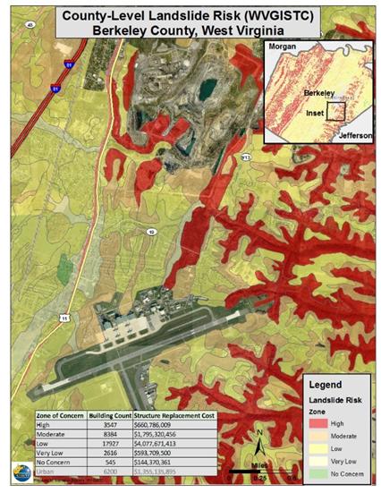

Since the slope is one of the most important controls on landslide susceptibility it is assigned the highest weighted value, in the range of 10-50. The six properties containing the weighted values were then summed to establish a landslide susceptibility “total score”. The total score ranged from 37 to 84. Range groupings were established from “total score” values to assign landslide susceptibility descriptive zones as “High” – greater than 75 (Red); “Moderate” – 61 – 75 (Orange); “Low” – 51 – 60 (Yellow); “Very Low” – 41 – 50 (Beige); “No Concern” – less than 41 (Green) (Figure D3). The approach for calculating landslide susceptibility in this pilot study shows high variability in landslide susceptibility risk in Berkeley County (Figure D3).

**Figure 3.** Map County level landslide risk for Berkeley County, WV performed by WVGISTC using heuristic methodology

* 1. **Proposed methodology for West Virginia landslide risk assessment**

We propose to research heuristic and statistical methods for landslide susceptibility and hazard analysis for counties in West Virginia. Previous studies by Professor Kite in Horse Shoe Run Watershed, Lower New River George and by the West Virginia Geological and Economic Survey will help us in refining our methodology.

The research will investigate regional variation in attributes for landslide risk assessment. A hybrid model of heuristic and statistical methods may be required to generate a statewide landslide susceptibility and risk assessment map. We will work with Professor Kite to research significant data attributes and their weightage for heuristic analysis. In statistical methods, we intend to research multivariate analysis. The multivariate statistical analysis explores the relationship among different type of attributes. We will analyze landslides using already identified potential explanatory variables from Professor Kite and WVGES studies and run regression analysis to test the impact of geography on variables. Some of the attributes that have been identified as statistically significant are elevation, slope angle, aspect, plan curvature, profile curvature, proximity to roads, proximity to streams, soils and bed rock factors. Statistical checks (Statistically significant probability, Koenker test, VIF, Jarque-Bera test, clustered residuals, adjusted R-squared and AIC) will be performed on the model to reduce the bias. If there is a need, geographically weighted regression (GWR) will be performed for the analysis. GWR is a local regression model as compared to an exploratory regression that is global regression model.

The validation will be done to perform analysis in the regions where landslide data is available. Results will be used to create landslide susceptibility and risk assessment maps for counties and the entire state.

1. **Output**

Landslide susceptibility maps for each of the 55 counties will created. Results from the counties will be integrated to create statewide landslide susceptibility maps. In addition, supplemental reports for local and state hazard mitigation plans will be compiled.

1. **Deliverables**

Following are the landslide risk assessment deliverables:

1. Develop a landslide inventory from various sources: WV GES, WV DOT, FEMA landslide buyout

properties, etc.

1. Create valid landslide model for West Virginia
2. Generate 55 county-level resolution landslide susceptibility maps and supplemental reports for Local and State Hazard Mitigation Plans
3. Create an interactive web map application named the WV Landslide Tool of the landslide inventory and landslide susceptibility zones

**References**

1. Barredo, J.I., Hervas, J., Lomoschitz, A., Benavides, A., Westen, C.V. 2000. Landslide Hazard assessment using GIS and multicriteria evaluation techniques in the Tirajana basin, Gran Canaria Island. Landslides-Disaster Risk Reduction, 355-365.
2. Guzetti, F., Reichenbach, P., Cardinalli, M., Galli, M. 2005. Probabilistic landslide hazard assessment at the basin scale. Geomorphology 72, 272-299.
3. Kappel, W., Kelley, W., Kozlowski, A., O’Brien, D., McWhirter, J., Zhang, R., Kalohn, J., Storti, M., Minnitti, T., and Emerick, S. 2007. Landslide Susceptibility – A Pilot Study of Schenectady County, New York. New York State Hazard Mitigation Plan.
4. Kish, M.P. 2004. Factors controlling landslide initiation as a result of July 2001 high precipitation events in a section of lower New River George, West Virginia. PhD Thesis 45.
5. Konsoer, K.M., Kite, J.S. 2014. Application of LiDAR and discriminant analysis to determine landscape characteristics for different types of slope failures in heavily vegetated, steep terrain: Horseshoe Run watershed, West Virginia. Geomorphology 224, 192-202.
6. Lessing, P., Kulander, B.R., Wilson, B.D., and Woodring, S.M. 1976. West Virginia Landslides and Slide‐Prone Areas: West Virginia Geological and Economic Survey Environmental Geology Bulletin EGB‐15A, 68 p., 28 maps, scale 1:24,000.
7. Martha, T.R., Westen, C.J.V., Kerle, N., Jetten, V., Kumar, V.K. 2013. Landslide hazard and risk assessment using semi-automatically created landslide inventories. Geomorphology 184, 139-150.
8. Outerbridge, W.F. 1987. The Logan Plateau: a young physiographic region in West Virginia, Kentucky, Virginia and Tennessee. US Geological Survey Bulletin 1620, 19 p.
9. Radbruch-Hall, D.H., Colton, R.B., Davies, W.E., Lucchitta, I., Skipp, B.A. and Varnes, D.J. 1982. Landslide Overview Map of the Conterminous United States, Geological Survey Professional Paper 1183, U.S. Geological Survey, Washington.

# APPENDIX E: USACE Support Letter

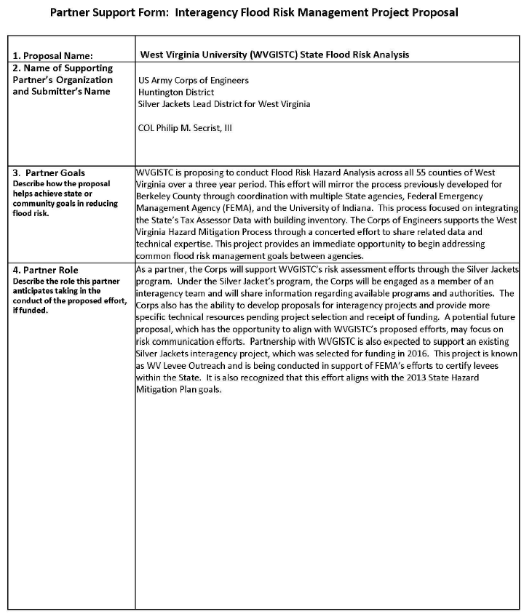

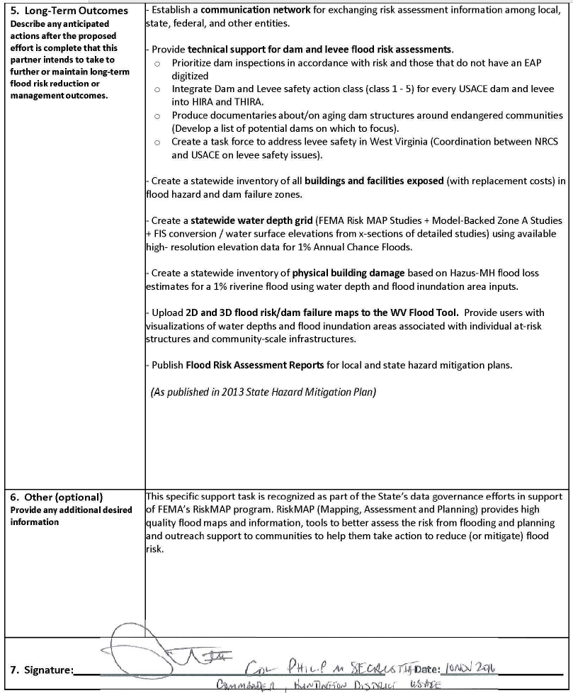

# APPENDIX F: Local Hazard Mitigation Plan Deadlines

**West Virginia Planning Status as of 7/31/2017**

| # | County | Plan Title | PDC | Expiration Date | Months until expires |
| --- | --- | --- | --- | --- | --- |
| 1 | McDowell County | McDowell County (PDC 1) | 1 | 1/31/2022 | 53 |
| 2 | Mercer County | Mercer County (PDC 1) | 1 | 1/31/2022 | 53 |
| 3 | Monroe County | Monroe County (PDC 1) | 1 | 1/31/2022 | 53 |
| 4 | Raleigh County | Raleigh County (PDC 1) | 1 | 1/31/2022 | 53 |
| 5 | Summers County | Summers County (PDC 1) | 1 | 1/31/2022 | 53 |
| 6 | Wyoming County | Wyoming County (PDC 1) | 1 | 1/31/2022 | 53 |
| 7 | Cabell County | Cabell County (PDC 2) | 2 | 5/14/2017 | 0 |
| 8 | Lincoln County | Lincoln County (PDC 2) | 2 | 5/14/2017 | 0 |
| 9 | Logan County | Logan County (PDC 2) | 2 | 5/14/2017 | 0 |
| 10 | Mason County | Mason County (PDC 2) | 2 | 5/14/2017 | 0 |
| 11 | Mingo County | Mingo County (PDC 2) | 2 | 5/14/2017 | 0 |
| 12 | Wayne County | Wayne County (PDC 2) | 2 | 5/14/2017 | 0 |
| 13 | Boone County | Boone County (PDC 3) | 3 | 2/21/2017 | 0 |
| 14 | Clay County | Clay County (PDC 3) | 3 | 2/21/2017 | 0 |
| 15 | Kanawha County | Kanawha County (PDC 3) | 3 | 2/21/2017 | 0 |
| 16 | Putnam County | Putnam County (PDC 3) | 3 | 2/21/2017 | 0 |
| 17 | Fayette County | Fayette County (PDC 4) | 4 | 2/21/2022 | 54 |
| 18 | Greenbrier County | Greenbrier County (PDC 4) | 4 | 2/21/2022 | 54 |
| 19 | Nicholas County | Nicholas County (PDC 4) | 4 | 2/21/2022 | 54 |
| 20 | Pocahontas County | Pocahontas County (PDC 4) | 4 | 2/21/2022 | 54 |
| 21 | Webster County | Webster County (PDC 4) | 4 | 2/21/2022 | 54 |
| 22 | Calhoun County | Calhoun County (PDC 5) | 5 | 2/21/2022 | 54 |
| 23 | Jackson County | Jackson County (PDC 5) | 5 | 2/21/2022 | 54 |
| 24 | Pleasants County | Pleasants County (PDC 5) | 5 | 2/21/2022 | 54 |
| 25 | Ritchie County | Ritchie County (PDC 5) | 5 | 2/21/2022 | 54 |
| 26 | Roane County | Roane County (PDC 5) | 5 | 2/21/2022 | 54 |
| 27 | Tyler County | Tyler County (PDC 5) | 5 | 2/21/2022 | 54 |
| 28 | Wirt County | Wirt County (PDC 5) | 5 | 2/21/2022 | 54 |
| 29 | Wood County | Wood County (PDC 5) | 5 | 2/21/2022 | 54 |
| 30 | Doddridge County | Doddridge County (PDC 6) | 6 | 4/30/2017 | 0 |
| 31 | Harrison County | Harrison County (PDC 6) | 6 | 4/30/2017 | 0 |
| 32 | Marion County | Marion County (PDC 6) | 6 | 4/30/2017 | 0 |
| 33 | Monongalia County | Monongalia County (PDC 6) | 6 | 4/30/2017 | 0 |
| 34 | Preston County | Preston County (PDC 6) | 6 | 4/30/2017 | 0 |
| 35 | Taylor County | Taylor County (PDC 6) | 6 | 4/30/2017 | 0 |
| 36 | Barbour County | Barbour County (PDC 7) | 7 | 8/13/2017 | 0 |
| 37 | Braxton County | Braxton County (PDC 7) | 7 | 8/13/2017 | 0 |
| 38 | Gilmer County | Gilmer County (PDC 7) | 7 | 8/13/2017 | 0 |
| 39 | Lewis County | Lewis County (PDC 7) | 7 | 8/13/2017 | 0 |
| 40 | Randolph County | Randolph County (PDC 7) | 7 | 8/13/2017 | 0 |
| 41 | Tucker County | Tucker County (PDC 7) | 7 | 8/13/2017 | 0 |
| 42 | Upshur County | Upshur County (PDC 7) | 7 | 8/13/2017 | 0 |
| 43 | Grant County | Grant County (PDC 8) | 8 | 5/2/2017 | 0 |
| 44 | Hampshire County | Hampshire County (PDC 8) | 8 | 5/2/2017 | 0 |
| 45 | Hardy County | Hardy County (PDC 8) | 8 | 5/2/2017 | 0 |
| 46 | Mineral County | Mineral County (PDC 8) | 8 | 5/2/2017 | 0 |
| 47 | Pendleton County | Pendleton County (PDC 8) | 8 | 5/2/2017 | 0 |
| 48 | Berkeley County | Berkeley County (PDC 9) | 9 | 2/28/2022 | 54 |
| 49 | Jefferson County | Jefferson County | 9 | 9/9/2018 | 13 |
| 50 | Morgan County | Morgan County (PDC 9) | 9 | 2/28/2022 | 54 |
| 51 | Marshall County | Marshall County (PDC 10) | 10 | 12/13/2016 | 0 |
| 52 | Ohio County | Ohio County (PDC 10) | 10 | 12/13/2016 | 0 |
| 53 | Wetzel County | Wetzel County (PDC 10) | 10 | 12/13/2016 | 0 |
| 54 | Brooke County | Brooke County (PDC 11) | 11 | 1/9/2017 | 0 |
| 55 | Hancock County | Hancock County (PDC 11) | 11 | 1/9/2017 | 0 |
|  |  |  |  |  |  |
| STATE | 2018 State Plan |  |  | **10/18/2018** |  |
| STATE | 2023 State Plan (aggregate county data) |  |  | **2023** |  |

# APPENDIX G: Correlation To State Mitigation Plan Actions

| **ID** | **Description** | **Priority**  **(H,M, L)** | **Responsible Agency** | **Potential Funding Sources** | **Interim Measure of Success** | **Target Completion Date** | **Hazard Mitigated** | **Comments** |
| --- | --- | --- | --- | --- | --- | --- | --- | --- |
| **\*\* Data Development \*\*** | | | | | | | | |
| 2010-  58 | Use State facilities vulnerability analysis (potential annualized losses) to prioritize State- owned facilities for mitigation project scoping. | H | DHSEM, Board of Risk and Insurance Management (BRIM) | Agency Budget | Acquire facilities vulnerability analysis from BRIM and establish project timeline | 2015 | All, except Dam & Levee | Flood, landslide, dams, levees |
| 2010-  16 | Create advisory flood heights for all approximately detailed study A zones in the State (currently around 8,000 stream miles). | H | DHSEM, Floodplain Management Section | FEMA Risk MAP; FEMA post-disaster funding | Project schedule is on track with no changes. | 2016 | Flood | Flood |
| 2010-  66 | Use 2013 State critical facilities risk assessment to target key State critical facilities vulnerable to loss of function due to utility outages, develop strategy for remediation. | H | DHSEM, BRIM | Agency budget | Develop list of key State critical facilities | 2015 | All, except Drought, Natural Resource Extraction, Hazardous Materials Release, Dan & Levee | Flood, landslide, dams, levees |
| 2010-  33 | Develop digital mapping of landslide prone areas, updating current maps and making data accessible to others/all. | M | WV Geological and Economic Survey (WVGES), U.S. Army Corps of Engineers (USACE), DHSEM | Agency budget | Perform a cost estimate for mapping. | Ongoing as resources become available. | Karst/Landslide | Landslide |
| 2010-  43 | Digitize hard-copy paper maps and surveys for karst topography, mine subsidence and landslide. Build on and utilize the statewide databases for geological hazards as new information is available from WVGES. | H | WVGES, WV Geographic Information Systems Technical Center (WVGISTC), USACE, FEMA | Agency budget | WVGES completed one database for earthquake epicenters in WV and has been incorporated into HIRA update. Use HIRA results to pinpoint facilities at risk for geologic hazards and use those areas as pilot studies for developing digitized mapped areas | Ongoing as resources become available. | Earthquake, Karst/Landslide | Landslide |
| 2010-  44 | Develop a single, standardized critical facilities, geo-coded dataset for State and local critical facilities. | H | WV GIS  Technical Center, DHSEM, WV BRIM | Agency budget | Determine facility types to be included in the database and what State facility attributes should be collected. | 2014 | All, except Dam & Levee | Flood, landslide |
| 2010-  49 | Perform a more comprehensive examination of State and critical facility vulnerability to natural hazards. | M | DHSEM, WV Geographic Information System Technical Center (WVGISTC), Contractor Support | Agency budget | Hazard data actions for data creation are in-progress | 2015 | Earthquake, Karst/Landslide | Landslide |
| 2013-  16 | Creation of a statewide tax parcel for use in the HIRAITHIRA. | H | DHSEM, WVGISTC | Agency budget | Develop a prototype map that would consist of a pilot study to determine what would be possible if/when data was available or created. | 2014 for pilot | All, except Dam & Levee | Flood, landslide |
| 2010-  19 | Develop prioritized list of State-owned or leased facilities at risk of flooding and conduct detailed site assessment to develop site- specific mitigation action plans. | L | DHSEM | FEMA HMGP program | By January 2014, a list of State-owned or leased facilities has been analyzed and prioritized for flood risk | 2014 | Flood | Flood |
| 2010-  77 | Support integration of local data from State vulnerability analysis into local plan updates for use in prioritizing mitigation projects. | H | DHSEM | Agency Budget | State vulnerability data has been compiled and distributed by July 2014 | 2015 | All, except Dam & Levee | Flood, landslide |
| **\*\* Flood and Landslide Risk Assessments \*\*** | | | | | | | | |
| 2013-  2 | Collaborate with local communities to utilize State hazard categories and risk assessment methodologies in order to facilitate State review and roll-up. | H | DHSEM | Staff time | Plans submitted one year after distribution of the plan standards use the new plan format. | 2015 | All, except Terrorism, Dam & Levee | Flood, landslide |
| 2010-  45 | Integrate 2013 HAZUS-MH 2.1 riverine flood analysis into 2016 risk assessment update. | H | DHSEM | Agency budget | Loss estimates from Phase I have been included in HIRA. Annualized losses for Phase II will not be available for the 2013 update and should be integrated into the next plan revision | 2014 | Flood | Flood |
| 2010-  51 | Incorporate digitized WV landslide quadrangle maps to support landslide risk analysis for the 2013 Mitigation Plan Update. | M | WVGES, WVU, WV Dept. of Transportation (WVDOT) | Agency budget | Maps have been georeferenced from the USGS reports. WVDOT Tied to 2010-43 and 2013-13 for statewide data sources. | 2016 | Karst/Landslide | Landslide |
| 2013-  11 | Collaborate with PDCs and local jurisdictions for standardization of hazard data and classifications for assessment of hazards in local mitigation plans in order to aid in future roll- up in the State Hazard Mitigation Plan (i.e., standard GIS layers). | H | DHSEM, WVGISTC | Staff time | Plans submitted one year after distribution of the data standards follow the new data format. | 2015 | All, except Dam & Levee | Flood and Landslide |
| 2013-  12 | Develop feedback loop between DHSEM and RPDCs to make recommendations to improve process for next planning cycle. | M | DHSEM | Staff time | By December 2013, conduct a survey with RPDCs to gain feedback on current planning process. | 2016 | All, except Dam & Levee | Flood, Landslide |
| 2013-  13 | Leverage the landslide inventory database and landslide rating research project. Pilot study will spatially document landslide occurrences along roadways. | M | WVDOT  Program, Planning and Admin Division | Agency budget | Consolidate landslide data into single resource. Incorporate District 2 pilot study (Fall 2013) in the 2017 HIRA update. | 2014 | Karst/Landslide | Landslide |
| 2013-  25 | Continue community outreach (public meetings) for coal dam emergency warning measures | M | DEP | Agency budget; federal funds | Determine specific venues/time periods in which to conduct outreach | Ongoing | Flood | Flood |
| 2013-  28 | Disseminate risk assessment information for communities near coal impoundments (i.e., news dept. includes this as a regular feature) | M | Public Broadcasting | Agency budget | Develop content to include talking points | Ongoing | Flood | Flood |
| **\*\* USACE Dam/Levee Risk Assessment \*\*** | | | | | | | | |
| 2013-  5 | Coordinate with NRCS and USACE on levee safety issues. | M | WV DEP Division of Water and Waste Management | Agency budget; Silver Jackets program | By March 2014, create a task force to address levee safety in West Virginia. | 2015 | Flood, Crime, Terrorism | Flood |
| 2010-  55 | Prioritize dam inspections and integrate known dam locations and downstream inundation zones, in accordance with risk, with location of residential communities and critical facilities at risk into the Flood Determination Tool. | Critical | DHSEM, Floodplain Management Section, WVCA, NRCS, USACE, WVGISTC | Agency budget | Prioritize dam inspections in accordance with risk and those that do not have an EAP digitized. Upload dam failure maps into flood tool. | 2014 | Flood | Flood |
| 2010-  79 | Perform pilot losses- avoided study for area with contiguous mitigated properties and convey results to policy makers, local government project sponsors, and property owners. | H | DHSEM, USACE | Agency budget | Consolidate benefit- cost analysis (BCA) data into single location. USACE pilot study of losses in areas with and without nonstructural mitigation. | 2016 | Flood | Flood |
| 2010-  48 | Further investigate implications for the State of climate change as it relates to potential future changes in temperature, storm track, and frequency as well as lake-effect and other winter weather processes. | M | DHSEM, National Oceanic and Atmospheric Administration (NOAA) National Weather Service, State Climatologist, BRIM, Contractual Assistance, Public Service Commission | Agency budget | USACE is leading an interagency climate change study for the Ohio River Basin to evaluate the impact of climate change on water resources and develop mitigation strategies. | 2015 | All, except Crime, Terrorism, Dam & Levee | Flood, landslide |
| 2010-  79 | Perform pilot losses- avoided study for area with contiguous mitigated properties and convey results to policy makers, local government project sponsors, and property owners. | H | DHSEM, USACE | Agency budget | Consolidate benefit- cost analysis (BCA) data into single location. USACE pilot study of losses in areas with and without Nonstructural mitigation. | 2016 | Flood | Flood |
| 2013-  14 | Incorporate climate change data for operating reservoirs. | H | USACE, NRCS, and WVCA | NIA should be researched for incorporation | Use and review of USACE report data (climate change study in Ohio Basin) | 2015 | Hurricane/Wind, Thunderstorm, Winter Storm, Flood, Tornado, Drought | Flood |
| 2013-  15 | Integrate Dam and Levee safety action class (class 1 -5) for every USACE dam and levee into HIRA and THIRA. | H | USACE, FEMA | Agency budget | Obtain the rating and accreditation data for dams and levees in West Virginia. | 2015 | Flood | Flood |
| 2013-  17 | Complete inundation flood risk mapping on streams that do not have hydrology & hydraulics modeling. | M | NWS, USGS,USACE, WVGISTC | Agency budget | Review USGS and NWS portals for inundation mapping on stream gages. Prioritize streams that do not have modeling and install stream gauges. | 2015 | Flood | Flood |
| 2013-  19 | Develop an inter-agency flood risk management Silver Jackets Team and approve a charter | H | DHSEM, USACE | Agency budget | Assemble a committee of interested agencies for developing the flood risk management team | 2014 | Flood | Flood |