project narrative

JEFFERSON COUNTY, WEST VIRGINIA

FEMA Project 21-03-0006S

Prepared for:

FEDERAL EMERGENCY MANAGEMENT AGENCY (FEMA) REGION III

|  |  |
| --- | --- |
| March 2024 |  |
|  | |

PROJECT NARRATIVE

JEFFERSON COUNTY, WEST VIRGINIA

FEMA Project 21-03-0006S

Prepared for:

FEDERAL EMERGENCY MANAGEMENT AGENCY (FEMA) REGION III

Prepared by:

WSP

13530 DULLES TECHNOLOGY DRIVE

SUITE 300

HERNDON, va 20171

wsp.com

WVDHSEM-2018-1

March 2024

1 INTRODUCTION 1

1.1 Project Overview 1

1.2 Scope of Work 1

2 methodology 3

3 task summary 4

4 References 5

5 digital data structure 6

###### Figures

Figure 1: Map of Streams Modeled in Jefferson County by Flood Zone Categorization 2

# Introduction

## Project overview

Jefferson County is located in the Eastern Panhandle portion of West Virginia. Jefferson County is bordered by Washington County, MD to the north, Loudoun County, VA to the east, Clarke County, VA to the south, and Berkeley County, WV to the west. Jefferson County is 212.4 square miles with a population of 58,979 (Census, 2022).

The purpose of this report is to summarize floodplain mapping and other work performed for this updated FEMA FIRM project in Jefferson County, West Virginia. The scope of work includes updating the hydrology and hydraulics of approximate (Zone A) and detailed (Zone AE) study reaches. The HUC-8 watersheds covering Jefferson County scoped reaches are 02070004 and 02070007.

## scope of work

The scope of work includes the study of 104.1 miles of Zone A streams and 47.4 miles of Zone AE streams. Hydraulic and hydrologic analyses were performed on these streams to estimate water surface elevations for six different flood events. For Zone AE streams, floodways and flood profiles were developed for the 10%, 4%, 2%, 1%, 1% plus, and 0.2%-annual-chance exceedance events. The 1% and 0.2%-annual-chance floodplains were mapped for Zone AE reaches. For Zone A streams, only the 1%-annual-chance floodplains were mapped. The location of the Zone A and Zone AE reaches are shown on Figure 1.

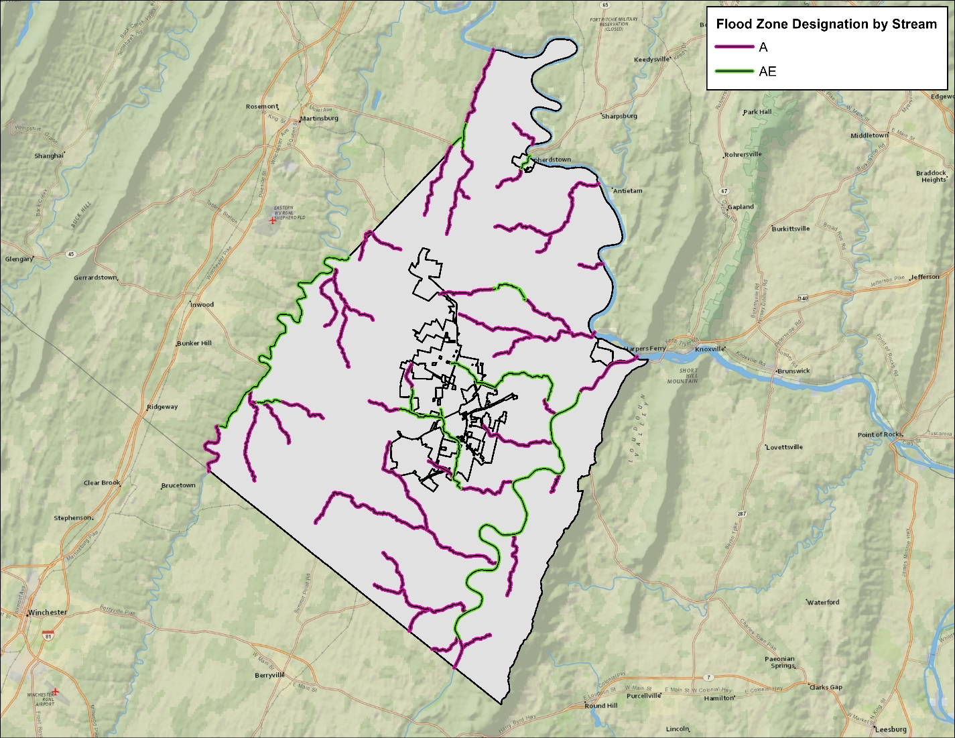

Figure 1: Map of Streams Modeled in Jefferson County by Flood Zone Categorization

# TASK SUMMARY

Draft DFIRM DB data includes floodplains and all related spatial and tabular data in the DFIRM database that will be used for community review during the comment period after the flood risk review meeting. Some profile-related tables, such as L_XS_Struct, will be incorporated at the preliminary stage as profile work finishes.

# References

* United States Census Bureau, 2022. Quick Facts – Jefferson County, West Virginia, Accessed online June 2023 at

https://www.census.gov/quickfacts/fact/table/jeffersoncountywestvirginia/PST045219

# DIGITAL DATA STRUCTURE

**Parent Folder**

* 54037C_DraftFIRM_metadata.xml
* L_Comm_Info.dbf
* L_Source_Cit.dbf
* S_BFE
* S_FIRM_Pan.shp
* S_Fld_Haz_Ar.shp
* S_Fld_Haz_Ln.shp
* S_Pol_Ar.shp
* S_Profil_Basln.shp
* S_Submittal_Info.shp
* S_XS.shp
* Study_Info.dbf

**Task Documentation**

* Project_Narrative_JeffersonCounty.docx
* Certificate_of_Completeness_54037C

**Correspondence**

* No data