**WV GIS Technical Center**

(July 1, 2021 – June 30, 2022)

2022 Annual Report

**WV GIS Technical Center**The West Virginia GIS Technical Center, located in the Department of Geology and Geography, West Virginia University, provides focus, direction, statewide coordination, and leadership to users of geographic information systems (GIS), digital mapping and remote sensing within the state of West Virginia. The Center was established by Executive Order 4-93 to provide coordination and technical support in the development and operation of geographic information systems (GIS) for the state. Statewide geospatial activities are coordinated through the WV Office of GIS Coordination, WV Geological and Economic Survey. *Below are selected highlights for Web Portals, GIS Data Development, GIS Map Applications, and GIS Services.*

**Web Portals**A core mission of the WV GIS Technical Center is to provide a mechanism to distribute GIS data and products to the public.  Two portals serve the means for achieving this goal – MapWV.gov and the WV GIS State Clearinghouse. The WV GIS State Clearinghouse ([https://wvgis.wvu.edu](https://wvgis.wvu.edu/)) catalogs over 300 unique datasets and 120 web services valued at more than $70 million dollars.  MapWV.gov ([https://mapwv.gov](https://mapwv.gov/)) provides the public accessible gateway to the wealth of GIS data available in the Clearinghouse.  The WVGISTC currently provides over 197 TB of storage space in a virtualized environment configured to maximize availability and access.  To continue this mission, the WVGISTC has invested considerably to expand and update this environment with new equipment and capabilities.

MapWV.gov continues to be impressively popular with users, largely due to important functions such as the Parcel Viewer, the Flood Tool, and the recreation tools like Trails Viewer and Hunting and Fishing Tool.  In the last year, the average daily page views jumped slightly over 30% to 171,768 compared to 131,841 the year before.  However, the number of unique users jumped a considerable 25% to 630,611 unique users this year compared to the previous year’s 505,303 unique users.  This suggests a significant number of new users are discovering the site’s capabilities and tools.

The GIS Data Clearinghouse similarly received an unprecedented jump in traffic, increasing 300% in one quarter alone.  Average page views per day jumped considerably from 1,900 to 7,650.  Total Unique users increased from 72,000 users to 85,000 users the following year. The availability of the new elevation data from FEMA contributed to the utilization increase.

**GIS Data Development**

The Center plays a crucial role in not only serving critical spatial data to state users but in updating and integrating local geospatial data within state and national geospatial databases. These data layers are utilized by **state agencies**, **communities**, and the **public** for applications that include emergency response, risk assessments, economic development, energy resource exploitation and management, transportation, natural resources, community planning, tax assessments, health studies, and election management. This past year the Center focused on the development of the geospatial data layers listed below to enhance the state’s spatial data infrastructure. The continued development and publishing of GIS layers through the state clearinghouse node hosted by the Center supports the Mineral Lands Mapping Program and other vital programs in the state that depend on current and accurate mapping layers.

* **Mineral Parcel Mapping:** The Mineral Parcels Map Project is a collaborative effort with the WV Property Tax Division and WV Geological and Economic Survey.  This past year the WV GIS Technical Center (WVGISTC) reviewed 98,054 mineral records, mapped 78,002 unique mineral records, and georeferenced 765 well plats.  WVGISTC progressed in mapping unmapped mineral records for three counties: Ritchie (28%), Doddridge (52%), and Harrison (62%) counties.
* **Highway Plans:** Completed the second phase of scanning 225,000 highway plan sheets to increase to 10,000 the total number of plan books scanned since the project was initiated in 2015. Scanning production increased significantly during this phase in which all the right-of-way and bridge plans were scanned. An interactive map viewer named the Highway Plans Locator ([www.mapwv.gov/DOTplans](http://www.mapwv.gov/DOTplans)) allows users to locate and view the archival plans.
* **County and Community Boundary Layers:** Updated the county boundary GIS layer with the 2016 Logan-Lincoln county boundary change. The updated community layer of all incorporated and unincorporated jurisdictions was created from U.S. Census incorporated boundaries, 1:24,000- scale USGS topo county boundaries, and local sources. Moreover, these updates additionally enhanced the FEMA community boundary layer to produce more accurate risk assessment products. A total of 268 flood-prone communities that include eight split communities that span over two counties were verified and updated.
* **Public Lands:** Coordinated with the WV Division of Natural Resources and other stakeholders to review and submit state public lands and local parks for submission to the Protected Areas Database of the United States.
* **Recreational Trails:** Maintained and published recreational trails for West Virginia comprised of 4,665 miles of land trails (85% non-motorized; 15% motorized) and 3,346 water trails (63% whitewater and 37% flatwater).

**Community GIS Data Development Projects**Two state contracts managed by the WV GIS Technical Center were awarded to GIS professional services companies for enhancing aerial imagery, parcel, and addressing data in the state. For West Virginia communities, a total of [45 distinctive data development projects](https://data.wvgis.wvu.edu/pub/RA/_resources/status/GISDataDevelopment.pdf) were completed with funding assistance from FEMA’s Hazard Mitigation Grant Program to improve leaf-off aerial imagery (30 unique counties; 41 total counties), parcels (7 counties), and E-911 addresses (8 communities). Multiple counties took advantage of the aerial imagery contract by paying for imagery for more than one year, and thus increasing the total data development projects to 56. These data development projects filled GIS data gaps that were preventing West Virginia from achieving detailed hazard identification and quality risk assessments. The total cost of the data development projects was $1,406,528, with the FEMA grant obligated dollars $542,541 and the county cost share 61% or $863,987.

* **Aerial Imagery:** Current and high-resolution aerial imagery is used throughout West Virginia to meet daily business needs and for developing other foundation framework layers to include E-911 addressable structures and parcels. A state contract executed between 2019 and 2022 through WVU Procurement allowed for 41 county leaf-off aerial imagery acquisitions for a total of 18,987 square miles. The total cost share by counties was 85% while the FEMA grant share was $124,478. Only two counties – Clay and Pendleton – could not contribute any cost share. *Milestone Accomplished:* Replaced the legacy statewide 12-inch resolution WV Sheriffs Association imagery acquired in 2010-12 with county leaf-off imagery that is higher resolution and more current (not older than 5 years). All the counties were collected at 4-inch resolution except for Cabell (3”), Pendleton (6’”), and Randolph (6”) counties. County imagery data sets acquired via the contract reside in the public domain. The best available, leaf-off countywide imagery is mosaicked together and published as a [statewide aerial imagery map service](https://services.wvgis.wvu.edu/arcgis/rest/services/Imagery_BaseMaps_EarthCover/wv_imagery_WVGISTC_leaf_off_mosaic/MapServer?f=jsapi). Status Graphic: [County Aerial Imagery Year Acquired](https://data.wvgis.wvu.edu/pub/RA/_resources/Status/CountyImageryYearAcquired.pdf). Refer to the [WV State Aerial Imagery](https://data.wvgis.wvu.edu/pub/RA/_resources/DataDev/Aerial/WVSIP_20191119.pdf) program for more information.
* **E-911 Addresses**: To update E-911 addresses, eight counties received grant funds of $96,220 with a 39% county cost share. A total of 56,818 E-911 addresses were mapped and verified.  
  E-911 addresses of flood-prone communities such as Marlinton (Pocahontas County), Mullens (Wyoming County), and Rowlesburg (Preston County) were updated. In addition, the community of Rowlesburg was re-addressed. Addressing deficiencies for the counties of Clay, Fayette, Hardy, Morgan, and Pocahontas counties were updated as well. *Milestone Accomplished:* This project resulted in Morgan County, which had major gaps in its E-911 address mapping, to receive a complete GIS addressing and mapping database. It also provided funding to correct addressing deficiencies for communities devastated by past floods.
* **Digital Parcels**: Seven counties received grant funds of $321,000 with a 22% county cost share to convert paper tax maps to digital. A total of 136,364 parcels were mapped. *Milestone Accomplished:* In 2004, only five counties in the state had GIS parcels; this grant provided funding to convert all remaining paper tax maps to digital so now all 55 counties maintain and publish tax maps in an electronic GIS format.

**GIS LiDAR Elevation Data Development and Products**High quality elevation data is essential for flood and landslide hazard mapping, terrain 3D maps, preliminary engineering assessments, etc. A multi-year effort finished the processing and publishing of all the FEMA-purchased QL2 LiDAR elevation data and products to the WV Flood Tool and WV Property Viewer.  This includes the 1-foot contours, 1-meter Digital Elevation Models (DEMs), and Hillshade basemap.  The Center also completed the redelineation mapping for all the Zone AE flood zones (1% recurrence interval) using the new FEMA elevation data. The statewide FEMA-purchased LiDAR and derived products are valued at $10 million.

* **Processed and Published Final FEMA-Purchased, High-Resolution Elevation Data:** The WV GIS Technical Center received two 10TB drives of new FEMA-purchased LiDAR data on September 27, 2021.  This final [2018-20 FEMA South Central WV LiDAR project](https://urldefense.us/v3/__https:/data.wvgis.wvu.edu/pub/RA/_resources/status/FEMA-purchased_LidarCoverage.pdf__;!!BClRuOV5cvtbuNI!WpSQMEN7LWJ3FYHK54TLJZS3sQkAMx8dY4KAXBYOQgyhR3SsS7O2BRSXF8Eh48hg09xYcFVs$) delivery from FEMA was quite large in extent in that it covered 38 counties in West Virginia or affected 70% of the counties in the state. Upon processing this final LiDAR data delivery, all elevation data for West Virginia derived from Quality Level 2 (QL2) LiDAR purchased by FEMA has been published to the WV Flood Tool.
* **Ground Elevation Products.**  All new elevation data was processed and incorporated into statewide elevation data products to include:
  + 1-foot contours
  + 1-meter Digital Elevation Model (DEM)
  + 1-meter Hillshade basemap
* **Special Note about Hi-Resolution Contours**.  The 1-foot contours of the 2018-20 FEMA South Central WV LiDAR project had to be quality checked, processed, cached, and then published to the WV Flood Tool and WV Property Viewer. The 1-foot contours are displayed at the highest zoom level scales (1:564 and 1:282 map scales). Caching the high-density contours to render on the online map viewers without performance issues was a lengthy, computer-intensive task and took 5.5 months to complete.
* **LiDAR Metadata.**  Metadata of all elevation sources was updated for the 2018-20 FEMA South Central WV LiDAR project.  Refer to the [WV Flood Tool elevation source](https://urldefense.us/v3/__https:/www.mapwv.gov/lidar-metadata__;!!BClRuOV5cvtbuNI!WpSQMEN7LWJ3FYHK54TLJZS3sQkAMx8dY4KAXBYOQgyhR3SsS7O2BRSXF8Eh48hg0xrJGoGf$) metadata document.  This data is accessible to the public and can be downloaded using the [WV Elevation Download Tool](https://urldefense.us/v3/__https:/data.wvgis.wvu.edu/elevation/__;!!BClRuOV5cvtbuNI!WpSQMEN7LWJ3FYHK54TLJZS3sQkAMx8dY4KAXBYOQgyhR3SsS7O2BRSXF8Eh48hg09CBnDsP$).
* **Milestones Accomplished.**  Both the WV Flood Tool and WV Property Viewer online applications now provide users with statewide coverage and access to the following high-resolution elevation products: 1-meter Digital Elevation Model (DEM), 1-meter Hillshade basemap, and 1- or 2-foot Contours.  It is presumed that the WV Flood Tool is the only statewide web map application in the nation that provides users with the ability to view and query high-resolution topographic data products. In addition, the completed LiDAR-derived elevation data on the WV Flood Tool now supports the submission of LiDAR Letters of Map Amendment (LOMAs) for the *entire* state via FEMA’s Online LOMC Portal.

**GIS Map Applications**

Continued application development and web programming assistance were provided for local and state agencies in support of West Virginia and its citizens. These applications support agencies via e-governance solutions to meet their regulatory and information exchange requirements. (Table 1). This past year, for example, the Center created online applications to support geo-enabled elections that included the WV 2022 Voter Map ([www.mapwv.gov/Vote](http://www.mapwv.gov/Vote)) for the Primary Election on May 10. The Center also updated the WV Elevation Download Tool ([www.mapwv.gov/Elevation](http://www.mapwv.gov/Elevation)) to allow users to download the statewide QL2 LiDAR high-resolution elevation products. Web statistics reveal that the most popular web application is the WV Property Viewer, which attracts six times the users than the WV Flood Tool. To assist disadvantaged counties in West Virginia with limited GIS resources, the Center now supports three major local government data producers with GIS technologies to validate and view their spatial data: county clerks (elections), county assessors (parcels), and local E-911 offices (addresses). Additionally, during this fiscal year, the Center began modernizing its applications to JavaScript 4.24 for the WV Property Viewer, WV Flood Tool, SHPO GIS Viewer, and WV Wetlands Functional Assessment Tool.

Table 1: Statewide Map Applications supported by Center

| **APPLICATION** | **PURPOSE** | **SPONSOR** |
| --- | --- | --- |
| ***WV Elevation & Lidar Download Tool*** | Download LiDAR, digital elevation models, and contours (www.mapwv.gov/elevation) | WV VIEW |
| ***WV Flood Tool*** | Flood hazard determinations, floodplain management, building-level risk assessments (www.mapwv.gov/flood) | WV DHSEM, FEMA |
| ***SHPO Map Viewer*** | Conduct Cultural Resource Section 106 reviews (www.mapwv.gov/SHPO) | SHPO |
| ***Statewide Addressing & Mapping System (SAMS)*** | Update address sites and road centerlines required for emergency response (www.mapwv.gov/address) | WV DHSEM, E-911 Address Coordinators |
| ***WV Hunting and Fishing*** | Search and identify hunting and fishing adventures (http://www.mapwv.gov/huntfish) | WV DNR |
| ***WV Trail Inventory*** | View publicly accessible recreational trails in the State (http://www.mapwv.gov/trails) | WV DOT |
| ***WV Highway Plans Locator*** | View and download archival highway plans (http://www.mapwv.gov/dotplans) | WV DOT |
| ***WV Conservation Interagency Conservation Tool*** | Determine conservation planning measures for endangered species in support of environmental site evaluations (www.mapwv.gov/ICT) | WV DNR, NRCS |
| ***WV Property Viewer & Property Record Search*** | Search and display property information for entire State (www.mapwv.gov/property). Includes delinquent properties managed by the WV State Auditor’s Office. | WV Tax, WV State Auditor, Assessors |
| ***Wetlands Functional Assessment*** | A standardized tool for assessing wetlands (https://mapwv.gov/wetlands) | WV DEP |
| ***WV Water Quality Impact Portal (WVWQIP)*** | Obtain information about past and current water quality in the 14 Marcellus Shale gas development counties (https://www.mapwv.gov/wvwqip) | WV DEP, EPA |
| ***WV Voter Map*** | A web map application for the public to look up election districts, polling sites, or sample ballots by address (https://www.mapwv.gov/vote) | WV SOS, County Clerks |

**GIS Voting Applications (Redistricting and Geo-Enabled Elections)**

In 2022, West Virginia joined the increasing number of states using geospatial technology to visualize and analyze their voter data in support of [geo-enabled elections](https://data.wvgis.wvu.edu/pub/temp/WVGISTC/2022/2022_October_StateElectionDirectorReport_final.pdf). This past year the WV GIS Technical Center collaborated with the Secretary of State's office and county clerks to geo-enable the Statewide Voter Registration System (SVRS) to assist with the redistricting of county election geographies and to improve the spatial accuracy of the state's 1.1 million voter registration points.

* **County Subdivision Redistricting of Magisterial Districts and Voting Precincts**
  + Created both tabular and map products for the county and state election officials to expedite the decennial redistricting process. This included creating a Geo-Enabled Statewide Voter Registration Tool for visualizing voter points in the context of election district boundaries, jurisdictional boundaries, E911 address points, and tax parcels. These redistricting products leveraged GIS map technologies to improve the accuracy and efficiency of the state's electoral system. Created SVRS-GEO redistricting reports (Geocoding, Pre-Redistricting Baseline V1, Geographic Split Precincts V2, and Redistricting New Geographic Precincts) to assist counties in redistricting their county subdivision election districts.
  + Performed redistricting mapping services for voting precincts and magisterial districts for 29 counties. Compiled and integrated voting precinct and magisterial district files from all 55 counties into statewide files. Published county redistricting [map files](https://wvgis.wvu.edu/data/dataset.php?ID=507) and subsequent changes for voting precincts and magisterial districts on the State Data Clearinghouse.
  + Employed Esri’s software for redistricting but transitioned to ArcGIS Pro for 30% of the counties if there were issues with census block boundaries.
* **Routine Spatial Audits of Voter Addresses and Election Geographies to Minimize Voting Errors**
  + Audited addresses of voter residents with election geography assignments. The spatial audits seek to ensure that voters are assigned to the right precinct or district, enabling them to receive the correct ballot.
  + Spatial audits of election data were provided in both tabular and geospatial formats to validate voter assignments in the Statewide Voter Registration System database. The Center employed E-911 address data and geocoding software to audit statewide voter lists to verify voters were assigned to the correct precincts and districts.
* **GIS Voting Applications**
  + Created two voter applications: the first to provide the voting information to the public; the second a non-public application for both county clerks and state election officials to review and resolve potential voting errors in the state’s election data management system (e.g., voter addresses mismatch with election geography assignments).
  + The interactive map voter application leverages GIS technology and is a result of collaboration between the state's 55 counties, their GIS mapping offices and vendors, and the WV GIS Technical Center. Due to redistricting of State Senate and House of Delegates districts by the WV Legislature and magisterial districts by the county commissions, many voting precinct lines were required to be modified which impacted many voters' in-person polling location.
  + The WV Interactive Map for Voting Precincts and Districts ([www.mapwv.gov/vote](http://www.mapwv.gov/vote)) allows the public to view the most current voter information: voting district maps (precinct, magisterial, state legislative, congressional), sample ballots, and polling site locations (both early voting and Election Day) and directions. A key accomplishment is that West Virginia may be the first state in the nation to create a statewide interactive voter map application for all its 1,675 voting precincts and 195 magisterial districts.
  + Ahead of the Primary Election, the Secretary of State's Office extensively promoted the new voting application on its GoVoteWV.com website and media outlets. "*We want to keep voters engaged in the outcome of the redistricting process*," [Secretary of State] Warner said. "This interactive map is a foundational tool for voters to find their voting precinct, Magisterial District, House of Delegates District, State Senate District and their Congressional District."
  + On the Primary Election Day of May 10 in West Virginia, the state's best-known broadcaster Hoppy Kercheval commented: "The Secretary of State's Office has a helpful interactive website with lots of voter information. Just go to https://www.mapwv.gov/vote/ enter your address and it will tell you your polling location and have links to sample ballots." After the election Hoppy Kercheval commented about the impact of the state's new interactive voter map: "*The Secretary of State's interactive map and the clerks' efforts to notify voters worked well. Yes, there was some confusion because of the new districts, but most of those problems were easily resolved on Election Day.*"
  + The Center used Esri's ArcGIS Web AppBuilder to create and standardize the voter application for both the desktop and mobile phone platforms.

**Statewide Risk Assessment Applications**Leveraging geospatial technologies, the GIS Technical Center completed preliminary risk assessment products focused on flood and landslide hazards for all 55 counties and 231 incorporated communities in West Virginia to supplement local and state hazard mitigation plans. This statewide approach and standardized methodology to multi-hazard risk assessments at the building level for every community in the state and for a geographic area over 24,000 square miles constitutes one of the largest risk assessment studies ever undertaken in the nation. Importantly, the various risk assessment products generated from this grant will benefit future risk reduction plans and projects.

* **Statewide Building Inventories:** Updated the structure-level inventory of all 1.1 million buildings and facilities exposed to multi-hazards. A more detailed inventory was created of 98,000 at-risk structures in the floodplain. Building-level risk assessments for a 1-percent-annual-chance (or 100-year) flood event were published to the WV Flood Tool’s RiskMAP View in support of flood reduction efforts. The building inventories include building occupancy and replacement values of every structure in the state.
* **Flood Risk Assessments:** Created site-specific flood risk assessments for 268 flood-prone communities (231 municipalities and 55 unincorporated areas). Referred to as the Total Exposure in Floodplains (TEIF) project. Results are published on the WV Flood Tool’s RiskMAP View (www.mapwv.gov/flood) and accessed using the [Risk Assessment Product Index](https://data.wvgis.wvu.edu/pub/RA/_engage/_IndexDocs/). A [FEMA Region 3 Resilience Report](https://content.govdelivery.com/accounts/USDHSFEMA/bulletins/32c8674) and the [WV Public Broadcasting](https://www.wvpublic.org/energy-environment/2022-11-01/southern-w-va-to-benefit-from-federal-flood-protection-funds) recently highlighted a successful cost-effective mitigation project whereby the building-level flood risk assessments identified voluntary floodplain buyout properties in McDowell County, WV.
* **Landslide Risk Assessments:** Referred to as the Total Exposure in Areas of Landslides (TEAL), this activity crated landslide incident and susceptibility maps for 55 counties. The landslide risk information is published on both the WV Flood Tool ([www.mapwv.gov/Flood](http://www.mapwv.gov/Flood)) and the WV Landslide Tool ([www.mapwv.gov/Landslide](http://www.mapwv.gov/Landslide)). Other states like Maryland have shown interest in the landslide maps and methodology developed by West Virginia. Refer to this [resource link](https://data.wvgis.wvu.edu/pub/RA/State/CL/Landslide/) for more information about the landslide risk assessments.

**GIS Services**

This past year the WV GIS Technical Center continued to assist the WV Geospatial Community with advisory, training, and outreach services. These services are coordinated with the WV Office of GIS Coordination and WV Association of Geospatial Professionals. Below are highlighted GIS services performed by the Center.

* **Public Technical Support:** Provided technical advisory services to the state geospatial community. The Technical Center responds to an estimated 15 calls per week from the public and clients regarding GIS data and applications. Many calls are received from the public about the WV Property Viewer, the most popular web application hosted by the Center.
* **Presentations and Outreach Services:** Presented on geospatial activities and projects at state and regional conferences/webinars such as the GIS-Transportation Day, WV Association of Floodplain Managers Conference, and FEMA Region III webinars.
* **E-911 Address Support:** Supported the WV Emergency Management Division and various communities with mapping support for the Statewide Addressing and Mapping System hosted on the Center’s servers.
* **Address Geocoding and Locator Services:** The Address and Street Locator Services created from the Statewide Addressing and Mapping Database were used extensively by state agencies like the DHHR and the Secretary of State’s Office.
* **WV DOT Transportation Conflation Project:**  Initiated research on how to update missing road segments in the WV DOT ‘s road network from the E-911 road database or Statewide Addressing and Mapping System (SAMS).
* **Property Tax Parcel Support:** Drafted a minor amendment for the WV Property Valuation Training and Procedures Commission’s (PVC) Procedural Rule §189-3 "Statewide Procedures for the Maintenance And Publishing Of Surface Tax Maps" (2009) to have the same annual tax map maintenance and GIS boundary file submission dates, by striking the text in paragraph §189-3-15 “during the month of April” and replacing with “by February 1st of each year.”
* **Redistricting and Election Support:** Supported the Secretary of State’s office and county clerks with redistricting and geo-enabled election services.
* **WV Floodplain Management Support:**  Training and outreach services were provided on numerous occasions in support of the WV Flood Tool, an important web application used extensively by floodplain managers and land surveyors.
* **Managed Timberland (MTL) Program:** Provided GIS technical support and consultations for the Forest Management Review Commission during the June Legislative Interims.
* **Execution of Daniel’s Law:** In the execution of Daniel's Law (W.Va. Code §5A-8-24) for the "protection of personal information relating to judicial officers, prosecutors, and law enforcement officers,” the WV GIS Technical Center coordinated with the WV Emergency Management Division to remove personally identifiable information (PII) of flagged individuals from online public databases controlled by the Center.
* **Potential Redevelopment Property Report:** For the WV Land Stewardship Corporation, which is part of the WV Abandoned Properties Coalition, created a programming script to search 1.4 million property parcels for redevelopment based on the flowing seven criteria: delinquent properties with status "No Bid" or "No Action"; located inside a municipal boundary, qualifying census tract and HUD opportunity zone; minimum lot square footage > 6,000 square feet; parcel does not intersect a flood zone; and median slope < 15 degrees (not steep).
* **Special Project - Land Use Query:** Supported U.S. Senator Manchin’s office in identifying large tracts of previously mined lands (50-100 acres) for a specific project. Quote from Senator Manchin’s Office Assistant: “*Finally got all of those maps downloaded last night and had the chance to look through a few with the index as a guide. That information looks amazing, I can’t imagine how you were able to pull everything together in such detail.”*
* **2022 GIS Strategic Plan:** In support of the WV Office of GIS Coordination, the WV GIS Technical Center was a principal author of the [2022 GIS Strategic Plan](https://data.wvgis.wvu.edu/pub/temp/WVGISTC/2022/WV_GIS_Strategic_Plan_2022.pdf). In February, the WV GIS Technical Center presented to the Transportation and Infrastructure Senate Committee of the WV Legislature on the potential for GIS to improve infrastructure in the state.  The committee was presented with information on statewide efforts that could potentially help localities, such as a statewide imagery program and a statewide addressing program.  The committee inquired as to the current local utilization of GIS and potential future use of GIS to assist communities.

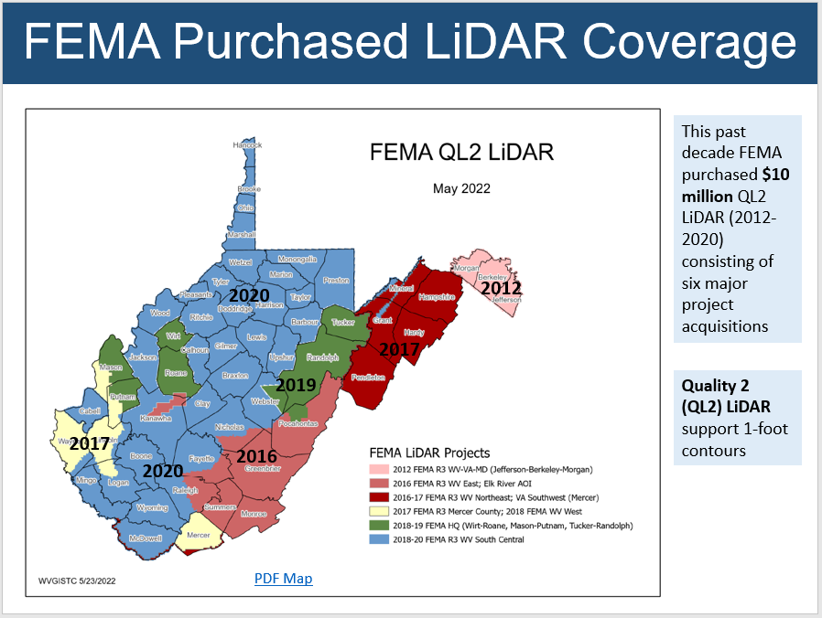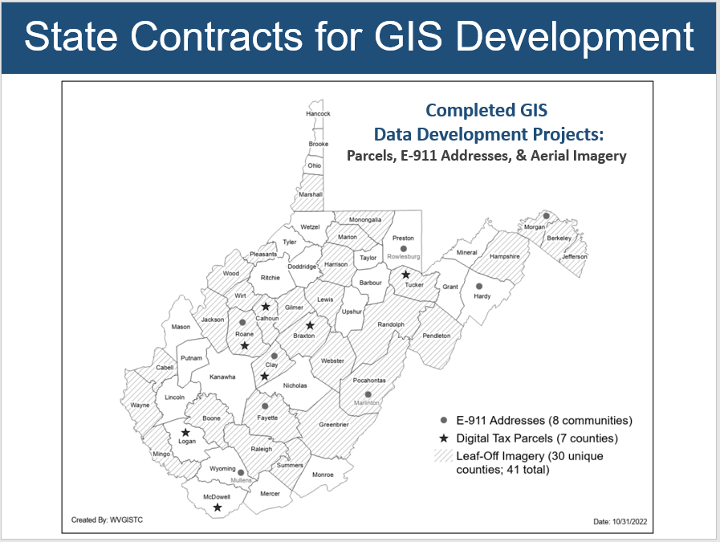

**Figure 1.** Two statewide GIS contracts through WVU Procurement supported [data development](https://data.wvgis.wvu.edu/pub/RA/_resources/Status/GISDataDevelopment.pdf) projects of parcels, addresses, and aerial imagery for multiple communities in West Virginia.

**Figure 2.** This past decade FEMA purchased $10 million dollars in QL2 LiDAR elevation data (2012-2020) consisting of [six major project acquisitions](https://data.wvgis.wvu.edu/pub/RA/_resources/Status/FEMA-purchased_LidarCoverage.pdf).

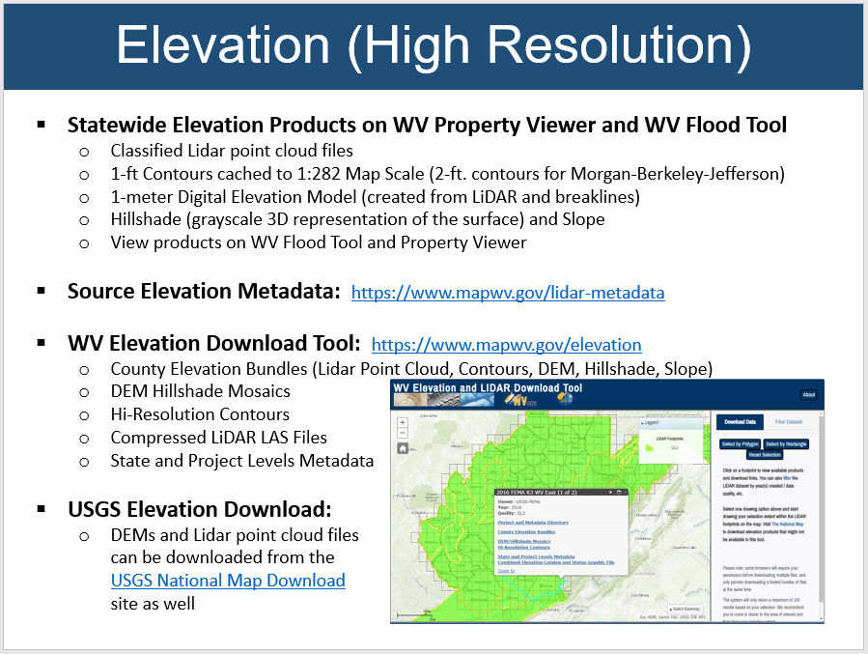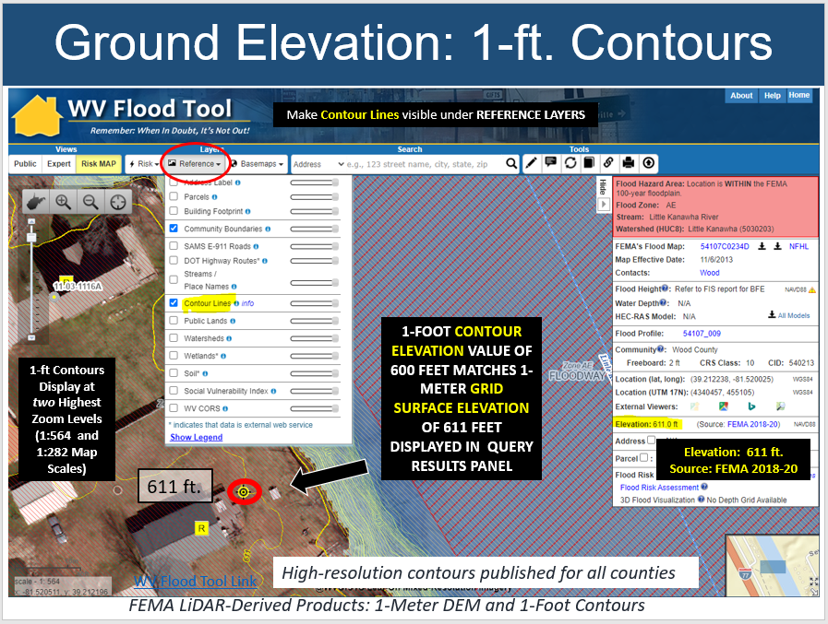

**Figure 4.** Download FEMA-purchased, high-resolution elevation data and products from the [WV Elevation Download Tool](https://data.wvgis.wvu.edu/elevation/) or the [USGS National Map](https://apps.nationalmap.gov/downloader/).

**Figure 3.** The WV Flood Tool allows users to view high-resolution elevation contours and query ground elevation values.

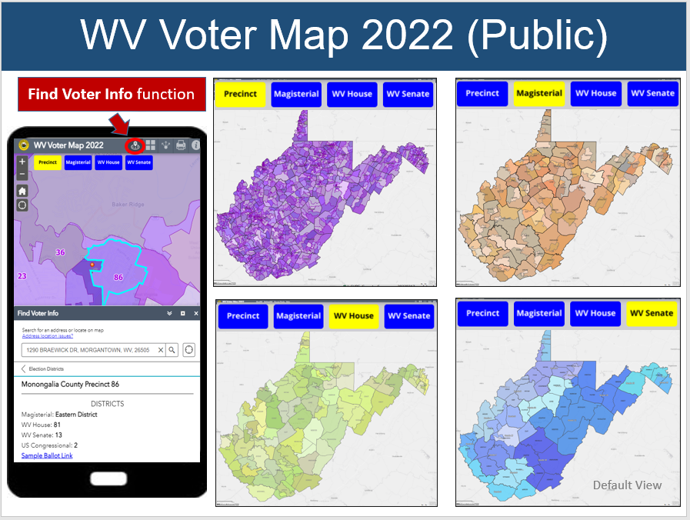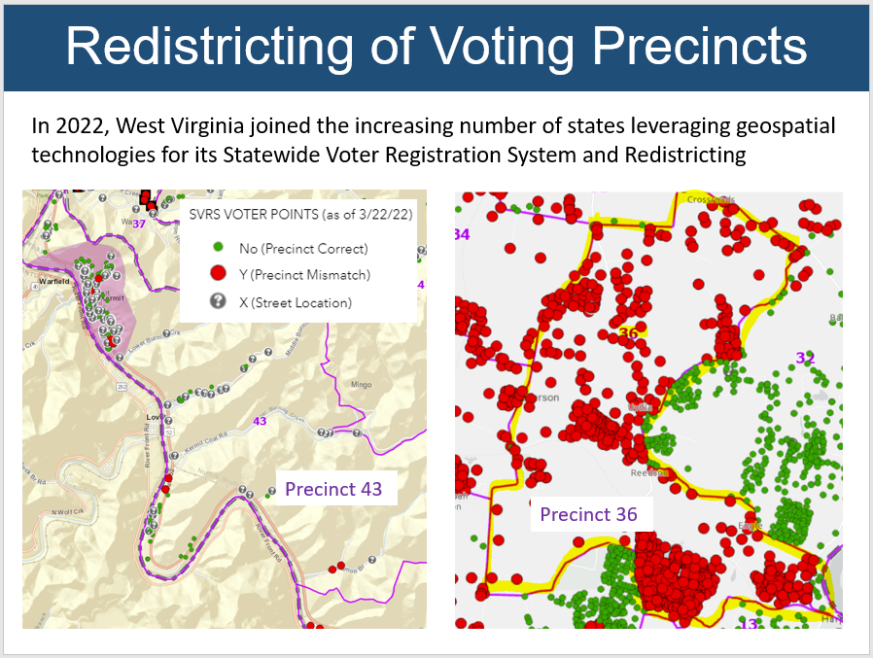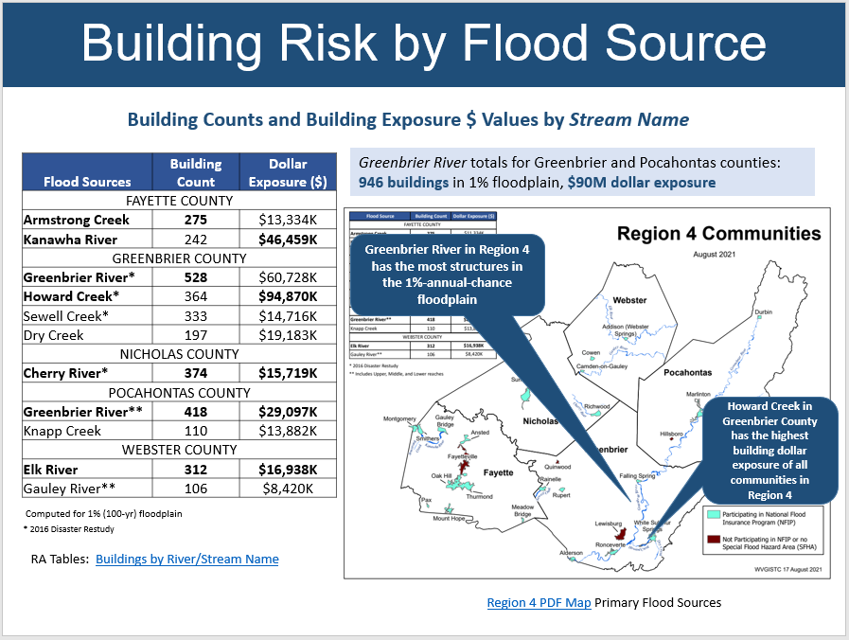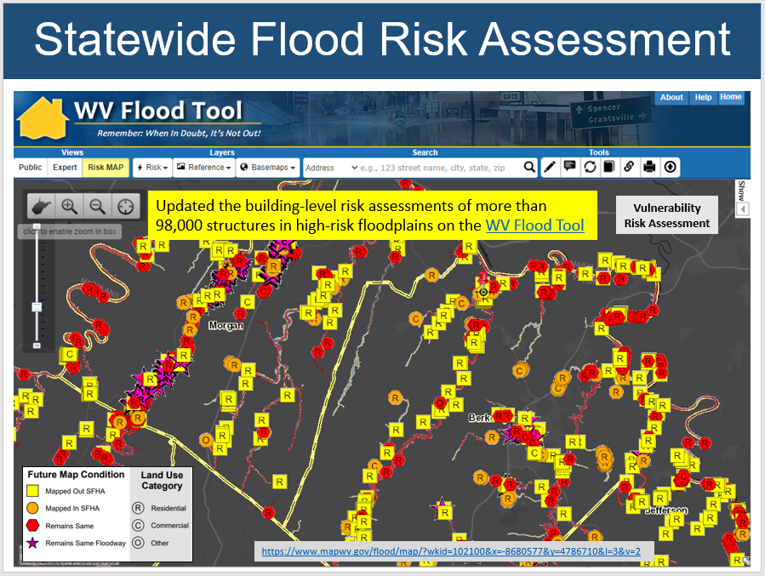 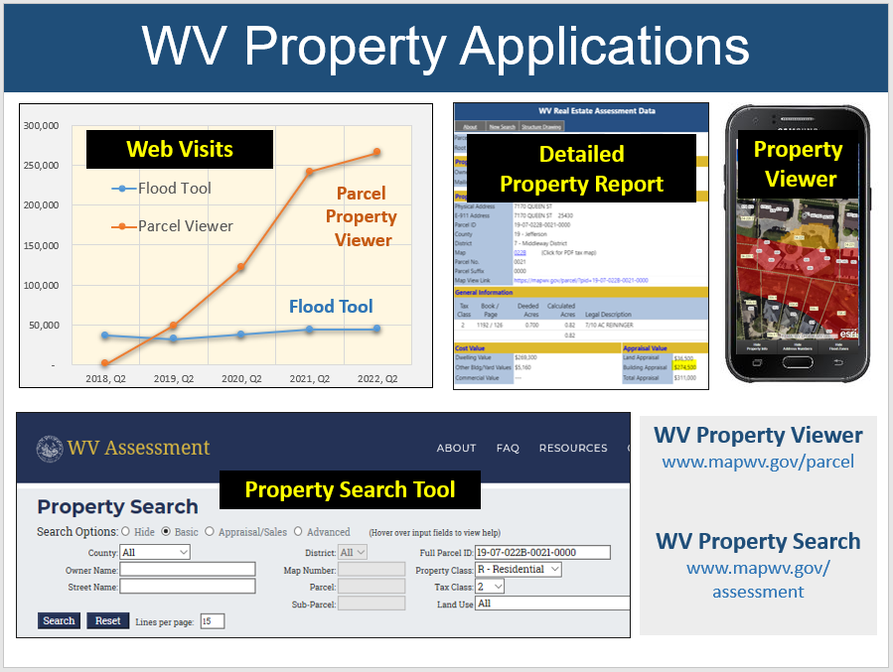

**Figure 6**. Geospatial technologies were leveraged for redistricting precincts and for routine spatial audits between voter addresses and GIS precinct boundaries to ensure that voters are assigned to the right precinct.

**Figure 5.**  The WV Interactive Map for Voting Precincts and Districts ([www.mapwv.gov/vote](http://www.mapwv.gov/vote)) allows the public to view the most current voter information: voting district maps (precinct, magisterial, state legislative, congressional), sample ballots, and polling site locations.

**Figure 7.** For flood risk vulnerability studies, updated the building-level risk assessments in high-risk floodplains for more than 98,000 structures statewide on the [WV Flood Tool](https://www.mapwv.gov/flood/map/?wkid=102100&x=-8680577&y=4786710&l=3&v=2).

Completed a [statewide building inventory](https://data.wvgis.wvu.edu/pub/temp/WVGISTC/2021/BuildingCountSFHA_Uninc_Inc_20210913.pdf) of primary structures in the 1-percent-annual-chance (or 100-year) floodplain

**Figure 8.**  Example statewide flood risk assessment [table](https://data.wvgis.wvu.edu/pub/RA/State/CL/Stream_Name/) and [graphic](https://data.wvgis.wvu.edu/pub/RA/State/CL/Stream_Name/graphics/) showing building counts and dollar exposure by flood source for the Region 4 Planning and Development Council.

**Figure 9.** The WV Property Viewer and Property Search Tool for searching and viewing property records ([www.mapwv.gov/property](http://www.mapwv.gov/assessment)) continues to grow in popularity.