West Virginia Statewide Imagery Program

Overview
West Virginia is one of the few regional states without a statewide imagery acquisition program. Aerial imagery is critical for state government, local government, law enforcement, economic development, emergency responders, private companies, and private citizens in the modern world. WV current imagery has no replacement plan in place, leaving local governments to fend for themselves. A Statewide Imagery Program can help alleviate these issues.

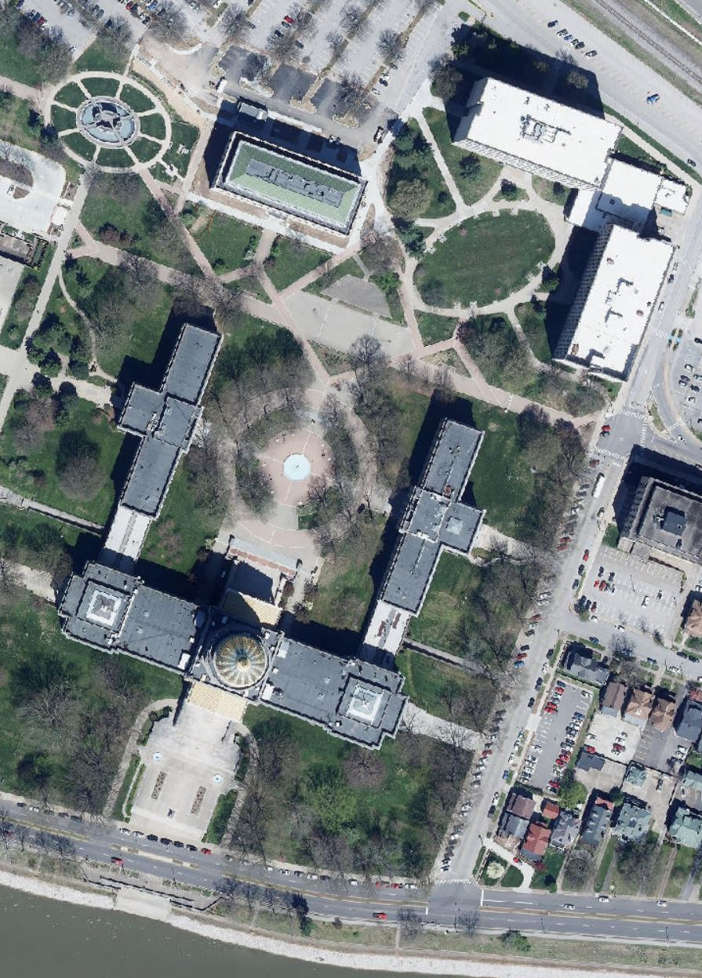
Benefits and Uses
Aerial Imagery is a fundamental spatial dataset that is used in an ever increasing variety of applications. Police and emergency responders use it to get an accurate understanding of the landscape. Private companies use it to efficiently explore an area for investment. County and Municipal governments rely upon it to show growth and attract investment and citizenry to their areas. It is used to help prevent damage from natural disasters and coordinate responses when disasters happen.

Why a Statewide Imagery Program?
Current methods of aerial imagery acquisition leave it to counties and municipalities to acquire their own imagery at their own costs, forcing them to negotiate in isolation from one another. A Statewide Program could provide a bulk discount for these products. Imagery is a snapshot in time for a landscape that is constantly changing. Up to date imagery can be critical for a locality, but differing access to resources means that the Digital Divide between ‘haves’ and ‘have nots’ is further exacerbated. Creating a statewide program will guarantee that each locality has access to high quality data at regular intervals.

How does a Statewide Imagery Program save money?
Aerial Imagery is delivered by a vendor flying an area, processing the data, and delivering the final products to the client. Getting a crew in the air to fly an area is a significant portion of the costs. Vendors have to meet different standards of data quality and data delivery for each client, adding to the costs. Delivered imagery must be housed and distributed, itself an IT cost for the locality. Each locality has to construct its own applications that leverage the data, and potential users have to know about each individual holding to use the data.
However, with a statewide program, economies of scale at each of these steps allows the state to negotiate a lower price for everyone. Flight plans can be longer and capture more at the same time. Vendors have one client and one standard for that client. That one client also has the necessary expertise and training to make certain the state gets the maximum quality and benefit for its dollar. A statewide program allows for one storage and distribution point for all stakeholders, both governmental and private. Applications can be centralized where it makes sense, such as the WV Flood Tool and WV Parcel Viewer, but still allow for locally customized applications as desired.

How would it work?
A Statewide Imagery Program would be a partnership between a state agency and localities. The state agency acts as a central client for the vendor or vendors. Minimum standards are set and an agreed upon price is negotiated per square mile of data acquisition. Localities are presented with a per square mile price at the minimum standard. Available funds may be used by the state agency to supplement the funds for counties who cannot meet that price for their area. A menu of ‘up charge’ items could also be negotiated, should any county wish to purchase additional products at the time - products that would also be cheaper than if they did it alone! Data is then delivered to the state agency, which adds it to the state imagery holdings and gives it to counties.
Most of the regional states follow a predictable cycle. A fraction of the state is flown every year - one third, one fourth, or even one fifth - so that every 3, 4, or 5 years the entire state is flown. This assures users the data is refreshed in a timely and cost efficient manner.

