West Virginia Statewide Addressing Program

# Overview

Accurate and reliable addresses are a critical dataset for emergency management, routing, policing, navigation, and efficient commerce in a community. Addresses describe a physical place but ideally, they also point to one and only one specific place on the planet. Keeping such a system up to date is most easily done at the local level, but the state level plays an important role in making that data available to the most number of users possible.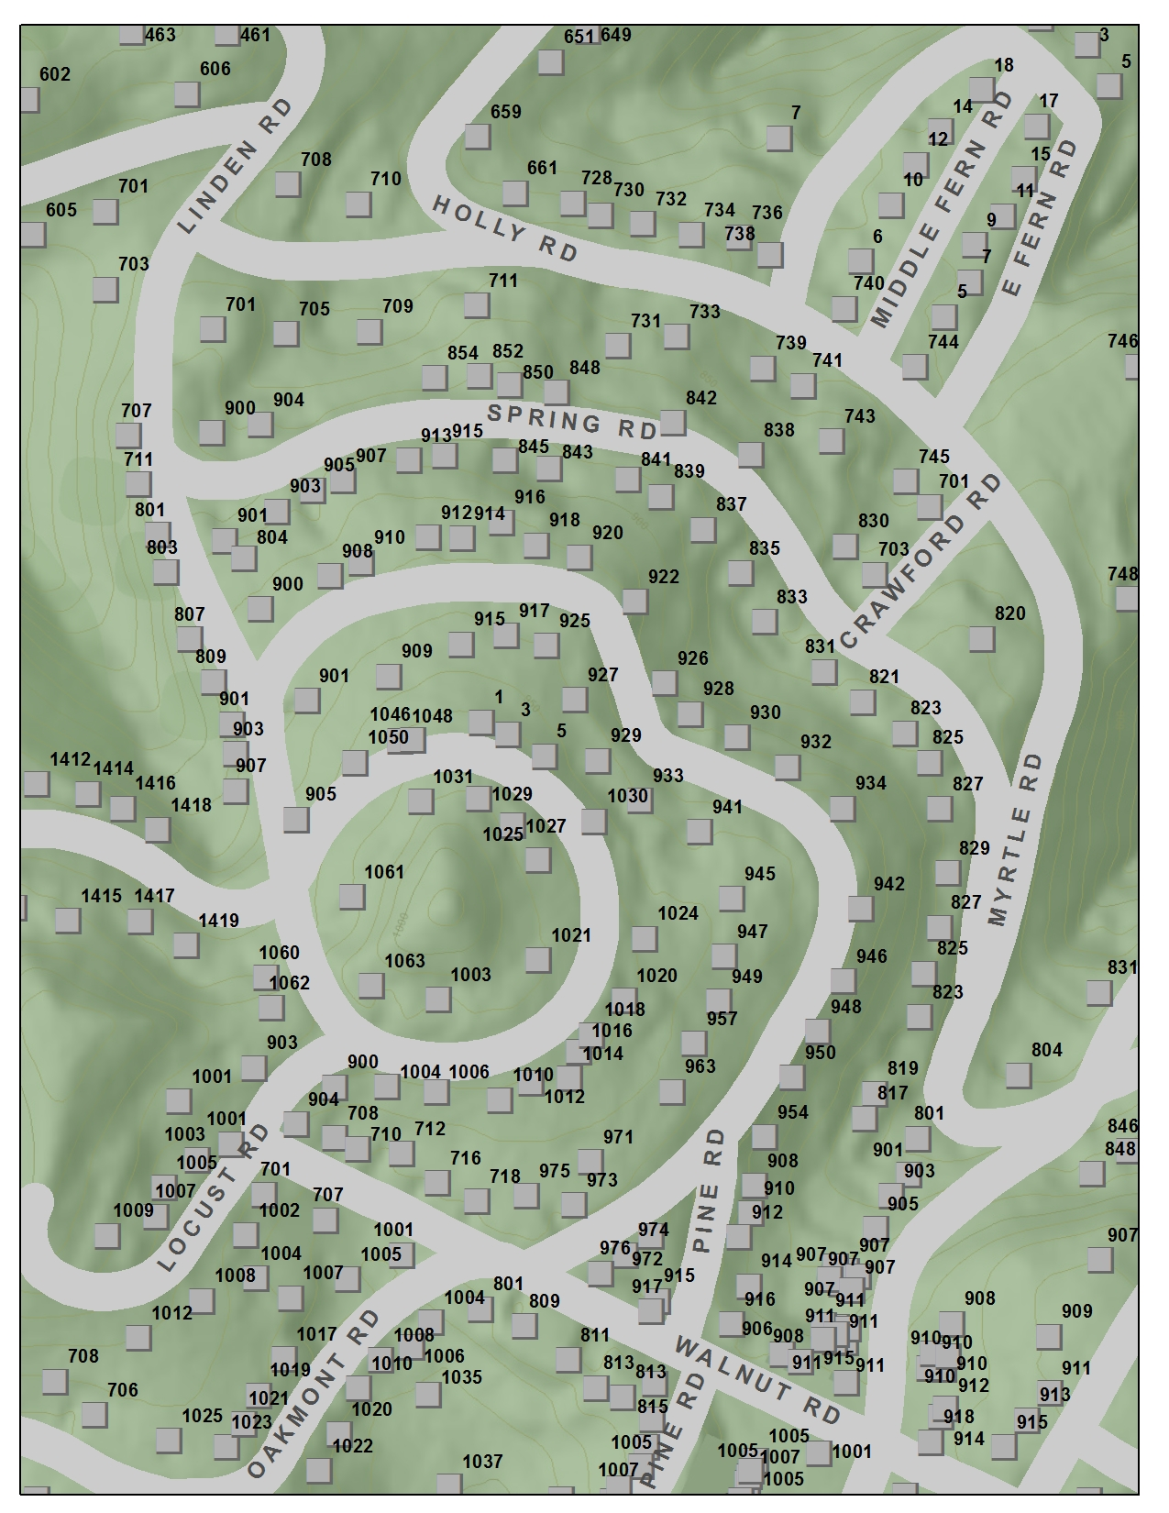

## Why do addresses matter so much?

Users of all walks, whether it be an emergency responder responding to a situation, a shipping company delivering a present, or a local government official looking to improve their community, need to be certain they are where they need to be. Nearly every facet of government, economic development, public safety, utilities, and commerce activity requires high quality, accurate, verified, reliable address location information.

## Why a Statewide Addressing Program?

A physical address seems a simple idea to capture and store. At its core, it is simply a street number, a street name, a city, a state, and an exact X/Y of the associated physical structure. A properly robust system requires not just sites, but road centerline data as well. Reaching even the simplest point is an incredibly labor intensive process. West Virginia has over 1 million addressable structures. Efficiently and accurately addressing requires coordination. Furthermore, making those available to a variety of end users demands technical expertise and informational infrastructure investment not widely available to all counties.

## How does a Statewide Addressing Program save money?

Statewide addressing has a long history in WV, dating back to the State Addressing and Mapping Board of 2003. These efforts have culminated in the current E911 addressing system, which is a system that integrates local efforts by County Addressing Coordinators into a master system designed to support E911 needs. However, these efforts primarily rely upon localities to spend limited resources to capture, update, and verify this data. The Digital Divide between ‘have’ and ‘have not’ counties has led to uneven quality data from county to county. A statewide program would provide minimum standards of reliability and accuracy while at the same time providing expert guidance, training, and resources to those counties most in need of support.

Furthermore, a statewide program could consider use cases outside the E911 context. Rather than force all users to make derivative data to meet their specific needs, the existing data could be enhanced with additional information, made more broadly available to a greater number of use cases by leveraging enterprise technology, and provide processes that allow localities to quickly get their data updates into a system and out to end users. Finally, roughly 30% of counties require the use of contractors to supplement local capabilities. A statewide addressing program could provide efficiencies in that process, potentially bringing cheaper contracts to individual counties, saving money for both the ‘have’ and ‘have nots’.

# How would it work?

A statewide addressing program would provide a centralized organizing point for addressing efforts and use in the state. Localities would utilize the program to help with contractor organization and bidding, provide data descimination tools, and provide training and support for their local efforts. The statewide system would provide quality assurance for end users. State government would tap into the centralized database to support their own efforts within their own agencies. Functions such as voting registration or motor vehicle licensing could use the system rather than make parallel datasets. The information would be publicly available such that private corporations or citizens could use the information for their own needs.